PurlandTraining.com
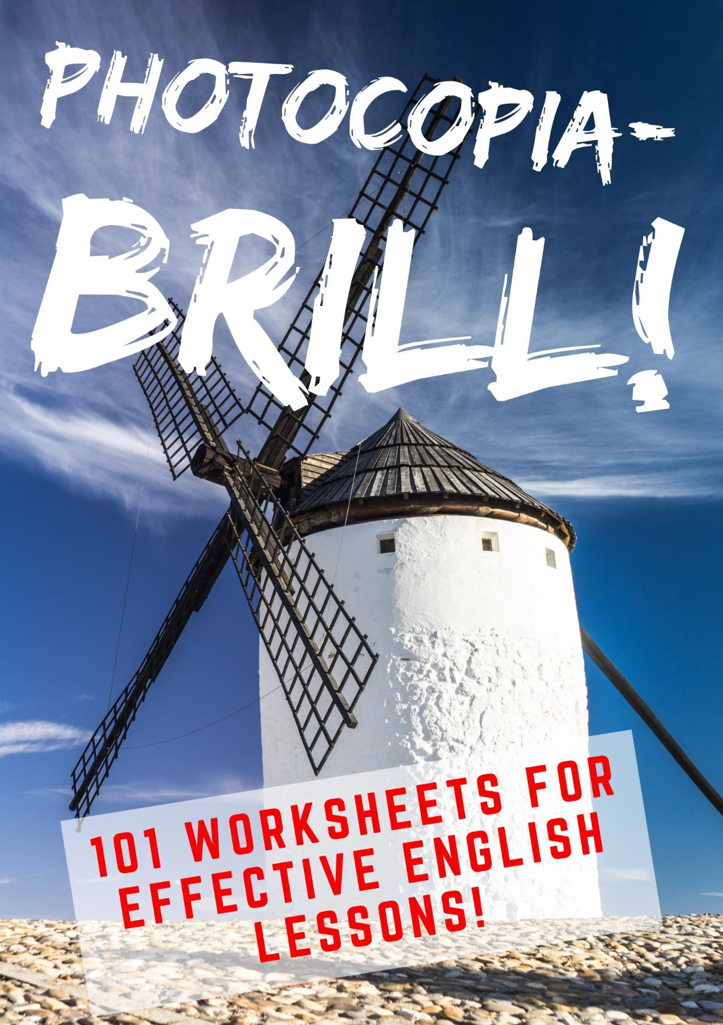
by Matt Purland

Intermediate Level (CEFR B1-B2)

PurlandTraining.com
info@purlandtraining.com https://purlandtraining.com

First published in the UK by PurlandTraining.com 2019

Hyperlinks are provided in this text for the reader’s convenience. The author and the publisher are not responsible for the contents or reliability of any websites which are listed and do not necessarily endorse the views expressed within them.

Image credits:

Front cover and flyleaf: https://pixabay.com/
pp.41-42, 43, 70, 71, 72, 86-88, 102, 103: https://pixabay.com/
p.45: https://www.template.net/design-templates/print/printable-clock-template/ p.48: https://pexels.com/
p.76: https://www.istockphoto.com/
p.98: Image uses elements of: https://commons.wikimedia.org/wiki/File:BBFC_18_2002.png p.99, 101, 112: https://www.canva.com/
p.107: https://purlandtraining.com/
pp.69 & 121: https://wordpress.org/plugins/crosswordsearch/

Please note: we have endeavoured to credit all the owners of images in this book. If we have not credited your image, please feel free to contact us and we will credit it in the next edition.

Public Domain

The author and sole copyright holder of this document has donated it to the public domain. Anybody can use this document, for commercial and non-commercial purposes.

Hi there . . . !

. . . and welcome to the first-ever collection of printable worksheets from my new website – PurlandTraining.com! I’ve called this first volume photocopiaBRILL! because: a) it’s a book of photocopiable worksheets, and b) they are BRILL(iant)! This book is for any student of English who wants to improve their language skills by self-study, since it includes full answers and notes for use (from p.115). It’s also suitable for any teacher of English who needs variety in their material and aims to provide thought-provoking and stimulating lessons for their students.

The worksheets cover a wide range of skills, from grammar, vocabulary, and reading, to speaking and listening, pronunciation, and writing. There’s loads of useful material here, including practice with tenses, conditionals, adjectives, quantifiers, and much more! There is an extensive section about word groups, including homonyms, homophones, antonyms, and minimal pairs, while the speaking and listening material features lots of useful discussion questions on interesting topics like social networks, graffiti, laughter, and, of course, breakfast! This book also features some terrific infographics, which will be sure to inspire discussion, for example Fight or Flight on p.102.

Most of this material is taken from the PurlandTraining.com website and has been collected together in book form (with answers) for the first time in this volume.
As usual, thanks to all my students who have tried out various drafts of this material and given feedback. If you have any comments or questions, I’d love to hear from you. Pease contact me via the website: PurlandTraining.com. If you do visit the site, be sure to check out the Free Books page, where you can download free PDF copies of all my previous books. This is my 27th resource book, but I feel like I’m just getting started! I’m absolutely delighted to still be able to produce new material for you after all these years!

I hope you like this book.

Matt Purland Ostróda, Poland, 28th October 2019

- Introduction
- Contents

Grammar
- This, That, These, Those 1
- This, That, These, Those 2
- When to Use Present Simple and Present Continuous 1
- When to Use Present Simple and Present Continuous 2
- When to Use Present Simple and Present Continuous – Writing Activity
- Future Simple and Future Continuous – Multiple Choice Quiz
- Using Future Perfect Continuous – Info Page
- Using Future Perfect Continuous – Activity
- Get to Know... the Conditional Family 1
- Get to Know... the Conditional Family 2
- Get to Know... the Conditional Family 3
- Get to Know... the Conditional Family 4
- Get to Know... the Conditional Family – Your Ideas
- Create Maths Problems with Zero Conditional Question Forms
- There is / There are – Info Page
- There is / There are – Exercises
- Countable and Uncountable Nouns – Info Page
- Countable and Uncountable Nouns – Exercises
- Adjectives – Info Page
- Adjectives – Exercises
- 100 Adjective + Preposition Collocations (A-Z List)
- 100 Adjective + Preposition Collocations (A-Z List – Gap Fill)
- 100 Words You Didn’t Know Were Adverbs – Ordered by Type
- When Do We Use All and Whole in English?
- Mega-List of Quantifiers in English
- 26 Past, Present, and Future Uses of Would
- 26 Past, Present, and Future Uses of Would – Activities
- Understanding Ellipsis – Info Page
- Understanding Ellipsis 1
- Understanding Ellipsis 2
- Causative Verbs – Have / Get 1
- Causative Verbs – Have / Get 2
- 20 Common Errors that English Students Make – Part 1
- 20 Common Errors that English Students Make – Part 2
- 20 English Phrasal Verbs with RUN

Vocabulary
- Telling the Time – Info Page
- Telling the Time – Exercises
- Describing People – Info Page
- Describing People – Exercises
- 6 Important Word Groups in English
- 6 Important Word Groups in English (Gap-Fill)
- 100 Common English Homonyms

- 100 Common English Homonyms (Gap-Fill)
- 200 Common English Homophones
- 200 Common English Homophones (Gap-Fill)
- 100 Common English Homographs
- 100 Common English Homographs (Gap-Fill)
- 100 Common English Antonyms
- 100 Common English Antonyms (Gap-Fill)
- 200 Common Minimal Pairs in English
- 200 Common Minimal Pairs in English (Gap-Fill)
- Learn 100 New English Words with the Suffix -ous (Part 1)
- Learn 100 New English Words with the Suffix -ous (Part 1) – Research
- Learn 100 New English Words with the Suffix -ous (Part 1) – Gap-Fill
- Learn 100 New English Words with the Suffix -ous (Part 2)
- Learn 100 New English Words with the Suffix -ous (Part 2) – Research
- Learn 100 New English Words with the Suffix -ous (Part 2) – Gap-Fill
- List of 300 Loanwords in English
- Raw Materials – English Idioms
- Word Search – Find 40 Two-Letter English Words
- 100 Great English Oxymorons
- Football Verb / Noun Collocations in English
- It Is What It Is! And 15 Other Infuriating English Phrases

Reading
- The Businessman and the Fisherman (Gap-Fill)
- The Businessman and the Fisherman (Discussion Questions)
- The Ultimate Tardigrade Quiz – 50 Questions!

Speaking and Listening
- Using an Object for Discussion Practice
- Giving Your Opinion – Info Page
- Giving Your Opinion – Exercises
- Which is Better? Discussion
- Just Forget It! Discussion – Part 1
- Just Forget It! Discussion – Part 2
- Just Forget It! Discussion – Part 3
- Talking about a Song in an ESOL Class (Blank)
- Find Alternatives to Plastic 1
- Find Alternatives to Plastic 2
- Find Alternatives to Plastic – Write Your Own
- Restaurants – Discussion Questions
- Social Networks – Discussion Questions
- Selfish People – Discussion – Part 1
- Selfish People – Discussion – Part 2
- Graffiti and Street Art – Discussion Questions
- Raw Materials – Discussion Questions – Page 1
- Raw Materials – Discussion Questions – Page 2
- Laughter – Discussion Questions
- Talk about Your Country / Breakfast – Discussion Questions
- At What Age Can I Legally… in the UK?
- The Only Discussion Question Starters You’ll Ever Need!

- Discussion Question Starters – Cheat Sheet
- 20 Lies that are Hard to Dispute
- Fight or Flight?
- 27 Different Kinds of Holiday

Pronunciation
- Silent Letters – Info Page
- Silent Letters – Exercises
- Glottal Stops – Info Page
- Glottal Stops – Exercises
- Intonation – Info Page (1)
- Intonation – Info Page (2)
- Intonation – Exercises
- How to Say the English Alphabet

Writing
- Story Planning – My Life Without…

- Answers to Worksheets and Notes for Use

PurlandTraining.com

grammar

This, That, These, Those 1

This, that, these, and those are called demonstratives. They can be either determiners (before a noun) or pronouns (before a verb). We use them to show the distance in space or time between the speaker/writer and the noun:

 | singular (1) | plural (1+)
near in space or time here / now | this | these
not near in space or time there / then | that | those

demonstrative determiners: | demonstrative pronouns:
before a noun, e.g.  This bag is heavy. | before a verb, e.g.  This is a heavy bag.

- Complete each sentence with this, that, these, or those. b) Write D for determiner and P for
pronoun. c) Discuss with a partner: which words in each sentence helped you to find the answer?

  - Look at
  - I’m getting off because
beautiful mountains.
is my stop.

  - I’ll use laptop and you use one over there.
  - Who was on the phone? My cousin Alan.
  - meeting last night was a waste of time.
  - I need to borrow book, but librarian said I couldn’t.
  - are my favourite plants. Yes, they are lovely. I don’t like over there by the gate.
  - Hi Paul, is Brian. Is a good time to talk?
  - Who are you meeting morning?
  - ‘Please take another cake.’ ‘Is the last one?’ ‘Yes, but you can have it.’
  - Mmm, cakes look delicious. I can’t wait to try one!
  - Do you remember the 1980s? Yes, were the days!
  - is going to be the best party ever!
  - Mmm, cakes are delicious. Please have another one!
  - is Joe who works in the accounts department.
  - I prefer trousers to in the other shop.
  - What have you been doing week?
  - OK, stop. ’s enough petrol! It’s full.
  - I think I’ll go to bed early tonight. Yes, ’s a good idea.
  - ‘I really hate Clive.’ ‘ was a nasty thing to say, Jo.’

This, That, These, Those 2

This, that, these, and those are called demonstratives. They can be either determiners (before a noun) or pronouns (before a verb). We use them to show the distance in space or time between the speaker/writer and the noun:

 | singular (1) | plural (1+)
near in space or time here / now | this | these
not near in space or time there / then | that | those

demostrative determiners: | demonstrative pronouns:
before a noun, e.g.  This bag is heavy. | before a verb, e.g.  This is a heavy bag.

- Complete each sentence with this, that, these, or those. b) Write D for determiner and P for
pronoun. c) Discuss with a partner: which words in each sentence helped you to find the answer?

  - classes began two months ago.
  - ‘Look! ’s my favourite actor!’ ‘Where?’ ‘Over there.’
  - is a good concert, isn’t it?
  - Did you go to Sally’s flat yesterday? No, but I’m going morning.
  - ‘My grandma gave me earrings.’ ‘They’re beautiful. They really suit you.’
  - Look at coin I found.
  - ‘ is a picture of my classmates.’ ‘They look nice.’

8.
- Did you watch
kids are playing too close to the road. Go and tell them. tv programme I told you about?

- They had to sell their car. Yes, was a shame.
- I wish bus would start moving. I’m going to be late.
- ’s my house on TV!
- Look at scar on my hand.
- class was so boring.
- guinea pigs are so cute. They’re happy for me to stroke them.
- Hi Mike. How are you? are my friends Millie and Liam.
- are my horses in the video.
- Look at man over there.
- ‘ are the last two pancakes.’ ‘Thanks, dad.’
- classes begin next week.

When to Use Present Simple and Present Continuous 1

- Study the information below about when to use Present Simple and Present Continuous tenses. Note that both tenses can be used in four different times: General Time, Present, Past, and Future.
- Match each sentence to one of the tenses and uses, e.g. 1. = PrS C. Write the code on the line.

When to use Present Simple:

PrS | Time: | Use: | Example:
A* | General Time | regular actions | I go to work every day.
B* | General Time | facts | Tokyo is the capital city of Japan.
C* | Present | state | I feel fine (at the moment).
D | Present | now – live commentary | Grant passes to Moore; Moore takes a shot; he scores!
E | Present | instructions | First you break two eggs, then you mix in the flour, and add milk.
F | Past | historic present 1 – slang story | So he says get out but I say no, I’m not going nowhere!
G | Past | historic present 2 – history | Napoleon leaves the chateau the next day and rides to Paris.
H* | Past | news headline | PM argues against road closures.
I* | Future | schedules | The train leaves at 8 o’clock on Wednesday morning.
J* | Future | after when, while, if, before, etc. | I will talk to you when you get home.

*most common uses

When to use Present Continuous:

PrC | Time: | Use: | Example:
A* | General Time | repeated actions | I’m always forgetting to take my lunch to work!
B* | General Time | after when, while, if, before, etc. | I love it when the sun is shining.
C* | Present | now – unfinished actions | Tina is walking to work (at the moment).
D* | Present | temporary situations | We’re living in Berlin (at present).
E | Present | trends | Jogging is getting more popular these days.
F | Present | now – live commentary | They’re sprinting up the track; getting closer; Thomas is leading…
G | Past | historic present 1 – slang story | I’m washing the car, right, and my kids are trying to help, but...
H | Past | historic present 2 – history | War is approaching and the United States is preparing for the worst.
I* | Future | arrangements (+ time phrase) | We’re meeting our son’s teacher on Monday.
J | Future | just about to start an action | We’re going to bed. Goodnight.
*most common uses

- The weather is lovely today.  - Claire is running for the bus. | PrS C
3. So my old man is rude to the bouncer and we are both chucked out of the club.
4. If you don’t stop misbehaving there will be trouble!
5. Barry visits his grandparents once a month.
6. Lucas is always messing around in class.
7. After that you put the tray into the oven and wait for fifteen minutes.
8. Don’s just leaving.
9. Paul usually eats breakfast while he’s reading the newspaper.
10. Ferguson warns of new debt crisis.
11. I’m staying with an old friend for a few weeks.
12. Timms opens the plane door and steps out; he waves then begins his descent.
13. Look! Bob’s coming, and he’s bringing his mates; they’re all running…!
14. We’re sitting in the garden, minding our own business, and a fox appears.
15. We start tomorrow at 9am.
16. Unemployment is rising and Thatcher is briefing her cabinet at Number Ten.
17. Motor vehicles cause most of the carbon monoxide poisoning in the U.S.
18. It’s becoming much harder for young people to get on the housing ladder, isn’t it?
19. Hugh is having a drink with Emily tomorrow evening.
20. Washington is elected Commander-in-Chief of the Continental Army on June 15, 1775.

When to Use Present Simple and Present Continuous 2

- Study the information below about when to use Present Simple and Present Continuous tenses. Note that both tenses can be used in four different times: General Time, Present, Past, and Future.
- Match each sentence to one of the tenses and uses, e.g. 1. = PrC J. Write the code on the line.

When to use Present Simple:

PrS | Time: | Use: | Example:
A* | General Time | regular actions | I go to work every day.
B* | General Time | facts | Tokyo is the capital city of Japan.
C* | Present | state | I feel fine (at the moment).
D | Present | now – live commentary | Grant passes to Moore; Moore takes a shot; he scores!
E | Present | instructions | First you break two eggs, then you mix in the flour, and add milk.
F | Past | historic present 1 – slang story | So he says get out but I say no, I’m not going nowhere!
G | Past | historic present 2 – history | Napoleon leaves the chateau the next day and rides to Paris.
H* | Past | news headline | PM argues against road closures.
I* | Future | schedules | The train leaves at 8 o’clock on Wednesday morning.
J* | Future | after when, while, if, before, etc. | I will talk to you when you get home.

*most common uses

When to use Present Continuous:

PrC | Time: | Use: | Example:
A* | General Time | repeated actions | I’m always forgetting to take my lunch to work!
B* | General Time | after when, while, if, before, etc. | I love it when the sun is shining.
C* | Present | now – unfinished actions | Tina is walking to work (at the moment).
D* | Present | temporary situations | We’re living in Berlin (at present).
E | Present | trends | Jogging is getting more popular these days.
F | Present | now – live commentary | They’re sprinting up the track; getting closer; Thomas is leading…
G | Past | historic present 1 – slang story | I’m washing the car, right, and my kids are trying to help, but...
H | Past | historic present 2 – history | War is approaching and the United States is preparing for the worst.
I* | Future | arrangements (+ time phrase) | We’re meeting our son’s teacher on Monday.
J | Future | just about to start an action | We’re going to bed. Goodnight.
*most common uses

- We’re going to the park now. PrC J
- There are fifty-two weeks in a year.

- Suddenly – it’s startin’ to rain and everybody’s packin’ away their picnic things.
- King Alfred is doing everything in his power to defeat the Viking hordes.
- You click on the ‘Contact’ link, open the web page, then type your comment in the box.
- Girls are learning faster than boys, according to new research.
- Peter plays tennis every Friday.
- So Barbara asks John to dance, but he says no, and then walks off in the other direction.
- Hammond’s car is now passing his teammate, who is trying his best not to let him through.
- I’m getting ready.

- The dancers join hands; they step forward; they bow; they thank the audience.
- The water is nice and warm.

- You can have a cake when they’re ready.
- I’m working with Corey on a new project at the moment.
- It’s hard to concentrate while the builders are making such a noise.
- The Rainhill Trials are a huge success and Stevenson’s Rocket wins a place in history.
- Wilkins aims for Cup Final glory.
- They’re always telling me to work harder.
- The first bus leaves at 6:42 in the morning.
- The inspectors are coming in to see us next Tuesday.

When to Use Present Simple and Present Continuous – Writing Activity

- Study the information below about when to use Present Simple and Present Continuous tenses. Note that both tenses can be used in four different times: General Time, Present, Past, and Future.
- Write one sentence to demonstrate each use.

When to use Present Simple (*most common uses)

PrS | Time: | Use: | Example:
A* | General Time | regular actions | I go to work every day.
B* | General Time | facts | Tokyo is the capital city of Japan.
C* | Present | state | I feel fine (at the moment).
D | Present | now – live commentary | Grant passes to Moore; Moore takes a shot; he scores!
E | Present | instructions | First you break two eggs, then you mix in the flour, and add milk.
F | Past | historic present 1 – slang story | So he says get out but I say no, I’m not going nowhere!
G | Past | historic present 2 – history | Napoleon leaves the chateau the next day and rides to Paris.
H* | Past | news headline | PM argues against road closures.
I* | Future | schedules | The train leaves at 8 o’clock on Wednesday morning.
J* | Future | after when, while, if, before, etc. | I will talk to you when you get home.
When to use Present Continuous (*most common uses)

PrC | Time: | Use: | Example:
A* | General Time | repeated actions | I’m always forgetting to take my lunch to work!
B* | General Time | after when, while, if, before, etc. | I love it when the sun is shining.
C* | Present | now – unfinished actions | Tina is walking to work (at the moment).
D* | Present | temporary situations | We’re living in Berlin (at present).
E | Present | trends | Jogging is getting more popular these days.
F | Present | now – live commentary | They’re sprinting up the track; getting closer; Thomas is leading…
G | Past | historic present 1 – slang story | I’m washing the car, right, and my kids are trying to help, but...
H | Past | historic present 2 – history | War is approaching and the United States is preparing for the worst.
I* | Future | arrangements (+ time phrase) | We’re meeting our son’s teacher on Monday.
J | Future | just about to start an action | We’re going to bed. Goodnight.

1. PrS A
2. PrS B
3. PrS C
4. PrS D
5. PrS E
6. PrS F
7. PrS G
8. PrS H
9. PrS I
10. PrS J
11. PrC A
12. PrC B
13. PrC C
14. PrC D
15. PrC E
16. PrC F
17. PrC G
18. PrC H
19. PrC I
20. PrC J

Future Simple and Future Continuous – Multiple Choice Quiz

Choose the correct answers to the questions below:

- How do you make Future Simple?
a) subject + will + infinitive b) subject + will + be + ing form

- How do you make Future Continuous?
a) subject + will + have + ing form b) subject + will + be + ing form

- Which sentence is Future Simple?
a) I will go to the shop later. b) I will be go to the shop later.

- Which sentence is Future Continuous?
a) He will be study later. b) He will be studying later.

- Which contraction (short form) is incorrect?
a) We’ll meet you at six o’clock. b) We will’ll meet you at six o’clock.

- Which statement(s) are true? We use Future Simple for:
a) immediate future b) promises c) future predictions d) future plans

- The negative form of will:
a) willn’t b) will not c) want d) will no

- The contraction of ‘will not’ is:
a) won’t b) willn’t c) weren’t d) want

- Choose the correct answer(s). We use shall instead of will:
a) to make suggestions b) in very formal sentences c) in everyday speech and writing

- Future continuous is also known as:
a) Future Simple b) Future Continuing c) Future Perfect d) Future Progressive

- Which Future Continuous sentence(s) are incorrect?
a) I will be being at home. b) We will be watching the match. c) We will be knowing the results.

- Put this Future Simple question in order: taxi will this a you getting home evening be
a) Will you a taxi be getting home this evening? b) Will you this evening be getting a taxi home?
c) Will you be getting a taxi this home evening? d) Will you be getting a taxi home this evening?

- We use Future Simple in Conditional.
a) Third b) Second c) First d) Future

- What is the correct answer to this question in Future Simple: Will you fly to Madrid tomorrow?
a) Yes, I won’t. b) Yes, I’ll. c) Yes, I will fly. d) Yes, I will.

- Which one of these is not a future form in English?
- present simple b) present continuous c) future continuous d) be + going to + ing form

Using Future Perfect Continuous

How Future Perfect Continuous is formed

Positive form: subject / will / (adverb) / have / been / ing form I will (probably) have been reading
Negative form: subject / (adverb) / will / not / have / been / ing form I (probably) will not (won’t) have been reading
Yes / no questions: will / subject / (adverb) / have / been / ing form? Will he (probably) have been reading? / Yes, he (a) will (have). / No, he (a) won’t (have).
Wh- questions: wh- / will / subject / (adverb) / have / been / ing form? What will he (probably) have been reading? / A book.

Typical Future Perfect Continuous sentence construction

TIME (BY / BEFORE / ON / AT / IN / /WHEN) [unless the time is known] + FPC phrase + FOR + NUMBER or TIME

Future:
Time Phrase: |  | Example:
BY + TIME | TIME IS STATED | By the end of August we will have been living here for three years. | FOR + NUMBER  or TIME
BY THE TIME + ACTION |  | By the time you get here, I will have been reading for two hours.
BEFORE + ACTION |  | Before you get here, I will have been reading for two hours.
ON + DAY / DATE |  | On January 18th we will have been living here for three years.
AT + CLOCK TIME |  | At 3pm I will have been reading for two hours.
IN + MONTH / SEASON |  | In January we will have been living here for three years.
WHEN + ACTION |  | When you get here I will have been reading for two hours.
AS OF + TIME |  | As of Friday we will have been living here for three years.
TIME |  | Tomorrow afternoon I will have been reading for two hours.
MIXED CONDITIONAL:  If + PRESENT SIMPLE + TIME / FPC |  | If you get here at 3pm I will have been reading for two hours.
AT THAT TIME | TIME IS KNOWN | At that time [previously mentioned] we will have been living here for three years.
BY THEN |  | By then I will have been reading for two hours.
BY THAT POINT / STAGE |  | By that point we will have been living here for three years.
TIME IS KNOWN |  | I will have been reading for two hours.
TIME IS IMPLIED |  | I will have been reading for the whole / entire day.

Past:
Time Phrase: | Example:
TIME | Yesterday Bill will have been reading (for two hours). | FOR IS OPTIONAL
TIME IS KNOWN | I will have been reading (for the last / past two hours).

Using Future Perfect Continuous

Complete the sentences using the sentence prompts below. Say which use you intended from the following options. Try to vary subjects, main verbs, and uses:

FUTURE: |  | PAST:
1. To predict the duration of a future action | By noon I will have been teaching for an hour. | 4. To speculate about a past action | I suppose Sarah will’ve been playing golf yesterday.
2. To mark an anniversary | On Friday I will’ve been living here for ten years. | PAST & FUTURE:
3. To mark how long sby has been waiting | In a minute Bob will’ve been waiting for half an hour. | 5. To demonstrate cause and effect | [P] Ian will’ve been cooking all day, so I bet he was tired.
 |  |  | [F] Ian will’ve been cooking all day, so he will be tired.

Example: Use:

By 2pm I

will have been
reading

for
two hours . 1.

(time) (subject) (will’ve) (present participle) (number / time)

1. By + time |  |  | will have been |  | for | .
2. By the time + action |  |  | will have been |  | for | .
3. By then |  |  | will have been |  | for | .
4. By that point / stage |  |  | will have been |  | for | .
5. Before + action |  |  | will have been |  | for | .
6. On + day / date |  |  | will have been |  | for | .
7. At + clock time |  |  | will have been |  | for | .
8. In + month / season |  |  | will have been |  | for | .
9. When + action |  |  | will have been |  | for | .
10. If + action + time |  |  | will have been |  | for | .
11. Time |  |  | will have been |  | for | .
12. Time is known |  |  | will have been |  | for | .

Get to Know... the Conditional Family 1

To remember conditionals, it can be helpful to think of them as members of a family. This enables us to understand the different mood of each conditional and when to use them:

 | Family Member: | 1st clause: | 2nd clause: | Time:
1st conditional | Ferne Conditional | present simple | future simple | real future
2nd conditional | Becca Conditional | past simple | would + infinitive | unreal future
3rd conditional | Herb Conditional | past perfect | would + have + 3rd form | unreal past
zero conditional | Nero Conditional | present simple | present simple | general time

Complete each gap using one of these verbs in the correct form:

APPLY | WORK | MESS ABOUT | GET | BRING | HURRY UP | GIVE | GO | MEET LOSE | REVISE | BOIL | LOVE | CRASH | HAVE | BE | LOOK | FALL | DRINK | FAIL
Ferne Conditional (42) Mother and office manager; focused on the short-term real future. She is:

  - Practical: If you 1. home from work early, we’ll go to the supermarket.
  - Caring: If I don’t iron your shirt, you’ll 2. really scruffy.
  - Nagging: If you don’t 3. for your exams, you won’t get good marks.
  - Organising: If the weather is nice tomorrow, we’ll 4. to the beach.
  - Realistic: If you don’t 5. , you’ll miss your bus!

Becca Conditional (18) Daughter and student: focused on a hypothetical or distant future. She is:

  - Introspective: If I 6. two kilos by next month, I would look OK in that dress.
  - Unrealistic: I would be a complete mess if I 7. David Beckham!
  - Planning ahead: If I 8. to study in Glasgow, I could live with my best friend.
  - Giving advice: If you paid for my driving lessons, I could 9. you a lift to work.
  - Cautiously optimistic: If I 10. my German exam, I could probably retake it.

Herb Conditional (48) Father and IT boss; focused on a hypothetical past and unhappy present. He is:

  - Depressed: If I’d 11. harder at school, I might have had a better career.

  - Regretful: If I hadn’t married Ferne, my life might have 12.
  - Relieved: If I hadn’t ordered the cake last week, we wouldn’t have 13.
time for Ferne’s birthday party.
more fun.

it in

  - Nostalgic: If I hadn’t 14. my dad’s car, I wouldn’t have had to leave home at eighteen and find a job.
  - Hopeless: If I’d 15. more cash, I could’ve had a takeaway on the way home.

Nero Conditional (10) Son and schoolboy; focused on things that are always true, e.g. facts. He is:

  - Enthusiastic: I 16. it if we have pizza and chips for tea!
  - Realistic: If I 17. off my bike it really hurts!
  - Positive: If I go skateboarding with my mates, we always 18. !
  - Factual: If the kettle 19. , the water is very hot.
  - Funny: If I 20. lemonade too quickly, the bubbles come out of my nose!

Get to Know... the Conditional Family 2

To remember conditionals, it can be helpful to think of them as members of a family. This enables us to understand the different mood of each conditional and when to use them:

 | Family Member: | 1st clause: | 2nd clause: | Time:
1st conditional | Ferne Conditional | present simple | future simple | real future
2nd conditional | Becca Conditional | past simple | would + infinitive | unreal future
3rd conditional | Herb Conditional | past perfect | would + have + 3rd form | unreal past
zero conditional | Nero Conditional | present simple | present simple | general time

Complete each gap using one of these verbs in the correct form:

COME | TAKE | LOSE | BECOME | BUILD | JOIN | DROP | BUY | SNOW RIDE | LEAVE | ASK | GET | EARN | SIT | MOVE | BE | DO | FIX | EAT
Ferne Conditional (42) Mother and office manager; focused on the short-term real future. She is:

  - Practical: If you want to 1. a sandwich for lunch, I’ll give you a fiver.
  - Caring: If the rash doesn’t clear up, I’ll 2. you to the doctor’s.
  - Nagging: I will be very cross if you 3. home later than eleven o’clock!
  - Organising: If the bus is late, I’ll 4. you in town next to the post office.
  - Realistic: You won’t get a pay rise if you don’t 5. your boss.

Becca Conditional (18) Daughter and student: focused on a hypothetical or distant future. She is:

  - Introspective: If I 6. more like my mate Debbie, boys would like me more.
  - Unrealistic: If I won the Nobel Prize for Physics, I would 7. rich and famous.
  - Planning ahead: If I worked during the summer, I’d 8. enough money for a car.
  - Giving advice: If we advertised in the paper, more people would 9. our team.
  - Cautiously optimistic: If I got a new bike for my birthday, I’d 10. to uni every day.

Herb Conditional (48) Father and IT boss; focused on a hypothetical past and unhappy present. He is:

  - Depressed: If I had 11. the shower, the family wouldn’t have been annoyed.
  - Regretful: I would have 12. a promotion if I hadn’t been rude to my boss.
  - Relieved: If I hadn’t 13. that boiled egg, I would have been hungry all day.
  - Nostalgic: If Betty hadn’t 14. to Leek, we would’ve probably got married.
  - Hopeless: If I’d been more careful, I wouldn’t have 15. Ferne’s brother’s Rolex.

Nero Conditional (10) Son and schoolboy; focused on things that are always true, e.g. facts. He is:

  - Enthusiastic: If uncle Gaz takes us to the cinema, we can 16. right at the back.
  - Realistic: If I don’t 17. my homework, my parents get cross.
  - Positive: If I wake up early, I 18. stuff with my LEGO.
  - Factual: If you 19. a dirty coin in some cola, it comes out really shiny.
  - Funny: If it 20. , we make a big snowman and stick in a carrot for his nose.

Get to Know... the Conditional Family 3

To remember conditionals, it can be helpful to think of them as members of a family. This enables us to understand the different mood of each conditional and when to use them:

 | Family Member: | 1st clause: | 2nd clause: | Time:
1st conditional | Ferne Conditional | present simple | future simple | real future
2nd conditional | Becca Conditional | past simple | would + infinitive | unreal future
3rd conditional | Herb Conditional | past perfect | would + have + 3rd form | unreal past
zero conditional | Nero Conditional | present simple | present simple | general time

Complete each sentence by adding appropriate main verbs in the correct form:

Ferne Conditional (42) Mother and office manager; focused on the short-term real future. She is:

  - Practical: If we 1. online, we’ll 2. time at the airport.
  - Caring: If you 3. to watch the match, I’ll 4. my film upstairs.
  - Nagging: If you don’t 5. your dirty clothes in the washing bin, I won’t be able to 6. them.
  - Organising: If my brother wants to 7. to the gig, I’ll 8. another ticket for him.
  - Realistic: We won’t 9. the car if we don’t 10. an advert in the paper.

Becca Conditional (18) Daughter and student: focused on a hypothetical or distant future. She is:

  - Introspective: I’d 11. better marks if my teachers 12. me more.
  - Unrealistic: If I could 13. anywhere in the world, I’d 14. to Canada.
  - Planning ahead: If dad 15. me some money, I’d be able to 16. on holiday.
  - Giving advice: If I 17. you, I wouldn’t 18. that violet jacket to the prom.
  - Cautiously optimistic: If Jackie 19. with Tim, I’d probably try to 20.
with him.

Herb Conditional (48) Father and IT boss; focused on a hypothetical past and unhappy present. He is:

  - Depressed: If I’d 21. my heart, I could have 22. a professional football player.
  - Regretful: If I’d 23. my health, I wouldn’t have had to 24. the rugby team.
  - Relieved: If the babysitter hadn’t 25. on time, we would have 26.
the beginning of the meeting, because the traffic was awful.
  - Nostalgic: If I hadn’t 27. glasses at school, I might have 28. more girlfriends.
  - Hopeless: If we hadn’t 29. a row at Mandy’s birthday party, we wouldn’t have
30. so stupid.

Nero Conditional (10) Son and schoolboy; focused on things that are always true, e.g. facts. He is:

  - Enthusiastic: If I 31. any new football stickers, I 32. them to school to swap.
  - Realistic: If I 33. late, I usually 34. tired for the rest of the day.
  - Positive: If the circus 35. in town, we usually 36. .
  - Factual: If you 37. there are any penguins at the North Pole, you
38. absolutely wrong!
  - Funny: Dad 39. shouting if he can’t 40. his car keys.

Get to Know... the Conditional Family 4

To remember conditionals, it can be helpful to think of them as members of a family. This enables us to understand the different mood of each conditional and when to use them:

 | Family Member: | 1st clause: | 2nd clause: | Time:
1st conditional | Ferne Conditional | present simple | future simple | real future
2nd conditional | Becca Conditional | past simple | would + infinitive | unreal future
3rd conditional | Herb Conditional | past perfect | would + have + 3rd form | unreal past
zero conditional | Nero Conditional | present simple | present simple | general time

Complete each sentence by adding appropriate main verbs in the correct form:

Ferne Conditional (42) Mother and office manager; focused on the short-term real future. She is:

  - Practical: If you 1. the grass this morning, I’ll 2. the garden table and chairs.
  - Caring: If you 3. any help, you should 4. me on my work phone.
  - Nagging: If you don’t 5. , you’ll 6. late for school, Nero!
  - Organising: I’ll 7. my brother if the plumber can’t 8. the sink.
  - Realistic: If we don’t 9. this bill on time, they will 10. the gas!

Becca Conditional (18) Daughter and student: focused on a hypothetical or distant future. She is:

  - Introspective: If I 11. more confidence, I would 12. the drama club.
  - Unrealistic: If I 13. a mouse, I’d 14. in a hole in the wall.
  - Planning ahead: If Jenny 15. ice-skating with me, we could 16. to David all night.
  - Giving advice: Dad, if you just 17. to look on the bright side, you wouldn’t
18. so grumpy all the time!
• Cautiously optimistic: If Terri 19. her cousins to the party, they might 20. us a lift home.

Herb Conditional (48) Father and IT boss; focused on a hypothetical past and unhappy present. He is:

• Depressed: If I hadn’t 21. Becca’s glasses, she wouldn’t have 22.
angry.
• Regretful: I would’ve 23. better if I’d 24. that third piece of cake!
• Relieved: If Erikson hadn’t 25. in extra time, we wouldn’t have 26.
the semi-finals!
• Nostalgic: If mummy had 27. me more, I would have 28. more confident at school.
• Hopeless: If I had 29. to bring my wallet, I could’ve 30. for our meal.

Nero Conditional (10) Son and schoolboy; focused on things that are always true, e.g. facts. He is:

• Enthusiastic: If Becca’s friend John 31. round, we 32. football.
• Realistic: If I forget to 33. my teeth before school, my mouth doesn’t

34.
  - Positive: If there 35.
that fresh.
a good film on at the cinema, I always 36. my

dad to take me.
  - Factual: If I haven’t 37. my room, my mum 38. annoyed.
  - Funny: If I want to 39. Becca laugh, I 40. a song in a silly voice.

Get to Know... the Conditional Family – Your Ideas

To remember conditionals, it can be helpful to think of them as members of a family. This enables us to understand the different mood of each conditional and when to use them:

 | Family Member: | 1st clause: | 2nd clause: | Time:
1st conditional | Ferne Conditional | present simple | future simple | real future
2nd conditional | Becca Conditional | past simple | would + infinitive | unreal future
3rd conditional | Herb Conditional | past perfect | would + have + 3rd form | unreal past
zero conditional | Nero Conditional | present simple | present simple | general time

Write five sentences for each person using the relevant conditional form:

Ferne Conditional (42) Mother and office manager; focused on the short-term real future:

1.
2.
3.
4.
5.

Becca Conditional (18) Daughter and student: focused on a hypothetical or distant future:

6.
7.
8.
9.
10.

Herb Conditional (48) Father and IT boss; focused on a hypothetical past and unhappy present:

11.
12.
13.
14.
15.

Nero Conditional (10) Son and schoolboy; focused on things that are always true, e.g. facts:

16.
17.
18.
19.
20.

Create Maths Problems with Zero Conditional Question Forms

Change a boring sum into an imaginative maths problem using zero conditional question forms – the funnier the better! Zero conditional is formed by using: If + present simple + present simple.

For example: Boring: 2 + 5 - 4 = 3. Imaginative: ‘If I have two bottles of Coke and I buy five more, but then my cousin steals four of them, how many bottles of Coke do I have in my fridge?’ Answer: 3.
Verb ideas for plus +
acquire, add, bring, buy, discover, earn, find, get, make, produce, receive, steal
Verb ideas for minus -
delete, destroy, drop, eat, get rid of, hide, lose, misplace, remove, sell, take away

Verb ideas for multiplied by x
breed, copy, discover, duplicate, grow, increase, multiply by, replicate
Verb ideas for divided by ÷
allot, apportion, assign, distribute, divvy up, share, split equally with/between

1. = 2. If
1 + 4 - 3

2. = 5. If
8 + 2 - 5

3. = 12. If
16 - 8 + 4

4. = 26. If
14 - 6 + 18

5. = 68.25. If
450 + 96 ÷ 8

6. = 6. If
44 + 4 ÷ 8

7. = 26. If
15.5 - 9 x 4

8. = 60. If
22 - 7 x 4

9. = 20. If
18 ÷ 6 + 17

10. = 1101. If
312 ÷ 8 + 1,062

There is / There are

  - We usually use there is and there are in the opening sentence when describing a place, e.g. “I’m at school but there is nobody here.” “Because it’s Saturday!”

We use there is / there to say what there is or is not – what exists or what does not. We also use it to talk about numbers/quantities (There are a lot of people here.); events (There’s a meeting later.) and the weather (There is rain forecast.). After there is we can use the pronouns: something/everything/nothing, and somebody/everybody/nobody. After there is not we use: anything/anybody.

There is: | There are:
Before singular countable nouns | Before plural nouns
Before uncountable nouns
Contraction is usual in spoken English: there’s | No contraction in written English: there’re

  - We use verb to be, so there is and there are can transformed into different tenses, e.g.

Tense: | Positive: | Negative: | Question:
Present Simple: | there is / there’s | there is not / isn’t | is there?
 | there are | there are not / aren’t | are there?
Past Simple: | there was | there was not / wasn’t | was there?
 | there were | there were not / weren’t | were there?
Present Perfect: | there has been / there’s been | there has not been / hasn’t been | has there been?
 | there have been | there have not been / haven’t been | have there been?
Future Simple: | there will be / there’ll be | there will not be / won’t be | will there be?

...and so on. Note that we don’t use be with continuous tenses because it is a state verb, so not:
There is being... / are being... etc. We can also combine there is/are with modal verbs, e.g. there must be, there can be, there used to be, there might have been, etc.

  - Collocation: after there is / there are we can use the following type of phrases:

There is / are: | noun phrase: | place:
There is | a bag | on the table.
We can make the sentence more interesting by:

    - adding another place:

There is / are: | noun phrase: | place #1 | place #2
There is | a bag | on the table | in the kitchen.

    - using a conjunction to add another clause:

There is / are: | noun phrase: | place: | conjunction + clause
There is | a bag | on the table, | because I put it there.

    - using a relative clause (which, that, who, etc.)

There is / are: | noun phrase: | place: | relative clause:
There is | a bag | on the table | which belongs to Dianne.

We can also make the sentence more interesting by using adjectives with the nouns:
There is a bag on the table. > There is a small blue bag on the kitchen table.

It is better to combine information to make a longer sentence, not use several short sentences, e.g.

Not: There is a bike. It is in my yard. It is great. I like it. but: There is a great bike in my yard, which I like.

  - Pronunciation: when we are speaking we use reduced forms rather than long vowel sounds, e.g.

- “There’s a film on TV.” We say thz not theirz. The phrase “There’s a...” is pronounced th z. The article “a” is far more likely to follow “There is” than “the”, because it forms an opening sentence (first mention).
- “There are two people here.” We say th r, not their rar
  - Avoid confusion with it: It is a book on the table. “There” is not a subject, while “it” is. “There” is a false subject. It introduces the thing that will become the subject – usually in the following sentence.

There is / There are – Exercises

- Correct the error in each sentence:

  - There is two trees in the garden.
  - It’s a good programme on TV.
  - There are too much information.
  - There’re a lot of people here.
  - There is being a lot of traffic today.
  - There’s anything I want to tell you.
  - There are some meat in the fridge.
  - It is a new printer in the office.
  - There must being a bigger plate.
  - There aren’t anything to do here.

- Complete the gaps below:
  - There a party down at the harbour yesterday.
  - There be time to call at the bookshop – sorry.
  - there enough worksheets for all the students?
  - There usually five kids at the chess club, but today only one.
  - there anybody who has a nut allergy?
  - There two female CEOs of this firm to date.

- i) Write each sentence in the correct order, adding punctuation as necessary:
  - left jar there in aren’t biscuits the many
  - lot has bad lately been a of there weather
  - an be meeting there’ll tomorrow important
  - late reason there today any is you why are

- Complete the table by writing your own sentences:

 | Noun Phrase: | Place #1: | Place #2:
There is
There are

 | Noun Phrase: | Place: | Conjunction + clause:
There is
There are

 | Noun Phrase: | Place: | Relative clause:
There is
There are

- Combine three sentences into one long sentence:

- There is a guy in my class. He comes from Brazil. He is really friendly.

- There will be a vacancy. It will be in personnel. It is the place where you want to work.

- There are some sweets. They are in the cupboard. The cupboard is in the kitchen.

- Match each sentence with its Clear Alphabet translation:
- Waiter! There’s a fly in my soup! 1) Th Wo zn_ E nii weir t Park.
- There are only three days until my birthday. 2) Thl bii y Bar bi kyoo won Frai dei.
- There wasn’t anywhere to park. 3) Wei t! Th z Flai yin mai Soop!
- There’ll be a barbecue on Friday. 4) Th r Eun lii Ttree Dei sn til mai Ber ttdei.

Countable and Uncountable Nouns

- Some English nouns are countable. We can count them using numbers: one, two, three, etc. They have plural forms, with -s or –es. They are individual items. Almost everything that you can see around you is a countable noun. For example: chair, table, book, pen, desk, door, wall, bag, etc. Countable nouns are far more common than uncountable nouns.

- Some English nouns are uncountable. We cannot count them using numbers. They are not individual items, but items which have no fixed shape or size. They are sometimes called mass nouns or uncount nouns. They have only one form. They do not have plural forms. They are substances which are made up of many smaller parts, for example:

food: pasta, pizza, cheese, rice, butter, meat, beef, lamb, chocolate, gum liquid: water, juice, wine, beer, vinegar
material: wood, paper, metal, iron, plastic, fabric, cotton sports: football, rugby, tennis, racing, swimming, basketball weather: rain, snow, sun, wind, thunder, lightning,

Many abstract nouns are uncountable. Abstract nouns are things that we cannot see or touch; which do not have a physical form, for example: accommodation, advice, happiness, information, progress, etc. However, not all abstract nouns are uncountable. Some are countable, for example: date, favourite, journey, mortgage, programme, etc. On the other hand, some common everyday things are uncountable, e.g. furniture, money, work, homework, luggage, etc. Activities with gerunds are uncountable, e.g. reading, writing, swimming, shopping, walking, sailing, etc.

- Some English nouns can be countable or uncountable, depending on the context. The meaning changes, depending on whether the noun is countable or uncountable. We need to learn them. For example:

Countable Meaning: | Uncountable Meaning:
Do you fancy a coffee? (one drink) | I don’t like coffee. (all coffee)
We saw a lamb in a field. | The lamb at this restaurant is great.
Shall we get a pizza? | Pizza is the national dish of Italy.
We had a good time at the party. | Time passed and night came.

- We can make uncountable nouns countable by using quantity words in front of them, e.g. These words are called partitives. For example:

a jar of jam
a piece of paper a bag of sugar
a bottle of juice
a packet of butter a glass of milk
a jug of cream
a slice of cheese a bar of chocolate

- It is important to know whether nouns are countable or uncountable, so that we use articles and determiners correctly. There must be an article (a, an, or the) or a determiner before singular countable nouns; there can be an article (the) before uncountable nouns if the context is specific, e.g. If not, we don’t use an article before uncountable nouns, or if
there is a certain amount we use some, e.g. ...

- A singular verb follows uncountable nouns, e.g. the meat was, not the meat were.
- We can use the following determiners:

Plural Countable Nouns: | Uncountable Nouns
some (positive forms) | some (positive forms)
a lot of | a lot of
all | all
any (negative and question forms) | any (negative and question forms)
many | much (negative and question forms)
- | a little

Countable and Uncountable Nouns – Exercises
  - Put each word into the correct category:

road, power, cotton, sand, chocolate, pizza, pepper, rule, hat, butter, hamburger, football

Countable Nouns: | Uncountable Nouns: | Can be Countable or Uncountable:

  - Add vowel letters to these common uncountable nouns:

- p st
- c ff
- s g r
- r n
- s l d
- pl st c
- ch s
- h pp n ss
- h m w rk

  - Complete the sentences using ‘a’, ‘an’, ‘some’, or ‘any’:

There is book on the table. There is music on the radio. There isn’t cheese in the fridge. There’s money in my purse.
There is apple in the basket. There is milk in that glass. There’s programme about fish. Is there snow outside?

  - Match the quantity words (partitives) with the uncountable nouns:

slice bowl gust jar bottle game tube plate

- a of soup
- a of peanut butter
- a of tennis
- a of toothpaste
- a of salad
- a of wind
- a of water
- a of cheese

  - Correct the errors in this shopping list:

- a can of bread
- 2 tins of ice cream
- 2 buckets of gum
- a tube of cake
- a loaf of coffee
- 3 mm of honey
- a bar of sugar
- a cup of beans

  - Add ‘a’, ‘an’ or zero article (nothing) in each gap:

- We bought new TV yesterday.
- The door is made of old wood.
- I don’t like watching TV.
- We played basketball for hour.
- They had a walk in wood.
- There was orange basketball.

  - Write any incorrect sentences out correctly: (singular verb forms)

- The gum were stuck to the desk.
- Dinner is ready.
- Printer paper cost a lot.
- The rice are coming to the boil.

  - Complete the gaps in the story using a little, any, a few, many, and much:

Yesterday was our day off, so we had a) __ free time. We did b)
shopping, then drove to the hills. There wasn’t c) __ traffic – just d)
cars – so we arrived at the picnic place quickly. We were so glad that Tina made
- __ sandwiches but unfortunately we had forgotten to pack f) plates!

Adjectives
- An adjective is a content word that describes a noun. Adjectives are the third largest word group in English, after nouns and verbs. An adjective usually goes before a noun but after an article, e.g.
a big fork, a green taxi, an old house, etc. The extra information makes the noun more interesting to the listener or reader, because it makes it more specific and therefore easier to imagine. Specific is interesting while general is boring. Consider which is more interesting:

General: “The man wore a t-shirt.” Specific: “The tall athletic man wore a blue striped t-shirt.”

We often find adjectives after verb be, e.g. It is a big fork. / There was an empty taxi. Here are some of the most common adjectives with their opposite adjectives:
big / small beautiful / ugly clean / dirty long / short It is possible to use many adjectives before a noun, e.g. “a large long white wooden Hawaiian
surfboard”, but it is better to limit the number of adjectives to two or three at the most, e.g. “a large white
Hawaiian surfboard”.

- There is a particular order for different types of adjective. For example, we can say: “I met an old Italian man”, but not “I met an Italian old man.” The correct order is:

opinion | size / length | shape | age | colour | origin | material | purpose | noun

- Adjectives have three forms: normal, comparative (for comparing one noun with another), and superlative (for saying that one thing is the most x). If an adjective has one syllable, we usually add
-er suffix + than to make comparative form and the + -est suffix to make superlative form:

Normal: | Comparative Form: | Superlative Form:
big | bigger than | the biggest

If an adjective has two or more syllables, we usually use more [adjective] than to make comparative form, and the most [adjective] to make superlative form. For example:

Normal: | Comparative Form: | Superlative Form:
beautiful | more beautiful than | the most beautiful

Some longer adjectives do not fit this pattern, e.g. tasty (two syllables) > tastier > tastiest, while a few common adjectives have irregular forms which we need to learn, for example:

Normal: | Comparative Form: | Superlative Form:
good / bad | better than / worse than | the best / the worst

- Adjectives, verbs, nouns, and adverbs can belong to word families. They look like they belong together, although they may have different suffixes, e.g.

Adjective: | Verb: | Noun: | Adverb:
clean | to clean | cleaner / cleanliness | cleanly

There is an important group of adjectives which have both -ing and -ed endings, for example: amazing/amazed, boring/bored, etc. In general, we use -ing adjectives to describe things and -ed adjectives to describe how people feel, e.g. “He was bored.” / “The party was boring.” We can use so, very, or another intensifier to make the adjective stronger, e.g. “He was so bored.” / “The party was very boring.” / “I felt absolutely amazed!” / “The concert was too long.” etc.

- Adjectives can be strong or weak (sometimes called base). Strong adjectives are more interesting than weak adjectives, because they are more expressive – so it is better to use them when we can, e.g.

Weak: | Strong: | Weak: | Strong:
angry | furious | happy | ecstatic

Remember that English is a rich language and many adjectives have synonyms (words that mean the same), e.g. the concert could be great, wonderful, fantastic, fabulous, terrific, magnificent, pleasing, and brilliant! Begin by learning weak adjectives, then their strong equivalents, then other synonyms.

Adjectives – Exercises

- i) Underline the adjective in each phrase:

  - my lovely goldfish b) a soft cushion c) Mike’s younger brother d) a great day

ii) Match the adjectives below with their opposite adjectives:

far weak small nasty dirty loud cold ugly

a) big |  | e) beautiful
b) hot |  | f) clean
c) near |  | g) quiet
d) nice |  | h) strong

- Change the order of adjectives to make them correct:

  - a wooden beautiful doll
  - an blue old car
  - a Swedish priceless clock
  - an cricket Australian expensive bat
  - smelly yellow round cheeses
  - a middle-aged woman tall
  - my brown favourite jacket
  - a square huge leather folder

- Rewrite the dialogue to make it correct:

  - My dog is biggest than yours.
  - No, my dog is biggest.
  - But mine is the most beautifulest.
  - No, mine is beautifuler than yours.
  - Your dog is the worse.
  - No, mine is the better!
  - OK, let’s say mine is the nicer.
  - And mine is stronger than.

- i) Complete the gaps in this word families diagram:

Adjective: | Verb: | Noun: | Adverb:
good | None | a) | b)
exciting | c) | d) | e)
hot | f) | g) | h)
safe | None | i) | j)
short | k) | l) | m)
wonderful | n) | o) | p)

ii) Add a suffix – either -ing or -ed:

- The match was so bor- .
- We were excit- about the gift.
- The sushi was disgust- .
- My boss is annoy- me now.
- The headphones were amaz- .
- Jennifer was really surpris- .
- Her reaction was interest- .
- By the end of the day I felt tir- .

- Match the weak adjectives below with the following strong adjectives:

hilarious priceless freezing ancient unforgettable silent lovely packed

a) cold |  | e) valuable
b) funny |  | f) nice
c) old |  | g) crowded
d) quiet |  | h) memorable

100 Adjective + Preposition Collocations (A-Z List)

accused of a crime
addicted to drugs
afraid of the dark / to do sth (something)
allergic to gluten
amazed at / by the news
angry about sth / with sby (somebody) annoyed about sth / with / by sby anxious about sth
appreciated for their hard work ashamed of doing sth wrong astonished by the news
aware of sth
bad at sport
bored by the bus journey brilliant at swimming busy with cooking dinner
capable of doing sth difficult careful with money / about sth careless of sby to do sth certain of the truth
clever with words
concerned about the latest news
conscious of the time
crazy about pets
critical of my employees crowded with people cruel to sby
delighted with my birthday present
dependent on my carer different to other people disappointed with you engaged in planning a meeting
enthusiastic about the race on Saturday
envious of my friend
excellent at English
excited about the party on Friday night
experienced in the truth
famous for his music
fed up with this homework
fond of my nephew
free of / from artificial flavours / to do sth
friendly to sby
frightened of / by the horror movie
full of fun
furious about my broken vase
generous to my friends
good at chess
grateful to everybody for their help guilty of a crime / about sth (feel) happy about going on holiday
hopeless with money
identical to yours
impressed with / about your new job
incapable of doing sth independent of other people innocent of a crime interested in sailing involved in a school play jealous of a crime
keen on fishing / him / her
kind to sby late for class married to sby
nervous about the job interview
nice to sby
notorious for a famous crime pleased with sby / myself polite to sby
proud of sby ready for work related to sby
responsible for cleaning the office
rude to my boss
sad about the accident safe from harm / danger satisfied with my life scared of spiders sensitive to sunlight serious about my job shocked by the news short of time
sick of your complaining silly of you to do sth similar to her
sorry for my mistake stupid of me to do sth successful in business
suitable for children aged 3+
sure about my choice of car surprised by the price of that dress suspicious of my husband
terrible at golf
terrified of drowning
tired of endless discussions typical of your behaviour upset by my friend
used by sby / sth weak at maths worried about the test
wrong about what happened

100 Adjective + Preposition Collocations (A-Z List – Gap-Fill)

Add a preposition and object to each adjective:

accused | e.g. of a crime | hopeless
addicted |  | identical
afraid |  | impressed
allergic |  | incapable
amazed |  | independent
angry |  | innocent
annoyed |  | interested
anxious |  | involved
appreciated |  | jealous
ashamed |  | keen
astonished |  | kind
aware |  | late
bad |  | married
bored |  | nervous
brilliant |  | nice
busy |  | notorious
capable |  | pleased
careful |  | polite
careless |  | proud
certain |  | ready
clever |  | related
concerned |  | responsible
conscious |  | rude | __
crazy |  | sad
critical |  | safe
crowded |  | satisfied
cruel |  | scared
delighted |  | sensitive
dependent |  | serious
different |  | shocked
disappointed |  | short
engaged |  | sick
enthusiastic |  | silly
envious |  | similar
excellent |  | sorry
excited |  | stupid
experienced |  | successful
famous |  | suitable
fed up |  | sure
fond |  | surprised
free |  | suspicious
friendly |  | terrible
frightened |  | terrified
full |  | tired
furious |  | typical
generous |  | upset
good |  | used
grateful |  | weak
guilty |  | worried
happy |  | wrong

100 Words You Didn’t Know Were Adverbs – Ordered by Type

We usually think of adverbs as words that end in -ly, like quickly and happily, but there are lots of everyday adverbs that don’t end in -ly. Here are 100 of the most common, ordered by type:

Conjunctive: | Frequency: | Place: | Probability:
again | always | about | maybe
also | ever | abroad | perhaps
besides | never | ahead
furthermore | often | anywhere | Time:
meanwhile | once | around | after
moreover | seldom | away | already
next | sometimes | back | before
 | twice | backward | late
Degree: |  | deep | later
almost | Interrogative: | down | now
as | how | downstairs | since
enough | when | east | soon
even | whenever | everywhere | then
less | where | far | till
little | wherever | here | today
more | why | home | tomorrow
most |  | inside | tonight
much | Linking: | near | until
no | however | north | yesterday
not | nevertheless | nowhere | yet
still | therefore | off
too | though | on
very |  | out
wide | Manner: | outside
 | fast | somewhere
Duration: | hard | south
forever | loud | there
long | so | together
 | straight | up
Emphasis: | well | upstairs
just | wrong | west
quite

When do we use all and whole in English?
Extension: Write a number to show which kind of error each sentence represents:
- Word Order
- Determiners
- Vocabulary
- Singular/Plural Nouns
- Countable/Uncountable Nouns

Practice Worksheet

Ex. 1 Write each sentence correctly:

1. I want all cakes.
2. I waited all the morning.
3. People all are very busy.
4. We ate three all apples.
5. The whole people are very busy.
6. All the morning it has been raining.
7. I waited all my the life.
8. He ate a whole apples.
9. I waited whole the morning.
10. He listened to the whole music.

Ex. 2 Write each sentence correctly:

  - I waited whole my life.
  - It’s been raining all days.
  - A whole days went by as I waited for her text.
  - We ate three whole the apples.
  - I waited my all life.
  - The whole my apple has gone.
  - Whole of day it has been raining.
  - We ate three whole my apples.
  - I have eaten the whole spaghetti.
  - We put all things in the car.

Ex. 3 Find the incorrect sentences, and write them correctly:

1. All people are very busy.
2. She has drunk the whole juice.
3. He has eaten two whole apples.
4. Of cake I ate the whole.
5. It rained all day on Friday.
6. We watched the whole concert.
7. I waited whole my the life.
8. We all missed the bus.
9. I want the all cakes.
10. Everybody finished work and went home.

Ex. 4 Find the incorrect sentences, and write them correctly:

- I ate all the cakes.
- I cooked the whole pasta.
- I’ve lived in Bournemouth all my life.
- I have waited for this moment my whole lives.
- Of cake I ate my the all.
- We ate three whole apple.
- I ate the whole cake.
- I have waited for this moment whole the my life.
- We went to England for three whole days.
- We had three whole puddings.

Mega-List of Quantifiers in English

Quantifiers are words that we use before a noun to say how many or how much there is.
They are determiners, pronouns, and numbers. Countable and uncountable nouns share many of the same quantifiers, but some are used only with either countable or uncountable nouns.
Countable noun = an individual item with a fixed shape, e.g. a book
Uncountable noun = a quantity of something which has no fixed shape, e.g. water

A Quantifiers used with countable and uncountable nouns:

Notes: | Countable Nouns (books / them) | Uncountable Nouns (water / it)
You should try to learn these quantifiers. They are the most useful, because we can use them with both count. and uncount. nouns! | all (of)
 | a lot of lots of
some / some of (positive)
any / hardly any / not any (negative)
 | part of / a bit of / a piece of
 | no / none of / zero
 | a load of / loads of / heaps of / tons of / a shedload of
1 | this / that
1 or more | the
¼, 1/3, ½, ¾, | (a) quarter of / a third of / (a) half (of) / three quarters of
 | more most (of)
plenty of
a good deal of / a great deal of
containers | a packet of / packets of a box of / boxes of
 | a pound of / 200 grams of
 | the rest of / the remainder of
 | enough / not enough / more than enough
 | a (small, medium, large) quantity of
 | either (of) or / neither (of) nor

B Different quantifiers that are equivalents:

Notes: | Countable Nouns (books / them) | Uncountable Nouns (water / it)
These quantifiers are the easiest to mix up, because we use a different word with each kind of noun! | a few / fewer / the fewest  few / very few / fewer / the fewest | a little / less / the least  little / very little / less / the least
 | many / so many / too many | much ( - & ? ) / so much ( + ) / too much ( + & ?)
 | both (of) | both (when 2 nouns)
 | a (small, medium, large) number of | a (small, medium, large) amount of

C Quantifiers used only with countable nouns because they signify numbers:

Notes: | Countable Nouns (books / them) | Uncountable Nouns (water / it)
1 | a / an | -
1 / 1+ | another / other | -
1 | every, each | -
1 | the whole (of) | -
1+ | these / those | -
2 | a couple of | -
1, 2, 3, etc. | one, two, three, etc. | -
approx. 1-10 | several / one or two | -
12 + 12, etc. | dozens of | -
100 + 100, etc. | hundreds of | -
1,000 + 1,000, etc. | thousands of | -
1m x 1m, etc. | millions of | -
1bn x 1bn, etc. | billions of | -
51%+ | the majority of | -
1+ | these / those | -

26 Past, Present, and Future Uses of Would
(see 7 sentences labelled P below) (see 12 sentences labelled H below) (see 7 sentences labelled F below)
Would is used:
- as the past form of will
- to describe hypothetical situations
- to create a formal or polite sentence

  - past intentions/expectations It was clear that they would phone back again. (P)
Connected:

  - reported speech (past of will) He said he would see me at work the following day. (P)
Fact file:
- would is a modal auxiliary verb. It only has one form, so cannot be conjugated.
- After would there must be a verb infinitive without to. The negative form is: would not / wouldn’t.
- The contraction is ’d, e.g. She would like to get a job. / She’d like to get a job. Avoid confusion with
1. Past:
  - used to They would walk home by the river every Friday. (P)
  - insistence He would keep (on) begging me to go, but I couldn’t. (P)
  - 3rd conditional If I hadn’t met her, we wouldn’t have become friends. (H)
  - would + have (did not happen) I would have gone to the match, but I didn’t have time. (H)
  - past possibility I needed to find somebody who would listen to me. (P)
  - future in the past #1 (result) Emily would go on to win first prize in the contest. (P)
  - future in the past #2 (prediction) I thought/knew/believed/was sure you would buy that car. (P)

- likes and dislikes I would like/love/hate another cup of tea. (F)
- offers and invitations Would you like to go for a walk, Deidre? (F)
2. Present:
- Polite requests (indirect questions) Would you.../Would you be able to.../Would it be possible
for you to... + infinitive; Would you mind... + gerund (F)
- typical behaviour You would say/do that, wouldn’t you? (H)
- to express uncertainty He would seem/appear to be late. / I wouldn’t know. (F)
- 2nd conditional (hypothetical) If I were better paid, I wouldn’t be living in this flat. (H)
- mixed conditional If I’d done more revision, I wouldn’t be so nervous now. (H)
- permission (formal/literary) “May I sit here?” “I would be glad/honoured if you would.” (F)
- adjective: a would-be + position John is a would-be pilot. = an aspiring/wannabe pilot (H)
- hypothetical behaviour (now) I’d give you half of my dessert, but it’s too delicious! (H)

- 2nd conditional – unreal future If I had enough money, I’d climb Mount Kilimanjaro. (H)
- advice: If I were you/him/her/them If I were you, I wouldn’t go to the gig next week. (H)
3. Future:
- imaginary/hypothetical plans It would be good to have a walk this evening. (F)
- preferences I would prefer not to/rather not go to the auction. (F)
- predictions/probability I’d think/imagine/guess it would probably rain later. (H)
- I wish / If only + would I wish it would snow tomorrow. (H)
- would that (formal/literary; Would that they would/could change their ways. /
strong wish/regret) Would that I were healthier/richer/stronger, etc. (H)

Fact file:
- would is a modal auxiliary verb. It only has one form, so cannot be conjugated.
- After would there must be a verb infinitive without to. The negative form is: would not / wouldn’t.
- The contraction is ’d, e.g. She would like to get a job. / She’d like to get a job. Avoid confusion with

26 Past, Present, and Future Uses of Would – Activities

- Write one sentence in three forms (+, -, ?) to show an example of would in each use:
(label your sentences P below) (label your sentences H below) (label your sentences F below)
- When is would used...?
  - as the past form of will
  - to describe hypothetical situations
  - to create a formal or polite sentence

  - past intentions/expectations
  - reported speech (past of will)
1. Past:
  - used to
  - insistence
  - 3rd conditional
  - would + have (did not happen)
  - past possibility
  - future in the past #1 (result)
  - future in the past #2 (prediction)

- likes and dislikes
- offers and invitations
2. Present:
- Polite requests (indirect questions)
- typical behaviour
- to express uncertainty
- 2nd conditional (hypothetical)
- mixed conditional
- permission (formal/literary)
- adjective: a would-be + position
- hypothetical behaviour (now)

- 2nd conditional – unreal future
- advice: If I were you/him/her/them
3. Future:
- imaginary/hypothetical plans
- preferences
- predictions/probability
- I wish / If only + would
- would that (formal/literary; strong wish/regret)

Understanding Ellipsis

Ellipsis occurs when we leave out unnecessary words from a sentence. The omitted words are unnecessary for working out the meaning, because they do not affect the meaning, e.g.

This is the book I like. NOT This is the book that I like.

In this way, ellipsis ‘tidies up’ the sentence by making it more streamlined or ‘word-efficient’. In English, it is not necessary to repeat words and phrases in the same sentence, for example: “The twins bought ice creams for the twins themselves.” This creates redundancy.

We can also use ellipsis when we know the listener or reader is aware of the meaning from the context, e.g.

Two friends walk into their work canteen and one goes towards the kettle. He says to his colleague: “Tea?” instead of “Would you like a cup of tea?”

Native speakers use ellipsis all the time, and are quite proficient with it. They know what is missing and why it does not matter to the meaning. However, learners of English may realise that part of the sentence is missing, but struggle to guess the missing part. They find they don’t get the meaning of the sentence, because “something is missing” – which is the definition of ellipsis. However, sometimes we don’t use ellipsis when we want to sound more formal, e.g. “It is the book that I like.” is more formal than “It’s the book I like.”

There are many kinds of ellipsis, some of which are listed below. We can use one or more of them in the same sentence:

Textual ellipsis – the surrounding text makes the meaning clear:

Type of ellipsis: | Example with ellipsis: | The full sentence without ellipsis:
1. contractions | We’ll go for a meal. | We will go for a meal.
2. relative pronoun (or clause) missing | The bike I bought yesterday... | The bike that I bought yesterday...
3. verb phrase missing before gerund | While driving, I thought of you. | While I was driving, I thought of you.
4. verb phrase missing after verb + to | We can leave, if you want to. | We can leave, if you want to leave.
5. pronoun replaces a noun phrase | That bike was the one I borrowed. | That bike was the bike that I borrowed.
6. imperative form replaces modal | Go with us tomorrow. | You could go with us tomorrow.

Situational ellipsis – knowledge of the context makes the meaning clear:

Type of ellipsis: | Example with ellipsis: | The full sentence without ellipsis:
7. a word or two replace a sentence | Football? | Do you want to go and play football?
8. auxiliary verb(s) (or be) missing | You watching the match later? | Are you watching the match later?
9. short answer instead of full | “Did you take the call?” “Yes, I did.” | “Yes, I did take the call.”

Structural ellipsis – general/cultural knowledge makes the meaning clear:

Type of ellipsis: | Example with ellipsis: | The full sentence without ellipsis:
10. news headline, title of book/film,  etc., slogan – assumes reader’s prior knowledge | Tories deliver killer blow at election. | The Conservative Party (nicknamed the  Tories = slang) wins decisively (delivers killer blow = slang) at the General Election.

Telegraphic ellipsis – note form, which is clear to the original writer:

Type of ellipsis: | Example with ellipsis: | The full text without ellipsis:
11. note form, e.g. diary entry, shopping list, note to self, etc. | Got up, had breakfast, went out, met Philip, walked to South Bank, then Tate M. | I got up and had breakfast, then I went out and met Philip. We walked to the South Bank, then we went to Tate Modern.

Note: in punctuation, an ellipsis is the symbol with three dots: ...
This also means that something is missing: We went to the library... five minutes later we had to leave!
or that something continues: Nobody guessed who broke the washing machine, but...

Understanding Ellipsis 1

Ellipsis occurs when we leave out unnecessary words from a sentence. Write each sentence again without ellipsis, and add numbers to show which kind of ellipsis was in each sentence:
Take a book if you need to. |  |  | No.
I’ve never been to Peru.
__
The last science-fiction film I saw was the one with blue people in it.
__

Talk later? OK?
__
The agreement we reached was unacceptable.
After reading the report, Jody concluded it’d been a waste of time for her.
I didn’t want to, but Jack forced me to attend the meeting.
Wash hair, get dressed, eat breakfast, leave by 8.
Tea?
The Amazing Sombrero
Dan saw a fox when out running.
Find the car keys?
“Bus gone?” “Yes. Just.”
Talks Fail
The book I needed wasn’t available.

1.

2.

3.

4.

5.

6.

7.

8.

9.

10.

Understanding Ellipsis 2

Ellipsis occurs when we leave out unnecessary words from a sentence. Write each sentence again without ellipsis, and add numbers to show which kind of ellipsis was in each sentence:

- He’s going to finish watering the plants later.
_
No.

- Put the vase on the table where the kids can’t break it.
_

- The map we’ve been using is the wrong one.

- Break?

- You coming with us?
_

- When shopping, I always look for bargains.
_

- Giraffe Fears Increase
_

- The hotel room is ready to use when you want to.
__

- Mike said he was busy, so I didn’t invite him.
__

- Collins Signs for City

- Contact the other players and tell them about the match.
_

- “Dave.” “Paul.” “Nice to meet you.”

- Was she late? No.

- Try the anchovies. Mmm! So divine!

- Leave work by 2, quick change, race to mum’s, home before dark.
__ __

The causative verbs in English are: HAVE, GET, LET, MAKE, and HELP. We use them to show that the subject caused the action to happen without actually doing it themselves. There are three structures with HAVE / GET. We often use them to talk about people who deliver services, e.g. a mechanic, a plumber, a dry-cleaner, etc. In each case using get is more informal:

- have / get + object + past participle I had / got my tyres changed (by the mechanic).
We do not know who did the action, or it is not important. The subject can take credit for something they do not do!

- have + person + infinitive + object I had the mechanic change my tyres.
We say who did the action for us

- get + person + to + infinitive + object I got the mechanic to change my tyres.
We say who did the action for us

TIP! have / get act as state verbs, so no continuous tenses, apart from present continuous for future

- Write five sentences with have / get + object + past participle and the given tense: Ex. pa/sim living room We had our living room decorated (by Frank) last week.
- pr/sim carpet

- pr/cont tax return

- pa/sim portrait

- pa/cont piano

- fu/going to package

- Write five sentences with have + person + infinitive + object and the given tense: Ex. pr/sim dentist I have the dentist look at my teeth fairly regularly.
- pr/perf designer

- modal verbs doctor

- imperative form plumber

- 1st cond electrician

- 2nd cond dietician

- Write five sentences with get + person + to + infinitive + object and the given tense:

Ex. pa/perf waiter We’d got the waiter to bring us a jug of water before our meal arrived.

- modal verbs bakery

- pa/perf builder

- 3rd cond vet

- zero cond gardener

- fu/perf mechanic

The causative verbs in English are: HAVE, GET, LET, MAKE, and HELP. We use them to show that the subject caused the action to happen without actually doing it themselves. There are three structures with HAVE / GET. We often use them to talk about people who deliver services, e.g. a mechanic, a plumber, a dry-cleaner, etc. In each case using get is more informal:

- have / get + object + past participle I had / got my tyres changed (by the mechanic).
We do not know who did the action, or it is not important. The subject can take credit for something they do not do!

- have + person + infinitive + object I had the mechanic change my tyres.
We say who did the action for us

- get + person + to + infinitive + object I got the mechanic to change my tyres.
We say who did the action for us

TIP! have / get act as state verbs, so no continuous tenses, apart from present continuous for future

- Write five sentences with have / get + object + past participle and the given tense: Ex. pa/sim duvet I had my duvet dry cleaned (by the dry cleaner) yesterday.
- pr/sim bouquets

- pr/cont hair

- pa/sim house

- pa/cont essay

- fu/going to sports injury

- Write five sentences with have + person + infinitive + object and the given tense:

Ex. pr/sim refuse collector Gerald often has refuse collectors take away large items of rubbish.

- pr/perf lawyer

- modal verbs tattooist

- imperative form window cleaner

- 1st cond car wash guys

- 2nd cond neighbour

- Write five sentences with get + person + to + infinitive + object and the given tense:

Ex. pa/perf postman They’d got the postman to deliver mail to her mum, instead of to me.

- modal verbs chiropodist

- pa/perf pizza place

- 3rd cond travel agent

- zero cond Alan

- fu/perf beautician

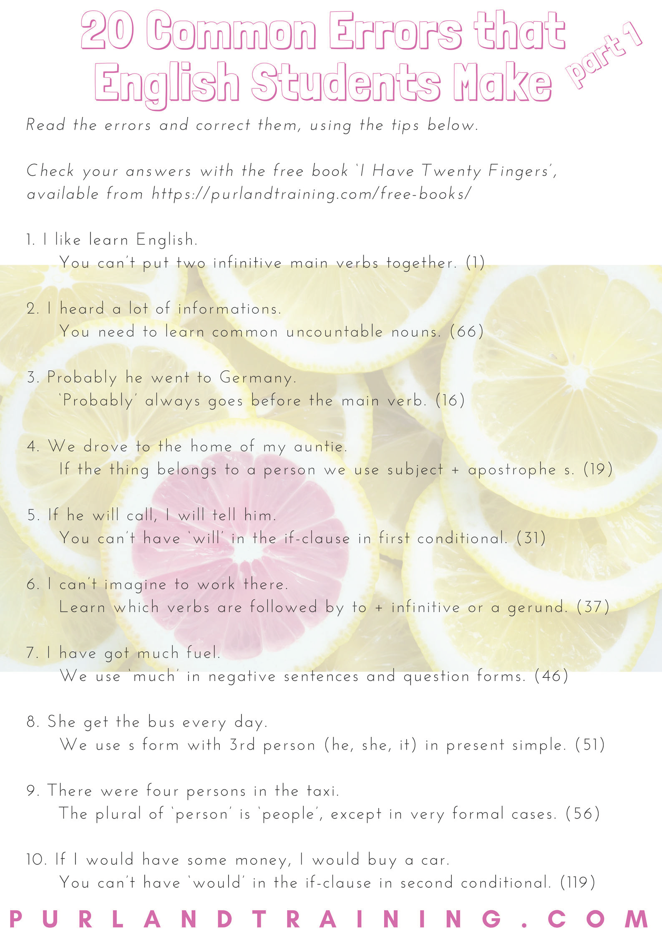

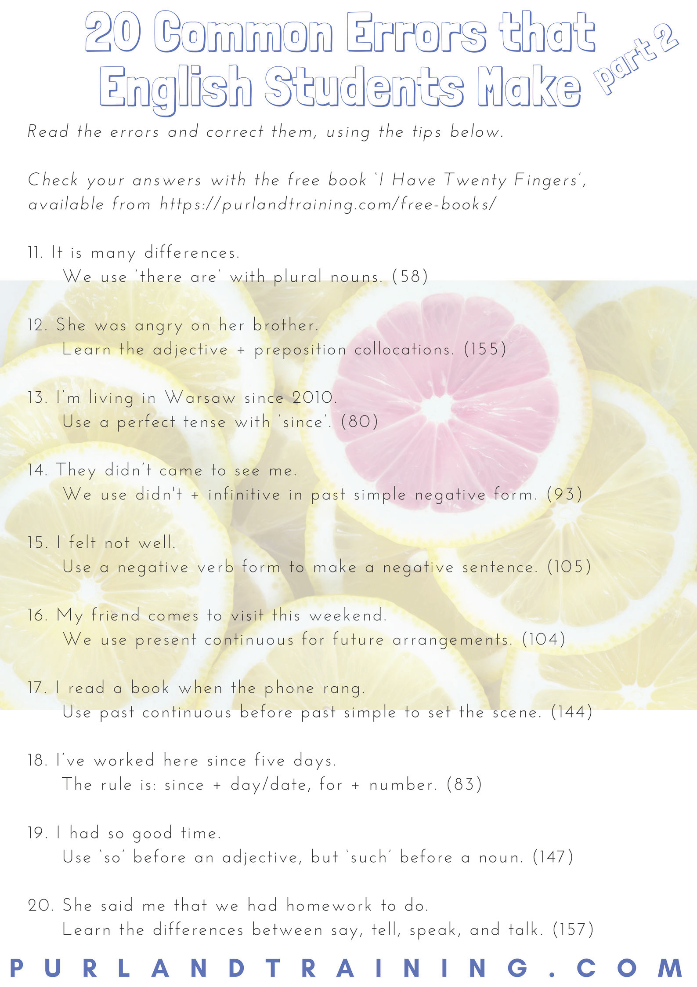

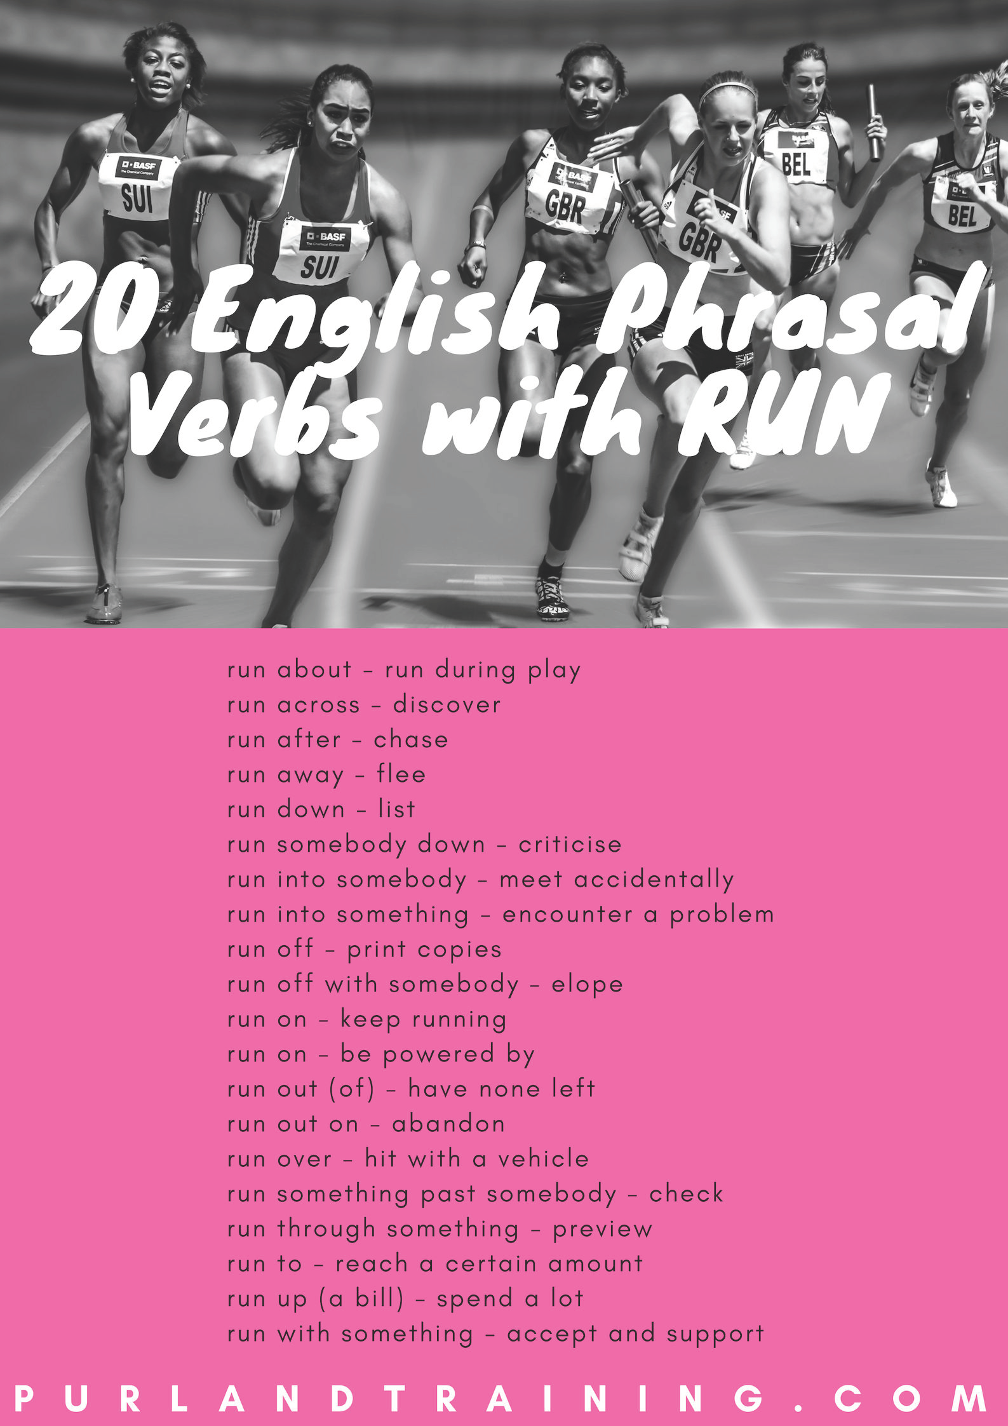

PurlandTraining.com

vocabulary

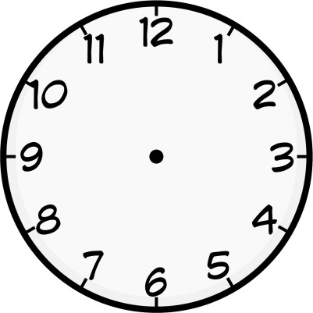
Telling the Time
We tell the time in English, not say the time. How could you be on time for your English class without a watch (wrist) or a clock (wall/phone)? We can ask: What’s the time? What time is it? or Have you got the time, please? To reply, we use it is... or it’s... We can say It’s time for + noun, e.g. It’s time for lunch. Or It’s time to + verb, e.g. It’s time to begin.
23
00
13
22
14
21
15
20
16
19
18
17
half past
twenty five past
twenty five to
twenty past
twenty to
quarter to
quarter past
ten to
ten past
five to
five past
o’clock
There are two ways of telling the time in English: saying two numbers together (10.40 = It’s ten forty), or using past and to (10.40 = It’s twenty to eleven). The easiest method is to say two numbers. We use past when the time is between 01 and 30, and to when the time is between 31 and 59. We only use o’clock when the time is on the hour: It’s ten o’clock. We count time on a clock in intervals of 5 minutes.
If the number of minutes past or to is odd, e.g. 6 or 19, we say minutes, e.g. 2:19 = It’s nineteen minutes past two. If the time is between 01 and 09 minutes past, we use the word oh, e.g. 7.08 = seven oh eight. Or we could say: It’s about / around / nearly ten past seven.

We don’t use the 24-hour clock in everyday speech or writing, e.g. it's fourteen o’clock, but we may need to read it when we look at a bus, train, plane timetable. However, we can use am (night & morning: 12.00am – 11.59am) and pm (afternoon, evening & night: 12.00pm – 11.50pm) to state which time period we mean. Usually the context makes am and pm redundant, e.g. ‘Your next lesson is at 3 o’clock on Tuesday.’ It is very unlikely for the lesson to be at 3am! 12pm = midday while 12am
= midnight.

A second is the smallest common unit of time. There are 60 seconds in a minute; 60 minutes in an hour; 24 hours in a day; 2 days (Saturday and Sunday) in a weekend; 7 days in a week; 2 weeks in a fortnight; 28, 29, 30, or 31 days in a month; 3 months in a quarter; 12 months or 365 days in a year; 366 days in a leap year; 10 years in a decade; 25 years in a generation; 100 years in a century; and 1,000 years in a millennium.

Time and prepositions: we say on + day (on Monday), in + month or year (in June; in 2016), and at for specific times (at 4 o’clock) and time periods (at the weekend).

Here are some common idioms connected with time: I can be on time for my lesson; spend time with a friend; kill time doing something trivial while waiting; have time for an activity; have a whale of a time or have the time of my life at an amazing party. That’s because time flies when you’re having fun – it goes quickly when you are not aware of it – but drags when you are clockwatching – counting the time until something boring ends.

Telling the Time – Exercises

- Write the times using It’s + numbers and It’s + past/to:

a) 11.40 e) 9.40

b) 10.15 f) 1.55

c) 7.55 g) 12.00

d) 3.12 h) 4.04

- Convert these times into the 24-hour clock using figures:

a) 2.15pm
b) 4.35pm
c) 1.10am
d) 10.20pm

e) 6.48pm
f) 10.08am
g) 9.30pm
h) midnight

- Write each time correctly:

- It’s fifty past twelve.
- It’s qarter past three.
- It’s four past eight.
- It’s ten.

- It’s thirty before ten.
- It’s ten oh five o’clock.
- It’s forty past second.
- It’s thirty two minutes to eight.

- Put the time periods in order of size from shortest to longest. Mark them 1-15:

week millennium day

decade weekend hour

generation month second

year minute fortnight

leap year quarter century

- Match the idioms on the left with their meanings on the right:

  - to be on time a) to have no time left
  - time is money b) to do nothing while waiting for something
  - to run out of time c) to not do something useful or worthwhile
  - to kill time d) you have got time to do something
  - time flies when you're having fun e) to be in prison
  - time is dragging f) time seems to be going slowly
  - to have a whale of a time g) to have a great time
  - to waste time h) time goes quickly when you don’t pay attention to it
  - to do time i) to arrive at the agreed time
  - time is on your side j) time is valuable

- Complete each gap using an appropriate word or phrase from this unit:

Tina: ‘Let’s meet a) five b) c) Sunday. I’ll try to d) , but I can’t guarantee it because my bus is often late. It will be great to e) time with you! I will get the bus home f) Tuesday morning g) five h) eleven. I hope we will i) time to visit the leisure centre. Last time we went I had j) . It was fantastic! Life here is so boring. I’ve been k) time every day, just playing on my phone. I don’t like l) time, so it will be good to see you next m) and do something fun!’

- Complete the gaps using prepositions of time on, at, or in:

- spring
- 12th February
- the morning
- the moment

- Christmas Day
- Monday afternoon
- a fortnight
- Monday

- 10 o'clock
- the weekend
- night
- July

- Write each time from its phonetic spelling:

- Ten t Siks
- Se v n Klok
- Too Wei teen
- For Fi fteen

- Kor t t Wun
- i Le v neu For
- Ttree yei Yem
- Har Fpar Steit

We can describe a person by talking about...
Describing People

- Personal Details:
Note: x = he (male), she (female), they (singular), or a person’s name
Examples of Vocabulary:

- name His/her/their name is... / x is called/named...
- relationship to you x is my... brother/sister, mum/dad, friend, wife/husband
- age x is (about)... years old. / in their (early/mid/late) twenties, thirties, etc.
- race x is... white (Caucasian), black, Asian, Hispanic, Chinese, Indian, etc.
- nationality x is... British, American, Japanese, etc. / is from... Mali, Sweden
- religion x is a... Christian, Buddhist, Sikh, Muslim, Atheist, etc. / x is Jewish
- address His/her/their address is... / They live in...
- family connections x has got ... brothers/sisters/children / is married/separated/divorced
- job/occupation x is a... teacher, manager, driver, etc. / works at... [company]
Try to combine information into one longer sentence, rather than several short sentences, e.g.
“Bob is my brother. He is 28. He is British.” “My brother Bob is a 28 year old British man.”

- Appearance – what they look like:
- height x is... ( x cm/m) tall, short, average height
- weight / build x is... fat/overweight, thin/slim, medium-/well-built, athletic
- face x is... handsome (m.), pretty, beautiful (f.), cute, plain, ugly
x has got a... big/long/round/ fat/lovely/ugly face/nose, etc.
- eye colour x has got... blue, brown, green, grey, black eyes
- hair length/style/colour x has got... long/short curly/wavy/straight brown/black/blonde/red/grey hair
- hair features x has got a... beard, moustache, pony tail, fringe / x is... bald
- glasses and accessories x is wearing... glasses, sunglasses, jewellery, earrings, bracelets, a hat/cap
- distinguishing marks x has got a... piercing, tattoo, mole, scar, big nose / freckles, braces, acne
- expression (they look...) x looks... happy, pleased, sad, serious, excited, tired, half-asleep, angry
- clothes and shoes x is wearing a... white shirt, jeans, new dress, blue trainers, old jacket
- general x is... smart, elegant (f.), well-dressed, casual, informal, scruffy

- Personality and Character – what they are like
- What you think of them? What do they think of themselves? (interview them, if possible!)
- personality positive/negative, open, friendly, quiet, shy/outgoing, moody, funny
- character honest/dishonest, hard-working/lazy, generous/selfish, reliable, brave
- opinions mainstream/left-field, opinionated, has strong opinions, right/left wing
- prejudiced towards a specific... race, gender, class, social group / tolerant, fair, easy-going
When giving information, remember: statement + reason(s) + example(s), for example:
“Bob is generous.” “Bob is generous, because he always lends me money if I ask, for example...”

- Preferences – what they like and don’t like, e.g. music, books, TV, film, culture, food, travel
- likes/dislikes, hobbies x likes/doesn’t like... because... for example...

- Actions – what they do:
- regularly (present simple) “x plays football every Saturday...” e.g. habits, routines, regular activities
- now (present continuous) “x is (probably) driving home from work at the moment...”
- past (past simple) “x went to the gym yesterday...”
- past up to now (present perfect) life experience and achievements, e.g. “x has been to Pisa twice...”
- future (future simple) “x will buy some new shoes tomorrow...”

Describing People – Exercises

- i) Correct the sentences:

  - My brother name is Adam.
  - He’s six year old.
  - Sarah is teacher.
  - Paul are a 26 year-old vet.
  - My mum is call Theresa.
  - Brian is a white Belgium soldier.
  - He live in Nepal.
  - She works in the town hall.

ii) Match the sentence halves:

- Laura is Catholic and comes from
- My sister is thirty and is married to
- Her name is Tina and she lives on
- Tim is nine years old and is
- a professor of music.
- a pupil at primary school.
- the south of France.
- Marlborough Street.

- i) Look at the pictures below and write three sentences to describe each person.
ii) Write three negative sentences to describe each person, e.g. “Sarah is not an old woman.”

Stewart Sarah Maisie Paul
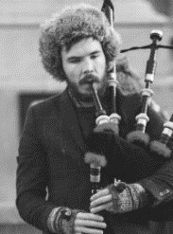
Mike Graham Zoe Tina
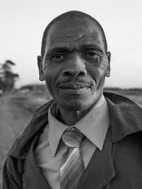

ii) Look at the pictures and say whether each statement is true, false, or we don’t know:

- Maisie has got straight hair.
- Sarah has got five tattoos.
- Graham is quite tall.
- Tina is ten years old.
- Graham looks serious.
- Stewart is middle-aged.
- Zoe is wearing glasses.
- Sarah has got short hair.
- Paul is about eleven years old.
- Tina has got blonde hair.

- i) Say whether each adjective describes personality or character. Write (P) or (C):
brave generous dishonest moody positive reliable quiet open friendly

ii) Complete the gaps with a time phrase:

Paul plays football a) . b) he went skiing in Switzerland. He has lived in Manchester c) . d) he is going to start secondary school. He had an open day there e) .

6 Important Word Groups in English

Homonyms: same sounds and spelling but different meanings; cause problems with reading:
Homonym: | Meaning 1: | Meaning 2:
bright | light | intelligent
can | metal container | modal verb
fly | insect | e.g. plane
glass | drinking | e.g. window
lie | recline | not true

Homonym: | Meaning 1: | Meaning 2:
mouse | animal | computer
orange | fruit | colour
play | sport | theatre
watch | time | TV
wave | beach | say hello

Homophones: same sounds but different spellings and meanings; cause problems with spelling:
Word 1: | Word 2:
aren’t | aunt
ate | eight
buy | bye
eye | I
flour | flower

Word 1: | Word 2:
hear | here
hole | whole
hour | our
it’s | its
knew | new

Word 1: | Word 2:
meat | meet
one | won
plain | plane
red | read
right | write

Word 1: | Word 2:
sea | see
son | sun
wait | weight
weather | whether
wood | would

Homographs: same spelling but different sounds and meanings; cause problems with pronunciation:
Homograph: | Noun: | Verb:
insult | abuse | offend
invite | invitation | request
present | gift | show
record | vinyl disc | note
transport | vehicle | move

Homograph: | Word 1: | Word 2:
close | adj. near | v. shut
live | adj. broadcast | v. exist
read | v. infinitive | v. 3rd form
tear | n. crying | v. rip
use | n. e.g. single | v. consume

Using synonyms helps to make our writing more interesting and raise the level:
Word 1: | Word 2:
big | large
bus | coach
but | however
by | beside
coat | jacket

Word 1: | Word 2:
eat | consume
find | discover
good | decent
hot | boiling
long | extended

Word 1: | Word 2:
loud | noisy
nearly | almost
on | upon
party | gathering
slowly | gradually

Word 1: | Word 2:
soon | shortly
under | below
usually | normally
walk | stroll
work | job

Learning words and their antonyms together allows us to increase our vocabulary twice as fast:
Adjectives:
best | worst
easy | difficult
good | bad
hot | cold
quiet | loud

Nouns:
day | night
floor | ceiling
man | woman
question | answer
work | rest

Adverbs:
always | never
before | after
fast | slow
more | less
now | then

Verbs:
buy | sell
give | get
go | come
open | close
start | finish

A minimal pair is a set of two words that have the same sounds apart from one different sound:
Vowel Sound (Middle):
ball | bowl
get | got
mat | met
ship | shop
will | wool

Initial Con. Sound:
bed | head
feet | meat
fun | done
learn | burn
rose | toes

Middle Con. Sound:
eaten | even
hobby | hockey
meaning | meeting
pedal | petal
simple | symbol

Final Con. Sound:
card | cars
gate | gave
made | make
rice | right
yes | yet

6 Important Word Groups in English (Gap-Fill)

Homonyms: same sounds and spelling but different meanings; cause problems with reading:
Homonym: | Meaning 1: | Meaning 2:
bright | light | intelligent
can
fly
glass
lie

Homonym: | Meaning 1: | Meaning 2:
mouse
orange
play
watch
wave

Homophones: same sounds but different spellings and meanings; cause problems with spelling:
Word 1: | Word 2:
aren’t | aunt
ate
buy
eye
flour

Word 1: | Word 2:
hear
hole
hour
it’s
knew

Word 1: | Word 2:
meat
one
plain
red
right

Word 1: | Word 2:
sea
son
wait
weather
wood

Homographs: same spelling but different sounds and meanings; cause problems with pronunciation:
Homograph: | Noun: | Verb:
insult | abuse | offend
invite
present
record
transport

Homograph: | Word 1: | Word 2:
close
live
read
tear
use

Using synonyms helps to make our writing more interesting and raise the level:
Word 1: | Word 2:
big | large
bus
but
by
coat

Word 1: | Word 2:
eat
find
good
hot
long

Word 1: | Word 2:
loud
nearly
on
party
slowly

Word 1: | Word 2:
soon
under
usually
walk
work

Learning words and their antonyms together allows us to increase our vocabulary twice as fast:
Adjectives:
best | worst
easy
good
hot
quiet

Nouns:
day
floor
man
question
work

Adverbs:
always
before
fast
more
now

Verbs:
buy
give
go
open
start

A minimal pair is a set of two words that have the same sounds apart from one different sound:
Vowel Sound (Middle):
ball | bowl
get
mat
ship
will

Initial Con Sound:
bed
feet
fun
learn
rose

Middle Con. Sound:
eaten
hobby
meaning
pedal
simple

Final Con. Sound:
card
gate
made
rice
yes

100 Common English Homonyms

Homonyms are words which have the same sounds and spelling, but different meanings, for example, ‘bat’ (cricket) and ‘bat’ (animal). It is good to be aware that the same word can have two or more meanings.

‘Homonym’ comes from the Greek words homos (same) + ónoma (name).
Homonym: | Meaning 1: | Meaning 2:
address | place | speech
back | body part | return
band | music group | ring
bark | tree | dog
bat | e.g. cricket | animal
bear | animal | put up with
board | wooden panel | directors
book | read | reserve
bow | ribbon | violin
box | container | hit
bright | light | intelligent
can | metal container | modal verb
cast | bandage | stage group
chair | furniture | chairperson
change | difference | small money
chip | food | computer
club | tool | organisation
cool | cold | trendy
crane | bird | machine
dance | waltz | action
duck | bird | crouch down
fair | blonde | pleasure park
fall | trip | autumn
fat | overweight | butter
film | movie | record
fine | good | punishment
fire | flames | sack
firm | company | hard
flat | horizontal | apartment
fly | insect | e.g. plane
foot | measurement | body part
fudge | confectionery | compromise
general | unspecific | army rank
glass | drinking | material
grand | impressive | a thousand
grave | ground | very serious
hide | skin | conceal
hip | body part | trendy
hit | successful | beat
iron | clothes | material
jam | food | problem
jerk | idiot | movement
jet | plane | water
just | adverb | fair
kid | child | baby goat
kind | nice | type
lap | seated | overtake
lark | bird | prank
leave | work holiday | go out
left | direction | past of leave

Homonym: | Meaning 1: | Meaning 2:
lie | recline | not true
light | not heavy | not dark
long | lengthy | yearn
match | football | light
may | modal verb | fifth month
mean | unkind | signify
mine | workplace | belongs to me
mole | animal | informant
mouse | animal | computer
musical | adj. of music | theatre
orange | fruit | colour
paper | printer | newspaper
park | green space | leave a car
peer | look closely at | aristocrat
pen | for writing | for animals
phone | mobile | call somebody
pick | choose | tool
play | sport | theatre
pop | music genre | fizzy drink
pound | currency | beat
printer | computer | business
racket | for tennis | scam
remote | far | TV
right | correct | direction
ring | jewellery | call somebody
rock | music | stone
rocket | spaceship | plant
rose | flower | got up
row | a boat | spreadsheet
saw | tool | past of see
seal | animal | official stamp
short | petite | alcohol
show | TV | let sby see sth
sick | unwell | fantastic
sink | furniture | move down
skate | fish | on a rink
space | place for sth | solar system
spring | season | metal coil
square | shape | not cool
stalk | follow | plant stem
suit | clothes | be suitable
taxi | car | plane
tie | clothing | fasten
tongue | body part | meat
trip | holiday | stumble
trunk | elephant | suitcase
watch | time | TV
wave | beach | say hello
well | adverb | water hole
yard | back garden | measurement

100 Common English Homonyms (Gap-Fill)

Homonyms are words which have the same sounds and spelling, but different meanings, for example, ‘bat’ (cricket) and ‘bat’ (animal). It is good to be aware that the same word can have two or more meanings.

‘Homonym’ comes from the Greek words homos (same) + ónoma (name).
Homonym: | Meaning 1: | Meaning 2:
address | place | speech
back
band
bark
bat
bear
board
book
bow
box
bright
can
cast
chair
change
chip
club
cool
crane
dance
duck
fair
fall
fat
film
fine
fire
firm
flat
fly
foot
fudge
general
glass
grand
grave
hide
hip
hit
iron
jam
jerk
jet
just
kid
kind
lap
lark
leave
left

Homonym: | Meaning 1: | Meaning 2:
lie
light
long
match
may
mean
mine
mole
mouse
musical
orange
paper
park
peer
pen
phone
pick
play
pop
pound
printer
racket
remote
right
ring
rock
rocket
rose
row
saw
seal
short
show
sick
sink
skate
space
spring
square
stalk
suit
taxi
tie
tongue
trip
trunk
watch
wave
well
yard

200 Common English Homophones

Homophones are words which have the same sounds, but different spellings and meanings, for example, ‘beat’ (hit) and ‘beet’ (vegetable). It is good to be aware that words can sound the same but be different.

‘Homophone’ comes from the Greek words homos (same) + phono (sound).
Word 1: | Word 2:
ad | add
ail | ale
air | heir
aisle | I’ll
allowed | aloud
aren’t | aunt
ate | eight
ball | bawl
bard | barred
bare | bear
base | bass
be | bee
beach | beech
bean | been
beat | beet
beer | bier
berry | bury
berth | birth
bite | byte
blew | blue
boar | bore
board | bored
bold | bowled
bolder | boulder
bough | bow
brake | break
buy | bye
canvas | canvass
carat | carrot
cell | sell
cent | sent
cereal | serial
cheap | cheep
check | cheque
chord | cord
coarse | course
council | counsel
cue | queue
dam | damn
dear | deer
desert | dessert
die | dye
doe | dough
does | doze
draft | draught
duel | jewel
dune | June
earn | urn
ewe | you
eye | I

Word 1: | Word 2:
faint | feint
fate | fete
feat | feet
fiancé | fiancée
fill | Phil
fined | find
fir | fur
flair | flare
flaw | floor
flea | flee
flew | flu
flour | flower
for | four
forth | fourth
foul | fowl
genes | jeans
grate | great
groan | grown
gym | Jim
hair | hare
hale | heil
hart | heart
heal | heel
hear | here
heard | herd
he’d | heed
hi | high
higher | hire
him | hymn
hole | whole
holy | wholly
hour | our
in | inn
it’s | its
key | quay
knead | need
knew | new
knight | night
knit | nit
knot | not
know | no
knows | nose
lain | lane
lays | laze
lead | led
leak | leek
leased | least
lieu | loo
light | lite
loan | lone

Word 1: | Word 2:
made | maid
mail | male
main | mane
mat | matte
meat | meet
meter | metre
mind | mined
missed | mist
moose | mousse
morn | mourn
morning | mourning
muscle | mussel
naval | navel
none | nun
oar | or
one | won
packed | pact
pail | pale
pair | pear
patience | patients
peace | piece
peak | peek
pedal | peddle
peer | pier
pi | pie
place | plaice
plain | plane
pleas | please
plum | plumb
pole | poll
poor | pour
practice | practise
pray | prey
pride | pried
profit | prophet
pseud | sued
rain | reign
raise | rays
rap | wrap
raw | roar
read | red
read | reed
retch | wretch
right | write
road | rode
roam | Rome
root | route
rose | rows
rote | wrote
rough | ruff

Word 1: | Word 2:
sacks | sax
sail | sale
sane | Seine
sauce | source
saw | sore
scene | seen
scent | sent
sea | see
seam | seem
sew | so
shake | sheik
side | sighed
sighs | size
sight | site
sky | Skye
sole | soul
some | sum
son | sun
stair | stare
suite | sweet
tail | tale
talk | torque
taught | taut
tea | tee
team | teem
their | there
threw | through
thyme | time
tide | tied
told | tolled
too | two
use | yews
vain | vane
vale | veil
wade | weighed
wail | whale
wait | weight
ware | wear
warn | worn
watt | what
weak | week
weather | whether
we’ll | wheel
wet | whet
while | wile
wine | whine
wood | would
yoke | yolk
you’ll | Yule
your | you’re

200 Common English Homophones (Gap-Fill)

Homophones are words which have the same sounds, but different spellings and meanings, for example, ‘beat’ (hit) and ‘beet’ (vegetable). It is good to be aware that words can sound the same but be different.

‘Homophone’ comes from the Greek words homos (same) + phono (sound).
Word 1: | Word 2:
ad | add
ail
air
aisle
allowed
aren’t
ate
ball
bard
bare
base
be
beach
bean
beat
beer
berry
berth
bite
blew
boar
board
bold
bolder
bough
brake
buy
canvas
carat
cell
cent
cereal
cheap
check
chord
coarse
council
cue
dam
dear
desert
die
doe
does
draft
duel
dune
earn
ewe
eye

Word 1: | Word 2:
faint
fate
feat
fiancé
fill
fined
fir
flair
flaw
flea
flew
flour
for
forth
foul
genes
grate
groan
gym
hair
hale
hart
heal
hear
heard
he’d
hi
higher
him
hole
holy
hour
in
it’s
key
knead
knew
knight
knit
knot
know
knows
lain
lays
lead
leak
leased
lieu
light
loan

Word 1: | Word 2:
made
mail
main
mat
meat
meter
mind
missed
moose
morn
morning
muscle
naval
none
oar
one
packed
pail
pair
patience
peace
peak
pedal
peer
pi
place
plain
pleas
plum
pole
poor
practice
pray
pride
profit
pseud
rain
raise
rap
raw
read
read
retch
right
road
roam
root
rose
rote
rough

Word 1: | Word 2:
sacks
sail
sane
sauce
saw
scene
scent
sea
seam
sew
shake
side
sighs
sight
sky
sole
some
son
stair
suite
tail
talk
taught
tea
team
their
threw
thyme
tide
told
too
use
vain
vale
wade
wail
wait
ware
warn
watt
weak
weather
we’ll
wet
while
wine
wood
yoke
you’ll
your

100 Common English Homographs

Homographs are words which have the same spelling, but different sounds and meanings, for example, ‘live’ (on TV) and ‘live’ (reside). ‘Homograph’ comes from the Greek words homos (same) + graph (writing). Group A: nouns (stress on 1st syllable), verbs (stress on 2nd syllable). Group B are general homographs:
Group A
Homograph: | Noun: | Verb:
accent | speaking | highlight
ally | friend | work with
combat | fight | prevent
combine | machinery | mix
commune | collective | pray
compost | fertiliser | break down
compound | bunker | combine
compress | bandage | flatten
conduct | behaviour | e.g. orchestra
conflict | war | clash
conscript | new recruit | recruit
consort | companion | accompany
construct | theory | build
content | matter | feel happy
contract | agreement | reduce
contrast | difference | compare
convert | new believer | change
convict | prisoner | find guilty
decrease | reduction | reduce
default | standard | evade
defect | fault | change sides
desert | wilderness | abandon
digest | publication | process
discharge | emission | dismiss
discount | price reduction | disregard
entrance | way in | captivate
escort | companion | accompany
essay | homework | attempt
exploit | adventure | make use of
export | goods | distribute
extract | excerpt | remove
finance | funding | provide money
impact | effect | hit
implant | transplant | insert
import | introduction | bring in
incense | e.g. candle | anger
incline | slope | slant
increase | growth | enlarge
insert | leaflet | include
insult | abuse | offend
intrigue | conspiracy | interest
invite | invitation | request
object | thing | complain
perfume | bottle | action
permit | licence | allow
pervert | deviant | corrupt
present | gift | award
proceeds | profits | continues
process | procedure | walk
produce | food | make
progress | headway | advance

Homograph: | Noun: | Verb:
project | assignment | protrude
protest | rally | complain
rebel | dissenter | protest
recall | memory | remember
recap | summary | review
record | vinyl disc | note down
refill | top-up | replenish
refund | repayment | repay
refuse | rubbish | decline
relapse | deterioration | deteriorate
remake | new version | re-create
reprint | reissue | republish
research | study | investigate
retake | exam | recapture
second | ordinal no. | transfer
segment | section | divide
subject | topic | endanger
survey | enquiry | measure
suspect | defendant | presume
torment | annoyance | annoy
transplant | e.g. heart | relocate
transport | vehicle | move
update | news | inform
uplift | support | raise
upset | shock | annoy
Group B
Homograph: | Meaning 1: | Meaning 2:
bass | n. instrument | n. fish
bow | n. violin | n. ribbon
close | adj. near | v. shut
does | n. female deer | v. 3rd form: do
excuse | n. reason | v. overlook
house | n. building | v. action
frequent | adj. regular | v. visit often
intimate | n. close friend | v. suggest
lead | n. metal | v. direct
live | adj. broadcast | v. exist
minute | n. 60 seconds | adj. very small
moped | n. vehicle | v. past / mope
perfect | adj. flawless | v. refine
putting | n. golf skill | v. placing
read | v. infinitive | v. 3rd form
resume | n. CV | v. restart
row | n. spreadsheet | v. argue
separate | adj. detached | v. disconnect
sewer | n. cesspit | n. seamstress
sows | n. female pigs | v. seeds
tear | n. crying | v. rip
use | n. e.g. single | v. expend
wind | n. breeze | v. coil
wound | n. cut | v. past of wind

100 Common English Homographs (Gap-Fill)

Homographs are words which have the same spelling, but different sounds and meanings, for example, ‘live’ (on TV) and ‘live’ (reside). ‘Homograph’ comes from the Greek words homos (same) + graph (writing). Group A: nouns (stress on 1st syllable), verbs (stress on 2nd syllable). Group B are general homographs:
Group A
Homograph: | Noun: | Verb:
accent | speaking | highlight
ally
combat
combine
commune
compost
compound
compress
conduct
conflict
conscript
consort
construct
content
contract
contrast
convert
convict
decrease
default
defect
desert
digest
discharge
discount
entrance
escort
essay
exploit
export
extract
finance
impact
implant
import
incense
incline
increase
insert
insult
intrigue
invite
object
perfume
permit
pervert
present
proceeds
process
produce
progress

Homograph: | Noun: | Verb:
project
protest
rebel
recall
recap
record
refill
refund
refuse
relapse
remake
reprint
research
retake
second
segment
subject
survey
suspect
torment
transplant
transport
update
uplift
upset
Group B
Homograph: | Meaning 1: | Meaning 2:
bass | n. instrument | n. fish
bow
close
does
excuse
house
frequent
intimate
lead
live
minute
moped
perfect
putting
read
resume
row
separate
sewer
sows
tear
use
wind
wound

100 Common English Antonyms

Antonyms are words that have opposite meanings, for example ‘yes’ and ‘no’. We often think of adjectives as words that have opposites, but many other kinds of words also have antonyms, e.g. ‘this’ and ‘that’.

‘Antonym’ comes from the Greek words anti (against) + ónoma (name).

Adjectives:
alive | dead
beautiful | ugly
best | worst
black | white
cheap | expensive
clean | dirty
easy | difficult
empty | full
funny | serious
good | bad
happy | sad
hot | cold
light | dark
nice | nasty
normal | weird
polite | rude
public | private
quiet | loud
rich | poor
right | wrong
same | different
soft | hard
true | false
warm | cool
young | old

Nouns:
arrival | departure
attack | defence
attic | cellar
birth | death
child | adult
day | night
employee | employer
error | correction
failure | success
floor | ceiling
friend | enemy
girl | boy
health | illness
hero | villain
man | woman
morning | evening
praise | insult
question | answer
sea | land
summer | winter
sun | moon
sunrise | sunset
victory | defeat
winner | loser
work | rest

Adverbs:
above | below
ahead | behind
always | never
backward | forward
before | after
carefully | carelessly
early | late
east | west
everybody | nobody
everywhere | nowhere
fast | slow
first | last
here | there
home | abroad
inside | outside
long | short
more | less
near | far
north | south
now | then
often | rarely
on | off
over | under
up | down
upstairs | downstairs

Verbs:
accept | refuse
add | subtract
agree | disagree
are | aren’t
arrive | leave
build | destroy
buy | sell
can | cannot
do | don’t
get on | get off
give | get
go | come
have | haven’t
laugh | cry
live | die
open | close
push | pull
put on | take off
read | write
save | spend
sit | stand
start | finish
stop | go
will | won’t
work | play

100 Common English Antonyms (Gap-Fill)

Antonyms are words that have opposite meanings, for example ‘yes’ and ‘no’. We often think of adjectives as words that have opposites, but many other kinds of words also have antonyms, e.g. ‘this’ and ‘that’.

‘Antonym’ comes from the Greek words anti (against) + ónoma (name).

Adjectives:
alive | dead
beautiful
best
black
cheap
clean
easy
empty
funny
good
happy
hot
light
nice
normal
polite
public
quiet
rich
right
same
soft
true
warm
young

Nouns:
arrival
attack
attic
birth
child
day
employee
error
failure
floor
friend
girl
health
hero
man
morning
praise
question
sea
summer
sun
sunrise
victory
winner
work

Adverbs:
above
ahead
always
backward
before
carefully
early
east
everybody
everywhere
fast
first
here
home
inside
long
more
near
north
now
often
on
over
up
upstairs

Verbs:
accept
add
agree
are
arrive
build
buy
can
do
get on
give
go
have
laugh
live
open
push
put on
read
save
sit
start
stop
will
work

200 Common Minimal Pairs in English

The term minimal pair describes two words that have the same sounds apart from one sound.

The different sound can be a vowel sound (middle) or a consonant sound in the initial (first), middle, or final position:
Different Vowel Sound (Middle)
bald | bold
ball | bowl
boat | bite
cane | keen
cap | cup
cheers | cheese
crate | Crete
crime | chrome
curse | course
dead | did
deep | dip
dig | dog
fail | fall
flag | flog
flight | float
gate | goat
get | got
guess | goose
hat | hate
heat | heart
height | hit
jam | gem
joke | Jack
lamp | limp
make | mark
mat | met
mate | might
neat | note
nice | niece
nine | none
noon | nun
plain | plan
pool | pull
pot | pit
queen | Quorn
rate | right
seek | soak
ship | shop
smell | smile
soon | sun
spin | spine
start | state
take | tech
through | throw
tide | towed
veal | vole
watt | wet
whale | while
will | wool
yarn | yawn

Different Initial Consonant Sound:
baby | maybe
bean | mean
beat | heat
bed | head
bees | knees
bell | well
bend | mend
boat | coat
book | look
bull | wool
cat | hat
clock | flock
coin | join
couple | supple
crack | track
curls | girls
daily | Haley
dear | peer
drone | prone
face | base
fail | tale
fan | man
feel | real
feet | meat
fill | hill
finger | linger
food | rude
fun | done
games | James
gate | wait
good | wood
half | laugh
hard | guard
heard | third
heart | part
heat | seat
him | gym
king | ring
knife | life
learn | burn
lose | zoos
lung | young
made | laid
meant | rent
meek | weak
moon | June
nose | rose
pillar | villa
rock | wok
rose | toes

Different Middle Consonant Sound:
Adam | Alan
alive | arrive
baker | bather
Benny | berry
bobble | bottle
body | bossy
boogie | booty
carbon | Carmen
colour | cutter
cycle | sidle
darling | darning
decree | degree
eaten | even
feature | feeler
feeding | feeling
hammer | hanger
heady | heavy
healing | heating
hobby | hockey
ladder | lacquer
leather | letter
loser | looser
maiden | mason
marker | martyr
meadow | mellow
meaning | meeting
measure | mega
medal | metal
melon | Megan
miner | miser
mugger | mother
mummy | money
nature | neighbour
omen | open
pager | paper
pedal | petal
precedent | president
rabbit | racquet
rabid | rapid
renew | review
Santa | sander
shadow | shallow
shocking | shopping
silly | ciggie
simmer | singer
simple | symbol
soggy | sorry
swigging | swimming
wader | whaler
wedding | webbing

Different Final Consonant Sound:
boom | boot
cap | cash
card | cars
cared | cares
cheap | cheat
close | clothes
drape | drip
fad | fed
gate | gave
guild | guilt
ham | have
home | hone
juice | jute
knife | nice
large | laugh
light | like
load | loaf
made | make
married | marries
might | mile
mouse | mouth
nail | name
nice | night
north | Norse
page | pain
pain | pays
peas | peep
quick | quiz
rain | raise
ran | rap
receipt | receive
refuse | refute
rice | right
roof | root
scene | seem
side | sign
slim | slip
some | son
tail | take
teach | team
thick | thin
touch | tongue
tried | trite
vague | vain
verb | verse
walk | warn
wash | watch
weed | wheel
wrote | rogue
yes | yet

200 Common Minimal Pairs in English (Gap-Fill)

The term minimal pair describes two words that have the same sounds apart from one sound.

The different sound can be a vowel sound (middle) or a consonant sound in the initial (first), middle, or final position:
Different Vowel Sound (Middle)
bald | bold
ball
boat
cane
cap
cheers
crate
crime
curse
dead
deep
dig
fail
flag
flight
gate
get
guess
hat
heat
height
jam
joke
lamp
make
mat
mate
neat
nice
nine
noon
plain
pool
pot
queen
rate
seek
ship
smell
soon
spin
start
take
through
tide
veal
watt
whale
will
yarn

Different Initial Consonant Sound:
baby
bean
beat
bed
bees
bell
bend
boat
book
bull
cat
clock
coin
couple
crack
curls
daily
dear
drone
face
fail
fan
feel
feet
fill
finger
food
fun
games
gate
good
half
hard
heard
heart
heat
him
king
knife
learn
lose
lung
made
meant
meek
moon
nose
pillar
rock
rose

Different Middle Consonant Sound:
Adam
alive
baker
Benny
bobble
body
boogie
carbon
colour
cycle
darling
decree
eaten
feature
feeding
hammer
heady
healing
hobby
ladder
leather
loser
maiden
marker
meadow
meaning
measure
medal
melon
miner
mugger
mummy
nature
omen
pager
pedal
precedent
rabbit
rabid
renew
Santa
shadow
shocking
silly
simmer
simple
soggy
swigging
wader
wedding

Different Final Consonant Sound:
boom
cap
card
cared
cheap
close
drape
fad
gate
guild
ham
home
juice
knife
large
light
load
made
married
might
mouse
nail
nice
north
page
pain
peas
quick
rain
ran
receipt
refuse
rice
roof
scene
side
slim
some
tail
teach
thick
touch
tried
vague
verb
walk
wash
weed
wrote
yes

Learn 100 New Words with the Suffix -ous (Part 1)

How many of these words do you know? Learn new words by studying the -ous words and their ‘easy’ synonyms:

acrimonious ambiguous arduous atrocious auspicious autonomous barbarous bulbous calamitous capacious capricious censorious chivalrous conscientious conspicuous contagious contemptuous copious courteous decorous deleterious dolorous dubious egregious eponymous expeditious facetious fatuous fictitious fortuitous frivolous gratuitous heinous hideous homogenous humongous illustrious imperious inauspicious incongruous indigenous infamous ingenious inglorious injudicious innocuous instantaneous invidious judicious lugubrious
bitter unclear difficult terrible favourable independent brutal
round disastrous roomy unpredictable critical
brave reliable visible infectious scornful plentiful polite
well-behaved harmful
sad uncertain shocking named after quick foolish childish made-up lucky
light-hearted unprovoked terrible
ugly standardised huge famous arrogant
unfavourable odd
native notorious clever shameful unwise harmless instant unfair wise gloomy
lustrous magnanimous mellifluous meticulous momentous monotonous mutinous nebulous noxious oblivious obnoxious officious onerous pernicious pompous portentous precarious precocious prestigious pretentious rambunctious raucous riotous sacrilegious salacious sanctimonious scrupulous seditious serendipitous specious spontaneous strenuous stupendous subconscious supercilious surreptitious suspicious tenacious thunderous traitorous tremulous tumultuous unambiguous uproarious vacuous vertiginous viscous vivacious voluminous voracious
shiny generous melodious thorough significant repetitive disobedient unclear poisonous unaware horrible bossy difficult wicked arrogant ominous risky
gifted respected self-important rowdy
wild violent heretical
scandalous self-righteous trustworthy rebellious unexpected false impulsive energetic amazing hidden arrogant secret
wary persistent loud disloyal trembling volatile clear hilarious empty high sticky lively
big hungry

Learn 100 New Words with the Suffix -ous (Part 1) – Research

Use the internet or a thesaurus to find an ‘easy’ synonym for each of the -ous words below:

acrimonious |  | lustrous
ambiguous |  | magnanimous
arduous |  | mellifluous
atrocious |  | meticulous
auspicious |  | momentous
autonomous |  | monotonous
barbarous |  | mutinous
bulbous |  | nebulous
calamitous |  | noxious
capacious |  | oblivious
capricious |  | obnoxious
censorious |  | officious
chivalrous |  | onerous
conscientious |  | pernicious
conspicuous |  | pompous
contagious |  | portentous
contemptuous |  | precarious
copious |  | precocious
courteous |  | prestigious
decorous |  | pretentious
deleterious |  | rambunctious
dolorous |  | raucous
dubious |  | riotous
egregious |  | sacrilegious
eponymous |  | salacious
expeditious |  | sanctimonious
facetious |  | scrupulous
fatuous |  | seditious
fictitious |  | serendipitous
fortuitous |  | specious
frivolous |  | spontaneous
gratuitous |  | strenuous
heinous |  | stupendous
hideous |  | subconscious
homogenous |  | supercilious
humongous |  | surreptitious
illustrious |  | suspicious
imperious |  | tenacious
inauspicious |  | thunderous
incongruous |  | traitorous
indigenous |  | tremulous
infamous |  | tumultuous
ingenious |  | unambiguous
inglorious |  | uproarious
injudicious |  | vacuous
innocuous |  | vertiginous
instantaneous |  | viscous
invidious |  | vivacious
judicious |  | voluminous
lugubrious |  | voracious

Learn 100 New Words with the Suffix -ous (Part 1) – Gap-Fill

Complete each gap with one of the options below + ous:

egregi capaci fatu lugubri pernici homogen injudici autonom salaci incongru copi tumultu nebul vivaci acrimoni surreptiti precoci speci supercili rambuncti
- The boys were so on the coach on the way home after the football match.

- We’re not looking for a lot of variety, so we want the jobs to be fairly .

- The tent was really , which meant we all had plenty of room.

- Our daughter is incredibly for her age, what with dancing, singing, music…

- I didn’t expect to meet my uncle at the nightclub, so it felt really .

- I don’t understand the point you are trying to make; your writing is completely .

- The defendant continued his behaviour by launching a one-man crime wave.

- I hope you are all taking notes. I will be asking questions after this presentation.

- Their divorce became when they failed to agree on the custody of their children.

- Have you got any gossip for me from the party?

- His decision to drive down the motorway at 4 mph may have cost him his licence.

- It was such a atmosphere, with grandpa in tears and Leo checking his watch.

- That new boy is so . He’s always looking down his nose at the other students.

- Emilia is such a lovely girl – always so lively, and she never stops!

- ‘My brother could have written a better story – and he’s two.’ ‘What a remark!’

- ‘Do you think we’ll all be travelling around in cars by 2025?’ ‘No.’

- Kami’s teenage years were as she went from jailbird to number one hockey star.

- Your proposal can never become law, because it is based upon a falsehood.

- Rejecting your own son as heir will be an mistake, sir!

- Petra leaned below her seat and gave the dog a cake in as a way as possible.

Learn 100 New Words with the Suffix -ous (Part 2)

How many of these words do you know? Learn new words by studying the -ous words and their ‘easy’ synonyms:

advantageous analogous anomalous assiduous audacious avaricious boisterous bumptious cacophonous callous cantankerous carnivorous clamorous conscious contentious contiguous credulous delirious desirous devious disingenuous duplicitous efficacious erroneous extemporaneous extraneous fastidious ferocious fractious garrulous glutinous gregarious hazardous heterogenous hilarious horrendous ignominious impecunious impervious impetuous inconspicuous industrious ingenuous iniquitous injurious insidious licentious ludicrous luminous luxurious
beneficial equivalent inconsistent diligent brave
mean lively conceited noisy cruel grumpy
meat-eating noisy awake
argumentative joining
naive delighted eager deceitful dishonest two-faced effective wrong unrehearsed unnecessary fussy
fierce irritable talkative gooey sociable risky mixed very funny awful
embarrassing poor waterproof hasty unobtrusive hard-working innocent wicked harmful sneaky immoral ridiculous shining deluxe
malicious meretricious miscellaneous monstrous multitudinous nefarious notorious nutritious obsequious ominous ostentatious parlous parsimonious perfidious perspicacious ponderous precipitous preposterous presumptuous prodigious pugnacious punctilious rapturous ravenous rigorous sagacious salubrious scrumptious scurrilous sententious simultaneous sinuous solicitous splendiferous spurious sumptuous superfluous tedious tempestuous tenuous tortuous treacherous ubiquitous unctuous venomous vexatious vicarious vigorous vociferous zealous
nasty superficial assorted horrific countless wicked disreputable wholesome flattering warning showy dangerous miserly disloyal wise
slow rash
outrageous rude remarkable aggressive meticulous delighted very hungry thorough wise healthy very tasty scandalous moralistic concurrent winding caring splendid fake
lavish unnecessary boring passionate questionable complicated disloyal universal sycophantic poisonous annoying indirect energetic vocal
keen

Learn 100 New Words with the Suffix -ous (Part 2) – Research

Use the internet or a thesaurus to find an ‘easy’ synonym for each of the -ous words below:

advantageous |  | malicious
analogous |  | meretricious
anomalous |  | miscellaneous
assiduous |  | monstrous
audacious |  | multitudinous
avaricious |  | nefarious
boisterous |  | notorious
bumptious |  | nutritious
cacophonous |  | obsequious
callous |  | ominous
cantankerous |  | ostentatious
carnivorous |  | parlous
clamorous |  | parsimonious
conscious |  | perfidious
contentious |  | perspicacious
contiguous |  | ponderous
credulous |  | precipitous
delirious |  | preposterous
desirous |  | presumptuous
devious |  | prodigious
disingenuous |  | pugnacious
duplicitous |  | punctilious
efficacious |  | rapturous
erroneous |  | ravenous
extemporaneous |  | rigorous
extraneous |  | sagacious
fastidious |  | salubrious
ferocious |  | scrumptious
fractious |  | scurrilous
garrulous |  | sententious
glutinous |  | simultaneous
gregarious |  | sinuous
hazardous |  | solicitous
heterogenous |  | splendiferous
hilarious |  | spurious
horrendous |  | sumptuous
ignominious |  | superfluous
impecunious |  | tedious
impervious |  | tempestuous
impetuous |  | tenuous
inconspicuous |  | tortuous
industrious |  | treacherous
ingenuous |  | ubiquitous
iniquitous |  | unctuous
injurious |  | venomous
insidious |  | vexatious
licentious |  | vicarious
ludicrous |  | vigorous
luminous |  | vociferous
luxurious |  | zealous

Learn 100 New Words with the Suffix -ous (Part 2) – Gap-Fill

Complete each gap with one of the options below + ous:

efficaci salubri cantanker impetu sagaci hazard anomal meretrici contigu parl obsequi pugnaci tortu perfidi splendifer disingenu parsimoni ludicr bumpti garrul
- My teacher described it as a piece of writing that was more style than substance.

- Your tone of voice is rather , so I would appreciate it if you could tone it down.

- I wouldn’t say that Todd was a person; in fact I’ve hardly heard him say a word.

- She shouldn’t have reacted so quickly, but unfortunately she was just far too .

- Dangling from a cliff with a storm swirling around him, Jeff was in a situation.

- There’s a old man who lives near me, who is always moaning about my kids.

- Oh, the roller coaster ride was ! I can’t describe how utterly fabulous it was!

- His brother is ingratiating – he’s so ; clearly making sure that he’s in the will.

- The two countries of Niger and Sudan are not , because Chad lies between them.

- Take three spoons of this medicine and I believe you will find it to be perfectly .

- Thank you for your advice, O Wise One. I am determined to put it into practice.

- The prices in the hotel restaurant were absolutely ! Forty-five pounds for a starter!

- Some of the figures on this spreadsheet you gave me are rather .

- What she did was pretty , because she filmed him at work without his permission.

- Deluded Alan and Pam believe they’re the best couple in the village; they’re so .

- It’s such a place to live – right on the coast, with a fresh sea breeze.

- I don’t know whether to trust Fay. Arthur told me that she is a little bit .

- We got lost because the satnav broke and we ended up following a route.

- There was plenty of ice on the road, which made my drive home rather .

- Why doesn’t Mr. Roland ever pay for a round of drinks? He’s such a old man.

List of 300 Loanwords in English

Loanwords are words that we borrow from other languages. Here are 300 common loanwords that we use in English:

a cappella (IT) abacus (HE) abseil (GE) ad hoc (GR)
ad nauseam (GR) aficionado (SP) aide-memoire (FR) aikido (JA) alchemy (GR) alcohol (AR) alligator (SP) ambiance (FR) angst (GE)
art nouveau (FR) avatar (HI) baguette (IT) balaclava (RU) balcony (IT) banana (SP) bandanna (HI) bandicoot (AA) bank (IT)
bar mitzvah (HE) bard (SG) baritone (IT) behemoth (HE) bigos (POL) billabong (AA) biro (HU)
biscuit (IT) bog (SG) bonsai (JA)
boomerang (AA) brouhaha (HE) buccaneer (POR) bungalow (HI) bureaucracy (FR) cabal (HE)
café (FR) cafeteria (SP) cairn (SG) candy (AR) canoe (SP) carat (GR) caricature (IT) cashew (POR) cauliflower (IT) ceilidh (SG) cello (IT) chauffeur (FR) cheetah (HI) chef (FR) chemistry (AR) cherub (HE) chocolate (SP) choir (GR) chutzpah (HE) ciao (IT)
cider (HE) clan (SG) coach (HU) cobra (POR)

cocoa (SP) coffee (AR)
commando (POR) concerto (IT) cosmonaut (RU) cotton (AR)
crag (SG) credit (IT) croissant (FR) cushy (HI)
dachshund (GE) delicatessen (GE) dingo (AA)
diva (IT) dodo (POR) dollar (GE)
doppelgänger (GE) drongo (AA)
duet (IT) dungaree (HI) edelweiss (GE) elixir (AR) embarrass (POR) emoji (JA)
emu (POR) encyclopaedia (GR) espresso (IT)
et cetera (etc.) (GR) eureka (GR) falsetto (IT)
fascism (IT) feta (GR) finale (IT) fjord (NO)
flamingo (POR) frankfurter (GE) futon (JA) gateau (FR) gauntlet SW) geisha (JA) gherkin (POL) giraffe (AR)
glockenspiel (GE) goulash (HU) government (FR) graffiti (IT) grotesque (IT) guarana (POR) guerrilla (SP) gymkhana (HI) haiku (JA) hallelujah (HE) hamburger (GE) hamster (GE)
hoi polloi (GR) honcho (JA) hosanna (HE) hotel (FR) hummus (AR) hurricane (SP) iguana (SP) intelligentsia (RU)

jaguar (POR) jasmine (AR) jeans (IT) Jesuit (HE) jodhpurs (HI) John (HE) jubilee (HE) judo (JA) juggernaut (HI) kamikaze (JA) kangaroo (AA) karaoke (JA) karate (JA) khaki (HI) kimono (JA)
kindergarten (GE) koala (AA) kookaburra (AA) kosher (HE) Labrador (POR) lacquer (AR) lager (GE) lemming (NO) lemon (AR) leviathan (HE) lieutenant (FR) limousine (FR) llama (SP)
loch (SG) lottery (IT)
mackintosh (SG) maestro (IT) magazine (AR) mammoth (RU) manga (JA) mango (POR) marmalade (POR) mattress (AR) mayor (FR)
mea culpa (GR) merchandise (IT) messiah (HE)
modus operandi (GR) monsoon (AR) moped (SW) mosquito (SP) moussaka (GR) mozzarella (IT) muesli (GE)
nacho (SP) nadir (AR)
Neanderthal (GE) ninja (JA)
oboe (IT) ombudsman (SW) opera (IT)
orange (AR) orienteering (SW) origami (JA) ouzo (GR)
paella (SP) paparazzi (IT)

paprika (HU) parliament (FR) pasta (IT) pasteurisation (FR) perestroika (RU) pet (SG)
pharaoh (HE) pharisee (HE) phoenix (FR) physics (GR) piano (IT) piazza (IT) piccolo (IT) pierogi (POL) pizza (IT) pizzeria (IT) poodle (GE) potato (POR) pretzel (GE)
prima ballerina (IT) ptarmigan (SG) putsch (GE) pyjamas (HI) quarantine (IT) quartet (IT)
quartz (POL) rabbi (HE) realpolitik (GE) ream (AR) restaurant (FR) rhumba (SP) rickshaw (JA) ruble (RU) rutabaga (SW) sabre (HU) sake (JA) salsa (SP) samurai (JA) satsuma (JA)
schadenfreude (GE) schmooze (HE) schnapps (GE) schwa (HE)
seltzer (GE) sequin (AR) serendipity (AR) sergeant (FR) shampoo (HI) sheikh (AR) shindig (SG)
ski (NO) slalom (NO) slogan (SG) smashing (SG)
smorgasbord (SW) sofa (AR)
solo (IT) sonnet (IT) soprano (IT) sorbet (IT)
sovereignty (FR) spaghetti (IT)

sporran (SG) spritzer (GE) stampede (SP) strudel (GE) sudoku (JA) sugar (AR) sumo (JA) sushi (JA) syrup (AR)
talc (AR) tangerine (AR) tapioca (POR) taverna (GR) telephone (GR) television (FR) theatre (GR) tomato (SP) topic (GR) tourist (SP) traffic (AR)
trio (IT) trousers (SG) tsar (RU) tsunami (JA) turquoise (FR) tycoon (JA) type (GR) typhoon (AR) umbrella (IT) utopia (GR) vamoose (SP) vanilla (SP) veranda (HI) vindaloo (POR) viola (IT)
violin (IT) virtuoso (IT) vodka (RU) wallaby (AA) wasabi (JA) whisky (SG) wombat (AA) wonga (AA) wunderkind (GE) yoga (HI)
zebra (POR) zeitgeist (GE) zen (JA) zenith (AR) zero (AR) zombie (POR) zoology (GR)

Key: AA (Australian Aboriginal), AR (Arabic), FR (French), GE (German), GR (Greek), HE (Hebrew), HI (Hindi), HU (Hungarian), IT (Italian), JA (Japanese), NO (Norwegian), POL (Polish), POR (Portuguese), RU (Russian), SG (Scottish Gaelic), SP (Spanish), SW (Swedish)

Raw Materials

  - Match an English idiom on the left with a literal translation on the right:

- ‘Only when the last tree has been cut a) Do not waste resources because they down, the last fish been caught, and may not be easily replaced.
the last stream poisoned, will we realise we cannot eat money.’ Cree Native American prophecy

- To cost / charge the earth. b) To feel like your contribution makes little
or no difference.

- To make the most of something. c) To start enjoying the outdoors again.

- To promise the earth. d) Why? (with emphasis)

- Waste not, want not. e) To enjoy something now because it will not last for long.

- To use something up. f) Don’t drop litter!

- Why on earth…? g) We must take care of the environment.

- To get back to nature. h) To use a resource until nothing remains.

- Don’t be a litter bug! i) To agree to a lot, but probably not deliver.

- To be a drop in the ocean. j) To be very expensive.

  - Write a sentence with each idiom. Say it aloud, then change the idiom for the literal phrase (above). Which sounds more natural?

1.

2.

3.

4.

5.

6.

7.

8.

9.

10.

Find 40 Two-Letter English Words

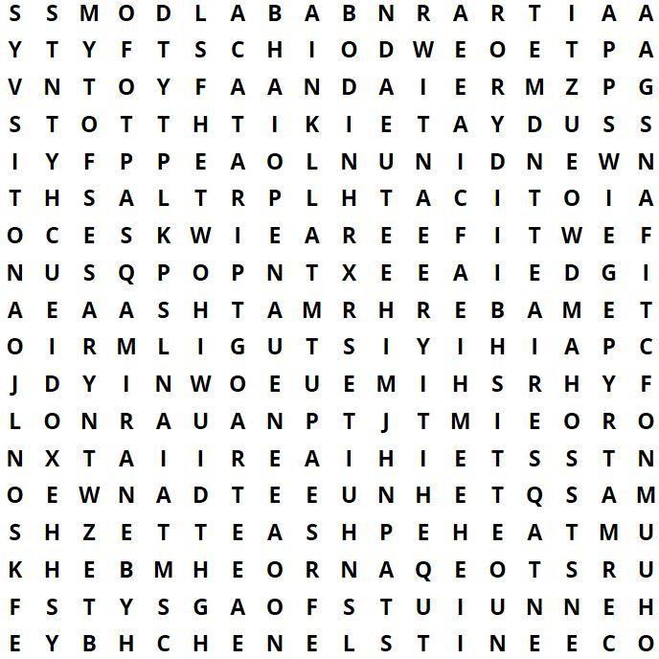

Find 40 two-letter English words in this fun word search puzzle:

1. up | 11. we | 21. | be | 31. | hi
2. my | 12. me | 22. | no | 32. | go
3. at | 13. ta | 23. | or | 33. | it
4. OK | 14. ex | 24. | he | 34. | um
5. ab | 15. ma | 25. | to | 35. | on
6. id | 16. an | 26. | in | 36. | op
7. er | 17. ow | 27. | of | 37. | by
8. us | 18. as | 28. | so | 38. | am
9. pa | 19. do | 29. | pi | 39. | yo
10. if | 20. ad | 30. | is | 40. | oh

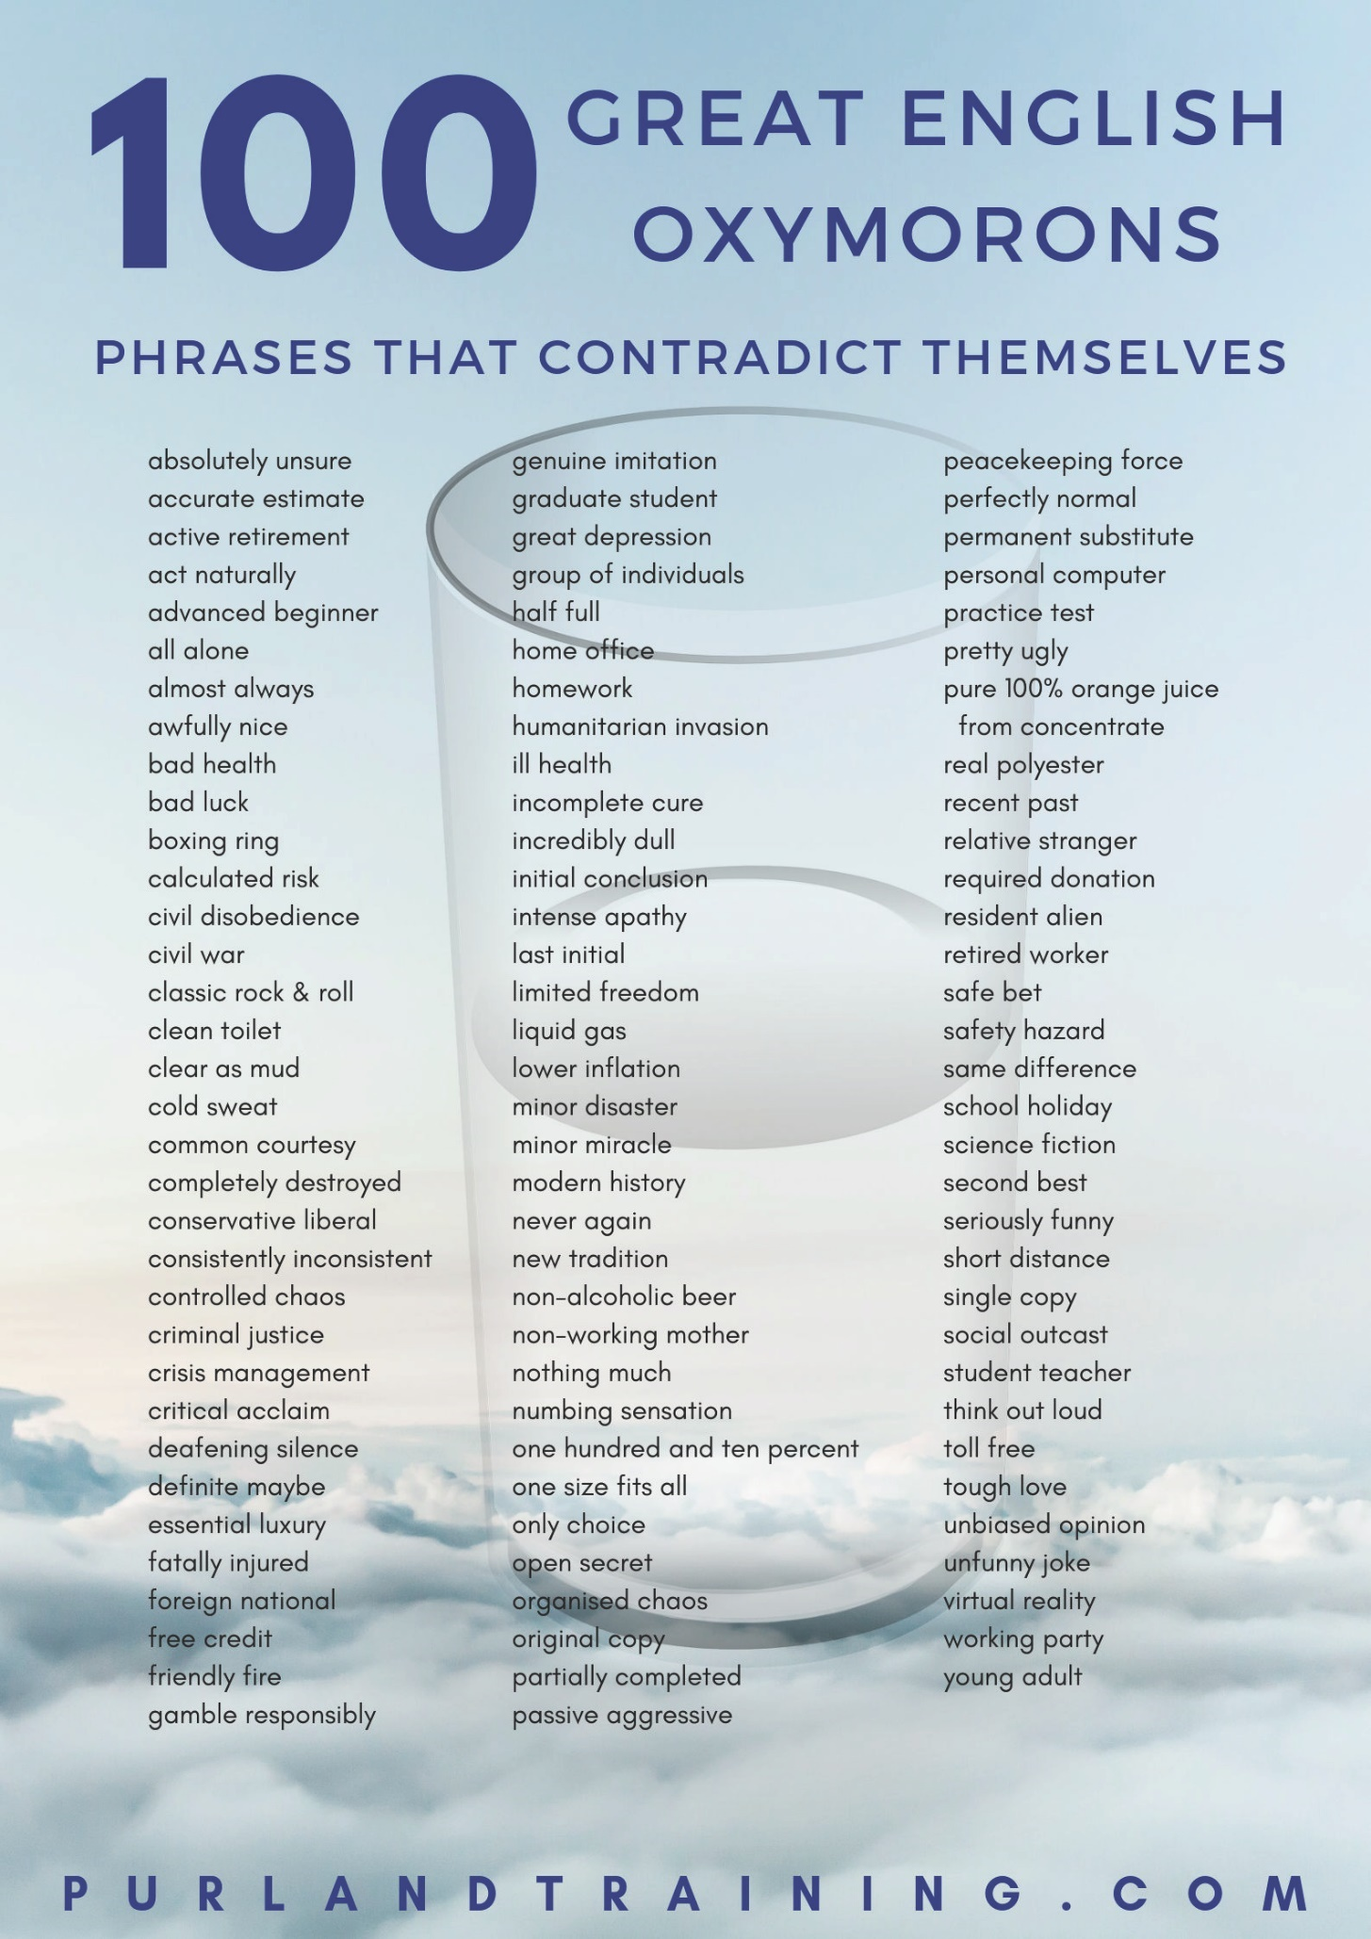

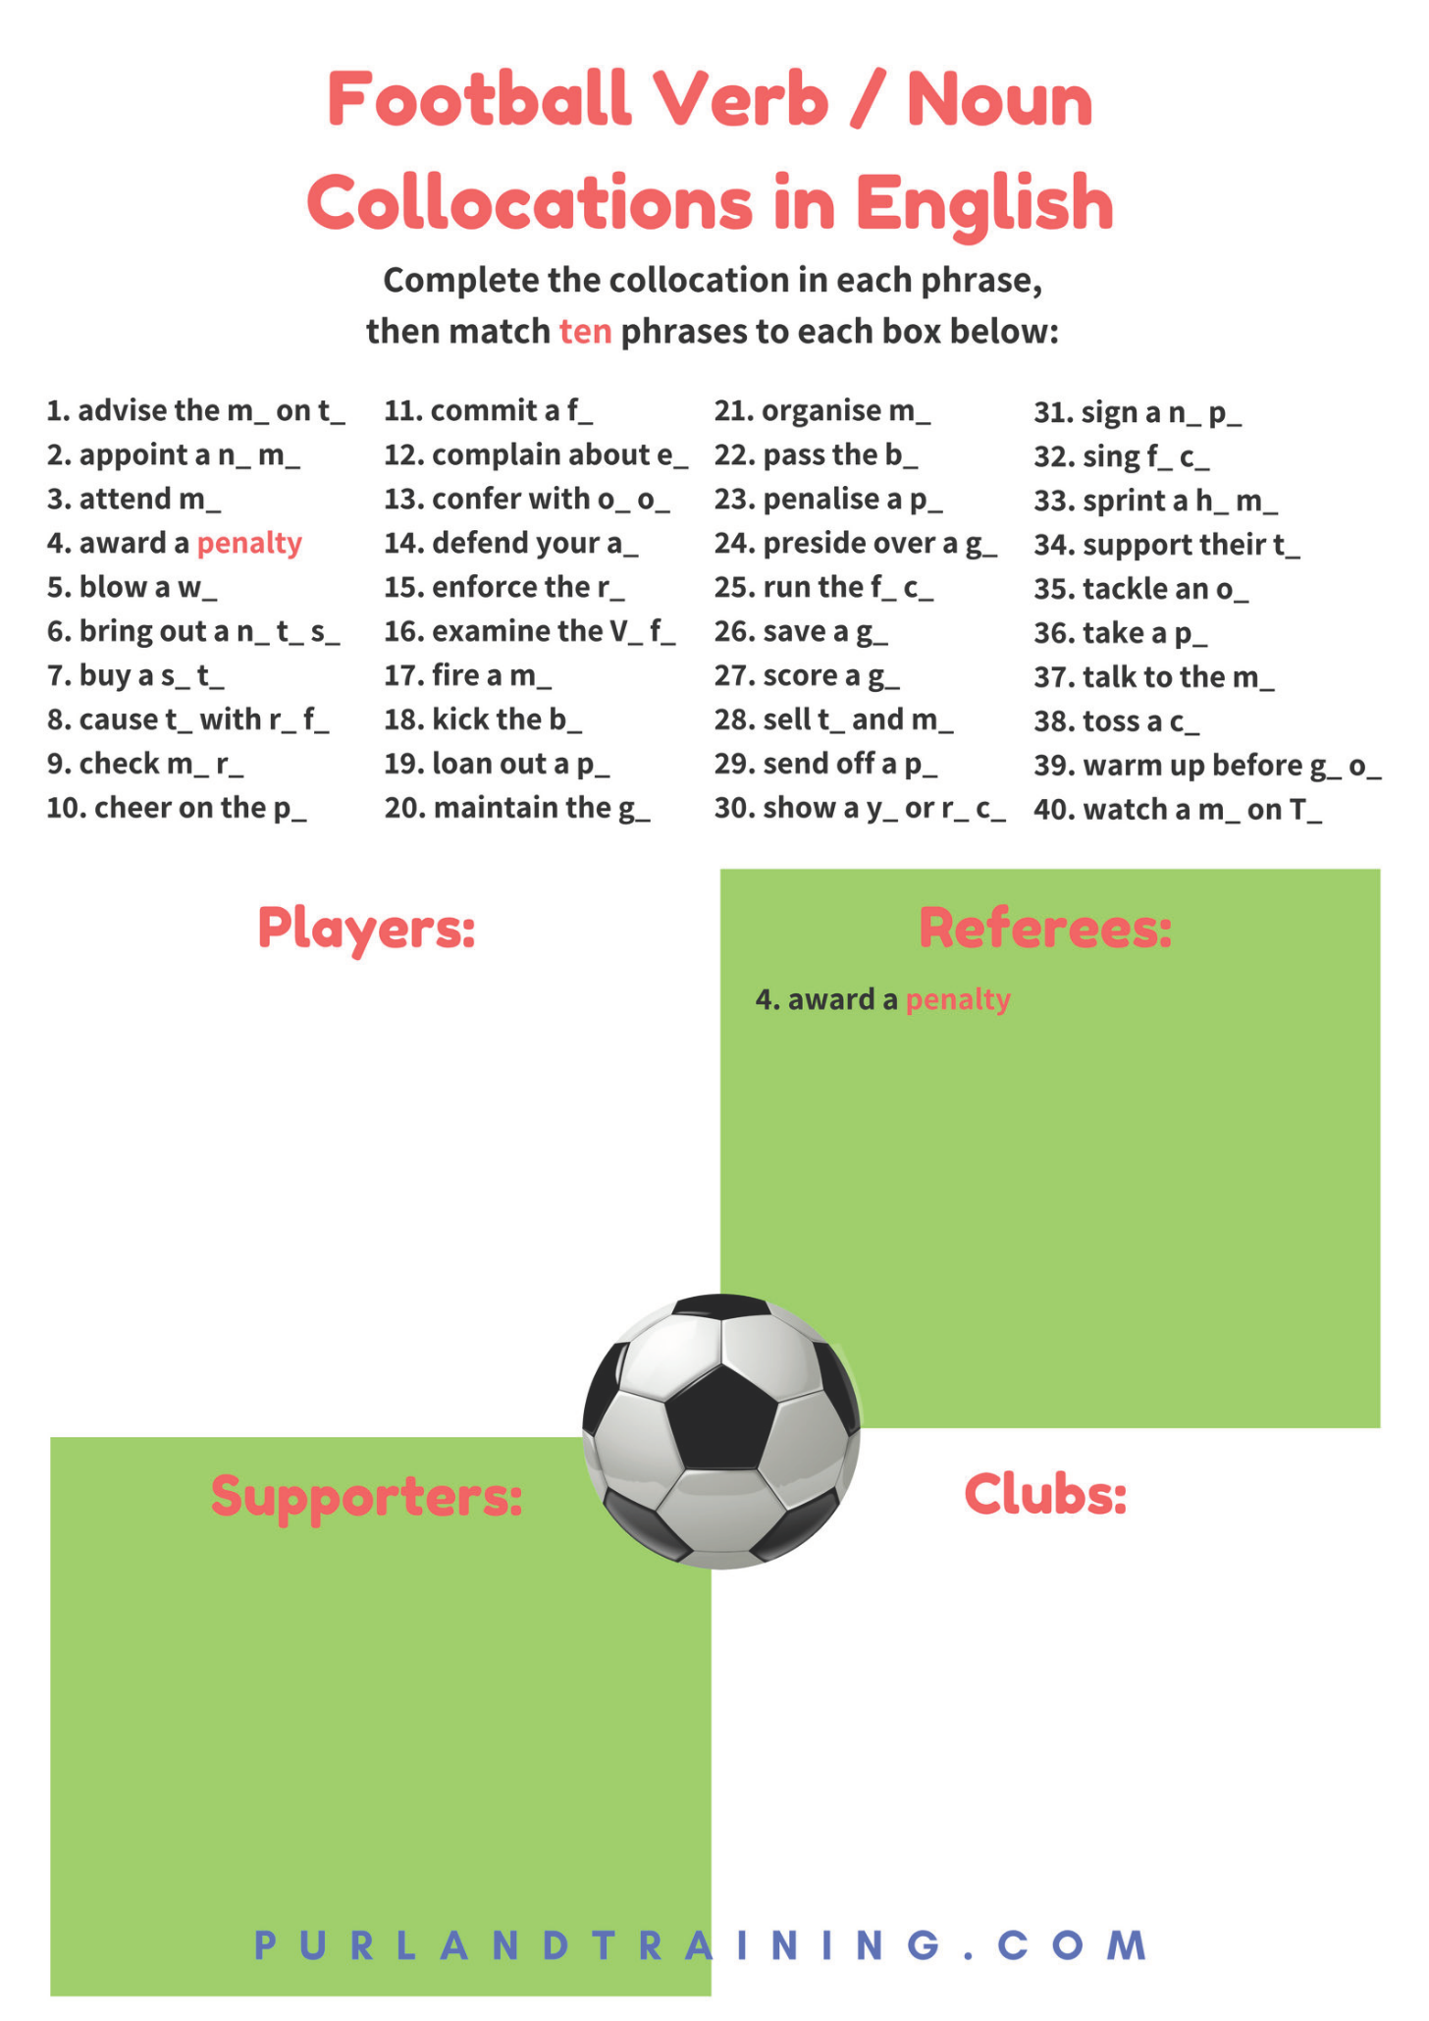
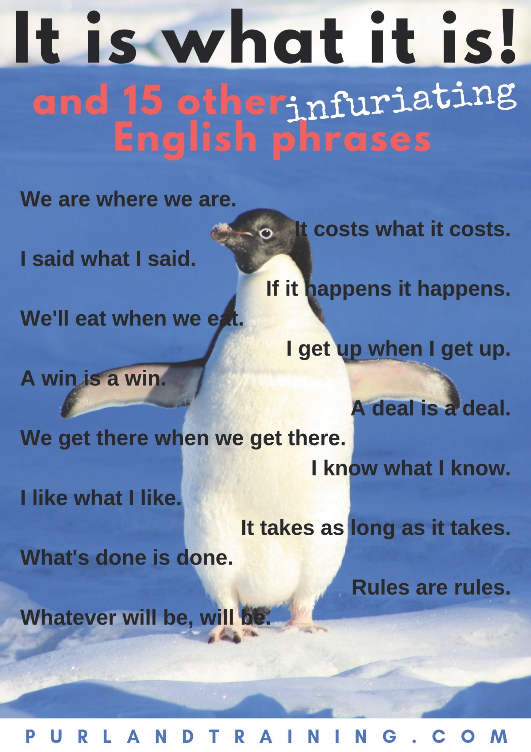

PurlandTraining.com

reading

Reading Gap-Fill

The Businessman and the Fisherman

  - Check that you understand these vocabulary words:

enough immediate needs sweat congratulated rewarding
centrally resting
deep in thought processor distribution
retire pier
badly-dressed profit eventually
seaside concerned fleet middleman wander

  - Work with a partner. Read the text, fill in the gaps, put the parts in the right order, then discuss the questions on the following page:


A well-dressed businessman – a tourist – was at the a) of a b) village when a small boat with just one c) fisherman appeared. Inside the small boat were several large tuna. The businessman d) the fisherman on the quality of his fish and asked him how long it had taken to catch them. The fisherman replied, “Not long.” The businessman then asked him

why he didn’t stay out longer and catch more fish, to which the fisherman replied, “I have e) to support my family’s f) .” The businessman then asked, “But what do you do with the rest of your time?” The fisherman said, “I sleep late,

fish a little, play with my children, rest with my wife, then g) into the village each evening
where I have a glass of wine and play guitar with my friends. I have a full and h) life.” The businessman looked i) and told him, “I’m a very successful businessman and may be able to help you. You

should spend more time fishing, and with the extra money buy a bigger boat. With the j) from the bigger boat you could buy several boats, and k) you would have a whole
l) of fishing boats. Instead of selling your catch to a m)

you would sell directly to the n) , and finally open your own factory. You would control the product, processing, and o) . Of course, you would need to leave this village and move to the big city, then possibly even a different country,

where you would run your growing business p) .” The fisherman asked, “But how long would all this take?” The businessman replied, “Fifteen to twenty years, I guess.” “But what then?” asked the fisherman,
- on the warm sand. The businessman laughed and said, “That’s the best part!

When the time is right you could launch your company on the stock market and become very rich. I feel sure you would make millions!” “Millions?” said the fisherman, “And then what?” The businessman wiped the
- from his forehead and smiled, “Then you would s) . Move to a small coastal fishing village

where you would sleep late, fish a little, play with your kids, rest with your wife, then wander into the village each evening and have a glass of wine and play guitar with your friends.” “But I’m doing that now,” said the fisherman, and the businessman walked away t) .


Adapted from a story by Heinrich Böll: https://en.wikipedia.org/wiki/Anekdote_zur_Senkung_der_Arbeitsmoral

The Businessman and the Fisherman

Read the story on p.74 and discuss the following questions with a partner or small group:

  - What are the main themes of the story?

  - What is the moral of the story? What lesson does the author want the reader to take away from it?

  - Who is right, in your opinion? Who do you identify with the most – the businessman or the fisherman? Why?

  - How did you react to the ending of the story? Were you surprised or moved, for example? Why? / Why not?

  - What are the pros and cons of each man’s point of view? Compare each man’s position.

  - Would this story be the same if both characters were women? If not, how would it be different?

  - Is the fisherman saying that it is wrong to plan for the future? Isn’t he being irresponsible? What about when he is too old to work? What about his family?

  - Should we be happy with what we have, or have ambition and strive for more / a better life?

  - Is it wrong to take pleasure in our achievements – setting a goal; striving for it; and achieving it?
  - Is the story biased in favour of either person? How does the narrative achieve this?

  - Can money buy happiness? What is the relationship between money and happiness?

  - What does the story mean to you? Does it make you want to change your way of life? How could you do this? Do you want to?

  - What is your ultimate goal – or end-game – in life?

  - Are you happy to accept the rat race: learn, earn, rest, then die? Can you imagine a different, more fulfilling way of life? Describe it. If not, why not?

  - Do you live in the moment, like the fisherman? What does it mean to do this? Have you ever tried it? How can we do this? What are the benefits/drawbacks of this?

The Ultimate Tardigrade Quiz – 50 Questions!

The tardigrade must be one of the most fascinating animals on the planet – and off it too! Work with a partner or small group and test your knowledge of tardigrades with our fun quiz. (Prior research is highly recommended!)

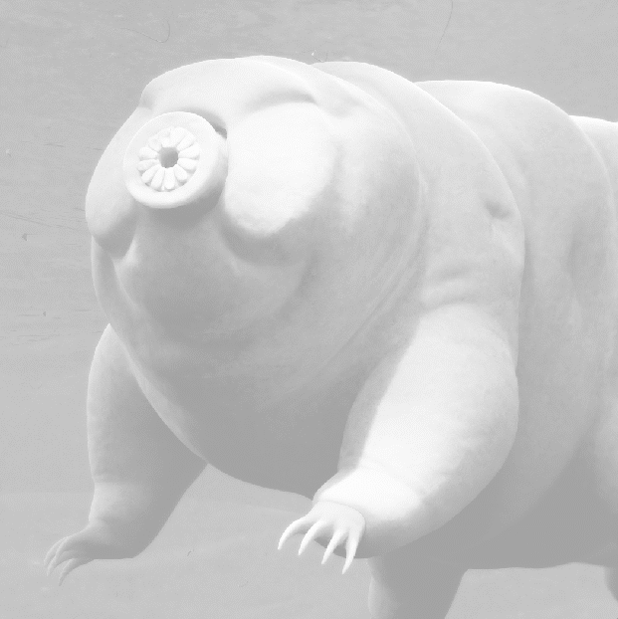
Print this page onto card, cut up the cards, then lay them face down on a table and mix them up. Take turns to draw one, read it out loud, and say whether the statement is TRUE, FALSE, or OPINION. If you get it right, keep your card. The one with the most cards at the end is the winner! Or work alone and sort the cards into the three groups, then check the answers.


1. Tardigrades are also known as moss piglets. | 26. They are among the most interesting animals.
2. There are more than 1,100 species of Tardigrade. | 27. They can live for up to two months.
3. Tardigrades have two arms and two legs. | 28. Some people like to dress up as tardigrades.
4. Tardigrades make excellent pets. | 29. Tardigrades are not invertebrates.
5. They are a type of micro-animal. | 30. Tardigrades are harmless if you eat them.
6. They eat soil. | 31. Tardigrades cannot swim.
7. They have been found almost everywhere. | 32. You have probably eaten a few on a fresh salad.
8. Tardigrades are awesome! | 33. My cousin kind of looks like a tardigrade.
9. They were discovered in 1846 by van der Groot. | 34. Tardigrades do not live on humans or animals.
10. They can withstand extreme temperatures. | 35. They can survive being eaten by humans.
11. They will be the last species left alive on earth. | 36. They’re called water bears due to how they move.
12. The word ‘tardigrade’ means ‘water bear’. | 37. Like insects, they have six legs.
13. They can live in the vacuum of outer space. | 38. You’re probably around ten metres from one now.
14. They can survive dehydration and starvation. | 39. They are like real life (miniature) gummy bears.
15. Tardigrades are also known as water pigs. | 40. No tardigrade fossils have been found.
16. Tardigrades are responsible for global warming. | 41. Tardigrades live in water.
17. Tardigrades do not have eyes. | 42. They are about 0.02mm long when fully grown.
18. They can withstand very high doses of radiation. | 43. They are incredibly resilient.
19. A person who studies tardigrades is a Tardist. | 44. They have two claws on the end of each leg.
20. They can suspend their metabolism for years. | 45. Tardigrades always reproduce asexually.
21. They cannot be seen under a normal microscope. | 46. Tardigrades are the best species on the planet.
22. Tardigrades have unpleasant features. | 47. Some tardigrades are cannibals.
23. They live in damp places, like mosses and soil. | 48. Tardigrades are mostly brown.
24. A tardigrade is not able to change its basic shape. | 49. Scientists do not use tardigrades for research.
25. They have telescopic mouths which spiral out. | 50. Tardigrades are impossibly cute.

PurlandTraining.com

speaking and listening

Using an Object for Discussion Practice

Work with a partner or small group. Both of you choose a different object that you would like to discuss. It can be something real from where you are – a book, a stapler, a board eraser – something that you’ve brought in from home – a cushion, a coffee mug, a shopping bag – or something from a catalogue, book, or newspaper. In fact, any real object that you can think of or imagine!

Then…

- Describe it for the other person to guess.
- Draw it for the other person to guess.
- Interview the other person about their object. Focus on correct question forms.
- Interview the other person, but imagine you are an alien called , who knows nothing about planet Earth…
- Talk about your object for no less than… a) 20 seconds, b) 40 seconds, c) one minute, etc. There could be ‘banned’ words that you can’t use, e.g. talking about a chair: ‘sit’, ‘furniture’, etc.
- Compare your object with another object; list at least 5 similarities and 5 differences.
- Talk about your object using a different tense and form (+ / - / ?) for each sentence, e.g.

  - present simple
  - present continuous
  - past simple
  - present perfect
  - future simple
and so on! See how many sentences you can make before you run out of tenses!

- Discuss at least 5 advantages and 5 disadvantages of your partner’s object, then swap over.
- Try to sell your object to your partner.
- Imagine your partner is a shopkeeper who sold you your object. Try to get a refund.
- Imagine your item is alive. Imagine:

    - its name
    - it’s life history to date
    - what it does in a typical day
    - how it feels about you – and humans in general

- Write or tell the official biography of your object in no more than 200 words.
- Describe how it is made / grown / produced, etc. What was its journey from the moment of its creation to this moment in your hands?
- Tell a weird / funny / sad, etc. story about your object.
- Make up a song about it – in different genres: pop, rock, country, rap, reggae, etc.
- Create a role play / short movie on your phone about your object.
- List at least six ways in which your object could be improved.
- How could you transform your object into something else or use it for another purpose? Think of at least four examples.
- Describe your object for at least a minute, but as if it is something else and not the object at all.
- Create a board game, card game, or puzzle based on your object.
- Write a quiz about your object, or create an app or mobile game based on your object.
- Write a social media post about your object and tag four friends.
Tip: to keep the class moving, each mini-game could be given a fixed time, e.g. 5 minutes. When a bell rings, students move on to the next game (and new partner) – or randomise the games by cutting up the list and putting the pieces on the walls around the classroom. Students choose their next game.

Giving Your Opinion
1. We can give our opinion about absolutely anything in life, but we most often need to give our opinion when choosing between different options. Here are a few more common occasions when you might need to give your opinion and recommend what to do, based on your experience and insight (how you see things):
shopping | clothes, jewellery, shoes, electrical equipment; especially big purchases, e.g. furniture, holidays, cars, our home, etc.
services | restaurants, hotels, resorts, RAC, plumbers, mechanics, lawyer, etc.
people | say what you think of other people, e.g. appearance, life choices; discuss family problems, decisions, news, events, work, education, travel, past mistakes, future options and possibilities, etc.
advice | tell others what you think they should do in a given situation
politics | talk about local, national, and world news, current affairs, famous people, events, religion, etc.
ethical issues | discuss contentious moral and ethical issues, e.g. the death penalty
culture | talk about / review music, books, film, TV, sport, games, theatre, art
judging | auditions, court cases, competitions, presentations, job interviews, homework, course work, exams, tests, etc.
time | talk about past, present, and future events, possibilities, ambitions, hopes, fears, dreams
weather / traffic | two topics that provide an endless source of discussion, opinion, and speculation for British people!

2. We can ask for other people’s opinions in various ways:

What do you think of / about...? What is your opinion / view of...? Do you think that...?
What / How about...? Do you agree that...?
Do you think / feel / believe that...?

Collocations with opinion: agree with, ask, disagree with, find out, get, give, have, hold, know, offer, receive, say, state, trust, value
- Agreeing and disagreeing: we can say simply “yes” (“yeah” – informal) or “no” (“nah” – informal). Here are some more phrases to choose from:
Disagreeing:

I (completely) disagree (with sth or sby). / No way! That’s / You’re (absolutely) wrong!
That’s not true / untrue / false.
I have a different opinion / view.
I respect your opinion, but... (formal)
I’m afraid I have to (respectfully) disagree. (formal) (What a load of) rubbish! (informal)
Don’t be ridiculous! (informal)
You must be joking / kidding! (informal)
Agreeing:

I (totally) agree (with sth or sby). / Me too. / So/Neither do I. Yes, of course. / Quite right! / Absolutely! / That’s a good point. That’s (absolutely) right. / That’s true. / You’re not (far) wrong.

- Our opinion is subjective, not factual. When giving our opinion we add an introductory phrase which acts as a kind of disclaimer, letting the listener know that this is what we think, feel, or believe, rather than a fact:
If you can’t agree:

We’re not going to agree (on this), so let’s agree to disagree / change the subject. / You don’t have to agree with me, but...

I think / feel / believe / guess / reckon... It is my (personal / strong) opinion that...
Giving a general opinion:
Most / some people think / feel (that)...
I’ve never thought about it before.
To state unrequested negative opinions:

In my opinion / view... / As far as I know... It is (widely) thought that.. Don’t take this the wrong way, but...

For me... / To be honest...
If you ask me... / If you want my opinion
When you don’t have an opinion:
I don’t know. / I’ve got no idea.
I’m not being funny, but...
[rude / negative opinion] Just sayin’!

After making our first statement we should back it up with reasons and examples. This model of speaking enables us to talk continuously, because the examples are themselves statements, which lead to further reasons and examples – and so on: statement -> reason -> example(s) -> statement, -> reason, etc.

- We can use verbs and adjectives graded from positive to negative to give an opinion:
Verbs: I it.

hate / can’t stand really dislike dislike don’t mind / like / enjoy really like love / adore negative - don’t like can put up with positive + 0% l l 50% l l 100%

Adjectives: It is .

terrible / awful really bad bad / poor OK / so-so / not bad good great / super fantastic / brilliant
negative - positive +
0% l l 50% l l 100%

Giving Your Opinion – Exercises

  - Write three things that you could give your opinion about in each category:

buying a new... | e.g. car
using a service
family and friends
ethical issues
judging something

  - Complete the gaps in the dialogue:

Phil: What a)

Simon: I thought it was b)
you think of the football match yesterday?
good. Samson played well. c) about you?

Phil: Yes it was a good result. You know what, I need to get a birthday present for my girlfriend. d)
you e) I should get her a voucher?
Simon: In my f) , that’s not very thoughtful. What g) jewellery?
Phil: That’s a good h) , but to be i) , I haven’t got much cash. What about a magazine?
Simon: Don’t take this the j) way, but I don’t k) she will l) that, Phil!

  - i) Put the parts together and write three sentences with statement -> reason -> example:
for example, on The Guardian website.
the style was really modern.
You shouldn’t buy that dress,

and you’ll look terrible!
She recommended her hairdresser
because most news is free online –
’cause she did a great job –
I don’t like buying newspapers,
because it’s so old-fashioned

ii) Write five sentences using the statement -> reason -> example model:

statement: | reason: | example:
e.g. I don’t eat meat | because I’m a vegetarian, | but I love salads, pasta, and rice.

  - Complete the gaps with the words below:
great | really like | good | like | poor | terrible | love | dislike not bad | hate | fantastic | don’t mind | really bad | really dislike
- Verbs:

  - b)

negative - positive +
0% l l 50% l l 100%

- Adjectives:

- i)

negative - positive +
0% l l 50% l l 100%

Which is Better? Discussion

  - Work with a partner. Discuss each pair below and make notes in the space provided. One of you argues that one of the things is better, while the other person argues the opposite – that the other thing is better. Think of at least four advantages / disadvantages for each thing:
- Hot or cold
- Night or day
- Rich or poor
- Black or white
- People or animals
- Coffee or tea
- Car or bus
- Cat or dog
- House or flat
- Summer or winter
- Beach or sea
- Wet or dry
- Coast or inland
- Town or country
- Wine or beer
- Orange or Apple
- Light or dark
- Sweet or sour
- Sweet or savory
- Happy or sad
- Salt or pepper
- Paper or pen
- Pen or pencil
- Work or play
- iPhone or Android
- Walk or ride
- TV or cinema
- Tree or bush
- Flower or plant
- Read or write
- Google or Yahoo!
- Apple or Microsoft
- Supermarket or corner shop
- MS Office or Open Office
- Painting or drawing
- Boat or yacht
- Train or tram
- Chocolate or sweets
- Angry or calm
- Sharp or blunt
- Stupid or clever
- Bright or dim
- Active or relaxed
- Full or empty
- Heavy or light

  - Think of your own pairs, then repeat the activity.

Just Forget It! Discussion – Part 1

When something unpleasant happens to you, there is always a friend or family member who advises you to ‘Just forget it!’ – as in, do not take any further action about the matter.
Discuss the situations below with a partner or small group and say whether you would ‘just forget it’ or take further action. If you would take further action, to what level would you take it? For example:

- complain at the time
- write an email
- write a letter
- make a phone call
- start a boycott
- contact the media
- organise a protest / direct action
- seek revenge

- You are passed over for a promotion at work – unfairly in your opinion.
- You witness a dog owner allowing their dog to poop on the pavement, then fail to pick it up and bag it.
- Your flight is delayed by six hours, causing inconvenience but no real extra expense.
- You are short-changed in a bakery by ninety-five pence.
- Your good friend does not invite you to their upcoming wedding.
- Your nursery teacher has overlooked your very talented child for the best parts in the school play – again – meaning that they have to play a tree.
- The bus fails to stop, making you twenty minutes late for work.
- Your pizza at a nice restaurant arrives cold.
- Your new lawnmower breaks down and needs a serious repair after using it only twice.
- Somebody spills your pint in a nightclub – all over your partner’s new white coat.
- Somebody eats the last slice of cake from the fridge when you had reserved it.
- Somebody backs into your car in a car park, causing minor damage.
- A group of teenagers are laughing and eating noisily behind you at the cinema – then start shouting out what happens next.
- You find out your partner of two years has been having an affair.
- You ask your child to clean up the house. They do it, but really badly.
- On a long-haul flight the person in front of you reclines their seat.
- The police stop you on suspicion of speeding, but you are adamant that you always obey the speed limit.
- Your father is wrongly diagnosed by his GP, which leads to his untimely death.
- Your insurance company refuses to pay out for a damaged mobile phone, worth over £1,000.
- Your best friend refuses to lend you his car while he’s away on holiday.

Just Forget It! Discussion – Part 2

When something unpleasant happens to you, there is always a friend or family member who advises you to ‘Just forget it!’ – as in, do not take any further action about the matter.
Discuss the situations below with a partner or small group and say whether you would ‘just forget it’ or take further action. If you would take further action, to what level would you take it? For example:

- complain at the time
- write an email
- write a letter
- make a phone call
- start a boycott
- contact the media
- organise a protest / direct action
- seek revenge

- The owner of the B&B where you stayed for a week charges you for damage to the room, which you know had been there when you arrived.
- You book tickets to see your favourite actress live in a West End musical, only to find that on the day you go it is her day off and her part is being played by an understudy.
- The launderette shrinks your favourite blouse.
- You send your brother £100 in cash in the post, but it doesn’t arrive.
- You are fired from your job after a few weeks for reasons that you feel are unfair.
- Somebody insults you on social media.
- Somebody blocks your parking space at work.
- Your train is cancelled three days in a row, meaning that you have to take the bus.
- A cyclist cuts in front of you when leaving the traffic lights, then gives you the finger.
- Another child has been bullying your child at school for a few months.
- You buy some clothes online, but they do not fit. The online retailer refuses to give a refund.
- At your child’s school sports day another parent insults your child’s weight.
- Your father borrows one of your books and returns it damaged.
- A funeral business uses one of your Facebook photos in an advert without asking you.
- You write a letter to HMRC to complain about overpayment of tax but they do not reply.
- You go on holiday abroad but find the hotel is nothing like what they advertised.
- You agree to let your friends stay in your house while you are on holiday, as long as they don’t smoke there. You arrive home to find that the house stinks of smoke.
- You go for a massage which should last one hour, but the massage therapist finishes the session after 50 minutes without comment.
- You have a haircut, but afterwards you feel very unhappy about how it looks.
- Twelve years ago your mother behaved in a manner which really upset you. You still feel hurt.

Just Forget It! Discussion – Part 3

When something unpleasant happens to you, there is always a friend or family member who advises you to ‘Just forget it!’ – as in, do not take any further action about the matter.
Discuss the situations below with a partner or small group and say whether you would ‘just forget it’ or take further action. If you would take further action, to what level would you take it? For example:

- complain at the time
- write an email
- write a letter
- make a phone call
- start a boycott
- contact the media
- organise a protest / direct action
- seek revenge

- You buy a coffee in a trendy coffee shop but find it is lukewarm.
- You pay £4.89 for some washing powder in a supermarket, but on the way out of the shop you notice it is on offer and should have been £3.49.
- Your child is hit by a car driven by a guy who is high on drugs. Your child will never walk again.
- You pay for a month of English lessons, but after the first one you are unhappy with the quality of the teaching.
- You receive an email from your parents informing you that you were adopted.
- Your neighbour’s cat keeps fouling in your vegetable garden.
- Your friendly neighbour’s likeable son has smashed your greenhouse window with his football.
- The local vicar refuses to let you and your fiancée get married in your local church, because you don’t attend regularly enough.
- You find a homeless man camping in the doorway of a shop that you own.
- You are involved in a film project but your name is misspelled in the credits.
- You phone up a talk radio station to discuss politics, but because of your views the presenter turns you into a laughing stock live on air – and later on social media.
- Your wife orders a birthday cake from a bakery for your daughter’s fifth birthday, but they deliver it two days late, making it redundant.
- Your taxi driver punctuates a long drive with his racist thoughts.
- Your son’s secondary school headmaster fines you £60 for taking him out of school during term time for a holiday.
- The last train home is cancelled meaning you have to book a hotel for the night.
- Your personal trainer is consistently late for your training sessions.
- When you have to pull out of a stag weekend in Prague due to family illness, your friend still charges you the full £900 cost of the weekend.
- You find an earwig in a tin of beans.
- A painter drops a paint pot on your head by accident as you walk down the road.
- Builders began work on your new bathroom, but you haven’t seen them for two months.

Talking about a Song in an ESOL Class

Complete the information about a song, and present it to the rest of the class:

About the song:
Title:
Artist:

Writer(s):
Country:

Release Date:
Duration:
About the music:
Genre:
Instrument(s):

Tempo:
Chord Sequence:

Melody:
Hooks:
Lyrics:
What is it about?

My memories of the song:
My favourite line:

5 facts about the song:
•

•

•

•

•
5 reasons why it’s great:
•

•

•

•

•

Speaking and Listening Discussion

Find Alternatives to Plastic 1

Work with a partner or small group. Write the source (e.g. online store) and the price of each plastic item below. Then search for an equivalent item which is biodegradable. Write the source and the price. Compare the items and prices. Discuss the pros and cons and how easy it was to find a non-plastic alternative. If there is no alternative invent one.

LIVING ROOM | Plastic |  | Biodegradable
Item: | Source: | Price: | Source: | Price:
TV
games console
tablet
children’s toy
fan heater

KITCHEN | Plastic |  | Biodegradable
Item: | Source: | Price: | Source: | Price:
bottle of milk
box of juice
bin bags
fridge freezer
lunch box

BATHROOM | Plastic |  | Biodegradable
Item: | Source: | Price: | Source: | Price:
tube of face cream
washing machine
baby wipes
bottle of bleach
multipack of loo rolls

86

Speaking and Listening Discussion

Find Alternatives to Plastic 2

Work with a partner or small group. Write the source (e.g. online store) and the price of each plastic item below. Then search for an equivalent item which is biodegradable. Write the source and the price. Compare the items and prices. Discuss the pros and cons and how easy it was to find a non-plastic alternative. If there is no alternative invent one.

BEDROOM | Plastic |  | Biodegradable
Item: | Source: | Price: | Source: | Price:
mobile phone
headphones
alarm clock
reading glasses
fitness ball

OFFICE | Plastic |  | Biodegradable
Item: | Source: | Price: | Source: | Price:
laptop
printer
A4 plastic wallet
modem
sticky tape

HOME | Plastic |  | Biodegradable
Item: | Source: | Price: | Source: | Price:
trainers
rucksack
vacuum cleaner
debit card
iron

87

Speaking and Listening Discussion

Find Alternatives to Plastic – Write Your Own

Work with a partner or small group. Write down three rooms and five plastic items found in each one. Write the source (e.g. online store) and the price of each item. Then search for an equivalent item which is biodegradable. Write the source and the price. Compare the items and prices. Discuss the pros and cons and how easy it was to find a non-plastic alternative. If there is no alternative invent one.

Room: | Plastic |  | Biodegradable
Item: | Source: | Price: | Source: | Price:

Room: | Plastic |  | Biodegradable
Item: | Source: | Price: | Source: | Price:

Room: | Plastic |  | Biodegradable
Item: | Source: | Price: | Source: | Price:

88

Restaurants – Discussion Questions

Discuss the following questions about restaurants with a partner or small group:

- What is your favourite restaurant? Why do you like it? How often do you go there? Who do you usually go with?
- What do you like to order at a restaurant? Do you always order the same thing?
- Do you leave a tip for the waiter/waitress when you pay? If yes, how much do you leave? If not, why not?
- Have you ever worked in a restaurant? Would you like to? Why? / Why not? Imagine what a normal shift would be like.
- Are you an easy customer or a difficult customer? Give examples.
- Has anything funny or surprising ever happened to you in a restaurant? Tell me about it.
- Would you like to own a restaurant? Do you think it would be a good investment? Why? / Why not? Why do people set up or buy restaurant businesses?
- Is restaurant food better than home-cooked food? Are you a good cook? Do you prefer home-cooked food? Why?
- Have you ever had food poisoning or felt sick after visiting a restaurant? What happened? Tell me about it.
- Do you like to visit different restaurants while on holiday, or do you stick to the hotel restaurant?
- Why do we need restaurants? What social / cultural functions do they have?
- What would happen if there were no more restaurants from next week?
- Do you prefer small and cosy restaurants to large busy ones? Why? Give reasons.
- Have you ever complained about the food or service at a restaurant? Tell me about it.
- If you could have a meal at a restaurant with five famous people (alive or dead), who would you choose and where would you dine? What do you think you would you talk about?
Who would be the most fun? Who would refuse to pay the bill? Why?
- Is it better to work in a restaurant than a shop? Why?
- Can you guess what my favourite restaurant is?
- Do you think restaurants should play background music or have a quiet ambience? Why?
- What is the oddest smell you have ever experienced at a restaurant?
- Have you ever popped into a restaurant just to use the toilet? Why? Did you get caught? What other funny or forbidden things have you done at a restaurant?

Social Networks – Discussion Questions

Discuss the following questions about social networks with a partner or small group:

- Which social networks do you use? What do you use them for?
- What is your favourite social network? Why? What is unique about it?
- What is the definition of a social network? What makes something a social network? What essential qualities does it have to have?
- Does peer pressure fuel the growth of social networks?
- Which social networks are the coolest? What makes them cool? Which social networks are uncool? What makes them uncool?
- Do you prefer to access social networks on a laptop, tablet, or mobile phone? Why?
- How many social networks do you belong to? What was the first social network you joined? What was the last social network you joined? Why did you sign up for it?
- Which social network has the most useful functions? Have you ever sold anything on a social network? Have you ever bought ads? How satisfied were you with the results?
- Which social network is the most fun? Why? Which social networks are boring? Why?
- If you could keep only three social networks and the rest disappeared, which ones would you choose and why? If you could keep only one, which would you choose and why?
- Can you remember a time before social networks? How did you... a) make new friends online?
    - Have fun online? c) Discover the news online? d) Share photos and videos online?
- How did people keep in touch with friends in the past, before social networks came along? Would you like to go back to those days? Why? Why not?
- Which social network is best for… a) sharing photos with friends, b) making new friends,
    - listening to music, d) watching films, e) finding new work contacts, f) learning, g) making calls, h) texting, i) selling your belongings. Give reasons for your choices.
- Are social networks essential, or an unnecessary distraction? Can you imagine a world without social networks? Give reasons for your answers.
- What dangers do social networks pose? Are you happy to trade your privacy in order to get free access to a social network? Why? / Why not? Would you pay monthly to get more privacy on a social network? Why? / Why not?
- Have you ever had a problem using a social network? Tell me about it.
- What do you do when you see something you don’t like, or don’t agree with online?
- Do you think that children should be allowed to register for social networks? Why? / Why not?
- Is the number of friends or followers that you have on social networks important to you? Why? / Why not? How many friends have you got on Facebook? How many of them are real friends? What about on other social networks?
- Do you rely on social networks to get… a) local news, b) national news, c) international news? How reliable do you think the news sources are?

Selfish People – Discussion – Part 1

Selfish people really are a uniquely gifted kind of human being. It takes a lot of skill to do what they do – i.e. to do whatever they want to do, without worrying about how their actions affect the rest of us!

  - Below is a list of some of the things that selfish people do on a regular basis. Discuss each one with a partner or small group. Say why they are annoying and how much they annoy you on a scale of 1 (OK) to 5 (very annoying).

  - You could also talk about what action you would take in each situation – if any. If you wouldn’t take any action, why not?

Selfish people… Annoyance
Level:

- play loud music in public.

- arrive uninvited (and late) at your birthday party – without a gift.
- drive their incredibly noisy motorbikes up and down the road.
- take up more than one seat on a bench when other people want to sit down.
- blow huge clouds of vapour into your face from their mouths while ‘vaping’.
- let their cat(s) enter your garden and foul on your prize vegetables. _
- include men who walk around topless in the summertime.
- play loud music at night while you are trying to relax or sleep.
- allow their dog(s) to come up to you and bother you without your permission.
- walk down designated cycle lanes.
- smoke close to you so that you end up stinking of tobacco smoke.
- cycle on the pavement.

- walk two abreast which means you have to move to the side of the pavement.
- finish the toilet roll but do not bother to replace it.
- start hoovering or switch on the washing machine at two in the morning.
- meet somebody they know in a queue and join the queue there instead of at the back.
- accept another driver’s invitation to enter a lane without waving to thank them.
- use both of the armrests on an aeroplane, meaning that you have none.
- park outside a shop ‘for a few minutes’ blocking other cars from leaving.
- shout and sing in the street when drunk, causing fear among other people.

  - Imagine if you were selfish and did all these things on a regular basis. How would your life be different? What would be the advantages and disadvantages of having the gift of being a selfish person?

Selfish People – Discussion – Part 2

Selfish people really are a uniquely gifted kind of human being. It takes a lot of skill to do what they do – i.e. to do whatever they want to do, without worrying about how their actions affect the rest of us!

- Below is a list of some of the things that selfish people do on a regular basis. Discuss each one with a partner or small group. Say why they are annoying and how much they annoy you on a scale of 1 (OK) to 5 (very annoying).

- You could also talk about what action you would take in each situation – if any. If you wouldn’t take any action, why not?

Selfish people… Annoyance
Level:

- drop litter without thinking about it.

- walk down the road with their head buried in their mobile phone.
- have the radio on in the garden.
- disrupt a flight with bad behaviour because they are on a hen or stag do.
- eat an apple or a bag of crisps noisily.
- wear an offensive amount of aftershave or perfume, so you can only smell them.
- allow their dog(s) to foul on the footpath, then walk off without picking it up.
- do not bother recycling, because they don’t care about the environment.
- talk and eat loudly at the cinema during the quiet parts of the film.
- regularly kick the back of your seat on an aeroplane ‘by accident’.
- drop their cigarette ash on the ground where they stand.
- spoil the plot of a book or film that you had hoped to enjoy.
- switch on the ‘big light’ in the bedroom at night when you are trying to sleep.
- never buy a round of drinks in the pub.
- take two seats on a bus or train with their bag on one seat, then pretend to be asleep when people get on and are looking for somewhere to sit.
- cross the road when a driver stops for them but do not thank them.
- walk into the living room where people are watching TV, pick up the remote and change channels, without saying a word.
- don’t return your phone calls.
- snore loudly and make no attempt to stop doing it.
- refuse to lend you anything – even a pen.

- Imagine if you were selfish and did all these things on a regular basis. How would your life be different? What would be the advantages and disadvantages of having the gift of being a selfish person?

Graffiti and Street Art – Discussion Questions

Discuss the following questions about graffiti and street art with a partner or small group:

- What is graffiti? What is a ‘tag’?
- What is street art?
- What is the difference between graffiti and street art? Is there a difference?
- Is street art better than graffiti? Why? / Why not?
- Do you like graffiti? Why? / Why not? What kind of art do you like the best? Who is your favourite artist? What do you like the most about them?
- Have you ever been involved in creating graffiti or street art? How did you feel?
- Would you like to be a graffiti artist? What would your ‘tag’ be?
- Can you draw your name or initials in the style of graffiti?
- Is there graffiti in your town? What do you think of it?
- Does street art or graffiti improve an environment or make it worse?
- Are graffiti artists criminals? Should they be punished, e.g. fined or put in prison? Why? / Why not?
- Does anybody have the right to paint on somebody else’s property?
- Are graffiti artists just people who can’t draw? Do they have talent? How do they compare to traditional artists?
- How would you feel if somebody painted graffiti on your property?
- Do you know any graffiti artists? Describe them.
- What causes graffiti?
- Have you ever been to a street art exhibition? Would you like to? What do you think it would be like?
- Is graffiti ‘the worst kind of art’, as some people think? Why? / Why not?
- Are graffiti artists selfish and inconsiderate towards other people? Why? / Why not?
- Are graffiti artists generally male? If so, why?
- Why do people feel the need to write their name on things, e.g. a book, table at school, or a wall in town? How is this connected with feelings of possession and belonging?
- Who is the best artist… a) in the world today, b) in history, c) that you know personally? Are you a good artist? Is artistic talent innate, or can it be learned?
- Is graffiti always political? What is the point of graffiti? What is the point of street art? What do the artists want to say about their lives or society?
- Who owns graffiti? If somebody paints on your property, can you legally claim the artwork as your own?
- Is graffiti threatening to people? What kind of people feel threatened by graffiti?
- Should we remove graffiti and street art? What is the cost of removing it? Who has to pay for it?
- Would your school director be happy if you wrote graffiti all over the school building? Why? / Why not?
- What would the world be like without graffiti or street art?

Raw Materials – Discussion Questions (Part 1)

Discuss the following questions about raw materials with a partner or small group:

- Which raw materials do we need to make... a) a mobile phone, b) a pen, c) a Sunday roast,
    - an ironing board, e) a guitar, f) a spoon, g) a carpet, etc.?

- Which raw material could you... a) easily live without, b) live without but it would be hard,
c) not live without? Why?

- Which materials do we waste the most? Why? How could we better save, manage, reuse, and recycle these materials, e.g. reuse old scrap paper as notebooks?

- Why are some raw materials more expensive than others? Which raw materials are the cheapest? Which are the most valuable? Why?

- Which raw material is the most used? List the top five most used raw materials in the world today. Discuss why they are the most useful. Which are the least useful?

- Should we use sentient beings (e.g. animals) as raw materials for food, clothing, shoes, entertainment, sport, etc.? Would you be happy to catch, kill, cook, and eat your own meals? Why? If no, why not?

- Should we use animals for our entertainment, e.g. bullfighting, cock fighting, dog fighting, in circuses, etc.

- What things can you do from scratch? Can you... a) build a fire outdoors, b) catch, kill, and cook your own food, c) make clothes, d) knit a jumper, e) make furniture, f) write and perform an entertaining show, g) build a car from a kit, etc.? What would you like to be able to do that you can’t do at the moment?

- How often do you think about the raw materials in the products that you buy? Do you ever wonder how many thousands of miles the materials in your hand have travelled to be there? Does it make any difference to your life? Why? / Why not?

- Which raw materials have been used to make the things around you where you are now? Are they natural or processed? How have they been processed?

- How important is recycling to you? Do you recycle regularly? Why do other people want us to recycle materials? Is it a good idea? Why? / Why not? What can we make from recycled...
  - paper and card, b) plastic, c) glass, d) metal, e) fabric, etc.?

- Can you make something useful or beautiful out of... a) wood, b) metal, c) glass, d) paper,
e) fabric, f) wool, g) clay? If not, why not? Would you like to learn one or more of these crafts? How could you learn them?

- How does intensive mining for raw materials affect local communities around the planet? Does it affect your community? If yes, how? If no, how would you feel if it did?

- What are the raw materials of your life? What is your life made up of, e.g. friendship, love, work, etc. What are the raw materials of... a) a successful life, b) a happy life, c) a happy marriage, d) a happy family, e) a good friendship, f) a great career?

Raw Materials – Discussion Questions (Part 2)

Discuss the following questions about raw materials with a partner or small group:

- Do we need to continually buy new ‘must-have’ gadgets? How often do you upgrade your…
  - mobile phone, b) laptop, c) tablet, d) car? Do you need to upgrade them so often? What happens to your old devices and gadgets? Can they be fully recycled?

- Why is the earth so rich in useful natural resources? Have you ever held in your hand…
  - raw gold, b) wool from a freshly shorn sheep, c) fresh rainwater, d) fresh milk from an udder, e) newly fallen snow, f) natural cotton, g) a fossil, h) coal?

- Will the planet’s raw materials ever run out? Which raw materials have already run out?
Which are close to running out? What will happen when all the raw materials have been used? Which raw materials used for fuel are running out? Should we be concerned?
Which raw materials are infinite, if any?

- Could you live in the wild? Could you gather raw materials? How and where? Do you agree with the hypothesis that mankind is the only species that is not naturally adapted to life on earth. For example, we need clothes, tools, heating etc. while other species do not.
How do we make life more comfortable for ourselves?

- Would you like to work as a... a) miner, b) sheep shearer, c) fisherman, d) metalworker,
e) butcher, f) lumberjack? g) cotton picker, h) JCB driver? Why? / Why not? Are they well paid jobs? Is the work easy and comfortable? Imagine a typical day in the life of one or more of these people.

- Why are people who collect raw materials often so badly paid? Why can it be so difficult to collect the fruits of the earth? How do you feel about child labour being used to bring us raw materials... a) in the past, b) today?

- How long have you had your mobile phone? How long will you keep it for? How long could it potentially last? How will you get rid of it? What will happen to it? What is its life cycle?
How could you possibly extend it?

- Could you live on only natural medication, i.e. homeopathic remedies? Why? / Why not? Since mankind has existed for more than two hundred thousand years without modern medicine, why couldn't you? What raw materials are humans made of?

- Why do we rely on plastic to make so many products? Could we ever get rid of plastic completely? Will plastic end when the oil runs out? Since plastic is in the food chain due to plastic waste in our oceans, are we part-plastic?

- Research then describe to your partner: find out how to make... a) paper, b) glass, c) steel,
d) leather, e) honey, f) a diamond, g) a tin can, h) a beef burger, i) wine.

- Which countries do raw materials come from? Why are countries which are so rich in raw materials often among the poorest on earth?

- Compare two different materials, e.g. wood and glass. What is different / similar about them, their uses, how they are harvested and then changed in production?

Laughter – Discussion Questions

Discuss the following questions about laughter with a partner or small group:

- What is laughter? Can you spell it? Can you pronounce it? How do you write laughter in your language, e.g. ‘ha ha!’ in English, but ‘Jajajajaja!’ in Spanish?
- When did you last laugh? Who or what made you laugh? How often do you laugh? What would I need to do to make you laugh right now?
- Do you like laughing? What is the difference between laughing and smiling?
- How do we laugh? What happens to our bodies, especially: a) mouth, b) eyes, c) chest,
d) diaphragm, e) heart, f) breath? What does laughter: a) sound like, b) look like, c) feel like?
- Where do you usually laugh? Why? What effect would laughter have on the atmosphere:
  - at a party, b) at a business meeting, c) in church, d) at a comedy club, e) at a funeral,
f) in an exam, g) at a family dinner, h) at the doctor’s?
- Are you self-conscious about laughing in front of: a) friends, b) family, c) strangers? Why?
- Is it easier to laugh in a big group e.g. at a comedy club or at the theatre? Would you laugh as much if you were the only person in the audience? If no, why not?
- Is laughter ever wrong? When is laughter inappropriate? Can it be illegal to laugh?
- How would you feel if you couldn’t stop laughing? Is it possible to die laughing?
- What is the point of laughter? Is there any evolutionary advantage? Does laughter send out useful signals, e.g. that the one laughing is not a threat?
- Do animals laugh? Do animals find things funny? If not, why not – and why do we?
- Can robots laugh? Do you think machines will enjoy our sense of humour in the future?
- Have you ever laughed till you cried? Have you ever laughed until you couldn’t breathe and thought you might black out, i.e. uncontrollable laughter? What were you laughing at?
Do you like that sensation? Why? / Why not?
- Can laughter be subversive? Can it be used as a weapon? Does satire make you laugh?
- Do you prefer to laugh on your own or with friends? Do you laugh at the same things as your friends and family? Do you believe that laughter is infectious? Why? / Why not?
- Is there anything that you wouldn’t laugh at? What? Is it possible to laugh even though you don’t really find something funny?
- Do you know anybody who doesn’t laugh very often – or who never laughs? Why is that?
- Are you good at making people laugh? What are the best ways to make other people laugh? How do you feel when a group of people are laughing: a) because of you, b) at you?
- What are the benefits of laughter? Is laughter ‘the best medicine’, for example?
- How would you describe your laugh? Are you a loud, moderate, or quiet laugher?
- Describe the difference(s) between these different kinds of laughter: a) chuckle, b) giggle,
c) cackle, d) guffaw, e) snigger, f) sneer, g) chortle, h) hoot, i) titter, j) snicker, k) roar, l) snort,
m) howl, n) fall about laughing? Do you laugh in all these different ways? In what situations would you laugh like that? Can you give an example of each kind of laughter now?
- Do you know the meaning of these idioms about laughter? a) to have a laugh, b) to have the last laugh, c) to get the giggles, d) laughter is the best medicine, e) to be laugh-a-minute,
f) he who laughs last laughs longest, g) to laugh your head off, h) to burst out laughing?
- Do adults laugh at different things to children? Do women laugh at different things to men?
- Do you agree that ‘the couple who laugh together, stay together? Is it important for married couples to have the same sense of humour? Why? / Why not?
- Do optimistic people laugh more than pessimistic people? If yes, why?
- Is it possible to change your mood from angry to happy by forcing yourself to laugh, thus releasing the feel-good chemicals endorphins in the brain?
- Do you ever say something immediately after laughing, like ‘Oh no!’ or ‘Oh dear?’ If yes, why?
- Do the things you laugh at change as you get older, or remain broadly the same? Why?
- How would you feel if you were walking down the street and heard the following people laugh?
  - a baby, b) a group of women, c) a group of teenage boys, d) a lone man, e) a lone woman,
f) a lone child? Why? What would be the difference?
- Do you agree with this quotation from the famous poem ‘Solitude’ by Ella Wheeler: ‘Laugh, and the world laughs with you; weep, and you weep alone’? What does it mean?

Talk about Your Country / Breakfast – Discussion Questions

Discuss the following questions about your country with a partner or small group:

- What country do you come from? Tell me all about it.
- What are the people like in your country?
- Who are some of the famous people in the history of your country? Who is famous now?
- What are the main industries in your country? How do people make their money?
- Do you have a good quality of life in your country? Why? / Why not?
- What are you most proud of when you think about your country?
- What do you think are the main problems facing your country at the moment?
- Have you ever lived in another country? If not, would you like to? Tell me more.
- Tell me about the natural landscape in your country.
- What about the different kinds of wildlife?
- If I were to take a holiday in your country, what would be the best places to visit? Can you plan an itinerary for me?
- What are the most famous culinary dishes in your country? Can you describe how to make one of them, for me, please?
- Do you have any unusual customs in your country? Tell me about one of them.
- What are the best TV shows, films, and cultural events from your country?

Discuss the following questions about breakfast with a partner or small group:

- What do you usually have for breakfast? What time do you usually have breakfast?
- What is your favourite breakfast cereal?
- What does the word ‘breakfast’ mean?
- What did you have for breakfast this morning?
- Where do you usually eat breakfast? Do you ever eat breakfast ‘on the go’?
- Do you prefer a quick breakfast or a leisurely breakfast?
- What is the most you would pay for breakfast in a restaurant?
- Can you describe a full English breakfast? Have you ever tried it? Do you like it?
- Has anybody ever made you breakfast in bed? How did you feel about it?
- Do you know how to make traditional porridge?
- Could you manage without breakfast each morning?
- Peanut butter, honey, jam, or Marmite on toast? Why?
- Some people call breakfast the most important meal of the day. Do you agree? Why? / Why not?
- What do you think I like to eat for breakfast?

At What Age Can I Legally… in the UK?

- Draw a line to show when you can legally do each thing in the UK.
- Discuss the differences and similarities between the UK and your country.

At what age can I legally…?
NO LIMIT

  - get married with my parent or carer’s consent
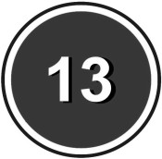
  - have a part-time job
  - buy cigarettes and tobacco
  - buy and drink alcohol in a pub
  - have a full-time job
  - place a bet in a bookmakers
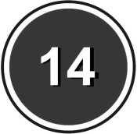
  - join the army with my parent or carer’s agreement
  - apply for a passport
  - drink alcohol with a meal in a restaurant
  - open a bank account without my parent or carer’s signature
  - have sex
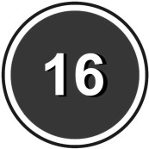
  - have an abortion without my parent or carer’s consent
  - make a will
  - live on my own
  - vote in elections and referendums
  - go into a pub and buy soft drinks
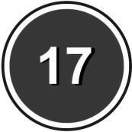
  - get a tattoo
  - ride a moped
  - have a driving licence for a car
  - change my name by deed poll
  - fly a hot air balloon
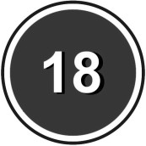
  - play the National Lottery
  - buy fireworks
  - pawn my belongings in a pawn shop
  - adopt a child
  - pilot a plane
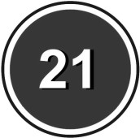
  - pay tax and national insurance
  - leave full-time education or training
  - claim benefits
  - become a blood donor

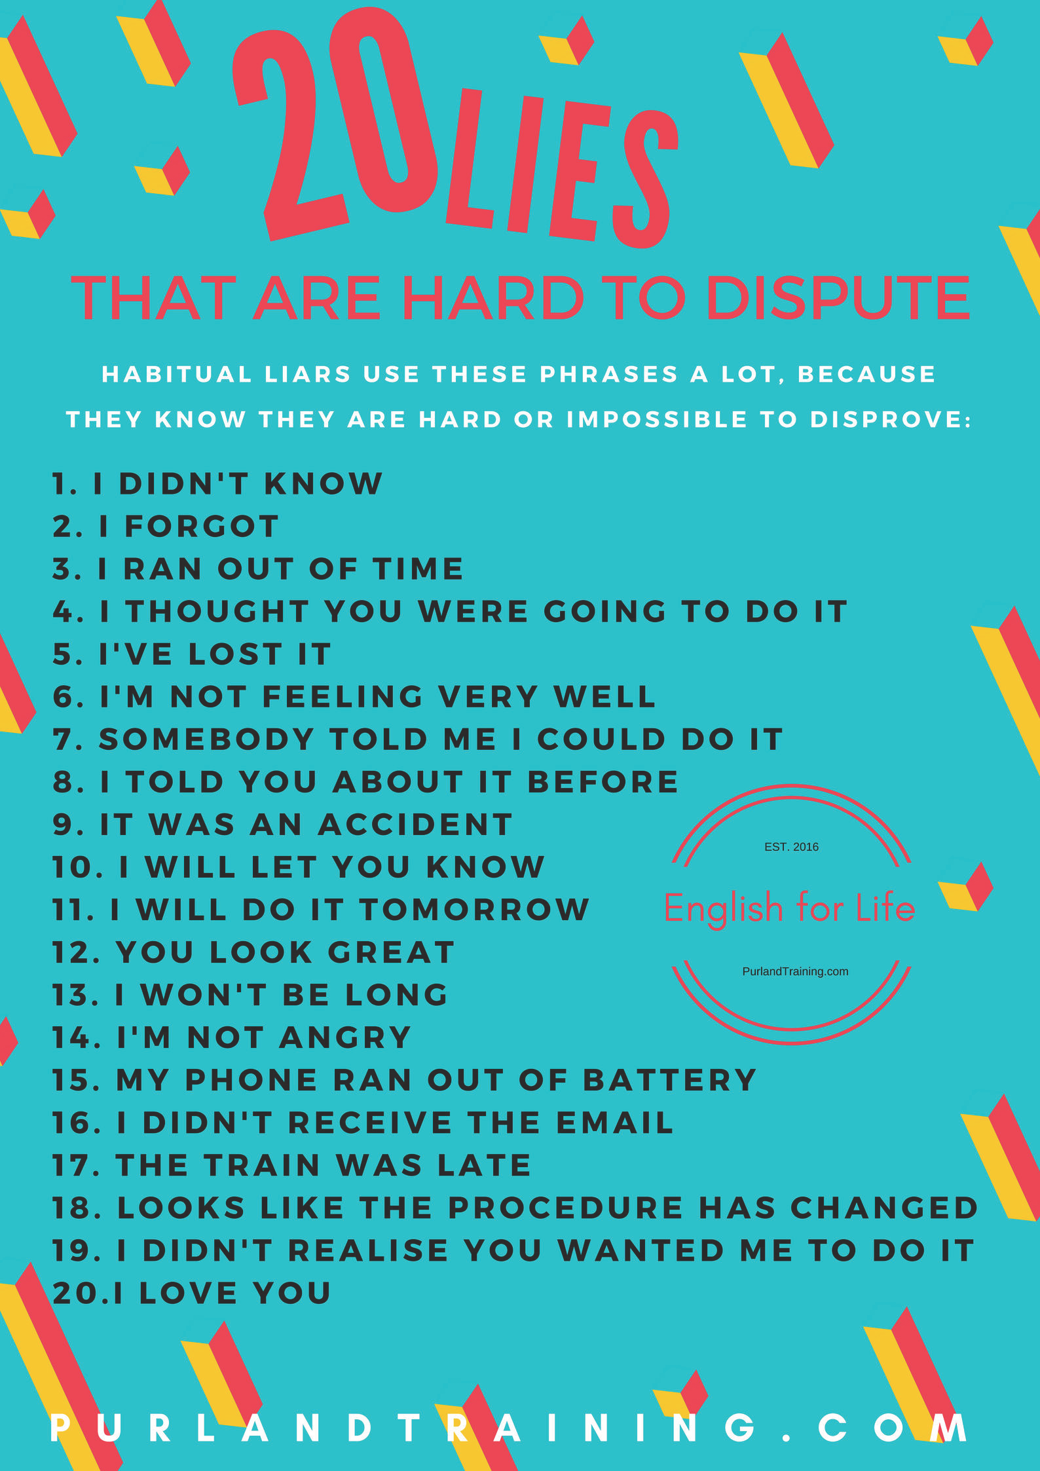

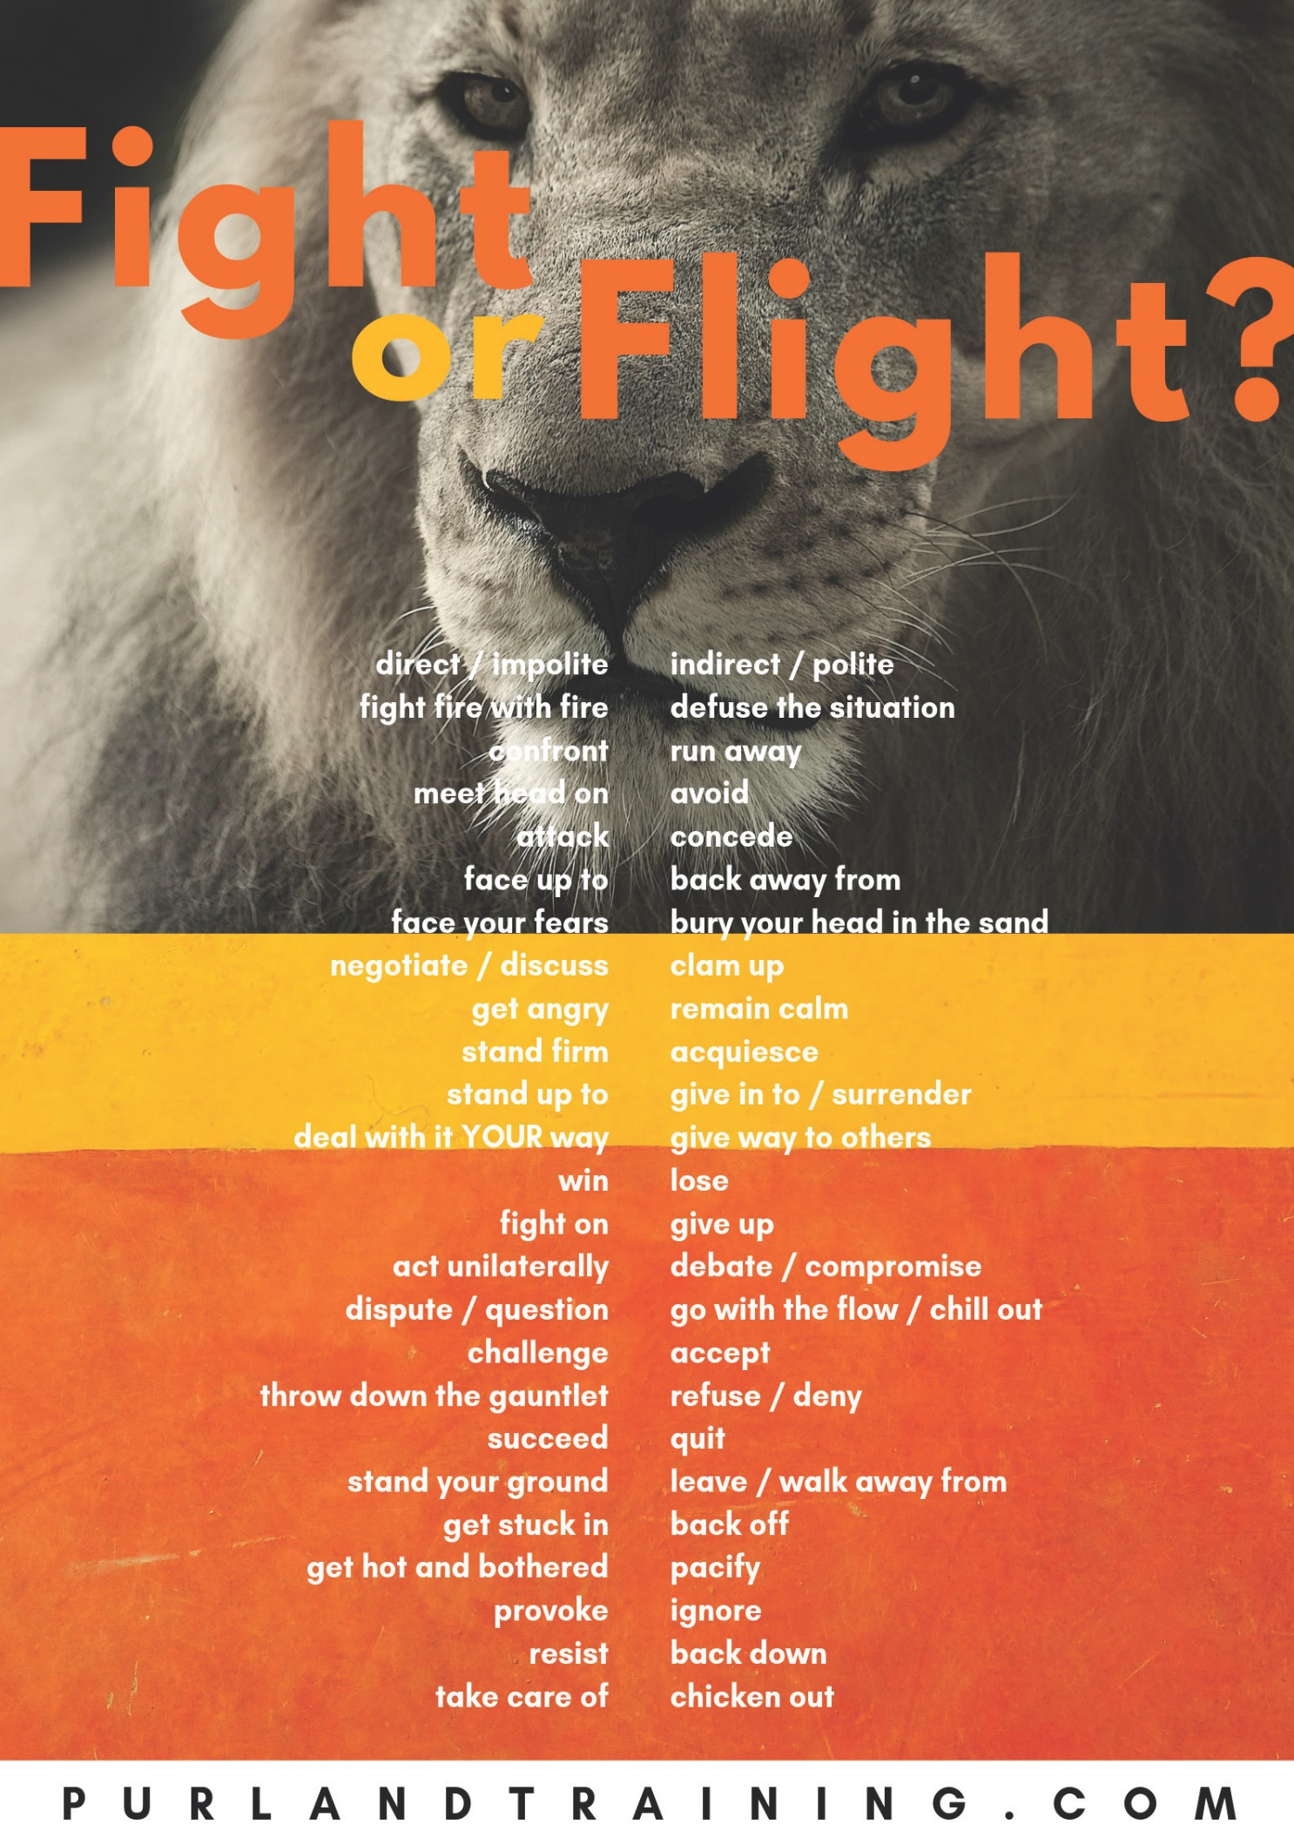

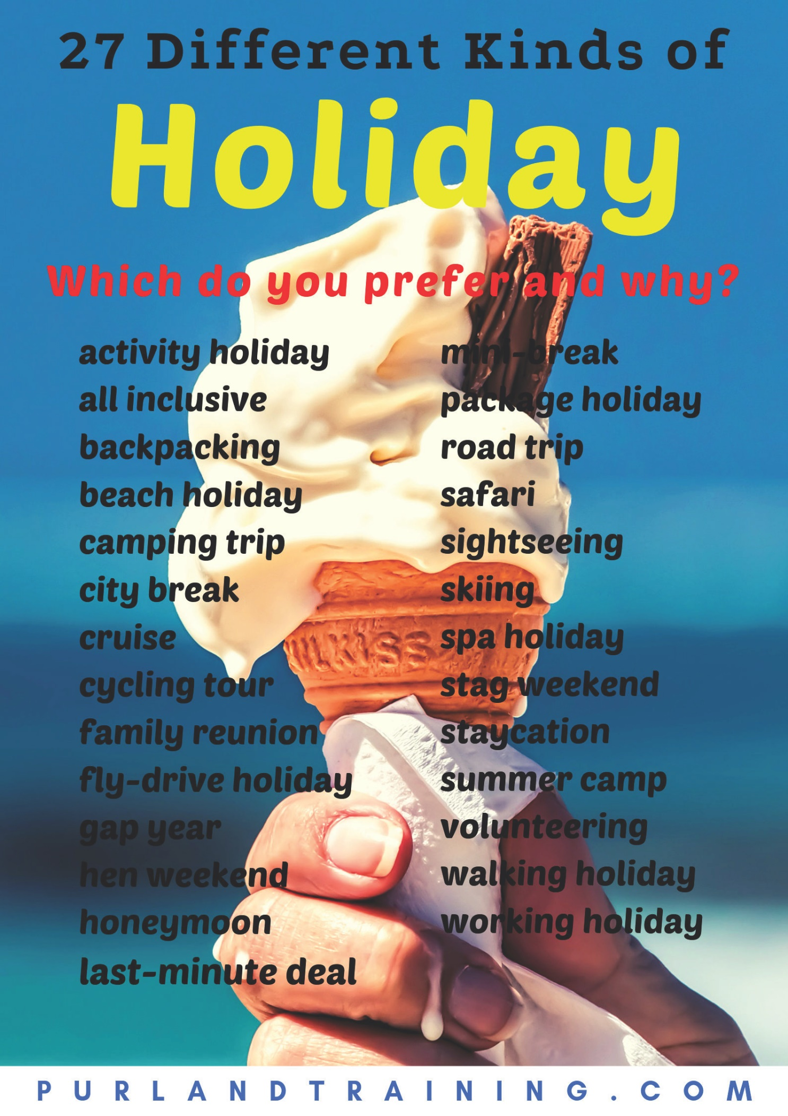

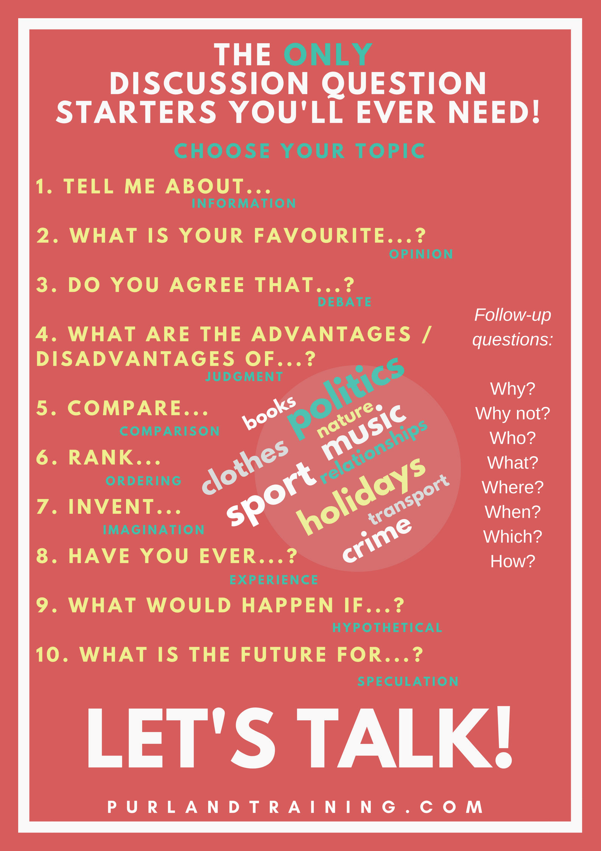

Speaking and Listening Discussion
Follow-up questions:

Why? Why not? Who?
What? Where? When? Which? How?

Discussion Question Starters – Cheat Sheet

Choose a topic and off you go!

General:
- What is…? Tell me about…
- Why do we have…? What do you know about…?
- What do you think of when you hear the word… / see…?
- Have you ever considered…?
- What are the main problems with…?
- What are the three most important facts about…?
- What different kinds of… are there?
Opinion:
- Do you agree or disagree with this quotation…?
- Do you believe that…?
- How important is… to you?
- What are the advantages / disadvantages of…?
- What is your favourite / least favourite…?
- What do you like / dislike the most about…?
- What do you think about…?
- Would you support a proposal to…?
- Would you like to…?
Comparison:
- Compare…
- Name five differences between… and…
- Do you prefer… or…?
Experience:
- Have you ever…? Do you ever…?
- Can you…?
- What do you usually do when…?
- What happens when / if…?
- When was the last time you…?
- What experience do you have of…?
- What is / are… like in other countries, e.g. …?
Hypothetical:
- How would your life be different if…?
- If you were… what would you be?
- If you could be… for one day, what would you do?
- What would life be like without…?
- What would the world be like if…?
- What would happen if…? What would you do if…?
- How would you convince somebody who…?
- If money were no object…?
- Invent your own…
Time perspective:
- How has… changed over the years?
- What are your earliest memories of…?
- How will… be different in the next ten / twenty / fifty years?

PurlandTraining.com

pronunciation

Silent Letters
- Silent letters are letters in words which are not pronounced, e.g. b in lamb and n in autumn. English is not a phonetic language – we do not speak as we write English. There are 48 different sounds in English but only 26 letters in the alphabet, which means that there isn’t one letter to represent each sound. This means that we often need to use digraphs – two letters together which represent either individual vowel or consonant sounds, e.g.

Con.Digraph: | Sound(s): Examples: | Vowel Digraph: | Sound(s): Examples:
ch | k / ch chord / cheese | ai | ei gain, pain, rain, vain
kn | n knee, knight, know | eigh | ai / ei height / eight
ps | s psalm, psychiatrist | oa | eu boat, coat, float, goat
qu | kw quick, quite, quiz | ough | eu / o / or dough / cough / bought
rh | r rhubarb, rhyme, rhythm | ui | i build, guild, guilt, circuit
sc | s muscle, scissors | ue | e guess, guest, parquet
wh | w / h whale, what / whole | ar / er / or | uh popular / teacher / doctor

We could call a in coat or h in what silent letters, because they are not pronounced. However, they are part of recognised spelling patterns (digraphs), which we can learn, so they are not true silent letters. Similarly, words with double letters – such as butter, illness, gorilla, and apple – could be said to contain silent letters. One letter in each is certainly redundant – e.g. the second t in butter – but double consonant letters help us to know how to pronounce words. Double letters usually make the first vowel letter short. For example, compare the pronunciation of biter (long ai sound) and bitter (short i sound).

- There are also words which have vowel letters that are not pronounced, because they are changed to schwa sounds (weak vowel sounds). For example, the first a in amazing is not pronounced as short a but rather as a schwa sound: uh: uh Mei zing. This is due to English word stress. In cinema we pronounce the first vowel letter i as strong short i, while the other two vowel letters become schwa sounds: cinema = Si n m. Does this make the e and a in cinema silent letters? They are still pronounced
– just not as you might expect. So, maybe not.

- True silent letters are letters which appear in words but do not have any connection with them. Below are some good examples. It is worth learning the spellings of these words and practising saying them out loud as you write them (sounding them out):
Silent Letter: Example(s):
b bomb, climb, comb, dumb, lamb, numb, plumb, thumb; plumber; debt, doubt, subtle
d grandson, handkerchief (nd changes to ng sound = assimilation), handsome; Wednesday h honest, honour, hour
l chalk, talk, walk; calf, half; folk, yolk; almond, calm; salmon; could, should, would n autumn, column, solemn; hymn; government
p cupboard, raspberry, receipt
- aisle, Isla, island, isle; chamois, debris
- listen, often, soften; ballet, duvet, haricot; Christmas, mortgage; tsunami

There is a special case with silent e at the end of a word, e.g. time, pale, role, etc. This is called the magic e rule, where the existence of vowel + consonant + e (or another vowel letter) causes the first vowel to be long. So while this e is a silent letter, it has a useful function. This applies to lots of words.

- Silent letters are caused by two main factors. English is an old language dating back to C5th AD and it is rich in vocabulary with over 1m words. As new words have been added over time, the spellings have become fixed by writing and printing them, while pronunciation evolved in a different direction, causing separation of written and spoken English. In the case of many words with silent letters the spelling shows how the word used to be pronounced in the past, when the English language was far more phonetic. For example, In the Middle Ages knight had two syllables and was pronounced with every letter sounded: k Neehht. As new words have been added to English from other languages, the spelling was often retained but the pronunciation was altered to fit our vowel sounds and stress rules. In American English there have been attempts to rationalise the spelling by deleting redundant letters, e.g. letters are dropped from the end of various words: omelette > omelet, programme > program, etc.

- Other silent letters are also useful because they provide a way of telling the difference between
homophones – words that have the same pronunciation, but different meanings and spellings, e.g.

- ad/add
- be/bee
- by/bye
- find/fined
- hart/heart
- hi/high
- hole/whole
- in/inn
- new/knew
- no/know
- nose/knows
- not/knot
- our/hour
- red/read (past)
- to/too/two
- way/weigh

Silent Letters – Exercises

- i) Circle the silent letter(s) in each word:

  - climb
  - cupboard
  - handsome
  - should
  - government
  - two
  - mortgage
  - talk
  - page

ii) Add a silent letter to complete the spelling of each word:

- l i s _ e n
- _ o n e s t
- r a s _ b e r r y
- l a m _
- b e _
- a _ m o n d
- a u t u m _
- i _ l a n d
- a b o v _

- Underline the letter(s) in each word which are pronounced as schwa sounds:

  - teacher
  - amazing
  - another
  - computer
  - popular
  - cinema
  - problem
  - internet
  - particular
  - current
  - nature
  - physical

- Put the following words into categories and circle the silent letter(s) in each word:
cheese rain bottle file guild redder know doubt question grandma fought psychic honest apple weight hotter seat why comb add
Silent letter is part of a consonant digraph: | Silent letter is part of a vowel digraph:
Silent letter is part of a pair of double letters: | True silent letter not connected to the word:
- Discuss the following questions with a partner:
- How phonetic is your first language? Are there silent letters? How did you learn to spell it?
- How difficult is English spelling? Do you feel confident with it? How can you improve?
- Why doesn’t anybody reform English spelling so that it makes sense? What would you do first? What would happen if English were written phonetically – as we speak it?

- Read the story and cross out the incorrect homophone in each pair:
Yesterday I a) red/read a b) finish/Finnish book for an c) our/hour. It was about an d) in/inn which nobody e) nose/knows about. There were f) to/too many boring characters for it to g) be/bee fun, so there was h) no/know i) way/weigh that j) I/eye could finish it. I k) new/knew I
l) wood/would m) find/fined it boring, and it was n) so/sew heavy that it was uncomfortable to
o) hold/holed. I p) told/tolled my friend q) not/knot to bother with it, but to r) by/buy something different instead. He is not s) one/won for t) hi/high culture!

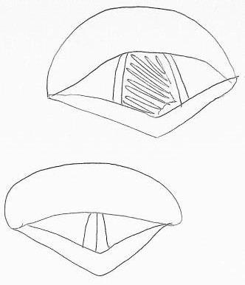
Glottal Stops
glottis open – we can breathe!
A glottal stop is a technique of connected speech. We use it to make our speech sound more fluent. A glottal stop is classed as a consonant sound, but it is really an action – the sudden cutting-off of a vowel sound just after making it, instead of letting it run on. We hear a glottal stop as a short gap in the flow of speech, so it is really the absence of sound – for about a quarter of a second. It happens when we close our glottis (our vocal cords and the opening between them, in the larynx). The air flow is stopped for a brief moment, and the previous sound is cut short – clipped. It is possible to learn to control the glottis – to open and close it. Try holding your breath – you just closed your glottis! The glottal stop is very common in Standard Pronunciation. It is not unique to English, but can be found in many other languages, e.g. Chinese, German, and Arabic.

In Clear Alphabet a glottal stop is written as _ (underscore) which implies that there is something missing (i.e. an unnecessary consonant sound). By using Clear Alphabet we can see this kind of hidden feature of spoken English. With the normal Roman alphabet we can easily forget about the glottal stop, but if we don’t use it our pronunciation is less natural and smooth, and communication is reduced. In IPA glottal stop is written as:
/?/

We make a glottal stop when we want to remove difficult cc sound connections from our speech. A cc sound connection occurs when the final sound of one syllable is consonant and the next sound, from the beginning of the next syllable, is also consonant. For example, “hot day”. We often use a glottal stop after elision. It is important to remember that we do not need to pronounce every letter in English when we speak. Elision occurs when we automatically delete a consonant sound (especially t) from the end of a syllable to make the sound connection easier. For example, in the phrase “a cat was playing”. the t sound in “cat” is automatically deleted by the speaker and replaced with a glottal stop: uh Ka_ w Splei ying. By replacing a consonant sound with a glottal stop, we stop the friction that would have occurred by the meeting of the two consonant sounds. Why can’t we just use elision and not a glottal stop...? It is our habit... If you use only elision without a glottal stop it will sound very odd,
glottis closed – we can eat and speak!
e.g. uh Ka w Splei ying. The rule: if vowel sound + t + con. sound use elision & glottal stop.

It occurs when vowel + t meets another consonant sound, i.e. not when t follows a consonant, e.g. in fast car. In this situation, t is deleted (elision) and s moves forward (FCL): Far Skar. But see also paint pot = Pain_ Pot.There are many common words which will create cc connections when followed by a consonant sound, meaning that you are likely to hear glottal stops quite often:

  - common function words that end with t : not, at, that, what, it just, out
  - contracted negative auxiliary verbs with not: don’t, didn’t, haven’t, won’t, can’t, wouldn’t, etc.
  - common verbs and associated phrasal verbs: get, put, sit, etc.
  - common one-syllable content words that end with t : white, hot, want, wait, etc.

Apart from using glottal stops with elision, we sometimes also use them when we move consonant sounds forward (FCL – Forward Consonant Linking), for example in the phrase “Let’s go”, we move forward s but we are still left with a cc connection, so we delete t and replace it with a glottal stop: Le_ Sgeu.

If you do not use glottal stops, your spoken English will not sound as natural and smooth as it could,
because you are pronouncing too many consonant sounds, especially t and d. This will slow down your speech and mess up the stress pattern and the sound spine. Making a glottal stop is a physical action which can be learned, just like any physical action, e.g. clicking your fingers. Unfortunately, the glottal stop can’t be avoided if you want to speak like a native speaker. It must – and can – be learned and mastered.

Note: in some accents of English, e.g. Estuary English, some people will use a glottal stop even when they don’t need to, e.g. late night = Lei_ Nai_ bottle = Bo_ uhl and better = Be_ uh There is no following consonant sound, but the speaker still uses a glottal stop.

Glottal Stops – Exercises

- Delete the unnecessary consonant sound (elision) in each phrase and underline the place where a glottal stop will occur. Practise saying each phrase out loud using a glottal stop, then say them without glottal stops. What is the difference?

- hot day
- got mail
- not many
- wet grass
- that man
- let them
- don’t worry
- at night

- Choose the correct answer:

  - A glottal stop is… a) a sound in English; b) a very short gap in a sentence
  - Using glottal stops makes our speech sound… a) more fluent; b) less fluent.
  - We use a glottal stop… a) before elision; b) after elision.
  - We usually need to use a glottal stop because of a troublesome… a) t; b) p sound.
  - We… a) can; b) cannot learn to control our glottis manually.

- Write your answers:

- Where is the glottis?

- What do the vocal cords do?
- What can happen when the glottis is open?
- What can happen when the glottis is closed?

- Discussion these questions with your partner or group and teacher:

- Were you aware of the glottal stop in English before this lesson?
- Do you use the glottal stop in your language? What are the similarities and differences in how you use it, compared with English?
- Do you feel confident about using glottal stops in English? If not, why not? How can you improve your glottal stop technique? Are you prepared to practise the technique repeatedly until you have completely mastered it? If not, why not?

- Translate these phrases from Clear Alphabet to the English alphabet. Each one includes one or more glottal stops. Practise saying each phrase out loud with a glottal stop:

- Pe_ Ka_ wz...
- Ho_ Dei_
- Si_ Daun
- No_ t Dei
- Nai_ nai_, Jon
- ai Weun_ Geu

- Delete the unnecessary consonant sound(s) (elision) in each sentence and underline the place where a glottal stop will occur. Practise saying each sentence out loud using glottal stops where necessary. Say them without glottal stops. What is the difference?

- Our cat got put down.
- Can you vote for me?
- Kate wrote a short note.
- Bart bought some light wheat.
- We ate out late last night.
- The boat house needs a paint job.
- It’s Pat’s mate’s pet dog Pete, dad.
- No, it’s not Pat’s mate’s pet!

- a) Find twenty one-syllable words ending in t (sound) in the word search. b) Write five sentences with the words and practise saying them out loud, including glottal stops:

t | n | o | t | h | w | a | i | t | u | p | o
e | t | t | t | i | a | o | a | t | e | h | t
e | e | h | a | w | h | a | t | t | c | e | h
m | t | a | e | f | o | o | t | e | a | a | g
t | i | t | m | i | g | h | t | i | t | r | u
p | k | e | t | g | e | t | a | o | b | t | o
t | e | l | w | h | i | t | e | t | e | g | b

Intonation

- In short, intonation means the ups and downs of the voice in a sentence. Good pronunciation involves three elements: sentence stress (the sound spine), connected speech (connecting syllables, not speaking word by word), and intonation. Varied intonation is more interesting than robotic, monotonous speech, and therefore easier and more appealing to listen to. For example, when reading aloud we should aim to “lift the words from the page” using intonation, rather than reading in a flat boring voice.

Stress is non-negotiable – the sound spine must be heard clearly – and connected speech is a must if you want to sound natural. But stress and connected speech are not enough – we need to use intonation. For example, we could have correct stress and connected speech, but still sound flat, dull, and emotionless. Without hearing emotion we cannot be sure of the speaker’s intention. English intonation is more familiar to speakers of some languages than others, e.g. European students of English may find English intonation patterns more familiar than speakers from the Middle East or the Far East. However, many non-English speakers of English would agree that English intonation (and stress) seem “too much” – too exaggerated – when compared with their language.

- Let’s say that we are clear about the sound spine of our sentence and we are using connected speech. What about intonation? Standard (neutral) intonation in a statement (not a question) usually involves going on a journey: up the mountain and back down again. We usually go up around the middle of the sentence, and back down at the end. We must have closure. Let’s take an example of a short sentence. We go up in the middle, either:

a) at a clause break, e.g.
I went to the post office, because I needed to buy stamps.

or b) on the key concept word, e.g.
I met my friend in the park. (“friend” is the key concept word – it is the main point of the sentence)

In a longer sentence, or a list, there will be more ups and downs. We have to decide which specific words or phrases are the most important in our communication. By “going up” on them we give them emphasis, e.g.
I met my friend with his aunt and brother in the park.

- Intonation in questions usually depends on the kind of question:
  - For yes/no questions – we go up at the end (rising intonation). The listener feels compelled to answer, because we need closure. For example,
Do you want a lift home?

  - For wh- questions (what, where, when, etc.) – we go down at the end (falling intonation). For example: Where has Tony gone?
  - When the speaker uses a question tag, they can go up if they want to check some information, e.g.
The concert starts at eight, doesn’t it?

  - ...and down if they are making a general statement and believe that the listener will agree, e.g.
We’ve had a lovely day, haven’t we?

We can add extra emphasis when replying to questions, depending on what part of the sentence the speaker asked about. In the sentence below there are seven possible wh- questions that could be asked.

John rode his bike to the city lake quickly yesterday, because he was late.
who | what – action | what – object | where, which | how | when | why

For example, if somebody asked: “Who rode their bike to the city lake?” you could put extra emphasis on the name in the answer, by going up on the word “John”: John rode his bike to the city lake. or John did.

Other intonation techniques include:

- Rising intonation at the end of a statement when we want to continue without being interrupted, e.g.
I wanted to get some rice at the supermarket. You know, the one on the corner. And it was closed, so...

- When making a list we use rising-falling intonation, e.g.
Jennifer bought a pencil, a pencil sharpener, some pens, a ruler, and a new bag for school.

Be sure to get that closure at the end!

Function words are usually unstressed in standard English pronunciation, but we can use intonation to give them extra emphasis – to make our point. Each function word has a strong form and a weak form, so we can use the strong form if we want to emphasise that word. For example, the weak form of the auxiliary verb “have” is uhv, while the strong form is Hav – i.e. we hear the strong vowel sound a in the strong form, but in the weak form it is reduced to a schwa sound. Here is a sentence with neutral (normal, standard) intonation:
I’ve finished doing my homework. (general statement – note the normal rise and fall)

...while here is the same sentence but with specific intonation:
I have finished doing my homework. (I’m confirming the news that my homework is finished – stop nagging!)

- Another important use of intonation is to show mood, which helps to express intention and meaning. There are several invaluable tools in the intonation toolbox and each one is adjusted to convey mood, for example:

tone of voice | pitch | extra emphasis on content words | volume | rhythm | speed | pausing (for effect)
angry | higher | yes | louder | intact | faster | yes
sad | lower | no | quieter | broken | slower | no

...and so on. An emotion like anger is a high-energy emotion and the speaker demands that the listener hears them clearly. The intonation toolbox enables this. On the other hand, sadness is a low-energy emotion and the speaker may be less focused on whether anybody is listening. The intonation tools used reflects this intention.

Of course, tone also depends on the personality of the individual person. For example, each person will “sound upset” in a different way. Furthermore, some people – typically men – will have a lower pitch range than others – typically women and children.

- There are a number of short words and sounds that change their meanings completely depending on the intonation. If we do not use intonation, or use the wrong kind, our meaning might not be clear and communication may fail. For example:

sound / word: | rising | flat | falling | rising-falling
oh | I’m interested | I’m annoyed | I’m disappointed | I understand at last
OK | Do you agree? | I’m frustrated / stop talking | I accept something | I’m happy to agree
yes | Tell me more / Can I help? | Please stop talking | I agree /  I accept something | I strongly agree / sarcasm
no | I didn’t know that | Refusal –no discussion | Standard negative reply | It’s fine / I don’t mind

Intonation – Exercises
- What is... a) sentence stress, b) connected speech, c) intonation?
- Draw the clause break in each sentence and draw intonation arrows in each:

  - I left early because I didn’t like the film.

  - It was past ten o’clock, so we had to go.

  - Jim bought some cornflakes and a pie.

  - The book was good at first, then boring.

- Listen* to four sentences and underline the key concept word or phrase in each one:

  - I got the tube to work today.
  - She left her brother at home.

  - There are three biscuits left.
  - I can’t find the remote control.

- Draw arrows to show standard intonation in each question:
  - Do you like raw fish?

  - We both enjoyed the gig, didn’t we?

  - This is the right bus, isn’t it?

  - What’s the date today?

- Listen* to four questions. Match each question to an answer below:

  - Perry did.
  - Red.
  - Yes, he did.
  - Last week.

- Write the tools in the intonation toolbox from the first letters:

  - t _ of v _
  - r _

  - e _ e _
  - p_ for e_

  - p _
  - s _

  - v _

- Listen* to the sentence read with different moods. Match each version to a mood below:

  - angry
  - happy

  - excited
  - sad

  - relieved
  - apologetic

- Complete the table to show what happens with four different moods. Write and read your own sentences out loud using the different moods:

tone of voice | pitch | extra emphasis on content words | volume | rhythm | speed | pausing (for effect)
nervous
surprised
tired
disgusted

- Read each sentence out loud with neutral intonation, then in different moods, e.g. happy, sad, nervous, etc. Which tools from the intonation toolbox did you use to make each mood?

  - I’ve gone to the shops.
  - He lived in Birmingham all his life.
  - There are two sausages left in the oven.
  - The garden needs watering.

- i) Listen* and match each short sound or word with a meaning below:

  - I’m interested.
  - I’m disappointed.

  - I understand.
  - It smells delicious.

  - Stop! Come back!
  - Thinking what to say.

ii) Create a role play using only short sounds, intonation, and mime.

- Discussion: How does your language compare to English when it comes to stress and intonation? Do you think there is too much of this in English? What short sounds do you use in your language, and what do they mean? List ones which are the same as in English. List ones which are different.

*Access the recordings here:
https://purlandtraining.com/free-lessons/elementary-english-course/unit-3-0-health-and-the-human-body/lesson-3-3-intonation/

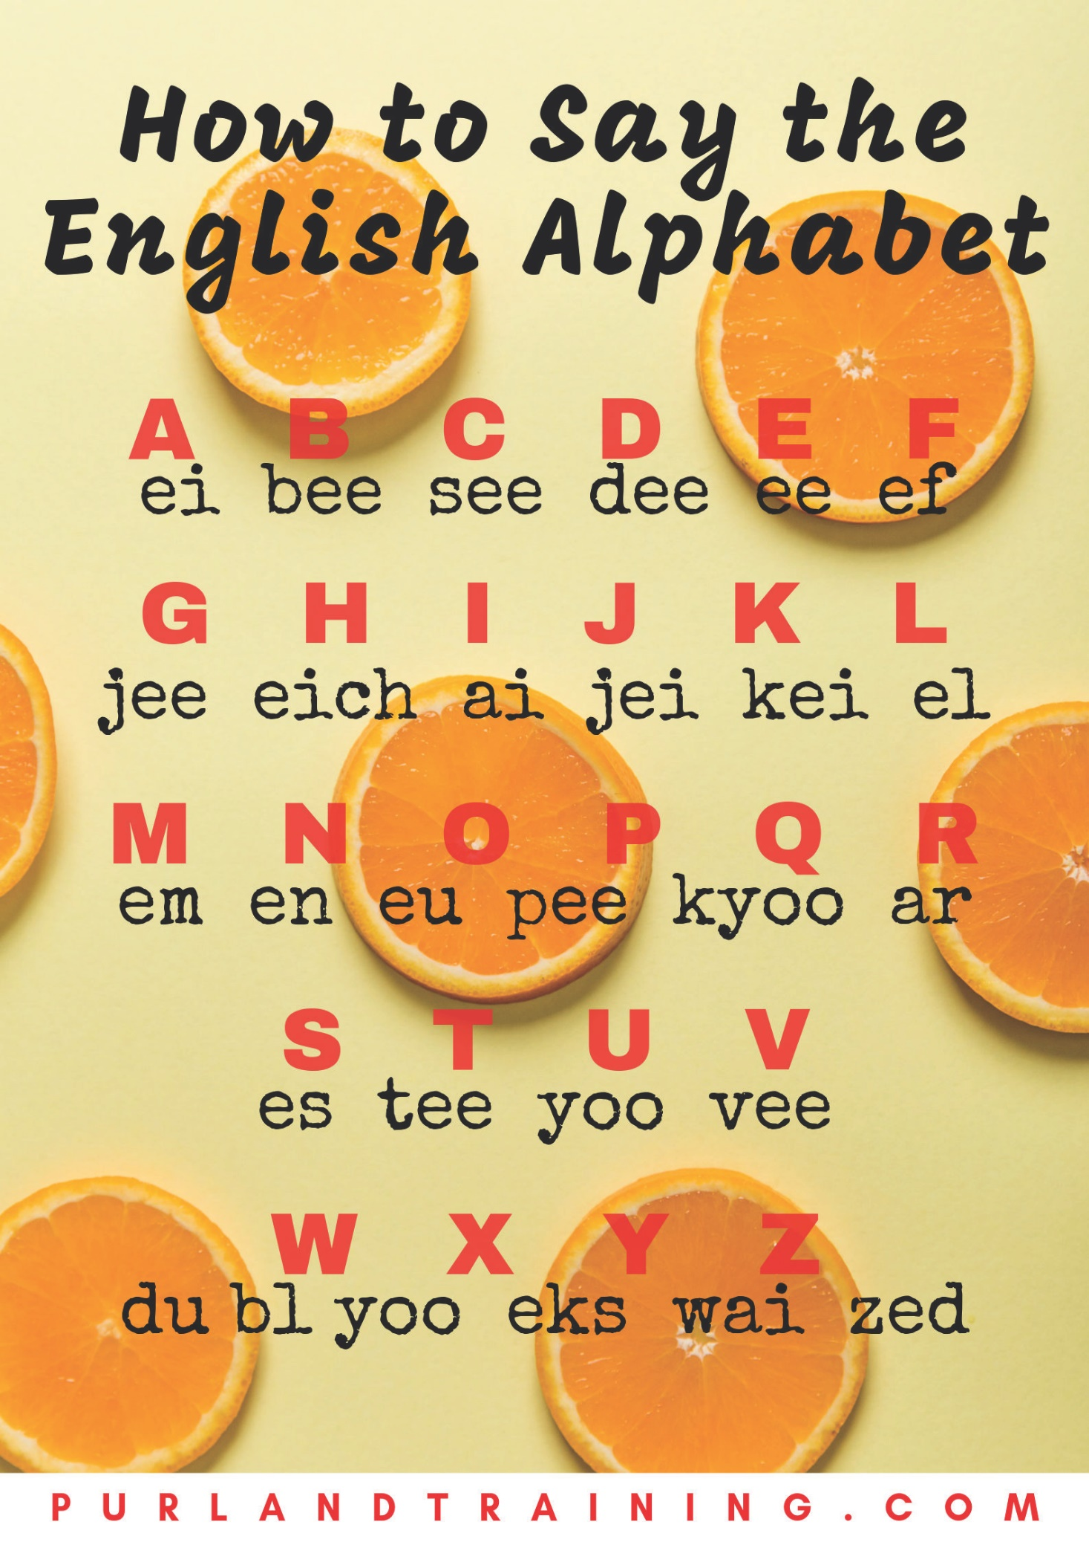

PurlandTraining.com

writing

Writing Creative Writing

Story Planning – My Life Without…

You’re going to write a newspaper or magazine article of around 200-300 words.

    - Choose a profession, a thing that starts with the first letter of that profession, and a time period, then fill in the gaps in the sentence below:
The who lived without for .
For example: The teacher who lived without tyres for a year.

    - Plan your story by answering the following questions. You can write in the first person (about yourself) or third person (about somebody else). Use this page to make notes, then write your story on the next page:
The situation now:

Future possibilities:

1.
2.
3.
EVENTS:

HOW?

WHY?

WHEN?

WHERE?

WHO?

    - When you have finished your text, check it for errors and make corrections.

    - Write ten comprehension questions based on your story, with answers, e.g. ‘Where did x
live?’ ‘In Ely.’ Share your quiz with another student. Check their work*.

    - Write ten true / false / don’t know statements based on your story, with answers, e.g. ‘Jo lived in Ely.’ ‘True.’ Share your quiz with another student. Check their work*.

    - Work with another student to produce a short role play based on one – or both – of your stories. Perform it for the rest of the class.

*Another option: students all put their finished stories in a box and each takes out a different story, writes the questions as in 4. and 5., then gives the text and quizzes to another student (not the original author).

PurlandTraining.com

answers to worksheets and notes for use

Grammar

- Look at those beautiful mountains. (D) Example of words that helped: ‘Look’ means that I’m pointing something out; ‘mountains’ – if you can see mountains, plural, they are not near, so we use ‘those’. 2. this (P). 3. this (D), that (P). 4. that (P). 5. That (D). 6. this (D), that (D). 7. These (P), those (P). 8. this (P), this (P). 9. this (D). 10. that (P). 11. those (D). 12. those (P). 13. This (P).
14. these (D). 15. This (P). 16. these (D), those (P). 17. this (D). 18. That (P). 19. that (P). 20. That (P).

- Those classes (D) began two months ago. Example of words that helped: ‘began two months ago’ – the time is not near; it is finished time (past simple), and ‘classes’ is plural, so we use ‘those’.
2. That (P). 3. This (P). 4. this (D). 5. these (D). 6. this (D). 7. This (P). 8. Those (D). 9. that (D). 10. that (P). 11. this (D). 12. That (P). 13. this (D). 14. That (D). 15. These (D). 16. These (P).
17. Those (P). 18. that (D). 19. These (P). 20. These (D).

- 1. PrS C. 2. PrC C. 3. PrS F. 4. PrS J. 5. PrS A. 6. PrC A. 7. PrS E. 8. PrC J. 9. PrC B.
10. PrS H. 11. PrC D. 12. PrS D. 13. PrC F. 14. PrC G. 15. PrS I. 16. PrC H. 17. PrS B.
18. PrC E. 19. PrC I. 20. PrS G.

- 1. PrC J. 2. PrS B. 3. PrC G. 4. PrC H. 5. PrS E. 6. PrC E. 7. PrS A. 8. PrS F. 9. PrC F.
10. PrC C. 11. PrS D. 12. PrS C. 13. PrS J. 14. PrC D. 15. PrC B. 16. PrS G. 17. PrS H.
18. PrC A. 19. PrS I. 20. PrC I.

- Answers will vary.

14 1. a). 2. b). 3. a). 4. b). 5. b). 6. a), b), c). 7. b). 8. a). 9. a), b). 10. d). 11. a), c). 12. d).
13. c). 14. d). 15. d).

- Answers will vary. Sample answers: 1. By four o’clock Tim will have been working for four hours. (Use 1.) 2. By the time I retire I will have been living here for twenty years. (Use 2.) 3. By then Betty will have been running for forty minutes, so she will be tired. (Use 5.) 4. By that point our parents will have been driving for five hours. (Use 1.) 5. Before you get there, I’m sure Mary will have been watching TV all afternoon. (Use 4.) 6. On Monday he will have been representing our company for five years. (Use 2.) 7. At ten pm he will have been waiting on hold for more than half an hour. (Use 3.)
8. In May Billie will have been working here for two years, which means she should get a pay rise. (Use 5.) 9. When the bell rings, we will have been studying for an hour. (Use 1.) 10. If the bus doesn’t arrive in the next five minutes, we will have been standing here for fifteen minutes. (Use 3.)
11. Yesterday I reckon Michael will have been cooking for about an hour. (Use 4.) 12. We will have been waiting at the bar for ten minutes. (Use 3.)

- 1. get. 2. look. 3. revise. 4. go. 5. hurry up. 6. lost. 7. met. 8. applied. 9. give. 10. failed.
11. worked. 12. been. 13. had. 14. crashed. 15. brought. 16. love. 17. fall. 18. mess about.
19. boils. 20. drink.

- 1. buy. 2. take. 3. come. 4. drop. 5. ask. 6. was / were. 7. become. 8. earn. 9. join. 10. ride.
11. fixed. 12. got. 13. eaten. 14. moved. 15. lost. 16. sit. 17. do. 18. build. 19. leave. 20. snows.

- Answers will vary. Sample answers: 1. check in. 2. save. 3. want. 4. watch. 5. put. 6. wash. 7. go. 8. get. 9. sell. 10. put. 11. get. 12. liked. 13. travel. 14. go. 15. gave. 16. go. 17. were.

18. wear. 19. broke up. 20. go out. 21. followed. 22. been. 23. looked after. 24. quit. 25. come.
26. missed. 27. worn. 28. had. 29. had. 30. looked. 31. get. 32. take. 33. wake up. 34. feel.
35. is. 36. go. 37. think. 38. are. 39. starts. 40. find.

- Answers will vary. Sample answers: 1. cut. 2. put out. 3. need. 4. call. 5. get up. 6. be. 7. call.
8. mend. 9. pay. 10. cut off. 11. had. 12. join. 13. was / were. 14. live. 15. went. 16. talk. 17. tried.
18. be. 19. invited. 20. give. 21. broken. 22. been. 23. felt. 24. had. 25. scored. 26. reached.
27. loved. 28. been. 29. remembered. 30. paid. 31. comes. 32. play. 33. brush. 34. feel. 35. is.
36. ask. 37. tidied. 38. gets. 39. make. 40. sing.

- Answers will vary.

- Answers will vary. Sample answers:

1. = 2. If my son invites four of his mates to join his Simply Red tribute band, but after two weeks three of them quit due to ‘musical differences’, how many go on tour?
1 + 4 - 3

2. 8 + 2 - 5 = 5. If eight apples fall from a tree in our garden, followed by two more, but then a roaming goat eats five of them, how many apples are in my fruit bowl?

24 1. a) There are two trees in the garden. b) There’s a good programme on TV. c) There is too much information. d) There is a lot of people here. e) There is a lot of traffic today. f) There’s something I want to tell you. g) There is some meat in the fridge. h) There is a new printer in the office. i) There must be a bigger plate. j) There isn’t anything to do here.

- a) was. b) will not / won’t. c) Are / Were. d) are, was. e) Is, Was. f) have been.

- i) a) There aren’t many biscuits left in the jar. b) There has been a lot of bad weather lately.
c) There’ll be an important meeting tomorrow. d) Is there any reason why you are late today?

- Answers will vary. Sample answers:

There is a book on the table in the office.

There are two pencils in the pencil case, but they are not mine. There is a laptop in the hall which belongs to my grandpa.
- a) There is a guy in my class from Brazil who is really friendly.
- There will be a vacancy in personnel where you want to work.
- There are some sweets in the cupboard in the kitchen.

4. a) 3). b) 4). c) 1). d) 2).

26 1. countable nouns: road, hat, hamburger; uncountable nouns: cotton, sand, butter; both: power, chocolate, pizza, pepper, rule, football.

- a) pasta. b) coffee. c) sugar. d) rain. e) salad. f) plastic. g) cheese. h) happiness. i) homework.

- There is a book on th table. There is some music on the radio. There isn’t any cheese in the fridge. There’s some money in my purse. There is an apple in the basket. There is some milk in that glass. There’s a programme about fish. Is there any snow outside?

- a) bowl. b) jar. c) game. d) tube. e) plate. f) gust. g) bottle. h) slice.

- a) a slice of bread. b) 2 tubs of ice cream. c) 2 pieces / packs / sticks of gum. d) a piece of cake.
e) a jar of coffee. f) 3 jars of honey. g) a bag of sugar. h) a tin of beans.

- a) a. b) zero article. c) zero article. d) an. e) a. f) an.

- a) The gum was stuck to the desk. b) Correct. c) Correct (past simple). d) The rice is coming to the boil.

- a) a little. b) a little. c) much. d) a few. e) many. f) any.

28 1. i) a) lovely. b) soft. c) younger. d) great.
ii) a) small. b) cold. c) far. d) nasty. e) ugly. f) dirty. g) loud. h) weak.

- a) a beautiful wooden doll. b) an old blue car. c) a priceless Swedish clock. d) an expensive Australian cricket bat. e) smelly round yellow cheeses. f) a tall middle-aged woman. g) my favourite brown jacket. h) a huge square leather folder.

- a) My dog is bigger than yours. b) No, my dog is bigger / the biggest. c) But mine is the most beautiful. d) No, mine is more beautiful that yours. e) Your dog is worse / the worst. f) No, mine is better / the best. g) OK, let’s say mine is nice / the nicest. h) And mine is the strongest / stronger than yours.

- i)

Adjective: | Verb: | Noun: | Adverb:
good | None | a) good / goodness | b) well
exciting | c) excite | d) excitement | e) excitedly
hot | f) heat | g) heat | h) hotly
safe | None | i) safety | j) safely
short | k) shorten | l) shortness | m) shortly
wonderful | n) wonder | o) wonder | p) wonderfully

ii) a) boring. b) excited. c) disgusting. d) annoying. e) amazing. f) surprised. g) interesting. h) tired.

- a) freezing. b) hilarious. c) ancient. d) silent. e) priceless. f) lovely. g) packed. h) unforgettable.

30 Answers will vary. For sample answers, see p.29.

32 Answers will vary. Sample answers: (error # in brackets.)

Ex. 1: 1. I want all the cakes. (2.) 2. I waited all morning. (2.) 3. Everybody is very busy. (3.) 4. We
ate all three apples. (1.) 5. Everybody is very busy. (3.) 6. It has been raining all morning. (1 & 2.) 7. I waited all my life. (2.) 8. He ate a whole apple. (4.) 9. I waited the whole morning. (1.) 10. He listened to all the music. (1.)

Ex. 2: 1. I waited my whole life. (1.) 2. It’s been raining all day. (4.) 3. A whole day went by as I waited for her text. (4.) 4. We ate three whole apples. (2.) 5. I waited all my life. (1.) 6. The whole apple has gone. (2.) 7. It has been raining the whole day. (1 & 2.) 8. We ate three whole apples. (2.)
9. I have eaten all the spaghetti. (2.) 10. We put everything in the car. (2.)

Ex 3: 1. Everybody is very busy. (3.) 2. She has drunk the whole bottle of juice. (5.) 3. He has eaten two whole apples. (Correct.) 4. I ate the whole cake. (1.) 5. It rained all day on Friday. (Correct.)
6. We watched the whole concert. (Correct.) 7. I waited my whole life. (1 & 2.) 8. We all missed the bus. (Correct.) 9. I want all the cakes. (1.) 10. Everybody finished work and went home. (Correct.)

Ex. 4: 1. I ate all the cakes. (Correct.) 2. I cooked all the pasta. (1.) 3. I’ve lived in Bournemouth all my life. (Correct.) 4. I have waited for this moment my whole life. (4.) 5. I ate all of the / my cake. (1 & 2.) 6. We ate three whole apples. (4.) 7. I ate the whole cake. (Correct.) 8. I have waited for this moment my whole life. (1.) 9. We went to England for three whole days. (Correct.) 10. We had three whole puddings. (Correct.)

35 Answers will vary. For sample answers, see p.34 and also below:

+ They would walk home by the river every Friday.
1. Past:
- They would not (wouldn’t) walk home by the river every Friday.
c) used to ? Would they walk home by the river every Friday?

- 1. You can take a book if you need to take a book. (6, 4.) 2. I have never been to Peru. (2.)
3. The last science-fiction film that I saw was the science fiction film with the blue people in the science fiction film. (2, 5, 5.) 4. Can we talk later? Will that be OK? (6, 7.) 5. The agreement that we reached was unacceptable. (2.) 6. After Jody had spent time reading the report, Jody concluded that reading the report had been a waste of time for Jody. (3, 5, 1, 5.) 7. I did not want to attend the meeting, but Jack forced me to attend the meeting. (1, 4, 4.) 8. I must wash my hair, get dressed, then eat breakfast and leave by 8 o’clock. (11.) 9. Would you like a cup of tea, Natalie? (7.) 10. The main character of the novel is called The Amazing Sombrero. (10.) 11. Dan saw a fox when Dan was out running. (5, 3.) 12. Did you find the car keys? (8.) 13. “Has the bus gone?” “Yes, the bus has just gone.” (8, 7.) 14. Talks to find a new deal for the manager of City Football Club have failed. (10.) 15. The book that I needed was not available. (2, 1.)

- 1. He is going to finish watering the plants later. (1.) 2. Would you put the vase on the table where the kids cannot break the vase. (6, 1, 5.) 3. The map which we have been using is the wrong map. (2, 1, 5.) 4. Do you want a break? (7.) 5. Are you coming with us? (8.) 6. When I am out shopping, I always look for bargains. (3.) 7. Fears about the giraffe that has got lost in Chicago have increased. (10.) 8. The hotel room is ready to use when you want to use the hotel room. (4.)
9. Mike said that he was busy, so I did not invite Mike. (2, 1, 5.) 10. A new striker called Mark Collins has signed a two-year contract with Bradley City Football Club. (10.) 11. You ought to contact the other players and tell the other players about the match. (6, 5.) 12. “Hi, my name is Dave.” “Hello, my name is Paul.” “It is nice to meet you.” (7, 7, 8.) 13. “Was she late?” “No, she was not late.” (9.) 14. You ought to try the anchovies. Mmm! The anchovies are so divine. (6, 5, 8.)
15. Tomorrow I will have to leave work by 2 o’clock, have a quick change, then race to my mum’s
house, and try to be home before it gets dark. (11.)

- Answers will vary. Sample answers:

- a) We have our carpet cleaned (by a specialist) once a month. b) I’m getting my tax return done (by my accountant) next week. c) Jane had her portrait painted (by an artist) yesterday. d) They were having their piano tuned (by a piano tuner) earlier on. e) I’m going to get my package delivered (by courier) tomorrow.

- f) They have had a designer create the wedding dress just for them. g) We can have the doctor make an appointment at the hospital for you. h) Have the plumber fix that leaky tap immediately! i) If we have the electrician check our boiler, it will be much safer! j) If I had a dietician create an eating plan, I might lose more weight!

- k) I might get the bakery to make Terry’s birthday cake. l) We’d got the builder to fix the wall, but then the roof collapsed. m) If I’d got the vet to look at my rabbit earlier, he might’ve saved him. n) If we get our neighbour’s gardener to cut the grass, he always does a really good job. o) Jan will have got the mechanic to fix her car by the end of the day.

- Answers will vary. Sample answers:

- a) We always have our bouquets made professionally (by the florist). b) I’m having my hair cut (by the hairdresser) tomorrow morning. c) We had our house valued (by the estate agent). d) Ivan was having his essay checked (by his tutor). e) I’m going to get my sports injury treated (by a physiotherapist).

- f) We have had lawyers consider his case on a number of occasions. g) I could have the tattooist create a floral pattern on your arm. h) Have the window cleaner do all the windows please! i) If I have the car wash guys clean my car, will it be worth paying £8? j) If I had my neighbour look after my parakeet I could go on holiday.

- k) You should get the chiropodist to examine your feet. l) I’d got that pizza place to reserve a table for us at 8pm. m) If I’d got the travel agent to book the tickets, I would have saved time. n) If we get Alan to organise the meeting, it always goes wrong! o) She must have got the beautician to paint her nails by now!

Vocabulary
46 1. a) It’s eleven forty. / It’s twenty to twelve. b) It’s ten fifteen. / It’s quarter past ten. c) It’s seven fifty-five. / It’s five to eight. d) It’s three twelve. / It’s twelve minutes past three. e) It’s nine forty. / It’s twenty to ten. f) It’s one fifty-five. / It’s five to two. g) It’s twelve o’clock / midday / midnight. h) It’s four oh four. / It’s four minutes past four.

2. a) 14:15. b) 16.35. c) 01:10. d) 22:20. e) 18:48. f) 10:08. g) 21:30. h) 00:00.

- Answers will vary. Sample answers: a) It’s ten to one. b) It’s quarter past three. c) It’s four minutes past eight. d) It’s ten o’clock. e) It’s half past nine. f) It’s five past ten. g) It’s two forty. h) It’s twenty- eight minutes past seven.

- 1. second. 2. minute. 3. hour. 4. day. 5. weekend. 6. week. 7. fortnight. 8. month. 9. quarter.
10. year. 11. leap year. 12. decade. 13. generation. 14. century. 15. millennium.

5. 1. i). 2. j). 3. a) 4. b) 5. h) 6. f). 7. g) 8. c) 9. e) 10. d).

- a) at. b) o’clock. c) on. d) be on time. e) spend. f) on. g) at. h) to / past. i) have. j) a whale of a time.
k) killing. l) wasting. m) weekend / Sunday.

- a) in. b) on. c) in. d) at. e) on. f) on. g) in. h) on. i) at. j) at. k) at. l) in.

- a) ten to six. b) seven o’clock. c) two eighteen. d) four fifteen. e) quarter to one. f) eleven oh four.
g) three am. h) half past eight.

48 1. i) a) My brother’s name is Adam. b) He’s six years old. c) Sarah is a teacher. d) Paul is a 26 year-old vet. e) My mum is called Theresa. f) Brian is a Belgian soldier. g) He lives in Nepal. h) She works at the town hall.

ii) a) – g). b) – e). c) – h). d) – f).

- i) Answers will vary. ii) Answers will vary. iii) a) False. b) We don’t know. c) We don’t know.
d) False. e) True. f) False. g) False. h) False. i) True. j) True.

- i) brave (C) generous (C) dishonest (C) moody (P) positive (P) reliable (C) quiet (P) open (P) friendly (P). ii) Answers will vary. Sample answers: a) every day. b) Last month. c) for five years.
d) Next week. e) two months ago.

63 1. rambunctious. 2. homogenous. 3. capacious. 4. precocious. 5. incongruous. 6. nebulous.
7. pernicious. 8. copious. 9. acrimonious. 10. salacious. 11. injudicious. 12. lugubrious.
13. supercilious. 14. vivacious. 15. fatuous. 16. autonomous. 17. tumultuous. 18. specious.
19. egregious. 20. surreptitious.

66 1. meretricious. 2. pugnacious. 3. garrulous. 4. impetuous. 5. parlous. 6. cantankerous.
7. splendiferous. 8. obsequious. 9. contiguous. 10. efficacious. 11. sagacious. 12. ludicrous.
13. anomalous. 14. perfidious. 15. bumptious. 16. salubrious. 17. disingenuous. 18. tortuous.
19. hazardous. 20. parsimonious.

68 A. 1. g) 2. j) 3. e) 4. i) 5. a) 6. h) 7. d) 8. c) 9. f) 10. b). B. Answers will vary.

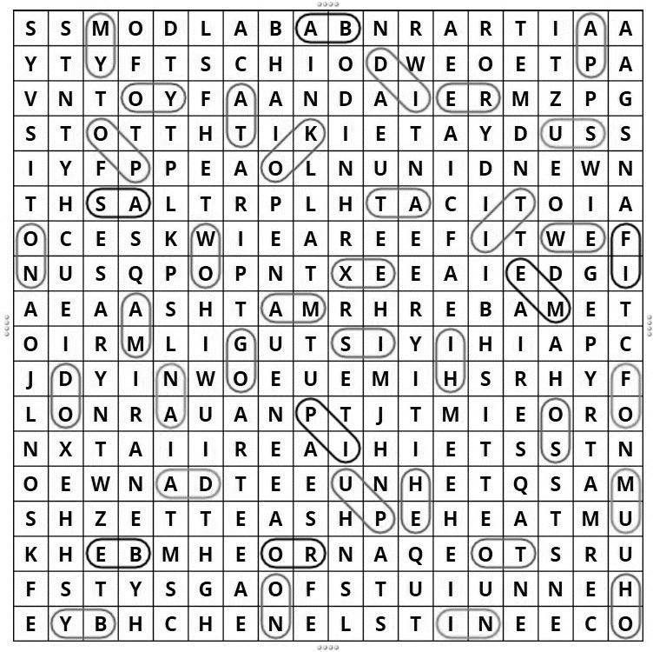
69

71 Players: 11. commit a foul. 14. defend your area. 18. kick the ball. 22. pass the ball. 26. save a goal. 27. score a goal. 33. sprint a hundred metres. 35. tackle an opponent. 36. take a penalty.
39. warm up before going on.

Referees: 4. award a penalty. 5. blow a whistle. 13. confer with other officials. 15. enforce the rules. 16. examine the VAR footage. 23. penalise a player. 24. preside over a game. 29. send off a player. 30. show a yellow or red card. 38. toss a coin.

Supporters: 1. advise the manager on tactics. 3. attend matches. 7. buy a season ticket. 8. cause trouble with rival fans. 9. check match results. 10. cheer on the players. 12. complain about everything. 32. sing football chants. 34. support their team. 40. watch a match on TV.

Clubs: 2. appoint a new manager. 6. bring out a new team strip. 17. fire a manager. 19. loan out a player. 20. maintain the ground. 21. organise matches. 25. run the football club. 28. sell tickets and merchandise. 31. sign a new player. 37. talk to the media.

Reading
- a) pier. b) seaside. c) badly-dressed. d) congratulated. e) enough. f) immediate needs.
g) wander. h) rewarding. i) concerned. j) profit. k) eventually. l) fleet. m) middleman. n) processor.
o) distribution. p) centrally. q) resting. r) sweat. s) retire. t) deep in thought.

- Answers will vary. Suggested answers to selected questions:

  - Here are some of the themes that can be found in the story:

- The fisherman may be saying to the businessman, “Why don’t you rest now, when your ultimate goal is to be able to make enough money to retire, i.e. to rest?” This paradox dates back to Parallel Lives by Plutarch, written in the late 1st century AD.
- Quality time spent with family vs. time spent at work.
- The fisherman lives in the moment, while the businessman lives in the future.
- Both characters are polar extremes; we need to find balance in our lives between both positions; the dream could be to live on the beach, but with a nice modern home, clean clothes, and MONEY; there could be a third character who represents a third more moderate position – a middle-way. Can we compromise? e.g. a four-day working week.

5. The reader can get a negative impression of the businessman from the story (see below). Here are some arguments in favour of the businessman’s point of view:

- He creates jobs for many people, not only his family; the fisherman only looks after his own family.
- The fisherman is a stereotype of the anti-materialist who is happy with his poor lot – but poverty is not fun.
- Human beings have higher needs than only food and subsistence, see for example Maslow's hierarchy of needs: https://en.wikipedia.org/wiki/Maslow%27s_hierarchy_of_needs

10. The story can be seen to be biased in favour of the fisherman’s point of view because:

- The businessman is shown as enquiring, while the fisherman has a fixed position that remains unchallenged.
- The ending shows the businessman’s position to be untenable, but without examining the fisherman’s position. He appears to be living a life without money, but where does he live, for example? How does he pay the bills? We don’t know his living conditions. How does he manage for heat, light, water, electricity, healthcare, hygiene (e.g. cleaning clothes, home, etc), entertainment, and so on?
- What happens when disaster strikes – his boat is stolen, the fish supply dries up/is poisoned, etc. There is no mention of insurance!
- There is a lack of variety: “Fish for dinner again, dear?” …and for every meal? The fisherman’s family’s immediate needs are met – but the family will be hungry again soon, and human beings crave variety in everyday life.

- 1. True. 2. True. 3. False. They have four pairs of legs. 4. Opinion. 5. True. 6.False. They eat plant cells, algae, and other small invertebrates. 7. True. 8. Opinion. 9. False. They were first discovered by a German zoologist called Goeze in 1777. 10. True. They can withstand temperatures between −272 °C (−458 °F) up to 151 °C (304 °F). 11. Opinion. 12. False. Tardigrade means ‘slowly stepping’, from the Latin: tardus (‘slow’) + gradior (‘step, walk’). 13. True. 14. True. 15. False. They are also known as water bears. 16. Opinion. 17. False. They have very simple single-celled eyes.
18. True. 19. False. They are known as Tardigradologists. 20. True. When their environment becomes untenable they enter a ‘tun’ state, where they can suspend their metabolism – even for ten years. 21. False. They can. 22. Opinion. 23. True. 24. False. They do not have a stable three- dimensional form, which means they are able to alter their basic shape. 25. True. Once the mouth is extended sharp teeth are revealed. 26. Opinion. 27. False. They can live for up to two and a half

years under normal conditions. 28. True. Search for ‘tardigrade costumes’. 29. False. They are invertebrates. 30. True. 31. False. They can, since they live in water. 32. True. 33. Opinion.
34. True. 35. False. They cannot. Our digestive system would kill them. 36. True. 37. False. They have eight legs. 38. True. 39. Opinion. 40. False. There are tardigrade fossils dating from 530 million years ago. 41. True. 42. False. They are usually 0.3-0.5mm long when fully grown. 43. True.
44. False. There are usually four to eight claws on the end of each leg. 45. False. Some are male, some female, and some are asexual. 46. Opinion. 47. True. 48. False. They are almost translucent.
49. False. Tardigrades are being used by scientists for research, including research into vaccines and space travel. 50. Opinion.

Sources and links to further reading:

https://en.wikipedia.org/wiki/Tardigrade https://www.livescience.com/61974-why-tardigrades-are-awesome.html

Speaking and Listening
80 1. Answers will vary. Sample answers:

buying a new... | house
using a service | restaurant
family and friends | appearance
ethical issues | global warming
judging something | competition

- Answers will vary. Sample answers: a) did. b) really. c) What. d) Do. e) think. f) opinion.
- about. h) idea. i) honest. j) wrong. k) think. l) appreciate.

- i) You shouldn’t buy that dress, because it’s so old fashioned and you’ll look terrible!
I don’t like buying newspapers, because most news is free online – for example, on The Guardian
website. She recommended her hairdresser ’cause she did a great job – the style was really modern.

ii) Answers will vary.

4.
i) Verbs:
a) hate  negative - | b) really dislike | c) dislike | d) don’t mind | e) like | f) really like | g) love  positive +
0% l l 50% l l 100%

ii) Adjectives:

- terrible i) really bad j) poor k) not bad l) good m) great n) fantastic
negative - positive +
0% l l 50% l l 100%

85 See example on p.128.

98 Answers correct at time of publication. 1. 16. 2. 13. 3. 18. 4. 18. 5. 18 (England only.) 6. 18. 7. 18. 8. 16. 9. 16. 10. 18. 11. 16. 12. no limit. 13. 18. 14. 16. 15. 18. 16. 14. 17. 18. 18. 16. 19. 17. 20. 16. 21. 16. 22. 16. 23. 18. 24. 18. 25. 21. 26. 17. 27. 16. 28. 18. (England only.) 29. 16. 30. 17.

Sources and links to further reading: https://fullfact.org/law/legal-age-limits/

https://www.gov.uk/know-when-you-can-leave-school http://www.themix.org.uk/crime-and-safety/your-rights/what-age-can-i-9102.html
http://www.themix.org.uk/housing/housing-problems/im-16-can-i-legally-move-out-of-my-parents- 8069.html
http://www.deedpoll.org.uk/WhoCanApply.html
https://www.caa.co.uk/General-aviation/Learning-to-fly/So-you-want-to-learn-to-fly-/

101 – 103 You could use this material as the basis for discussion and/or role playing.

Pronunciation

106 1. i)
 | b
p | bo
 | d

- clim
- cu
- han

ard some

- should
- government
- two

- mortgage
- talk
- page

ii)  a) | l i s t e n | d) | l a m b | g) | a u t u m n
b) | h o n e s t | e) | b e e | h) | i s l a n d
c) | r a s p b e r r y | f) | a l m o n d | i) | a b o v e
2.  a) | teacher | e) | popular | i) | particular
b) | amazing | f) | cinema | j) | current
c) | another | g) | problem | k) | nature
d) | computer | h) | internet | l) | physical

3.
Silent letter is part of a consonant digraph: Silent letter is part of a vowel digraph:

know psychic why

Silent letter is part of a pair of double letters:
bottle redder apple hotter add
rain guild fought weight seat
True silent letter not connected to the word:
cheese file doubt question grandma honest comb

- Answers will vary.

- The correct homophones are: a) read. b) Finnish. c) hour. d) inn. e) knows. f) too. g) be. h) no.
- way. j) I. k) knew. l) would. m) find. n) so. o) hold. p) told. q) not. r) buy. s) one. t) high.

108 1.

  - ho_ day
  - go_ mail
  - no_ many
  - we_ grass
  - tha_ man
  - le_ them
  - don_ worry
  - a_ night

- i. b). ii. a). iii. b) iv. a). v. a).

- a) It is part of our larynx, in the neck. b) i) protect us from choking; ii) regulate airflow; iii) produce sounds when we speak. c) We can breathe. d) We can eat and speak.

- Answers will vary.

- a) pet cat was… b) hot date. c) sit down. d) not today. e) night, night, John. f) I won’t go.

6.
  - Our ca_ go_ pu_ down.
  - Can you vo_ for me?
  - Ka_ wro_ a sho_ note*.
  - Bar_ bough_ some ligh_ wheat*.
  - We a_ ou_ la_ last** night.
  - The boa_ house needs a pain_ job.
  - It’s Pa_’s ma_’s pe_ dog Pe_, dad.
  - No, it’s no_ Pa_’s ma_’s pet*!

* could also end with a glottal stop
** no glottal stop; t is deleted and s moves forward

7. a) 11 across: not, wait, put, ate, what, foot, might, let, white, hit, get. 7 down: meet, kite (or kit), hate, meat, cat, heart, bought. 2 diagonal: hot, hat.

t | n | o | t | h | w | a | i | t | u | p | o
e | t | t | t | i | a | o | a | t | e | h | t
e | e | h | a | w | h | a | t | t | c | e | h
m | t | a | e | f | o | o | t | e | a | a | g
t | i | t | m | i | g | h | t | i | t | r | u
p | k | e | t | g | e | t | a | o | b | t | o
t | e | l | w | h | i | t | e | t | e | g | b

b) Answers will vary.

- Note: you can access the recordings you need for these exercises here:

https://purlandtraining.com/free-lessons/elementary-english-course/unit-3-0-health-and-the-human- body/lesson-3-3-intonation/

1. a) Sentence stress is the sequence of stressed and unstressed syllables in a spoken sentence.
b) Connected speech is the group of techniques we use to connect syllables in a sentence in spoken English. c) Intonation is the way we put emphasis on different parts of a sentence, using varied pitch, volume, rhythm, etc.

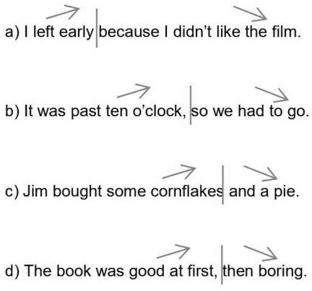
2.

3. a) tube. b) brother. c) three biscuits. d) remote control.

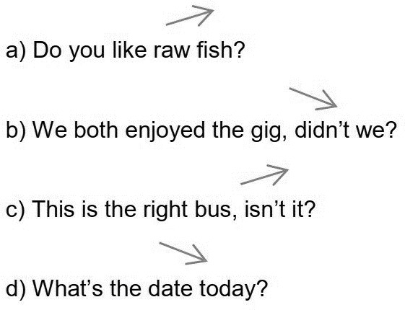
4.
5. 1. c). 2. d). 3. b). 4. a).

6. a) tone of voice. b) rhythm. c) extra emphasis. d) pausing for effect. e) pitch. f) speed.
g) volume.

7. 1. c). 2. e). 3. b). 4. d). 5. a). 6. f).

- Answers will vary. Sample answers:

tone of voice | pitch | extra emphasis on content words | volume | rhythm | speed | pausing (for effect)
nervous | lower | no | quieter | broken | slower | no
surprised | higher | yes | louder | broken | slower | yes
tired | lower | no | quieter | intact | slower | no
disgusted | higher | yes | louder | broken | faster | yes

- Answers will vary.

10. i) 1. c). 2. e). 3. a). 4. d). 5. b). 6. f).

- Answers will vary.

11. Answers will vary.

- Listen to a recording of how to say the English alphabet here. Why not listen and repeat?

https://purlandtraining.com/free-lessons/elementary-english-course/unit-1-0-learning-english/lesson-1- 1-alphabet/

114 Answers will vary.

Talking about a Song in an ESOL Class – Example

About the song:
Graceland
Paul Simon

Paul Simon
USA

1986
4:48
About the music:
Folk rock
guitar, pedal steel guitar, drums, bass

Mid-tempo
D G Bm A D

Melody:
Hooks: bass line; South African rhythms
Lyrics:

“The lyrics deal with the singer’s thoughts during a road trip with his son to Graceland (the legendary home of Elvis) after the breakup of his marriage to actress and author Carrie Fisher…”

“My grandma bought the CD; I played it a lot. I got into Paul Simon again in 1988 when we moved to Dorset and I started college... Walking through the passageway; playing guitar with my friends…”

My favourite line: “And she said losing love is like a window in your heart…”

4 facts about the song:
- It features backing vocals by the Everly Brothers and Ladysmith Black Mambazo

- Paul Simon broke an embargo to work with South African musicians

- It won the 1988 Grammy Award for Record of the Year

- It only reached 82 in US charts
3 reasons why it’s great:
- The use of South African musicians and instruments

- It’s a sad song; emotive; plaintive

- The lyrics are interesting and evocative: “The Mississippi Delta was shining like a National guitar...”

101 photocopiable worksheets for effective English lessons!

Practice the following skills:

grammar vocabulary reading
speaking and listening pronunciation
writing

Including full answers and notes for use

PurlandTraining.com
info@purlandtraining.com

Intermediate Level (CEFR B1-B2)

