PurlandTraining.com

ELT Bible Study Pack #1

60+ hours of teaching material for Bible Study and English classes

Matt Purland

ELT Bible Study Pack #1

PurlandTraining.com

info@purlandtraining.com https://www.purlandtraining.com

First published in the UK by PurlandTraining.com 2018

Holy Bible text courtesy World English Bible, used by permission: http://ebible.org/web/index.htm Images: https://unsplash.com/, used by permission

Public Domain

The author and sole copyright holder of this document has donated it to the public domain. Anybody can use this document, for commercial and non-commercial purposes.

Dear Reader,
In this book you will find 30 printable worksheets for either Bible Study or English language classes – or a mix of both! The dual aims of this book are to help you move closer to God by learning about Him through His Bible, while at the same time improving your English through an interesting and wide range of activities.
This book is designed to be used with groups or individuals, in a church, school, or home environment. Full answers and notes for use are provided (from p.42). If you spent around two hours working on each activity, including a warmer at the beginning, feedback at the end, and plenty of discussion throughout, you could easily build this material into a course lasting more than 60 hours.
The worksheets span the whole Bible, including specific verses, people, and incidents: from Noah to the Life of Moses, and Samson to Jonah in the Old Testament, and from John the Baptist and the Sermon on the Mount, to the Resurrection and the day of Pentecost in the New Testament.
The Bible verses have been specially chosen to be encouraging:
Even though I walk through the valley of the shadow of death, I will fear no evil. Psalm 23:4

inspiring:

and challenging:

If God is for us, who can be against us? Romans 8:31

‘Unless you turn and become as little children,

you will in no way enter into the Kingdom of Heaven.’ Matthew 18:3
You may even find some language-related verses or stories! I hope that the Bible will come alive for you through these verses, people, and stories, and that you will enjoy working and walking with them as much as I have in writing this book.
The ELT (English Language Teaching) input covers a number of important skill areas, including: grammar, vocabulary, speaking and listening, and writing. The material includes a real variety of language topics, from question forms to punctuation, and error correction to tenses – plus much more.
The material is aimed at intermediate level and above. Of course, teachers will know whether this book is suitable for their class simply by browsing it, but you are welcome to adapt material in this book, making it more suitable for other levels. To make this easier, all the Word document files for the pages in this book are available to download from the website: https://purlandtraining.com
Perhaps you would like to add pictures or change something, or add ten more of your own questions to an activity. The original Word files make this easy to do.
This book is in the public domain, so feel free to share it with your friends, students, and colleagues. You can even print copies in bulk, sell them, and keep all the profits! I’d love to know what you think of this book, and how you used it; as well as where and in what situation. Also, if you have any ideas or suggestions for future volumes, please contact me: info@purlandtraining.com
Kind regards,

Matt Purland
Ostróda, Poland – 18th October 2018

Bible Reference: Title: Skills: Answers:

Whole Bible

- 66 Books of the Bible – Gap-Fill grammar > alphabetical order 9
Various Various Various Various Various

- 66 Books of the Bible – Reference grammar > alphabetical order N/A

- Trace Encouraging Bible Verses 1 writing > alphabet 44

- Trace Encouraging Bible Verses 2 writing > alphabet 45

- 40 Famous People from the Bible – DWs speaking and listening > discussion 46

Old Testament

- In the Beginning speaking and listening > error correction 49
Genesis 1:1-8

Genesis 6:13-22

Genesis 11:1-9

Exodus 1-4

Ex., Num., Deut. Judges 15-16
Psalm 23:1-6

Isaiah 53:3-9

Jonah 1-4

Jonah 1-4

Jonah 1-4

Jonah 1-4

- Noah – Which Article and Why? grammar > articles 50

- The Tower of Babel reading for specific information 51

- Life of Moses – Part 1 grammar > question forms 52

- Life of Moses – Part 2 grammar > question forms 53

- The Fall of Samson reading > anagrams 54

- Psalm 23 vocabulary > word classes 55

- Isaiah 53 – Change the Infinitives grammar > verb transformation 56

- Jonah – Wh-Questions 1 grammar > question forms > punctuation 57

- Jonah – Wh-Questions 2 grammar > question forms > punctuation 58

- Jonah – Yes / No Questions 1 grammar > question forms > punctuation 59

- Jonah – Yes / No Questions 2 grammar > question forms > punctuation 60 New Testament
28. | Matthew 5:3-10 | The Beatitudes – Complete the Missing Vowels reading > vowel letters | 62
29. | See Answers | Jesus said… Word Chain 1 grammar > alphabet > word sequencing | 63
30. | See Answers | Jesus said… Word Search Puzzle 1 vocabulary > word sequencing | 64
31. | See Answers | Jesus said… Word Search Puzzle 2 vocabulary > word sequencing | 65
32. | Matthew 28:1-8 | He is Risen! speaking and listening > error correction | 66
33. | Mark 1:4-8 | John the Baptist vocabulary > reorder a text > synonyms | 67
34. | Luke 15:11-32 | The Prodigal Son – Who Said What? 1 reading > present continuous > categorisation | 68
35. | Luke 15:11-32 | The Prodigal Son – Who Said What? 2 reading > present continuous > categorisation | 69
36. | Luke 19:1-10 | Zacchaeus grammar > past simple > verb transformation | 70
37. | See Answers | Jesus said… Word Chain 2 grammar > alphabet > word sequencing | 71
38. | Acts 2:1-21 | The Day of Pentecost reading for specific information | 72
39. | 1 Corinthians 13:4-13 | 1 Corinthians 13 – Change the Infinitives grammar > verb transformation | 73

Review

41. Review reading for specific information 75
Various

Worksheets

WHOLE BIBLE

Write the books of the Bible in alphabetical order:

A A
B
- 1 C
2 C

D
A

2 C C

D

- C

- E E E
E E E

F

G
- H
- I
- J

G
H H

J J

H

J J

1 J

J
- J J

J J J
- 1 K 2 K

L L L
- M _ M M M
- N N N
- O

- 1 P

P
2 P P

P P

Q

R R R

- 1 S
- 1 T

T
2 S
2 T
S

T

- T

U – Y
Z Z Z

Here is a complete list of the books of the Bible in alphabetical order:

A ACTS AMOS B
C 1 CHRONICLES 2 CHRONICLES COLOSSIANS 1 CORINTHIANS 2 CORINTHIANS D DANIEL DEUTERONOMY
E ECCLESIASTES EPHESIANS ESTHER EXODUS EZEKIEL EZRA F
- GALATIONS GENESIS
- HABAKKUK HAGGAI HEBREWS HOSEA I ISAIAH
- JAMES JEREMIAH JOB JOEL JOHN 1 JOHN 2 JOHN 3 JOHN JONAH JOSHUA JUDE JUDGES
- 1 KINGS 2 KINGS
- LAMENTATIONS LEVITICUS LUKE M MALACHI MARK MATTHEW MICAH N NAHUM NEHEMIAH NUMBERS
- OBADIAH
- 1 PETER 2 PETER PHILEMON PHILIPPIANS PROVERBS PSALMS Q
- REVELATION ROMANS RUTH
- 1 SAMUEL 2 SAMUEL SONG OF SONGS
- 1 THESSALONIANS 2 THESSALONIANS 1 TIMOTHY 2 TIMOTHY TITUS U
V W X Y
Z ZECHARIAH ZEPHANIAH

- Practise drawing the letters of the English alphabet by tracing the encouraging Bible verses below. Try to keep to the lines as much as possible!

- Write the bible verse for each quotation.

1. If God is for us, who can be against us?

2. But those who wait for Yahweh will renew their strength.
3. Be strong and courageous. Don’t be afraid. Don’t be dismayed, for
Yahweh your God is with you wherever you go.

4. God is our refuge and strength, a very present help in trouble

5. We know that all things work together for good for those who love God.

6. Yahweh’s name is a strong tower: the righteous run to him, and are
safe.

7. Yahweh is my shepherd: I shall lack nothing.

8. ”With men it is impossible, but not with God, for all things are possible with God.”

9. ”Come to me, all you who labor and are heavily burdened, and I will give you rest.”

10. ”For I know the thoughts that I think toward you,” says Yahweh, “thoughts of peace, and not of evil, to give you hope and a future.”

- Practise drawing the letters of the English alphabet by tracing the encouraging Bible verses below. Try to keep to the lines as much as possible!

- Write the bible verse for each quotation.

1. I can do all things through Christ, who strengthens me.

2. For God didn’t give us a spirit of fear, but of power, love, and
self-control.

3. Yahweh is my rock, my fortress, and my deliverer; my God, my rock, in whom I take refuge.

4. ”Therefore don’t be anxious for tomorrow, for tomorrow will be
anxious for itself.”

5. You are my hiding place. You will preserve me from trouble.

6. Even though I walk through the valley of the shadow of death, I will fear no evil, for you are with me.

7. Yahweh is my light and my salvation. Whom shall I fear? Yahweh is the strength of my life. Of whom shall I be afraid?

8. Cast your burden on Yahweh and he will sustain you.

9. In nothing be anxious, but in everything, by prayer and petition with thanksgiving, let your requests be made known to God.

10. Don’t you be afraid, for I am with you. Don’t be dismayed, for I
am your God. I will strengthen you. Yes, I will help you.

A. Work with a partner or small group. Print this page onto thin card, then cut out the discussion word cards and lay them on the desk printed side up. Mix them up, then answer questions from the following page.


1.  Jesus | 2.  Mary | 3.  David | 4.  Abraham
5.  Moses | 6.  Paul | 7.  Jeremiah | 8.  Elijah
9.  Eve | 10.  Rachel | 11.  Elizabeth | 12.  Isaiah
13.  Delilah | 14.  Deborah | 15.  Leah | 16.  Anna
17.  Jacob | 18.  Martha | 19.  Adam | 20.  Esther
21.  Peter | 22.  Mary Magdalene | 23.  Bathsheba | 24.  Rebecca
25.  Ruth | 26.  Noah | 27.  Goliath | 28.  Miriam
29.  Joseph | 30.  John | 31.  Sarah | 32.  Daniel
33.  Solomon | 34.  Jonah | 35.  Hannah | 36.  Rahab
37.  Pontius Pilate | 38.  Salome | 39.  Stephen | 40.  Dorcas

Language Questions

- Put the names into… a) alphabetical order, b) reverse alphabetical order.

- a) Put the names into groups according to how many syllables each one has.
  - Mark the strong stressed syllable on each card.
  - Write the stressed vowel sound on the card with Clear Alphabet.
  - Put the names into sound groups according to their strong stressed vowel sounds.

Ask questions, e.g. ‘Whose name has three syllables?’ ‘Whose name is stressed on…’

- Which names have a schwa sound on the: a) 1st syllable, b) 2nd syllable, c) 3rd syllable,
d) 4th syllable? Which name(s) do not contain a schwa sound?

Comprehension Questions

- Take a card. Describe the person without saying their name. Your partner has to guess.

- Which person… a) wrestled with God, b) ate forbidden fruit, c) waited her whole life to meet Jesus, d) composed poetry and ruled Israel, e) had a brother called James, f) was the mother of two nations, g) predicted the restoration of Israel, h) was too busy to listen to Jesus?

- Take a card. Retell the story of the person: a) through mime, b) through sounds and gestures,
c) through pictures, d) through song, d) through words, e) through video.

- Put the people into groups: a) male and female, b) heroes and villains, c) leaders and followers, d) Old Testament and New Testament.

- Order the people by how familiar you are with their stories: from most familiar to not previously known.

- Which person is also known as: a) Simon, b) Saul, c) Immanuel, d) Abram, e) Tabitha,
f) Israel, g) Governor of Judaea, h) Queen of Persia?

- Pick a card and… a) say an adjective you associate with that person, b) describe the person in exactly five words, c) give a clue in one word. Your partner has to guess.

- Find a person connected with each place: a) Jericho, b) Bethlehem, c) Ninevah, d) Eden,
e) Egypt, f) Babylon.

- Find a person connected with… a) wisdom, b) height, c) miracles and prophecy, d) crying,
e) a dove carrying an olive branch, f) a burning bush, g) the cross.

- Who is… a) the first Christian martyr, b) a first wife, c) a second wife, d) 127 years old,
e) ‘well advanced in years’, f) the only female judge, g) having a bath, h) Moses’ sister?

- Find the person who… a) dedicated her miracle baby to God, b) laid her baby in a manger,
c) ordered a haircut for her lover, d) demanded the head of a prisoner, e) discovered the empty tomb, f) was faithful to her mother-in-law Naomi.

- How many people can you remember in one minute when all the cards are turned over?

OLD TESTAMENT

- Work with a partner. Each of you has half of the creation story from Genesis 1:1-8. Both of you read your text for the other to write down – without looking at the other person’s paper – until you both have the full text.

- Work together to find and correct 10 spelling errors in each half of the text.
-------------------------------------------------------------------------

Student A:
- In the bginning, .
- . Darkness was on the surfice
of the deep and God’s Spirit was hovering over the surface off the waters.
- God said, .
- God saw the ligth, and saw that it was good. .
- God called the light ‘day’, and the darknes he called ‘night’.
.
- God sed, ‘Let there be an expanse in the midle of the waters,
.’
- God made the expanse, and divided the waters which were under the expense from the waters which were abuve the expanse; .
- God caled the expanse ‘sky’.
.
-------------------------------------------------------------------------

Student B:
- , God created the hevens and the earth.
- The eirth was formless and emty.
.
- , ‘Let there be light,’ and there wos light.
4 . God dividen the light from the darkness.
5 . There was evening and ther was morning, the furst day.
6 , and let it divide the waters from the waters.’
7
;and it was sew.
8 . There was evning and there was morening, a second day.

- Read the story about Noah in Genesis 6:13-22.

- Complete the gaps below with an article (a, an, the) or put - to mean zero article (none):

13 God said to a) Noah, “I will bring b) end to all flesh, for c) earth is filled with d) violence through them. Behold, I will destroy them and the earth. 14 Make e) ship of gopher wood. You shall make rooms in f) ship, and shall seal it inside and outside with g) pitch. 15 This is how you shall make it. The length of the ship shall be three hundred cubits, its width fifty cubits, and its height thirty cubits.

- You shall make h) roof in the ship, and you shall finish it to
i) cubit upward. You shall set j) door of the ship in its side. You shall make it with k) lower, second, and third levels.
- I, even I, will bring l) flood of m) waters on this earth, to destroy all n) flesh having the breath of life from under
o) sky. Everything that is in the earth will die. 18 But I will establish my covenant with you. You shall come into the ship, you, your sons, your wife, and your sons’ wives with you. 19 Of every living thing of all flesh, you shall bring two of every sort into the ship, to keep them alive with you. They shall be male and female.

20 Of p) birds after their kind, of q) livestock after their kind, of every creeping thing of r) ground after its kind, two of every sort will come to you, to keep them alive. 21 Take with you some of all
s) food that is eaten, and gather it to yourself; and it will be for food for you, and for them.” 22 Thus Noah did. He did all that t) God commanded him.
---------------------------------------------------------------------------
- Say why you chose each article. Write letters in the following groups:

  - a because: singular countable noun general not known

2. an | because: | singular countable noun general | vowel sound
3. the | because: | singular countable noun specific | known
4. zero | because: | plural noun general
5. the | because: | plural noun specific
6. zero | because: | uncountable noun general
7. the | because: | uncountable noun specific
8. zero | because: | proper noun

    - Read the story about the Tower of Babel in Genesis 11:1-9.
    - Below is a multiple choice quiz. With multiple choice questions there are usually three types of answer to choose from: i) answers which are correct, ii) answers which are plausible – they seem possible, but are incorrect, and iii) answers which are plainly wrong, because either they do not make sense or they are impossible.

Discuss the answers below with a partner or small group, and mark each option:
(C) for correct, (P) for plausible, or (I) for impossible.

Ex. The people built the city on a… a) hill (P), b) bridge (I), c) plain (C).

- Their aim was to build a city and a great… a) cathedral, b) temple, c) tower.
- Their plan was for the tower to reach up to… a) the sky, b) more than 500 metres,
c) the ceiling.
- In those days everybody spoke the same… a) words, b) tales, c) language.
- The people said to one another, ‘Come, let’s make…’ a) stones, b) bricks, c) pizza.
- The people wanted to make a name for… a) himself, b) themselves, c) the Lord.
- The people feared having to populate the whole… a) region, b) earth, c) city.
- God came down to see… a) the river, b) the completed tower, c) the city and the tower.
- God declared that if the people were able to cooperate so efficiently with one language…
  - they would be glad, b) they would learn English, c) anything would be possible.
- God decided to give the people many different… a) blessings, b) languages, c) clothes.
- The people were not able to continue… a) building the city, b) praising God, c) having lunch.
- They built with brick instead of… a) plastic, b) stone, c) rock.
- The city and tower remained… a) uninhabited, b) unfinished, c) unavailable.
- The place was named Babel, because this word sounded like the Hebrew word for…
  - ‘completed’ b) ‘confused’ c) ‘tower’.
- At the beginning of the story, the people decided to travel… a) west, b) up, c) east.
- God was angry because the people were acting out of fear and… a) anxiety, b) fun, c) pride.
- The people wanted to become like God, and in doing so to… a) replace Him, b) be near Him,
c) earn money.
- The people aimed to stay together… a) at all costs, b) for the next few years,
- until something better came along.
- They used tar for… a) mortar, b) making shampoo, c) fuel.
- The people found a plain in the land of… a) Shinar, b) Israel, c) Esdraelon.
- The story concerns the descendants of… a) Moses, b) Paul, c) Noah.

A. Write a question to match each answer below using the question prompts to help you. Choose an appropriate question word in each case. Don’t forget to use punctuation.

- / Moses / hide / first / three months / life (passive voice)
Exodus 1:22
Q:
A: Because Pharaoh had commanded that all male Hebrew babies be killed.

- / Moses’ sister / Miriam / place / basket
Exodus 2:3
Q:
A: Among the reeds on the River Nile.

- / adopt / baby / own
Exodus 2:10
Q:
A: Pharaoh’s daughter.

- / Moses / do / see / Egyptian / hit / fellow Hebrew
Exodus 2:12
Q:
A: He killed the Egyptian.

- / Pharaoh / angry / Moses
Exodus 2:15
Q:
A: Because he had killed the Egyptian.

- / Moses / run away
Exodus 2:15
Q:
A: To Midian.

- / Moses / help / daughters / Midian
Exodus 2:17
Q:
A: By rescuing them from a band of shepherds and watering their flock of sheep.

- / angel / Lord / appear / Moses
Exodus 3:2
Q:
A: In the flames of a burning bush.

- / God / concern / people / Israel
Exodus 2:24-25
Q:
A: Because they were living in slavery in Egypt and he remembered his covenant with Abraham, Isaac, and Jacob.

- / Moses’ / reaction / God’s call
Exodus 4:10-13
Q:
A: He felt unworthy and pleaded with God to send somebody else.

  - Write a question to match each answer below using the question prompts to help you. Choose an appropriate question word in each case. Don’t forget to use punctuation.

- / Moses / go / speak / Pharaoh
Exodus 7:7
Q:
A: When he was eighty years old.

- / plagues / God / send / Egypt
Exodus 7-12
Q:
A: Ten.

- / God / part / waters / Red Sea
Exodus 14:21
Q:
A: Moses stretched out his hand over the waters, and God made the sea recede by a strong wind.

- / God / provide / Israelites / eat / wilderness
Exodus 16:4 & 13
Q:
A: Manna and quail from heaven.

- / Moses / first / get / water / rock / strike
Exodus 17:6
Q:
A: Horeb.

- / commandment / concern / Sabbath day
Exodus 20:8
Q:
A: The fourth commandment.

- / Israelites / spend / forty years / walk / wilderness
Numbers 14:34
Q:
A: Because of their lack of faith in God’s promises.

- / wood / Ark of the Covenant / make (passive voice)
Exodus 25:10
Q:
A: Acacia wood.

- / not / Moses / lead / children / Israel / Promised Land
Numbers 20:6-12
Q:
A: Because he had been disobedient towards God.

- / bury / Moses / land / Moab
Deuteronomy 34:6
Q:
A: God did.

  - Read about Samson in Judges 15-16. Solve the anagrams and complete the ending of each sentence with one of the words.

  - If any of the sentences contain incorrect information, please correct them.

---------------------------------------------------------------------------

MITES | ALLHIDE | HNRTGETS | REALISESIT | RESAY
RESETC | FEELIMIT | ORSPIN | UNDRK | KAWE
GTRONS | YEKDNO | RAZEINIT | GREENVE | EESY
UTC | UNTOMAIN | ARHI | LINESTISHIP | WODN
---------------------------------------------------------------------------

    - Samson was a legendary priest and leader of the .
    - He killed an entire army with only the heel of a .
    - He judged Israel for thirty .
    - He picked up the doors of the gates of Gaza and took them up a .
    - He fell in love with an Israelite called .
    - She begged him to tell her the place of his great .
    - He lied to her four .
    - He was ambushed on two occasions by the .
    - His wife nagged him every day to confide in her his .
    - She persuaded him to tell her what made him .
    - He confided that his beard had never been .
    - This was because his father was a .
    - When Samson was asleep she got a guard to shave off all his .
    - The power of the Lord departed from Samson and he became .
    - The Philistines attacked him and gouged out his .
    - He was sent to bake bread in the .
    - He performed for his fellow prisoners when they were .
    - He called on God to help him get .
    - Samson’s wife returned and he literally brought the house .
    - Many were killed – even more than he had killed during his .

      - Complete the gaps in Psalm 23 with the following words:

- forever
- a
- green
- through
- you
- shepherd
- me
- will
- righteousness
- in
- still
- lie down
- my
- restores
- and

Psalm 23 / A Psalm by David.

- Yahweh is my a) : I shall lack nothing.

- He makes me b)
in c)
pastures.

He leads me beside d) waters.
- He e) my soul.
He guides me in the paths of f) for his name’s sake.
- Even though I walk g) the valley of the shadow of death,
I will fear no evil, for h) are with me.
Your rod i) your staff, they comfort j) .

- You prepare k) presence of my enemies.
table before me l)
the

You anoint my head with oil.
m) cup runs over.
- Surely goodness and loving kindness shall follow me all the days of my
life, and I n) dwell in Yahweh’s house o) .
---------------------------------------------------------------------------
      - Using the same 15 words, find and write down:

an abstract noun |  | a main verb
an adjective |  | an object pronoun
an adverb |  | a phrasal verb
an auxiliary verb |  | a possessive adjective
a colour |  | a preposition of movement
a common noun |  | a preposition of place
a conjunction |  | a subject pronoun
an indefinite article

      - Divide the words into two groups: content words (meaning) and function words (grammar).

Holy Bible text courtesy World English Bible: http://ebible.org/web/PSA023.htm

- Translate each infinitive verb into your first language.

- Write the correct form of each verb on the right:

3 He was DESPISE and REJECT by men, a man of suffering
and ACQUAINT with disease.
He was DESPISE as one from whom men HIDE their face; and we didn’t RESPECT him.
4 Surely he has BEAR our sickness
and CARRY our suffering;
yet we CONSIDER him PLAGUE,
STRIKE by God, and AFFLICT.
5 But he was PIERCE for our transgressions.
He was CRUSH for our iniquities.
The punishment that BRING our peace BE on him;
and by his wounds we are HEAL.
6 All we like sheep have GO astray.
Everyone has TURN to his own way;
and Yahweh has LAY on him the iniquity of us all.
7 He was OPPRESS,
yet when he was AFFLICT he didn’t OPEN his mouth.
As a lamb that is LEAD to the slaughter,
and as a sheep that before its shearers BE silent,
so he didn’t OPEN his mouth.
8 He was TAKE AWAY by oppression and judgment. As for his generation,
who CONSIDER that he was CUT OFF out of the land of the living and STRIKE for the disobedience of my people?
9 They MAKE his grave with the wicked, and with a rich man in his death,
although he had DO no violence,
nor BE any deceit in his mouth.

Holy Bible text courtesy World English Bible: http://ebible.org/web/ISA53.htm

- Read the story about Jonah in Jonah 1-4.

- Rearrange the words in each sentence to make a wh-question. Wh-questions are questions that begin with what, where, when, etc. The answer will be information. For example: ‘Where was Jesus born?’ ‘In Bethlehem.’ Don’t forget to put a capital letter at the start and a question mark at the end.

- Read the Bible text again and answer the questions.

- go did Jonah when Ninevah to

- to did which want Jonah God visit city

- to Lord did the Jonah pray when

- did Jonah the vomit where out fish

- fish how in long Jonah was the great the of belly

- God what Jonah want did to do

- decide did where to to flee Jonah

- caused wither who vine to the

- feel did the how the during storm mariners

- storm was during doing Jonah the what

  - Read the story about Jonah in Jonah 1-4.

  - Rearrange the words in each sentence to make a wh-question. Wh-questions are questions that begin with what, where, when, etc. The answer will be information. For example: ‘Where was Jesus born?’ ‘In Bethlehem.’ Don’t forget to put a capital letter at the start and a question mark at the end.

  - Read the Bible text again and answer the questions.

- the have on did mercy why of Ninevah people God

- stormy who the sea made

- pray who that Jonah to demanded God

- lived in many Ninevah people of how the city

- port which from did leave Jonah

- they what the because were mariners afraid do did

- did way suggest as what Jonah a storm of calming the

- the why sea they cargo into the throw did

- Jonah was why angry

- story what of moral is the the

  - Read the story about Jonah in Jonah 1-4.

  - Rearrange the words in each sentence to make a yes / no question. Yes / no questions begin with an auxiliary verb, e.g. do, will, or did. The answer is usually ‘yes’ or ‘no’. For example: ‘Did Jonah disobey God?’ ‘Yes, he did.’ Don’t forget to put a capital letter at the start and a question mark at the end.

  - Read the Bible text again and answer the questions. Note: a few of the answers may be ‘We don’t know’, because the information is not given in the text.

- asleep the was Jonah ship on deck the of

- the did of Ninevah people God’s word believe

- Jonah did preach God tell Ninevah to against

- the did row mariners try land to back to

- had from told the already mariners Jonah he God fleeing was that

- walk did Joppa to Jonah

- four Jonah in three the of and fish days for the nights belly was

- Jonah belly pray to did the God in the of fish

- about was the God of people concerned Ninevah

- city sit Jonah on west the did the side of

  - Read the story about Jonah in Jonah 1-4.

  - Rearrange the words in each sentence to make a yes / no question. Yes / no questions begin with an auxiliary verb, e.g. do, will, or did. The answer is usually ‘yes’ or ‘no’. For example: ‘Did Jonah disobey God?’ ‘Yes, he did.’ Don’t forget to put a capital letter at the start and a question mark at the end.

  - Read the Bible text again and answer the questions. Note: a few of the answers may be ‘We don’t know’, because the information is not given in the text.

- Jonah in the afraid was the of fish belly

- it right about vine for to be Jonah was angry the

- the mariners Jonah did home to take tell him

- go commanded him to Ninevah God did Jonah first when

- was worm vine Jonah that ate the angry the

- a medium-sized Ninevah city was

- prophecy Jonah to this other cities did after episode

- Ninevah was people after God spared discouraged the of Jonah

- head the did shade for vine Jonah’s provide

- did believe God he better knew that than Jonah

NEW TESTAMENT

  - Read the words of Jesus from Matthew 5:3-10 and complete the missing vowel letters. There are five vowel letters in English: a, e, i, o, and u.

  - Write the missing half of each verse below. Use the text boxes to help you.

3 | Bl_ss_d | _r_ | th_ p_ _r _n sp_r_t,
4 | Bl_ss_d | _r_ | th_s_ wh_ m_ _rn,
5 | Bl_ss_d | _r_ | th_ g_ntl_,
6 | Bl_ss_d | _r_ | th_s_ wh_ h_ng_r _nd | th_rst f_r | r_ght_ | _ _ sn_ss,
7 | Bl_ss_d | _r_ | th_ m_rc_f_l,
8 | Bl_ss_d | _r_ | th_ p_r_ _n h_ _rt,
9 | Bl_ss_d | _r_ | th_ p_ _c_m_k_rs,
10 | Bl_ss_d | _r_ | th_s_ wh_ h_v_ b_ _n | p_rs_c_t_d | f_r

r_ght_ _ _sn_ss’ s_k_,
”
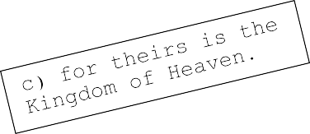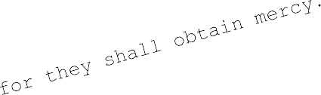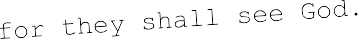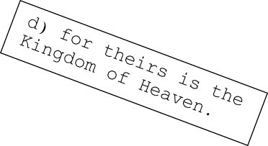

Holy Bible text courtesy World English Bible: http://ebible.org/web/MAT05.htm

A. Work out the well-known saying of Jesus and write it on the line below. Find the letters by changing each letter. Begin with H (count 4 letters forward to L) then X (count 2 letters back to V) and keep going with the next letters, alternating 4 forward and 2 back. Then fill in the blank circles with vowels.
Tip: you may need to overlap the beginning and end of the alphabet, e.g. 4 back from C will be Y.
Jesus said: “ .”

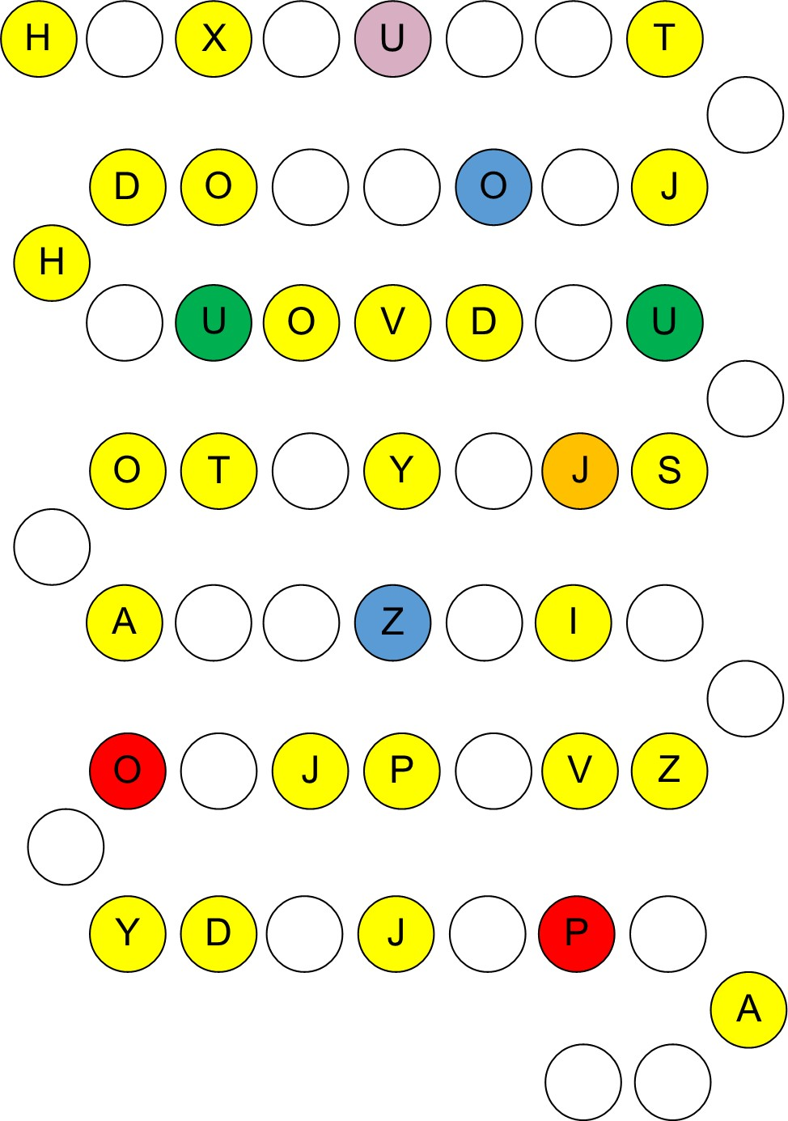

- Find 26 words in the word search puzzle (not duplicates). Note: words can be in any direction, including diagonal and backwards.

- Write the words (including duplicates) in order to form a well-known saying of Jesus.

- kingdom x2  - humbles  - therefore  - greatest | - child  - the x3  - will  - enter | - turn  - heaven x2  - way  - whoever | - become  - himself  - is  - children
5. you x2 | 12. in x2 | 19. little x2 | 26. unless
- this  - of x2 | - and  - no | - as x2  - into

Jesus said: ‘
.’

- Find 29 words in the word search puzzle (not duplicates). Note: words can be in any direction, including diagonal and backwards.

- Write the words (including duplicates) in order to form a well-known saying of Jesus.
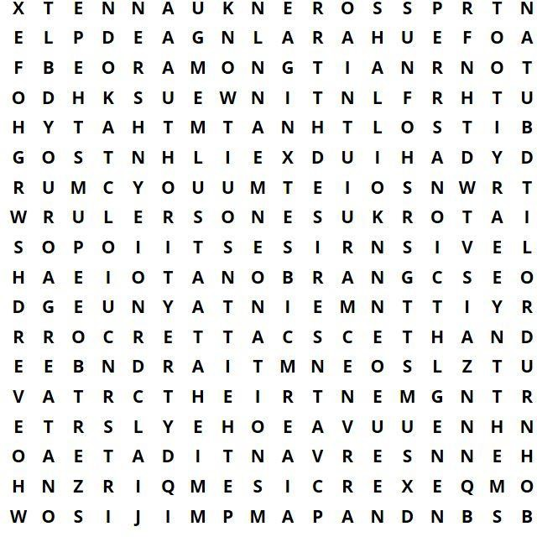

- nations  - among  - ones |  | x2 | - become  - your  - but | - over x2  - know  - be x2 |  | - authority  - you x3  - not | - servant  - shall x2  - so
- rulers  - that |  |  | - desires  - to | - lord  - and |  | - the x2  - of | - their  - it x2
6. | great x2 | 12. exercise |  | 18. them | x2 | 24. whoever

Jesus said: ‘

.’

- Work with a partner. Each of you has half of the resurrection account from Matthew 28:1-8. Both of you read your text for the other to write down – without looking at the other person’s paper – until you both have the full text.

- Work together to find and correct 10 spelling errors in each half of the text.
-------------------------------------------------------------------------

Student A:
1 , Mary Magdalene and the othe Mary came to see the tomb.
- , for an angel of the Lord descended from the sky and came and roled away .
- His apperance was like ligtning, .
- , the gaurds shook, and became like dead man.
- , ‘Don’t be afraid,
for I know that you seek Jesus, who has been crucified.
- He is not hier, for he has risen, just like he said.
.
- Go quikly and tell his disciples, ‘
; there you will seen him.’ Behold, I have told you.’
8 , and ran to bring his disciple word.
-------------------------------------------------------------------------

Student B:
- Now after the Sabbath, as it begin to dawn on the first day of the weak,
.
- Behold, there was a grate earthquake,
the stone from the dooor and sat on it.
- , and his clothing wight as snow.
- For fear of him, .
- The angel ansered the womens, .
6 . Come, see the place were the Lord was lying.

7
and behold, he goes before you into Galalee;
, ‘He has risen from the dead,
.’

.’
8 They depated quickly from the tomb with fear and great joy,
.

Holy Bible text courtesy World English Bible: http://ebible.org/web/MAT28.htm

- Read the story about John the Baptist in Mark 1:4-8.

- Print this worksheet onto thin card; cut out the sentence cards, jumble them up, then put them back into order:

and a leather belt around his waist.
All the country of Judea
confessing their sins.
but he will baptize you in the Holy Spirit.”
John came baptizing in the wilderness
I am not worthy to stoop down and loosen.
the thong of whose sandals
for forgiveness of sins.
They were baptized by him in the Jordan river,
John was clothed with camel’s hair
He ate locusts and wild honey.
I baptized you in water,
and preaching the baptism of repentance
He preached, saying, “After me comes he who is
mightier than I,
and all those of Jerusalem went out to him.

---------------------------------------------------------------------------
- Synonyms: write a highlighted word from the text which means the same as:

- acceptable  - clemency |  | - proclaiming  - region
3. cord |  | 11. skin
4. desert |  | 12. turning from sin
5. greater |  | 13. untie
6. H20 |  | 14. waterway
7. immerse |  | 15. wearing
8. insects |  | 16. wrongdoing

Holy Bible text courtesy World English Bible: http://ebible.org/web/MRK01.htm

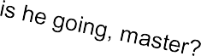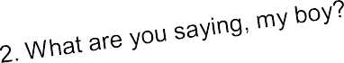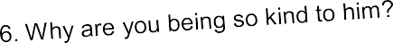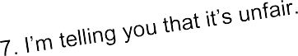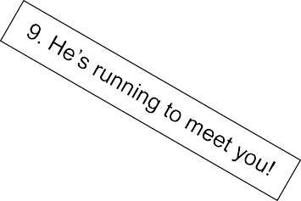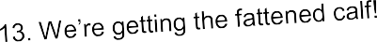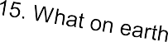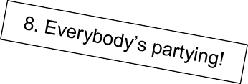
- Read the story of the prodigal son in Luke 15:11-32.

- Read each sentence and decide who said what. Write the number of each sentence in the appropriate box below. There are five sentences in each category.

- Identify a verse in which you think each sentence could have been said.

The father: | The elder son:
The prodigal son: | The father’s servants:

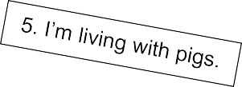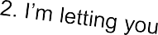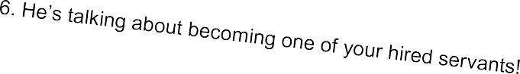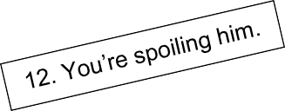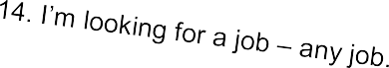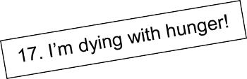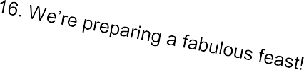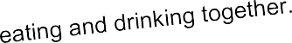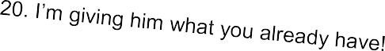
- Read the story of the prodigal son in Luke 15:11-32.

- Read each sentence and decide who said what. Write the number of each sentence in the appropriate box below. There are five sentences in each category.

- Identify a verse in which you think each sentence could have been said.

The father: | The elder son:
The prodigal son: | The father’s servants:

- Read the story about Zacchaeus in Luke 19:1-10.

- Write an appropriate past simple verb in each gap below. Choose from the list and change each verb from infinitive form to past simple:

be (x4) climb come (x2)
enter hurry look
murmur receive run
say (x2) see (x2) stand

1 He a) and was passing through Jericho. 2 There b) a man named Zacchaeus. He c) a chief tax collector, and he
- rich. 3 He was trying to see who Jesus e) , and
couldn’t because of the crowd, because he was short.
4 He f) on ahead, and g) up into a sycamore tree to see him, for he was going to pass that way. 5 When Jesus h) to the place, he i) up and j) him, and k) to him, “Zacchaeus, hurry and come down, for today I must stay at your
house.”
- He l) , m) down, and n) him joyfully.
- When they o) it, they all p) , saying, “He has gone in to lodge with a man who is a sinner.”
- Zacchaeus q) and r) to the Lord, “Behold, Lord, half of my goods I give to the poor. If I have wrongfully exacted anything of anyone, I restore four times as much.”
- Jesus said to him, “Today, salvation has come to this house, because he also is a son of Abraham. 10 For the Son of Man came to seek and to save that which was lost.”
---------------------------------------------------------------------------
- Say whether each statement is true (T), false (F), or we don’t know (DK):

  - Zacchaeus had little money.
  - Zacchaeus climbed up into an olive tree.
  - Zacchaeus lived in a large house.
  - Zacchaeus owed money to many people in the crowd.
  - There was a crowd around Jesus.
  - Zacchaeus enjoyed his job.
  - Jesus promised salvation to Zacchaeus.
  - The crowd were pleased that Jesus went to Zacchaeus’s home.
  - Zacchaeus was a very tall man.
  - Zacchaeus worked in Jericho.
  - The crowd spoke out loudly against Zacchaeus.
  - Jesus told Zacchaeus to take his time.
  - Zacchaeus was a chief tax collector.
  - Zacchaeus tried to see who Jesus was.
  - The crowd considered Zacchaeus to be a good man.
  - Jesus wanted to stay at Zacchaeus’s house that day.
  - Zacchaeus gave half of his belongings to the poor.
  - There were hundreds of people in the crowd.
  - Zacchaeus promised to pay back those he had cheated twice as much.
  - Zacchaeus quit his job.

Holy Bible text courtesy World English Bible: http://ebible.org/web/LUK19.htm

    - Work out the well-known saying of Jesus and write it on the line below. Find the letters by changing each letter. Begin with Q (count 4 letters back to M) then R (count 2 letters forward to T) and keep going with the next letters, alternating 4 back and 2 forward. Then fill in the blank circles with vowels.
Tip: you may need to overlap the beginning and end of the alphabet, e.g. 4 back from C will be Y.
Jesus said: “ .”

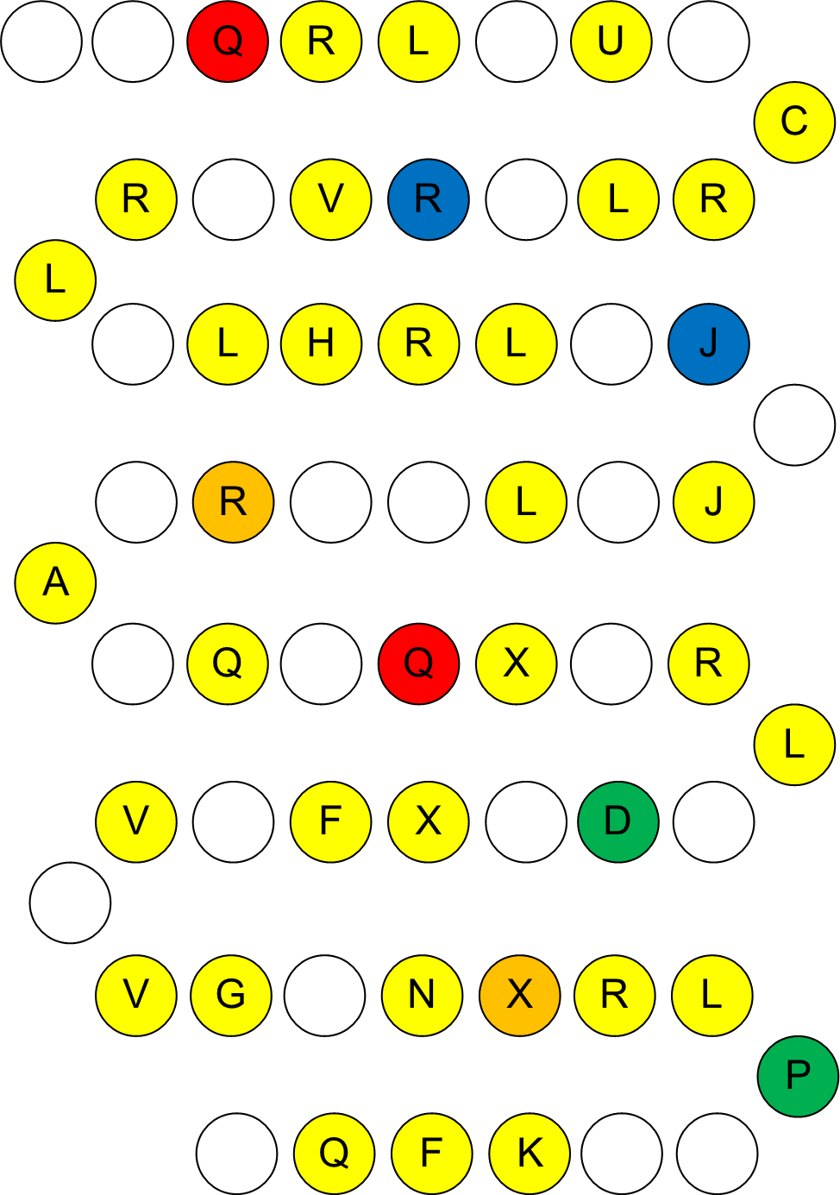

Holy Bible text courtesy World English Bible: http://ebible.org/web/index.htm

- Read the story about the day of Pentecost in Acts 2:1-21.
- Below is a multiple choice quiz. With multiple choice questions there are usually three types of answer to choose from: i) answers which are correct, ii) answers which are plausible – they seem possible, but are incorrect, and iii) answers which are plainly wrong, because either they do not make sense or they are impossible.

Discuss the answers below with a partner or small group, and mark each option:
(C) for correct, (P) for plausible, or (I) for impossible.

Ex. Peter stood up and addressed the… a) group (P), b) crowd (C), c) children (I).

- The story occurred in… a) a field, b) Jerusalem, c) Jericho.
- Peter proclaimed that ‘whoever will call on the name of the Lord will be…’
  - healed, b) saved, c) called.
- They saw what looked like tongues of… a) light, b) books, c) fire.
- The apostles began to speak in different… a) languages, b) ways, c) stories.
- They were able to speak other languages because of… a) the Holy Spirit,
  - an online course, c) a mighty wind.
- The apostles were all sitting together in… a) an apartment, b) a house, c) a minibus.
- The sound filled the house where they were… a) running, b) sitting, c) standing.
- There were people in Jerusalem from… a) almost every nation, b) every nation,
  - the Bull Ring Shopping Centre in Birmingham.
- The apostles were… a) Egyptians, b) Galileans, c) Judaeans.
- Peter quoted from the prophet… a) Isaiah, b) Stephen, c) Joel.
- This story is about… a) spreading the gospel, b) the twelve disciples, c) the day of Pentecost.
- The apostles were filled with the Holy Spirit on the day of… a) Pentecost,
b) Fasting, c) the week.
- The people who heard the apostles speaking their languages were… a) amazed,
b) aggrieved, c) surprising.
- They heard a sound like… a) a car alarm, b) a mighty wind, c) a roll of thunder.
- The people in Jerusalem asked one another… a) ‘What is the time?’
b) ‘What does this mean?’ c) ‘What do they want?’
- The number of apostles was… a) twelve, b) four hundred, c) eleven.
- The apostle who stood up and addressed the crowd was… a) Paul, b) James, c) Peter.
- Some people claimed the apostles had been… a) drinking, b) dreaming, c) jogging.
- Peter said that ‘Your young men will see…’ a) visions, b) televisions, c) dreams.
- Joel is a prophet from… a) the New Testament, b) the Old Testament, c) Isaiah.

- Translate each infinitive verb into your first language.

- Write the correct form of each verb on the right:

4 Love BE patient and BE kind. Love doesn’t envy.
Love doesn’t brag, be not proud,
5 doesn’t behave itself inappropriately, doesn’t seek its own way, is not provoke, take no account of evil;
6 doesn’t rejoice in unrighteousness, but rejoice with the truth;

7 bear all things, believe all things, hope all things, and endure all things.
8 Love never fail. But where there BE prophecies,
they will be do away with.
Where there BE various languages, they will cease.
Where there BE knowledge, it will be do away with.
9 For we know in part and we prophesy in part;
10 but when that which BE complete has come,
then that which BE partial will be do away with.
11 When I BE a child, I SPEAK as a child, I FEEL as a child,
I THINK as a child. Now that I have become a man,
I have put away childish things.
12 For now we see in a mirror, dimly, but then face to face.
Now I know in part, but then I will know fully,
even as I was also fully know.
13 But now faith, hope, and love remain – these three.
The greatest of these BE love.

Holy Bible text courtesy World English Bible: http://ebible.org/web/1CO13.htm

REVIEW

A. Write the answers in the spaces on the right. All the answers can be found in the pages of this book. Find the Bible verse by reading down the centre line and write it below:

__

- His descendants built the Tower of Babel. N H
A
O
- ‘I shall nothing.’ Psalm 23:1
- ‘Blessed are the .’ Matthew 5:5
- AKA the Queen of Persia.
- Ended up in the belly of a fish.
- ‘Become as little .’ Matthew 18:3
- Destination for Jonah.
- The Philistine giant who fought David.
- Received the Holy Spirit at Pentecost.
- The only book of the Bible beginning with ‘O’.
- This word was misspelled as ‘GAURDS’.
- If you want to be great become like this.
- Thrown for the Prodigal Son.
- Moses was buried here.
- ‘ those who curse you.’ Matt. 5:44
- What did Zacchaeus climb?
- The ninth word in Word Chain 1.
- The ark was 30 high.
- This verse mentions ‘My God, my rock.’
- ‘By his wounds we are .’ Isaiah 53:5
- What did Anna do?
- ‘Love never _ .’ 1 Cor. 13:8
- In the beginning…
- The second wife of Jacob.
- Samson carried off the doors of the gates of this city.
- John baptised in this river.
- Solomon was known for this.

ANSWERS

WHOLE BIBLE

Answers:

B.

- Romans 8:31
- Isaiah 40:31
- Joshua 1:9
- Psalm 46:1
- Romans 8:28
- Proverbs 18:10
- Psalm 23:1 8. Mark 10:27
- Matthew 11:28
- Jeremiah 29:11

Answers:

B.

- Philippians 4:13
- 2 Timothy 1:7
- Psalm 18:2
- Matthew 6:34
- Psalm 32:7
- Psalm 23:4
- Psalm 27:1
- Psalm 55:22
- Philippians 4:6
- Isaiah 41:10

Answers:

1.

Language Questions

a) and b) Abraham, Adam, Anna, Bathsheba, Daniel, David, Deborah, Delilah, Dorcas, Elijah, Elizabeth, Esther, Eve, Goliath, Hannah, Isaiah, Jacob, Jeremiah, Jesus, John, Jonah, Joseph, Leah, Martha, Mary, Mary Magdalene, Miriam, Moses, Noah, Paul, Peter, Pontius Pilate, Rachel, Rahab, Rebecca, Ruth, Salome, Sarah, Solomon, Stephen.
2.
a), b), and c) Stressed syllables are underlined: ee o iy or oo
- syllable: Eve, John, Leah, Paul, Ruth
a a a ei e or e aiy a aiy ei ee eu eu
- syllables: Adam, Anna, Daniel, David, Deborah, Dorcas, Esther, Goliath, Hannah, Isaiah, Jacob, Jesus, Jonah, Joseph, ar eir i eu eu ee ei ei eir ee
Martha, Mary, Miriam, Moses, Noah, Peter, Rachel, Rahab, Sarah, Stephen
ei ee ai ai aiy e eu o
- syllables: Abraham, Bathsheba, Delilah, Elijah, Jeremiah, Rebecca, Salome, Solomon i ai
- syllables: Elizabeth, Pontius Pilate

a
- syllables: Mary Magdalene

d)
a Adam, Anna, Daniel, Hannah, Mary Magdalene ai Delilah, Elijah, Pontius Pilate
aiy Goliath, Isaiah, Jeremiah

ar Martha

e Esther, Deborah, Rebecca

ee Eve, Jesus, Peter, Stephen, Bathsheba ei David, Jacob, Rachel, Rahab, Abraham
eir Mary, Sarah

eu Jonah, Joseph, Moses, Noah, Salome i Miriam, Elizabeth
iy Leah

o John, Solomon

oo Ruth

or Paul, Dorcas

3.

a) 1st syllable: Delilah, Elizabeth, Goliath, Salome. b) 2nd syllable: Abraham, Adam, Anna, Deborah, Dorcas, Esther, Hannah, Jacob, Jeremiah, Jesus, Jonah, Joseph, Martha, Moses, Noah, Peter, Pontius Pilate, Rachel, Sarah, Solomon, Stephen.
c) 3rd syllable: Bathsheba, Delilah, Elijah, Elizabeth, Rebecca, Solomon. d) 4th syllable: Elizabeth, Mary Magdalene, Pontius Pilate. e) No schwa sound: Daniel, David, Eve, Isaiah, John, Leah, Mary, Miriam, Paul, Rahab, Ruth.

Comprehension Questions

- Answers will vary.

- a) Jacob, b) Eve, c) Anna, d) David, e) John, f) Rebecca, g) Isaiah, h) Martha.

- Answers will vary.

4.

- Male: Abraham, Adam, Daniel, David, Elijah, Goliath, Isaiah, Jacob, Jeremiah, Jesus, John, Jonah, Joseph, Moses, Noah, Paul, Peter, Pontius Pilate, Solomon, Stephen. Female: Anna, Bathsheba, Deborah, Delilah, Dorcas, Elizabeth, Esther, Eve, Hannah, Leah, Martha, Mary, Mary Magdalene, Miriam, Rachel, Rahab, Rebecca, Ruth, Salome, Sarah.
- Answers will vary. Suggested answers. Heroes: Abraham, Anna, Daniel, David, Deborah, Dorcas, Elijah, Elizabeth, Esther, Hannah, Isaiah, Jacob, Jeremiah, Jesus, John, Jonah, Joseph, Leah, Martha, Mary, Mary Magdalene, Miriam, Moses, Noah, Paul, Peter, Rachel, Rahab, Rebecca, Ruth, Sarah, Solomon, Stephen. Villains: Adam, Bathsheba, Delilah, Eve, Goliath, Pontius Pilate, Salome.
- Answers will vary. Suggested answers. Leaders: Abraham, Daniel, David, Deborah, Elijah, Esther, Eve, Jacob, Jesus, Joseph, Moses, Noah, Paul, Peter, Pontius Pilate, Rahab, Solomon. Followers: Adam, Anna, Bathsheba, Delilah, Dorcas, Elizabeth, Goliath, Hannah, Isaiah, Jeremiah, John, Jonah, Leah, Martha, Mary, Mary Magdalene, Miriam, Rachel, Rebecca, Ruth, Salome, Sarah, Stephen.
- Old Testament: Abraham, Adam, Bathsheba, Daniel, David, Deborah, Delilah, Elijah, Esther, Eve, Goliath, Hannah, Isaiah, Jacob, Jeremiah, Jonah, Joseph, Leah, Miriam, Moses, Noah, Rachel, Rahab, Rebecca, Ruth, Sarah, Solomon.
New Testament: Anna, Dorcas, Elizabeth, John, Martha, Mary, Mary Magdalene, Paul, Peter, Pontius Pilate, Salome, Stephen.
Both: Jesus.

- Answers will vary.

- a) Peter, b) Paul, c) Jesus, d) Abraham, e) Dorcas, f) Jacob, g) Pontius Pilate, h) Esther.

- Answers will vary.

- a) Rahab, b) Jesus, Mary, c) Jonah, d) Adam and Eve, e) Joseph, Jesus, Mary, f) Daniel.

- a) Solomon, b) Goliath, c) Elijah, d) Jeremiah, e) Noah, f) Moses. g) Jesus.

- a) Stephen, b) Leah, c) Rachel, d) Sarah, e) Elizabeth, f) Deborah, g) Bathsheba, h) Miriam.

- a) Hannah, b) Mary, c) Delilah, d) Salome, e) Mary Magdalene, f) Ruth.

- Answers will vary.

OLD TESTAMENT

Answers:

Here is the complete text with the corrected spelling mistakes in boxes. Student A’s corrected words are shaded, while Student B’s are not:

- In the
beginning, God created the
and the earth.

- The

was formless and
earth

empty. Darkness w
heavens

on the
as of

surface

of the deep

and God’s Spirit was hovering over the surface

- God said, ‘Let there be light,’ and there
divided
was
the waters. light.

- God saw the the darkness.
the there
 | darkness
first |  | day.

light, and saw that it was good. God
the light from

- God called evening and
light ‘day’, and the was morning, the
he called ‘night’. There was

- God
said, ‘Let there be an expanse in the
of the waters, and let

it divide the waters from the waters.’
middle

- God made the expanse, and ed the waters which were under the
divid above
expanse

from the waters which were
the expanse; and it was
so.

- God second

called day.

the expanse ‘sky’. There was

and there was
evening

morning, a

Holy Bible text courtesy World English Bible: http://ebible.org/web/GEN01.htm

Answers: B.
a)  b)  c) | -  an the | - the  - -  - a | - -  - the  - - | - the  - the  - the
d) | - | i) a | n) - | s) -
e) | a | j) the | o) the | t) -
C.  1. | e), h), i)
2. | b)
3. | c), f), j), l), o)
4. | k), m)
5. | p)
6. | d), g), n), s)
7. | q), r)
8. | a), t)

Answers:

B.

  - a) I, b) P, c) C.
  - a) C, b) P, c) I.
  - a) P, b) I, c) C.
  - a) P, b) C, c) I.
  - a) I, b) C, c) P.
  - a) P, b) C, c) I.
  - a) I, b) P, c) C.
  - a) P, b) I, c) C.
  - a) P, b) C, c) I.
  - a) C, b) P, c) I.
  - a) I, b) C, c) P.
  - a) P, b) C, c) I.
  - a) P, b) C, c) I.
  - a) P, b) I, c) C.
  - a) P, b) I, c) C.
  - a) C, b) P, c) I.
  - a) C, b) P, c) I.
  - a) C, b) I, c) P.
  - a) C, b) I, c) P.
  - a) P, b) I, c) C.

Note for teachers: you could make this activity more difficult by removing the bible verses, so that your students have to search their Bibles for help.

Answers will vary. Suggested answers:

- Why was Moses hidden for the first three months of his life?
A: Because Pharaoh had commanded that all male Hebrew babies be killed. (Exodus 1:22)

- Where did Moses’ sister Miriam place the basket?
A: Among the reeds on the River Nile. (Exodus 2:3)

- Who adopted the baby as her own?
A: Pharaoh’s daughter. (Exodus 2:10)

- What did Moses do when he saw an Egyptian hitting a fellow Hebrew?
A: He killed the Egyptian. (Exodus 2:12)

- Why was Pharaoh angry with Moses?
A: Because he had killed the Egyptian. (Exodus 2:15)

- Where did Moses run away to?
A: To Midian. (Exodus 2:15)

- How did Moses help the daughters of Midian?
A: By rescuing them from a band of shepherds and watering their flock of sheep. (Exodus 2:17)

- How did the angel of the Lord appear to Moses?
A: In the flames of a burning bush. (Exodus 3:2)

- Why was God concerned for his people Israel?
A: Because they were living in slavery in Egypt and he remembered his covenant with Abraham, Isaac, and Jacob. (Exodus 2:24-25)

- What was Moses’ reaction to God’s call?
A: He felt unworthy and pleaded with God to send somebody else. (Exodus 4:10-13)

Note for teachers: you could make this activity more difficult by removing the bible verses, so that your students have to search their Bibles for help.

Answers will vary. Suggested answers:

- When did Moses go to speak to Pharaoh?
A: When he was eighty years old. (Exodus 7:7)

- How many plagues did God send upon Egypt?
A: Ten. (Exodus 7-12)

- How did God part the waters of the Red Sea?
A: Moses stretched out his hand over the waters, and God made the sea recede by a strong wind. (Exodus 14:21)

- What did God provide for the Israelites to eat in the wilderness?
A: Manna (Exodus 16:4) and quail from heaven. (Exodus 16:13)

- Where did Moses first get water from a rock by striking it?
A: Horeb. (Exodus 17:6)

- Which commandment concerns the Sabbath day?
A: The fourth commandment. (Exodus 20:8)

- Why did the Israelites spend forty years walking in the wilderness?
A: Because of their lack of faith in God’s promises. (Numbers 14:34)

- What kind of wood was the Ark of the Covenant made from?
A: Acacia wood. (Exodus 25:10)

- Why didn’t Moses lead the children of Israel into the Promised Land?
A: Because he had been disobedient towards God. (Numbers 20:6-12)

- Who buried Moses in the land of Moab?
A: God did. (Deuteronomy 34:6)

Answers: A.
---------------------------------------------------------------------------

TIMES | DELILAH | STRENGTH | ISRAELITES | YEARS
SECRET | LIFETIME | PRISON | DRUNK | WEAK
STRONG | DONKEY | NAZIRITE | REVENGE | EYES
CUT | MOUNTAIN | HAIR | PHILISTINES | DOWN
---------------------------------------------------------------------------
B.

  - Samson was a legendary and leader of the Israelites.
judge
  - He killed an entire army with only the of a donkey.
jawbone
  - He judged Israel for years.
twenty
  - He picked up the doors of the gates of Gaza and took them up a mountain.
  - He fell in love with called Delilah.
a woman
  - She begged him to tell her the of his great strength.
cause
  - He lied to her times.
three
  - He was ambushed on occasions by the Philistines.
three
  - His nagged him every day to confide in her his secret.
lover
  - She persuaded him to tell her what made him strong.
hair

  - He confided that his
  - This was because
he
had never been cut. was a Nazirite.

When Samson was asleep she got a to shave off all his hair.
man
  - The power of the Lord departed from Samson and he became weak.
  - The Philistines attacked him and gouged out his eyes.

  - He was sent to
grind grain
  - He performed for
in the prison.

when they were drunk.
the lords of the Philistines

He called on God to help him get revenge.
  - Samson’s returned and he literally brought the house down.
strength
  - Many were killed – even more than he had killed during his lifetime.

Answers:

A.

- shepherd  - lie down  - green  - still  - restores  - righteousness  - through  - you |  | - and  - me  - a  - in  - My  - will  - forever
B.
an abstract noun | righteousness | a main verb | restores
an adjective | still | an object pronoun | me
an adverb | forever | a phrasal verb | lie down
an auxiliary verb | will | a possessive adjective | My
a colour | green | a preposition of movement | through
a common noun | shepherd | a preposition of place | in
a conjunction  an indefinite article | and  a | a subject pronoun | you

C.
content words (meaning):

an abstract noun righteousness
an adjective still
an adverb forever
a colour green
a common noun shepherd
a main verb restores
a phrasal verb lie down

function words (grammar):

an auxiliary verb will
a conjunction and

an indefinite article a
an object pronoun me

a possessive adjective My
a preposition of movement through a preposition of place in
a subject pronoun you

Answers:

A.

Answers will vary.

B.

despised, rejected, acquainted, despised, hide, respect, borne, carried, considered, plagued, struck, afflicted, pierced, crushed, brought, was, healed, gone, turned, laid, oppressed, afflicted, open, led, is, open, taken away, considered, cut off, stricken, made, done, was.

Answers:

B.
- When did Jonah go to Ninevah?
- Which city did God want Jonah to visit?
- When did Jonah pray to the Lord?
- Where did the fish vomit out Jonah?
- How long was Jonah in the belly of the great fish?
- What did God want Jonah to do?
- Where did Jonah decide to flee to?
- Who caused the vine to wither?
- How did the mariners feel during the storm?
- What was Jonah doing during the storm?

C.
- After God spoke to him a second time.
- Ninevah.
- When he was in the belly of the fish.
- Onto dry land.
- Three days and three nights.
- Go to Ninevah and preach against it.
- Tarshish.
- God.
- They were afraid.
- He was sleeping.

Answers:

B.
- Why did God have mercy on the people of Ninevah?
- Who made the sea stormy?
- Who demanded that Jonah pray to God?
- Why did they throw the cargo into the sea?
- How many people lived in the city of Ninevah?
- Which port did Jonah depart from?
- What did the mariners do because they were afraid?
- What did Jonah suggest as a way of calming the storm?
- Why was Jonah angry?
- What is the moral of the story?

C.
- Because they turned from their evil way.
- God.
- The ship master.
- To make the ship lighter.
- More than one hundred and twenty thousand.
- Joppa.
- They each cried out to their own god.
- Throwing him into the sea.
- Because he had thought that God would be merciful from the beginning.
- It is not for us to know God’s reasons, but to trust Him.

Answers:

B.
- Was Jonah asleep on the deck of the ship?
- Did the people of Ninevah believe God’s word?
- Did God tell Jonah to preach against Ninevah?
- Did the mariners try to row back to land?
- Had Jonah already told the mariners that he was fleeing from God?
- Did Jonah walk to Joppa?
- Was Jonah in the belly of the fish for three days and four nights?
- Did Jonah pray to God in the belly of the fish?
- Was God concerned about the people of Ninevah?
- Did Jonah sit on the west side of the city?

C.
- No, he wasn’t. He was asleep in the innermost parts of the ship.
- Yes, they did.
- Yes, He did.
- Yes, they did.
- Yes, he had.
- We don’t know.
- No, he wasn’t. He was there for three days and three nights.
- Yes, he did.
- Yes, He was.
- No, he didn’t. He sat on the east side of the city.

Answers:

B.
- Was Jonah afraid in the belly of the fish?
- Was it right for Jonah to be angry about the vine?
- Did Jonah tell the mariners to take him home?
- Did Jonah go to Ninevah when God first commanded him?
- Was Jonah angry that the worm ate the vine?
- Was Ninevah a medium-sized city?
- Did Jonah prophecy to other cities after this episode?
- Was Jonah discouraged after God spared the people of Ninevah?
- Did the vine provide shade for Jonah’s head?
- Did Jonah believe that he knew better than God?

C.
- We don’t know.
- No, it wasn’t.
- No, he didn’t. He told them to throw him overboard.
- No, he didn’t.
- Yes, he was.
- No, it was a very large city.
- We don’t know.
- Yes, he was.
- Yes, it did.
- Yes, he did.

NEW TESTAMENT

Answers:

- and B.

- “Blessed are the poor in spirit,
c) or d) for theirs is the Kingdom of Heaven.

- Blessed are those who mourn,
b) for they shall be comforted.

- Blessed are the gentle,
f) for they shall inherit the earth.

- Blessed are those who hunger and thirst for righteousness,
h) for they shall be filled.

- Blessed are the merciful,
a) for they shall obtain mercy.

- Blessed are the pure in heart,
e) for they shall see God.

- Blessed are the peacemakers,
g) for they shall be called children of God.

- Blessed are those who have been persecuted for righteousness’ sake,
c) or d) for theirs is the Kingdom of Heaven.

Answer:

Jesus said: “Love your enemies, bless those who curse you, do good to those who hate you…” Matthew 5:44

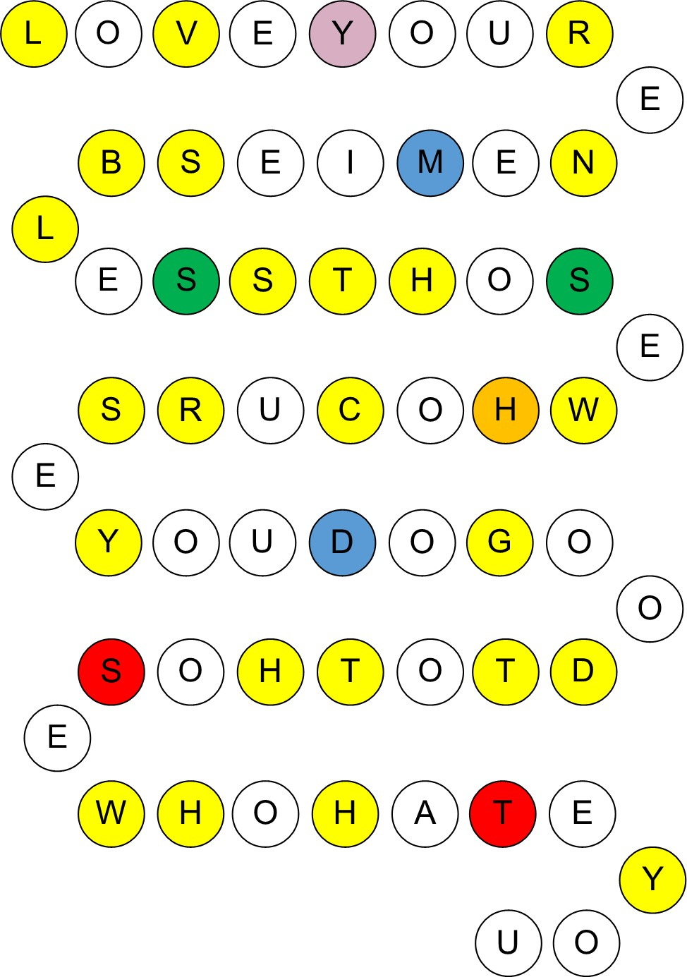

Note: the different colours have no significance in the activity. They are there to make it harder to form a sequence!

Answers:

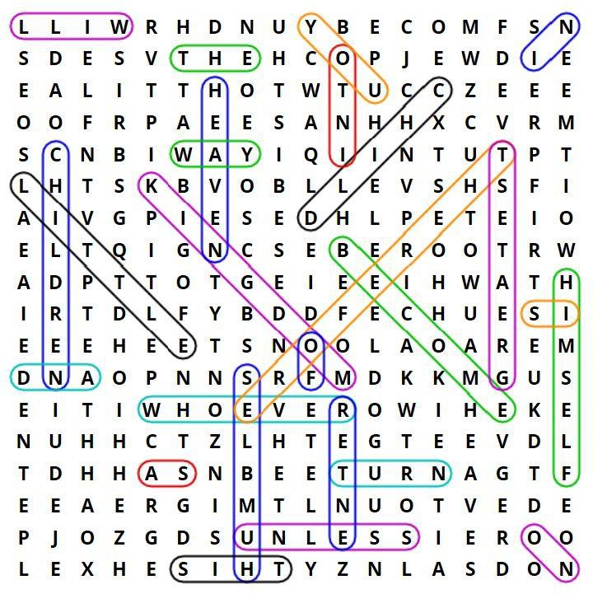
Matthew 18:2-4:
- Jesus called a little child to himself, and set him in the middle of them
- and said, ‘Most certainly I tell you, unless you turn and become as little children, you will in no way enter into the Kingdom of Heaven.
- Whoever therefore humbles himself as this little child is the greatest in
the Kingdom of Heaven.’

Answers:

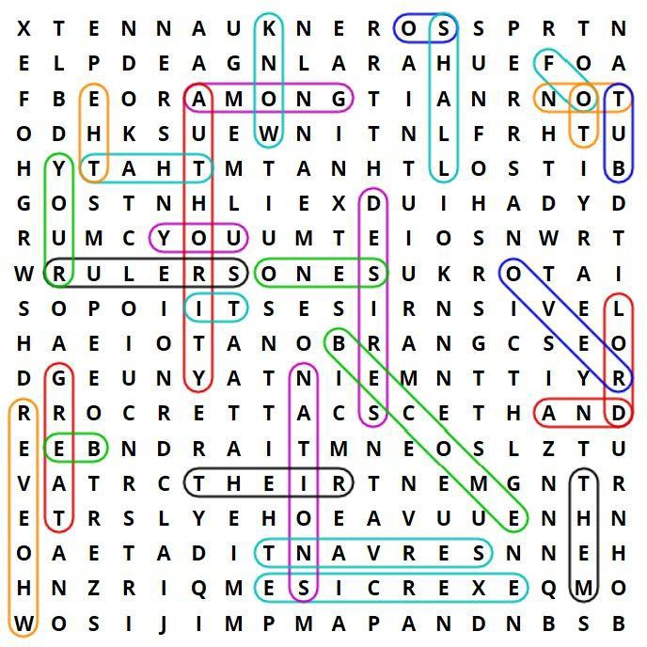

Matthew 20:25-26:
25 But Jesus summoned them, and said, ‘You know that the rulers of the nations lord it over them, and their great ones exercise authority over them. 26 It shall not be so among you; but whoever desires to become great
among you shall be your servant.’

Answers:

Here is the complete text with the corrected spelling mistakes in boxes. Student A’s corrected words are shaded, while Student B’s are not:

- Now after the Sabbat
h, as other
it began
to dawn on the first day of the
week,

Mary Magdalene and the

- Behold, there was a
great
and | rolled

Mary came to see the tomb.

earthquake, for an angel of t

rd descended
he Lo door

from the sky and came it.
appearance
away the stone from the
and sat on

- His
was like
lightning, and his clothing
as snow.

- For fear of him, the

shook, and became like dead
guards
white

men.

- The angel

answered

the

women, ‘Don’t be afraid, for I know that you seek

Jesus, who has been crucified.

is not here, for he has risen, just like he said. Come, see the place the Lord was lying.
6 He where
the see

- Go
quickly
and tell his disciples, ‘He has risen from
dead, and

behold, he goes before you into have told you.’
Galilee; there you will
him.’ Behold, I

- They bring his
disciples
departed
quickly from the tomb with fear and great joy, and ran to word.

Answers:

- Mark 1:4-8:

John came baptizing in the wilderness
and preaching the baptism of repentance
for forgiveness of sins.
All the country of Judea
and all those of Jerusalem went out to him.
They were baptized by him in the Jordan river,
confessing their sins.
John was clothed with camel’s hair
and a leather belt around his waist.
He ate locusts and wild honey.
He preached, saying, “After me comes he who is
mightier than I,
the thong of whose sandals
I am not worthy to stoop down and loosen.
I baptized you in water,
but he will baptize you in the Holy Spirit.”

- Synonyms:

  - worthy
  - forgiveness
  - thong
  - wilderness
  - mightier
  - water
  - baptize
  - locusts
  - preaching
  - country
  - leather
  - repentance
  - loosen
  - river
  - clothed with
  - sins

Holy Bible text courtesy World English Bible: http://ebible.org/web/MRK01.htm

Answers:
B.  The father: | 2, 11, 12, 16, 20
The elder son: | 6, 7, 10, 15, 19
The prodigal son: | 1, 4, 14, 17, 18
The father’s servants: | 3, 5, 8, 9, 13
C.

Answers may vary. Sample answers:

1. v.13 | 6. v.30 | 11. v.12 | 16. v.12
2. v.12 | 7. v.30 | 12. v.22 | 17. v.12
3. v.13 | 8. v.27 | 13. v.23 | 18. v.13
4. v.15 | 9. v.20 | 14. v.12 | 19. v.12
5. v.27 | 10. v.30 | 15. v.26 | 20. v.20

Answers:
B.  The father: | 2, 3, 9, 15, 20
The elder son: | 4, 7, 8, 12, 18
The prodigal son: | 1, 5, 11, 14, 17
The father’s servants: | 6, 10, 13, 16, 19
C.

Answers may vary. Sample answers:

1. v.18 | 6. v.21 | 11. v.17 | 16. v.27
2. v.12 | 7. v.29 | 12. v.30 | 17. v.17
3. v.23 | 8. v.13 | 13. v.25 | 18. v.29
4. v.30 | 9. v.32 | 14. v.15 | 19. v.27
5. v.15 | 10. v.27 | 15. v.28 | 20. v.32

Answers: B.
a) | entered | j) | saw
b) | was | k) | said
c) | was | l) | hurried
d) | was | m) | came
e) | was | n) | received
f) | ran | o) | saw
g) | climbed | p) | murmured
h) | came | q) | stood
i) | looked | r) | said
C.  1. | F | 11. | F
2. | F | 12. | F
3. | DK | 13. | T
4. | DK | 14. | T
5. | T | 15. | F
6. | DK | 16. | T
7. | T | 17. | T
8. | F | 18. | DK
9. | F | 19. | F
10. | T | 20. | DK

Answer:

Jesus said: “I am the way, the truth, and the life. No one comes to the Father, except through me.” John 14:6
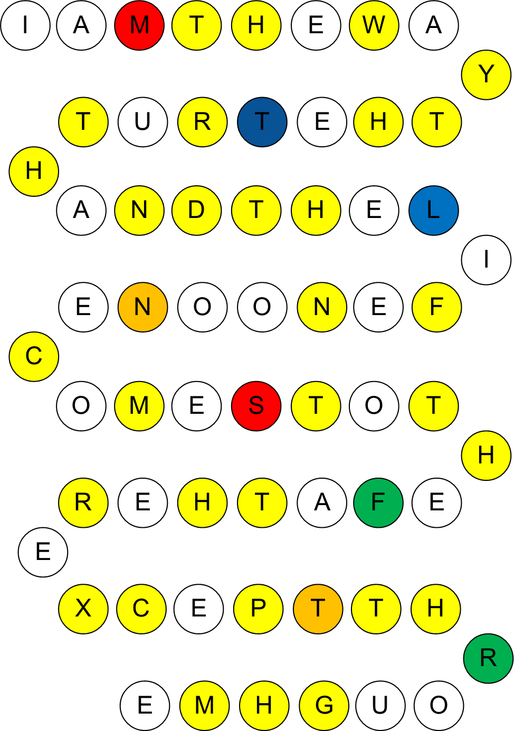

Note: the different colours have no significance in the activity. They are there to make it harder to form a sequence!

Holy Bible text courtesy World English Bible: http://ebible.org/web/JHN14.htm

Answers:

B.

- a) I, b) C, c) P.
- a) P, b) C, c) I.
- a) P, b) I, c) C.
- a) C, b) P, c) I.
- a) C, b) I, c) P.
- a) P, b) C, c) I.
- a) I, b) C, c) P.
- a) P, b) C, c) I.
- a) I, b) C, c) P.
- a) P, b) I, c) C.
- a) P, b) I, c) C.
- a) C, b) P, c) I.
- a) C, b) P, c) I.
- a) I, b) C, c) P.
- a) I, b) C, c) P.
- a) C, b) I, c) P.
- a) I, b) P, c) C.
- a) C, b) P, c) I.
- a) C, b) I, c) P.
- a) P, b) C, c) I.

Answers:

A.

Answers will vary.

B.

is, is, envy, brag, is, behave, seek, provoked, takes, rejoice, rejoices, bears, believes, hopes, endures, fails, are, done away with, are, cease, is, done away with, know, prophesy, is, come, is, done away with, was, spoke, felt, thought, become, put away, see, know, know, known, remain, is.

REVIEW

Answers:
  - Jesus said, ‘All things are possible with God.’ Mark 10:27

(Maybe an appropriate verse for students having problems with this book!)

 |  | N | O | A | H
 |  |  |  | L | A | C | K
G | E | N | T | L | E
 |  | E | S | T | H | E | R
J | O | N | A | H
 |  | C | H | I | L | D | R | E | N
 |  | N | I | N | E | V | A | H
 |  |  |  | G | O | L | I | A | T | H
 | A | P | O | S | T | L | E | S
 |  | O | B | A | D | I | A | H
 | G | U | A | R | D | S
 |  |  | S | E | R | V | A | N | T
 |  |  |  | P | A | R | T | Y
 |  |  | M | O | A | B
 | B | L | E | S | S
 |  |  |  | S | Y | C | A | M | O | R E
 |  |  | L | I | F | E
 |  | C | U | B | I | T | S
 | P | S | A | L | M | 1 | 8 | : | 2
 |  |  | H | E | A | L | E | D
 |  |  |  | W | A | I | T
 |  | F | A | I | L | S
C | R | E | A | T | I | O | N
 | R | A | C | H | E | L
 |  |  |  | G | A | Z | A
 |  |  | J | O | R | D | A | N
 | W | I | S | D | O | M

Holy Bible text courtesy World English Bible: http://ebible.org/web/index.htm

ELT Bible Study Pack #1

60+ hours of teaching material for Bible Study and English classes

About the author:
Matt Purland is an English teacher and materials writer from Cambridge in the UK. He has a BA Honours degree in Drama from the University of Wales and a Postgraduate Certificate in Further Education from the University of Derby. He has been teaching English since 1999 and writing resource books since 2003. This is his twenty-fifth book for teachers and students of English. He is married and lives in Poland with his family.

PurlandTraining.com
info@purlandtraining.com

Public Domain

