Elementary English Course

by Matt Purland

Volume 2 Unit 3: Health and the Human Body

Elementary Level (A1 / A2)

Unit 3.0

Health and the Human Body
Public Domain
The author and sole copyright holder of this document has donated it to the public domain. Anybody can use this document, for commercial and non-commercial purposes.

Unit 3.0

Health and the Human Body CONTENTS

4 | Unit 3.0 | INTRODUCTION | Health and the Human Body
12 | Unit 3.1 | GRAMMAR | Articles
25 | Unit 3.2 | GRAMMAR | SVOPT Word Order
36 | Unit 3.3 | PRONUNCIATION | Intonation
43 | Unit 3.4 | GRAMMAR | Past Simple and Past Continuous
53 | Unit 3.5 | GRAMMAR | Common Regular and Irregular Verbs
69 | Unit 3.6 | GRAMMAR | This, That, These, and Those
77 | Unit 3.7 | VOCABULARY | Daily Routines
87 | Answers

Unit 3.0

INTRODUCTION

Health and the Human Body

Unit 3.0 Health and the Human Body

    - This unit is called Health and the Human Body. We are going to learn about the following topics:
      - Articles
      - SVOPT Word Order
      - Intonation
      - Past Simple and Past Continuous
      - Common Regular and Irregular Verbs
      - This, That, These, and Those
      - Daily Routines

Exercises

Ex. 3.0.1 Speaking Discuss the following questions with a partner or small group:

- Have you ever been to hospital? Tell me about it.
- What would you do if a member of your family, or your best friend, had an accident?
- How healthy are you? How often do you get ill? Do you go to the gym or exercise regularly?
- What do you like the most / the least about your body? What would you like to change about your body if you could?
- Would you ever consider having plastic surgery? If yes, what would you have done, and how would you pay for it? If no, why not?
- What is the name, address and phone number of your dentist?
- How would you make an appointment with your doctor – in English?
- How often do you get your hair cut? Where do you get it cut? How much does it cost? Would you recommend your hairdresser? When did you last have a new hairstyle? When are you planning to have a new one? Have you got any tattoos or body piercings? If yes, where are they? Why do people have them?
- Do you know anyone who is a hypochondriac? Are you one? Tell me more.
- Do you take vitamin supplements or natural remedies? Do they have any effect?
- In your opinion, who are the most attractive people in the world? Why are they attractive? What makes a person attractive? Is beauty only skin deep?
- How would you feel, and how would you handle it, if you lost your… a) hair b) sense of taste
c) sight d) hearing e) arms f) legs g) speech?
- Would you like your body to be cryogenically frozen when you die so that you can perhaps be brought back to life in the future? Why? / Why not?
- Do you carry a donor card? Would you like to give another person part of your body when you die? Why? / Why not? Should it be compulsory to carry a donor card?
- Who is the unhealthiest person you know? Have you tried to encourage them to be healthier? Tell me more.
- If you could swap bodies with somebody else for one day, who would it be? Why? What would you do?

Ex. 3.0.2 Vocabulary Here are the parts of the body. Translate them into your language and learn them:

hair forehead
nose

nostril
head
cheek

mouth
face
lip

throat
inside: teeth, tongue, tonsils
eyebrow

eye ear chin neck
17.

behind: back 

elbow wrist
hand

thumb

body
shoulder chest arm abdomen waist
hip
nerve spine
blood

vein

skin
kidney stomach pancreas intestines appendix bladder

other parts of the body:
bone skeleton
muscle

liver

lung
internal organs:
brain larynx trachea (windpipe) _ heart

finger (nail) thigh

calf foot
toe (nail)
leg

knee

ankle

Ex. 3.0.3 Speaking Work with a partner or small group. Study the vocabulary on this page and p.6. Think of some real-life situations where you could use the following functions, then create short dialogues or role plays based on the topic of Health and the Human Body:

- tell
- explain
- warn
- confirm

Ex. 3.0.4 Writing Here are 30 words connected with the topic of Health and the Human Body.
Translate them into your first language and learn them:

1. toothbrush |  | 16. crutch
2. health |  | 17. ambulance
3. emergency |  | 18. nurse
4. illness |  | 19. tablets
5. pharmacy |  | 20. examination
6. surgery |  | 21. x-ray
7. stethoscope |  | 22. doctor
8. stretcher |  | 23. plaster
9. toothpaste |  | 24. appointment
10. hospital |  | 25. prescription
11. dentist |  | 26. wheelchair
12. injection |  | 27. patient
13. stitches |  | 28. accident
14. receptionist |  | 29. problem
15. waiting room |  | 30. needle

Ex. 3.0.5 Writing Translate the health problems into your first language and learn them, then put them into groups below. Note: answers may vary and provoke discussion!

- infection
- cut
- stomach ache
- broken bone
- cancer
- HIV / AIDS
- headache
- fever
- allergy
- rash
- toothache
- migraine
- sunburn
- diabetes
- heart attack
- cold
- Parkinson’s disease
- flu
- leukemia
- asthma

not serious: | serious: | life-threatening:

Ex. 3.0.6 Vocabulary Write the parts of the body:

h

n f

n e
h
c e

m e
_
f
l c

t n

inside: t , t , t
internal organs:

b _n l _x t a (w e) h_ t l _g l _r k _y
s _h p s i _s a x b r

other parts of the body:
b _e s _n m _e s _n v _n n_ _e s _e
b _d

behind: b  s

c
b
a
e
a
w
w
h
h
t
l
f r (n l)

t
k

c
a
f

t (n l)

Ex. 3.0.7 Writing Draw an outline of a human body and label it with 20 (or more) external
parts:

Ex. 3.0.8 Writing Draw an outline of a human body and label it with 10 (or more) internal
parts:

Ex. 3.0.9 Reading Solve the anagrams and write the names of 20 parts of the body:

1. are 11. daeh
- knec  - osen |  | - hoctsma  - oludsreh
4. yee |  | 14. anhd
5. rottha |  | 15. techs
6. gel |  | 16. loebw
7. kelan |  | 17. ote
8. tofo |  | 18. kabc
9. grenif |  | 19. thoum
10. ram |  | 20. eekn

Ex. 3.0.10 Reading Complete the parts of the body with vowel letters:

- sp n
- ch k
- tr ch
- f r h d
- wr st
- th mb
- t th
- br n
- k dn y
- h r
- m scl
- y br w
- th gh
- l rynx
- v n
16. t n l
- n str l
- nt st n s
- b w l
- l v r

Ex. 3.0.11 Speaking & Listening Complete the table with a partner or small group, then create role plays based on the different patients visiting their doctor. Try to use the functions from Ex. 3.0.3 too:

 | Patient & Age: | Symptoms: | Diagnosis: | Treatment: | Result after Two Weeks:
Example: | Mrs. Jones, 44 | runny nose | cold | rest; hot honey and lemon drinks | cured / better
1
2
3
4

For homework, students could write up each patient’s notes as a doctor’s report, e.g.

“Mrs. Jones came to see me on Monday. She had a runny nose and I diagnosed a cold. I told her to rest and encouraged her to drink hot honey and lemon drinks. After two weeks I saw her again and she confirmed that she felt much better...”

Ex. 3.0.12 Writing Write about a memorable visit to your doctor, dentist, or a stay in hospital:

Name: Date:

Unit 3.1

GRAMMAR

Articles

Unit 3.1 Articles

    - There are only three articles in the English language – a, an (indefinite articles), and the (definite article) – but they cause an enormous amount of confusion among students! They can be difficult to understand because many languages do not include them so they cannot be translated, e.g. Polish, Japanese, and Russian. Articles are function words, rather than content words, and belong to a larger group of words called determiners. Unfortunately, we need to study articles because these words are very common in the English language. In fact, the is the most common word in written English, while a is #6 and an is #32. We often need to put an article before a noun. Which article we use and whether we use one at all depends on the type of noun and the context:

 | Type of Noun: | Example: | Context: | Use this Article:
A | singular countable | book | general | a (before a consonant sound)
B |  |  |  | an (before a vowel sound)
C |  |  | specific | the
D | plural | books | general | zero article
E |  |  | specific | the
F | uncountable – concrete | water | general | zero article
G |  |  | specific | the
H | uncountable – abstract | music | general | zero article
I |  |  | specific | the
J | proper | Barcelona | N/A | zero article
If you are unsure about using articles you should check your writing when you finish: look at each noun, think about what type it is and the context, and whether an article is required – or not.

See also the larger photocopiable version of this table on p.16.

    - Why do we even need articles anyway? One of the advantages they have is that they introduce a weak stressed syllable with a schwa sound right before a content word, which often has a strong stressed first syllable.This helps to emphasis the content word, from which we get meaning, as well as creating the typical rhythm and ‘bounce’ of spoken English. For example:

o / o o / o / o /

I’m reading a book. sounds much better than: I’m reading book. It sounds more like English.

    - As you can see from the table above, if the noun is singular and countable there must be an article before it. If the context is general, you can use a or an. We use an before a noun that begins with a vowel sound, e.g.

A: I need a book. noun begins with a consonant sound = use a
B: I need an egg. noun begins with a vowel sound = use an

In both sentences the context is general – we don’t know anything about the book or the egg. It is the first time they are mentioned = first mention.

In the following sentence, because we now know about the two nouns (book and egg), the context becomes specific and we use the.

C: This is the book I need. C: This is the egg I need.

If a countable noun is plural and the context is general or it is first mention, we don’t use an article. This is called “zero article” – when there is no article, e.g.

D: I like books.

But if the context is specific – the noun is defined in some way – then we use the: E: The books in this library are really old.
The same applies to uncountable nouns – both real (concrete):

F: I use water every day. general context, i.e. any water = no article
G: The water is very hot. specific context, i.e. this water = use the

...and abstract:

H: I love music. general context, i.e. all music = no article
I: The music in this club is great. specific context = use the

Proper nouns are words which always start with a capital letter, like the
names of people (“Eric Harrison”), cities (“Birmingham”), countries (“Mexico”), companies (“McDonalds”), products (“Coke Zero”), days (“Monday”), months (“December”), etc. We do not usually put an article before a proper noun.
Exception 1: when the proper noun is made up of an adjective + noun (e.g. “United”
= adjective + “Kingdom” = noun) we need to use the definite article: “I live in the United Kingdom.”

J: Barcelona is such a beautiful city. NOT The Barcelona...

Exception 2: We use the definite article with plural place names, e.g. the Bahamas. If you are still not sure which article to use with each noun in your text, use the flow chart on p.17.

    - Some example errors:

“I live in the house in Bristol.”
Use a because there is more than one house in Bristol!

“What’s a phone number for the swimming pool?”
Use the because the swimming pool has got one specific phone number.

“Music was too loud so we had to leave.”
Use the because in this context music is specific – the music in that place.

    - We use the when the noun is specific or known to each person in the conversation. For example:

I went to the new cinema on Leyland Street last night.
It is a specific cinema – not just any cinema. We cannot say “...a cinema on Leyland Street” because it is very unlikely for there to be more than one!

Let’s switch on the TV and watch Coronation Street.
The person or people I am talking to know about the TV and can probably see it because we are all in the same room.

We also use the before superlative adjectives and ordinal numbers:

It is the best TV programme. best is the superlative form of the adjective ‘good’

I’m the first person to finish! first is an ordinal number (of one)

Interestingly, the word the has two different pronunciations:

- before a consonant sound: | th | with an embedded schwa sound
- before a vowel sound | thii | with a short ii sound

    - We can use the determiner some before plural and uncountable nouns instead of zero article:

I would like spaghetti. > I would like some spaghetii.

It sounds better because the weak stressed word some has a schwa sound and this extra weak syllable improves the rhythm and ‘bounce’ of the sentence. It sounds more naturally English:

o o / o / o o o / o o / o I would like spaghetti. > I would like some spaghetti.

If the sentence is negative or a question form we use any instead of some: Would you like any spaghetti? / No, I wouldn’t like any spaghetti.
    - We use a when we talk about frequency or quantity: ‘Once a week.’
‘Three times a day.’ ‘£1.15 pence a litre.’

    - If the thing has one or more modifier before it – e.g. an adjective or an intensifier – the article goes before the first modifier:

‘It was a great party.’
‘My grandma had a really lovely day.’

    - We can use a possessive adjective (e.g. my, your, our, etc.) instead of an article – but never with an article! – when the noun belongs to somebody:

This is a book. > This is my book. This is a my book. / This is her the book.

Or we can use different determiners, e.g. this, that, these, those instead of an article
– but never with an article:

I want a book. > I want this book. I want this a book. / I want these the books.

See also the information on p.18 regarding articles and how to use them.

Use of Articles in English

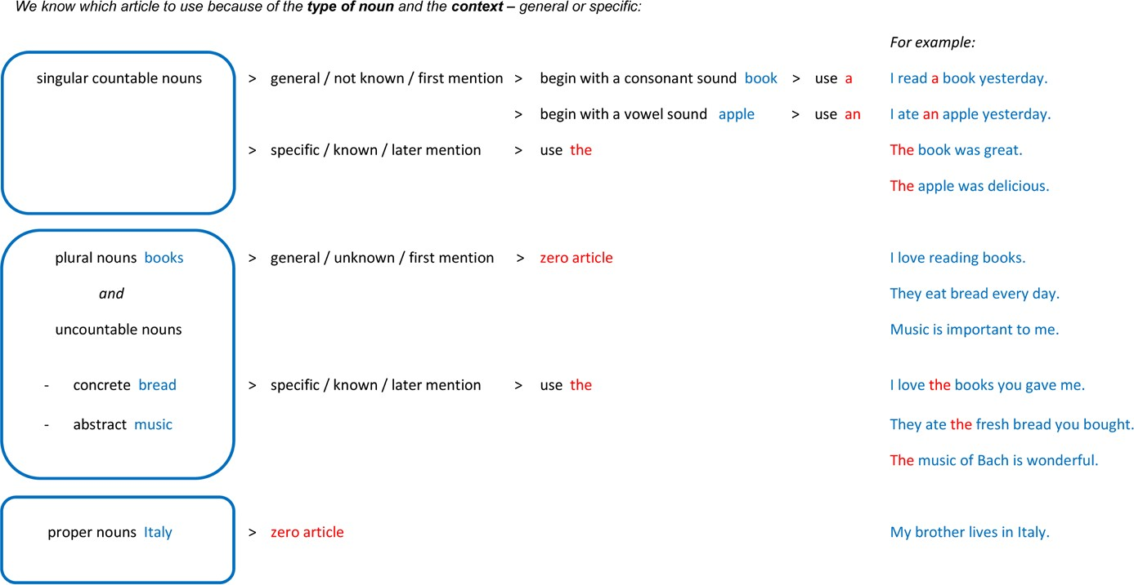

Use of Articles in English – Flow Chart

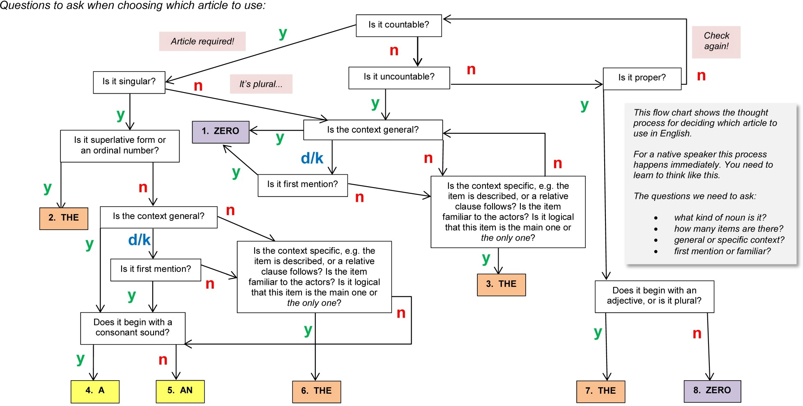

Understanding Articles in English

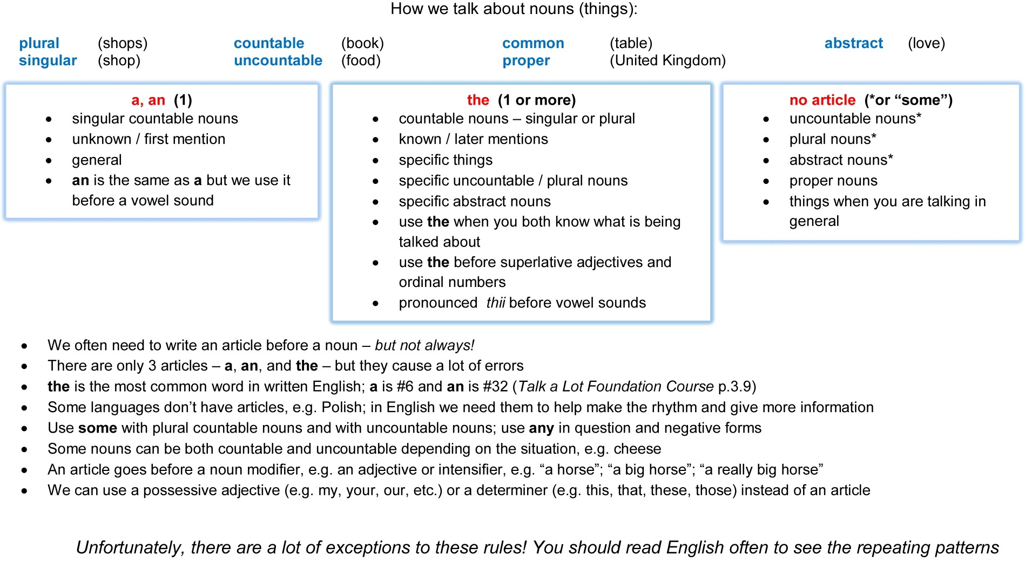

Exercises

Ex. 3.1.1 Writing Which indefinite article should we write in front of the following words - ‘a’ or ‘an’?

1. chair | 11. address | 21. number
2. girl | 12. ear | 22. heater
3. school | 13. sheep | 23. interview
4. egg | 14. tie | 24. appliance
5. hour | 15. union | 25. heir
6. apple | 16. orange | 26. computer
7. exam | 17. ice cream | 27. bag
8. hospital | 18. pencil | 28. octopus
9. year | 19. umbrella | 29. ewe
10. university | 20. shoe | 30. fridge

Ex. 3.1.2 Writing Complete the four gaps in each question with a, an, the, and - (zero article):

      - - Do you like a) Copenhagen?
        - Yes, I do. b) first time I came here I stayed in c) tiny guest house. The owner had
d) enormous dog!

      - I read a) good book last week.
- book was by Alfredo Montessauri. He is
- Italian writer. I got a lot of d) pleasure from it.

      - a) Sarah works at b) bank. c) bank is forty miles from her home. She has
- eighty-minute commute each way.

      - I really love a) fish, and b) fish in this restaurant is superb. I’m looking forward to eating
c) big juicy fish in d) hour from now!
      - I went to a) swimming pool yesterday. b) little boy fell over and had to have
c) treatment on his leg. d) assistant said that he would be OK.

      - - I can meet you tomorrow.
        - Have you got a) time?
-Yes. I’ve got b) appointment with
- builder at eleven, but I can change
- time.

      - - Don’t be late for a) work, or
b) manager will be angry with you.
        - OK, I will use c) alarm clock and also ask
d) friend to give me a wake-up call at six o’clock.

      - - I bought a) blue guitar on Wednesday.
        - The one I saw? Super! Can you play it?
        - No, but I’m having b) few lessons with
c) old guy called d) Barry.

      - - Have you seen a) old jumper anywhere?
        - Is it b) one with the blue collar?
        - Yes, and it’s got c) orange stripes.
        - It’s over there, under d) pile of cushions.

      - I went to a) post office yesterday to post
b) parcel. It cost about c) twenty pounds, which I thought was d) extortionate amount of money.

      - One of our neighbours is a) guy who hails from b) Finland. He is c) interpreter who works at d) same firm as my uncle.

      - - Let’s put a) kettle on and have b) nice cup of tea.
        - Good idea! There’s c) open packet of chocolate biccies in the cupboard! What shall we drink to?
        - To d) friendship!

      - I haven’t been to a) work for fourteen days because I’ve had b) really bad back. I got c) awful pain at the base of my spine and
d) doctor told me that I had to rest.

      - - Shall we meet at a) Burger King, or

b) new coffee house in Market Street?
        - They’ve got c) offer on at the moment – if
you buy d) latte, you get two free mini doughnuts.

      - Geoffrey Chaucer was a) English poet and philosopher who is considered by b) scholars

to be c)

The Canterbury Tales is d) of literature.
greatest writer of the Middle Ages.
wonderfully rich piece

      - - Is there a) free table anywhere in this café?
        - Yes, look – b) table by the window is available. Oh – hang on – c) old feller’s just sat down.
        - Just our d) luck!

Ex. 3.1.3 Reading Print the worksheet on p.21 titled ‘Noun Categories’ and follow the instructions.

Ex. 3.1.4 Reading Print the worksheet on p.22 titled ‘Use of Articles in English – 40 Question Quiz’ and follow the instructions.

Noun Categories

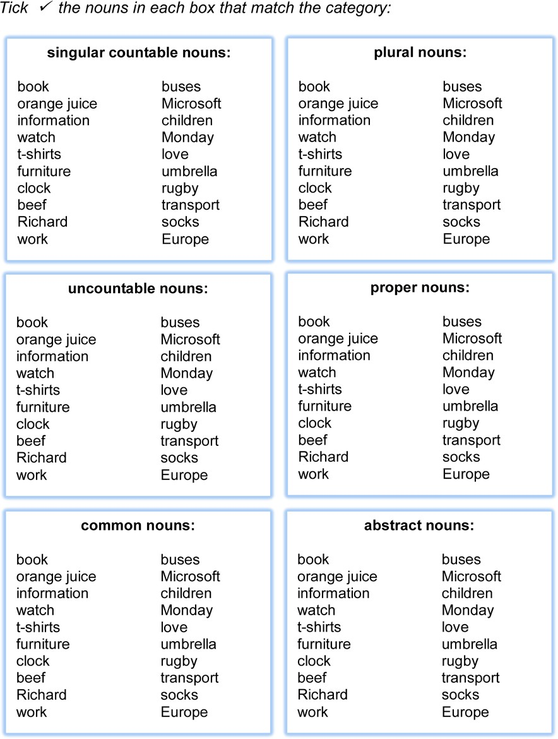

Use of Articles in English – 40 Question Quiz

Write a, an, or the in each gap, or put - to mean zero article

He was born in August.
- John sells bikes every day.
- Do you want spaghetti today?
- It was hottest day ever!
- He prefers Adidas.
- I put unopened letters over there.

- Is
- Would you like
clock slow, or is it me?
apricot?

- We were moved by kindness that he showed.
- I got puppy yesterday.

- We’ve booked taxi for you.
- Do you believe in justice for everybody?
- Please would you put rubbish out?
- What about beef for dinner?
- Is milk semi-skimmed or skimmed?
- It seems that mobiles are getting bigger rather than smaller!
- Do you fancy omelette?

- Has
- I didn’t know that
power come back on yet?
dictionary belonged to you.

- Have you eaten chocolate from Grandma?

- Both of us took umbrella just in case.
- We’ll ask her for information tomorrow.
- There were toys everywhere!
- It’s so important that you tell me truth about them.
- These are channels that I watch most often.
- He lived on Porter Road when I used to know him.
- Surprisingly, unemployment had fallen again.
- I need new kettle, because this one is broken.
- Can you bring me all empty coffee cups, please?
- You are first person I have truly loved!

- We’ll be upset if he gets infection.
- Be careful! It’s made of glass.
- How essential is quality to you?
- You need to replace printer paper.
- We start to develop teeth when only a few months old.
- She found pen outside.
- I don’t like peanut butter.
- He was pleased with poetry that he had written.
- I told them about Amanda.
- Our swimming costumes were dry, but children’s weren’t.

Ex. 3.1.5 Writing Remember the main point: we know which article to use because of the type of noun and the context – general or specific. Look at the summary of rules for using articles in English from 3.1.1:

 | Type of Noun: | Example: | Context: | Use this Article:
A | singular countable | book | general | a (before a consonant sound)
B |  |  |  | an (before a vowel sound)
C |  |  | specific | the
D | plural | books | general | zero article
E |  |  | specific | the
F | uncountable – concrete | water | general | zero article
G |  |  | specific | the
H | uncountable – abstract | music | general | zero article
I |  |  | specific | the
J | proper | Barcelona | N/A | zero article
  - Underline the noun in each sentence. Say what kind of noun it is
  - Write a, an, or the in each gap, or put - to mean zero article
  - Write a letter A-J to show which rule the sentence follows

Type of Noun: Rule:

- Do you often listen to music?
- He said new employees were wonderful.
- It was second time I had asked you.
- Is chewing gum allowed?
- I watched good film yesterday.
- She lived in Paris.
- I downloaded app last week.
- He often bakes cakes.
- I would like biggest potato.
- He always drinks Coca-Cola.
- I was surprised by progress we made.
- He has bought new car.
- She thought that rice was a bit undercooked.
- I wonder why children love to play.
- I ate egg yesterday.
- He didn’t have patience to be a teacher.
- I showed her red socks that I had bought.
- We have already spent money you gave us.
- I believe that perseverance is important.
- He has got short brown hair.

Ex. 3.1.6 Writing Follow the instructions from Ex. 3.1.5:
Type of Noun: | Rule:
a) He needs to cut grass.
b) He looks similar to Darren.
c) She doesn’t like ice cream.
d) I used green pen.
e) She is looking for work.
f) Would you like orange?
g) This is second photo that he took.
h) We appreciate dedication that you have shown.
i) I think students should always work hard.
j) We arrived on Tuesday.
k) We’ll get petrol later on.
l) I didn’t have courage that I needed.

m) Sometimes life is hard.
n) I put on coat and went out.
o) I don’t usually get colds.
p) We suggested idea to her.
q) They preferred leather furniture.
- Did you understand assignments from yesterday?
- She picked up book and started to read it.
- Are chips ready yet?

Ex. 3.1.7 Reading a) Read the text, which has a gap before every noun. Complete the gaps with a, an, the, or - (zero article):

Yesterday 1.
Ellen went to 2.
new clothes shop on 3.
Bude

Street and bought 4.
new dress. 5.
dress was light green and had

6. white collar. She also went to 7. supermarket and bought

8. groceries. She needed to get 9. chocolate cake and 10.

candles for 11.
birthday party on 12.
Monday. On the way home she had

13.
idea and phoned 14.
friend. 15.
Mandy is 16.

florist who works near 17.
health centre. 18.
Ellen asked 19.

Mandy to order 20. flowers.

- Look at the 7 statements below and say which one applies to each article in the text:

  - We use a or an because the noun is singular, countable, and in a general context. It is first mention.

  - We use the because the noun is used again – after first mention. We are already familiar with it.
  - We use the because it is logical that there is only one of these nouns, so it is something
specific.
  - We use the because the noun is something specific or something familiar to us.

  - We do not use an article (zero article) because the noun is a proper noun.
  - We do not use an article (zero article) because the noun is plural or uncountable and in a general context.

  - We use a possessive adjective (e.g. my / her) because it is clear that the noun is something that belongs to somebody or is closely connected with them.

1. | 11.
2. | 12.
3. | 13.
4. | 14.
5. | 15.
6. | 16.
7. | 17.
8. | 18.
9. | 19.
10. | 20.

Unit 3.2

GRAMMAR

SVOPT Word Order

Unit 3.2 SVOPT Word Order

    - Word order in a sentence in English is fairly strict compared to other languages. We often use SVOPT word order in a sentence:

S | V | O | P | T
subject | verb | object | place | time
e.g. I, you, we, Jenny |  | noun phrase | adverbial of place | adverbial of time
For example:
S | V | O | P | T
subject | verb | object | place | time
Jenny | ate | a sandwich | in the kitchen | last night.

This is the order in which English native speakers want to get their information. We generally want to know:

1st who does the action S ubject
2nd what they do V erb
3rd what they do it to O bject
4th where they do it P lace
5th when they do it T ime

    - It is possible to put the time phrase first in the sentence, if you want to emphasise that piece of information:

T | S | V | O | P
time | subject | verb | object | place
Last night | Jenny | ate | a sandwich | in the kitchen.

However, it is better to start with the subject so that we establish WHO is doing the action first. We also get time information from the verb tense. For example, by using the past tense verb ‘ate’ we understand immediately that the action happened in finished time, in the past. This time information is sufficient until we get final confirmation of the exact time at the end of the sentence: ‘last night’.

    - However, changing the word order in other ways is not permitted in English. For example, the following sentences would be incorrect:

V | O | S | P | T
Ate | a sandwich | Jenny | in the kitchen | last night.
P | S | V | T | O
In the kitchen | Jenny | ate | last night | a sandwich.

They just sound like jumbled up sentences, rather than English. It may be that the person listening can work out what you are saying because all the keywords are present and they are able to ‘unjumble’ them in their mind as you speak, but it makes a lot of extra work for your listener, who is rather expecting to hear the information presented in SVOPT order.

    - Not every verb has an object, so sometimes this part of SVOPT will be blank. They are called intransitive verbs. For example:

S | V | O | P | T
subject | verb | object | place | time

Jenny goes - to Birmingham every Friday.

The verb ‘go’ does not have an object. It is intransitive, so the O part of SVOPT is blank.

    - Similarly, we do not need to include every part of SVOPT word order in every sentence. It is the order that is important and should be followed:

S V O P T
subject verb object place time Jenny ate a sandwich. - last night.

    - We can easily turn a SVOPT sentence into a compound sentence but using a conjunction such as:

Jenny ate a sandwich in the kitchen last night...

and | = addition | e.g. | ...and then read a book.
but | = contrast | e.g. | ...but she didn’t enjoy it.
because | = reason | e.g. | ...because she felt hungry.
so | = result | e.g. | ...so she wouldn’t feel hungry in the night.

Exercises

Ex. 3.2.1 Writing Write 10 sentences with SVOPT word order. You don’t need to include an object each time:

subject verb object place time

1.

2.

3.

4.

5.

6.

7.

8.

9.

10.

Ex. 3.2.2 Writing Complete the worksheets on pp.29-32: Make a Sentence with SVOPT – Subject Verb Object Place Time 1-4.

Ex. 3.2.3 Writing Complete the worksheets on pp.33-34: Sentence Building with SVOPT Word Order 1-2.

Ex. 3.2.4 Writing Complete the worksheet on p.35: Practice with SVOPT-R Word Order.

Make a Sentence with SVOPT – Subject Verb Object Place Time 1

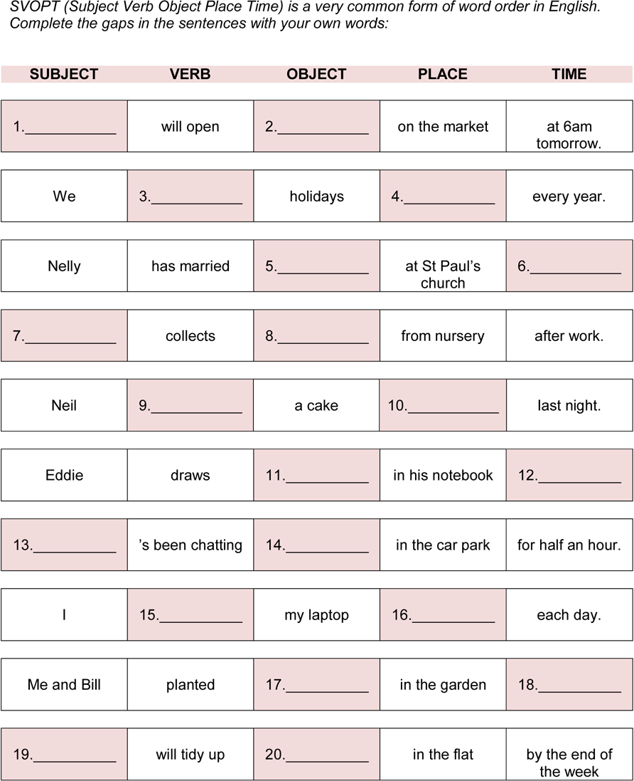

Make a Sentence with SVOPT – Subject Verb Object Place Time 2

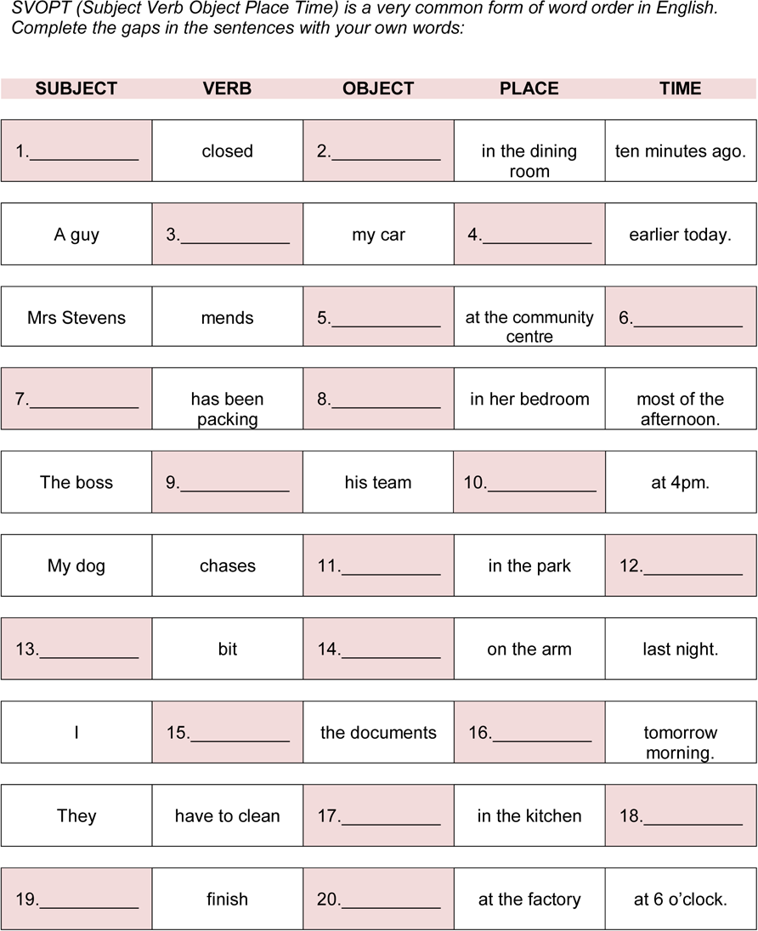

Make a Sentence with SVOPT – Subject Verb Object Place Time 3

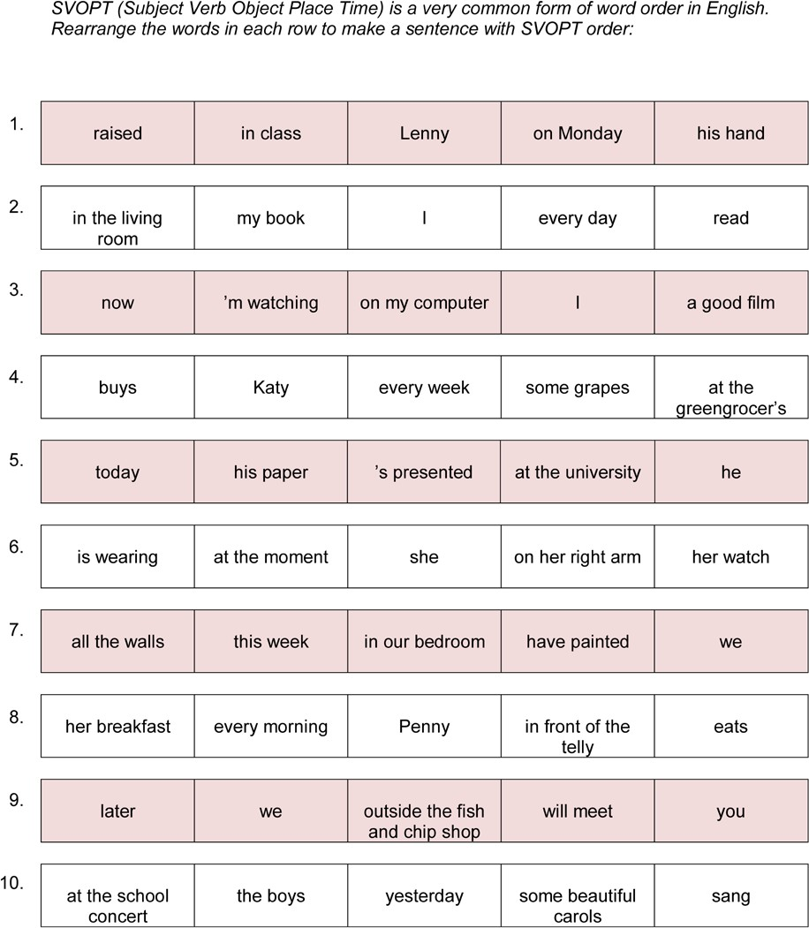

Make a Sentence with SVOPT – Subject Verb Object Place Time 4

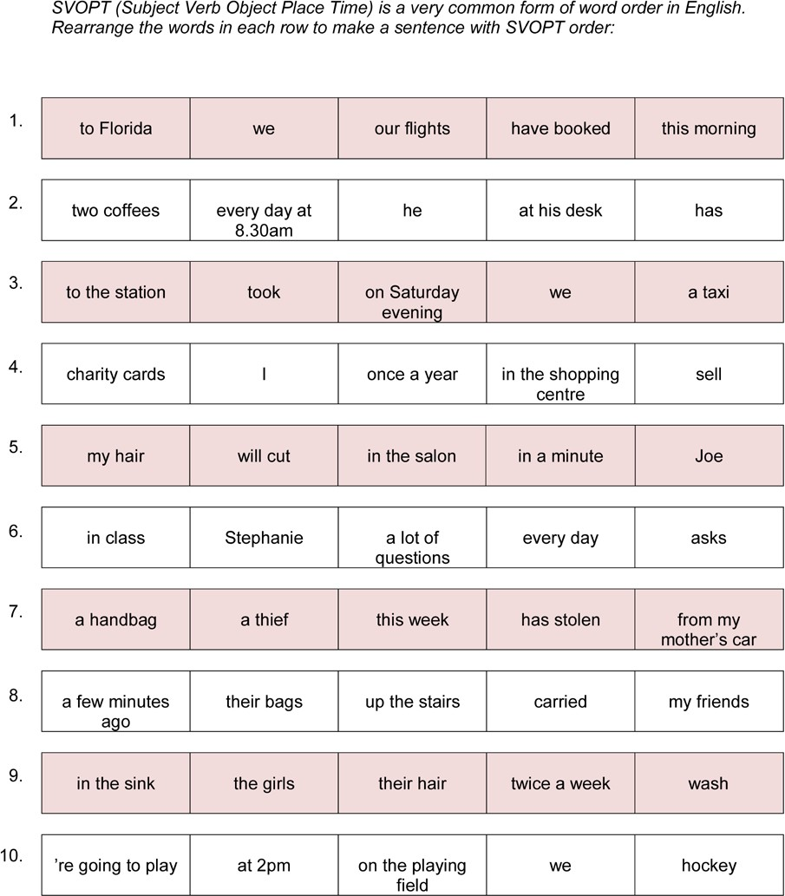

Sentence Building with SVOPT Word Order 1

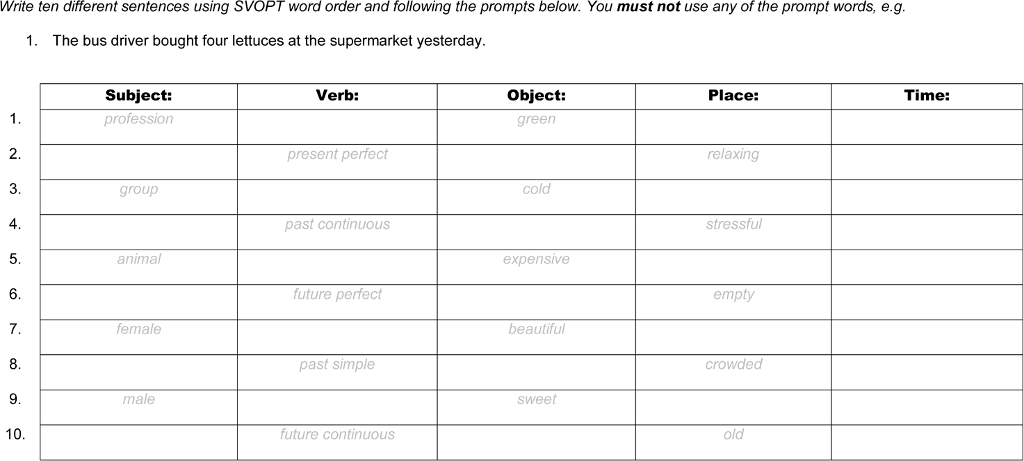

Sentence Building with SVOPT Word Order 2

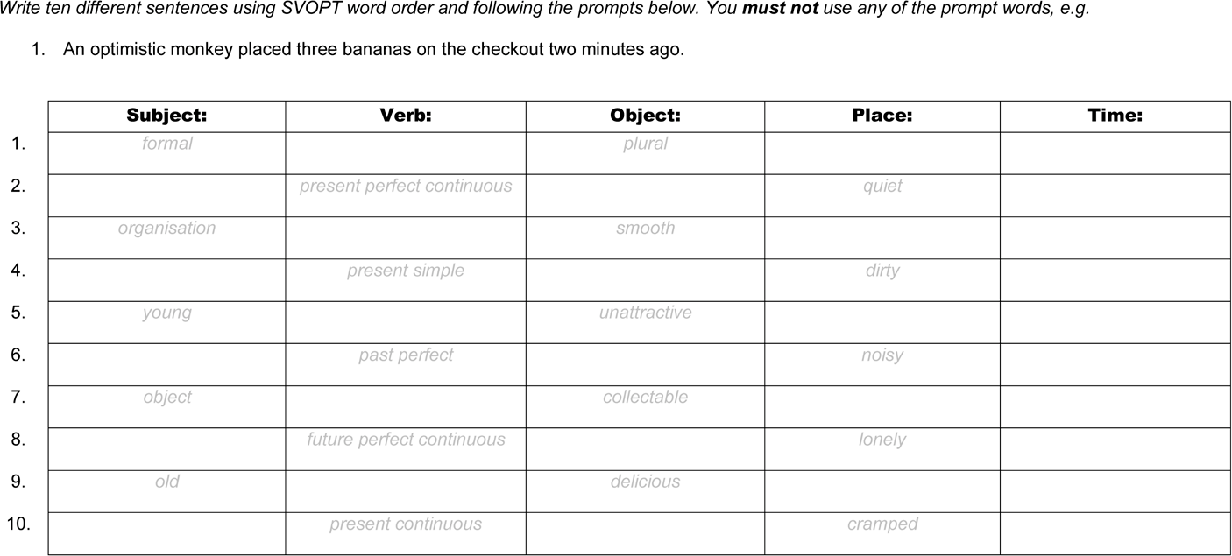

Practice with SVOPT-R Word Order
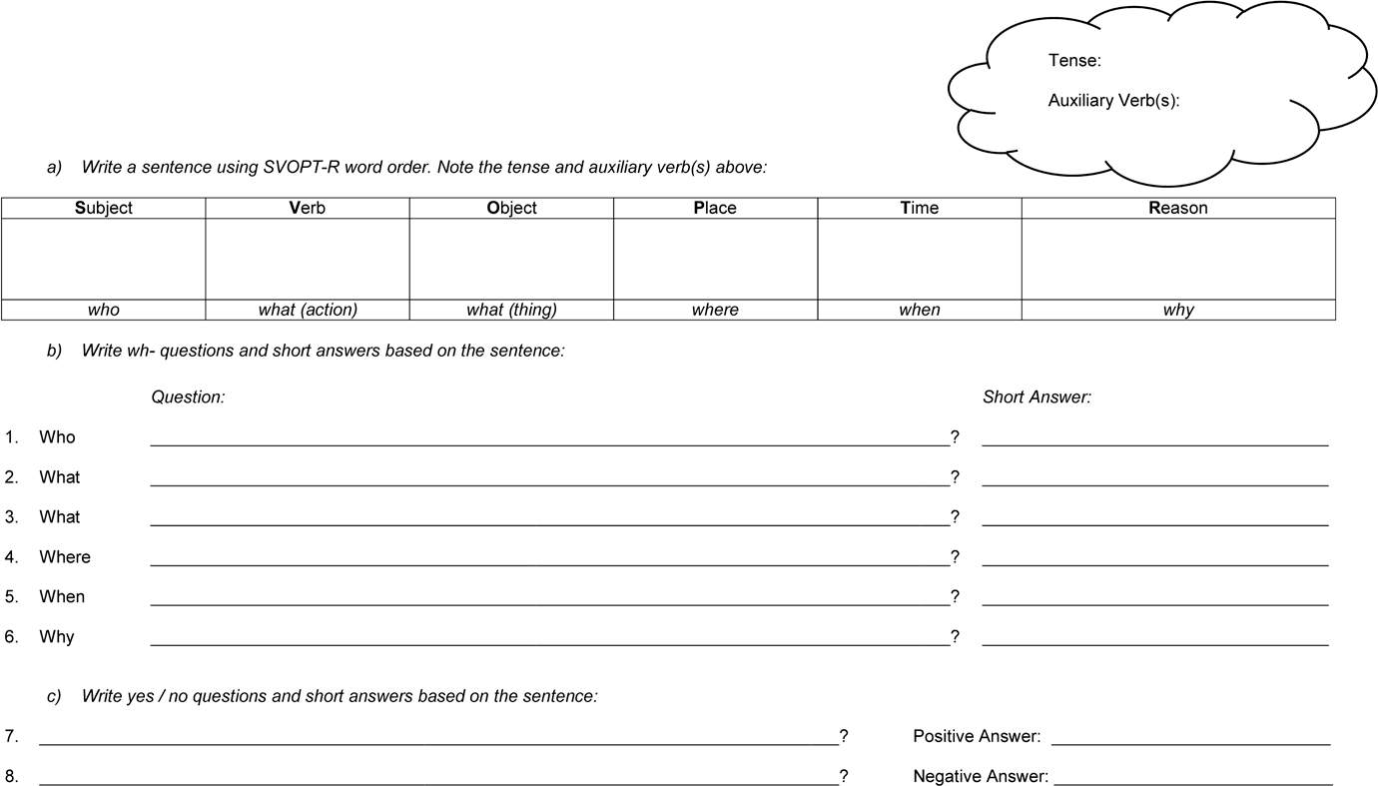

Unit 3.3

PRONUNCIATION

Intonation

Unit 3.3 Intonation

    - Along with the phonetic alphabet, sentence stress, and connected speech, intonation is an important element in learning English pronunciation. Read the information on the following two pages and check that you understand it. You could discuss it with a partner or small group, and be sure to ask your teacher to explain anything you don’t understand.

    - Study the table of 21 English Sounds and Words where Intonation Changes the Meaning on p.42. There are some short sounds and words in English that have different meanings depending on the intonation. Practise saying them out loud. How many are familiar to you? How many are the same or similar in your first language? See how many you can hear when you are listening to real English conversations. You could create role plays with a partner where you use a number of these sounds or words.

Exercises Ex. 3.3.1 Writing Complete the exercises on p.40.

Intonation

- In short, intonation means the ups and downs of the voice in a sentence. Good pronunctiation involves three elements: sentence stress (the sound spine), connected speech (connecting syllables, not speaking word by word), and intonation. Varied intonation is more interesting than robotic, monotonous speech, and therefore easier and more appealing to listen to. For example, when reading aloud we should aim to “lift the words from the page” using intonation, rather than reading in a flat boring voice.

Stress is non-negotiable – the sound spine must be heard clearly – and connected speech is a must if you want to sound natural. But stress and connected speech are not enough – we need to use intonation. For example, we could have correct stress and connected speech, but still sound flat, dull, and emotionless. Without hearing emotion we cannot be sure of the speaker’s intention. English intonation is more familiar to speakers of some languages than others, e.g. European students of English may find English intonation patterns more familiar than speakers from the Middle East or the Far East. However, many non-English speakers of English would agree that English intonation (and stress) seem “too much” – too exaggerated – when compared with their language.

- Let’s say that we are clear about the sound spine of our sentence and we are using connected speech. What about intonation? Standard (neutral) intonation in a statement (not a question) usually involves going on a journey: up the mountain and back down again. We usually go up around the middle of the sentence, and back down at the end. We must have closure. Let’s take an example of a short sentence. We go up in the middle, either: a) at a clause break, e.g.
I went to the post office, because I needed to buy stamps. or b) on the key concept word, e.g.
I met my friend in the park. (“friend” is the key concept word – it is the main point of the sentence)

In a longer sentence, or a list, there will be more ups and downs. We have to decide which specific words or phrases are the most important in our communication. By “going up” on them we give them emphasis, e.g.
I met my friend with his aunt and brother in the park.

- Intonation in questions usually depends on the kind of question:
  - For yes/no questions – we go up at the end (rising intonation). The listener feels compelled to answer, because we need closure. For example,
Do you want a lift home?

  - For wh- questions (what, where, when, etc.) – we go down at the end (falling intonation). For example: Where has Tony gone?
  - When the speaker uses a question tag, they can go up if they want to check some information, e.g.
The concert starts at eight, doesn’t it?

  - ...and down if they are making a general statement and believe that the listener will agree, e.g.
We’ve had a lovely day, haven’t we?

We can add extra emphasis when replying to questions, depending on what part of the sentence the speaker asked about. In the sentence below there are seven possible wh- questions that could be asked.

John | rode | his bike | to the city lake | quickly | yesterday, | because he was late.
who | what – action | what – object | where, which | how | when | why

For example, if somebody asked: “Who rode their bike to the city lake?” you could put extra emphasis on the name in the answer, by going up on the word “John”: John rode his bike to the city lake. or John did.

Other intonation techniques include:

- Rising intonation at the end of a statement when we want to continue without being interrupted, e.g.
I wanted to get some rice at the supermarket. You know, the one on the corner. And it was closed, so...

- When making a list we use rising-falling intonation, e.g.
Jennifer bought a pencil, a pencil sharpener, some pens, a ruler, and a new bag for school.

Be sure to get that closure at the end!

Function words are usually unstressed in standard English pronunciation, but we can use intonation to give them extra emphasis – to make our point. Each function word has a strong form and a weak form, so we can use the strong form if we want to emphasise that word. For example, the weak form of the auxiliary verb “have” is uhv, while the strong form is Hav – i.e. we hear the strong vowel sound a in the strong form, but in the weak form it is reduced to a schwa sound. Here is a sentence with neutral (normal, standard) intonation:
I’ve finished doing my homework. (general statement – note the normal rise and fall)

...while here is the same sentence but with specific intonation:
I have finished doing my homework. (I’m confirming the news that my homework is finished – stop nagging!)

- Another important use of intonation is to show mood, which helps to express intention and meaning. There are several invaluable tools in the intonation toolbox and each one is adjusted to convey mood, for example:

tone of voice | pitch | extra emphasis  on content words | volume | rhythm | speed | pausing  (for effect)
angry | higher | yes | louder | intact | faster | yes
sad | lower | no | quieter | broken | slower | no

...and so on. An emotion like anger is a high-energy emotion and the speaker demands that the listener hears them clearly. The intonation toolbox enables this. On the other hand, sadness is a low-energy emotion and the speaker may be less focused on whether anybody is listening. The intonation tools used reflects this intention.

Of course, tone also depends on the personality of the individual person. For example, each person will “sound upset” in a different way. Furthermore, some people – typically men – will have a lower pitch range than others – typically women and children.

- There are a number of short words and sounds that change their meanings completely depending on the intonation (see p.42). If we do not use intonation, or use the wrong kind, our meaning might not be clear and communication may fail. For example:

sound / word: | rising | flat | falling | rising-falling
oh | I’m interested | I’m annoyed | I’m disappointed | I understand at last
OK | Do you agree? | I’m frustrated /  stop talking | I accept something | I’m happy to agree
yes | Tell me more / Can I help? | Please stop talking | I agree /  I accept something | I strongly agree / sarcasm
no | I didn’t know that | Refusal –no discussion | Standard negative reply | It’s fine / I don’t mind

Intonation – Exercises
- What is... a) sentence stress, b) connected speech, c) intonation?
- Draw the clause break in each sentence and draw intonation arrows in each:

  - I left early because I didn’t like the film.

  - It was past ten o’clock, so we had to go.

  - Jim bought some cornflakes and a pie.

  - The book was good at first, then boring.

- Listen to four sentences and underline the key concept word or phrase in each one:

  - I got the tube to work today.
  - She left her brother at home.

  - There are three biscuits left.
  - I can’t find the remote control.

- Draw arrows to show standard intonation in each question:
  - Do you like raw fish?

  - We both enjoyed the gig, didn’t we?

  - This is the right bus, isn’t it?

  - What’s the date today?

- Listen to four questions. Match each question to an answer below:

  - Perry did.
  - Red.
  - Yes, he did.
  - Last week.

- Write the tools in the intonation toolbox from the first letters:

  - t _ of v _
  - r _

  - e _ e _
  - p_ for e_

  - p _
  - s _

  - v _

- Listen to the sentence read with different moods. Match each version to a mood below:

  - angry
  - happy

  - excited
  - sad

  - relieved
  - apologetic

- Complete the table to show what happens with four different moods. Write and read your own sentences out loud using the different moods:

tone of voice | pitch | extra emphasis on content words | volume | rhythm | speed | pausing (for effect)
nervous
surprised
tired
disgusted

- Read each sentence out loud with neutral intonation, then in different moods (see Role Plays – Mood Chart on p.41). Which tools from the intonation toolbox did you use to make each mood?

  - I’ve gone to the shops.
  - He lived in Birmingham all his life.
  - There are two sausages left in the oven.
  - The garden needs watering.

- i) Listen and match each short sound or word with a meaning below:

  - I’m interested.
  - I’m disappointed.

  - I understand.
  - It smells delicious.

  - Stop! Come back!
  - Thinking what to say.

ii) Create a role play using only short sounds, intonation, and mime.

- Discussion: How does your language compare to English when it comes to stress and intonation? Do you think there is too much of this in English? What short sounds do you use in your language, and what do they mean? List ones which are the same as in English. List ones which are different.

Role Plays – Mood Chart

I’m feeling...

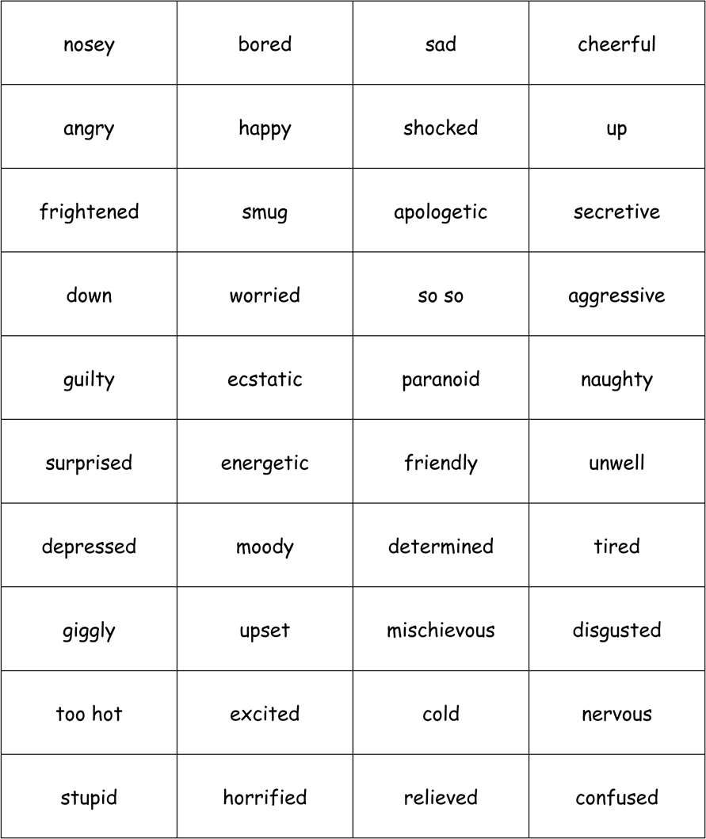

Elementary English Course Unit 3: Health and the Human Body

21 English Sounds and Words where Intonation Changes the Meaning

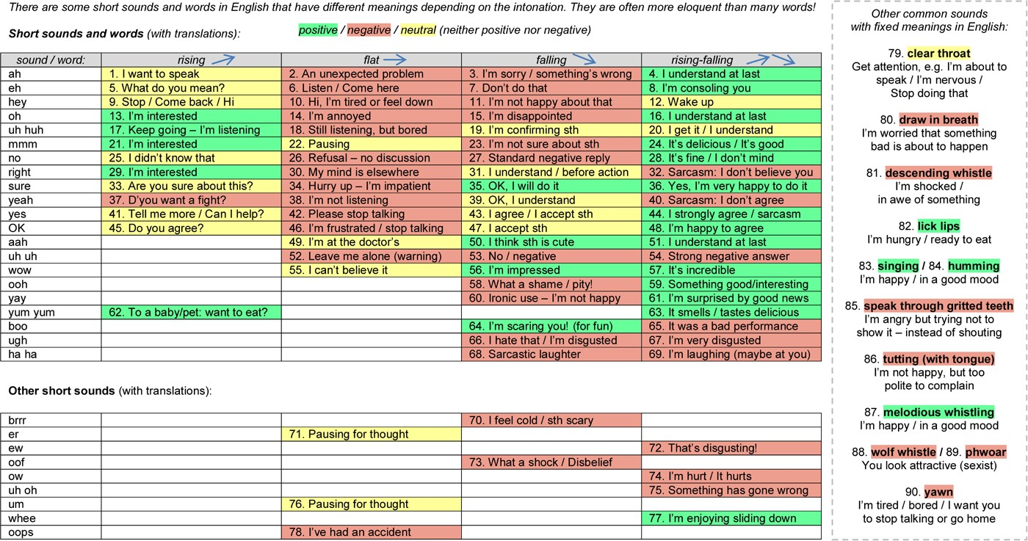

Unit 3.4

GRAMMAR

Past Simple and Past Continuous

Unit 3.4 Past Simple and Past Continuous

    - Past Simple and Past Continuous are often used together because they happen in the same time: finished time in the past. For example:
      - yesterday
      - last... (e.g. last week / month / year)
      - ...ago (e.g. two weeks / months / years ago) Let’s look at these tenses in more detail:
Tense: | Time: | Forms: | Auxiliary Verbs: | Example Sentences:
past simple | finished time in the past,  (e.g. yesterday, last..., ...ago) | past tense infinitive  (for negative and question forms) | did  was / were  (if main verb is BE) | + I met my friend.  - I did not meet my friend. /  - I didn’t meet my friend*.  ? Did you meet your friend?  + You were early.  - You were not early. /  - You weren’t early*.  ? Were you early?
past continuous | as above | ing form | was / were | + I was watching TV.  - I was not watching TV. /  - I wasn’t watching TV*.  ? Were you watching TV?
- contraction (short form) is more informal

In short, we use past simple to talk about finished actions in the past – time which is finished, e.g.
  - He got to work at 8 o’clock yesterday morning.

    - Past simple is the most commonly used tense in English. If you think about it, we use it all the time to talk about what happened in the past – to give news and tell stories.

For example:
      - You get home from somewhere and tell your partner or friend a funny story about what happened that day, or previously in the past
      - You go to the doctor’s and tell them how you got a big bruise on your leg
      - You read a newspaper article about something interesting that happened yesterday
      - You read a novel in which almost every sentence uses past simple or past continuous and the past tense verb “said” appears many times on every page
      - ...and so on!

    - Though not as common as past simple, we use past continuous when the action is continuous, i.e. for longer actions. Another difference is that in past continuous the action is often unfinished and interrupted:

past simple: | I brushed my teeth before going to bed. | finished action
past continuous: | I was brushing my teeth before going to bed when they all fell out! | unfinished action

We also use past continuous:
      - to set the scene (see 3.4.4, below): I was making lunch when Bob got home.
      - to describe specific times in the past: ‘What were you doing at 1pm yesterday?’ ‘I was washing my car.’
      - to describe repeating actions in the past – with always: Philip was always talking to his friends in class.

Past continuous is not usually found on its own in a sentence. We use it in the first clause (part) of the sentence, then often use a conjunction such as and, but, because (or when and while, see below), then another clause with a different tense
– probably past simple. The following sentence would be odd, for example:

‘I was reading a book.’ We have to ask, ‘When?’ or ‘Which book?’ etc.

In general, a sentence with past continuous on its own seems incomplete. An exception is when you describe repeating actions in the past with ‘always’ (see above), and also when you are answering a question, for example:

‘What were you doing all morning?’ ‘I was reading a book.’

Note: it is not possible to use state verbs with past continuous, because they do not have ing forms. For example, we can say “I was enjoying the concert” because enjoy is an active verb, but not “I was liking the concert” because ‘like’ is a state verb.

    - We often put both tenses together in the same sentence, as in the second example above, using the conjunctions when and while:

I was walking to work when I met Bill.

We start with past continuous in the first clause of the sentence and then use when or while to connect to a past simple clause. If we use when, something happens after the past continuous clause; so past continuous is used to set the scene before a main action with past simple. If we use while, something happens during the past continuous clause:

when | I was eating an apple when the phone rang. | p.s. action happens  after p.c. action
while | I was eating an apple while the phone rang. | p.s. action happens  during p.c. action

    - This table can help us to understand the differences between these two common tenses:

 | Past Simple | Past Continuous
Example: | I ate breakfast yesterday. | I was eating breakfast yesterday.
Time: | past (finished time) | past (finished time)
Forms: | past tense  infinitive (for questions and negatives)  -ed (regular verbs) / if irregular, learn the form(s) | ing form (present participle)
Auxiliary Verbs: | did / did not (didn’t)  if main verb is BE, use was, were | was / was not (wasn’t) were / were not (weren’t)
Typical Times: | yesterday / last… / …ago | yesterday / last… / …ago when / while  an action is in progress before or during a  past simple action
Uses: | finished actions in the past  to tell stories / news  second conditional (unreal future) | interrupted actions in the past to set the scene in the past  specific times in the past, e.g. at 2 o’clock  repetition with always

    - As you can see from the information above, in past simple we have to remember to use did + infinitive form to make negative and question forms. This is not really logical and students often forget to do this extra thing – it’s just one more thing to remember! It would be far more logical if we could say:

positive | He went to the shop yesterday. | ✓
negative | He no went to the shop yesterday. | x
question form | He went to the shop yesterday? (with rising intonation) | x

Of course, this is the way that many students make negative and question forms in past simple, perhaps because it is more logical or closer to their first language. However, we must remember to take that extra step and use did + infinitive form.

    - In past simple we need to use past tense form. Past tense form is similar to past participle form (used for present perfect) because with both forms it is necessary to know about irregular verbs. We add -ed to a regular verb to make both past tense and past participle forms, but since irregular verbs are all different (they are irregular!) we have no choice but to learn the different forms. There are thousands of regular verbs in English, with -ed endings, and only a few hundred common irregular verbs. The problem is that irregular verbs occur very frequently, so it is necessary to learn the different past tense and past participle forms. That is why you will often see a chart of irregular verbs on the classroom wall at a language school. There is no getting away from irregular verb endings – you just have to learn them, if you want to be correct using past simple.

    - On the next two pages you can see how the most common verbs in English – BE, DO, HAVE, and GO – look in past simple and past continuous tenses. Try to learn these important verb tables.

The Most Important Verbs in English – Past Simple

 |  | BE
 | Positive: | Negative: | Question:
I | was | was not / wasn’t | Was I?
you | were | were not / weren’t | Were you?
he | was | was not / wasn’t | Was he?
she | was | was not / wasn’t | Was she?
it | was | was not / wasn’t | Was it?
we | were | were not / weren’t | Were we?
they | were | were not / weren’t | Were they?

DO

 | Positive: | Negative: | Question:
I | did | did not / didn’t | Did I?
you | did | did not / didn’t | Did you?
he | did | did not / didn’t | Did he?
she | did | did not / didn’t | Did she?
it | did | did not / didn’t | Did it?
we | did | did not / didn’t | Did we?
they | did | did not / didn’t | Did they?

HAVE

 | Positive: | Negative*: | Question:
I | had | had not / did not have | Had I? / Did I have?
you | had | had not / did not have | Had you? / Did you have?
he | had | had not / did not have | Had he? / Did he have?
she | had | had not / did not have | Had she? / Did she have?
it | had | had not / did not have | Had it? / Did it have?
we | had | had not / did not have | Had we? / Did we have?
they | had | had not / did not have | Had they? / Did they have?

GO

 | Positive: | Negative: | Question:
I | went | did not go / didn’t go | Did I go?
you | went | did not go / didn’t go | Did you go?
he | went | did not go / didn’t go | Did he go?
she | went | did not go / didn’t go | Did she go?
it | went | did not go / didn’t go | Did it go?
we | went | did not go / didn’t go | Did we go?
they | went | did not go / didn’t go | Did they go?

*contractions are possible, e.g. I had not = I hadn’t; she did not have = she didn’t have, etc.

The Most Important Verbs in English – Past Continuous

BE

 | Positive: | Negative: | Question:
I | was being | was not being / wasn’t being | Was I being?
you | were being | were not being / weren’t being | Were you being?
he | was being | was not being / wasn’t being | Was he being?
she | was being | was not being / wasn’t being | Was she being?
it | was being | was not being / wasn’t being | Was it being?
we | were being | were not being / weren’t being | Were we being?
they | were being | were not being / weren’t being | Were they being?

DO

 | Positive: | Negative: Question:
I | was doing | was not doing / wasn’t doing Was I doing?
you | were doing | were not doing / weren’t doing Were you doing?
he | was doing | was not doing / wasn’t doing Was he doing?
she | was doing | was not doing / wasn’t doing Was she doing?
it | was doing | was not doing / wasn’t doing Was it doing?
we | were doing | were not doing / weren’t doing Were we doing?
they | were doing | were not doing / weren’t doing Were they doing?
 |  | HAVE
 | Positive: | Negative: Question:
I | was having | was not having / wasn’t having Was I having?
you | were having | were not having / weren’t having Were you having?
he | was having | was not having / wasn’t having Was he having?
she | was having | was not having / wasn’t having Was she having?
it | was having | was not having / wasn’t having Was it having?
we | were having | were not having / weren’t having Were we having?
they | were having | were not having / weren’t having Were they having?
 |  | GO
 | Positive: | Negative: Question:
I | was going | was not going / wasn’t going Was I going?
you | were going | were not going / weren’t going Were you going?
he | was going | was not going / wasn’t going Was he going?
she | was going | was not going / wasn’t going Was she going?
it | was going | was not going / wasn’t going Was it going?
we | were going | were not going / weren’t going Were we going?
they | were going | were not going / weren’t going Were they going?

Exercises

Ex. 3.4.1 Writing Complete the sentences below using one of these past tense verbs: went ate watched rained came enjoyed had drank heard walked
- Last week I to London for the weekend.
- I you talking about my friend yesterday.
- Last night I a film about space travel.
- I missed the bus so I home.
- I’m not here on my own. My friend with me.
- We the concert.
- It this morning so I didn’t go out.
- I two glasses of water before going to bed.
- I some cereal and toast for my breakfast.
- I went to the shop to see if they any postcards.

Ex. 3.4.2 Writing Complete the sentences below using one of these past tense verbs: went laughed made thought left bought finished tried wanted cooked
- I a really nice meal for my mum’s birthday.
- My brother to come too, but he wasn’t allowed.
- We all when Tina fell off her chair!
- I think that we were for each other!
- Kim and Charlotte the party at 1.40am.
- He to call you but couldn’t get through.
- I about driving to the coast for the weekend.
- Tessa her wedding dress last Monday.
- I went home after the concert .
- My friends all to see the new exhibition in town.

Ex. 3.4.3 Writing Complete the verb tables using past simple (positive):

I | to be: | I | to have:
You |  | You
He |  | He
She |  | She
It |  | It
We |  | We
They |  | They
 | to do: |  | to go:
I |  | I
You |  | You
He |  | He
She |  | She
It |  | It
We |  | We
They |  | They

Ex. 3.4.4 Writing Complete the verb tables using past continuous (positive):

I | to be: | I | to have:
You |  | You
He |  | He
She |  | She
It |  | It
We |  | We
They |  | They
 | to do: |  | to go:
I |  | I
You |  | You
He |  | He
She |  | She
It |  | It
We |  | We
They |  | They

Ex. 3.4.5 Writing Rearrange the words in each sentence to make a question in past simple. Don’t forget to put a capital letter at the start of each sentence and a question mark at the end:

- company you which did recommend taxi
- last watch did film you night that
- did you learning when English start
- results your about you ask did
- call your morning why this you boss did
- did Tina say to what you
- on parcel arrive time your did
- go how your did exam
- you did party who to invite your
- the rest did where go cheesecake of the

Ex. 3.4.6 Writing Rearrange the words in each sentence to make a question in past continuous tense. Don’t forget to put a capital letter at the start of each sentence and a question mark at the end:

- you the as leaving arrived was train just
- you phone when kitchen going the were rang the into
- most night posts of were reading on the you Twitter funny
- you Tim’s of meal my to were thinking mother birthday inviting
- in yesterday annoying buzzing the was an manner bee around
- you up about were in-jokes always Kevin making
- uncle the running was when your began earthquake bath a
- when their salad to the refusing grandma children eat were arrived
- heading when exploded for it the was straight earth meteorite
- Lena’s a to former son husband was meet marriage going his from

Ex. 3.4.7 Writing Write 10 sentences using this model:

past continuous + conjunction + past simple

- I was  - You were |  | when  while
3. He was |  | but
4. She was |  | because
5. It was |  | and
6. We were |  | or
7. They were |  | when
8. I was |  | while
9. You were |  | but
10. We were |  | because

Ex. 3.4.8 Writing a) Write about what you were doing yesterday at the following times. Use past continuous and try to use a different verb for each sentence. For example:

At 4 pm I was reading a book.

1. At 6.30 am
2. At 7.45 am
3. At 8.25 am
4. At 9.05 am
5. At 10.40 am
6. At 11.15 am
7. At 12.50 pm
8. At 2 pm
9. At 3.23 pm
10. At 4 pm
11. At 5.35 pm
12. At 6.48 pm
13. At 7.55 pm
14. At 9.05 pm
15. At 11 pm

b) Ask your partner about what they were doing yesterday and complete the sentences again. Or think of a famous person and imagine what they were doing!

Ex. 3.4.9 Writing Complete each sentence using either yesterday or tomorrow:

- I went to the cinema .
- I’m playing golf .
- We had an early lunch .
- Her sister is going into hospital .
- What time are you getting up ?
- I’m taking the car to the garage first thing .
- My brother moved house .
- Did you see that new music shop in town ?
- I met Lisa and Isabella for a coffee .
- He’s visiting his friend afternoon.
- There was a lot of noise outside .
- We’re going swimming morning.
- Are you coming round evening?
- He wasn’t at work afternoon because he went to hospital for an appointment.
- John was in Birmingham all day for a meeting.
- I gave them some homework .

- I’m not going on holiday until .
- I missed the last bus , so I had to walk home.
- It was cold , wasn’t it?
- Sally is getting her exam results .
- We packed our suitcases evening.
- Is he still cooking lunch for his girlfriend and her family ?
- Bob and Janet are coming round for a game of cards night.
- We’re flying to Spain afternoon.
- He’s playing football for a couple of hours morning.
- I saw your friend Ian in Sainsbury’s .
- I’m doing all my ironing .
- We both bought the same pair of shoes .
- Is he going to tell you about the course , or later on today?
- Jen swam forty lengths of the pool .

Ex. 3.4.10 Writing Complete the table from memory, then check your answers:

 | Past Simple | Past Continuous
Example:
Time:
Forms:
Auxiliary Verbs:
Typical Times:
Uses:

Unit 3.5

GRAMMAR

Common Regular and Irregular Verbs

Unit 3.5 Common Regular and Irregular Verbs

    - Look at the list of the 40 most common verbs in English on p.57. It is a really good idea to set yourself the goal of learning them, along with all five forms. In the last column on the right we can see whether each verb is regular or irregular. Every verb in English is either regular or irregular. The difference is in the past tense and past participle forms. If the verb is regular, these two forms end with ‘ed’, for example:

I look I looked I have looked If the verb is irregular, the endings vary, for example:
I give I gave I have given

    - There are thousands of regular verbs in English compared with a few hundred irregular verbs. (See the list of 40 common regular verbs on p.58.) The problem for students is that these regular verbs are very common, describing many everyday actions and states, like: be, have, do, say, go, get, make, put, etc. Note that in the list of the 40 most common verbs in English 27 of the verbs are irregular! If we make new verbs, we generally make them regular. Nobody wants to create new irregular verbs that we have to learn. For example:

He spams us He spammed us He has spammed us
(sends spam)

She chillaxes She chillaxed She has chillaxed
(a cross between chill out and relax)

This goes for other newly-coined verbs too, like: email / emailed; tweet / tweeted; unfriend / unfriended; photobomb / photobombed; facepalm / facepalmed; snapchat / snapchatted; glamp / glamped, etc. One exception is the verb to text:

Is it: I texted John last night. Or, I text John last night?

The latter is much easier to pronounce, and some people treat ‘text’ as an irregular verb, while others say that it is regular, with -ed. There is no authority giving rules to the English language, so both uses can be correct. Other verbs can be both regular and irregular at the same time too, e.g.

regular: irregular:
burned burnt
dreamed dreamt
learned learnt

...and so on. You can use either form, but the -ed ending is accepted as the modern form.

    - In general, it would be better for learners of English if all English verbs could be regular! If English could be reformed so that learners just added -ed to every verb to make past tense and past participle forms, it would remove a big headache from the learning process. For example we could see the following new regular verbs:

doed sayed
goed getted
maked knowed

...and so on. I feel sure that the language would survive such a change! In fact, when English native speaker children begin to write their own sentences and stories at primary school they often naturally write irregular verbs as regular, with -ed endings, for example:

I thinked... | instead of | I thought...
I telled her... | instead of | I told her...

Children learning English grammar often sense a logical rule – past tense of verbs end in -ed – only for their teacher to dash their hopes:

Teacher: No, that’s wrong. It should be ‘thought’.

Child: But why?

Teacher: It’s just like that. or, more helpful: Because ‘think’ is an irregular verb...

Child: But why?

Teacher: Er... [long pause] It just is, OK?

    - In terms of spelling, we usually add -ed to regular verbs to make the past tense and past participle forms:

want + ed = wanted
work + ed = worked However, if a verb ends with ‘e’ we add only ‘d’:
change | + d | = | changed
love | + d | = | loved

Sometimes we have to double the final consonant before adding -ed:

beg | + g + ed | = | begged
rob | + b + ed | = | robbed

Sometimes we have to delete the ‘y’ at the end of an infinitive verb and add ‘ied’:

fry | - y + ied | = | fried
try | - y + ied | = | tried

    - If a verb is irregular you just have to learn the different forms. (See the list of
40 common irregular verbs on p.59.) It is impossible to predict the forms of irregular verbs and there is no choice but to learn them. You need to get familiar with them, study them, test yourself, correct yourself, study them again, and continue the process until you know them by heart. A small number of irregular verbs have three forms the same, e.g. let, put, hit, bet, bid, set, cut, shut, cut, spread, and quit:
infinitive: past tense: past participle:
I let | every day | I let | yesterday | I have let | today
I put |  | I put |  | I have put

Some irregular verbs have two forms the same, e.g.:

infinitive: | past tense: | past participle:
I feel | I felt | I have felt
I make | I made | I have made
While the rest have three forms different, e.g.:
infinitive: | past tense: | past participle:
I give | I gave | I have given
I see | I saw | I have seen

    - The -ed ending of regular verbs is pronounced in three different ways, depending on the final sound of the infinitive verb. See p.67 to learn more about this issue. On
p.68 there is a list of 200 common regular verbs in English, ordered by final sound.

Exercises

Ex. 3.5.1 Writing Complete the table on p.60.

Ex. 3.5.2 Writing Regular verbs – complete the gaps in the table on p.61. Ex. 3.5.3 Writing Irregular verbs – complete the gaps in the table on p.62. Ex. 3.5.4 Writing Write each verb in the correct box below:
want | take | use | seem | arrive | go | need | be
know | try | help | have | get | ask | call | think
play | make | say | work | do | clean | run | sing

regular verbs: | irregular verbs:

The 40 Most Common Verbs in English (in order)

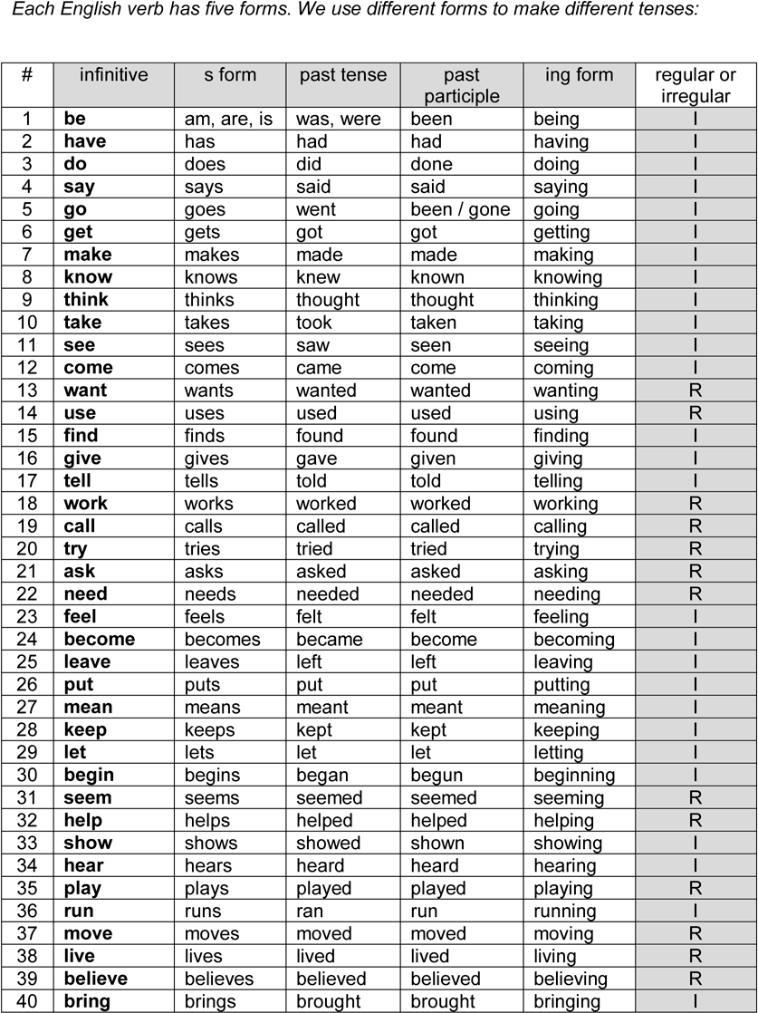

Learn 40 Common Regular Verbs in English

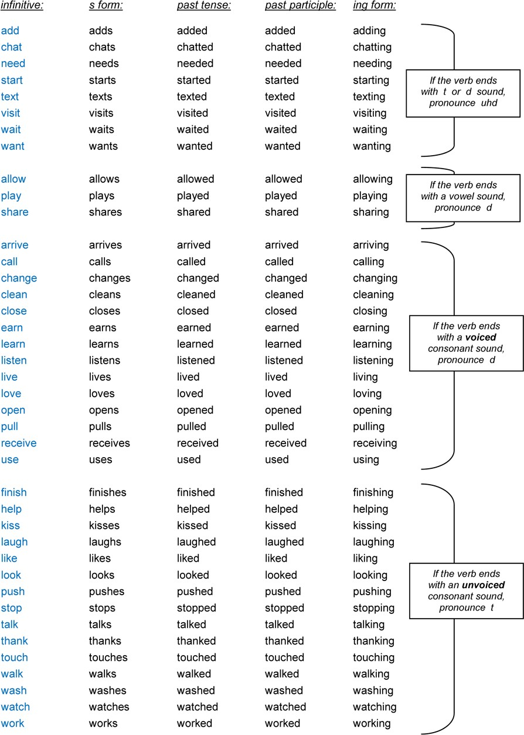

Learn 40 Common Irregular Verbs in English

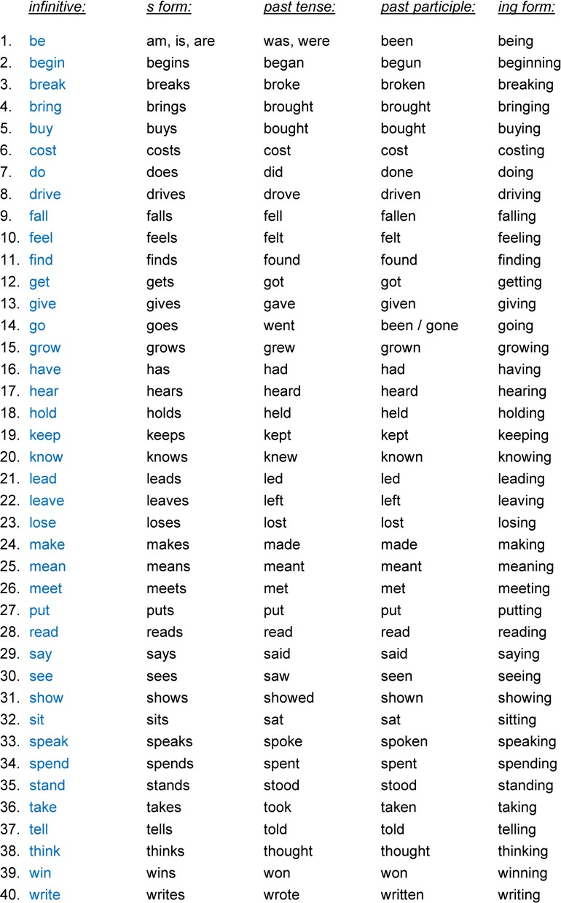

The 40 Most Common Verbs in English (in order) – Gap-Fill

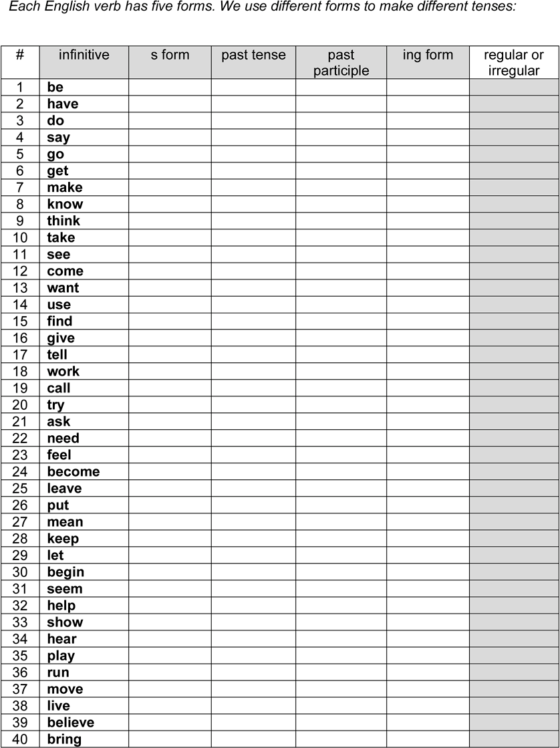

Learn 40 Common Regular Verbs in English – Practice

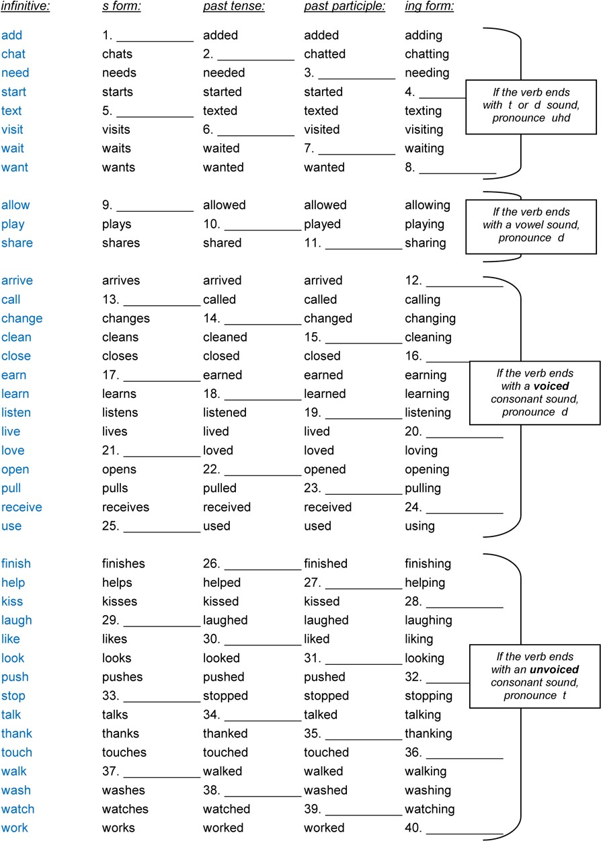

Learn 40 Common Irregular Verbs in English – Practice

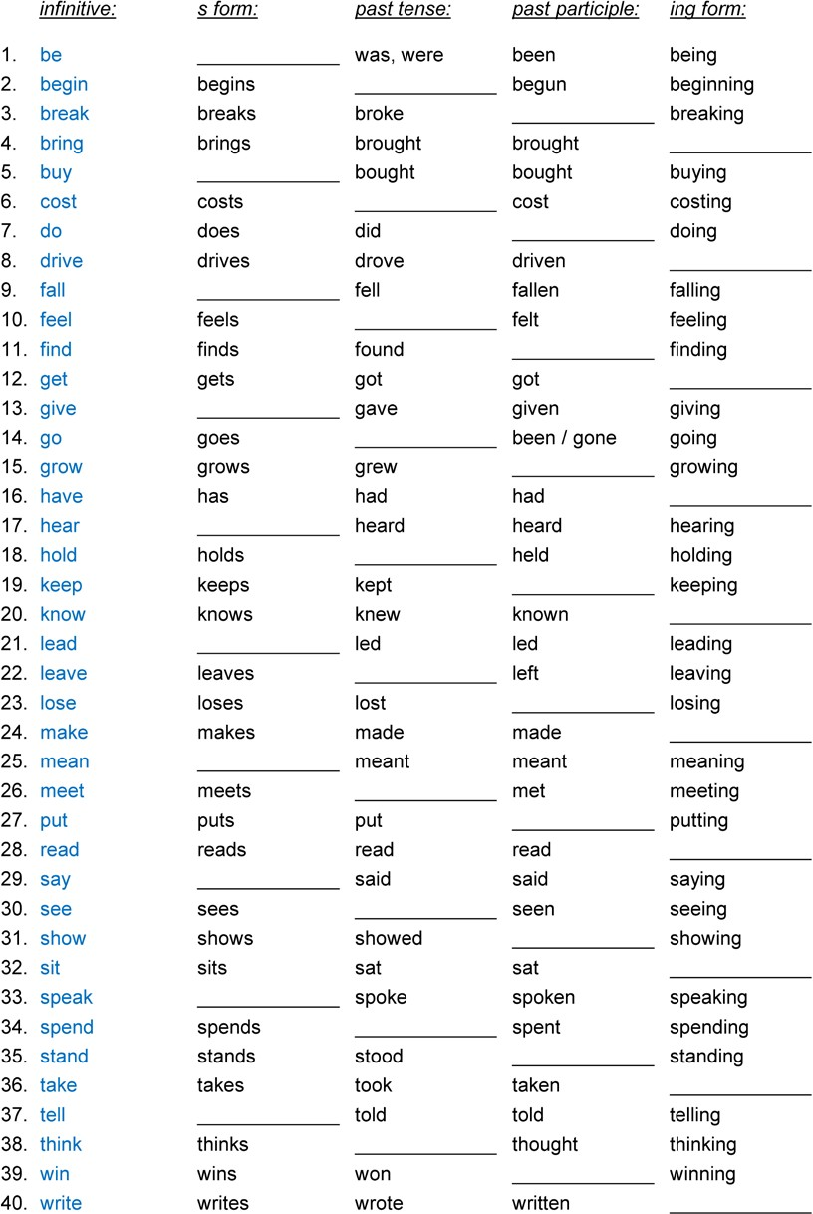

Ex. 3.5.5 Reading Complete each sentence by adding the best form of the verb:

      - I (been/went/gone) shopping yesterday.
      - He hasn’t (bought/bring/brought) his passport.
      - Emily (choose/chosed/chose) a light blue carpet for her living room.
      - Have you (get/got/getted) your train ticket?
      - James (drove/drive/driven) a long way to visit his girlfriend, but she was out.
      - I have (grow/growed/grown) two big tomato plants.
      - Don (put/putted/puts) his bag on the table and went upstairs.
      - I (thinked/thunk/thought) I (knew/new/known)
you from somewhere.
      - We (leaved/left/leaving) on Monday night at about eight o’clock.
      - Sarah has (swim/swam/swum) for her country in the Olympics.
      - Lenny (wore/weared/wearing) a new suit and tie to work.
      - The whole kitchen (stink/stank/stinked) of garlic and onions!
      - Darling, you have (stole/stolen/stealed) my heart!
      - Maggie (taken/took/taked) a pen out of her bag and wrote a quick note to her husband.
      - Ludwig van Beethoven (wrote/written/writed) some fantastic symphonies.

Ex. 3.5.6 Reading Write the sentences again, changing each underlined verb from the present simple to the past simple tense:
- I wake up at 6.50am when I hear the alarm clock.
- I jump out of bed and switch it off before it wakes up all the neighbours.
- I switch on the light and the heater, because it’s cold in my room.
- I use the bathroom; then look for a clean shirt to wear.
- I go into the kitchen and put the kettle on.
- I get dressed and brush my hair.
- I have a shave and then pack my bag ready for work.
- The kettle boils so I make a cup of tea; then I watch TV for a few minutes.
- I open all the curtains in my house and pick up my sandwiches from the fridge.
- I put on my shoes and coat; then check that I haven’t forgotten anything.
- I leave on the light in the hall because I know it will be dark when I get home.
- I unlock and open the front door; then I go outside.
- I lock the front door and walk a few metres to my car.
- I get into the car and turn the key in the ignition.
- I put on a tape and turn up the volume.
- I look in my mirrors, then reverse up the drive and onto the road.
- I drive for five miles until I reach a traffic-jam.
- I sit in the traffic-jam for twenty minutes; I drive forward slowly, a few metres at a time.
- I change the tape in my car stereo, and tap my fingers on the steering wheel.
- I put on the radio and listen to the news, followed by the weather forecast.
- The radio plays one of my favourite songs, so I sing along loudly.
- I turn right into the road where I always leave my car. I park and turn off the engine.
- I get out and shut the door. I lock my car door and then walk for about twenty minutes.
- I buy a newspaper and a sandwich at the newsagent; then I head for work.
- As I enter the building I say “Hi” to the people I work with.
- I get to my desk at about 8.50 am and put down my bag.
- I’m ready for another cup of tea and to have a long nap start the day!

Ex. 3.5.7 Writing Translate 20 common irregular verbs from Clear Alphabet (see Unit 1.6):

1. Bee |  | 11. Faind
2. Reed |  | 12. Bring
3. Hiy |  | 13. Greu
4. See |  | 14. Ttingk
5. Bai |  | 15. Neu
6. Breik |  | 16. bi Kum
7. Eet |  | 17. Draiv
8. Rait |  | 18. f Get
9. Sleep |  | 19. Leev
10. Meet |  | 20. Tel

Ex. 3.5.8 Writing Translate 20 common irregular verbs into Clear Alphabet:

1. make |  | 11. ring
2. build |  | 12. get
3. lose |  | 13. feel
4. take |  | 14. go
5. drink |  | 15. put
6. let |  | 16. pay
7. have |  | 17. wear
8. can |  | 18. send
9. do |  | 19. understand
10. catch |  | 20. fly

Ex. 3.5.9 Reading Complete each gap with an irregular verb in past simple. Choose from:
be, break, buy, come, drive, eat, feel, find, get, give, go, have, hear, hold,

know, let, lose, make, put, read, ring, run, say, sleep, take, think, tell, write

Note: you will need to use some verbs more than once.

Dear Ethel

I’m writing to tell you about something that happened yesterday. I 1) up at the usual

time – about 10 am – 2)
a shower and 3)
breakfast. I 4) a

big bowl of cereal and some toast and watched TV for a while. Then I 5) into the kitchen

where I 6)
a funny noise. I 7)
it 8)
from behind the cooker. I

9) my tool box and moved the cooker out of the way.

The noise 10)
louder but I couldn’t see anything. I 11)
my uncle to ask his

advice. He 12)
that he 13)
it could be a gas leak. When I 14)

this I just panicked! I 15)
the phone down, 16)
outside, 17) in

my car and 18)
to the local police station. I 19)
them about my gas leak

but the constable 20)
his patience with me. He 21)
that I should have

phoned the gas company. He 22) me.
his report, then 23)
the gas company for

Then I remembered that my house doesn’t have gas – only electricity! I 24) really stupid
and 25) that the constable would be angry with me for wasting his time, so I

26)
out of the police station while he 27)
still on the phone. I

28) home to try to find out what the noise 29) . On the way I

30)
a newspaper and I 31)
about an escaped llama that 32)

out of the city safari park last Wednesday.

When I 33)
home I 34)
my key in the door, turned it, 35)

inside and straight away 36)
that funny noise again. I 37)
my breath and

opened the door slowly. Guess what? I 38) the llama hiding in my cupboard! I

39)
him stay and he 40)
in my garden last night. The snoring

41)
so loud! This morning I 42)
him back to the safari park. They

43)
really pleased to see him again and 44)
me a reward of £50!

Hope you are well. Write soon and let me know how you are. Your friend, Alan

Ex. 3.5.10 Reading a) Read the story below. All of the irregular verbs in past tense have the wrong ending – a regular -ed ending! Underline each one. b) Write the story again, using the correct past tense form of each irregular verb. c) Underline the regular verbs in past tense form:

A few days ago Michael Morrison heared a really good programme about yaks on the radio. He remembered that he once readed a very interesting book about yaks, and he decided to buy a copy and read it again. The next day he waked up early, haved a shower, getted dressed, runned downstairs, haved breakfast, then phoned his friend Mandy Minton, who beed a zoologist, but unfortunately she didn’t know about the book. Michael putted on his coat and goed outside. He drived to the library and asked the assistant if they haved a copy of “Yaks of the World – Illustrated Edition”. The assistant thinked for a moment and spended a few minutes checking the records on his computer, but nothing comed up.

Michael leaved the library and walked into town. He stopped at the huge bookstore on Crompton Street and goed in. He browsed the books, but could not find “Yaks of the World” anywhere – illustrated or not. A bookseller sayed that there beed a book called “Just Yaks”, but Michael did not want it. A passing vegan telled Michael to try a specialist bookseller on Marriott Street – a place where they selled unusual books. Michael thanked the lady and payed for a copy of “Bridge Repair Weekly” magazine. At the specialist bookstore on Marriott Street Michael feeled sure that he would find the book he wanted, but after talking with a very quiet man in a long cardigan, Michael understanded that they didn’t have any books about yaks – or indeed any other kind of long-haired animal. He exited the shop sadly and drived home.

He maked a quick sandwich and watched an excellent online video about clever llamas on YouTube. Then he haved a bright idea: “I haven’t looked online for the book yet!” He spended the next few hours searching for the book in online bookstores, auction sites, and forums – but without any luck. There beed no such book as: “Yaks of the World – Illustrated Edition” “Maybe I dreamed it,” he sighed to himself and goed to bed, where he doed in fact dream about finding the book. In his dream he seed it at the bottom of his wardrobe, underneath a pile of socks. When he waked up he looked in his wardrobe, but there beed not any books there. Only the socks.

A fews days later, Michael sitted down at his computer and begined to write the first chapter of “Yaks of the World – Illustrated Edition”. After fourteen years of hard work – including many trips to the zoo – it beed finally ready to publish and it becomed a number one bestseller – among zoologists.

How to Pronounce the Past -ed Form of Regular Verbs

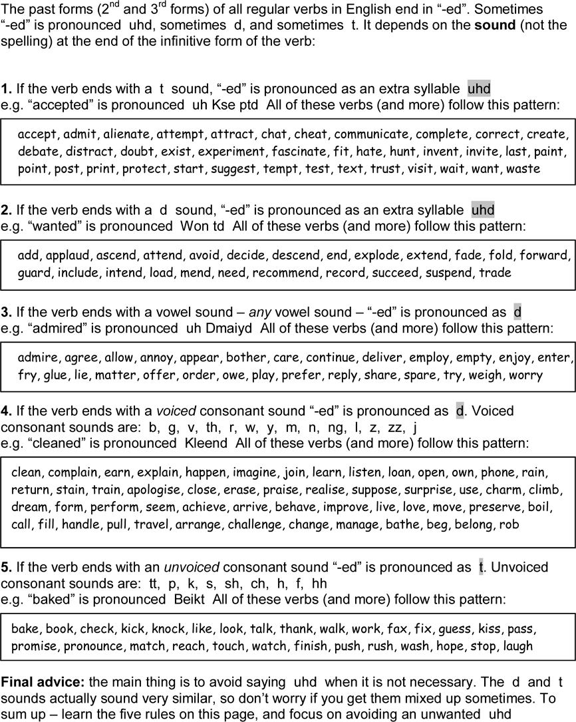

200 Common Regular Verbs in English – Ordered by Pronunciation

Rule 1
verb ends in t = uhd accept
admit
alienate attempt attract chat cheat
communicate complete correct create debate distract doubt
exist experiment fascinate fit
hate hunt invent invite last paint point post print protect start suggest target tempt test
text trust visit wait want waste

Rule 2.
verb ends in d = uhd add
applaud
attend avoid decide descend end explode extend fade fold forward guard include intend load mend need
recommend record succeed suspend trade

Rule 3.
verb ends in a vowel sound = d
admire agree allow annoy appear bother care consider continue deliver employ empty enjoy enter
fry glue ignore lie matter occupy offer order owe play prefer reply share spare survey tire tour
try weigh worry

Rule 4.
verb ends in a voiced consonant = d
n
clean complain contain determine earn explain happen imagine join
learn listen loan open
own phone rain return stain train

z
advise apologise close erase exercise finalise praise realise socialise suppose surprise use

m charm climb dream form perform seem
transform zoom

v achieve arrive behave deceive halve improve live love move
preserve receive

l boil call fill
handle pull travel

j
arrange challenge change manage

th
bathe

g
beg
ng
belong

b
rob
Rule 5.
verb ends in an unvoiced consonant = t
k bake book brake check kick knock like lock look pick talk thank walk work

s announce fax
fix guess kiss miss notice pass place promise
pronounce replace

ch match reach switch touch watch

sh finish push rush wash

p help hope jump stop

f
laugh

Unit 3.6

GRAMMAR

This, That, These, and Those

Unit 3.6 This, That, These, and Those

    - This, that, these, and those are members of a small class of words called demonstratives. They are function words, rather than content words, with a grammatical function. We use them to indicate the distance – in space or time – between the speaker/writer and the noun. For example:

This is my pen. this one here

That is her pen. that one over there

    - This and that are used with singular and uncountable nouns, while these and those
are used with plural nouns.

 | singular (1) | plural (1+)
near in space or time  here / now | this | these
not near in space or time  there / then | that | those

The word ‘that’ can be used in a contraction, e.g. that is = that’s while the other three words cannot be contracted: this’s / these’re / those’re are all too difficult to pronounce.

    - This and these indicate that the noun is near in space or time, while that and those indicate that the noun is not near in space or time. For example:

This is my pen and that is her pen.
my pen is nearer to me than her pen

These are my books and those are her books.
my books are nearer to me than her books.

This and these indicate possession – that you have something – while that and those indicate that you do not have something, for example:

‘Can I borrow those marker pens, please?’ ‘Yes, when I’ve finished using them.’

That’s my balloon flying in the sky! you don’t have it – it’s gone

We say ‘not near’ rather than ‘far’ (as the opposite of near) because the ‘that/those’ noun doesn’t have to be far. It just has to be farther than the ‘this/these’ noun.

    - If the time is past or future – i.e. not now – we tend to use that and those: That was a great holiday. the holiday is finished
That will be a great holiday. the holiday is in the future, not now

If we say: ‘This was a great holiday’, when referring to the past, it is incorrect, because the holiday is not present. Similarly, if we say ‘This will be a great holiday’ it is incorrect, for the same reason.

    - This, that, these, and those can be determiners or pronouns:

demonstrative determiners: | demonstrative pronouns:
before a noun, e.g.  This bag is heavy. | not before a noun, e.g.  This is a heavy bag.

We use a determiner before a noun and it gives some information about that noun. Articles – the, a, and an – are also determiners (see Unit 3.1). We know that ‘the’ indicates a specific noun, but ‘this’ (or the others) indicate a more specific noun. If somebody asked, ‘Which book do you want?’ we could answer ‘The book on the table’, but saying ‘This book’ – and pointing – would be much clearer. Also we don’t need to add extra information about the place – ‘on the table’ as we would if we used only ‘the’.

    - We know whether a demonstrative is a determiner or pronoun by its position in the sentence. If it is before a noun or noun phrase (e.g. this book, or this wonderful book), it is a determiner. If it is not before a noun – let’s say it is before a verb (e.g. this is a wonderful book) – then it is a pronoun.

Pronoun means ‘instead of a noun’. In Latin the prefix ‘pro’ means ‘in place of’ or ‘in exchange for’. A pronoun replaces an unnecessary noun and makes the sentence tidier:

Not: ‘This bag is a heavy bag.’ ...but: ‘This is a heavy bag.’

    - We can add ‘one’ (for singular nouns) or ‘ones’ (for plural nouns) to the demonstrative pronoun if, for example, you are choosing something. It makes the sentence more emphatic and your choice more specific:

“I want this.” “Which one?” “This one!”

“Do you like these trousers?” “Which ones?”
“These ones!”

However, ‘these ones’ and ‘those ones’ are not commonly used in standard English. We prefer to say: ‘these’ or ‘those’.

    - Although this, that, these, and those are function words, they are often pronounced with stress in spoken English. This is because of their function – to emphasise which one – and their position in a clause, which is often at the end for demonstrative pronouns. If a function word comes at the end of a clause, it is usually stressed.

Yes, I agree with that! ‘that’ is pronounced That (strong form)

In fact, ‘these’ and ‘those’ do not even have weak forms. They are pronounced Theez and Theuz in every context. Demonstrative determiners ‘this’ and ‘that’ can be unstressed:

That was a nice meal. th_ w s Nai Smiyl.

Each has a weak form with a shwa sound:

 | weak form (not stressed): | strong form (stressed): | notes:
this | ths | this | with a schwa sound
that | tht | that | with a schwa sound
these | - | theez | no weak form
those | - | theuz | no weak form

Students may make two common errors when pronouncing demonstratives :

      - this and these both pronounced the same: theez
      - failure to learn to pronounce the voiced th sound, meaning the pronunciation is more like: Dis, Dat, Deez, Deuz, or Zis, Zat, Zeez, Zeuz, rather than: This, That, Theez, Theuz

    - Common functions of this, that, these, and those:
      - to specify a noun: I want this one.
      - to compare two things: I like this chair, but not that one.
      - to introduce somebody: This is my brother, Jack.
      - to introduce yourself on the phone: Hi, this is Jane.
      - to refer back to something: ‘I’m going to be on time.’ ‘That’s good.’
      - before time words and phrases This morning, this month, this evening, etc.

This week / month / year, etc. (unfinished time) contrasts with last week / month / year, etc. (finished time) and next week / month / year, etc. (future).

    - Demonstratives connect with other pronouns in the following way: If singular (thing): this / that use: it / its / itself
If plural (thing/people): these / those use: they / them / their / theirs /
themselves
For example:
      - This book is great, isn’t it.
      - That cat is washing itself
      - These books are interesting, aren’t they?
      - Those boys are eating their lunch. etc.
Note: if the subject is singular and male or female, we use he / she etc. See Unit 4.3 for more about pronouns.

    - Remember, ‘that’ as a demonstrative determiner or pronoun is different to ‘that’ as a relative pronoun in relative clauses, e.g. ‘I enjoyed the book that you gave me.’ It looks and sounds the same, but has a different use.
Idioms corner:
this and that is an idiom that means: ‘a few different things’. For example: ‘What did you buy at the shop?’ ‘This and that.’
‘What are you doing later?’ ‘This and that.’

We can use it when we don’t want to be too specific.
Exercises

Ex. 3.6.1 Writing Some of the sentences are incorrect. Write them correctly:

1. This book is good.
2. Those flowers were beautiful.
3. This books is good.
4. These reports is interesting.
5. This books are good.
6. Those flower was beautiful.
7. These reports are interesting.
8. That meal were lovely.
9. This book are good.
10. These report are interesting.
11. That meals was lovely.
12. These report is interesting.
13. That meal was lovely.
14. Those flower were beautiful.
15. That meals were lovely.
16. Those flowers was beautiful.

Ex. 3.6.2 | Writing Write 4 sentences with this, that, these, those as a determiner:
 | 1.
 | 2.
 | 3.
 | 4.
Ex. 3.6.3 | Writing Write 4 sentences with this, that, these, those as a pronoun:
 | 1.
 | 2.
 | 3.
 | 4.
Ex. 3.6.4 | Writing Write 4 sentences using this, that, these, those to compare two things:
 | Ex. This is my pencil and that is her pencil.
 | 1.
 | 2.
 | 3.
 | 4.
Ex. 3.6.5 | Writing Correct each sentence using a demonstrative pronoun:
1. This book is a good book.
2. Those seats are empty seats.
3. That film was an enjoyable film.
4. These cars are fast cars.
5. That game was an amazing game.
6. This meal is a delicous meal.

Ex. 3.6.6 Reading a) Complete each sentence with this, that, these, or those. b) Write D for determiner and P for pronoun. c) Discuss with a partner: which words in each sentence helped you to find the answer?

- Look at
- I’m getting off because
beautiful mountains.
is my stop.

- I’ll use laptop and you use one over there.
- Who was on the phone? My cousin Alan.
- meeting last night was a waste of time.
- I need to borrow book, but librarian said I couldn’t.
- are my favourite plants. Yes, they are lovely. I don’t like over there by the gate.
- Hi Paul, is Brian. Is a good time to talk?
- Who are you meeting morning?
- ‘Please take another cake.’ ‘Is the last one?’ ‘Yes, but you can have it.’
- Mmm, cakes look delicous. I can’t wait to try one!
- Do you remember the 1980s? Yes, were the days!
- is going to be the best party ever!
- Mmm, cakes are delicious. Please have another one!
- is Joe who works in the accounts department.
- I prefer trousers to in the other shop.
- What have you been doing week?
- OK, stop. ’s enough petrol! It’s full.
- I think I’ll go to bed early tonight. Yes, ’s a good idea.
- ‘I really hate Clive.’ ‘ was a nasty thing to say, Jo.’

Ex. 3.6.7 Reading a) Complete each sentence with this, that, these, or those. b) Write D for determiner and P for pronoun. c) Discuss with a partner: which words in each sentence helped you to find the answer?
- classes began two months ago.
- ‘Look! ’s my favourite actor!’ ‘Where?’ ‘Over there.’
- is a good concert, isn’t it?
- Did you go to Sally’s flat yesterday? No, but I’m going morning.
- ‘My grandma gave me earrings.’ ‘They’re beautiful. They really suit you.’
- Look at coin I found.
- ‘ is a picture of my classmates.’ ‘They look nice.’

8.
- Did you watch
kids are playing too close to the road. Go and tell them. tv programme I told you about?

- They had to sell their car. Yes, was a shame.
- I wish bus would start moving. I’m going to be late.
- ’s my house on TV!
- Look at scar on my hand.
- class was so boring.
- guinea pigs are so cute. They’re happy for me to stroke them.
- Hi Mike. How are you? are my friends Millie and Liam.
- are my horses in the video.
- Look at man over there.
- ‘ are the last two pancakes.’ ‘Thanks, dad.’
- classes begin next week.

Ex. 3.6.8 Reading a) Complete each sentence with this, that, these, or those. b) Write D for determiner and P for pronoun. c) Discuss with a partner: which words in each sentence helped you to find the answer?
- Were you alright during storm last night?
- jacuzzi is so relaxing!
- What are kids doing over by old oak tree?
- I don’t like very hot weather we are having at the moment.
- ‘Who’s ? ‘ is my cousin John.’
- jacuzzi was so relaxing.
- new trams are so cool. I can’t feel one moving.
- Shall we park in space or the one over there?
- ‘Have you finished exercise five?’ ‘No, I didn’t have time for one.’
- ‘Take bags upstairs please.’ ‘Which ones.’ ‘The ones over there.’
- ‘Our date went really well, mum.’ ‘ ’s nice dear.’
- is what I’ve written so far.
- ’s a nice guitar you are holding.

- ‘Are you using
bag is too heavy. I’m going to put it down.
spoon over there?’ ‘No, I’ve got one.’

- Here you are – put bags in the boot, please.
- shoes are so uncomfortable. I can’t wait to take them off.
- who dislike classical music will not enjoy the concert.
- are my shoes on top of the cupboard.
- pullovers belong to Jenny and the other ones are mine.

Ex. 3.6.9 Reading a) Complete each sentence with this, that, these, or those. b) Write D for determiner and P for pronoun. c) Discuss with a partner: which words in each sentence helped you to find the answer?

- is a wonderful meal! I hope it never ends!
- gardens were so beautiful. I’m so glad I went on day trip.

3. ‘

is a rare stamp.’ ‘What about one is rare too.’
one over there?’ ‘Yes,

- ‘Look – it says bridge is closed.’ ‘How can you read it from here?’

- pages contain gap-fill exercises, while the next page is a writing activity.
- ‘ is my dad.’ ‘It’s nice to meet you, Carla.’
- ‘Can I borrow marker pens, please?’ ‘Yes, when I’ve finished using them.’
- ‘Let’s meet at 9.30am tomorrow.’ ‘OK, ’ll be great.’
- was a wonderful meal! I was hoping it would never end!
- ‘Which milk do you want in your coffee.’ ‘ one. Here you are.’
- bridge was closed, so we had to turn round.
- stones have been here for thousands of years. Please don’t touch them!
- ’s my balloon flying in the sky!
- I’m going to see my solicitor afternoon.
- ‘I forgot to set my alarm and now I’m late.’ ‘ was careless, wasn’t it?’
- Hey! Who is responsible for mess? kids, or outside?
- Look! students have got blue hair! Don’t laugh – they might come over!
- suitcase was too heavy.
- trams were so uncomfortable. I won’t use them again.
- gardens are so beautiful. I’m so glad I came on day trip.

Ex. 3.6.10 Writing Write 20 sentences for your teacher to mark. In each sentence you should use a demonstrative incorrectly. Write WHY it is incorrect and the correction, for example:
Ex. That schools is closed. ‘That’ + ‘schools’ do not match, because ‘that’ is used with singular nouns and ‘schools’ is plural. Correction: That school is closed.
1.
2.
3.
4.
5.
6.
7.
8.
9.
10.
11.
12.
13.
14.
15.
16.
17.
18.
19.
20.

Unit 3.7

VOCABULARY

Daily Routines

Unit 3.7 Daily Routines

    - It is important to be able to talk about the everyday things that we do – in past, present, and future tenses. These are actions that happen regularly, so we will often need to talk or write about them.

    - In this unit we will revise and practise some of the material from three previous units, so you might want to refer back to them as you study this unit. These units are:

      - Unit 2.2 5 Tenses and 5 Forms of the Verb
      - Unit 2.7 Telling the Time
      - Unit 3.5 Common Regular and Irregular Verbs

    - We use present simple (with infinitive and s-form, for he/she/it) to talk about regular actions, so we often use it to talk about our daily routine:

I drive to work at 8am.

We can add an adverb of frequency like ‘usually’ before the verb (or after if the verb is ‘be’):

I usually drive to work at 8am. | I am usually late every Monday!

...or we could use a time phrase at the end of the sentence, for example: I drive to work at 8am every day.

    - Remember that we use present continuous (with ing form) to talk about actions that are happening now or in the future at an arranged time:

I’m driving to work at the moment. I’m driving to work tomorrow.

We use past simple (with past tense form) to talk about actions in finished time: I drove to work yesterday.
...and present perfect (with past participle form) to talk about actions in unfinished time:

I have (just) driven to work.

We use future simple (with infinitive form) to talk about actions in the future: I will drive to work tomorrow.

    - Here are some of the actions that we do every day. In the table below you will find a list of common verbs in different forms, along with examples of words and phrases that collocate (go well with) those verbs, on the right. Note how many of the verbs that we use to describe regular actions are irregular (in red).These are all phrases that you could use to talk about your daily routine. Of course, we do different things on different days. We may have one routine for weekdays (Mondays to Fridays), another for weekends (Saturdays and Sundays), another for holidays, and yet another for special occasions (e.g. your birthday / graduation, etc.).

Let’s look at a typical weekday, starting from early morning and finishing at night:

irregular verbs

Morning:

infinitive | s form | past tense | past participle | ing form | example collocation
wake up | wakes up | woke up | woken up | waking up | at 7am / early
switch off | switches off | switched off | switched off | switching off | the alarm
snooze | snoozes | snoozed | snoozed | snoozing | for 10 minutes
get up | gets up | got up | got up | getting up | at 7.10am / early
take | takes | took | taken | taking | a shower / a bath
have | has | had | had | having | a wash
dry | dries | dried | dried | drying | my hair
put on | puts on | put on | put on | putting on | my clothes / make-up
get dressed | gets dressed | got dressed | got dressed | getting dressed | quickly
switch on | switches on | switched on | switched on | switching on | the radio
check | checks | checked | checked | checking | my phone / email
get ready | gets ready | got ready | got ready | getting ready | for school / work
eat | eats | ate | eaten | eating | breakfast
brush | brushes | brushed | brushed | brushing | my teeth
leave | leaves | left | left | leaving | my house / flat
travel | travels | travelled | travelled | travelling | to work / school
get | gets | got | got | getting | the bus / train
get to | gets to | got to | got to | getting to | school / work
start | starts | started | started | starting | work
work | works | worked | worked | working | hard
do | does | did | done | doing | some work
go to | goes to | went to | been to / gone to | going to | classes
have | has | had | had | having | lessons
send | sends | sent | sent | sending | an email
attend | attends | attended | attended | attending | a meeting
talk to | talks to | talked to | talked to | talking to | colleagues / friends

Afternoon:

infinitive | s form | past tense | past participle | ing form | example collocation
have | has | had | had | having | lunch
work | works | worked | worked | working | hard
have | has | had | had | having | a break
finish | finishes | finished | finished | finishing | work
leave | leaves | left | left | leaving | work
go | goes | went | been / gone | going | home
buy | buys | bought | bought | buying | a sandwich / magazine

Evening:

infinitive | s form | past tense | past participle | ing form | example collocation
get | gets | got | got | getting | home
make | makes | made | made | making | dinner
eat | eats | ate | eaten | eating | dinner
do | does | did | done | doing | the washing up
tidy up | tidies up | tidied up | tidied up | tidying up | my home
clean | cleans | cleaned | cleaned | cleaning | the kitchen
relax | relaxes | relaxed | relaxed | relaxing | at home / all weekend
enjoy | enjoys | enjoyed | enjoyed | enjoying | some free time
do | does | did | done | doing | something
do | does | did | done | doing | my homework
go out | goes out | went out | been / gone out | going out | for a drink / with friends
go | goes | went | been / gone | going | to the pub / cinema
watch | watches | watched | watched | watching | TV
read | reads | read | read | reading | a book / newspaper

surf | surfs | surfed | surfed | surfing | the internet
play | plays | played | played | playing | a game
phone | phones | phoned | phoned | phoning | a friend / mum / brother
get | gets | got | got | getting | ready for bed
get | gets | got | got | getting | undressed
take off | takes off | took off | taken off | taking off | my clothes / make-up
put on | puts on | put on | put on | putting on | my pjs / nightdress
brush | brushes | brushed | brushed | brushing | my teeth
go | goes | went | been / gone | going | to bed
go | goes | went | been / gone | going | to sleep
sleep | sleeps | slept | slept | sleeping | all night / for 8 hours

    - Look at the table above again and note the very common verbs that repeat a few times:

do eat get go have put work

It is so important that you know each form of common verbs like these. Note that they are all irregular verbs, apart from ‘work’:

infinitive | s form | past tense | past participle | ing form
do | does | did | done | doing
eat | eats | ate | eaten | eating
get | gets | got | got | getting
go | goes | went | been / gone | going
have | has | had | had | having
put | puts | put | put | putting
work | works | worked | worked | working

The verb ‘get’, in particular, is one of the most common and flexible verbs in English. It has many different meanings (see p.86), including the following in brackets:

get angry (become)
get the bus (catch) get a cup of tea (make) get a job (find)
get an email (receive) get the phone (answer) get there (arrive)
get better (recover)

    - At weekends we might do other things, for example:

Weekends:

infinitive | s form | past tense | past participle | ing form | example collocation
have | has | had | had | having | a lie in
go | goes | went | been / gone | going | shopping
do | does | did | done | doing | some gardening
meet | meets | met | met | meeting | friends
do | does | did | done | doing | the washing / ironing
practise | practises | practised | practised | practising | a musical instrument
write | writes | wrote | written | writing | a story
work on | works on | worked on | worked on | working on | a project
do | does | did | done | doing | some DIY
play | plays | played | played | playing | football / golf
have | has | had | had | having | a party
go | goes | went | been / gone | going | swimming
ride | rides | rode | ridden | riding | my bike
bake | bakes | baked | baked | baking | a cake

    - When we are on holiday we have a break from our normal routine. We may do a number of different actions, depending on where we go and what kind of holiday we have. Look at the lists of common regular and irregular verbs in Unit 3.5 for ideas of verbs you can use. Similarly, on special days, such as birthdays, festivals, and milestones (e.g. your graduation), or unusual days when something extraordinary happens, you will need to use a range of different verbs.

Exercises

Ex. 3.7.1 Writing Write 10 different times and infinitive verbs on the timelines to show what you usually do each day from Monday to Friday:

night / morning: afternoon / evening / night:

12am

12pm
12pm

12am

Write 10 sentences in present simple tense, for example: I usually eat breakfast at 8am every day.

1.
2.
3.
4.
5.
6.
7.
8.
9.
10.

Ex. 3.7.2 Writing Write 10 sentences in present simple tense to show what you usually do at the weekend. For example: I usually play football at the weekend.

1.
2.
3.
4.
5.
6.
7.
8.
9.
10.

Ex. 3.7.3 Speaking & Listening Discuss your activities with your partner. Find out what they usually do during the week and at the weekend. Ask and answer questions in different tenses, e.g. ‘What do you usually do on Sundays?’ / ‘What did you do last Sunday?’ Then tell the whole class about your partner’s activities.

Ex. 3.7.4 Writing Convert the 10 sentences from Ex. 3.7.1 into present continuous. Add a time phrase to make each sentence an arrangement:

Example: I’m eating breakfast at 8am tomorrow morning.

1.
2.
3.
4.
5.
6.
7.
8.
9.
10.

Ex. 3.7.5 Writing Write 10 sentences with past simple to show what you did yesterday:

Example: I played football in the park yesterday.

1.
2.
3.
4.
5.
6.
7.
8.
9.
10.

Ex. 3.7.6 Writing Convert these 10 sentences into present perfect, as if you have done them today:

Example: I have played football in the park today.

1.
2.
3.
4.
5.
6.
7.
8.
9.
10.

Ex. 3.7.7 Writing Write 10 sentences with future simple to show what you will do tomorrow:

Example: I will do my homework tomorrow.
1.
2.
3.
4.
5.
6.
7.
8.
9.
10.

Ex. 3.7.8 Reading a) Complete the sentences below using present simple verbs:

I the newspaper at 8.00am. I a coffee break at 10.30am. I a shower at 7.30am.
I a bus to work at 8.30am. I up at 7.15am.
I work at 9.00am. I lunch at 1.00pm.
I to my friend on the phone at 2.30pm. I an email at 2.40pm.
I up at 7.05am.
I breakfast at 7.45am. I home at 5.00pm.
I my guitar at 9.00pm. I dinner at 6.00pm.
I to bed at 11.10pm. I football at 7.00pm. I a book at 10.00pm.
I to the radio at 10.40pm. I TV at 8.30pm.
I the dishes at 6.30pm.
I to sleep at about 11.20pm.

b) Write the sentences in the order that they happen.

Ex. 3.7.9 Reading a) Complete the sentences below with a different past tense verb form:

- Billy a book with his sister on Sunday before tea.
- Billy a dictionary in class on Tuesday at about 10am.
- Billy an argument with his sister on Sunday after breakfast.
- Billy breakfast on Monday at 7.20am.
- Billy his friend about his new dog on Friday at lunchtime.
- Billy late for school on Tuesday.
- Billy a gold bracelet in the park on Wednesday at 4.35pm.
- Billy his sister with her homework on Thursday night.
- Billy to the cinema on Wednesday evening.
- Billy around the park ten times on Saturday morning.
- Billy rugby for an hour on Monday after school.
- Billy a new bike on Thursday afternoon.
- Billy ill on Tuesday before breakfast.
- Billy his teacher a gift on Thursday at 8.15am.

- Billy a model of the Leaning Tower of Pisa on Friday afternoon.
- Billy his friend borrow his pencil on Thursday at 9.45am.
- Billy some news about his grandma on Friday at 11.25am.
- Billy his younger sister to a concert on Saturday at 3.10pm.
- Billy his house early on Wednesday morning.
- Billy a few emails on Monday after tea.

- Put the sentences into time order, from Monday morning to Sunday evening.
- Write a quiz based on this information, e.g. ‘When did Billy...?’ or ‘Did Billy...?’

Ex. 3.7.10 Reading a) This week Billy’s mum has been on a business trip to Stockholm, Sweden. Complete the sentences below with a different past participle verb form:

- She has her tablet by dropping it on the ground.
- She has hard with her international team.
- She’s the hotel manager for more pillows.
- She’s forgetting to ask for things in Swedish.
- She has to enjoy travelling without her family.
- She has sushi for the first time.
- She has two important contracts with local builders.
- She’s an open air performance of Aida.
- She has four seminars for local business leaders.
- She has on her hotel balcony and admired the lovely view.
- She has the tickets to an exciting event.
- She has the president of a local cheese manufacturer.
- She’s too many cups of expensive coffee.
- She’s for a celebratory meal with all her colleagues.
- She has to her husband a few times.
- She’s on a terrace beside a beautiful fountain.
- She has $100 by coming third in a karaoke competition.
- She’s some interesting and useful work.
- She has the city’s famous art gallery.
- She has a lot to tell her family!

b) Write a quiz based on this information, e.g. ‘What has...?’ or ‘Has Billy’s mum...?’

Ex. 3.7.11 Speaking & Listening Work with a partner. Using present perfect, tell them five things that you have done this week that are true and five things that are false. Mix up the order and ask them to guess which five things you have really done! Then swap roles.

Ex. 3.7.12 Speaking & Listening a) Talk to your partner about how your routine changes when it is not a normal weekday or weekend, but rather a holiday, special day (e.g. a birthday), or an unusual day (e.g. you do something that you don’t normally do).

b) Use your imagination and describe the daily routine of a famous person or fictional character. What do they do each day – and when? c) Use would + infinitive to talk about your ideal day – what would you do if you could do anything in the world? For example: I would go shopping in Paris; then I would fly to Barcelona... and so on.

Ex. 3.7.13 Writing Write up your ideas from Ex. 3.7.12 as an essay, short story, poem, or dialogue:

Name: Date:

100 Collocations and 30 Different Meanings of Get

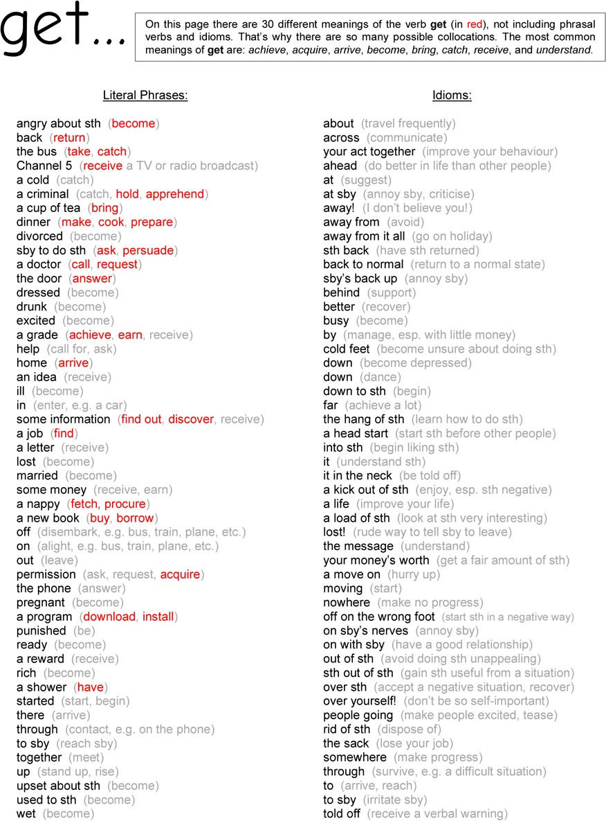

Unit 3.0

Health and the Human Body ANSWERS

Unit 3.0 Learning English:

Ex. 3.0.1 Answers will vary.

Ex. 3.0.2 Answers will vary.

Ex. 3.0.3 Answers will vary.

Ex. 3.0.4 Answers will vary.

Ex. 3.0.5 Answers will vary. Suggested answer:

not serious: | serious: | life-threatening:
cut  stomach ache headache rash toothache sunburn  cold | infection broken bone fever  allergy migraine diabetes flu asthma | cancer HIV / AIDS  heart attack Parkinson’s disease leukemia

Ex. 3.0.6 See diagram on p.6.

Ex. 3.0.7 Answers will vary.

Ex. 3.0.8 Answers will vary.

Ex. 3.0.9 1. ear. 2. neck. 3. nose. 4. eye. 5. throat. 6. leg. 7. ankle. 8. foot. 9. finger. 10. arm. 11. head.
12. stomach. 13. shoulder. 14. hand. 15. chest. 16. elbow. 17. toe. 18. back. 19. mouth. 20. knee.

Ex. 3.0.10 1. spine. 2. cheek. 3. trachea. 4. forehead. 5. wrist. 6. thumb. 7. tooth / teeth. 8. brain. 9. kidney.
10. hair. 11. muscle. 12. eyebrow. 13. thigh. 14. larynx. 15. vein. 16. toenail. 17. nostril. 18. intestines.
19. bowel. 20. liver.

Ex. 3.0.11 Answers will vary.

Ex. 3.0.12 Answers will vary.

Unit 3.1 Articles:

Ex. 3.1.1 1. a. 2. a. 3. a. 4. an. 5. an. 6. an. 7. an. 8. a. 9. a. 10. a. 11. an. 12. an. 13. a. 14. a. 15. a. 16. an.
17. an. 18. a. 19. an. 20. a. 21. a. 22. a. 23. an. 24. an. 25. an. 26. a. 27. a. 28. an. 29. a. 30. a.

Ex. 3.1.2 1. a) no article. b) The. c) a. d) an. 2. a) a. b) The. c) an. d) no article. 3. a) no article. b) a. c) The. d) an.
4. a) no article. b) the. c) a. d) an. 5. a) the. b) A. c) no article. d) An. 6. a) no article. b) an. c) a. d) the.
7. a) no article. b) the. c) an. d) a. 8. a) the. b) a. c) an. d) no article. 9. a) an. b) the. c) no article. d) a.
10. a) the. b) a. c) no article. d) an. 11. a) a. b) no article. c) an. d) the. 12. a) the. b) a. c) an. d) no article.
13. a) no article. b) a. c) an. d) the. 14. a) no article. b) the. c) an. d) a. 15. a) an. b) no article. c) the. d) a.
16. a) a. b) the. c) an. d) no article.

Ex. 3.1.3 4 singular countable nouns: book, watch, clock, umbrella. 4 plural nouns: t-shirts, buses, children, socks.
8 uncountable nouns: orange juice, information, furniture, beef, work, love, rugby, transport. 4 proper nouns: Richard, Microsoft, Monday, Europe. 16 common nouns: all the words, apart from the 4 proper nouns. 7 abstract nouns: information, work, Microsoft, Monday, love, rugby, transport.

Ex. 3.1.4 1. - . 2. - . 3. - . 4. the. 5. - . 6. the. 7. the. 8. an. 9. the. 10. a. 11. a. 12. - . 13. the. 14. - . 15. the. 16. - .
17. an. 18. the. 19. the. 20. the. 21. an. 22. - . 23. - . 24. the. 25. the. 26. - . 27. - . 28. a. 29. the. 30. the.
31. an. 32. - . 33. - . 34. the. 35. - . 36. a. 37. - . 38. the. 39. -. 40. the.

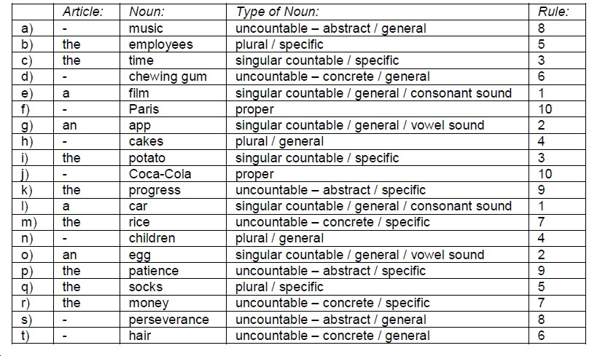
Ex. 3.1.5
Ex. 3.1.6
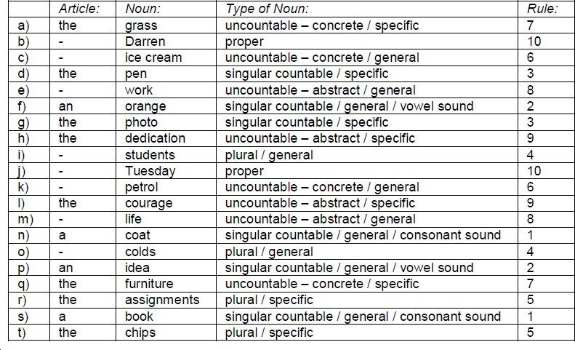

Ex. 3.1.7 a) 1. - . 2. the. 3. - . 4. a. 5. The. 6. a. 7. the. 8. - . 9. a. 10. - . 11. a / her. 12. - . 13. an. 14. a.
15. - . 16. a. 17. the. 18. - . 19. - . 20. - .

b) 1. E. 2. D. 3. E. 4. A. 5. B. 6. A. 7. D. 8. F. 9. A. 10. F. 11. A / G. 12. E. 13. A. 14. G. 15. E.
16. A. 17. C. 18. E. 19. E. 20. F.

Unit 3.2 SVOPT Word Order

Ex. 3.2.1 Answers will vary.

Ex. 3.2.2 Note for these pages: you could cut up the cards in any of these activities and mix them up for students to put back into order.

1. Answers will vary. Sample answers: 1. Lou. 2. his stall. 3. book. 4. to Greece. 5. her husband. 6. today.
7. Simone. 8. her daughter. 9. baked. 10. in the kitchen. 11. pictures. 12. every day. 13. Sue. 14. to Oliver.
15. charge. 16. in the office. 17. seeds. 18. yesterday. 19. The students. 20. the mess.

2. Answers will vary. Sample answers: 1. Mum. 2. the curtains. 3. damaged. 4. on the street. 5. clothes.

6. once a week. 7. Polly. 8. her suitcase. 9. met. 10. in the boardroom. 11.squirrels. 12. every day. 13. My brother. 14. me. 15. will take. 16. to work. 17. the oven. 18. later. 19. I. 20. work.

3. 1. Lenny raised his hand in class on Monday. 2. I read my book in the living room every day. 3. I’m watching a good film on my computer now. 4. Katy buys somegrapes at the greengrocer’s every week.
5. He’s presented his paper at the university today. 6. She is wearing her watch on her right arm at the moment. 7. We have painted all the walls in our bedroom this week. 8. Penny eats her breakfast in front of the telly every morning. 9. We will meet you outside the fish and chip shop later. 10. The boys sang some lovely carols at the school concert yesterday.

4. 1. We have booked our flights to Florida this morning. 2. He has two coffees at his desk every day at 8.30am. 3. We took a taxi to the station on Saturday evening. 4. I sell charity cards in the shopping centre once a year. 5. Joe will cut my hair in the salon in a minute. 6. Stephanie asks a lot of questions in class every day. 7. A thief has stolen a handbag from my mother’s car. 8. My friends carried their bags up the stairs a few minutes ago. 9. The girls wash their hair in the sink twice a week. 10. We’re going to play hockey on the playing field at 2pm.

Ex. 3.2.3

- Answers will vary. Sample answers:
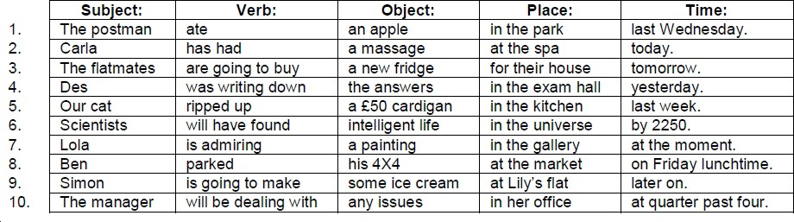

- Answers will vary. Sample answers:
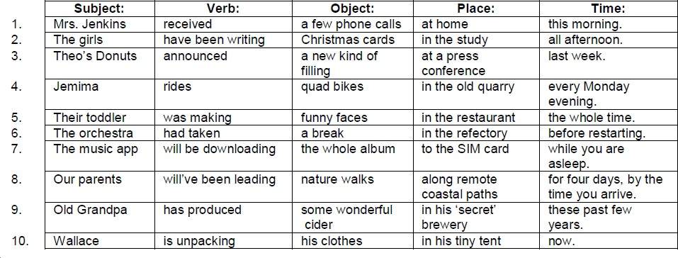

Ex. 3.2.4 Answers will vary.

Unit 3.3 Intonation

Ex. 3.3.1 1. a) Sentence stress is the sequence of stressed and unstressed syllables in a spoken sentence.
b) Connected speech is the group of techniques we use to connect syllables in a sentence in spoken English. c) Intonation is the way we put emphasis on different parts of a sentence, using varied pitch, volume, rhythm, etc.

2.

- I left early because I didn’t like the film.

- It was past ten o’clock, so we had to go.

- Jim bought some cornflakes and a pie.

- The book was good at first, then boring.

- a) tube. b) brother. c) three biscuits. d) remote control.

4.

- Do you like raw fish?

- We both enjoyed the gig, didn’t we?

- This is the right bus, isn’t it?

- What’s the date today?

5. a) 4. b) 3. c) 1. d) 2.

6. a) tone of voice. b) rhythm. c) extra emphasis. d) pausing for effect. e) pitch. f) speed. g) volume.

7. a) 5. b) 3. c) 1. d) 4. e) 2. f) 6.

- Answers will vary. Sample answers:

tone of voice | pitch | extra emphasis  on content words | volume | rhythm | speed | pausing  (for effect)
nervous | lower | no | quieter | broken | slower | no
surprised | higher | yes | louder | broken | slower | yes
tired | lower | no | quieter | intact | slower | no
disgusted | higher | yes | louder | broken | faster | yes

- Answers will vary.

10. i) a) 3. b) 5. c) 1. d) 4. e) 2. f) 6.

ii) Answers will vary.

11. Answers will vary.

Unit 3.4 Past Simple and Past Continuous

Ex. 3.4.1 1. went. 2. saw. 3. watched. 4. walked. 5. came. 6. enjoyed. 7. rained. 8. drank. 9. ate. 10. had.

Ex. 3.4.2 1. cooked. 2. wanted. 3. laughed. 4. made. 5. left. 6. tried. 7. thought. 8. bought. 9. finished. 10. went. Ex. 3.4.3 See p.47.
Ex. 3.4.4 See p.48.

Ex. 3.4.5 1. Which taxi company did you recommend? 2. Did you watch that film last night? 3. When did you start learning English? 4. Did you ask about your results? 5. Why did your boss call you this morning? 6. What did Tina say to you? 7. Did your parcel arrive on time? 8. How did your exam go? 9. Who did you invite to your party? 10. Where did the rest of the cheesecake go?

Ex. 3.4.6 1. Was the train leaving just as you arrived? 2. Were you going into the kitchen when the phone rang?
3. Were you reading funny posts on Twitter most of the night? 4. Were you thinking of inviting my mother to Tim’s birthday meal? 5. Was the bee buzzing around in an annoying manner yesterday? 6. Were you always making up in-jokes about Kevin? 7. Was your uncle running a bath when the earthquake began?
8. Were the children refusing to eat their salad when grandma arrived? 9. Was the meteorite heading straight for earth when it exploded? 10. Was Lena’s husband going to meet his son from a former marriage?

Ex. 3.4.7 Answers will vary.

Ex. 3.4.8 Answers will vary.

Ex. 3.4.9 1. yesterday. 2. tomorrow. 3. yesterday. 4. tomorrow. 5. tomorrow. 6. tomorrow. 7. yesterday.
8. yesterday. 9. yesterday. 10. tomorrow. 11. yesterday. 12. tomorrow. 13. tomorrow. 14. yesterday.
15. yesterday. 16. yesterday. 17. tomorrow. 18. yesterday. 19. yesterday. 20. tomorrow. 21. yesterday.
22. tomorrow. 23. tomorrow. 24. tomorrow. 25. tomorrow. 26. yesterday. 27. tomorrow. 28. yesterday.
29. tomorrow. 30. yesterday.

Ex. 3.4.10 See 3.4.5.

Unit 3.5 Common Regular and Irregular Verbs

Ex. 3.5.1 See p.57.

Ex. 3.5.2 See p.58.

Ex. 3.5.3 See p.59. Ex. 3.5.4
regular verbs: | irregular verbs:
want use seem arrive need try help ask  call play work clean | take go be know have get think make  say do run sing

Ex. 3.5.5 1. went. 2. brought. 3. chose. 4. got. 5. drove. 6. grown. 7. put. 8. thought, knew. 9. left. 10. swum.
11. wore. 12. stank. 13. stolen. 14. took. 15. wrote.

Ex. 3.5.6 1. woke up, heard. 2. jumped, switched off, woke. 3. switched on, was. 4. used, looked. 5. went, put.
6. got, brushed. 7. had, packed. 8. boiled, made, watched. 9. opened, picked up. 10. put on, checked, hadn’t. 11. left on, knew, got. 12. unlocked, opened, went. 13. locked, walked. 14. got into, turned.
15. put on, turned up. 16. looked, reversed. 17. drove, reached. 18. sat, drove. 19. changed, tapped.

20. put on, listened to. 21. played, sang along. 22. turned, parked, turned off. 23. got out, shut, locked, walked. 24. bought, headed. 25. entered, said. 26. got to, put down. 27. was.

Ex. 3.5.7 1. be. 2. read. 3. hear. 4. see. 5. buy. 6. break. 7. eat. 8. write. 9. sleep. 10. meet. 11. find. 12. bring.
13. grow. 14. think. 15. know. 16. become. 17. drive. 18. forget. 19. leave. 20. tell.

Ex. 3.5.8 1. Meik. 2. Bild. 3. Looz. 4. Yeik. 5. Dringk. 6. Let. 7. Hav. 8. Kan. 9. Doo. 10. Kach. 11. Ring.
12. Get. 13. Fiyl. 14. Geu. 15. Puut. 16. Pei. 17. Weir. 18. Send. 19. un d Stand. 20. Flai.

Ex. 3.5.9 Answers may vary. Sample answers: 1. got. 2. had. 3. made. 4. ate. 5. went. 6. heard. 7. thought.
8. came. 9. got. 10. got. 11. rang. 12. said. 13. thought. 14. heard. 15. put. 16. ran. 17. got.
18. drove. 19. told. 20. lost. 21. said. 22. wrote. 23. rang. 24. felt. 25. knew. 26. ran. 27. was.
28. went. 29. was. 30. bought. 31. read. 32. broke. 33. got. 34. put. 35. went. 36. heard. 37. held.
38. found. 39. let. 40. slept. 41. was. 42. took. 43. were. 44. gave.

Ex. 3.5.10 A few days ago Michael Morrison heard a really good programme about yaks on the radio. He remembered that he once read a very interesting book about yaks, and he decided to buy a copy and read it again. The next day he woke up early, had a shower, got dressed, ran downstairs, had breakfast, then phoned his friend Mandy Minton, who was a zoologist, but unfortunately she didn’t know about the book. Michael put on his coat and went outside. He drove to the library and asked the assistant if they had a copy of “Yaks of the World – Illustrated Edition”. The assistant thought for a moment and spent a few minutes checking the records on his computer, but nothing came up.

Michael left the library and walked into town. He stopped at the huge bookstore on Crompton Street and went in. He browsed the books, but could not find “Yaks of the World” anywhere – illustrated or not. A bookseller said that there was a book called “Just Yaks”, but Michael did not want it. A passing vegan told Michael to try a specialist bookseller on Marriott Street – a place where they sold unusual books. Michael thanked the lady and paid for a copy of “Bridge Repair Weekly” magazine. At the specialist bookstore on Marriott Street Michael felt sure that he would find the book he wanted, but after talking with a very quiet man in a long cardigan, Michael understood that they didn’t have any books about yaks – or indeed any other kind of long-haired animal. He exited the shop sadly and drove home.

He made a quick sandwich and watched an excellent online video about clever llamas on YouTube. Then he had a bright idea: “I haven’t looked online for the book yet!” He spent the next few hours searching for the book in online bookstores, auction sites, and forums – but without any luck. There was no such book as: “Yaks of the World – Illustrated Edition” “Maybe I dreamed it,” he sighed to himself and went to bed, where he did in fact dream about finding the book. In his dream he saw it at the bottom of his wardrobe, underneath a pile of socks. When he woke up he looked in his wardrobe, but there weren’t any books there. Only the socks.

A fews days later, Michael sat down at his computer and began to write the first chapter of “Yaks of the World – Illustrated Edition”. After fourteen years of hard work – including many trips to the zoo – it was finally ready to publish and it became a number one bestseller – among zoologists.

Unit 3.6 This, That, These, and Those

Ex. 3.6.1 Answers may vary. Sample answers: 1. Correct. 2. Correct. 3. This book is good. 4. These reports are interesting. 5. This book is good. 6. That flower was beautiful. 7. Correct. 8. That meal was lovely.
9. This book is good. 10. These reports are interesting. 11. That meal was lovely. 12. This report is interesting. 13. Correct. 14. Those flowers were beautiful. 15. Those meals were lovely. 16. Those flowers were beautiful.

Ex. 3.6.2 Answers will vary.

Ex. 3.6.3 Answers will vary.

Ex. 3.6.4 Answers will vary.

Ex. 3.6.5 1. This is a good book. 2. Those are empty seats. 3. That was an enjoyable film. 4. These are fast cars.
5. That was an amazing game. 6. This is a delicious meal.

Ex. 3.6.6 1. Look at those beautiful mountains. (D) Example of words that helped: ‘Look’ means that I’m pointing something out; ‘mountains’ – if you can see mountains, plural, they are not near, so we use ‘those’. 2. I’m getting off because this (P) is my stop. 3. I’ll use this laptop (D) and you use that one (P) over there. 4.

Who was that (P) on the phone? My cousin Alan. 5. That meeting (D) last night was a waste of time. 6. I need to borrow this book (D), but that librarian (D) said I couldn’t. 7. These (P) are my favourite plants. Yes, they are lovely. I don’t like those (P) over there by the gate. 8. Hi Paul, this (P) is Brian. Is this a good time to talk? 9. Who are you meeting this morning (D)? 10. ‘Please take another cake.’ ‘Is that (P) the last one?’ ‘Yes, but you can have it.’ 11. Mmm, those cakes (D) look delicous. I can’t wait to try one!
- Do you remember the 1980s? Yes, those (P) were the days! 13. This (P) is going to be the best party ever! 14. Mmm, these cakes (D) are delicious. Please have another one! 15. This (P) is Joe who works in the accounts department. 16. I prefer these trousers (D) to those (P) in the other shop. 17. What have you been doing this week (D)? 18. OK, stop. That (P)’s enough petrol! It’s full. 19. I think I’ll go to bed early tonight. Yes, that (P)’s a good idea. 20. ‘I really hate Clive.’ ‘That (P) was a nasty thing to say, Jo.’

Ex. 3.6.7 1. Those classes (D) began two months ago. Example of words that helped: ‘began two months ago’ – the time is not near; it is finished time (past simple), and ‘classes’ is plural, so we use ‘those’. 2. ‘Look! That (P)’s my favourite actor!’ ‘Where?’ ‘Over there.’ 3. This (P) is a good concert, isn’t it? 4. Did you go to Sally’s flat yesterday? No, but I’m going this morning (D). 5. ‘My grandma gave me these earrings (D).’ ‘They're beautiful. They really suit you.’ 6. Look at this coin (D) I found. 7. ‘This (P) is a picture of my classmates.’ ‘They look nice.’ 8. Those kids (D) are playing too close to the road. Go and tell them. 9. Did you watch that tv programme (D) I told you about? 10. They had to sell their car. Yes, that (P) was a shame. 11. I wish this bus (D) would start moving. I’m going to be late. 12. That (P)’s my house on TV!
- Look at this scar (D) on my hand. 14. That class (D) was so boring. 15. These guinea pigs (D) are so cute. They’re happy for me to stroke them. 16. Hi Mike. How are you? These (P) are my friends Millie and Liam. 17. Those (P) are my horses in the video. 18. Look at that man (D) over there. 19. ‘These are the last two pancakes.’ ‘Thanks, dad.’ 20. These classes (D) begin next week.

Ex. 3.6.8 1. Were you alright during that storm (D) last night? Example of words that helped: ‘last night’ – the time is finished (past simple), so it is logical that the storm has finished too; also ‘storm’ is singular, so we use ‘that’. 2. This jacuzzi (D) is so relaxing! 3. What are those kids (D) doing over by that old oak (D) tree?
4. I don’t like this very hot weather (D) we are having at the moment. 5. ‘Who’s this (P)? ‘This is my cousin John.’ 6. That jacuzzi (D) was so relaxing. 7. These new trams (D) are so cool. I can’t feel this one (P) moving. 8. Shall we park in this space (D) or the one over there? 9. ‘Have you finished exercise five?’ ‘No, I didn’t have time for that one (P).’ 10. ‘Take those bags (D) upstairs please.’ ‘Which ones.’ ‘The ones over there.’ 11. ‘Our date went really well, mum.’ ‘That (P)’s nice dear.’ 12. This (P) is what I’ve written so far. 13. That (P)’s a nice guitar you are holding. 14. This bag (D) is too heavy. I’m going to put it down. 15. ‘Are you using that spoon (D) over there?’ ‘No, I’ve got this one (P).’ 16. Here you are – put these bags (D) in the boot, please. 17. These shoes (D) are so uncomfortable. I can’t wait to take them off. 18. Those (P) who dislike classical music will not enjoy the concert. 19. Those (P) are my shoes on top of the cupboard. 20. These pullovers (D) belong to Jenny and the other ones are mine.

Ex. 3.6.9 1. This (P) is a wonderful meal! I hope it never ends! Example of words that helped: ‘is’ – the time is present – near to the subject – and ‘meal’ is singular, so we use ‘this’. 2. Those gardens (D) were so beautiful. I’m so glad I went on that day trip (D). 3. ‘This (P) is a rare stamp.’ ‘What about that one (P) over there?’ ‘Yes, that one (P) is rare too.’ 4. ‘Look – it says that bridge (D) is closed.’ ‘How can you read it from here?’ 5. These pages (D) contain gap-fill exercises, while the next page is a writing activity.
6. ‘This (P) is my dad.’ ‘It’s nice to meet you, Carla.’ 7. ‘Can I borrow those marker pens (D), please?’ ‘Yes, when I’ve finished using them.’ 8. ‘Let’s meet at 9.30am tomorrow.’ ‘OK, that (P)’ll be great.’ 9. That
(P) was a wonderful meal! I was hoping it would never end! 10. ‘Which milk do you want in your coffee.’ ‘This one (P). Here you are.’ 11. That bridge (D) was closed, so we had to turn round. 12. These stones
(D) have been here for thousands of years. Please don’t touch them! 13. That (P)’s my balloon flying in the sky! 14. I’m going to see my solicitor this afternoon (D). 15. ‘I forgot to set my alarm and now I’m late.’ ‘That (P) was careless, wasn’t it?’ 16. Hey! Who is responsible for this mess (D)? These kids (D), or those (P) outside? 17. Look! Those students (D) have got blue hair! Don’t laugh – they might come over!
18. That suitcase (D) was too heavy. 19. Those trams (D) were so uncomfortable. I won’t use them again.
20. These gardens (D) are so beautiful. I’m so glad I came on this day trip (D).

Ex. 3.6.10 Answers will vary.

Unit 3.7 Daily Routines

Ex. 3.7.1 Answers will vary.

Ex. 3.7.2 Answers will vary.

Ex. 3.7.3 Answers will vary.

Ex. 3.7.4 Answers will vary.

Ex. 3.7.5 Answers will vary.

Ex. 3.7.6 Answers will vary.

Ex. 3.7.7 Answers will vary.

Ex. 3.7.8 I wake up at 7.05am. I get up at 7.15am. I have/take a shower at 7.30am. I have/eat breakfast at 7.45am. I read the newspaper at 8.00am. I catch a bus to work at 8.30am. I start/begin work at 9.00am. I have/take a coffee break at 10.30am. I have/eat lunch at 1.00pm. I talk to my friend on the phone at 2.30pm. I send/write/read an email at 2.40pm. I go home at 5.00pm. I have/eat dinner at 6.00pm. I wash the dishes at 6.30pm. I play football at 7.00pm. I watch TV at 8.30pm. I play my guitar at 9.00pm. I read a book at 10.00pm. I listen to the radio at 10.40pm. I go to bed at 11.10pm. I go to sleep at about 11.20pm.

Ex. 3.7.9 A) Answers will vary. Sample answers: 1. read. 2. used. 3. had. 4. ate. 5. told. 6. was. 7. found.
8. helped. 9. went. 10. ran. 11. played. 12. bought. 13. felt. 14. gave. 15. made. 16. let. 17. heard.
18. took. 19. left. 20. sent. B) Time order: 4, 11, 20, 13, 6, 2, 19, 7, 9, 14, 16, 12, 8, 17, 5, 15, 10, 18, 3, 1.
C) Answers will vary.

Ex. 3.7.10 A) Answers will vary. Sample answers: 1. broken. 2. worked. 3. asked. 4. kept. 5. tried. 6. eaten. 7. signed.
8. watched. 9. led. 10. stood. 11. bought. 12. met. 13. drunk. 14. paid. 15. spoken. 16. danced. 17. won.
18. done. 19. visited. 20. got. B) Answers will vary.

Ex. 3.7.11 Answers will vary.

Ex. 3.7.12 Answers will vary.

Ex. 3.7.13 Answers will vary.

Purland English

Elementary English Course – Volume 2 Elementary Level (A1 / A2)
This is a brand new Elementary English course from Purland Training, written by Matt Purland, author of Big Grammar Book and the Talk a Lot Elementary series. Featuring easy-to-read, accessible text, and hundreds of interesting exercises practising grammar, vocabulary, and pronunciation, it’s a must-read for any learner at beginner or elementary level.

Inside Volume 2:

Volume 2 of 5 contains the next two complete units of the course:
3.0 Health and the Human Body and 4.0 Family, with the following lessons:

Unit 3: Health and the Human Body

3.0 Introduction

4.0 Introduction
Unit 4: Family

  - Articles
  - SVOPT Word Order
  - Intonation
  - Past Simple and Past Continuous
  - Common Regular and Irregular Verbs
  - This, That, These, and Those
  - Daily Routines
  - Wh- Questions
  - Yes / No Questions
  - Subject Pronouns
  - Describing People
  - Present Perfect and Present Perfect Continuous

Auxiliary Verbs
  - Punctuation Marks

info@purlandtraining.com

