Download this FREE book today from:
PurlandTraining.com

You Are The Course Book 2 – In Practice
Teaching English for one year without a course book

by Matt Purland

You Are The Course Book 2 – In Practice
Teaching English for one year without a course book

Public Domain

The author and sole copyright holder of this document has donated it to the public domain. Anybody can use this document, for commercial and non-commercial purposes.

“It is not so very important for a person to learn facts. For that he does not really need a college. He can learn them from books. The value of an education [at an institution] is not the learning of many facts but the training of the mind to think something that cannot be learned from textbooks.”

Albert Einstein, 1921

This book is for all the English teachers who have been misled by the course book into believing that they cannot teach without it

The International Phonetic Alphabet (IPA) is © Copyright the International Phonetic Association, and is used in this book with kind permission

Note: hyperlinks are provided in this text for the reader’s convenience. The author and the publisher are not responsible for the contents or reliability of any websites which are linked to and do not necessarily endorse the views expressed within them

You Are The Course Book 2 – In Practice

Contents

9 Contents
- Introduction
- Acknowledgements
- Meet the Students

20 Part 1
51 Part 2
83 Part 3
117 Part 4
151 Part 5
183 Part 6

Appendix 1 – Supporting Documents

Note: All teaching work was done at Study English Language Centre, Ostróda, unless otherwise stated. All material is by Matt Purland, unless otherwise stated

Part 1 – Supporting Documents:

- Written planning notes for Talk a Lot Intermediate Book 2 course book-style spread; Derby; 22.10.11
- The No-Course Book Course – Outline; first planning document for YATCB method; 24.02.12
- First Progress Tracker; April-June 2012
- Notes from Mode 1 process, including picture story work; Foresters; 26.04.12 & 10.05.12 Part 1 – Additional Documents:
- Example of home-made gap-fill material for a Mode 2 lesson about the new Apple iPad; 08.03.12
- Planning page for the same lesson; 08.03.12
- Mode 1 lesson; Piotr; 25.04.12 Part 2 – Supporting Documents:
232 | 80 Common Functions of Spoken English; material pack; 08.06.12
244 | Planning an English Class without a Course Book to Hold your Hand; material pack; an
 | example of how to plan for a Mode 2 lesson using the Mode 2 Lesson Planner; 04.06.12
253 | Revised Progress Tracker for individual students and groups; 07.06.12
254 | Connected Speech Game; material pack; 24.07.12
258 | English Banana Trust Summer School – Participant Questionnaire; emailed to
 | candidates on 09.07.12
260 | Improvisation in Teaching; notes for an online class; 31.07.12

Part 2 – Additional Documents:

- Mode 1 lesson with the topic of “Football”; Foresters; 31.05.12
- Example of using the Mode 2 Lesson Planner to build a three-hour lesson process using text from a FAQs page on an English bus company’s website; 13.06.12

Part 3 – Supporting Documents:

267 | The plan for the summer school that I sketched in my diary; 06.08.12
268 | Clear Alphabet – 48 Phonemes; from Clear Alphabet Dictionary
269 | Learn the Clear Alphabet with Flashcards; from Clear Alphabet Dictionary
281 | A random page from Clear Alphabet Dictionary for translation activity
282 | Translate 40 Famous People from the Clear Alphabet; from Clear Alphabet Dictionary
283 | Role Play 1 – Mei king Planz; from Talk a Lot Foundation Course
284 | Clear Alphabet Test (Sample); from Clear Alphabet Dictionary

Part 3 – Additional Documents:

- English Banana Trust’s First Summer School – official timetable; 31.07.12
- Diagrams I drew during the summer school to represent YATCB method; 14.08.12
- Discussion questions on the topic of “Travelling”; created by Nadia and Kata during the summer school; 15.08.12
- Mode 1 text created by the students at the summer school – 14.08.12
- Friday: Mode 1 text created by the students during Kata’s lesson, using the words that Marija had elicited – 17.08.12
- More pictures from the summer school – August 2012 Part 4 – Supporting Documents:
294 | List of Games and Warmers for Free Practice and Filling Time; September 2012
296 | My pictures – the results of a dictated picture session; pre-intermediate level Polish
 | students; Olsztyn; September 2012
297 | The Glottal Stop in English – handout for students; Olsztyn; September 2012
303 | Feedback form that I created to gather feedback at the end of a short conversation
 | course; Olsztyn; September 2012
304 | Discussion questions and ideas for role play situations; Mode 2 lesson on the topic of
 | “Harvest Festival”; 08.10.12

Part 4 – Additional Documents:

- You Are The Course Book – Mode 1 – in 60 Minutes; notes for a faster version of Mode 1; 28.08.12
- Sentences from Mode 1 texts; conversation course students; Olsztyn; 17.09.12
- My initial notes during a class which led to the PPRR activity; Olsztyn; September 2012
- Notes on forward consonant linking (FCL) in cc sound connections; September 2012
- Planning notes for a Mode 2 lesson on the topic of “Harvest Festival”; 02.10.12
- Discussion words template for 20 vocabulary words; 15.10.12
- Matching cards activity for a Mode 2 lesson on the topic of “How French Fries Are Made”; we cut up the cards and students had to match verbs and sentences; October 2012

Part 5 – Supporting Documents:

- The original running order of Mode 3 activities; 29.10.12
- Updated running order of Mode 3 activities – which still hangs on my classroom wall today! (09.11.12)
- Board plan of a PPRR session with Emilia on the topic of “Health”; 02.11.12
- Examples of Topic Template grids with various topics; November 2012; pages should be placed side by side
- Revised Progress Tracker which is suitable for use with Mode 3 lessons; November 2012
- Progress Tracker for an online course which used only Mode 3; November-December 2012
- Feedback given by students after the first class of that free online course; 16.11.12

321 | Progress Tracker for a free online course that I taught for an Egyptian company;
 | November 2012-February 2013
322 | Notes about You Are The Course Book and Mode 3 that I discussed during an online
 | lesson; 12.12.12
337 | A Standard 90-Minute Lesson for Elementary and Pre-Intermediate with New Method
 | [Mode 3]; 21.11.12; note it was called “New Method” – not yet Mode 3!
340 | Board plan from a Mode 3 Studying Language lesson with Emilia on the topic of “Toy
 | Catalogue”; 01.12.12
341 | Board plan from a Mode 3 Studying Language lesson with Dorota on the topic of “Toy
 | Catalogue”; 04.12.12
342 | New Talk a Lot Idea Book – Elementary Book 1; planning notes for a new kind of Talk a
 | Lot course book, incorporating YATCB techniques; November 2012
343 | New Talk a Lot Idea Book; proposed first unit on the topic of “Toy Catalogue”;
 | November 2012
348 | You Are The Course Book – Mode 3: Self-Study Quiz; proposed material that students
 | could use to practise YATCB methods at home and check the answers themselves
352 | Study English Language Centre Progress Test 1 (Sept-Dec 2012); 03.12.12
355 | Individual Record of Achievement; example of a proposed certificate, which was not
 | used
356 | Sound wave comparison of a beginner student’s voice with mine; based on Progress
 | Test 1 recordings; 11.12.12
358 | Rough draft of the first Study English Language Centre syllabus for January-March 2013;
 | 02.12.12
359 | Obviousness prompt cards, which can be cut up and shuffled; also, text version of the
 | cards which could be copied and used in online classes; December 2012
360 | Outline for a proposed online YATCB method teacher training course; 12.11.12
361 | Homework produced by Krzysztof after a Mode 1 writing process in class; text type: a
 | children’s story; January 2013
362 | Homework produced by Agnes after a Mode 1 writing process in class; text type: a
 | children’s story; January 2013
363 | Dorota’s Mode 1 text process: vocabulary – elicited; first draft (initial ideas – dictated for
 | me to type); second draft (corrections), and final draft – handwritten for homework; text
 | type: a children’s story; 18.12.12 & 02.01.13
367 | Board plan for Tomek and Bartek’s Mode 1 lesson, stage 2.1 (initial ideas); text type: a
 | children’s story; 20.12.12

Part 5 – Additional Documents:

- My first notes on a variation of Mode 1, which would develop into Mode 3; 26.10.12
- Outline for a 4-day intensive course with Krzysztof P. – using only the brand new Mode 3 model; 29.10.12-02.11.12
- Prompt sheet that I hung on the wall to remind me of effective discussion questions that I could potentially ask in any topic; 28.10.12
- List of discussion words in the topic of “Cars”; I gave this word list to students instead of using the little cards, as a way of more quickly injecting the vocabulary into the lesson; 10.11.12
- Outline of a new activity in the vocabulary stage of a YATCB lesson; 20.12.12

Part 6 – Supporting Documents:

- Revised Progress Tracker which is suitable for use with Mode 1, 2, and 3 lessons; 08.02.13
- Verb Forms Revision Test – Sample Answers; from You Are The Course Book
- Word Classes in English – Revision; handout for reference given to students at Input Lesson #1; January 2013
- Board plan from Input lesson #2 (Connected Speech) with Krzysztof P. ; 04.02.13
- Connected speech homework by Agnes, after Input Lesson #2; 06.02.13
- Connected speech homework by Tomek B., after Input Lesson #2; 14.02.13
- Input Lesson #3 – Improvisation and Imagination; lesson notes; March 2013

384 | Board plan for Dorota’s Input Lesson #3; 07.03.13
385 | “What’s just happened?” game cards, used in Input Lesson #3; March 2013
386 | Homework written by Bartek to demonstrate the difference between using basic
 | vocabulary words and higher-level words; 14.03.13
387 | Board plan of Foresters’ Mode 3 lesson on the topic of “The Environment”; 08.01.13
388 | Example of one of the Foresters’ picture stories; from Mode 3 The Environment (Using
 | Language) lesson; January 2013
389 | Original picture story, created by Dorota for homework after The Environment (Using
 | Language) lesson on 15.01.13
391 | Mode 3 Office (Using Language) lesson notes; w/c 18.02.13
394 | Board plan for a Mode 3 Office (UL) PPRR activity with Bartek, Tomek, and Sebastian;
 | 21.02.13
395 | Dorota’s Mode 1 text – stages 1, 2.1, 2.2, and 2.3; text type: a factual text, e.g. a
 | magazine article; 26.02.13
396 | Bartek and Tomek’s Mode 1 text – stages 1, 2.1, 2.2, and 2.3; text type: a factual text, e.g.
 | a magazine article; 28.02.13
397 | Krzysztof P.’s Mode 1 texts – stages 1, 2.1, 2.2, and 2.3; written during an online lesson
 | on 15.03.13
398 | My first example of a completed Auto Mode 3 page (in portrait mode); 25.02.13
399 | You Are The Course Book – Auto Mode 3 blank template; finished version in landscape
 | mode; March 2013
400 | Auto Mode 3 – example completed by Agnes for homework; 04.03.13
401 | Auto Mode 3 – example completed by Bartek for homework; 07.03.13
402 | Mode 3 Beginner (SL) board plan on the topic of “Easter”; 60-minute lesson with Bartek
 | (company); 26.03.13
403 | Mode 3 Beginner (SL) lesson – comparison with using the course book; 28.03.13
405 | Mode 3 Beginner (UL) board plan on the topic of “Easter” – PPRR activity; 60-minute
 | follow-on lesson with Bartek (company); 02.04.13
406 | Mode 3 Beginner (SL) annotated board plan on the topic of “Public Transportation”; 50-
 | minute lesson with Irek, who chose the topic; 03.04.13; the notes show the Mode 3
 | Beginner process
407 | Differences between YATCB Method and Standard Practice; notes after researching
 | phonetics and phonology; March 2013
411 | Study English Language Centre – Student Questionnaire; March 2013
412 | General Principles of You Are The Course Book Method; manifesto; 08.01.13
413 | Blank syllabus for YATCB lessons over a twelve-week period; March 2013
414 | My proposed syllabus for Term 3 at Study English, Ostróda – April-June 2013; 13.03.13
415 | Feature article that I wrote about YATCB method, commissioned by Guardian Online
 | website, but unused; January 2013

Part 6 – Additional Documents:

- Example of students from Egypt creating their own discussion questions based on elicited vocabulary during a Mode 3 (UL) class online – topic: Hospital; 04.01.13
- A matching activity made by The Foresters for homework; 12.02.13
- Mode 3 The Environment (UL) planning notes for the picture story activity; 15.01.13
- The 40+ vocabulary words from Emilia’s presentation that we checked for stress and vowel sounds; 16.02.13
- The Foresters’ Mode 1 text – stages 1, 2.1, 2.2, 2.3, and 5; text type: a factual text, e.g. a magazine article; 26.02.13
- My feedback on students’ presentations during Mode 3 Office (UL) lesson; 19.02.13
- Notes written by Emilia about Past Perfect form during a Mode 3 (SL) lesson on “Fame and Fortune”; 15.03.13
- Notes about an improvisation lesson with Tomek (company) on 31.01.13
- Board plan from a Mode 3 (SL) lesson with Bartek and Tomek on the topic of “Fame and Fortune”; 14.03.13
- Board plan from a Mode 3 (UL) lesson with Dorota on the topic of “Fame and Fortune”, showing the template for the Create a Celebrity activity that led into role playing; 19.03.13

- Emilia’s written homework after the chat show improvisation lesson (M3 UL Fame and Fortune; 23.03.13)
429 My planning notes for Mode 3 (UL) lessons on the topic of “Fame and Fortune”, with notes taken during the lessons, including presentation feedback for Dorota, role play feedback for various students, and notes about my role play character, prolific author Herbert Stevenson; 17.03.13-23.03.13

Appendix 2 – Complete Set of Talk a Lot Discussion Words – for use in Mode 3 lessons

Note: Most of this material has been published before; please see Talk a Lot Elementary Books 1-3 and Talk a Lot Intermediate Book 1

- Blank Discussion Words Page
- Index of 42 Topics with Discussion Words
- 10 Famous Events in British History
- Airport
- Animals
- Australia
- Bonfire Night
- Books
- Cars
- Christmas
- Clothes
- Colours and Numbers
- Crime
- The Environment
- Fame and Fortune
- Family
- Films
- Food and Drink
- Free Time
- Getting a Job
- Health
- Home
- Hospital
- Hotel
- The Human Body
- Internet
- Learning English
- Life Events
- Media
- Money
- Music
- Nature
- Office
- Places in the UK
- Politics
- Problems
- Railway Station
- Shopping
- Sport
- Town
- Toy Catalogue
- Transport
- Weather
- Work

You Are The Course Book 2 – In Practice

Introduction

It’s been a great year! I’m at the end of a whole year teaching English with You Are The Course Book method – and I’m still revved up and raring to go for more lessons! Even today I had a Mode 2 lesson with a Pre-Intermediate-level student on the topic of prison food and how it compares with hospital food, based on a real newspaper article, and the vocabulary and teaching points that came up were fascinating – for both of us.

This book is for teachers who want to find out more about this new method and perhaps learn to use it. Ideally, you should be familiar with the first book – You Are The Course Book – because it sets out the stall, and you will learn all about how Modes 1 and 2 work. Because this is a sequel, I haven’t bothered to repeat all that stuff here. If you need a quick introduction to the method, you could try the article that I wrote for an online newspaper (p.415).

The main body of this book consists of a narrative describing the remarkable journey that my teaching took me on during the year April 2012 to March 2013. During this account, I mention many documents that you can find in Appendix 1, from p.219 onwards. Much of this is evidence to show how the method works: board plans, homework by students, and so on. There is also an Appendix 2, from p.432, which contains all of the Talk a Lot discussion words to date.

I have written this book because I wanted to reveal how I have been teaching, in the hope that you will be able to gain something from this method, and share in the pleasure that it brings too. My hope is that more English teachers will learn how to encourage their students to be the course book – to provide the lesson material – rather than relying on the course book to do everything for them. This book describes how I have done it – and how the method has developed up to this point. All I can say is that it really does work! I’m a satisfied teacher who can’t wait for the next lesson – and my students are really happy with their progress as well.

If you would like to contact me to find out more, or to tell me about your experiences with You Are The Course Book method, please feel free to email me here: info@purlandtraining.com. I’d love to hear from you!

Thanks to all my students who have helped me with this work. It’s been fantastic working with you! You can meet them on p.16.

Enjoy teaching English!

Matt Purland

Ostróda, Poland, 4th May 2013

You Are The Course Book 2 – In Practice

Acknowledgements

A big thank you to my wife and family for their love and support and for letting me write this book.

I would like to thank all of my students at Study English, Ostróda, who have participated in a full trial of YATCB method over the past year. Meet them over the next few pages! I couldn’t have written this book without you! Thank you for giving me permission to share examples of your work in this book. I really appreciate it!

Thanks also to the other students I have taught throughout the year, especially the wonderful summer school teachers, Nadia, Larisa, Kata, and Marija (see pp.291-292).

Thanks to the staff and students at the other schools – in Olsztyn and Ostróda – where I have tried out this method during the year:

Up & Up Szkoła Języków Obcych, Ostróda King’s School of English, Ostróda
English Perfect Szkoła Języków Obcych, Olsztyn

Thanks to the staff and students I have worked with at various online schools during the year – in particular Brigitte, Hiroki, and Dario at:

WizIQ.com http://www.wiziq.com/

A special thank you to the organisers and helpers at the English Banana Trust Summer School, in particular Glyn and Diana who did so much to organise it, and to Robert who gave up part of his holiday to spend five days with us recording the teaching sessions.
Thanks for making it possible!

Finally, thank you to everybody who has given feedback regarding the first You Are The Course Book, especially Richard, Fabiana, and Nate.

Meet the Students

Find out more about the students at Study English, Ostróda 2012-2013, who have been working with You Are The Course Book method:

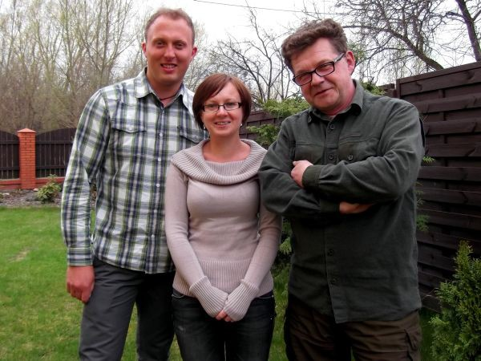
The Foresters (L-R) Krzyzstof, Agnes, and Lech (Elementary)

Lech and Krzyzstof are forest rangers while Agnes works in administration with the Forestry Commission. They have been studying at SELC since January 2012; before YATCB method we worked with a course book and worksheets.

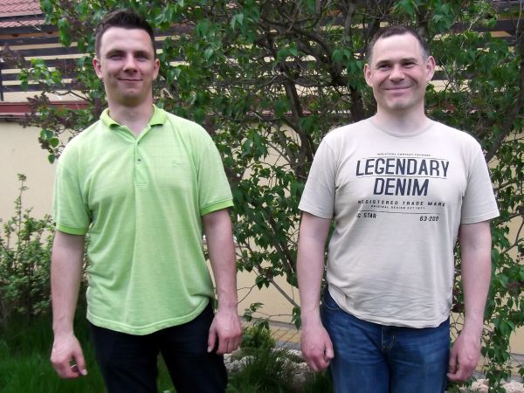
(L-R) Bartek and Tomek (Pre-Intermediate)

Bartek is an IT specialist and Tomek is an engineer at a local heating company. They have been studying with me since September 2011 (from Beginner level); before YATCB method we worked with a course book and worksheets. Sebastian (Pre-Intermediate) is a manager at a local boat building company. He joined the group in February 2013.

Emilia (Pre-Intermediate) and Krzysztof (Elementary)

Emilia is a research scientist at a local university. Her fiancé Krzysztof is an engineer working for a major firm in The Netherlands. They began classes in October 2012.

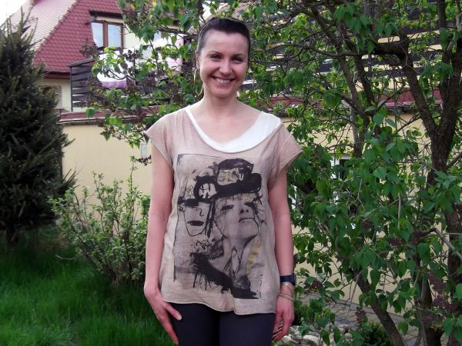

Dorota (Pre-Intermediate) Dorota is an accountant. She began classes in December 2012.

Dario (Intermediate)

Dario is an Italian builder who joins me for regular lessons on Skype. He has been having private one-to-one lessons since November 2012 after attending my free YATCB classes on WizIQ.com.

Danuta (Beginner)

Danuta began lessons in October 2012, but had to give them up in January 2013.

Piotr (Pre-Intermediate)

Piotr is a delivery driver; he attended classes between September 2007 and June 2012, starting at Beginner level. This year he is having a break from studying to build his house.

The Company

In September 2012 I began working with a group of employees from a local road maintenance company:

Hania (Pre-Intermediate) is a manager
Tomek (Pre-Intermediate) is the Health and Safety Manager Bartek, Irek, and Marta, (Beginner) work mainly in the office

Bartek (Beginner)

Irek (Beginner)

My simple classroom setup at Study English, Ostróda

In You Are The Course Book method, the essential resources for teaching English are...
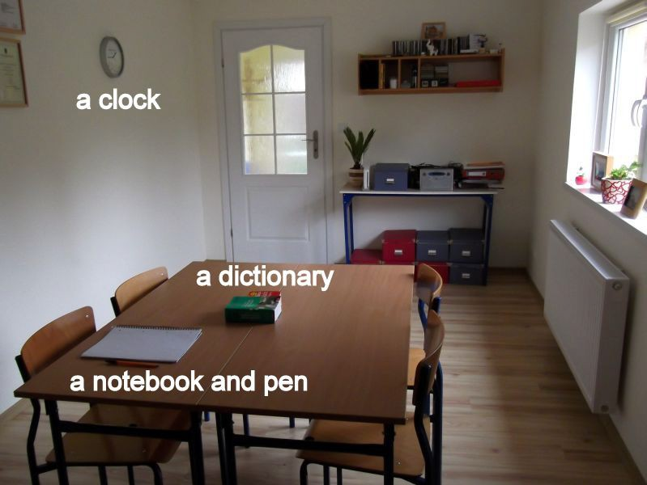
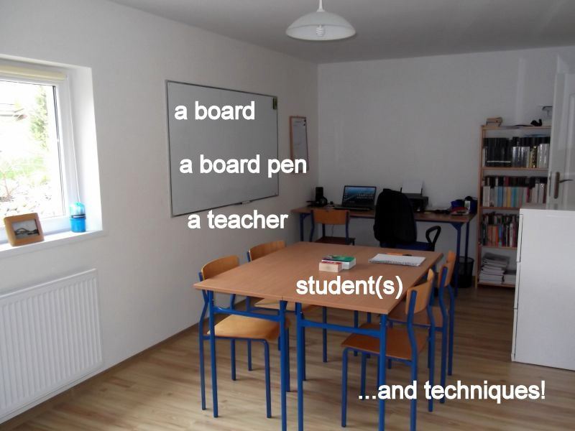

Part 1 February to April 2012

Thanks for agreeing to meet me for these few weeks.

It’s no problem. I can give you the next six Monday nights, but after that I’m starting a Kung Fu class.

You don’t need to defend yourself do you?

You haven’t seen my students, have you? Some of them are horrible little monsters. Only joking. So where do we start off?

Well, I’ve been on what I can only describe as a teaching odyssey for nearly a year now.

Oh dear. I can tell it’s going to get heavy. Is it?

No, well, it might do a bit. It started in February 2012. I was still writing my new course book – Talk a Lot Intermediate Book 21. It was what I thought was going to be a new course book, but I was getting fed up with writing it. I was starting to get the impression that it wasn’t necessary to write another course book, because each unit had the same elements: vocabulary, text, grammar point, pronunciation, listening, and so on. I was starting to get the idea that all you really needed for the unit was a text, because from the text you could pull out everything else: the vocab words that you wanted the students to learn would be the new words or most difficult words from the text; the grammar point could be something that was a natural part of the text, e.g. present continuous form; the text and listening activities could be given through the method of discovering the text,
e.g. a dictation or a reading race; and the sentences for practising pronunciation could be grabbed from the text. So all you needed was a text. The activities could be the same, or similar each time. It wasn’t necessary, then, for me to write more and more units of this course book.

So what did you do?

1 Purland, Matt. Talk a Lot Intermediate Book 2. Ostróda: English Banana.com, 2012. Hardback. Available for free download: https://purlandtraining.com/ See p.221 for original planning notes for this book.

I stopped writing it. And I started to develop the You Are The Course Book Method, which led to me writing the book, You Are The Course Book2, which was published online in May 2012.

And what has been the response?

Well, the raw figures are not encouraging. The book is on Scribd.com as a free download and so far only around 7,700 people have “read” it, which means that they have opened the page with the book in their browser. And there have been 993 downloads.

Pathetic.

It’s not the response I was hoping for.

So why are you keeping on with this project?

Because I need a method to teach by. I don’t want to use a course book. I’m just sharing what I’m doing with the world. If the world doesn’t want to listen it’s their problem! But I have to teach 20 hours a week and I need a method I can use that I enjoy – that gives me great satisfaction.

So you are really a selfish teacher then? All this is for your own benefit.

It’s funny you say that, but I was going to call this book The Selfish Teacher. It’s an oxymoron, isn’t it? But I thought I’d better not. I don’t know if I will even publish this. I just know that since I started using YATCB in my lessons I’ve begun to really enjoy teaching again and I’ve gathered loads of tips and material on the way that I would like to share with other people – whether they would like to know about it or not, I guess! The other point is, that a writer’s gotta write. If I can’t write course books or photocopiable worksheets any more – because we don’t need them any more in YATCB
– then what can I write, if not books about teaching techniques?

2 Purland, Matt. You Are The Course Book. Ostróda: English Banana.com, 2012. Hardback. Available for free download: https://purlandtraining.com/

Or just do something different. Find a different hobby. Have you thought of that?

Yes, but what? And anyway, I feel compelled to share my findings.

OK then. Go ahead. Share your findings. At least I’m listening. For the next six weeks anyway. Like I said I’m starting Kung Fu after that.

I need to explain about what work I was doing at the beginning of 2012. I had various different teaching jobs, which required different teaching methods. I was working with students in their late teens and early twenties from Saudi Arabia four mornings a week. For that job I had to follow a course book and a syllabus that couldn’t really be deviated from, because lots of groups at the school were following the same syllabus. Then twice a week in the afternoons I had classes with a small school near to where I live. Again, I had to use a course book with the students, who were young Polish school kids in their mid-teens. Most evenings I had students who came to my home to study. So they were our private students and I had no restrictions on what I could teach them, or the methods I could use. They were my “guinea pigs” and often got to try out whatever worksheets or Talk a Lot material I was working on at the time. I also had a few online lessons in the evenings – often later, e.g. at 8 or 9pm – and with those students I used mainly discussion questions from the Talk a Lot books. I had already written 34 different Talk a Lot units by then! I classified each group as follows: the morning classes were just for the money, and it was good money. Although I could from time to time teach them something a little different, like my connected speech method, or group games. The afternoon job at the school was my least favourite, due to the combination of having unmotivated and bored high school kids, and having to teach them with a boring course book, with little or no deviation for what I considered more interesting and more useful lessons. It’s the school I mention in You Are The Course Book, where M. is the owner and Director of Studies.

Ah yes. Did we ever find out who this mysterious M. was?

Ha ha, I don’t think it would be fair to say, bless her. Let’s say that we remain firm friends, although I’m not working at her school this year. So, where was I? The afternoon and evening classes with my private students were the best times, as I said,

because I could choose what we did. Although the syllabus was non-existent. We just did whatever I was working on at the time. Some of them followed a course book, because they had requested it, and that was boring for me. The evening lessons online were on the most part rather tedious; partly because I had been teaching all day – some days – and partly because it’s difficult to feel a connection with people you can’t see – just through their voices. Again, these lessons were just about the money. Meanwhile I was teaching every week on WizIQ.com – an online platform – where I had a group of dedicated regular students who seemed interested in whatever passion I presented – whether a new worksheet, book, or a new way of teaching pronunciation. I enjoyed those lessons too – probably because I had control.

OK, we get it. You like to be in control of what you teach. I’m getting that loud and clear!

But if you think that what you would like to teach is better than what you have been told to teach, you have a conflict, and if money is involved it becomes more difficult, because you need to earn money, but you long to try out your own methods and work. So this is the problem I had. I had to teach to earn money, but I couldn’t teach how I wanted to – most of the time. And when I could teach my way – with my private students – I didn’t know exactly how to go about it. After 20 or 25 hours of teaching per week I would often feel discouraged, like I don’t even like teaching or want to teach.
And yet I knew that I loved to teach. So this was the beginning of the process. Like I said, I had decided not to write any more of Talk a Lot Intermediate Book 2, but I was exploring how to use the template of elements that could be in each lesson. I remember laying out a huge sheet of paper and writing my manifesto:

THE NO-COURSE BOOK COURSE – OUTLINE (24.02.12)3
- VOCABULARY
- READING
- GRAMMAR POINT
- PRONUNCIATION
- VERB FORMS REVISION

3 p.222

- FREE PRACTICE
- WRITING (CONSOLIDATION)

For each section I had listed loads of different possible activities. This was enormously encouraging and inspiring – and it still is as I look at it today. Because this is what we need to do in the lesson. This is what the course book includes. It’s what our students need to practice. So once we have established that we can think about building lessons – not based on a course book, but based around a real text.

Something like a paragraph from a book, or a newspaper article .

Exactly. Why use specially written texts when real texts contain real examples of English language? I started to collect suitable articles from online newspapers that I would be able to use with this kind of lesson. This is where Mode 2 of YATCB came from. The benefit was that I could choose an article that I felt was interesting – first and foremost – to me.

The selfish teacher again?

Yes, but my reasoning was that if I was excited about the lesson, I would transmit some of my feeling to the students. My taste in online reading material is quite quirky, as you can see from some of the titles below, but I was never going to use an academic text about the discovery of fossils, for example. Of course I picked texts which I thought my students would be interested in too. Here are some of the articles that I didn’t use, but they would have been absolutely suitable, with interesting vocabulary (including idioms, phrasal verbs, and slang), and an intriguing premise that would surely spark some sort of discussion and interest among my groups:

“Ceefax service switched off in many areas today” (Digital Spy) “49% of adults can’t do basic Maths” (The Sun)
“Twitter appeal saves couple’s wedding day” (The Guardian) “World record human dominoes bid is taken lying down” (The Sun) “A user’s guide to nanotechnology” (The Guardian)
“‘Do aliens exist?’ The question Brits most want answered” (The Sun)

“Homeless to act as Wi-Fi hotspots” (The Sun)

Anyway, these are all the kinds of articles that we usually find in a general English/ESL course book. The difference is that these articles are written for English native speaker readers, while the articles in a course book have been specially written for a particular level, or adapted and simplified. Because of this I believe that the real texts are, by definition, more interesting for learners, because by using them we are putting the learners on a level playing field with “real” English native speakers, rather than patronising them with simplified texts. In general, the course books can’t use real texts because they would have to pay too much for the rights. For the same reason, I can’t reproduce any real texts in this book and when I have used texts to give an example of Mode 2 I have had to go to places like Project Gutenberg and find out-of-copyright material. By the way, I was shocked a few months later when I realised that one or more of the texts in the flagship ELT course book that I was using (that I had to use) with my Saudi students had been copied virtually wholesale from Wikipedia! That’s open source, but in YATCB method you can use any text, copyright or not, because you are not publishing it, but simply using it in the classroom with your students. Because the course books have to be published and sold – to make money – the choice of texts is restricted.

Here are some of the real texts that I did use with my classes:

“British woman paid to eat chocolate around the world” (Digital Spy) – used with my Saudi students
“Woman resorts to eBay in attempt to find job” (Digital Spy) – used in various classes “Latest Apple iPad has screen that’s crisper than HDTV” (The Sun) – used in various classes
“Wacky Sarah spends £20k on a lot of Pony” (The Sun) – used in various classes

You can probably still find them all online. I also used some of the texts from the work book element of the course book that I was working with to try out Mode 2 lessons. The method went as follows:

- Take any text – which is level-appropriate to your students

- Underline up to twenty new or “higher level” words and phrases, including idioms, phrasal verbs, and slang
- Think about how to give them the text; the method could be via dictation, via students matching a cut-up text, via a reading race, and so on
- Think about what grammar point you could pull out from the text; what tenses are used? How can you best practise them, e.g. sentence blocks; what constructions may be unfamiliar to your students, etc.
- Find a few whole or part sentences that could be suitable for studying sentence stress and connected speech
- Think about what free practice activities this text inspires, e.g. a debate, role plays, think of some discussion questions, and so on
- Think about what kind of written text you want them to practise writing (e.g. a formal email). This could be given as a homework task

So you see that from one short text – something real and interesting for both me and my students – we had enough material for around 3 hours of lesson time, i.e. two x 90 minutes lesson blocks. As I wrote in YATCB one of the main anxieties for the teacher is how to fill the allotted time. This method – Mode 2 – answers that question quite comprehensively. In fact, there is usually not enough time to do everything and we run out of time.

Yes, I’ve often heard you complaining about that.

You just need a text. Of course, in Mode 1 the students create the text, and in Mode 3 it is slightly different, because everything is speeded up and there is no need for a long text.

Mode 3? I’m intrigued.

I’ll come to that later on. I’m still in the early days of YATCB. Before I had written the book even. In March I was still intending to publish a very long and comprehensive updated Talk a Lot Handbook, and all this about Mode 2 was going to be part of that. YATCB was still really an adjunct of Talk a Lot. But in the end I ditched all my plans to make a comprehensive guide to Talk a Lot, and just settled for a brief polemical book – You Are The Course Book – which outlined the problems that teachers have with course

books, but didn’t just state the problems but also suggested a possible solution: Mode 1 and Mode 2.

So what did your students make of working in this style then, with just a real text?

They enjoyed it. Ha ha, of course I would say that, wouldn’t I? I didn’t do a satisfaction survey after each lesson, but the students worked well and responded really well to these lessons. With some groups it was a change for them from doing the normal course book lessons. It was a real text, so that was something different. There was certainly more
non-standard language in the texts that in their normal course book, e.g. idioms, which made it interesting for them. Let’s look at one of the real texts I used, from The Sun Online. You know, The Sun is a good place to look for texts for pre-intermediate- intermediate levels because their target reading age is around 10 years old. It’s not complicated language, but it’s interesting linguistically. I can’t reproduce the text, but here are the 18 keywords that I chose for my pre-intermediate level students to learn. They are the words from the text that are the most likely to be difficult for them:

crisper (comparative adjective) unveil (verb)
tablet (noun)
super-sharp (compound adjective) processor (noun)
rumours (noun) display (noun) mobile device (noun) resolution (noun)
improvements (noun) on-board (adjective) megapixels (noun) dictation (noun) showcase (noun)
redefined (past participle) potential (noun)
poster child (noun)
post-PC world (noun phrase)

The text is interesting to me, because I love reading about new technology, but also for my Saudi students, many of whom carried iPhones and all manner of gadgets around with them to classes. I guessed – rightly – that they would interested in learning about, and in being able to describe and talk about in English, the new features in the – then – new iPad. At the same time I could use it as an opportunity to teach them about word stress (suffixes are not stressed; compound nouns are stressed on the first syllable; we always stress the syllable before -tion, and so on); about comparative adjectives and

present perfect passive form – which was rife in the text, e.g. “...has been introduced’; and all the other things which this method gives space for, e.g. sentence stress, debating, question forms, and so on. I quickly jotted down 8 discussion questions that we could use with this text, e.g.

- Do you have any gadgets? What are they? Do you like them? Why? / Why not?
- Do you usually buy Apple products? If yes, how often? What? Why? If no, why not? Would you consider...?
- What is the environmental impact of devices such as the iPad – including production, usage, and disposal?
- Could you manage for one day/week/month without any gadgets? If no, why not? Describe the effect it would have on your life.

This took just a few minutes. Everything was suggested by the topic and the text. I had a few more free practice activities up my sleeve too:

  - Prepare and give a launch presentation for this product, or another gadget
  - Role play: your gadget is stolen on a train; what can you do to get it back?
  - One group: try to persuade your “parents” to buy you an iPad – think of the advantages; another group is the “parents” – outline the disadvantages of such a device; ultimately come to a compromise

Because I had chosen the text, the vocabulary words, the grammar point, the sentences for pronunciation practice (sentence stress and connected speech), and the free practice activities – because I had invested time preparing the lesson4 – I felt an emotional connection to it, and I looked forward to delivering it. Plus, once it was prepared I could use it again if I wanted to. I probably won’t, because part of the fun is being able to choose any text and this one is too out of date for me now. This is in contrast to the course book, where I don’t need to prepare the lesson: everything is written for me; the grammar and vocabulary is easy and well known to me as a native speaker – as is the spread itself, because I probably taught the same book last year. But this lesson about the iPad is new to me. It’s fresh.

4 See p.229 for planning notes and p.228 for student handout

So this is where you got the slogan “The Course Book is All Around You”?

That’s right. At this stage, I was confident that all you needed to plan a lesson was a text
– any suitable text – that you could grab from anywhere, and use as the “material” for the same basic activities. As I kept ruminating that we could do the same things – vocabulary, reading, grammar point, etc. – with any text, it came to me that the students could produce this text, and that this process could be part of the lesson content for them. I was still very much feeling my way. In one memorable lesson with my low- elementary level Saudi group I stumbled by accident on the technique of asking each student in turn to give me one sentence of the text, that I would type on the laptop. The results were being projected onto the screen behind me, so everyone could see the text as it was being built. I quickly realised that I was onto something valuable, and with more practice I standardised the Mode 1-style lesson:

- Vocabulary – students suggest interesting and random words
- Text
  - First Draft – Getting the Initial Ideas (whole group)
  - Second Draft – Corrections (whole group)
  - Third Draft – Improvements (pairs or small groups)

This was fascinating to me and deeply exciting, because in Mode 1 students could do everything themselves! The teacher could stand back and simply be a guide, ensuring that learning points were highlighted and noted. It was interesting to me that it didn’t matter what errors the students made at stage 2.1 – whether projected or written on a white board – because they would be corrected at Stage 2.2, with the whole group suggesting what the errors were, and then improved at Stage 2.3, again with the whole group participating. The teacher was just a guide – eliciting everything. That was the keyword from when I first trained to be a TEFL teacher in February 1999. Elicit – don’t tell! So within the space of about three months (February to April) I had been given two different teaching formats with which I could replace course book learning forever.

Except you still had to work with the course book in your paid school jobs, didn’t you?

Yes, although I was able to sneak a Mode 1 or Mode 2 lesson in there from time to time. Actually, having to use the course book just further underlined how far it was from what I wanted to do – how far away it was from my new YATCB method.

Let me give you a real example from that first accidental Mode 1 lesson. There were 11 late-teenage Saudi students who were at low elementary level. Their desks were arranged in a horseshoe shape; they were sitting two to a desk, side by side; my desk was at the front. I was facing them. In the centre of the wall at the front of the class was an interactive whiteboard – the pride of the school! – and on the left there was a smaller whiteboard. I asked the students to shout out keywords, which I wrote on the board.
They could be any words within categories that I gave them, like “colour”, “shape”, “person”, “place”, “thing”. I also stipulated that they had to be “interesting and random”.

So you were filtering their ideas from the start, really.

Yes, but I think it was more a quality control thing. The first impulse of the students seemed to be to say the names of things around them, like “table”, “chair”, “book”, and so on. You can see this by the way they gave the name of one of the students – Abdulrahman – when I asked for a name – any name. I also attempted to get words from students who were not taking part, or who were shy, rather than just getting all of the words from the loudest and most active two or three students. My feeling was that it didn’t really matter what the words they chose were, because we could still examine them for stress, sounds, schwa sounds, etc. – but they had to be interesting to the students in the class. These are some of the keywords we got: president, the Moon, Abdulrahman, stingy, purple, midnight, and bike.

So what happened next?

I told them that we were going to write a story all together as a group. Each student would produce one sentence of the story and the text had to include all of the keywords that we’d decided on. At this there were some gasps, but I reassured them saying don’t worry, we will all participate in correcting the sentences and making a good text.

I asked each student in order, going from right to left around the desks. The first sentence was this:

The President of the Moon is Abdulrahman.

I typed whatever the students said. They had to tell me which letters were capital and what punctuation was used. Right away this is a disarming sentence and a strong opening for a short story. We are intrigued! The President of the Moon? The students laugh because their colleague is mentioned and given a high status and a highly imaginative role. So the next student has to build on this with their sentence:

The President of the Moon is Abdulrahman. The people there are anti the President.

This is good. Straightaway there is some conflict in the story, which is necessary to create plot. There is a question in my mind about phrasing, because we wouldn’t say “anti the President” because a better alternative exists, but I stay quiet and let the students do the work. This first stage (2.1 in Mode 1) is the time for the students to get their initial ideas on paper, or on the board or screen – not the time for heavy corrections, although if a student suggested a correction I used it.

The President of the Moon is Abdulrahman. The people there are anti the President. The Prime Minister this country he recommend the President do something good for people.

With the next sentence we can see grammar errors. These are real mistakes made by students in this group. Nobody corrects him. I can see what grammar point we will need to cover later as we correct the text and dwell on grammar – prepositions and third person present simple. This contrasts with the course book approach because in their course book they had already covered this point many weeks ago, and this week their grammar point was something entirely different. Yet this error clearly needed to be worked on, and we did it. But how did we diagnose this need? By asking them to produce written English in a group.

We continued around the group and each student said their sentence. They were interested by this kind of lesson – it was interesting and new for them, as it was for me too. The text was built up until the final student, who I told to try to conclude the story:

The President of the Moon is Abdulrahman. The people there are anti the President. The Prime Minister this country he recommend the President do something good for people. But the President don’t agree with his Prime Minister because he stingy loves money. I would like to recommend for generous president. The President likes purple colour. I don’t like the President Abdulrahman. The President always sleep at midnight. The people inside when the President decide do revolution. The President ride a bike and go away.

Of course this text could be used with a different group at a higher level who could analyse the errors. I was proud of what they had achieved, but stressed that this was only the first draft. Some of the students had focused on moving the plot forward (“But the President...”) while others had written fairly random sentences to try to use the keywords that had been decided on. (“The President likes purple colour.”) But this is no problem, because it can be worked out in the next two stages: 2.2. corrections, and 2.3. improvements.

Maybe that student hadn’t understood what was required?

Possibly. It may have been a weaker student, but I didn’t dismiss or reject the sentence, because I knew that it could be used in the later stages. It hasn’t happened yet but I don’t think at this stage I would reject any ideas, unless they were deliberately offensive, e.g. using bad language or culturally offensive ideas.

Was everybody involved in writing this first draft? Was anybody chatting on their iPhone?

I honestly believe they were all involved. They were all looking at the board where the text was taking shape. I hope they were thinking about what errors they could see and how the story could be improved. I think it was fascinating for them because perhaps

they had never been asked to write a group text before, either in their country or here in Poland, where the norm is to read texts from a course book out loud.

The next step was to ask them: “Can you see any errors here?” Of course they could! And then I elicited all the errors. I acted as a guide – eliciting not telling. If I told them they would have heard the error and perhaps noted it down, but by having to think they had to learn by doing. It’s like the old Chinese proverb:

I am told, and I forget I see, and I remember I do, and I understand

Try telling somebody how to tie their shoelaces. It would be very complicated. Then try showing them – they are more likely to catch on. But give them the time and space to practise doing it and they will always remember how to do it, because they understand what they have to do. YATCB makes students think and gives them space and time to think and practise – especially writing and speaking, which a course book does not usually allow enough time for. I think this process from the vocabulary through to stage 2.2., which I’ll show you in a moment, took about 90 minutes.

So what about the result of the corrections – after you’d elicited all the corrections. Did they know what was wrong in each sentence?

Most of the time they did, yes. Only occasionally did I have to tell. But before telling try every avenue to get them to think and explore all the stored up knowledge of English grammar that they already have. This is the stage 2.2. corrected version:

The President of the Moon is Abdulrahman. The people there are against the President. The Prime Minister of this country recommends that the President does something good for the people. But the President doesn’t agree with the Prime Minister because he is stingy and loves money. We would like to recommend to him to be more generous. The President likes purple because it’s the colour of his flag. We don’t like President Abdulrahman. The President

always sleeps at midnight when the people work. The people have decided to have a revolution. The President rode a bike and went away.

This is before we improved it, in stage 2.3. We didn’t, because the lesson ended and in the next lesson we were back to the uninteresting and unhelpful reading texts and yes/no, true/false questions of the generic course book. At this stage it’s still a good piece of work, which hangs together quite well, but after spending time improving it, we could have a really good piece of writing here.

We can see why the President likes purple. This sentence fits in better now.

Exactly. This is where Mode 1 really grew from; from these experiments. I tried the same process again with another Saudi group at the next level up – pre-intermediate. The beauty of YATCB – all three modes – is that the process can be exactly the same, but the results will be completely different, depending on the students on the day you do it.
Here are the vocabulary words that they chose, in categories that I gave them:

Person: Mohammed
Place: France
Thing: Toyota
Time: midnight
Number: 69007
Rule: no smoking
Clothes: dress
Shape: diamond

And here is their 2.1 initial ideas text, alongside the corrected version – where grammar, punctuation, and spelling have been corrected:

Mode 1 – 2.1 Initial Ideas:
There is a person his name is Mohammed. He was in France to buy Toyota car. He has a meeting with a friend at midnight. The number of his car is 69007. He was a smoking in the car but the rule in France you don’t allowed to do that. He stopped in the shop and bought a diamond painting. He bought a dress for his

girlfriend. Then he went to restaurant to have dinner. After that he went hotel and slipped. After that he got back to his country by his car.

Mode 1 – 2.2. Corrected Version:
There was a person who was called Mohammed. He was in France to buy a Toyota. He had a meeting with a friend at midnight. The number of his car was 69007. He was smoking in the car but the rule in France was that you mustn’t do that. He stopped in the shop and bought a diamond picture frame. He bought a dress for his girlfriend because she liked it. Then he went to a restaurant to have dinner. After that he went to a hotel and slept. Finally he returned to his country in his new car.

But are these your corrections, or their corrections?

All their corrections. I’m guiding them, maybe highlighting errors, but they have to suggest the corrections. Some of it is logical for them if somebody directs them to think about it, like the fact that a story is usually told in the past simple tense, with some past continuous, and the occasional past perfect bit. You are guiding them in this way, so that the next time they remember, or if they don’t you can refer back to this teaching point. What is shocking is that – look at their first text. This is from bright students at pre- intermediate level. They weren’t weak students, but look at the tenses; look at the use of articles. But in the course book the grammar point would have been something completely different, because the all-seeing, all-knowing course book writer decrees that basic tenses and simple grammar (like articles) are covered at a lower level. Yet in my experience we need to practise tenses in every lesson. With YACTB we can. We make time for it – at the expense of reading and listening practice, and the endless true/false or matching comprehension questions. And trying to sell the cultural concept of the unit,
e.g. “The scariest house in the world” or some such rubbish. And yet the concept that my students came up with in this story is really interesting. It could almost develop into a James Bond-style tale of intrigue and international intrigue. This was what they were interested in pursuing on that particular day in that lesson. Perhaps they were amazed that I had given them time and space to pursue it. And what about the earlier lesson – Teenage Saudi students wanted to talk about the negative traits of authority figures and a resultant revolution – albeit in a safely-removed fantasy environment – the Moon.

They wouldn’t find this content in a vanilla course book, because it is aimed at non-real, generic students around the world. Yet my students are not generic or non-real. They are very real and have real concerns that they would like to talk about.

Did you tell your manager that you were teaching like this?

No. They were happy for us to vary from the syllabus occasionally when we had some free time – i.e. when the syllabus had been covered. I didn’t do it a lot. Maybe twice a month. And I covered all the course book spreads in the syllabus. I did everything that I had to do.

But you worked on your type of lessons with special enthusiasm and motivation, and treated the boring course book lessons as a contractual requirement – without effort?

I tried to be professional. But, yes, I preferred teaching in my method. In the course book everything is laid out for you. Especially if you have an interactive whiteboard program with all the listening and video programs. My beef was always that content that could be absorbed by students individually at home – like reading texts, video, listening practice, and so on – should be done at home. But this is what the course book sells, because it has to be full of content. You can’t have on the first page of a course book: “Make up a text; correct it; improve it; discuss the resultant grammar points; practise the tenses; look at pronunciation; devise a role play...” and so on, because it makes the book redundant – and the book has to be full of text – which in my view is redundant!

But you were getting paid to do the syllabus, so you should have done it, and just got on with it, without questioning? In your private lessons it’s a different story. They’re coming to your home classroom, so you can teach them what you like. And they’re trusting you to provide the best syllabus for them. But in your paid school jobs you should have just done it without moaning.

But do you always do your lessons without moaning?

Yes, but I haven’t got an alternative like you. I don’t want to change the world. I work to live, not live to work. I’m satisfied when I can get out of the classroom and go for a walk

by the sea – or go to a gig. I’m not bothered what I teach as long as the students are happy, which makes the bosses happy – which makes my job secure for another year. It’s like a bus driver. He doesn’t decide what route to drive – he doesn’t take the scenic route. He has to do what he’s told. He can’t drive to Bognor for a day by the seaside if his route is the Edgware Road.

Ha ha, I take your point. But I didn’t train to be a bus driver. Teaching is a creative job. Or it should be. Of course, I did work on this method with my private students at home. I had a few groups, who I’ve still got.

You’d better introduce them then. I know who you mean, but the 993 people who download this book won’t be that familiar with them.

Very funny. OK. So you know I live and work in Ostróda, which is a small, picturesque tourist town of around 33,000 inhabitants situated in north-eastern Poland.

So far, so Wikipedia. Go on.

Well, in April 2012 I had 8 different private students5 who came to my home for lessons once a week. At these lessons I could choose my own methods and materials being the nominal head of my “school” – if you can call it a school, being so small. There were 3 individual students and 2 small groups:

Piotr: this guy in his early thirties had been coming to me for lessons since just after I moved to Poland in September 2007. He was married with a small son, and worked in Olsztyn as a driver, delivering newspapers at night. He was highly-motivated and enjoyed studying English for studying’s sake. He wasn’t going to use what he was learning, but he approached it as a hobby – and he took pride in his increasing level. He started off at a very low level, but by this stage his level in my school was pre- intermediate. Before YATCB he had worked in small groups doing a lot of lessons with Talk a Lot material, and in the last two years or more we had been using a course book

5 Turn to p.16 to find out more about my students

in lessons as well. His lessons lasted for two clock hours – 120 minutes – every second week, so we needed to find a lot to do to fill up the time productively.

Hania: this is a lady in her thirties who is a manager at a medium-sized local company here in Ostróda. She is also highly-motivated and needs to learn English because the parent company, who owns her subsidiary company, is Swedish and the shared language of the company as a whole is English. She was also at pre-intermediate level. She began her lessons a few months before I started the whole YATCB thing, and we generally used a course book in the lessons – as well as the Talk a Lot Intermediate Book 2 units that I had been writing.

A.: this shy 14-year old girl is one of my neighbours and is learning English at school. She came to me for extra speaking practice. Again, before YATCB we worked with a course book and various random materials from the Talk a Lot books. She only attended for 45 minutes a week – which counted as one lesson hour – so it was quite limited what we could do in that time.

Bartek and Tomek: these young guys, who work as engineers, and are also in their early thirties, had been coming for over a year, prior to my YATCB phase beginning. They wanted to learn English to improve their job prospects. We would embark every week on a new two-page course book spread. They did the homework and the following week we would do the next spread. I found these lessons quite boring, to be honest. I rebelled against them inside, without knowing what I could do about it, or even knowing why I disliked the lessons. Occasionally I would introduce something else, but generally they liked and wanted to have a course book. Perhaps because it gave them a sense of continuity and a syllabus.

The Foresters – Lech, Krzysztof, and Agnes: Lech and Krzysztof work as forest rangers in the huge forest near Ostróda, while Agnes, who is married to Krzysztof, works in administration for the same company. We know them as “The Foresters”. At 50+ Lech is older than the others, who are both in their early thirties. This group started coming at the beginning of 2012 and were at low Elementary level. Again, I did a mish-mash of lessons with them: sometimes Talk a Lot, discussion questions, or discussion words; sometimes material from a course book; sometimes a discussion of a grammar point or

tenses. (One of their favourite topics to look at – really!) But it was an unfocused syllabus
– like the rest of the work I was doing with my private students. Looking back I can see that I didn’t value them as a coherent whole. In my mind each lesson was separate and quite unconnected to the last. I never saw them as the single body of people that they were – the students in my school. Most of them are still coming to me for lessons. I want to describe how we started off on this journey with YATCB together.

So at what stage did you decide that you were going to change the format of your private lessons?

I think about mid-April 2012. I was writing You Are The Course Book, and I thought that I really should be using my own – radical – method in the lessons that I could control – my private lessons at home. I had to have the courage of my convictions; to put my money where my mouth was. So there came a point when I thought: OK, I’m not going to do any more course book lessons with my private students – with my eight private students. Just Mode 1 and Mode 2.

Did you tell them what you were doing?

No. I rather arrogantly assumed – or hoped – that they would trust my judgement in what I was doing. And that if they didn’t like it they would vote with their feet.

Risky strategy.

But I hoped I would win them round! And I told them they could work in their course books for homework. You know that most of the exercises on a course book page can be done by a student working on their own at home.

Yes, of course. It’s just more profitable for me if they can do it in a classroom – in a large group.

Like I said earlier, I had started experimenting with Mode 2 lessons with them – using interesting texts – and they had enjoyed that kind of lesson. And now – in the absence of the course book or any “proper” published teaching materials I began doing more and

more Mode 1 lessons with them. And I really think that they found this kind of work fascinating – because it all came from them and they had to be so active in the classes; not simply reading out loud or answering comprehension questions, but having the ideas.

Have you got any examples of Mode 1 lessons with those private students from around that time?

Yes. This is from Piotr, from 25th April 2012. Don’t worry, I’m not going to go through every lesson I had in 2012! These are just the highlights. Anyway, this was a 90-minute Mode 1 lesson. I gave him the text type: write a story. These are the eight interesting and random words that he produced:

writer driver the Arctic monkey running white
“Shut up!” jungle

Straightaway I challenged him to make them more interesting, by making them more specific; by using adjectives and adverbs. You know, I was asking him questions like, “What kind of writer?”, “What kind of monkey?”, and, “How was somebody running? What was the manner?” So we ended up with a much more interesting list of items:

comedy writer bus driver
the Arctic big monkey
running quickly white
“Shut up!”

Amazonian jungle

This is his first draft. He dictated it to me and I typed it up in Word, then printed out a copy for each of us. I didn’t comment on the content or errors. I wanted him to do all the work; I was just a scribe, recording his words:

Mode 1 – 2.1 Initial Ideas:

Comedy writer and bus driver are very good friends. They lived in Warsaw, and twenty five years ago the there studied together. One month ago they decided that they wanted organisate a great journey. After long speaking they decided to drive to the Arctic. Because they didn’t know geography of the world and the maps by mistake they drived to the Amazonian jungle. When they were on place they saw that this place is not white just very green. They began shouted each other that here they can not wear winter clothes, just they can make running quickly. Suddenly they watched a big monkey and one man said to second man, “Shut up! Because this big monkey can kill us.”

It’s much harder for a one-to-one student to do this kind of Mode 1 lesson on their own, because everything depends upon their effort; but for the motivated student there are great rewards.

I can see typical errors for the Polish native speaker, like the lack of articles, errors like “watched” instead of “saw”, and interference from Polish in phrases like “long speaking” and “on place”, which would be correct in Polish. But there is also a lot that is good.

Yes, when the student is speaking you can hear the errors and they grate, but in your mind you are thinking about how you are going to elicit the errors from them, and how you can possibly improve the text. But yes, you’re right, there is a lot for Piotr to be proud of here, even in this first draft. It’s a coherent story; there’s a beginning, a middle, and a cliff-hanger ending. We don’t know what happens yet. The use of imagination is excellent. Remember, Piotr is a van driver who delivers newspapers at night for his living. He enjoys singing along to classic soft metal groups like Cream and Queen when he’s driving along in his cab. But for two hours every fortnight he is a short-story writer,

who is working in a foreign language. It’s a massive achievement. I haven’t attained the equivalent in Polish. However, it’s my lesson structure that has allowed him to do this; the course book lessons wouldn’t have drawn this quirky tale out of Piotr.

So what about the corrected draft [2.2] 6?

OK, here it is:

A comedy writer and a bus driver were very good friends. They lived in Warsaw, and twenty five years ago they studied there together. One month ago they decided that they wanted to organise a great journey. After speaking for three hours they decided to drive to the Arctic. Because they didn’t know the geography of the world and how to read maps they drove to the Amazonian jungle by mistake. When they arrived they saw that it wasn’t the Arctic – just very green instead of white. They began to shout at each other that here they could not wear winter clothes, just they could start running quickly. Suddenly they saw a big monkey and one man said to the second man, “Shut up! Because this big monkey can kill us!”

By a process of eliciting and discussing the various grammar points we ended up with this corrected text. We fixed articles, prepositions, odd words like “organisate”, and all the outstanding grammar errors. In the same 90-minute lesson we used this second draft text as the basis for verb forms revision – questions and answers in a sentence block style, e.g.

Piotr: A comedy writer and a bus driver were very good friends. Me: Who were very good friends?
Piotr: A comedy writer and a bus driver.
Me: Were a comedy writer and a bus driver very good friends? Piotr: Yes, they were. etc.

6 See p.230 for the original Word document version of this corrected text 2.2

We also used some of the sentences to look at sentence stress, so Piotr got a lot of value from the lesson, and he provided everything. We didn’t need a course book or any photocopies of anything, although we did use a laptop and printer. But you could do the same process using just a white- or blackboard. It’s all about production by the student.

What about improvements? Did he work on the text – what – for homework?

Yes. As you can see, there were still parts to improve, including sentences that were “too Polish” in their construction, like “They began to shout at each other that here they could not wear winter clothes, just they could start running quickly.” I outlined areas for improvement, to be done in a third draft for homework:

- add more adjectives
- put in more detail
- add motivation – e.g. why are they going on this great journey?
- include some dialogue between the two principal characters – and give them names
- add some pictures to illustrate the story
- finish the story – what happens in the end?

And sure enough, a fortnight later, Piotr brought to the lesson a much longer, far more detailed third draft of his story, which was excellent. He’d even printed out some illustrations. I pointed out to him that from 8 simple words – “writer”, “driver”, “monkey”, “running” – he had created all that, and he was beaming with pride.

This is the first lesson that I put on my new Progress Tracker, which I had printed out from my (nearly finished) draft of You Are The Course Book. Again, I was trying to live out what I was preaching in the book. It was also evident to me that I needed to be more organised with my private students and take their lessons more seriously. By recording what we did I was able to continue the following week from where we had left off, and avoid repeating the same elements two weeks running. Prior to this I had made notes in my diary for some of the lessons, but there was nothing recorded in this structured way. So this was a huge breakthrough in getting organised! Look, you can see all the private

classes I had between the end of April and the end of June, when we broke up for the summer7.

Usually in my classes we just do the next two pages of the course book, so I always know where to start. I don’t really need to prepare. I can just ask the students what page we’re on, and off we go. It’s great when you’ve got a hangover. That is the benefit of the book. 90 minutes is enough time to finish one spread, and if we have any time left over I let them mess about for a bit. They like a lenient teacher.

OK, but I’m talking about methodology – how to teach better; be more effective – not simply getting by in the classroom and earning a wage. I can’t do those lessons from the course book any more, because I’m bored to tears. If I have to do that, then I need to find a different profession.

The next problem I faced was adapting my new method for lower-level students. I mentioned that The Foresters were sort of low elementary level. They were also lacking in confidence and were only three people instead of a large group, where it would have been easier to hide. For Mode 1 I turned the focus away from creating a long narrative,
e.g. a short story, and gave them a simpler task: create a short dialogue. The aim of this first Mode 1 lesson with them was to revise vocabulary about places in a city, and practise giving directions. They told me the following places:

church motel hospital post office
police station Park Avenue museum

plus a name – Peter. Then each student had to give one line of the dialogue. Since the situation and aim had been stated – asking for and receiving directions – the task was

7 p.223

much easier than if I’d said, “Write a letter that includes all of these words.” In fact they came up with two short dialogues. Their first draft (2.1) went as follows:

1.
A: Hello. Excuse me. Where is church?
B: I don’t know. I’m not from here. I’m from forest. A: Thanks. Missus. Could you help me found church? C: You must go turn left in the hospital.
A: Tell me, where is hospital?
C: Hospital is near here on a First Street. It’s only two hundred metre from here. It’s not a far for you.

A: Thanks.

2.
A: Excuse me I’m looking for a cheap English restaurant with food. B: You must go straight on twenty metres. Restaurant is near church.

I typed it up as they dictated each line from their heads, one student at a time. Then I printed out a copy for each of them and they discussed the errors. Of course, there were errors which were typical for Polish learners – articles, use of past simple after modal “could” – and also some more interesting points of language that we could examine, for example, the use of “Missus” as a way of attracting attention. What is the appropriate use for this word? Even though “Could you help me...” is already polite, how can we make the person asking for directions even more polite? English people are polite! English is an indirect language, in contrast to Polish which is a far more direct way to communicate.
I’ve done this kind of activity – getting directions – in lots of classes with lots of different text books over the years, and students always have to read the dialogues, which are of course written perfectly; but there is no way of checking that they have really understood, apart from the usual comprehension questions. When a student is reading silently the teacher can’t jump in between the text and the student’s mind, and check what’s going on – or going in – which is why reading is better left for homework. With this freshly-produced text I could see everything that was going on – and going wrong –

and we were able to fix the errors together. Here is stage 2.28:

1.
A: Hello. Excuse me. Where is the church?
B: I don’t know. I’m not from here. I’m from the forest.
A: Thanks. Excuse me. I’m sorry to bother you but, could you help me find the church?
C: You must turn left at the hospital. A: Tell me, where is the hospital?
C: The hospital is near here on First Street. It’s only two hundred metres from here. It’s not far for you.

A: Thanks.

2.
A: Excuse me, I’m looking for a cheap English restaurant.
B: You must go straight on for twenty metres. The restaurant is near the church.

Yes, that definitely sounds more like an English native speaker now: “I’m sorry to bother you but...” Why use two words when ten will suffice?

They didn’t use all of the vocabulary words, but by the time they had the corrected text, the students looked happy and pleased with their achievement. The text transformation is really one of the most magical parts of this method – how something rough and ropey can become something really really good. But you must let them do the work – let them suggest the vocabulary; write the first draft; think up the corrections; make the improvements, and so on. Another point is that you mustn’t do just text transformation in Mode 1 classes – even though it is a very satisfying and enjoyable activity for students
– while neglecting the rest of the process. There’s much more to discover in the rest of the activities. I know I have been guilty of doing that in the past. The challenge is to build an interesting and varied programme.

8 See p.224 for notes from the lesson

I didn’t see The Foresters again until two weeks later; their class the following week was cancelled due to May Day bank holiday in Poland. This lack of continuity is one of the problems that I face with my private students. With YATCB method the ideal would be to have each group for 3 hours per week – 90 minutes on a Tuesday, for example, and 90 minutes on a Thursday – but the norm is 90 minutes per week. There is only so much you can do in 90 minutes a week, and when they miss the following week and you’re in the middle of a YATCB process, as in the case of this lesson, it can seem a bit pointless going back to work which already seems stale. Anyway, we did continue the process.

What are these pictures you’re showing me?9

Well I’d discovered this book10 at the school where I worked in Olsztyn which had a really good concept, which I thought I could adapt for YATCB lessons. It was aimed at young learners and each lesson consisted of a set of about 10 or 12 picture cards. The pictures told the story. The teacher had to photocopy, cut out, and mix-up the pictures, and the students were supposed to put them into order. There were activities too, based on grammar and so on. I tried a few of these with my groups at that school and the concept worked well, but in YATCB the idea is for the students to produce everything, so why not picture cards? I gave The Foresters the task of drawing six pictures to match the vocabulary (places in a town) and situation (giving directions). They could then use them to tell a story, or make up a dialogue, or just describe what was happening in each one, using a given verb form. It was a speaking and listening activity, which also activated grammar and vocabulary from the previous lesson – two weeks ago! – while allowing them to be creative, when, perhaps, they didn’t think they could be – or had any right to be. How often are students encouraged to draw by the course book? In the course book, all the wonderful pictures already exist. In my method there’s no material, so the students have the challenge of providing everything. But by doing, they learn.
Learn by doing... Students don’t learn much by flicking through pictures in a course
book. But with this picture story activity they have to consider the message that they want to deliver – piece by piece, picture by picture.

9 pp.225-227
10 Puchta, Herbert, and Gerngross, Gunter. Do and Understand: 50 Action Stories for Young Learners. London: Longman, 1996. Paperback.

Yes, but my students enjoy looking at the pictures in their “generic” course book. They colour in the eyes of the people in the photos and draw beards, moustaches, and glasses on the happy smiling people. It’s fun for them.

Because they’re bored. If they want to draw, why not let them draw? But give them an aim.

Giving aims is boring. While they’re doodling in their course books, I can be watching funny videos on YouTube and commenting on the people who leave comments – ones with bad grammar. It’s rather satisfying to read their – often blue – responses!

But you could be devoting your time to commenting on your students’ grammar! I give up.

OK, but it’s coming to the end of a long evening. It’s a lot to take in in one go. Maybe too much. I’m not convinced. You haven’t won me over, but because I like an easy life – and your nagging and complaining is second to none – I will agree to meet you again next Monday night. I’m a man of my word after all. You’re buying the pints – like tonight. OK?

But I haven’t finished! Let me just tell you this one more bit about my Mode 1 experiments...!

You’re a hard taskmaster, Purland. Make it quick. I’ve got a tram to catch.

OK, I was just going to say that I was experimenting with different ways of getting the initial vocabulary words from the students. At first I was giving them categories to fill, like “Person”, “Place”, “Adjective”, “Adverb” – and so on. In some lessons I asked them to give me words based around a particular topic, like the “places in a town” lesson with The Foresters. Other times I would feel in a completely random mood and just say, “Give me eight interesting words starting with the letter P”, or “B”, or whatever. On the latter occasion, A. – the 14-year-old high school student – came up with:

baboon

blank cartridge busker
bundle bride
boy scout bobble hat bandstand

Talk about interesting and random! What a brilliant start to a Mode 1 process. Make up a story with these words. Go on! I challenge you.

I don’t want to. I just want to go home.

But there were other times when – realising that it didn’t matter at all where these initial words came from, as long as they weren’t boring – I just asked for any content words – or keywords – any words that were interesting and random.

It’s a wonderfully pure method, Mode 1. You don’t bring anything to the classroom, apart from your experience, your knowledge of English, and the techniques. You are the guide. But they bring everything – and they do everything. You are the course book.
Both of you – you the teacher and they the students. But I realised that we couldn’t just do Mode 1 all the time. There needed to be some input, which is where Mode 2 came in handy...

OK, have you quite finished? Did I mention about my tram?

Part 2

May to July 2012

Thanks for coming back.

Pleasure. So what happened next?

At the end of April 2012 I had a few free days over the May Day public holiday when I had the chance to sit down and write You Are The Course Book. In the end it just fell out of me. I wrote it very quickly and all of the stuff that I was going to include – if you remember I was going to make it an updated version of Talk a Lot Elementary Handbook1 and call it The Revised Talk a Lot Handbook, or something like that – all of that fell away to leave the slim volume that remains. It was my manifesto. A polemic and a rant. By 7th May it was finished and ready to be published online.

So what was the reaction?

We discussed this a bit last week, didn’t we. Its reception was underwhelming. To date there have been only 993 downloads of this book.

And that’s an amazingly low number when compared with your “hits” – Big Grammar Book2 and Talk a Lot Elementary Book 13?

I know.

It’s not like you are slaving away in anonymity, is it? Teachers worldwide know about English Banana resources.

Yes, so the reaction to You Are The Course Book has been, by comparison, rather disappointing. But this is what I’m doing now.

1 Purland, Matt. Talk a Lot Elementary Handbook. Ostróda: English Banana.com, 2009. Hardback. Available for free download: https://purlandtraining.com/

2 Purland, Matt. Big Grammar Book. Belper: English Banana.com, 2004. Hardback. Available for free download: https://purlandtraining.com/ It has been downloaded more than 430,000 times to date.
3 Purland, Matt. Talk a Lot Elementary Book 1. Ostróda: English Banana.com, 2008. Hardback. Available
for free download: https://purlandtraining.com/ It has been downloaded more than 720,000 times to date.

And what about this follow-up book? What if that is equally ignored?

I have to write it. I have to write what I feel.

You can’t just sit down and knock out another Big Grammar Book? We could call it Big Grammar Book 2. Now, there’s a thought.

OK, but now my thing is that you don’t need any printables or resources to teach English – just a board! So, no, not really.

Pretty ironic for a guy who has written and is offering 3,200 free downloadable resources on his website.

Ironic, I know. But what can I do about it? Now I’m trying to tell teachers that you don’t need a photocopier – your students are your best resource. I’m trying to tell them. If people still want printable resources let them print away – I’m doing this! But there was some initial reaction to me publishing this book.

Self-publishing.

Yes, OK. But it’s still a form of publishing. You know, the people who have been interested in this method – in You Are The Course Book – have been very interested. Like the summer school candidates. We’ll come to them a bit later on. For some teachers I know it has completely changed the way that they teach. For me it has changed how I teach and plan lessons, and the user-experience for my students is now completely different from before. I hope it’s ten times better! Here’s a tweet I got on Twitter from a teacher in Japan, the day after I published the book:

Just finished reading. Brilliant and exactly what I've been feeling!

Don’t forget there are many teachers out there who don’t like being forced to teach with the course book – who feel their vital creative juices draining away with each new matching activity. This email arrived from an American teacher in his late 60s, with the subject header “Congratulations”:

Great work. You are bringing up the scary part of teaching. Have to know more than the students, and learn from them. Thanks.

Been travelling around the world teaching a certification course for oil well pressure control. The classes are still fun and now I'm seeing new ways to make them more fun for me. :)

Been thinking about what to do next year when I plan to stop travelling. I'll be 68 next year and while I don't plan to stop working I do plan to stop travelling so much. 36 hours in airplanes and airports is not as much fun as it used to be.
Takes longer to recover. :)

So I began getting out the EB.com books.
So, along comes the new and improved Intermediate course --YATCB! And you are teaching it again.

Thanks again for making this information and these insights available. Saludos,
Richard.

You know, that was encouraging. People are looking for alternatives. I have spent the last ten years designing and publishing resources for teachers and students to use in the classroom, when the truth is that you don’t need any of it. That is bizarre for me, but maybe I had to go through those ten years to get to this conclusion. What I have learned along the way are the techniques for teaching: how to teach vocabulary, grammar, verb forms, the sounds of English, connected speech, games, warmers, free practice activities, and writing. YATCB is all about techniques rather than materials. The problem for the ELT industry is that you can’t sell techniques. They are free to learn. There must be a product. Another teacher from Japan tweeted:

It's a great text book to give equal opportunity to people who want to learn English all over the world. Have a nice weekend!

Then, a few weeks later, I got some in-depth feedback on the method from Fabiana, an English teacher in Argentina. Her response came after attending an online class that I’d given about YATCB method on WizIQ.com:

While listening to your lesson, lots of thoughts came to my mind. I never really wondered why one of the main jobs before starting a year was choosing a course book, and a series of books for several levels. Of course, teachers got them for free, but... there was always something missing and we ended using a complex coursebook and lots of photocopies to supplement the book! Strange ha?!
Anyway, I think your lesson addresses these questions and shows how a teacher can leave the “comfort zone” (sometimes not so comfortable) of having a book and having the sense that someone else had thought about your lessons for you. Anyway, leaving this “comfort zone” is great in my opinion, though not all students are happy with teacher-made material, they like the brands (especially in South America, and especially if it comes from the US).

Congratulations on showing how a teacher can have students get to “practice oral skills” with time to do it; and I am sure the many teachers that complain that their students do not participate in class have not tried anything not even near “being the book”. My question is: do you really get your students to do their homework? In my experience, individual practice is something students like to do in class, because they like having the teacher correct them immediately, and especially adults, just forget about the homework the minute they leave the classroom. But it’s the same attitude as the teacher attaching to the course book.

Now regarding copyrights, its something that it is not in our culture, so we are used to using magazines, newspapers or any “real life” input in the classroom. We do not give much thought to who owns the material, though I know we should and some of us are surprised when we see “photocopiable sections” in books. (Oh, that means the other pages were “not” photocopiable!) But I have already learnt this, and when dealing with foreign students I will pay attention to that. I wonder how you can present this kind of lesson and answer questions such as your linguistic objectives, grammar items, vocabulary, etc for the school year. Maybe I am going too far, and you can mingle your own created lessons

and material from coursebooks. As you said at the end of the lesson, one of the main points is finding the right text, the right size (not too long or short).

Thank you for sharing your knowledge. (It’s real!) Warm regards,
Fabiana

I’ve underlined the part that spoke to me the most. “Having the sense that someone else had thought about your lessons for you.” It’s a eerie feeling. I mean, if you haven’t thought about or are not able to think about the content of your lessons – what your students need to learn – what are you doing there in the first place? Are you a teacher?

I’m more of a supervisor.

Well that’s really sad to hear. Don’t you want any job satisfaction? Don’t you hope your students will achieve?

I do what I’m told and keep my mouth shut – and, guess what! I get paid. That’s my job satisfaction. Of course I hope my students will achieve. I get a bonus when I do – I get to keep my job next term. What’s this you’re showing me now?

It’s another project that I was working on at about the same time. It’s called 80 Common Functions of Spoken English4.

But this looks like photocopiable worksheets to me. I thought you’d stopped writing those?

This was a topic that I had come across in March. I had never written about it before. I had never really thought about it before, to be totally honest. But I could see the potential it had for spoken English lessons. It’s one of the beauties of working with English. There is always something new to discover. It’s what has kept me writing through all these years. I saw the potential for using functions with the free practice

4 p.232

stages of Modes 1 and 2. For example, the students are planning a role play with a given situation or outcome and each of them has to include certain functions – which the other could try to guess. For example, two people are having an argument in a pub about a car. One has to include the functions: greet, attack, ask, arrange, while the other has to include the functions: criticise, mock, predict, and promise. This makes the role play a lot more challenging, but also more fun. We all use functions all day without thinking about them. This pack just helps teachers to bring functions into the spotlight so students can be more aware about why they are using language. If I was doing this lesson now it would be as part of an “input lesson”, which is where I deliberately teach some information which is then subsequently useful in Mode 1, 2, or 3 lessons. At the moment [January 2013] I have one input lesson per month in my syllabus. But I’m getting ahead of myself.

Syllabus? You’ve got a YATCB syllabus now?

I’ll come to it later on. I want to tell the story of my year in a more or less chronological order. We’re still in mid-May at the moment!

OK, I’m keeping up. Pass us another packet of crisps. Ta.

In this period I planned and delivered three Mode 2 lessons, using real texts. My approach was to prepare a text and then use it with my different private groups and individuals, adapting it to meet each level, rather than preparing a different text for each level or group. I found that this worked well. If anything, my lesson improved the more often I taught it, with the first group to try it getting the most experimental version!
After a few attempts I had found some useful shortcuts and the lesson flowed very well. I still use this method now: one lesson, or type of lesson, for all groups and levels, but adapted to meet their needs. The texts I used were:

- Pipes of Peace (music video) by Paul McCartney

The Mouse, the Frog, and the Hawk – one of Aesop’s Fables
- Trent Barton bus company website

Why did you choose Pipes of Peace? That’s an ancient song.

Well this is one of the benefits of YATCB method and Mode 2! As the teacher, you can choose the text. You can choose something that you’re interested in or love.

The selfish teacher again. OK. Go on.

When I was a little boy I was a big fan of Paul McCartney’s solo work. I got this album for Christmas – Pipes of Peace – in 1983, when I was 11, and I loved it. I’ve always loved this song in particular. I remember seeing the video for the first time on Blue Peter.

It’s like Desert Island Discs, this! But, OK, keep going.

So you’ve got to choose something which you like, which you think they will like, and which has a usable text. It has to be workable. Not too difficult. A good level. Full of interesting language and keywords. Of course we can’t reprint any of the lyrics here...

Heaven forbid!

...for copyright reasons. But here are some of the keywords that I picked out of the song for us to discuss in stage 1 Vocabulary. These all came from the first verse:

candle love problems disappear discover
to long (to do sth)

Imagine this kind of vocab with elementary and pre-intermediate level students. There were words that they didn’t know, but which are useful, everyday words, like “disappear” and “discover”. Anyway, I created a gap-fill page using the lyrics, which I’d copied from online. There were 26 gaps and each gap was one of the vocabulary words in our lesson, like the ones above. OK, 26 gaps was a bit excessive, but I got carried away! 15 or 20 would have been enough. The way I introduced the words was interesting, though, and worked well. Because there were so many words, I told the

students to draw a long vertical line and write A at the top and Z at the bottom. Then, as I dictated the words, they had to write them in place – in alphabetical order – on the line. So this helped them to practise alphabetical order as well as spelling. I needed to check the spelling after dictating, but there weren’t too many errors. The students learned from their mistakes and we were able to check any new vocabulary.

After we’d discussed all the words together, they had to watch the music video – again online, on YouTube – and write down the missing words.

Like something from a course book. So...?

Yes, but I had chosen the text – the video! I had chosen the words for them to learn. I controlled the topic and all the lesson activities. In Mode 2 you can use a gap-fill to introduce the text. But you are in control. I got to watch the video – which I loved – time and time again. And each time it brought a hardly-discernible tear to my eye.

You big softy!

It’s moving. We did loads with this video. This song gave us the chance to study non- standard English:
’til, ’round, ’em – using short forms that scan in the song gonna = going to

...idioms:
all in all
“burn, baby, burn” – a reference to the song Disco Inferno
pun on the words “run” and “race”

...traditions:
peace pipes
to light a candle to something – why?

For the grammar point we studied the word “instead” – from the song – and the students wrote their own sentences with “instead”, focusing on opposing forces, i.e. this, not this.

For stage 5 Pronunciation we looked at the use of the glottal stop. There were some good examples in the song, for example: “got to give” = Go_ t Giv. Students could practise doing a glottal stop. We analysed sentences with Clear Alphabet (or NEA as it still was at that point), and discussed how the singer uses d instead of t in some words and phrases, like “little” and “light a”. The students were amazed when we discovered that the line “What are we going to do?” could be written phonemically as: Wo d wi g n Doo?

We found words from the song that had the same stressed vowel sounds, e.g.

or | eu | er
all | show | work
ball | going | world
war | won’t

For free practice we discovered themes of war, putting aside differences, pacifism, World War I, coming together vs. nationalism, and so on. We discussed the historical events behind the song, which are depicted in the video – the legendary truce and football match in No Man’s Land at Christmas 1914. There needs to be some substance in the text that you choose, so this song is perfect for Mode 2 – it’s got the lot!

Apart from the frankly faintly disturbing sight of you quietly weeping during Macca’s only solo number one single in the UK, what did the students actually gain from the text? A better knowledge of words and idioms from Pipes of Peace?

We were practising general English. They practised all the skills that would have been in a standard course book: vocabulary, reading, listening, grammar, pronunciation, discussion, and writing. Well, OK, maybe not writing. That could have been for homework. Or in a Mode 1 lesson. They had a well-balanced lesson on the topic of war and peace, using realia – a real text – learning some unfamiliar but useful and common new words, and doing activities that I believe were interactive and productive. That’s the difference from what is in the course book. In my classes they have to produce. For example, if that had been a course book lesson the vocabulary would have been printed, while in my lesson they had to listen to and write down the words – and put them in

order too – then check them, before moving on. Plus I got to choose the text. It was something I enjoyed. I had lovingly prepared it for my students. There was no shadowy figure of a course book writer hovering over me “thinking about my lessons for me”.
But it didn’t take too much planning, because we were just following the Mode 2 process, which can be the same each time. It’s a question of form and content. Form and content. The same form, with a different text and different students, generates different content.

Unlike Mode 1 – where everything comes from the students in the classroom – and Mode 3 – where all you need are the initial vocabulary words – Mode 2 does require some planning. I had used quite a few different texts in Mode 2 by this time, so I decided to create a standardised planning template. While you might be happy just to print or photocopy a text for Mode 2 and map out the lesson on the printout in a free styling way (like me), this blank lesson planner5 could be useful for teachers who are new to working with the YATCB method, as well as for less-experienced teachers, or just those who enjoy doing lots of planning. I think it’s really useful and it gives a good idea of what Mode 2 and YATCB in general is all about – making the most of the resource, whether that’s the text or the students themselves.

It looks like a lot of work.

Some teachers do plan their lessons, you know. They spend hours reading the teacher’s book and boning up on the vocabulary and grammar point. By planning their Mode 2 lesson, teachers will ensure that both they and their students get the most out of the lessons. I planned a sample lesson using the planner, based on one of Aesop’s fables – “The Mouse, the Frog, and the Hawk”.

Ah. Good old Aesop. His fables are the gift that keep on giving.

Yes, I chose it because it was part of a free text. Copyright free.

He’s lost millions in potential royalties over the years, has poor Aesop.

5 p.245

It’s good that somebody would let me use their text royalty-free! I found this piece at Project Gutenberg6, which has thousands of free texts available. Like I said, we can use any text in Mode 2, as long as it’s only for our classroom and you don’t publish it. For this lesson I wanted to be able to share the text online as part of a sample lesson planner7, so that other people could see how I had planned a Mode 2 class. I won’t go through it all with you –

There’s a mercy!

because you can see what I did. I found the vocab; I found a way of introducing the text to the students (cut-up story); I found the grammar point (articles, mainly); I wrote some potential questions and answers for verb forms revision... and so on. In Mode 2 everything comes from the text.

So this was developed for an online lesson?

Yes, it was for a teacher training session on WizIQ.com, and I published the notes (that you can see here) on Scribd.com. All the time I wanted to share what I was doing; what conclusions I was coming to.

How very generous of you.

Well if you can see a better way of doing something, don’t you want to tell other people and help them?

Not really. It’s a dog-eat-dog world out there. If I know I’ve got an advantage, I’ll keep it to myself.

You don’t really mean that, I don’t think. Do you? I’m the sort of person who wants to change things – if I perceive it to be wrong or inefficient. And I’m happy to share what I’m doing online. It’s such a brilliant medium for sharing.

6 Vernon Jones, V. S. (1912). Aesop’s Fables. Retrieved on May 3rd 2013, from Project Gutenberg: http://www.gutenberg.org/files/11339/11339-h/11339-h.htm
7 p.244

I’m usually happy with the status quo, to be honest. But I’m intrigued to hear about your teaching journey, so do continue!

Ha, ha! OK, there’s no need to be so sarcastic. I know that other teachers are using these innovations to help them teach in better ways and to enjoy their work more. It’s just not on a large scale. But that’s OK. I’m doing this anyway. This is my work and also my project! If I wasn’t writing about it, I would still be teaching like this, so I might as well share what I’m doing because it works – in my experience.

So what was the third Mode 2 lesson you mentioned?

It was the middle of June and I was looking for another topic that could be interesting to my various private students. What about transport? It’s a perennial favourite in the ESL classroom. Everybody needs to learn about transport, right? I wanted something real and I thought about printing off a bus timetable from a UK bus company. Because I don’t live over there it isn’t easy to just pick up leaflets and timetables, but you can print something off online. As it was, there wasn’t enough interesting text on the bus timetable itself, being mainly a list of place names.

Er – yeah. Right.

So instead I looked again at the website and found the company’s FAQs page, which did have lots of interesting text. I was looking at the website of the bus company that I used to use in Derby. It was nice for me to give the lesson a personal feel. I had been a happy customer many times on this company’s fleet of buses, so it meant something to me – making it easier to transmit that to my students, as opposed to the topics in a course book which you might not feel any connection to. If I’m engaged in the lesson, it’s far more likely that my students will be engaged too.

OK, we get it – course books are BAAAAAAAD!
I can’t show you this lesson, because the bus website text is copyright.

What a pity.

But I can give you some examples of what we did8. I did this lesson with Piotr and Hania and it gave us plenty of material. Here is just a taste of what I prepared:

- Vocabulary:
Normal Spelling: NEA Spelling (Clear Alphabet):
fare Feir
change Cheinj
bus pass Bu spars
payable Pei y bl
fleet Fleet (this word is phonetic – it looks like it sounds)

Interesting features:
Idioms, e.g. “the right money”, “we’re happy to...”, “What about...?”, “to make the going easier”, “you’re welcome”

- Text:
- Discovery method: reading race (always a favourite) or dictation (good for listening practice)
- Comprehension questions (if required), e.g. “Why do some people have bus passes?”, “Why do children under 5 travel free?” etc.

- Grammar Point:
- Asking for permission – formal and informal constructions, e.g. Is it possible to...? Can I...? What about...?
- Using contractions, e.g. we’re, won’t, there’s, that’s, etc.
- Find these tenses in the text, e.g. present simple, future simple, passive voice, etc.

- Verb Forms Revision:
Questions (for students to pick out from the text: Short Answers: What are you happy to give? Change.
How much do 5-15 year olds have to pay? Half price.
Who should I call to find out more? Our customer services team.

8 See bus company lesson planner on P.264

etc.

- Pronunciation:
Sentence from the text which students can analyse for stress, sounds, and connected speech:
ee eu o u
Our fleet is the most modern in the country.
ar Flee_ sth Meu Smo d nin th Kun trii. (in Clear Alphabet)

- Free Practice:
  - Your use of buses / your experiences (discussion)
  - Advantages / disadvantages, including environmental (debate)
  - “If cars were banned or limited, buses could be the safest, cheapest, and greenest alternative. Discuss.”
  - Imagine a day in the life of a bus driver (role play or monologue)
  - Project: rebrand a bus company – design buses, uniforms, company logo, etc.

- Writing:
Write up any of the free practice ideas, e.g. use the topic of the debate to write an essay; or write down your role play and expand it.

As you can see there is just hours and hours of material that can be taken from one short text. This text is around 200 words. You never need to be worried about not having enough material to fill your class. If anything there is too much. We did this complete bus company website process in two 90-minute lessons, but the material would have lasted for the same duration again – and we still wouldn’t have done everything.

OK, I get it. You’ve found a way of filling hours of lesson time with just a tiny text and a handful of favourite activities. But how can you be sure what the students are learning? It all seems a bit random. It’s not tied to any sort of syllabus. In Mode 1 the students produce the vocabulary – interesting and random – so you’ve got no control over the input. In Mode 2 you are picking just random texts – an Aesop’s fable here; a song by Paul McCartney there. Where is the syllabus? How do you know you are covering key vocabulary and grammar at each level? Yes, with your techniques you are teaching them

to think – about word stress, schwa sounds, glottal stops, writing techniques, devising role plays, being active and productive learners – but the input from you just seems a little bit random.

So this was one of the weaknesses of the method at this stage.

Oh! We finally get a weakness. Do go on.

Well by the end of the year I had devised a proper three month syllabus for my students using Mode 1, 2, and 3.

Spoiler alert!

I’m trying to tell you this in order. Yes, it was a bit random. I was essentially trying to practise the same skills in each lesson with the students9, but I realise now that there was some structure missing. If you look at the course book there are usually 7 to 10 different units, and each has its own topic. If you look at the Talk a Lot books you can see that.
Each unit of a normal course book contains key vocabulary and different grammar points so that if a student does the whole level – the whole book – they supposedly cover everything. My point about grammar in YATCB is that we cover what is most necessary in the class. The course book covers a grammar topic in one unit and then barely mentions it again. If my students have a particular problem with articles or prepositions then it will come up every week in the YATCB class – quite naturally. But yes, by the end of the year I had devised a syllabus which had different verb forms to study each week. It was a lot more organised by then.

At first, with this exciting new method I was like a kid running round in a sweet shop. It was so amazing to do lessons where hours of material and activities seemingly appeared from nowhere: from the students’ mouths in Mode 1 and from a short text in Mode 2. I didn’t think about putting together a programme for my private students. I was essentially doing what I had always done: going from week to week doing whatever I wanted at the time. The difference was that I had these fantastic new teaching structures

9 See P.263 for written work by The Foresters from a Mode 1 lesson in May 2012

to work with, so I didn’t need to spend hours writing material. Apart from special worksheets like the ones on functions – which were also useful in YATCB method lessons. I was moving slowly towards getting more organised with my private students. I showed you the Progress Tracker last time, didn’t I?

Yes. So what’s this you’re showing me now?

It’s a revised version10. I realised from using the original version – you can see how confusing it is to follow – that I needed to have one tracker for each individual student or group.

Oh yes – that’s much better. It’s going to be a lot easier now to follow an individual student or group’s progress.

That was the idea. So I had that ready and prepared, but I couldn’t use it until the following school year started in late September, because June is the month when all our private students finish for the long summer holiday.

How selfish of them!

Yes, it is annoying. Joking apart, it’s really disruptive that they have this 10- or in some cases 12-week break from learning. Of course most students don’t even look at their English books or work over the summer. It makes it that much more difficult to get back into the swing of things in September. But that’s what they want to do. It’s cultural.

Have you considered that some of your students might be treating learning English like a hobby – a bit like you or I might go to the cinema once a week, or take a course in flower arranging? They probably don’t all want to become native speaker level. For some of them I guess it is just a fun diversion once a week. Yes, a hobby.

OK, but I’m trying to give them the best learning experience that I can. I know that for private students studying General English the aims and objectives are a bit different from

10 p.253

people who are studying in large schools to be able to take and pass particular exams. I would love to try YATCB method at a big school with lots of students and teachers all working with Modes 1, 2, and 3 in a systematic, methodical way, with the results being assessed and noted, but I haven’t had the chance to do that – not yet! What I’m doing now is like a gardener experimenting with a few samples or cuttings in a greenhouse. I’m sure the results could be applied on a larger scale though.

You’re too ambitious.

At the same time as this I was writing my Clear Alphabet Dictionary11, which I published on Scribd.com on 27th August 2012.

Yes, I’ve seen it. I don’t think it will catch on myself.

Have you ever used Clear Alphabet – this new phonemic alphabet – in the classroom?

No.

Well how do you write on the board phonemically – to show the difference between spelling and sounds, and to show connected speech – how we adapt the syllables in a sentence?

I don’t. That’s how I cover that particular problem. I just don’t.

I put this on the back cover:

Let’s learn the Clear Alphabet so that we can understand the differences between spelling and sounds in English and the wonders of connected speech! ... The Clear Alphabet Dictionary is a tool to enable students of English to learn the Clear Alphabet, so that they can use it confidently as a means to read, write, and understand the sounds of English – and as a result to pronounce words and

11 Purland, Matt. Clear Alphabet Dictionary. Ostróda: English Banana.com, 2012. Hardback. Available for free download: https://purlandtraining.com/

sentences better.” The Clear Alphabet Dictionary will be useful for students at all levels.

We use the Clear Alphabet in every YATCB lesson. It’s a really good way to explain how the sounds of English operate in individual words and in a sentence. You can use it to teach loads of things in the vocabulary and pronunciation stages of a process.

Like what?

For example:

- homophones – “eight” and “ate” are both spelled Eit in Clear Alphabet
- minimal pairs – words that have one different sound, like “nice” and “night”: Nais / Nait
- silent letters – students frequently mispronounce a word because it is spelled with a strong vowel sound, e.g. “e” or “a” which is actually pronounced as a schwa sound, the weak stress sound, like in: m Ka nik (“mechanic”), Ter mi nl (“terminal”), or We th (“weather”).
- hidden sounds – where a sound is pronounced but is not included in the spelling, like in the words: Nyoo (“new”), Ung kl (“uncle”), and pr Joos (“produce”).

We need a phonemic alphabet to be able to represent all of this on the board. Not to mention connected speech in a sentence. My students can put any sentence on the board; we can correct it and improve it, and then I can break it down into syllables and write it with Clear Alphabet – or help them to do it – so that we can look at how the syllables are mashed together when we speak, like this:

“I like eating cakes.” becomes: ai Lai Kee ting Keikz.

The difference between how my students want to say the sentence – every word separately pronounced – I. like. eating. cakes – and how it sounds when they use Kee ting instead, is the difference between that of a foreign learner and a native speaker. They are fascinated to learn this and when I ask them can you hear the difference, they say that they can. How do you teach this if you don’t use a phonemic alphabet?

There is no mention of the phonemic alphabet in the course book that I have to use at my school – I don’t think – so we don’t cover it. We are more focused on grammar and reading strategies – for the exam.

But what about speaking and pronunciation? Isn’t that important?

Do they really need to be able to speak well to pass an international exam? Come on. You’re kidding yourself if you think they do.

But they need to practise pronunciation skills as part of their all-round education in the English language. All the skills should be covered: speaking, listening, reading, and writing.

Yes, but it’s reading, vocabulary, grammar, and exam techniques that they need to be able to pass the exams. Good pronunciation is a luxury. You can do it if you have got time – like you have with your private students at your home.

That’s why everywhere I go – every class I try YATCB method in – nobody has ever heard of the schwa sound or glottal stops or connected speech.

Nobody’s that interested in it. They just want to get by.

But you’re wrong. When I teach it students are really interested. It’s just they have never heard about it before.

Does it work, though?
I think my students are improving their pronunciation; but I would say that, of course! YATCB has not been tested on a large scale. We’d need to have 100 or more students all following a YATCB syllabus over nine months and then give them exams to sit, and compare their results with another cohort of similar students who had been following a standard course book – and their results. I would love to do it, but at the moment, I’m in my greenhouse tinkering away!

It’s good that you’ve got some students to work with. That they haven’t all run away in horror at the things you are making them do! Connected speech! Tenses! Role play! Give them a long reading comprehension handout to do, then you can go and make a nice cup of tea for yourself. Have a biscuit. Maybe make a few phone calls.

It’s good that you’ve got a job! Seriously – .

I’m being serious! Do I not look as though I’m being serious? It’s you who is taking all this teaching lark far too seriously. Teaching English abroad is supposed to be the fun option. If you want all the hassle and bother, then go and teach in a state school in the inner cities of London or Newcastle. That shut you up, didn’t it?

OK, so you won’t like what I’m going to show you next.

What is it?

It’s an activity12 for practising connected speech techniques that I developed with my Saudi students in Olsztyn during July 2012.

Let me see that.

I gave each student a strip of paper with the blank grid from the first page printed on it. There are four sentences and each one is broken down into syllables, using normal spelling, for example, this is the first sentence:

1 | 2 | 3 | 4 | 5 | 6 | 7 | 8 | 9
The | best | kind | of | bread | is | white | sliced | bread.

Then I drew a blank grid on the board with enough gaps for each syllable from one sentence. You can see it on the picture there. There were two spaces for each syllable, like this:

12 p.254

 | 1 | 2 | 3 | 4 | 5 | 6 | 7 | 8 | 9
 | The | best | kind | of | bread | is | white | sliced | bread.
Team 1
Team 2

I split the class into two teams and gave each team a board marker. It was a competition. I said a syllable from the sentence and wrote it on the board in Clear Alphabet, e.g. th, and a student from each team would have to run out and write the syllable using Clear Alphabet in the right box for their team, i.e. number 1. This syllable was fairly easy, but some of the others were harder, e.g. number 4 was just d, and number 7 included a glottal stop: Zwai_ Here is the answer:

1 | 2 | 3 | 4 | 5 | 6 | 7 | 8 | 9
The | best | kind | of | bread | is | white | sliced | bread.
th | Be | Skain | d | Fbre | di | Zwai_ | Slai | Stbred.

Part of the reason for doing this was to introduce the concepts of Clear Alphabet and connected speech, and also to show that logic could be used to find the right answers. Of course th has to go in box number 1. It is obvious, despite th being a different spelling to usual. We were able to discuss the differences between spelling and sounds in English. Why is number 4 simply one phoneme d which looks completely different to the word “of”? Because d from “kind” moves forward in a cv connection, and brings with it an embedded schwa sound, while f from “of” moves forward in a cc connection. Of course, you can use it as a chance to revise the four sound connections: vc, cv, vv, and cc
– .

Wait a minute! You’ve lost me there. What’s all this about?

It gives us an opportunity to study sounds and connected speech. Have you read my book, Talk a Lot Foundation Course13?

Yes, er, of course I have.

13 Purland, Matt. Talk a Lot Foundation Course. Ostróda: English Banana.com, 2011. Hardback. Available for free download: https://purlandtraining.com/

It’s all in there. And we can play this game using any sentence – one of the students’ sentences – or something from a text in Mode 2. It’s active and fun – people are running; people are winning points for their team – yet the students are learning about sounds and writing them on the board in Clear Alphabet. It’s highly motivating – students will feel encouraged because they can see that it’s not too difficult to hear the sounds in a sentence and what happens between the syllables. Maybe they have never done that or thought about that before? You’re helping them; guiding them. But they can do the work – putting syllables in boxes. It really is a great activity for YATCB method. For students who have got more experience of this kind of work you could make it more difficult by swapping it round and getting them to write the normal spelling of syllables in the box to match the Clear Alphabet versions:

1 | 2 | 3 | 4 | 5 | 6 | 7 | 8 | 9
th | Be | Skain | d | Fbre | di | Zwai_ | Slai | Stbred.

This involves them reading Clear Alphabet and sounding out the syllables out loud.

It all sounds too complicated me for. And messy. I don’t want my students running around all over the place. What if they have an accident? I prefer it when they’re sitting quietly at their desks.

But it’s good for them to move around from time to time in the lesson.

It’s not an aerobics class! Quiet comprehension is the quickest way to exam success – and it means I can put my feet up for a bit.

I was also preparing for the summer school during this period.

Summer School? Oh yes, I think you did mention something about it.

It was in Holt, which is a small town in North Norfolk, about ten miles from the coast.

Go on.

So the summer school was organised by English Banana Trust under the banner of “Free Teacher Training in the UK!” We officially announced the summer school on February 28th, welcoming applications from English teachers from anywhere in the world. Here is some of the blurb about it that I put on the English Banana Blog14:

The Opportunity of a Lifetime for English Teachers Using English Banana Materials!

English Banana Trust (founded in 2008) aims to support teachers who are helping people to find a route out of poverty through learning English.

We are currently inviting applications for the first English Banana Free Summer School, which will be held at the prestigious Gresham’s School in Holt, Norfolk, England this summer from 13th to 17th August 2012.

This summer school gives you the unique opportunity to learn how to get the most out of English Banana worksheets and books with the author of the material – English teacher and writer Matt Purland. As you improve your teaching skills through a series of practical, hands-on sessions, you will learn a wide range of valuable and effective teaching methods that you can take home with you and share with your colleagues. The programme will also include other expert educational input and a range of activities designed to support you in your work environment after the school has finished.

Who is eligible to apply?

Professional English teachers (including ESL, EFL, TEFL) aged 21 or over, living in the UK or overseas. You must be able to demonstrate that you are using English Banana materials in your school and have a strong interest in learning how to use them more effectively.

14 Purland, M (2012). Announcing the First Ever English Banana Summer School – 13th-17th August 2012! English Banana.com ESL Blog. Retrieved May 3rd 2013, from http://englishbanana.wordpress.com/2012/02/28/announcing-the-first-ever-english-banana-summer- school-13th-17th-august-2012/

If you would like to find out more, please email the following information to... We hoped it would be a good opportunity for people. Of course, we didn’t know who would apply or how many, but I think there was going to be space for up to ten teachers. In the end we had four teachers and it was a very interesting experience. You can see that the original aim was to train teachers to “get the most out of English Banana worksheets and books”, but as my work with YATCB evolved, the aims changed as I realised that I could take this opportunity to train teachers in using Mode 1 and Mode 2. The Trustees at English Banana Trust were not concerned about this change, and I believe the summer school was really productive for everyone who participated. I certainly got a lot out of it. But I will tell you all about it next week, if you don’t mind.

OK. I’ll look forward to it.

Between May and July there was a process of getting to know the candidates that we had chosen. I also set them homework tasks to do – partly to check whether they were serious about studying with us at the summer school. At first we had six candidates, but one was forced to pull out due to ill health, and the other – who was a local candidate from a Norfolk school – pulled out of her own accord. The other four candidates came through the summer school with flying colours – they totally exceeded our expectations for this first summer school; what we hoped would be the first of many such opportunities.

So who were these four intrepid candidates, and where did they come from?

Well, they were a varied bunch of ladies, but all of them were very nice and – more importantly – very keen to embrace YATCB method. Larisa was a Professor of Foreign Languages in her early thirties, working at a state university in Russia. Nadia, in her forties, was also from Russia, so she was able to meet up with Larisa in Moscow and they travelled from there to Holt together. Nadia was an English teacher working at a Secondary School in Moscow. She also taught online classes, and I had known her for a few years from my free classes on WizIQ. She had been an enthusiastic supporter and encourager of my methods via online classes. Kata was a teacher trainee studying at a university in Hungary. She also had private English language students and had worked as

a translator. Finally, there was 25-year-old Marija from Serbia, who had worked in marketing and was just starting to teach paid English lessons.

So they were all ladies from eastern Europe, then?

Yes, that’s right. The summer school was open to anybody who wanted to come, so I guess that was just a coincidence. I wanted to be sure of the commitment of the candidates who had applied, so between May and August I gave them a series of preparatory homework tasks to do and allocated some time for group and individual tutorials with them via Skype. They could also attend my free classes on WizIQ.com, where I was banging on about the principles of YATCB to anybody who would listen. The first meeting on 28th May was really encouraging. It gave a chance for everybody to get to know one another. I gave them a homework task to do: prepare a lesson plan for a Talk a Lot lesson. At this stage I wasn’t asking them to think about YATCB method – I just wanted to see what they could do already with English Banana material – although by mid-May I had decided on the course books that I wanted them to study on the course – of course one was You Are The Course Book, and the other was Talk a Lot Foundation Course – for the pronunciation element of YATCB. Their finished lesson plans were really impressive. Larisa produced a multimedia intermediate-level class about The Underground Railroad in post-Civil War USA; Nadia took the Transport unit from Talk a Lot Elementary Book 1 as her starting point and developed it into an in- depth lesson comprising vocabulary and grammar study, and group discussion; she also included two elaborately and colourfully illustrated PowerPoint presentations, along with two music files; Kata sent a lesson plan detailing an advanced-level lesson for learning the Clear Alphabet; while Marija took Unit 8 – Politics – from Talk a Lot Elementary Book 3 as her starting point for pre-intermediate learners. It was clear that all four of the candidates had taken on board the methodology of Talk a Lot, particularly as expounded in Talk a Lot Elementary Handbook, and that – although at different points in their teaching journeys – each was committed to learning new methods and providing varied, learner-focused lessons. After receiving those lesson plans, I felt very pleased that we had found such high-quality candidates!

The next stage was to get to know each candidate a little better via individual tutorials which we had on Skype. We were able to discuss their lesson plans; their reasons for including what they had included; and their hopes and expectations – and fears, if any! –

regarding the summer school in August. I wanted to get to know the candidates and their work beforehand so that I could tailor the summer school week exactly to their requirements – to their strengths and weaknesses. Also by preparing beforehand we would save time because I was very aware that we would only have twenty-five hours of teaching time during the one-week summer school – five hours per day for five days. I encouraged them to download and read – and inwardly digest! – the two course books and sent them another test in the form of the grandly-titled “English Banana Trust Summer School – Participant Questionnaire”15. I deliberately made it reference key parts of the two books – YATCB and Talk a Lot Foundation Course – because I wanted to make sure that they had read them – or at least expertly skim-read them!

It would have been very hard to complete if they hadn’t skimmed through them! I suppose they were getting an image in their mind of you as a demanding teacher.

I wanted to be demanding at this stage, because I knew the summer school would be demanding too. We would only have a short time together on the course and I wanted to pack in the most value that I could. I wanted them to know that they weren’t coming for a relaxing holiday in Norfolk, but that I would give them a really valuable learning opportunity! I gave them a two-week deadline to return it and waited expectantly. Here are some of the answers I received:

Larisa:

What do you want to get out of the summer school?
I am interested in innovative methods and techniques of teaching, for that reason I believe that the summer school is a great opportunity for me to learn about non-traditional methods of teaching the language, created by a native speaker.

What are the advantages of YATCB method compared with using a course book?
- You can create your own lesson which will perfectly meet your students’ needs
- It is easy to motivate your learners using the material they are really into
- The students are involved into the process of creating the lesson

15 p.258

  - Active input gets better results

Nadia:

Why do you teach?
There are 2 answers to this question –
- I teach because I have a diploma in Teaching English and this is how I earn money
- I teach because I view this profession as a mixture of all the things I have always admired in my life – theatre, design, painting, dancing, sport, music, psychology, philosophy and even sewing… I have a chance to be a designer when I design my classes, I can be a stage director, a costume designer and tailor, a music arranger, a choreographer and a dancer when I prepare school performances and festivals with my students, I have to be sporty and take part in some sports activities with my students at school, and I have to study practical psychology and apply it in classes, in building relationship with my students and their parents, my fellow teachers, I have to be a philosopher sometimes as well...

Why should students learn to use connected speech?
It is impossible to understand the natural flow of speech without connected speech; ‘swallowing’ unstressed syllables, endings, suffixes, prefixes while speaking makes listening comprehension so difficult for non-native speakers; knowing the rules of connected speech will make their lives a great deal easier and improve their level of listening skills as well as speaking skills

Kata:

What do you want to get out of the summer school?
I want to get a nearer view of your teaching methods, at the same time I want to extend my own ideas about and practice of teaching English. I have been also waiting for the Summer School in order to get to know new, already experienced teachers who has the same purpose and who are hopefully enthusiastic. Besides, I expect to come home from the Summer School with a more native-like pronunciation of English and a lot of ideas for my language teaching practice.
Last but not least, I hope I become a more confident speaker of English due to the new approach of pronunciation and the one week spent in England. To say

you the truth, when I got the admission letter to the Summer School, I thought the best field to practice in England with the guidance of a native speaker would be just pronunciation. Then in a further letter I read it. Yes, dreams come true.

What are the disadvantages of YATCB method compared with using a course book?
It needs more fantasy, more work, more thinking. It needs more confidence in part of the teacher, I mean in his/ her knowledge of English. I think to gain self- confidence in this sense is a great challenge for non-native speakers, because the teacher training e.g. in Hungary in any subjects is rather de-motivating and gets the confidence of the teacher-trainees away. Last but not least, the teacher has to persuade the parents, who are very much used to course books, about his professionalism.

Marija:

How will other people benefit from your attendance at the summer school? My students will have an opportunity to learn a language with the new kind of learning method, which I believe would make them more open, when it comes to the language adoption.

Why do you teach?
I teach because I love English language and I love to use my knowledge and skills to help other people. It is a very good feeling when students adopt something you teach them.

What do you want to get out of the summer school?
I would like to improve my teaching skills.

What are you most looking forward to?
I am looking forward to improve my English, especially the fluency.

Great! That sounds like a really interesting group of people!

Yes, you’re not wrong! Reading their questionnaires was so encouraging, and by this time I was feeling really excited about the summer school! Here were four people who were motivated – fired up and ready to learn more about using YATCB method and teaching pronunciation! We felt really lucky to have found such promising candidates – by “we” I mean the Trust and me. It was nice to find some individuals who shared my views about course books and wanted to discover a new way of teaching English. It was also interesting to read comments about how these ladies, who were already teachers of English, were so keen to improve their own English skills, for example, Kata’s statement: “I hope I become a more confident speaker of English due to the new approach of pronunciation and the one week spent in England.” It made me consider the challenge that YATCB method may present to non-native speaker teachers of English – especially those who are near the beginning of their teaching careers. It made me more aware of the need for teacher training – not only for using this new method, but also in all the skill areas, e.g. teaching grammar, speaking, listening, reading, writing, and so on. With YATCB method comes a big opportunity – for me, or for somebody else – for providing teacher training.

So what else did you do to prepare for the summer school?

The final task was for each of the four candidates to prepare a lesson plan for part of an upper-intermediate level Mode 2 lesson based on a text from one of my favourite ever novels: Waterland16, by Graham Swift.

The selfish teacher is back again!

I was just sharing a book that I love. Why not? Teach something that you are interested in and your passion is more likely to shine through. I gave them a one-week deadline to send me their lesson plan for part of a lesson, with each candidate doing one stage. I emailed them:

On the first day of the summer school (on Monday 13th August), each candidate will teach one 45 minute lesson, with the other candidates acting as the students.

16 Swift, Graham. Waterland. London: Picador, 1984. Paperback. pp.243-244.

Your lesson should demonstrate some of the techniques from You Are The Course Book Mode 2.
I would like each candidate to teach a different stage of the same Mode 2 process
– as below:

Stage 1: Vocabulary – Nadia
Stages 2 & 3: Text & Grammar Point – Larisa Stage 5: Pronunciation – Kata
Stage 6: Free Practice – Marija

(Note: we won’t worry too much about Stages 4 and 7 in this exercise)

I allocated the stages based on their strengths that I had witnessed in the previous tasks and from chatting with them online.

It’s a bit harsh, isn’t it, to make them do all the work on the first day?

It’s an old teaching trick! Why should I be nervous about delivering the first lessons on the first day with people I’ve never met before, when I can get them to do it? Anyway, YATCB is all about getting the students to do all the work. I’m already an experienced teacher. They are there to practise, not me. So I received their lesson plans and had an individual tutorial with each candidate on Skype. On the whole I was feeling very optimistic and excited about the coming summer school! Anyway, I’ll tell you what happened – how they did with Waterland – next week, when we talk about the summer school in detail.

That’s good. Because I’ve got a bus to catch now.

A bus – not a tram?

I’m going to my Director of Studies’ house. It’s her dog’s fourth birthday party. She’ll kill me if I’m late.

OK. I won’t keep you. Oh. Before you go – there is one other thing. Here are some notes17 that I put together at about this time – the end of July 2012 – on the topic of improvisation. I did a class on WizIQ.com about it. It’s a skill that’s really important for teachers and students to learn – and we practise it a lot in YATCB – especially in Mode 3.

OK, I’ll read them on the bus. Until next Monday night.

Thanks. See you then. I’ll take the glasses back to the bar.

17 p.260

Part 3

Summer School – August 2012

It’s good to see you again. You too. Pint of mild, please. OK.

So this week it’s the summer school.

Yes, I’m going to give you a blow by blow account.

Try not to blow my mind, though, OK, Einstein? Let’s keep it light.

OK. I’ll try. I made a list of the main things that I learned from doing the summer school, so we can cut straight to the chase.

So this is a spoiler alert, is it?

Not really. These are the main things I ascertained from doing the summer school. We’ll come to them in turn when I go through what we did over each of the five days. But here’s a handy summary for now:

What I learned from doing the summer school:

- The thesis works! It’s not just me! The four teachers were able to work with and use You Are The Course Book method effectively. They were able to teach confidently without resources. This was the most exciting and stimulating development for me that came out of doing the summer school.
- They were able to generate a lot of material from one short text (in the first day’s
Waterland teaching practice, and in the Mode 2 session on the third day.
- Mode 2 seemed to be a bit easier for the teachers than Mode 1, perhaps because it involved using a pre-written text, which is something that they were used to from working with a course book.
- Clear Alphabet seemed to be the most difficult aspect for the teachers to get their heads round. With one notable exception, they weren’t at all confident with it –

despite having been given Talk a Lot Foundation Course to study and other Clear Alphabet practice tasks before the course began.
- If You Are The Course Book method takes off – I mean, becomes popular – there would need to be plenty of teacher training for teachers in using the Modes, and particularly helping students to understand and use Clear Alphabet. This summer school was really a practice exercise in the kind of teacher training that we could eventually roll out.
- In the final challenge for the teachers, on the Friday – day five – they had to teach without any resources, but I didn’t stipulate that they did a proper Mode 1 process, where each teacher carried on one after the other. It didn’t quite work out like that; and I think that was a mistake, that I would rectify if we did another summer school or YATCB teacher training course.

There were also a few key questions that cropped up again and again during the week:

- Does the teacher need to know all of the answers in the classroom – or can they “trick it”? In other words, pretend to know and maintain a veneer of authority in front of the students, or admit that they are not infallible and do not know every single thing there is to know about English grammar and pronunciation? It struck me, as a native speaker, that this is a pertinent question for non-native teachers, like the ones on the summer school, who inevitably need to spend a lot more time preparing material for classes than native speakers, who are steeped in the language and culture of English. This was an interesting realisation for me.
- How can the teacher encourage students to work together on a YATCB process when they don’t want to? At some points on the summer school there was silence during lessons when the students should have been working together, but were in fact quite content to pursue tasks on their own. YATCB makes a big point of pair work and group work. We need to help and train teachers to be able to get students working together – particularly in cultures where this is not the norm.
- How can teachers “un-train” themselves from top-down teaching, where they are always in control of the material, and instead let the students do all the work. There were times during this week when our teachers didn’t want to let go of the lesson and disappear.

So this is the summary then? Bring on the main course!

OK, well I explained about the candidate teachers last time, didn’t I? Four ladies from eastern Europe; very nice; very professional; a five day summer school organised by the now defunct English Banana Trust, located in two portable classrooms at the prestigious Greshams public school in Holt, Norfolk. We worked for about five hours per day, so it was twenty-five hours over one week1. We started at 9.30am and worked until 12.30pm, with one short break; then after a buffet lunch we recommenced at 1.30pm and did two more hours until about 3.30pm. After that point the teachers were free to enjoy the lively surroundings of the pretty and cultured town of Holt, as well as being entertained by trustees from English Banana Trust, who organised trips – like visiting the seals who bask lazily off the Norfolk coast at Blakeney, and the cultural highlights and history of Norwich – and arranged shared teas and picnics.

It all sounds absolutely charming, old chum!

It was. It was good fun. I enjoyed it. The outline of the week was fairly simple. I sketched it out in my diary before flying to England2:

Monday: Mode 2 – “Show me what you know at the moment.” The teachers have to teach one 45-minute session each – based on the text extract from Waterland
Tuesday: Mode 1. I do a full demo of how to teach a Mode 1 lesson, with the teachers being the students
Wednesday: Mode 2. I do a full demo of how to teach a Mode 2 lesson, with the teachers being the students
Thursday: Pronunciation Focus. I demonstrate how to teach Clear Alphabet
– and how to teach with it
Friday: Mode 1 – “Show me what you’ve learned this week.” The teachers have to teach one 45-minute session each – without any teaching material, using YATCB techniques that have been demonstrated during the week

1 See p.286 for the official timetable
2 p.267

We didn’t get off to a very good start when the first session on the Monday morning was delayed due to the late arrival of two of the teachers the night – or the early morning – before. So we didn’t kick off until around 11am. It was unfortunate because we didn’t manage to catch up with our schedule until Thursday morning. We were always about half a session behind.

These things are sent to try us.

Exactly. It was a bit trying. So after I introduced the course and set the course objectives and schedule with the teachers, Nadia did the first session of the Waterland lessons, and then we had to go for lunch. Nadia’s task was to unpack some of the vocabulary in the extract, but she had prepared reams and reams of material based on the text. She had emailed me an eleven-page Word document full of activities and material for teaching with this text; she had in fact done far too much, but I felt encouraged that another teacher was able to find so much to teach in this short extract. I was also quietly thrilled to see another teacher employing my method successfully.

Don’t be a big-head.

Anyway, Nadia had prepared a lot of material, as I said, but she wasn’t too confident about using it. When she asked students to give definitions for words from the text, such as “deft-handed” and “numbskull” she tried to reassure them with: “Some of them were new for me.” And when she was asking them to give her the word stress of certain words she commented: “It’s a little bit of a mystery to me,” and “It’s hard for everybody.” In my feedback I encouraged her to be more confident with her material and to really know it. For example, for each of the words and phrases that she looked at there are definitive answers for questions like “What is the word stress?”, “What is the stressed syllable?” and so on. I encouraged her to “trick it” a bit more if she didn’t know the answer.

What do you mean, “trick it”?

This is something I learned from one of my drama teachers when I was doing my degree course in Wales. Ian Morgan, his name was. He said, if you can’t do something, make it

look as though you can – and the audience won’t know the difference. Trick it. I wanted Nadia to encourage the illusion of her knowing, so that the onus of finding out the answer would fall back upon the students, rather than them thinking, “Oh well, if the teacher doesn’t know, how can we possibly be expected to know? So let’s let her find out and then she’ll tell us later – or we’ll all just forget about it.”

After lunch, Larisa came next with her prepared Mode 2 lesson on text and grammar point – using the same text. Larisa presented a lesson where students had to practise paraphrasing, taking the longest sentence in the extract – which was very long indeed – and making as many shorter sentences out of it as possible. Her grammar point involved comparing and contrasting the use of past simple verb form vs. “used to” – using sentences from the text. Again, it was wonderful to see her being able to pull out this kind of interesting and varied lesson from the same text that Nadia had successfully used before lunch. There was not a text book in sight. Dictionaries, yes. Course book, no. Just teaching. They were free to teach, but yes they had to plan.

I don’t like planning. I let the course book – oh, the teacher’s book – do it for me.

I know you do, but we were fortunate enough to have real teachers on this course.

I notice a slight dig at me. Never mind. I’ll get over it.

Larisa was very confident, but it was clear that she wasn’t an “invisible” teacher. I had told them all that they could arrange the desks and furniture in the classroom however they wanted to. Of course, this was part of the test for them, really. Larisa had her three “students” – the other teachers – sitting side by side in a neat row facing her, while she towered above them (she is tall). It was clear that she – the teacher – was the focus; the most important person in the equation. Body language and class layout is important. In this method, the students should be at the centre, with the teacher circling the edges.
Larisa came across the problem of the “students” not working together, as she had asked them to. Could it have been something to do with the layout that she made them fit into? “I see you don’t want to work together,” she commented loudly, “That’s very strange.” This seemed to jolt the “students” into doing what she wanted. At one point the group ran up against a word in the text which nobody could pronounce: “Velocette”.

Larisa said, “I don’t know. We’ll ask the experts later on.” She nodded at me. I wrote down: “Is it necessary for T. to know all the answers?” A few minutes later there was some discussion about whether the word “which” was a relative pronoun in a particular sentence. Larisa said, “Frankly speaking, I’m not sure if it is – to be honest!” What would have been the effect on the students if she had simply said, in both cases, “So please find out for homework, and tell us what you discover tomorrow,” while keeping poker-faced about whether she knew the answers herself? Maintaining an authoritative air, while pushing the onus for learning back onto the students. Of course she could also have checked the answers for herself at home. I don’t like advertising my weaknesses in the classroom. Let’s make the students do the work.

Kata did the final lesson of the day – looking at pronunciation. We had to push Marija’s lesson into Day 2, which should have been all about my Mode 1 demonstration, so that was annoying.

Yes, I can imagine there was a certain lack of symmetry.

Yes. Kata did a really good lesson practising pronunciation, and she gave the Clear Alphabet a good try too. Out of all of the teachers, she was the one who was most interested in practising and improving her understanding of Clear Alphabet. All of the lessons had had to be aimed at upper-intermediate level and the text – from a modern literary novel – was matched to that level. It was interesting – and disappointing – that she had chosen to stick with Larisa’s seating plan, and have everybody sitting side by side facing her. She started out by eliciting the features of connected speech, using the mnemonic GLACIER, from Talk a Lot Foundation Course. Then she used the method shown in Practice Page 2 from that course for analysing a sentence and eventually breaking it down into a syllable-by-syllable version in Clear Alphabet. Of course, I was pleased that she was using material from my pronunciation course. The problem was that the extract she had chosen was too long – 21 syllables. She commented, “Maybe it’s a bit long,” and I wrote down: “You chose it!!” She cut it down to only nine syllables, but then it wasn’t a full sentence and the end result wasn’t very satisfying because there was an incomplete meaning.

Another problem was that she had given out a handout to each student – Practice Page 2 from Talk a Lot Foundation Course – and they were all doing the various activities – finding stresses, sounds, sound connections, and so on – on their own, when they would have all got so much more out of it by doing it on the board together. This would have made the activity more democratic – everybody would have been able to see the same thing at the same time. The process continued until Kata actually did write the final Clear Alphabet version of the sentence on the board. There were errors there, for example, Woo dn instead of Wuu dn to represent the word “wooden” and Lor wd instead of Leu wd for “lowered” and this made me think how hard the Clear Alphabet must be for teachers to use – especially non-native teachers. Of course there is scope there for training. I understand it because I invented it, but what about teachers who teach students “Lor wd” instead of “Leu wd” and drill it with them. Does it matter if it’s wrong? The process that Kata went through of finding stress, sounds, reduction, focus on schwa sounds, glottal stops, and the features of connected speech is so useful generally – does it matter if the end product is not 100% correct? But I challenged her: “Why didn’t you choose a sentence; look up the key words in a dictionary; check the Clear Alphabet by cross-referencing it with the IPA version in the dictionary – and know your material before the lesson began?”

You’re a hard taskmaster.

I know, but they were there to learn how to do well – not to get a pat on the back. At the end of the day I felt exhausted – and I didn’t go to a planned shared meal that the Trustees had organised that evening. I just wanted to be by myself and take it all in. It had been a good day, though. My comment in my notebook at the end of Kata’s session was: “Note to all – let your SS do more – elicit more!!” Also I reminded them that the class layout and teacher-student spatial relationship are both important in this method: the teacher should set up the activity, then disappear! I also briefly talked about form and content. (By this point in the day the teachers were itching to get back to their host families and visit the seaside, or the shops, or whatever!)

Who can blame them for that? All work and no play makes teachers, well, rather jaded and grumpy, I guess.

I just stressed about YATCB method, that with this method the form is the same – the Modes 1 and 2, and now Mode 3 – but that the content is different. The inherent repetition is deliberate. For example, if we repeated the same kind of pronunciation lesson – like Kata’s lesson, which was very useful – every week for ten weeks, by the end of the course the students would just know how to do these things – finding the stressed vowel sound, connected speech, glottal stops, and so on. The students would recognise the type of lesson and feel comfortable – they would automatically try to remember what they had learned so far in this type of lesson and apply it to a fresh piece of text. By contrast, a course book is different in each spread with very little page by page recapping. The students do something different each week, but students often need to practise the same thing again and again for it to sink in – verb forms, for example. There’s a theory of repeating something seven times to be able to really memorise it, isn’t there?

Is there? Are we onto Day 2 already then?

Yes.

Another pint. You?

I’ll get them.

Day two kicked off with Marija’s free practice lesson. She had taken a key theme from the Waterland text – family life and relationships – and prepared some discussion questions based upon it, for example:

- What aspects of human life have improved over the last one hundred years
- What has stayed the same, and what if anything has got worse?
- What is the best environment to raise a family in?

Marija stood over the table with her three “students” sitting down and asked them questions individually, one by one. While one “student” answered, the other two were listening – or sitting idly doing nothing. As with Larisa and Kata’s seating plans, it was clear that the teacher was in control and of higher status in the space, because the

students were forced to look up at her. It probably felt very natural to Marija to teach in this way, and it seemed generally that our teachers found it more natural to work this way and weren’t thinking about the effect the spatial dynamics would have on their lessons. Also, I wondered why the students couldn’t have been made to work in pairs, with Marija becoming the partner for the odd student out. If they had done this, everybody would have got the chance to talk far more in the twenty-minute session than they actually did – and they would have been able to control how long they talked about a particular question – and what they talked about – rather than the teacher. Although the questions that Marija had prepared were very interesting – another example of the text yielding up plenty of interesting lesson material, without the need for a course book
- I noted: “T. asks the qs. T. controls the content. Why can’t SS devise their own?” In this lesson Marija should have followed these steps:

- Elicit from the students different themes from the text
- Ask each pair to quickly write down six questions based on these themes
- Ask the pairs to swap question papers – hey presto! Instant lesson material. The teacher doesn’t need to think up any questions!
- She should have worked with the student who didn’t have a partner
- When working with the students, she should have sat with them – been at their eye level, rather than towering over them, commanding them

The second part of Marija’s lesson involved the students enacting role plays based on the family life/relationships theme:

Student A:
Your parent (Student B) is 68 years old and lives with your family. He/she is completely dependent on you. This is having a bad effect on your personal life and career…

Student B:
You live with Student A, who is your daughter/son, in a house you built with your own hands in 1930. Your daughter/son says she/he wants to speak with you about something.

Marija gave out the roles and situation to two students and they had to come up to the front of the classroom and immediately improvise the scene, which they did – Larisa and Nadia – with aplomb, to be fair.

I don’t think my students would feel confident enough to do that from a standing start. Just get up and start improvising.

Well don’t forget this was supposed to be a lesson for upper-intermediate level students, but you’re right. I thought that Marija should have given them some prep time, away from her watching gaze, where they could have developed their ideas first. At any rate, she should have first elicited the characters and situations from the students. If they had done the work, they would have felt a greater sense of achievement and a stronger attachment to their learning. And anyway, it’s possible that they could have arrived at a similar kind of story:

Person: You
Problem: Your parent is 68 years old and lives with your family.
He/she is completely dependent on you.
Reason why it’s a problem: This is having a bad effect on your personal life and
career…
Result: Students decide the result together!

I have used this framework with lots of different levels of learner, and even the lowest level learners are able to respond and put together a basic plot. At one stage Nadia asked Marija what age her character was supposed to be. Marija replied without hesitation, “Twenty years old.” Why not elicit this from Nadia? Students learn more when they are in control of the material. Anyway, as Larisa and Nadia performed, and then two further role plays followed, Marija stood out of the way, taking notes, but she didn’t give any kind of feedback at the end of the session – just like she hadn’t at the end of the discussion questions session – so the teachers would have been unaware that throughout the forty-five minute session they had been making errors like: (grammar) “The place you live belongs to me and your father,” (pronunciation) saying “live” instead of “leave”
- a minimal pair error – and (usage) saying “Bye bye” – which is really only used with children – as a leave-taking phrase, instead of the more appropriate “Bye” or “See you”.

There was no feedback or positive reinforcement for the students, not a single “Well done!” – so they might have thought, “What was the point of doing that session? We had fun and I practised my English, and I know I made a lot of mistakes, but I don’t know how to stop myself from making them the next time we have free practice, because they weren’t pointed out.”

At the end of each of the teacher’s lessons I had given everybody a few minutes to write down some feedback for the teacher, which could then be discussed. At the end of Marija’s lesson, Larisa commented:

“In real situations our students do not talk a lot. They are not experienced enough in the matters that we were discussing. I would need to prepare more questions.”

It made me wonder how I would be able to get Larisa to see that the students would be more engaged if they were able to create their own material – with the teacher’s help. After that I discussed briefly how I would have used the same Waterland text in a Mode 2 lesson and gave my feedback to all the teachers for their four Waterland sessions.
We’ve already been through that, so let’s move on to the start of Day Two proper, which was going to be a Mode 2 demo.

I’m all ears. So what did the students come up with?

A funny text featuring a certain Mrs. Nozzle!

What a peculiar bunch they must have been.

Not really. It’s normal when you let your students use their imaginations. They come up with all sort of things. So it was after break on Tuesday morning, about quarter past eleven. I drew three diagrams on the board (see picture3) and talked about modes of learning for a few minutes. What is good and what is bad. The first one is good for learning on your own, for example, doing your homework; the second one is how the

3 P.287

course book classroom can often look – all the students working silently in their heads – but together – as the teacher walks around the class checking up on them. The third one is of course what I’m trying to encourage with YATCB method. There are students who are working together – in pairs and in groups – sharing ideas and producing material, while the teacher walks around the class guiding and offering help and assistance where necessary – but generally away from the main action whenever possible. The problem in the “bad” class picture is reading. If you are reading then you are working in your head – in your own private space. In the “good” classroom model the students are using each other as the main resource, and actually producing the material, rather than being locked inside their own heads, answering comprehension questions. But of course a course book has to be full of text to justify its cover price. But let the students make the text – as in the Mode 1 that we are about to look at – and they learn more.

So you keep on saying. But can you back it up with exam results?

Not yet! I’d like to do some bigger trials, but no, I can’t. Not yet. This is dipping my toe in the water. But from my experience this year I know it works and that it has a really positive effect on the students.

So – Mode 1 then. What words did you manage to elicit?

We did a classic version of Mode 1. We didn’t finish it all on the Tuesday. It rolled over onto the Wednesday morning because we had been behind since Monday. The ten “interesting and random” words they gave me were:

repulsive
indefatigable (I asked Larisa to spell this as I wasn’t sure of it!) brightness
medieval nozzle breakthrough sparkling cruise sophisticated

seagull

You see, this is the wonderful thing about Mode 1. What a fantastic set of vocabulary words to work with! And on a different day the words these students gave me would have been completely different. We can also see some of the group’s preoccupations by the choice of vocabulary, for example, “cruise” and “seagull” and maybe even “brightness” perhaps inspired by their new home close to the sea. This lesson was supposed to be intermediate level, but it appeared that the teachers couldn’t prevent themselves from showing their higher level. I didn’t enforce the intermediate role- playing but let them get away with being themselves. Everybody copied the word list and they checked the meanings of new words. I didn’t tell the answers, I encouraged the students to ask each other – whoever had given the words. I said, “You provided the words. My mind was as empty as the field outside.” Their choice of vocabulary was a good foundation for the rest of the lesson.

We followed the vocabulary stage, checking stress and translating words into Clear Alphabet. I let the students make mistakes without interfering all the time, saying, “I’ll give you some help at the end.” I kept the pace quite quick. Every student was involved
- either writing, helping, or giving advice. At times I stepped out of the lesson and pointed things out to them about the process as teachers, for example, “You’re not staring down at the paper (a book) but coming to write on the board and looking up. It’s positive!” I set up the text task – to write a short dialogue of eight sentences (two each) that included all ten words. Their Stage 2.1 first draft attempt went like this4:

A: I can’t stand this repulsive taste! (Nadia) [“taste” was later changed to “smell”]
B: You are not sophisticated enough then! (Larisa) A: It’s maybe because of the cruise. (Marija)
B: Yes, on this cruise we’re seeing the seagulls. I think they smell bad. (Kata) A: They are really indefatigable. (M.)
B: Can anyone bring me a glass of sparkling water? I am seasick! (L.) A: I can, it’ll be a breakthrough for you!

4 p.289

B: It all reminds me of a classical medieval horror novel.

You can see the imagination involved and the humour of definite characters. This was only the first draft, so it didn’t need to be perfect. Can you imagine how much fun it was for them to write this story together? There was a lot of laughter among the ladies. It’s good fun – but also a language challenge. There were two words missing from the text: “brightness” and “nozzle”, which they added with the extra sentences:

B: You are not sophisticated enough then! [Extra:] Your brightness does not shine today for some reason.
B: Yes, on this cruise we’re seeing the seagulls. I think they smell bad, [Extra:] like a nozzle.

I praised the students: “You’ve done it! I just set up the task, but you wrote the text; it wasn’t from the course book. It’s from your heads! Hopefully you’re interested in these ideas. They’re your ideas, not mine. I didn’t have these ideas…” In fact, while they had been writing on the board I had been standing by watching, but really doing nothing – on minimum energy level. If I had been a laptop I would have been on standby mode.

You lazy git!

But the teacher doesn’t have to burn themselves out. The students should be working. It’s their lesson, not yours. They need to practise – you don’t. Set up the activity and move away from the area. Of course you can be watching how they interact, what kinds of errors they are making on the board – which you can pick up again in the grammar point later on – and monitoring the time; deciding how long you want this stage to go on for; hurrying them up if necessary. You’re not falling asleep or going outside for a walk, but you can be on kind of low-energy mode.

We did Stage 2.2 – Corrections. I reminded them that, “We must have correct grammar by the end of this stage.” Nadia had the pen and wrote the corrections on the board as the other students suggested them. All had to agree on the changes in this democratic process. There was discussion about whether “seeing” was a stative verb or not, and they decided to change it to “watching”. There was talk about whether there should be a

comma after “smell bad”. They reached a compromise where they deleted “bad” and made one clause (“they smell like a nozzle”). This went on, but it was the students doing the work. If they had reached an insoluble impasse I would have stepped in to have the final word. After lunch they worked in pairs on improving the text (Stage 2.3 Improvements), for example changing low-level (basic) vocabulary words to higher-level words; working on characters, background, motivation, and so on, and here are the two texts that they produced after about half an hour:

Larisa and Marija wrote a short story:

The Brightness of Seagulls

It was the second day of the voyage. Mrs Hermione went out of her cabin and spotted Mrs Nozzle, who looked very pale.
“I can’t stand this repulsive smell. What is it?” asked Mrs Nozzle.
“If you were sophisticated enough you would notice the birds following our ship,” replied Mrs Hermione. “They seem to spoil the whole of the cruise,” cried Mrs Nozzle.
“Oh. I enjoy watching the seagulls. They are so indefatigable.” “Oh please, can anyone bring me a bottle of sparkling water?”
“Your brightness sleeps today, dear Mrs Nozzle. The seagulls do not like sparkling water.”
“I’m seasick, you potato head!”
“What medieval behaviour. You should be more polite. Otherwise, you will never do any breakthrough in society,” said Mrs Hermione, and went away.

I noted:

- It’s a good text
- More interesting than something that might appear in a course book
- High sense of achievement for learners. Their work is appreciated and congratulated. It is plainly so much better than the first draft sketch. It has life and colour and wit. It is a springboard for a longer text.

I asked them how they could improve it further. Larisa replied, “To think about the relationship between the characters and the ending, but it was the Titanic, you know, and we all know what happened in the end!” I asked for feedback from the other pair and Nadia was beaming and praised them, quoting words from the original text: “Your brightness is shining very bright!” There was no negative feedback from their peers. As we did this I sat with them – at eye level with them.

Nadia and Kata went down a different route with their text, producing a dialogue – and this is the nice thing about doing stage 2.3 Improvements: you get a lot of variety. Each pair or small group will produce a different take on the original text. Here is their dialogue:

Carcass on the Ship [a crime story]

[Characters: newlyweds on the second day of their honeymoon and a drunken sailor]

George: I can’t stand this repulsive smell.
Billie: You are not sophisticated enough then. Your brightness is not shining enough today, for some reason.
Drunken Sailor: Have you never tasted the smell of a cruise ship?
Numbskulls!
George: This smell could come from the seagulls. They smell like a nozzle.
Billie: They are really indefatigable, soaring up in the sky. Drunken Sailor: Guys – I need another glass of sparkling champagne.
Could you fetch it for me now?

It turned out that the smell is from a human carcass. I asked why there was a carcass on board, and Nadia replied, “It’s another story!” So they were obviously thinking of developing the tale much further. Of course, this dialogue is also so much better than the original draft version that they first came up with as a group. The first draft is really just a springboard. And this improved version is also a springboard to an even better and more ambitious final draft – which I asked them to write up for homework (Stage 7

Writing). By the way, it’s interesting that both teams had used words that, without being asked to, they had learned from the Waterland text on the first day: “potato head” and “numbskull”.

That was obviously a memorable session on vocabulary that first day. They’re great insults. You probably wouldn’t come across them in a general ESL course book.

Exactly. For the grammar point I picked out the idiom “can’t stand” from the corrected text (stage 2.2) which was still on the board. I wiped the board and elicited synonyms, like “hate”, “can’t bear”, and “despise”, and antonyms, such as “love”, “like”, and so on. They had to work in pairs and write three sentences using “can’t stand” – one in the past, one in the present, and one in the future. We worked towards the grammar point that we usually follow a “liking” verb with either a gerund or a noun – for example, “I can’t stand doing something” – or to + infinitive – “I love to do something.” I talked to them about the value of getting students to write on the board for the whole class to see, rather than all writing privately in their notebooks: “If the students put their work on the board, you can see where the errors are. If it’s in their books, then you’ve got to walk round and mark every book. If they put it on the board they are active, not asleep; they’re moving around.” For Stage 4 Verb Forms Revision I worked with the sentences that were on the board from the grammar point. I reminded them: “Your material for the next stage comes from the previous stage. It’s instant material.” I elicited the seven question words of English – what, where, when, why, who, which, and how – and asked them to practise making questions and answers together in pairs, for example, “What can’t you stand?” / “This repulsive smell.” And so on. I went through a couple of examples with them, and then let them get on with it. I listened to individual groups and suggested corrections if there were errors. In the group feedback session that followed the students felt confident enough to be able to correct each other. I said, “A lot of this method relies on peer correction – you’re correcting each other. I could easily write three sentences on the board myself, but the teacher should always try to pull everything out of the students.”

We were coming to the end of the afternoon session, but I sensed that the group still had a lot of energy. They were interested in the activities and buzzing with excitement. Stage 5 Pronunciation was the final stage of the day – we had about 40 minutes left in which to

do it. I took a sentence from their stage 2.2 corrected text, which also linked back to the grammar point that we had studied:

I can’t stand this repulsive smell.

While they had been doing the improvements stage (2.3), I’d been thinking about and preparing this sentence for the pronunciation stage. I wanted them to break it down and write it in Clear Alphabet. This is the final result, that we got to after a lot of interesting pair work, discussion, thought, and writing on the board (by the students trying out different outcomes):

ai Karn_ Stan thi sr Pul si Fsmel.

We were able to discuss and practise the use of a glottal stop – between “can’t” and “stand” and the way we use assimilation in a cc sound connection, when the voiced v sound at the end of “repulsive” changes to an unvoiced f sound when it begins the next syllable. This is normal in a cc sound connection and doing this sentence allowed us to focus on this point – although that wasn’t my intention when I chose it. It was just something that came up that we could look at.

There’s a lot of serendipity in this method, isn’t there?

It’s easy going. You find interesting things to talk about in each sentence. You know, you could teach the pronunciation session with any sentence, and always find something interesting and useful to discuss. The main points are always the same:

- vc sound connections are the easiest to pronounce
- cc sound connections are the hardest
- vv sound connections are joined by an inserted consonant sound, either w, y, or r
- in cv connections the final consonant sound at the end of the first syllable moves forward to become the first sound of the next syllable
- when a voiced consonant sound moves forward it changes to an unvoiced one

- when a syllable ends with a t sound followed by another consonant sound a glottal stop sound will replace the t

…and so on. So because the outcomes are always the same, you can practise with any short sentence. It needs to be short. Maximum about ten or twelve syllables, or the process will take too long. So that was the end of our second day. We nearly got through the whole of a Mode 1 process. We just had to roll over the free practice to the Wednesday. The teachers seemed surprised that we had spent around three hours on the Mode 1 process, working with their text – without any professional material. They said it felt much shorter than that. It was a good day. And after we finished we went on a group trip to see the famous seal colony5 which was lounging on the rocks out in the bay, off the coast at Blakeney Point.

I bet you felt like having a lounge too after all that work, didn’t you? I would’ve.

It wasn’t that tiring for me because, remember, I wasn’t doing much of the work. The students were. I bet they were more tired than I was. I felt happy and satisfied because of the work that they had created and the things that the process had enabled us to discover and work on during the day. Students always produce memorable texts – when you let them. The following day the students finished off working on the pronunciation task, and I made them write discussion questions based on their own text for free practice – each group then swapped their questions with the other team’s and spent time in discussion. Here is a quick sample of some of the questions6 that they produced:

- What is your favourite type of travelling? Why?
- Do you believe it is right to be rude to other people?
- How would you feel if your boat was sinking?
- Invent your own cruise line.

As they discussed I took notes which I went through with them afterwards on the board as group feedback. In general I was thrilled with the quality of their questions. I told

5 p.291
6 p.288

them, ““You don’t need somebody from Oxford or Cambridge to write the discussion questions. You can write them.”

At the end of the Mode 1 process I reminded the teachers that we had spent four and a half hours working on the process using only their ideas. We had started with nothing but a blank board. I asked them if they had been bored, to which they shouted, “No! No!”

Of course they did!

They did! I reminded them that their lesson was totally unique. There aren’t thousands of classes around the world all working on the same material, regardless of age, race, and interests – as with popular course books. I told them: “It’s interesting for me. I’ve never seen this lesson before. It is original and totally unique. We’ll never see it again. I provide the framework (form) and you provide the content, in Mode 1. I just set up and allow the process and guide it along. Like winding up a clockwork toy and watching it go. In Mode 2 I will provide more of the content…”

Ah yes, Mode 2. The Mode 2 demo followed…

So, yes, we wrapped up Mode 1 and after the morning break on Wednesday we commenced with my Mode 2 demo, with again the teachers pretending to be the students. I don’t want to tell you too much about it, because I reckon you’ve got the idea of what is involved in a Mode 2 lesson.

And I’ve got a plane to catch.

Seriously?

No, but I do need to get off soon, because I’m going to a wake at half-past nine. Alright. So let’s go quickly. I used a short article from a British daily newspaper which was on the topic of officialdom and petty rules. The lesson was pitched at intermediate level and we followed the Mode 2 outline (form):

- Vocabulary
- Text
- Grammar point (Passive Voice)
- Verb forms revision
- Pronunciation
- Free Practice
- Writing

The interesting vocabulary words that I picked out for study were:

potty, bonkers, to ban, fire hazard, health and safety, killjoys, combustible,
to outlaw, net curtains, regime, crackdown, to contravene, MP, bizarre, edict

You can probably get a good idea from those of what the story was about. The text discovery method – how the students found the text – was cut-up text, so they had to find the parts which I’d placed around the room and piece them together, then read the text. We looked at passive voice, which was appropriate for a newspaper article, focused on making questions in Verb Forms Revision, and followed the usual process in the pronunciation stage. For free practice I elicited the topics from the students – authority, Health and Safety, petty rules, illogical rules, and human rights intrusion – and left them to work in pairs on preparing short role plays.

And what was the result?

Really intriguing! Larisa and Marija devised a story about unfair laws and the way laws are “cooked up”. Larisa asked us to guess the novel. Here’s their story outline:

An authority figure – Larisa – comes to the door and demands to enter, asking Marija if she has books at home. Larisa breaks in and searches for books. She finds a large book (one of our class dictionaries) and seizes it, along with Marija, shouting: “It is death penalty! I will take you to prison! You are killed! Come with me!”

Did you guess it?

No.

It was 451 Fahrenheit by Ray Bradbury. He’s Larisa’s favourite writer. The lesson – the process – allowed her to explore a book and a topic that was really interesting for her. She was fully engaged and her enthusiasm was infectious. Nadia and Kata imagined a scene portraying a press conference with a local MP discussing a newly-introduced petty rule. After giving my feedback and eliciting solutions to errors that I had noted during the role play preparation and performance time, I asked the group, “How did you feel doing this process?” Immediately Larisa replied, “Super!” I asked her why, and she told us, “There are many different activities – very many different – and you don’t get bored. And you are always active and feel involved.” Nadia agreed with her: “At the end of the day there was a new fresh impulse, a new energy. I didn’t expect it from myself.” I asked them where we had got that energy from. She replied, “Because the work, the type of work, was really creative… and it was interesting and it required all my energy, and it appeared – I don’t know from where.” I added, “And the time has gone – two hours.
Does it feel like two hours? Say no!” Of course, they said no.

There was still more that we could have brought out of the text. I reminded them, “Every time I’m fighting the time with this process. I’m not waiting for the end of the lesson – watching the clock – but fighting for time. I need more time. What didn’t we have time for? For example, we could have looked at puns, idioms, and phrasal verbs that were in the text.” I find myself editing the lesson as we go, predicting how long what I want to do next will take and then cutting down what I’m doing now, if necessary. For example, if I have two more activities to do, but only 30 minutes left, I may cut short what I’m doing to fit them in, or reduce the time of each so they will fit into 20 minutes, and so on.

I see.

I didn’t give them writing to do, because they had done it the night before.

Very kind of you.

Anyway, in the evening we were treated to a very nice barbecue at the home of the headmaster of the Prep School at Greshams School, with trustees and friends of the charity.

A very civilised affair. I can see why you did the summer school now. For the free food. And seal trips.

There was only one trip to see the seals.

Once seen, never forgotten.

Thursday was a short day because we gave the teachers a half day off from the course. We worked till about 12.30pm, then in the afternoon they went off for a cultural tour of Norwich with a couple of the trustees – and shopping.

Lucky them.

I dedicated the morning session to Clear Alphabet: ways to teach it; ways for students to practise what they have been learning; and why it is useful. First I wrote a question on the board:

Why do you teach?

I gave the students two minutes to discuss this question in pairs and then asked Larisa to write the teachers’ feedback on the board as they gave it. The results were rather surprising:

Why do you teach?

- Challenging, rewarding
- Feels the passion for teaching English in particular. To use the talent that I have
- Share the knowledge, experience, and values
- The fastest way to learn the culture (native and foreign)

- Creative [my note: yet the course book has someone being creative for us – not what teachers generally want]
- Develop our inner self, e.g. psyche, “Spiritual things as well”, (self-development)
- Long career – e.g. still teaching when you’re 70

I kept waiting for somebody to say “for money” or “to get paid”. Of course that is the reason that most people work.

It’s what I do it for.

I know. And there’s nothing wrong with teaching to make a living. Of course not. But it was nice to see some more idealistic and romantic answers take precedence. In the end I had to elicit “money” as a reason. I added another important reason too:

Why do you teach?

- Because I’ve got something important to share. I know something that you don’t, and I’ve got a passion to tell you about it so that you will know it too

That’s why I did this as the lead in to the morning session about Clear Alphabet. Clear Alphabet is a way to show students how to pronounce English – how the stress and sounds in words and sentences work. It’s a really clear way to show this – hence the name7. The problem is that teachers and students need to learn how to use it first, before they get the value out of it. There is some initial outlay of time in learning it – just like there would be if you spent time learning and then teaching your students the IPA (International Phonetic Alphabet) – or any phonemic alphabet. There is an outlay, but the rewards are great, because you can study the sounds in words and how they change when they come together as phrases and sentences and syllables mash and crash together in our mouths.

So it’s worth learning then? Did your summer school teachers know it?

7 It was originally called NEA (New English Alphabet)

Only Kata had really tried to get to grips with it. The others were struggling, and clearly hadn’t done enough work to know it pre- the summer school. This was disappointing and the session turned into a real lesson, with me teaching them Clear Alphabet – demonstrating the techniques as we went through them – rather than a teacher-training session. I wish they had done the hard work of learning the sounds of English and how they are represented in Clear Alphabet before the summer school – as I had asked them to.

Oh dear. So that wasn’t very good, was it?

Not really. I said at the beginning that I thought this element was one of the hardest things for our teachers – but it didn’t have to have been really. I learned the IPA on my own when I was training for my Cert. TESOL back in 1999. I had to learn it to pass the course. I learned it by flipping flashcards back and forwards. I did it on the bus and on the train, and when I was watching telly – when I had a free minute. I learned it and learned to write in IPA – and Clear Alphabet is much easier. You just have to practise. During the week Kata would ask me questions about Clear Alphabet and give me sentences that she had written in it to check, which was good. The others were not so forthcoming, but I have noticed that there is always one individual in a class who becomes very interested in phonics and the phonemic alphabet while the rest of the group take longer to acquire an interest. Maybe I was that one person in my group when I first became interested in the IPA. Kata was that person in her group.

So what did you do with them to teach the Clear Alphabet?

We did a range of fairly short activities. I kept the pace quick, and the time flew by. We went through the sounds of English using the Clear Alphabet chart8; we worked with flashcards9 printed from the Clear Alphabet Dictionary; we translated a page of words10 from the Clear Alphabet Dictionary and went through the feedback of which words had been easy to read and which had not – and why; we did a practice handout, which was

8 p.268
9 p.269
10 p.281

another translation activity – Translate 40 Famous People from Clear Alphabet11; the teachers practised reading a role play in Clear Alphabet from Talk a Lot Foundation Course – “Making Plans”12; we even did a short test13 at the end to find out what they had picked up about Clear Alphabet.

But hang on a minute! Here you are suddenly using a load of books and worksheets as material for your lesson. What gives?

This was an input lesson, so I could use outside material. The focus was on “inputting” something to the teachers, rather than getting them to “output” – as the Modes 1-3-type lessons require. There has got to be some input. Input lessons are about equipping students with skills that they can then go on and use and also sharpen in the regular Mode 1-3 lessons.

Oh, I see.

Asking the teachers how they felt about reading the dialogues in Clear Alphabet – actually reading aloud how native speakers speak – they were unanimous in their approval. Nadia said, “It was fun! Because some of the sounds and syllables were swallowed and they sounded so natural that it sounds to my non-native ear funny.” Kata said, “It was jolly. It was strange and unusual to our ears.” I asked them whether they thought Clear Alphabet was difficult. Kata replied, “For me, not the most difficult because I just practised these texts at home.”

There you go. Practice makes perfect.

Exactly. I wrapped up the morning session – and the day’s work – by giving them their homework task for the next day: prepare a 45-minute lesson for tomorrow which uses no material whatsoever, using the techniques from Mode 1 and Mode 2 that we’ve studied this week. The students seemed rather rattled when I said that they would have to teach without any material – just the white board and notebooks, and the students as

11 p.282
12 p.283
13 p.284

the resources – and they raised a lot of questions. Larisa wanted to know whether I meant four standalone lessons, or lessons that continued one after the other, in a true Mode 1 process. I made a mistake here and said that they should be four separate lessons. I think I did this because I wanted to make it easier for them – so that they could prepare something – but with hindsight I realised that I should have said four continuing lessons. Of course, if they had done a Mode 1 process, there wouldn’t have been any lessons to prepare, because everything would have been spontaneous on the day.

You don’t sound like you know what you wanted them to do.

I think I wanted them to just teach for 45 minutes without material. And that was to be the big finale of the whole week – not teach a Mode 1 lesson. Maybe I didn’t think they would be able to manage improvising a Mode 1 lesson together at this stage. Perhaps if I run this course again I will ask them to do a Mode 1. Anyway, I sold it to them like this: “No books! No material! Imagine you’re going to work in a small African village and you have no material whatsoever!” Larisa was given the pronunciation stage to teach. She looked stressed and declared, “I won’t be able to improvise tomorrow. I will need to prepare everything at home, because it is the most challenging part of our study, so I won’t ask my students to give me the words [to improvise] because I’m afraid I won’t be able to analyse them.” Her fears betrayed a lack of confidence, which was perhaps caused by insufficient study in the area of pronunciation.

They also had other work to finish from the morning’s pronunciation session – doing the test and writing a short dialogue in Clear Alphabet – and they faced a dilemma, because in the afternoon they were going on an excursion with some of the trustees and planning various social gatherings at home with their host families… I just wanted them to focus on the work and getting the most out of the course. Not everybody did finish all the homework.

Never mind. It was meant to be fun, wasn’t it? They were on holiday, don’t forget.

Yes, I know. Well, my job was to look after the teaching side of the week, not the fun part. I mean that in a slightly ironic way.

So they all packed off to Norwich then.

Yes, and I had an afternoon off. I can’t remember what I did.

I would have had a lie down in a dark room with a glass of something cold and alcoholic.

The big challenge came on the Friday then. Don’t forget that it is hard to ask a teacher to walk into a classroom empty-handed and teach a session with nothing. With no material. What would you do?

Of course I would follow the process as laid out in Mode 1.

Good answer! So the teachers went away stressed, wondering what they were going to do. There wasn’t a final exam at the end of this week, but I was going to be watching closely to see how much they had picked up from our study of You Are The Course Book method. It was their time to show me what they had learned.

The running order for Friday went as follows:

Marija: Vocabulary
Kata: Text and Grammar Point
Larisa: Pronunciation
Nadia: Free Practice

Marija kept it simple and did a good vocabulary lesson, eliciting ten “interesting and random” words:

grasshopper, chilly, picturesque, fabulous, headmaster, scholarship, monarchy, whiteboard, capacity, elaborate, elicit, exaggerate

Marija checked that the “students” understood the meaning of each word; Kata came up to the board and put stress marks; Larisa and then Nadia came up and divided them into syllables, with a line between each one. Marija was following the Mode 1 method perfectly. Next she asked for any examples of glottal stops, elision, assimilation, and so

on. The students worked together and thought about it for a couple of minutes. Marija was taking a real risk and improvising because she didn’t know what the teachers would pick out for her. Larisa found two examples of glottal stops. It was hard for Marija because she hadn’t been able to prepare for these words. The outcome was that she wasn’t sure about the results of using glottal stops or elision, and neither were the students. I wanted to say to her, if you’re not sure, just trick it. Try to gloss over it, or ask the students to find out the answers by looking in a dictionary – or for homework. One of them was very obvious: whiteboard has a glottal stop – Wai_ bord – because there is a t sound at the end of a syllable, followed by a consonant sound. Confidence with this will come the more she practises using it. After discussing the different word classes of the vocabulary words, it was time to stop Marija’s excellent lesson. I gave everybody ten minutes to write feedback about the lesson – and Marija wrote down her reflections on her lesson.

Kata followed and I was so pleased because she grasped the baton and carried on the process – getting the teachers to create a text using the words that they had studied during Marija’s lesson. This gave a wonderful sense of flow to both sessions. In my notes I wrote: “Builds on M.’s lesson – awesome.” In both lessons the teachers were sitting together facing each other in pairs, as they had been since Tuesday. There was none of the three in a row with the teacher dominating business of Day 1.

Oh, that was good then.

Yes. Kata told them the type of text that she wanted – write a love letter from a woman to a married man – and the teachers set to work, following the different text stages: 2.1 Original Text, 2.2 Corrections, and 2.3 Improvements. Here is their original text14 to give you a flavour of their work:

Dear Headmaster

I would like to thank you for the fabulous newly-made lawn at Greshams. It was a good idea to cut off your students’ scholarships to raise money for that. it’s not

14 p.290

that I exaggerate but I think I’m falling in love with you. All of the grasshoppers will definitely have more capacities to express our affection to you. Could I possibly elicit one more thing… But I think I will elaborate on it more in my next letter.

Your grasshopper.

It sounds intriguing.

It was another interesting, fun text – with lots of potential. The sad thing is that the other teachers – Larisa and Nadia – didn’t also grasp the baton, take the challenge, and run with it, using this text as the basis for their lessons which followed. Instead Larisa taught a lesson on stress and connected speech in greeting phrases, like “How are you?” and “How do you do?” It was all stuff that she had been able to prepare and therefore she was in full control of her lesson before the start of the day. Nadia presented a very unusual lesson involving drawing mind maps and using free association. This led into a structured for and against debate on the proposition: “The sun is not the most important factor in people’s lives. Discuss.” Since this argument is patently one-sided – er, it is the most important factor – it was very difficult for people to argue for the motion, so the teachers struggled a bit. I was also cross with Nadia for bringing handouts into the lesson with question beginnings on them, when I had strictly forbidden any material. She could have dictated the sentences rather than giving handouts, for example.

So in the end the teachers passed the test. They did what I had asked them to do – that is, they taught for 45 minutes without material. (Apart from Nadia’s handouts!) But it is perhaps significant that the most successful lessons – the ones that flowed the most naturally – followed the Mode 1 process – Marija and Kata’s lessons. But it was my fault. I should have been clearer about what I had wanted – and stricter – and had more faith in my method and in the abilities of the students to do their own Mode 1 process. Maybe I assumed that they would try to follow on, like Kata did from Marija. She had taken the biggest risk – but it paid off in spades. It was great.

Never mind, old bean. I’m sure you’ll do that next time. If there is a next time.

I’d like to do it again. Something like this course. It was really fascinating for me to see how other teachers can use my ideas to improve their teaching.

Did you answer your questions from earlier on?

Yes, I think so.

- Does the teacher need to know all of the answers in the classroom? No, they don’t. But with practice and experience they will get to know more of the answers. Where possible they should remain serene and encourage their students to find out the answers, rather than betray their lack of knowledge or experience.
- How can the teacher encourage students to work together on a YATCB process when they don’t want to? Again, more practice and working together will seem like the normal thing to do – the usual mode. Students are generally sociable and want to be able to speak in class. Reading a course book is an individual activity that makes silence reign. Get them working together on focused, interesting activities that they lead – that use their imaginations and input; that value their gifts – and they will want to do more of it, believe me.
- How can teachers “un-train” themselves from top-down teaching? Try YATCB method. Let the students do the work. See the potential they have coming out. See the results for yourself and then judge.

What was the feedback from the teachers like?

Good. I was really pleased with the whole week and how they did. It was something new and different for our teachers! And they did it. They conquered their fears. Here are a few selections from their end of course feedback forms. I know that nine months on, Larisa and Nadia are still using Modes 1 and 2 in their everyday teaching – both online and in the real classroom. I’m not sure what Marija and Kata are doing because I haven’t heard from them in a while. You can read what I wrote about the summer school at the time on English Banana Blog15.

15 Purland, M (2012, August 20th). The First English Banana Trust Summer School was a Great Success! English Banana.com ESL Blog. Retrieved May 3rd 2013, from: http://englishbanana.wordpress.com/2012/08/20/the-first-english-banana-trust-summer-school-was-a-great-success/

So let’s have a look at their feedback, and we’ll call it a night. Until next time.

Marija wrote:
“[Mode 1] is my favourite teaching mode and I will definitely use it with private and online students! … I feel I’ve gained enough confidence to teach without materials. I also feel that my creativity has been exposed to the higher level and that’s really good and exciting. I can’t wait to apply your teaching method on my students!”

Larisa wrote:
“It was unique experience to be taught by the author of the method. I am happy to learn much from YATCB. Modes 1 and 2 can be successfully used in my teaching practice. Clear Alphabet is still a bit challenging, but thanks to much practice I feel more confident now with it and connected speech features. … I feel I’ve made progress indeed. … I’d love to help you promote YATCB in my university, because we very often do not have good course books to use. My colleagues will be delighted to obtain new ideas how to deal without any material.”

Nadia wrote:
“I had an invaluable impact being a trainee and now I have learnt loads from my mistakes. I feel the passion to continue my self-education in this area which I consider to be really innovative and saving teacher energy, as well as preparation time. I feel the urge to master YATCB Modes 1 and 2, Clear Alphabet, and connected speech, and am going to stay in touch with my classmates and my tutor. … I definitely feel that I’ve managed to move some big steps forward in understanding how to set YATCB methods in my real classroom. I hope to find and recruit like-minded teachers at home who are eager to improve their teaching techniques in understanding this innovative and in many ways breakthrough method.”

Kata wrote:
“[About Mode 1:] A text written by the learner is always much more motivating for him to use it. We really don’t need any course books – we only need

confidence to start to give through a never-100% knowledge of ours to the students. The text we created here about the seagulls and the repulsive smell was exciting. I’ll use this mode. I’ve got familiar with it here better than I could have got at home alone sitting hours over your book! … [About Clear Alphabet and connected speech:] I realised I started to pay attention to the native pronunciation in my speech and in my listening to others since I’ve started using the CA. I find this alphabet useful. I’d like to deal with it further and it would be nice if I could also teach it to others. … Thank you Matt!! It was a fascinating week!”

Part 4

August to October 2012

Thanks for coming out again. It’s good to see you.

No problem.

Last time we talked about the summer school.

Yes.

This time I just want to mention a couple of things that happened just before I went to the UK for the summer school.

OK. Go on.

The first occurred early in August, when I was being given a lift home from school by another teacher – one of my friends – in his car. We encountered a traffic jam and had to sit there for almost twenty minutes. It was really inconvenient because neither of us had expected it. He was getting annoyed because he was due to start a private lesson at his own school in about ten minutes’ time, and it would take longer than that to get back.
He took out his phone and was about to ring the client. I asked him, “What are you going to do?” He replied, “I don’t know.” “What kind of lesson is it?” I asked. “One to one. Conversation class.” I suggested, half-jokingly, “You could do it over the phone.” Thinking I was being serious, he answered immediately, “I haven’t got the book.” He rang his client and they agreed to meet half an hour later than scheduled, but it struck me as odd that he didn’t feel able to – even in theory – hold a one-to-one conversation class by phone without the book. It struck me how much teachers rely on the course book, rather than their own imaginations. The bottom line is that all this client wanted was to be able to talk in English with her teacher. Of course, she would have wanted the teacher to provide some structure for the lesson, which is what my colleague was unable to do. After practising with YATCB, I’m sure I would have been able to manage without any problems.

The second note that I remembered and tucked away as material for this book is a page from the course book that I was using at the time, with my Saudi students in Olsztyn. The course book was brand new, up to date, and published by a major ELT publisher.

Of course, on each page there were large pictures and acres of white unused space, but this page jumped out at me due to the discussion questions given in the first speaking activity. The topic was “maps”, but here I will choose a different topic while retaining the question forms used:

- Do you like onions?
- Are you good at peeling onions?
- Do you have any onions at home? How many? Where are they?
- Have you ever chopped up an onion? Do you prefer onions to carrots?
- Could you draw an onion?

Do you notice anything strange about these questions?

They’re all yes/no questions, apart from a couple of very weak follow up questions.

Exactly! I noticed something wrong when, after setting the task for students to discuss the questions in pairs, they had finished after about four minutes. I went to listen to them “discuss” the questions and heard something like this:

A: Do you like onions? B: Yes.
A: Are you good at peeling onions? B: Yes.
A: Do you have any onions at home? B: Yes.
A: How many?
B: Four.
A: Where are they?
B: In my room.

And so on! Of course, it shows the importance of open questions in discussion, and of course I encouraged my students to ask follow-up questions, like “wh” questions – what, where, why, when, etc. – and it shows that I should have pre-read the pages and

prepared for the lesson, which I hadn’t done, since it was a course book lesson. But surely somebody testing or proofreading this book – if not the author himself – should have noticed the absurdity of putting such useless questions for discussion.

You say you didn’t bother preparing for the lesson. So maybe the fault lies with you.

OK, maybe. But the material was poor, that’s all I’m saying. These expensive, glossy course books are given to us as the answer to all our teaching problems, yet you can encounter material like this which is just rubbish. After writing dozens of pages of discussion questions for my Talk a Lot books I know that you can’t just ask yes/no questions – but every teacher who facilitates discussion in class knows that. But you’re right. I should have planned the lesson – even read through the lesson once. If I had I would have been more prepared, but I still would have highlighted this activity to show how useless the course books can be. My third tale is actually on the topic of what happens when you don’t prepare properly for lessons.

How convenient!

It’s advice from an ESL website which offers resources for teachers, and the headline goes: “Check for Errors in Online Printables”. The author bemoans the fact that sometimes after downloading and using free English worksheets in class, errors have been discovered in said worksheets:

Unfortunately, I’ve often learned about this only after one of my ESL students has come back to me and said that the instructions didn’t make sense, or some of the questions were confusing.

Now, I always try to find the time to review my exercises before I give them to my students. (I know that’s so basic, but sometimes a teacher is just rushed!)1

1 Garcia, D (2012). Free ESL Worksheets for Beginners, Intermediate, and Advanced Students. Teaching ESL to Adults. Retrieved April 15th 2013, from http://www.teaching-esl-to-adults.com/free-esl- worksheets-for-beginners.html

I was amazed when I read this that this teacher had been giving out worksheets to their students without even looking at them first – and doing it “often” – but I realise that that’s what I was doing with the course book. However, you do expect the course book to be more professionally produced and fit for purpose than free worksheets that you download from the internet. This snippet just shows what I believe to be prevelant in teaching English – that we often don’t check our resources before using them; we don’t plan, and we rely on whoever had produced the resources to do all the work for us.

Yes, I know I do that. What’s the point in wasting time planning lessons when you could be lying on the beach? It’s only a problem when one of their parents complains.

But in Mode 1 you don’t need to prepare anything, and in Mode 2 you just need to find a text that is usable. But you want to prepare it in Mode 2 because it’s your idea, it’s something you’re interested in, and you feel motivated to do it. Anyway, at the end of August I published my next book online: Clear Alphabet Dictionary2. I had been working on it throughout the summer and it was good to get this project finished and online. The Clear Alphabet is so useful in lessons for explaining what happens with the sounds in words when we speak.

Right.

I also started trying to write spontaneously with Clear Alphabet. Just writing with Clear Alphabet, without thinking; without translating from normal written English first. This was a departure for me, but I wanted to try doing it. Here is a piece of text I wrote spontaneously with Clear Alphabet:

ai Yar skthm t Wer kin Peir sn thei ha_ t pr Peir r Shor_ Daiy lo k bau_ t Pro blm k Ne kt twi Ttmee diy. thei Seem t wn Joy yi_ bi ku sthei w Rorl Wer king Har don th Pro jekt.

Can you read it?

2 Purland, Matt. Clear Alphabet Dictionary. Ostróda: English Banana.com, 2012. Hardback. Available for free download: https://purlandtraining.com/

No. Is it something about a project?

Yes, I was writing about one of my lessons:

I asked them to work in pairs and they had to prepare a short dialogue about a problem connected with media. They seemed to enjoy it because they were all working hard on the project.

Ah, yes. I can see some of that now.

Here’s another text I wrote in Clear Aphabet without planning it – just spontaneous, like when you normally write something:

Diy Gran mar,
Ha w Yoo? Heu pyoo w Doo wing wel.

Is it a letter to your grandma?

Yes.

It’s hard to read because I expect the first word to be pronounced D.I.Y. rather than “dear”.

Think in sounds and syllables; read in sounds syllable by syllable and it will get easier for you:

Wiy rorl fain, orl theu wai fbi n Bi_ Run Daun Ree sn_ lii…

Something about being “a bit run down”?
That’s it! Good. Here is the normal text: Dear Grandma,
How are you? Hope you are doing well.

We’re all fine, although I’ve been a bit run down recently…

But what is the point of that, apart from as a bit of fun? Like writing in a secret code.

It’s to help students learn the difference between written English – where we write individual words – and spoken English, where we connect syllables together, often not finishing a word or syllable before linking it to the next one. The problem is that our students learn to speak English word by word, and they never “un-learn” that; so they always say, “How. Are. You?” instead of “Ha w Yoo?”, for example.

But why would they want to say “Ha w Yoo”? Do you want them all to sound like you?

They want to sound more natural – like native speakers.

But there are a million different ways that a native speaker would pronounce “How are you?” Aren’t there?

OK then, like Standard Pronunciation. They want to be understood. The point about this is that I have been able to teach myself to write more or less spontaneously in Clear Alphabet – it’s coming more and more naturally – and if I can do it, I have no doubt at all that others can learn to do it too.

Whatever floats your boat.

You’re not interested in this today, are you?

I’m not that interested in phonics. I don’t think students are. Are they?

Have you ever tried to teach it?

No. I’m happy to get in, do the course book, and get out. Make a clean getaway.

I’m wasting my time talking to you.

Don’t get funny about it. I agreed to give you six evenings and six evenings I will give you.

OK, but please try to be more constructive.

Don’t tell me how I should react to your work. You’re not in the classroom now.

OK. So, do you want to hear the next bit?

I’m going to get a packet of peanuts. And another pint. And go for a pee.

* * * * *

OK, so let’s continue. Ready? At the end of August I taught a lesson on WizIQ where we tried to do the whole of Mode 1 in 60 minutes. I dubbed it “You Are The Course Book Express!” Here are the notes I made at the time3:

Basic Principles:

- No materials or course book required
- Students have to do all the work
- Teacher controls the timing of each stage
- Teacher elicits everything (where possible)
- One of the aims is to develop improvisation skills
- Form (teacher) and content (students)
- The usual slower process could last for 4 hours (4 x 45 minute lessons)

The lesson outline remained the same: 1. Vocabulary, 2. Text, 3. Grammar Point,
- Verb Forms Revision, 5. Pronunciation, 6. Free Practice, 7. Writing. But the activities were shorter and more concise:

  - Vocabulary (5 mins) tell me four content words;

3 See the original page on p.305

stress and strong vowel sounds
  - Text (10 mins) first draft: make a sentence including these four words; corrections: correct errors
improvements: conjunctions / relative clauses / adjectives
  - Grammar Point (10 mins) pull out any grammar point from the text process; practise making further example sentences
  - Verb Forms Revision (10 mins) what question words can we use? make q and a’s with different tenses (suggested by students)
  - Pronunciation (15 mins) sentence stress (5 mins) connected speech with Clear Alphabet (10 mins)
  - Free Practice (10 mins) chosen by students from a list:
- general discussion (elicit topic/s)
- devise a role play or dialogue (elicit scenario/s)
- picture story
- group debate
  - Writing task given for homework – chosen by SS from a list:
- article
- short story
- email (formal or informal)
- leaflet

I can’t remember what prompted me to try this. I think I was getting frustrated at work because I had 90-minute lessons with my Saudi students but we could never seem to get through a whole process, because after 90 minutes they would still be doing the Pronunciation stage and we never got on to Free Practice, since we could only do this method once a week. The rest of the lessons had to be devoted to the sacred course book. So I wondered whether we could speed up Mode 1 by cutting the amount of text production down from one paragraph to one sentence. With one sentence, I reasoned, we could use the elicited vocabulary, study any grammar point that came up, practise verb forms with sentence blocks, practice pronunciation and connected speech, and do some free practice work based on the topic of the sentence. Another aim was for the students to be in control and choosing what activities they did, e.g. in the Free Practice and Writing stages. In reality the lesson was pretty bad. It felt rushed, like we were

running headlong through the process, when it should have been nice and leisurely. I think there was just too much to do in sixty minutes. It was too full of content and felt like we were doing all the stages for the sake of it. I didn’t feel encouraged to try it again, and I put it on the back burner; but this experience proved a reference point when I came to devise Mode 3 a few months later, at the end of October. Mode 3 is doable in 60 or 90 minutes and fits the time slot like a glove. So it wasn’t a wasted experience.

The next writing project I got my teeth into was Stress, Reduce, Merge4. This came out of a desire to write some material that students could use for self-study – to study and practise the process of finding connected speech from Talk a Lot Foundation Course, without the need for a teacher. This meant writing material that had definite answers, which students could check their work against. It was possible to write because in this method there are fixed answers, for example in the sentence “I’m going to the shop” the words “going” and “shop” are the only content words. It gets harder when looking at connected speech and writing the sentence using Clear Alphabet, but I do believe that the more often you repeat this process the easier it becomes, because the same things keep cropping up time and again; for example the rule that if a t sound ends a syllable, and is followed by another consonant sound, the t will be deleted and a glottal stop will be inserted in its place.

It all sounds very technical to me.

But it’s possible to learn. You use glottal stops naturally, but our students have to learn how to use them. This material is intended to help them. The aim was to make homework material that would supplement what was going on in the lessons. I also made an online version with a couple of sentences and I had ambitions for making an app or something really interactive based on this process, but that was beyond my knowledge, and I couldn’t find a developer to collaborate with.

What a shame. The App Store’s loss, no doubt.

4 Purland, Matt. Stress, Reduce, Merge. Ostróda: English Banana.com, 2012. Material pack. Available for free download: https://purlandtraining.com/

So, sometimes you have to just accept your limitations and move on. I’m sure there would be a market for such an app. I spent a fair bit of time in September and October working on and thinking about connected speech, and I taught three free classes on WizIQ.com about it. But I was also working on a few other projects related to YATCB at this time. I was doing research about how voiced consonant sounds change to unvoiced consonant sounds when they move forward in cc connections5. This is something I had noticed while writing the Clear Alphabet Dictionary:

Out of the 15 voiced consonant sounds, 8 have equivalent unvoiced consonant sounds which we use in cc connections to reduce the noticeability of the forward consonant linking:

For example, in these phrases:
b changes to p Globe Theatre, pub food, rib tickler, club night d changes to t head boy, bird bath, cloud nine, find something
g changes to k big picture, flag day, dog days, pig pen
j changes to ch large piece, page ten, wage packet, fridge magnet th changes to tt breathe quickly, loathe rap, with you

(but ending a syllable with th is not very common)
v changes to f five people, they've gone, live concert, above you z changes to s his pen, cheese board, peas which, she’s gone
zz changes to sh beige jumper (zz is a rare sound)

Of course, friendly consonant sounds m, n, ng, and l do not move forward in cc connections, because we can rest on them, and the other voiced consonant sounds, r, w, and y never occur at the end of a syllable. It was good to get all this down on paper and finally understand why we have to write Bi Kben (Big Ben) in Clear Alphabet, rather than Bi GBen. The aim of connected speech is to enable us to speak more quickly and with a smoother flow, so the use of unvoiced consonants makes the linking much less obvious.

At the same time I was compiling a “definitive” list of games and warmers that I could keep and use in my lessons, whether Mode 1 or Mode 2. One of my problems is that I

5 See my original notes on p.308

can’t remember things, and I often have trouble remembering short activities that work well in the classroom. I know a few, but it’s good to have variety. So I made a list6. It was in keeping with YATCB because none of them required any printed material or additional resources.

Yes, I have tried some of these. I-Spy. We used to play it in the car when we were going on holiday.

Well that’s just a very quick one. For when your lessons have slightly overrun, and you can’t let them go early.

What else were you working on?

I did a lesson on WizIQ based on the topic of “How people say ‘Daddy’ around the world”7 – and how many totally different languages use a vc connection – the easiest and most natural sound connection for us to pronounce out of the four. Of course, when babies begin to learn to speak they do whatever comes naturally! (Until they learn a few more consonant sounds.) I can use it to illustrate my work on connected speech, which stresses the importance of changing sound connections to either vc or friendly. The most common words for “father” seem to be: daddy, tata, papa, and baba:

English: daddy Irish : daidí

Romanian/Polish: tata Yiddish: tateh
Czech : táta Filipino : tatay
Sanskrit : tàtah

Latin/French/Dutch/Hungarian/ Korean: appa Russian/Hindi/Japanese : papa Hebrew: abba
Venetian/Spanish: papà Sicilian: patri
Swedish/Norwegian: pappa Afrikaans: vader

6 p.294
7 Author unknown (2008, June 13th). 45 ways to say “dad” in different languages. Want a Piece of Me? Retrieved April 15th 2013, from http://tteokbokki.wordpress.com/2008/06/13/45-ways-to-say-dad-in- different-languages/

German: papi

Turkish/Swahili/Mandarin Chinese: baba Italian: babbo Arabic: babba Nepali: buwa
Persian/Farsi: baabaa Malay/Indonesian : bapa

But I did find some exceptions:

Slovak: otec Maori: haakoro ; kohake
Croatian/Bosnian: otac Latvian: tevs
Slovenian: ôèe Lithuanian: tevas Portuguese/Brazilian Portuguese: pai Finnish/Estonian: isä

I never realised that. I guess there might be something in it – your vc connections.

Definitely! It’s much easier for English native speakers to say “daddy” or “papa”, than the Maori “haakoro”, isn’t it? We are born better equipped to say “daddy”, thanks to the time we spent listening to our parents – and the world around us – before we popped out into the world.

What a lovely turn of phrase.

Let me just show you this quickly.

What is it?

It’s professional development feedback I received from my Director of Studies at the school where I worked three mornings a week from January to September 2012.
Although I taught using the course book for around 70% of the time, I did do lots of YATCB method lessons there and working with those students helped me to develop this method –both Modes 1 and 2. Look. It just shows that in all the teaching observations I had and in the feedback from the students that the school received, there wasn’t any harm in my trying something new. In fact, it enhanced my performance:

You have a teaching style that is student- rather than teacher-centred, with the students working in pairs, being active and made to work while you are monitoring their work all the time. Your focus on pronunciation is worth following. You also have creative ideas and a very positive, friendly attitude to the students. Score: 5/5

I would have been pleased with that. My observation results have been a bit poor lately.

OK, but you are only in it for the money, remember? I like the phrase “students… being active and made to work”! That’s what it’s all about. Get the students to do all the work. Student-centred means that the pressure is off you. Just wind them up and watch them go. Set up the activity and disappear into the background. “Light blue touch paper and retire.”

I wish I bloody could retire.

You’ve got a few more years in you yet!

As a call-centre operative, perhaps.

When the morning course with the Saudi students finished at the beginning of September I was given another course by the same school, a 30-hour conversation course: 10 x 3-hour sessions over a period of three weeks. It was perfect for me because I was told by one of the owners of the school: “do what you like”. It was a bit of a loss- leader for the school, with students paying very low rates, and the idea being that they would see how great the school was and sign up for a proper nine month course in October. I took this as an opportunity to base an entire course on YATCB using only Mode 1 and Mode 2.

Somehow I thought you would.

It was a gift for me, because I was able to find out what the effect would be on students who studied for a short period using only this method. It was great because the three hour (3 x 45 mins) session meant that we had lots and lots of time to do stuff. It meant

that we could pretty much finish a complete Mode 1 or 2 process in one session, but there was no hurry to – which was fantastic. We started at 4.30pm and finished at 7pm, with a short ten minute break at around 6pm. Here’s a rough sketch of what we did over the ten sessions of the course:

- Mode 1 – text: a letter of complaint
- Mode 2 – text: a short extract from The Secret Diary of Adrian Mole8
- Mode 1 (Part 1) – vocabulary: words beginning with the letter M
- Mode 1 (Part 2) – finish the process, then games
- Input session: Learn the Sounds of English with the Clear Alphabet; Mode 2 – text: Internet Ban (The Guardian)
- Mode 1 (Part 1) – text: an email written to fire somebody
- Mode 1 (Part 2) – finish the process
- Mode 2 – video comprehension: The Emperor’s New Groove9
- Input session: The Glottal Stop
- Talk a Lot – topic: Music; feedback forms and fuddle

There’s a lot of variety there.

Yes. It’s not just Mode 1, Mode 1, Mode 1. There’s light relief provided by a variety of different types and genres of text – Adrian Mole, The Guardian, a Disney DVD – and a couple of input sessions – on Clear Alphabet and the glottal stop. It was a great time. I really enjoyed teaching them.

What did the students make of it?

I got them to fill in feedback forms. I will show you them later. I started with twelve students at around pre-intermediate (B1) level – mostly female, mostly late twenties and thirties, professional people. I started with twelve students and ten completed the course, giving me a retention rate of 83% - which I was really happy with. It seems they were generally satisfied with the course.

It was a cheap course though, remember.

8 Townsend, Sue. The Secret Diary of Adrian Mole aged 13¾. London: Methuen, 1983. Paperback. p.53.
9 Dindal, M. (2001). The Emperor’s New Groove. [Region 2 DVD]. USA: Disney DVD, Chapter 18.

I know, but that makes it more likely for them to miss lessons and drop out, since they haven’t invested very much money in the course. I had them working in teams, and they had to think of different team names each day. Let’s look at one of their Mode 1 lessons. There were three teams: Muppets, The Miners, and Mice10. They had to give me ten words – interesting and random – beginning with the letter M. They came up with:

mosque mixture
miracle monsters
microchip marvellous
murderer message
mosquito monk

You can imagine the text they produced. What a fantastic starting point! In another Mode 1 process they had to produce a text telling somebody they’d been fired. Here are some extracts from their Stage 2.3 texts – each group had a different one by this stage – that we used to look at pronunciation and connected speech:

I’m going to fire you, because you behaved like a jester

You should have been at work yesterday… I’ve heard you were riding on a merry-go-round

Even icing sugar doesn’t help you in this situation

You should take your pungent xylophone from the office

Can you see the level of invention and imagination – and the fun we had? Imagine the laughter! You can see their original interesting and random words sticking out.

Let me guess… jester, merry-go-round, icing sugar, pungent, and xylophone.

10 On a different day their team names were: “Frogs”, “Girl Power”, and “Sunny Group”!

Exactly! It’s trying to fit them into a given text situation that makes it more of a challenge for them – and more fun. I could use them to examine connected speech, for example:

y sh d Fbi n_ Wer Kye st dei /You should have been at work yesterday11

I’ve always loved the Adrian Mole books – ever since I was a pre-pubescent library haunter – and it was great to share part of a text from the first book with my students. I can’t reprint the extract here, but there was lots of good, interesting vocabulary to discuss with them – to teach them:

to be done by the police plenty more fish in the sea / pebbles on the beach a detention centre Mother’s Day
to split up (romantically) to be in two minds about something to be heartbroken

Although the text is written for children and adolescents, it was quite difficult for my pre- intermediate-level students – something which I hadn’t really factored in when planning the lesson. But at the beginning of the course I was still assessing their general level, session by session. However, they enjoyed the challenge and the idiosyncrasy of some of the words and expressions. Of course, I chose this text because it’s something that is close to my heart – as was the film I chose (The Emperor’s New Groove), which is one of my favourite animated films of all time. The other text I chose for Mode 2 was also something that – above all – I was interested in: technology and how people manage to live and survive without constantly checking things on the internet every five minutes.

The selfish teacher strikes again.

The selfish teacher – but the engaged teacher, the prepared teacher, and the excited teacher. If you choose something that you want to work with – and, yes, you do have to consider the students too – but if it’s something you are interested in, it is much easier to pass on your enthusiasm to your students.

11 Read more examples on p.306

Like this text about a computer hacker12, whose punishment has partly involved being banned from using the internet for over a year.

That’s right. We got some fabulous vocabulary out of it – and it’s vocab that is not solely limited to the topic of a Google-less hacker, for example:

evolved | serene | to be glued to a screen
adapted | dull | tranquil
comprehend | trivial | uninterrupted

And so on.

So you did nothing but Mode 1 and Mode 2 with them? Wasn’t that a bit relentless?

No, I padded out the sessions with warmers, like Whispering Trees (where they have to pass a word down a line by whispering), Doctor and Patients (where the doctor has to guess the patient’s problem by asking yes/no questions), and Dictated Pictures (where I
- or a student – describe what the rest should draw, e.g. draw a self-portrait in the centre of the page, then above it draw a large round circle, and so on. You can see the results of one round of the game here13). The main reason for the games and warmers was to provide an effective way for the group – who were all strangers at the beginning – to get to know each other in a short space of time. I think, as well, that I didn’t feel 100% confidence in my method – in just doing Mode 1 and Mode 2, so I wanted to do some purely “fun” stuff as well.

It’s interesting that you thought your method wasn’t “fun” enough.

Here’s a game we played which involved modelling with chrupki, which are unflavoured maize snacks. Something like Wotsits, but without any colouring or flavouring. The fun part is that they stick together with water. I gave each group a bowl of the snacks and a bowl of water and told them that I was going to write a sound from Clear Alphabet on

12 Davis, J. (2012, September 9th). My life after Anonymous: “I feel more fulfilled without the internet.” The Guardian. Retrieved April 15th 2013, from http://www.guardian.co.uk/technology/2012/sep/09/jake-davis-anonymous-charged-bail
13 p.296

the board, e.g. ei and they had to make a 3D model of a word that contained this sound,
e.g. a cake. I wasn’t sure about whether to do this activity.

Because they were an adult class after all, right? Not kids.

I know. Well here I’ve got a surprise for you.

What?

Because it was about this time – in late September – that I began keeping an audio diary of my lessons, which I’ve continued right up to now.

OK. So…?

So I’m going to play you some extracts from it!

What? Really? Can’t you just tell me what you did, like before?

But this is my real voice talking at the actual time, so it might contain some fresh insights.

I’ll be the judge of that. OK, go on then. I’m game. In for a penny, in for a pound.

So this is what I recorded about the chrupki game:

I thought, shall I do that or not because they’re all adults. But I just thought, no, just do it, and just see what happens. See the reaction. But they really, really loved it, and they were so into it, doing the modelling. I gave them a sound on the board, like ei or ai or a, and then they had to make something which contained this sound, so for example, ai, somebody made a bike. And they really did make a good bike out of it. They did really well. And I thought it might be too childish as an activity, so you never know. You have to do these things and try them, and you never know till you do it.

And so each student was able to find his or her inner child?

Right, and the warmers did have real worth:

But I think the warmers do help the students to get to know one another, and to have a bit of fun, and to gel in the group, and to trust the teacher. And they enjoy that. So it really is valuable as well. Maybe half an hour of warmers is too long…

I was also really pleased with how well they had retained and assimilated what I had been teaching throughout the course. By the last few lessons they were comfortable with Clear Alphabet, and students felt confident writing on the board in this new strange phonemic script – and they did it well:

Sure enough, after ten minutes of doing it, each group had their sentence in Clear Alphabet, which wasn’t 100% right, but it was sort of 85-90% right! The hardest bit they had was “belongings as soon as possible” and this was quite tricky. But the point is they could do it. They were able to do it. So they didn’t get it 100% right, but most of it was right…

[In Stage 5 Pronunciation:] The students were engaged, they were busy, they were working hard and they enjoyed it. They were working together – talking together in English – and learning this strange thing [connected speech and Clear Alphabet] which they can’t learn anywhere else, or which they’ve never seen before – in a course book or in another lesson – and it looked like they’re getting really confident with it. And I said to them, well, this is after two weeks – you’re doing so well, but just imagine how you would feel after ten weeks of this kind of method. And there was a pause, like, oh yeah, wow; but the reality is if they did join another course there at that school they would end up doing lessons from the course book every week, and they wouldn’t get this kind of interaction, because it’s all about reading and listening from the CD and so on.

I was happy to be able to set off the activities and let the students do all the work, rather than running around like a headless chicken trying to motivate them. I noted how I was able to conserve my energy during Mode 1 and Mode 2 lessons:

Often I can sit down and have a rest. I set them off and they do the task. I was reading somewhere yesterday about someone saying that the teacher is like a battery14, and the students drain it throughout the day or throughout the lesson, and then the teacher has to go away and recharge it and come back as a fresh battery. But I thought, well why does the teacher have to be the battery? The students should be drawing the energy off each other, from each other, and from the group work and pair work and the teacher is not the battery. I don’t want to be drained. I don’t want to be the battery for anybody. I think the best thing about this, especially Mode 1, or even both modes, is that you can really see the students drawing the group energy out, as they do the activities, and the teacher can be even disconnected from it at times.

Another similar sentiment came my way when I got an email from Nadia celebrating Teacher’s Day, with a picture of a candle and the text: “A good TEACHER is like a candle – it consumes itself to LIGHT the way for others.” (Author Unknown)

I don’t want to wear myself out either.

I don’t buy into this self-sacrificial view of the teacher. The students should be doing the work, not you. If you are worn out at the end of the lesson then that is down to bad planning – because you have been doing too much – working harder than the students.

The selfish teacher again – don’t strain yourself!

Yes, but isn’t it also selfish if the teacher has to participate in and do everything in the class. If they are doing everything then what can the students do? It’s like if I stand at the board and tell the students all the answers, rather than patiently waiting for them to tell me. The teacher must elicit not do. I don’t believe that I should be burnt out. My Mode 1 and Mode 2 lessons give the students a framework to work hard. I’m just there as a guide. More often than not, I’m leaning against the wall watching as the students do a
14 “Someone once told me being a teacher is like being a battery, your students plug into you and drain you; you go home and recharge and go back and they plug in again. That’s why teachers need long holidays, but after so many years the charge doesn’t take and the battery becomes emptier and emptier… I was lucky to escape and have my own children.”
Elsden, L (2012, April 23rd). My novels. Lois Elsden – Writer. Retrieved April 15th 2013, from http://

task, like find the stressed syllables in a group of words, or find the errors in the text they have just created. It’s heaven. If you do it all for them, what is left for them to do? They are there to learn English, not me. I’m already good at English!

Towards the end of the course we did a Mode 2 video lesson based on one of my favourite films, The Emperor’s New Groove – a crazy Disney animation from the mid- Nineties. Here is the procedure we followed to give you a flavour of the lesson:

- Topic: friendship – through thick and thin
- Photocopy three pages of an excerpt from the script (which I had found on the internet) for each student, with gaps – the target vocabulary words are the missing words
- Watch extract
- Learn vocab words, then fill in the gaps. A typical EFL kind of activity. Students worked in pairs quietly and “got on with it”
- Watch it again and check answers. All got all right. They learned new vocab, e.g. “to go back on a promise”, “calm down”, etc. Non-standard vocab
- List the main points of the plot in the extract; then come out in groups of four (two groups); one at a time describe what is happening in the film without sound
– a film commentary. It was quite difficult for them. I was writing down errors
- Then describe what isn’t happening in the clip – an alternative commentary. They were good at it, even though it was kind of a surreal activity!

I noted in my audio diary:

And they really surprised me with the last activity; they were good at doing that. And they did it each one at a time, describing a little bit and really they were just making up a story, so they didn’t even need to have the film playing, but they were able to do it and they carried on each other’s story. So it was an improvised story – completely on the spot. But I think they enjoyed that and they felt some confidence from doing it. It just made me think, wow, we didn’t really need to play the film and in the next lesson maybe we could just do an improvised story just sitting each person telling a bit, you know, because they were able to delve into their

imaginations and come up with it. Maybe an alternative would have been to say the opposite of what the characters are doing, for example if they’re falling down a cliff side, you could say they’re flying up into the air, and so on…

The main benefit from this for me is it’s something that I’m interested in, like I said it’s one of my favourite animation films. It really is funny. I prepared the script; I had to do that; it didn’t take more than about twenty minutes. I had to photocopy it, of course, a few pages, but only for this class, for eight people, so we can do that. I didn’t publish the script – although it had already been published many times over online. And then I chose the vocabulary and I chose the activities. So the great thing about this method – YATCB – is that the teacher can prepare this kind of thing and it’s something you want to teach. You might not want to teach about Disney’s The Emperor’s New Groove, but you might want to teach about the lakes of Switzerland. If you can find a text about that, or a film, or something... Some kind of text form that you can use… and of course it’s the same sort of things: discussion, comprehension, listening, vocabulary, grammar, and all this without the course book. By the end of the activity I was getting carried away, I said, oh it’s great to do this with you because it’s all without the book, we don’t need a book for this course. You’re providing the material; you’re thinking! Like with the improvisation – it was quite hard for at least one of them, who said, “Oh it is difficult. I can’t do it!” But with perseverance she did manage it, so it really proves the point that it is possible to do this, for the students to provide a lot of it, and in Mode 2 the teacher provides a bit, but it’s something the teacher wants to do. It’s not from one of the course books where we have to say, OK, this is a text about Pablo Picasso. You know, I’m not interested in Picasso. Maybe he was a wonderful painter, but if I wanted to teach about a painter I would choose one of my favourite painters: Breughel or Seurat, for example. You know, then I would be interested; then I would be engaged, and that would come across hopefully to the students. And that would get them into it. So, if I’m going to the lesson with this in my bag ready; a lesson which has taken a few minutes to prepare – but I’m really interested in seeing what the students are going to make of it – then that’s half the battle won, isn’t it? I’m not going to school thinking, “Oh gosh – not this again about Pablo Picasso – it’s so boring...”

I had also done an adapted version of this lesson the day before with the Foresters – who had by now returned to our school from their long (three month!) summer break. I didn’t use the script, but I used the discussion questions that I had prepared – e.g. Do we need friends? Who are your friends? etc. – then showed them the extract and they did the comprehension questions. They could do it. We didn’t go into vocab or expressions or onomatopoeic words – which was another activity that I had up my sleeve, looking at all the non-standard English expressions in the script, like “uh!”, “ooh!”, “boo-hoo”, “Yaah!” and so on. It was a good example of how I could use the same material at a different level. You have to grade the activities to the right level – trying to keep the level of challenge right. And not repeating the same kinds of activities, so not lots of comprehensions or grammar points in the same lesson.

The lesson that I prepared for this group about glottal stops15 was another one that I have been able to recycle and reuse since. Once you have prepared this kind of lesson once, and road-tested it, you can safely use it again, so you don’t need to reinvent the wheel each time.

So what did you learn from doing this course? And, much more importantly, what did the students take away from it?

This is what I recorded in my audio teaching diary:

I think I’ve moved on a lot since last year when I taught the same conversation course and I used mainly Talk a Lot materials – a different unit each lesson; lots of photocopies. But this time it was a lot freer; a lot more in-depth, and a lot more complex, and the students got it and they understood what I was saying. And tonight I said to them, you know, this is just a short course – 30 hours – but imagine after nine months with me, what it would be like! And I thought, wow, that sounds a bit big-headed, but if you could do that, 6 hours a week, every week for 9 months, they would be ready for anything – I’m sure of it. They’d be ready for any exam – in their level. So I’m really pleased about this work. It’s really encouraging me and I feel really blessed in this work. It’s not boring for me; it’s not boring for them.

15 p.297

Another activity that I tried for the first time – developed really with this group – was the PPRR framework for improvising role plays – Person, Problem, Resolution, Result (Positive or Negative). We did it using the topic of Music, and the people with problems were: composer, conductor, xylophonist, and music teacher16. It gave us over an hour of classroom material. This is a technique that I would go on to practise a lot more in the next few months. What did the students take away? I think they learned and practised a lot of things that they had never come across before – and wouldn’t have been likely to encounter – such as connected speech, glottal stops, and schwa sounds. I don’t know why they are not covered more in mainstream course books. During the last session I had arranged to have a “fuddle” – which is a friendly get-together with food and drink, which they brought in. I brought some too! My idea was to “soften them up” because after the fuddle I gave them all feedback forms to fill in – my own design17 – so that I could read their opinions and evaluate how they felt about the course as a whole. The feedback form had five headings. Here are some of their remarks:

What I enjoyed most about the course:
- “Learning about schwa sounds and correct pronunciation!”
- “Stressed syllables; native teacher; discussion; glottal stops”
- “Different methods; every time we did something different. It was very good course!”

New things I learned:
- “Clear alphabet; glottal stop; content and function words”
- “Stress in sentence; content and function words”
- “Schwa sound ☺ and new words”

While they had undoubtedly enjoyed working on their pronunciation, it was also, according to their feedback forms, the most difficult part of the course – learning to speak with correct stress and sounds. I was really surprised by some of their comments about what they had disliked. Of course it is a fatal question to ask students, but I was interested in seeing their responses:

16 See my notes on p.307
17 p.303

What I disliked about the course:
- “We could exercise more conversation”
- “Too less conversations”
- “I expected more conversations”

But you can’t be that surprised. It had been billed as a conversation course, hadn’t it?

I know, but what did they want to do, just sit around chatting about different topics – like last year? Using Modes 1 and 2 they had created most of the course content themselves. Here’s what I noted in my audio diary:

I find this a bit strange, because in doing Mode 1 and Mode 2 they’re talking all the time in English. They’re talking all the time, because they’re problem solving and thinking of the text, or working together in groups… I find this really strange because the perception is that they’re not talking because they’re not sitting conversing having a chat, like Talk a Lot discussion questions chat, and yet they are talking the whole time. But they’re also learning about pronunciation as well
– things that they’ve never learned before. So it’s a disparity between what they think they’re doing and what they’re actually doing. So I don’t know how I could have addressed that.

Ultimately, I didn’t follow the remit of the course, but instead used it for my own ends. For experimental purposes.

Like the selfish teacher that you are!

Therefore the expectations of the learners were not fulfilled – or just baffled in some cases. But it was far from a failure. Of course, if I had been going to continue with that group I would have been able to take their feedback on board and modify the next batch of lessons to include more “pure” conversation. This is one of my favourite comments from a student on this course: “We had to use our brains in different ways.” I think that is fantastic feedback on this method.

By the end of the month I had had some positive feedback from two of our summer school students – Nadia and Larisa – who had started to put their new knowledge into practice with their own students. Nadia wrote:

I just wanted to tell you that I worked in Mode 1 with my adult group of students in our first class this year in that private language school where I have a part-time job. They said that it was highly unusual for them and challenging. I have not finished the whole cycle. I feel they were surprised and excited. I was excited and worried because I did not feel so confident. But I liked it.

I also did the same thing with my 10th graders at school. They felt a bit crazy and excited too. All of them wrote their own improved stories at home and we are going to work on them further this week. Frankly speaking, there were 14-15 of them in class and I had more problems with discipline than I had in a class with adults. 1st graders seemed to have lots of fun working on draft 1 and 2 in class and did not notice how fast the time flew. They felt energetic and intrigued.

I am sending “their fruits of labour”. I am sending only the stories which were sent to my e-mail by some of the students. The rest of them wrote their stories in their notebooks. I am amazed how varied and different their fantasy is... It was something.

It was wonderful to read the Mode 1 texts that Nadia’s students in Moscow had written, and great to hear that she was still being encouraged and challenged by YATCB. Larisa also filed a positive report from Saratov State University, in southern Russia:

As for my work… I enjoy it more than ever, so do my students. :) The process of learning appeared to be great fun for them. We just do not use the course book any more, that’s it!

Meanwhile, my students were returning from their long summer holiday – as I said before – sleepy and as if they had had their memories wiped of all things connected with English grammar and pronunciation! At times it felt like starting with scratch with them after such a long break from English lessons. I had resolved to run my private classes

more professionally and to this end gave everyone an initial assessment test before they started their course. We had a few new students, including several from a local highway company. After their assessments, the students were put into the following groups:

Beginner: Bartek and Irek (company), Sebastian and Danuta Elementary: Hania (company), The Foresters
Pre-Intermediate: Tomek and Bartek, Tomek (company)

Piotr had decided not to come back to our school, because he was focusing on building his own house in the countryside. During October I tried several lines of attack with my students but it felt like nothing was really working out.

What do you mean?

For example, I planned a Mode 2 process – which would cover two weeks of lessons – based on the topic of Harvest Festival, which I felt sure they would be able to relate to. It was a topical topic, we live in a Catholic country, which is generally in tune with the church calendar, which includes Harvest Festival, and we live in an agricultural area where what is grown on the land is important and relevant. I thought the Foresters – who make their living on the land – would be more interested in it than they were. I had chosen an informational kind of text from a primary school’s website – “What is Harvest Festival?”18 The vocab words were – I felt – interesting and useful in their own right, for example, “celebration”, “ceremony”, “tradition”, and “ancient”. I did the same process with several different groups, adapting the activities to match each level. In the first week, we got through vocabulary, text, grammar point, verb forms revision, sentence blocks, etc. in either 60 minutes or 90 minutes, with pronunciation, free practice and writing stages to follow in the second week. I noted in my audio diary:

The problem with this text is that it is a little bit boring! It didn’t grab me and make me excited; and I think that they felt the same. The text didn’t really connect with them. Why not? Next week I could widen the topic out to include autumn. The reason for harvest was and is to give food to poor people; harvest

18 See my planning notes on p.309

was important because if it failed that was a big problem for the community. This point didn’t connect with our consumer-students. In this text there is nothing that sparks our imaginations. No people, situations, or problems, e.g. a text about a poor person in times gone by relying on the harvest would have opened up the topic more. Nowadays we walk to LIDL or McDonalds if we’re hungry, but in the past, even within our grandparents’ lifetimes the harvest was everything. Without a good harvest there could have been a very difficult time. Next week we will pull out more of the topics in free practice, e.g. think about hungry people all over the world – and to make it more relevant to the students’ lives. It shows that you have to be so careful when choosing the text in Mode 2 lessons.

In the second week of the process I focused on Free Practice activities, like discussion questions and PPRR role playing. I spent a few minutes preparing a long list of nice, open discussion questions,19 which I hoped would open out the topic and make it more meaningful. During the Foresters session I dictated some of the questions to them and then let them lead their discussion. This was the first time they had ever done that:

I said to them, “You’ve got the time now for speaking practice.” They asked, “Do we have to write everything?” and I said, “No, just speaking practice. You lead it, and I’ll sit here. And if there’s a long silence then I will say something. I’ll get involved.” This is autonomous learning! While they were talking I wrote down loads of notes. When there was a pause I helped them along a bit. They had to work – and they did a lot of work in this lesson… I just thought, let them do it. I don’t want to be doing everything in the lesson. They can get on with it. And they did it. And I think they feel empowered by that. So this week was much more of their input… so that’s maybe why it was more successful… It was so nice to hear their voices speaking during the lesson time. Then I gave feedback on the board from my notes.

Another problem that I became aware of –

19 p.304

Apart from boring texts and topics?

Yes, apart from that, was that some of my learners were having only one 60-minute lesson per week, while others were having one 90-minute lesson. Sixty minutes isn’t really long enough to get into a Mode 1 or Mode 2 process. After you’ve checked the students’ homework – because they were all using a course book at home and bringing their work to check it at the start of the lesson – you’ve lost 15 minutes, so if you are doing a Mode 1 process you might just get the first draft of a text on the board before it’s time to set the next homework and the students disappear off home.

You needed a shorter process.

Well yes. I’m going to come to that. In next week’s session with you I will tell you all about how Mode 3 came about.

What joy! I can hardly wait.

Well, I thought I would save it till next week because it’s getting late now.

Yes, and I’ve got a bicycle to, er, jump on – waiting outside.

OK. I had sixty-minute lessons with the students from the company, for example, which was enough, because they were very low level.

What were you doing with them?

A mix of things. Not pure Mode 1 or Mode 2, but various activities; pages from Big Grammar Book; alphabet; numbers; basic tenses – and then drilling them. For example, I would try to have the following sort of improvised conversation with them:

Me: What did you do at the weekend?
SS: Go to shopping.
Me: (immediately correcting) Go shopping. SS: (repeating correctly) Go shopping.

Me: Did you go shopping?
SS: Yes, I go.
Me: (immediately correcting) Yes, I did. SS: (repeating correctly) Yes, I did.

And so on. It certainly passed the time.

Which is what you want, isn’t it?

Yes, and with a few students in a group you can cross-check around the room, for example: “Did Marta go shopping at the weekend? Bartek?” “Yes, she did.” “Did you go shopping at the weekend?” “No, I didn’t. I play football.” “I played football”, and so on. It was fun and was just my response to the problem of having a group of learners who were almost zero beginners. They quickly picked up the points about different tenses having different auxiliary verbs, and different times. I was also able to use that old standby with them – Talk a Lot discussion word cards. In my experience, all students seem to enjoy playing with these cards – moving them around into groups; thinking about the number of syllables and the stressed syllables; playing guess the word or putting them into order of something. My beginner groups were no exception. I developed a new set of discussion word cards on the topic of Railway Station20 – my first new Talk a Lot topic for a while. I thought it would give us some interesting general vocabulary at quite a low level – elementary to pre-intermediate. Nothing too difficult.
And it was possible to adapt them for beginner level by halving the number of words – taking out twenty of the more difficult words. Sure enough I was able to use this material with all my groups, as well as for an online lesson on WizIQ.com too.

We did some good, fun activities based on this topic. For example, Bartek and Tomek’s free practice activity involved them making a listening activity for each other about making announcements; they had to each write down a place, a time, and a platform number for five different announcements, then one read theirs out – announced it – while the other had to listen and write down the information. It was like an information gap activity, practising listening and speaking. For example,

Tomek said: “The next train at platform four will be the 9:18 from Edinburgh to Inverness” – and Bartek wrote down the information. It could have become more elaborate if time had allowed. This idea actually occurred to me spontaneously during the lesson. I didn’t plan it, but it worked well and I could use it again.

With the Foresters we did PPRR stories: I elicited people connected with the topic (from the discussion words), for example, guard, vandal, ticket office employee, driver, and passenger, and they had to think of a problem for each, then why it was a problem, then the resolution – positive or negative, e.g.

Person: driver
Problem: he’s an alcoholic
Reasons why it’s a problem: he is responsible for over 200 lives on a train Resolution: Positive: he dries out and goes to rehab
Negative: there’s an accident and 100 people are killed

From this framework students can improvise lots of different formats: a role play; a dialogue; a newspaper article; a radio interview; a film, and so on. The only limit is their imagination. It’s all based on the point that to make drama you need a problem and a resolution. Everybody in every topic has a problem, with numerous potential resolutions, so there should never be a shortage of ideas for role plays – and you don’t need a course book to give you the situations. (Not even my Talk a Lot Elementary Book 1 with its finely-crafted role play ideas!)

I even asked Bartek and Tomek to write their own railway-themed words on large blank discussion word cards21 – in addition to the original forty words. I felt that this was in keeping with Mode 1… a merging of ideas – YATCB and Talk a Lot coming together.
But that is for next time. I noted: “This was quite a successful week with this idea and this topic. I enjoyed it really, and it was a good, interesting topic.” But I think it worked because of the language input and flexibility we were given by using the Talk a Lot discussion word cards with YATCB methodology.

And so…? What next?

Well, apart from another failed lesson based on a text that I had found online – “How French Fries Are Made”22 – which I only taught once, it was so awful, boring, and badly thought- through – despite my native speaker friend Neil helping me out in recording various listening parts and my spending over 90 minutes planning it (when I used to do zero planning with the course book!) – that was the end of a very disappointing month. I didn’t really know where I was going. I was trying out lots of different ways to engage my learners – with Modes 1 and 2; with Talk a Lot; with topics that I found interesting but they didn’t – and I felt really like I was going nowhere. I had some good news, when Bartek and Tomek agreed to have longer lessons – from 60 minutes to 90 minutes per week, as they had had before the summer – in exchange for me cutting their rate. I told them I would prefer to earn a little less but have them for 90 minutes per week – when we can do more! I contrasted my frustrations with my friend Neil’s situation: he had just started back again for another year as a full-time EFL teacher at the school in Olsztyn where I had taught the Saudi students and the conversation class:

I asked Neil about teaching with the course book: he said he has to do it. I said do you use your own material? He said, not really, because in nine months the students expect him to finish a minimum of ten out of the twelve units in the book. He told me, “They expect it, and they’re unhappy if we don’t.” He doesn’t mind. He’s happy to do it, but I much prefer my way of doing things. It’s much more exciting and creative…

My students are doing all the core things that they should be doing: vocabulary, text, listening, grammar, tenses, pronunciation, free practice, and writing, so there’s nothing missing. They’re not missing anything. And they’re doing the course book at home. (I’m just annoyed at how much time it’s taking to check their homework out of my lesson!) Plus they’ve got something in their hands that they can flick through at home and feel like they’re part of a “proper” course.

22 Matching activity with vocabulary from this topic, p.311

So that’s it. Next week I’ll tell you all about Mode 3 – how I took all the best things from what I had been doing – what I had been learning about teaching English – and put them together into a package that was lighter, more flexible, and more able to be useful to all my different learners – no matter what their level.

OK. Until next week.

Part 5

October to December 2012

Let’s start with a joke.

OK. What have you got?

Well there’s this ginger-haired Viking called Alfred – in the olden days, you know – and he’s a pretty obnoxious kind of guy – always putting other people down.

I think I’ve heard it before.

OK, well, one evening he was popping out for a spot of pillaging – as was his habit – and his wife started nagging him: “Put your big fur coat on today – it’s snowing.” And he replied, “No, it isn’t. It’s raining.” “No, it isn’t,” countered his wife, bringing with her the heavy fur jacket, “It’s definitely snow. Look – big white flakes.” “For the last time,” roared Alfred, “It isn’t snowing – it’s raining. It’s raining, I tell you!” “How can you be so sure?” asked his wife, timidly. “Because Rude Alf the Red knows rain, dear!” shouted Alfred, heading out into the night.

Very droll.

Do you get it? “Rudolph the red-nosed reindeer.”

Yes, I get it. What, do I look like a simpleton?

No, but… you know. I was just checking.

So what’s that got to do with the price of anything?

Well, we’re at the end of October and that’s when I did a free lesson on WizIQ called “sound spine jokes”. The whole point was to look at shaggy dog stories – like the one I mentioned – where the punchline is a sentence that sounds very like another well- known sentence. As I wrote, “The joke works because the stressed vowel sounds in the punchline sentence are the same as (or almost identical to) those in another sentence. We hear something new, but we are reminded of something else. We laugh because we are surprised at how clever it is to do this.” I wanted to show students the importance of

finding and stressing the sound spine and remind them that the stressed vowel sounds in the sentence are the ones that we are listening for. In the punchline to the “Rude Alf” joke, all of the stressed vowel sounds are the same in both sentences:

oo |  | e | eu | ei | iy
Ru | dolph the | Red- | Nosed | Rain | deer
Rude | Alf the | Red | knows | rain | dear

The stress and rhythm are the same too. Here’s another example:

Last week, just before Christmas, my mate was telling me about how he and his friends – all expert chess players – had been kicked out of a posh hotel reception for talking loudly in public about how easily they had won their games. I told him that the manager probably didn’t like “chess nuts boasting in an open foyer”.

e |  | eu |  |  |  | eu |  | aiy / oy yei
Chest | nuts | roast | ing | on | an | o | pen | fire
Chess | nuts | boast | ing | in | an | o | pen | foyer

Here only the final syllables have slightly different sounds. It’s a fun activity and there are lots more shaggy-dog stories you could look at. Students love to share the jokes with their friends. Of course you might need to pre-teach some of the vocabulary. The punchlines are essentially just very long and elaborate puns. Another similar activity would be to look at misheard lyrics, for example at a website like Kiss This Guy1. We’ve all got lyrics that we routinely sing wrongly, for example, in the Creedence Clearwater Revival song “Bad Moon Rising” you could hear: “There’s a bathroom on the right” instead of “There’s a bad moon on the rise”; or in the U2 track “She Moves in Mysterious Ways” you might mistakenly sing “Shamu the mysterious whale”. They work as puns because the stressed vowel sounds are the same. You could make a good listening activity using something based on shaggy dog stories or misheard lyrics.

Yes, I could. If I had a lot of free time for planning lessons – which I haven’t.

1 HumorBox Entertainment. Home page. Kiss This Guy: The Archive of Misheard Lyrics. Retrieved April 15th 2013, from http://www.kissthisguy.com

Anyway, that’s beside the point really. This meeting I want to tell you all about Mode 3 of You Are The Course Book method. How it jumped out of nowhere2 and developed during November and December to become a staple part of the method. I told you last time how I had been having problems fitting Mode 1 or 2 into short 60 minute lessons; and problems choosing interesting texts.

Yes, I remember you chose some boring texts for your students – about harvest, wasn’t it? And how to make French fries.

Well, with Mode 3 all I would need to choose was a topic. Everything would flow from there. No text. The students doing everything. Here’s what I noted in my audio diary after that French fries lesson flopped. It was the last week in October:

So I resolved not to do this lesson again, and I was thinking of other things to do and I’m always looking for the simple way to do something, like a simple formula that we can use, and I had a lesson with a new student on Friday called Emilia, and the lesson sort of evolved naturally.

Hang on! Who is this Emilia?

She was a new student who had just joined me for individual lessons – every fortnight. She is a scientist working at the University of Warmia and Mazury in Olsztyn. She is a really bright and enquiring woman in her late twenties. My first lesson with her really laid the foundation for Mode 3:

We started off doing the alien game3. It was with the topic about Railway Station, so I used the same discussion words that I’d used with the other students in the previous week. We did the alien game, then discussion words, which I started to use in a natural sort of question and answer session. We put on the board four words, and then she had to collocate them with verbs; and then I started asking her questions, for example, in present simple or past simple. And so she had the word “platform” and the verb could have been “wait”. And so I

2 p.368
3 See You Are The Course Book, p.68.

said, OK remember this in your head: “ten minutes”. And then I said a sentence: “I usually wait on the platform for five minutes. How long do you usually wait on the platform?” She said, “I usually wait on the platform for ten minutes.” So we did this and it went well, and she seemed to respond to it really well.

We went through the four sentences and I thought this could be a more formal version of the Q & A activity that I’ve been doing with the company students – which they enjoy and you can really see their minds working, the thinking process. And then I said, OK, please choose four more words and write four sentences on the board – two with present simple and two with past simple – and of course she did and we could go through the whole process of correction and improvement (from Mode 1) and then Stress, Reduce, Merge. It seemed like a really natural flow of activities. And by then it was really the end of the lesson, and I thought – wow!

After doing this I was really on fire. I was really excited because most of it was speaking and listening practice and it was really useful stuff. It was good material, and it had all originated from the discussion words about Railway Station. And I thought about how to build a lesson structure using this. So I wrote down a list of what we had done:

- Alien Game – which I renamed obviousness; the aim is to get students to say and use the target vocabulary by asking obvious questions, like “What is a railway station?” “What is a train?” and so on.
- Discussion Words – 10, 20, or 40 depending on the time and on the level; I can choose the words, e.g. from a Talk a Lot book, or the students could write their own interesting and random words for discussion (like in Mode 1) on blank cards; or I could elicit the key words from a topic that the students or I want to work with.
- Q & A – similar to drilling methods, but without a book to read; collocate the discussion word nouns with verbs; focus on particular verb forms

Then one or more of four optional activities:

  - Sentence Building – corrections and improvements
  - Stress, Reduce, Merge (which flows on from Sentence Building)
  - Discussion Questions4 – spontaneously improvised with the student(s)
  - PPRR – creating role plays, dialogues, or stories

Then finish the lesson with dictation and give writing homework based on something we’ve done in the lesson.

It sounds exhausting! Wouldn’t you rather just give them a few pages of the course book to do and let them get on with it, while you put your feet up?

I think you know my answer to that!

This was the very early model! And this has really livened me up a bit – rejuvenated me. And I thought, wow, I could try this with any of my groups – low level and higher level; and if it’s 60 minutes I can do less in the middle block, and take out something, and make a note of it and the following week do what we didn’t do. I tried it this week with all the groups.

So in one lesson with Emilia – by trying new ways and pulling together activities that had been working for me recently – like Obviousness and Q&A – and matching them with trusted favourites like Discussion Words, the writing stages of Mode 1 (but just a few sentences, not a whole text), and Stress, Reduce, Merge (which I had also recently hammered into shape) – I had a flexible lesson outline that could be completed in 90 minutes – or in 60 if I left bits out – with higher- or lower-level students. The level of the lesson could be adapted by the initial choice of topic and vocabulary words. I resolved to practise this set of activities5 as a fixed structure with all my different groups and individual students as much as possible, and see if it really was as enjoyable – and as useful for practising productive skills – as it appeared to be.

4 This prompt sheet (p.370) was compiled from You Are The Course Book (p.71) and hung on the wall of my classroom. It reminded me of good questions to ask – questions that would hopefully elicit a lot of speaking from the students
5 See the original version on p.313 and the revised version on p.314

The next student in line for Mode 3 experimentation6 was – coincidentally – Emilia’s fiancé, who was visiting Ostróda for a week, on holiday from his regular job in The Netherlands. Krzysztof was elementary level (while Emilia was good pre-intermediate level) and I think he was expecting some traditional course book-based action in the classroom. He wasn’t expecting to have to be so active, I don’t think, but he must have liked the process, because he is still with me now (in May 2013) as a regular weekly student via Skype. Over a period of four separate 90 minute lessons in one week7 we did the Mode 3 process four times, with four different topics taken from Talk a Lot Elementary Book 1: Town8, Food & Drink9, Shopping10, and Health11. During each lesson we used different verb forms, so over the week he learned about and practised six different forms that are pertinent to his level: present simple, past simple, present continuous, present perfect, and future with will and going to. We did pretty much the same activities in each lesson:

- Obviousness
- Discussion Words
- Q & A
- Sentence Building
- Stress, Reduce, Merge

Wasn’t it boring doing the same core activities each time?

No, because each topic was different and each set of forty vocabulary words (from Talk a Lot) were different, which meant the collocations were different; the verb forms were different each time, so the Q & A improvised chat was different, as well as the sentence building and study of stress and connected speech. Like Mode 1 and Mode 2 – form and content – the form can be the same while the content is different each time. I think he learned a lot of new vocabulary; a lot of new stuff about stress; was encouraged by how

6 Although it wasn’t called Mode 3 yet; I thought of it more as an offshoot of Mode 1 – or a cross between Talk a Lot and YATCB.
7 p.369
8 p.472
9 p.450
10 p.470
11 p.453

he was able to improvise and participate in speaking with me in Obviousness and Q & A. I was impressed with him too – how well he did with this new method – which was new to me too. I recorded:

The Obviousness discussion with Kris was really good. He went off on lots of different tangents, and we even started discussing things like, well what is the sun? The sun gives light. What is light? And he really had to think, defining different things, and it was up to me to let him go on longer or shorter, and choose which word or process I wanted him to describe… By the end of 90 minutes he looked tired, and a bit stressed because he’d had to work so hard in the lesson – to produce so much. It was really practical work.

But it should be a kind of workout for students, shouldn’t it? At this time, my daughter had started going to swimming lessons – to learn to swim basically – and also piano lessons, and I began to compare the methods of those lessons that I was observing to my English language lessons:

I started to think about the lesson as a music lesson or swimming lesson, because in these kinds of lesson they’re practising the same techniques again and again, but each time adding a bit more. So in my lesson we should practise the word stress, the discussion, the describing things, the Q and A on the tenses, the auxiliary verbs, which everyone gets wrong – we should do all this again and again – repeating and repeating – but then adding a bit more; pushing a bit more each time.

It was this idea of repetition again. In the course book repetition seems to be a dirty word. Each page is different to the last, like in a magazine. Each grammar point is paraded once and then generally forgotten. But what students really need to practice – maybe every week if necessary, like the scales on a piano keyboard – is something like “do” is the auxiliary verb in present simple: “What do you want?” not “What you want?” This is the kind of thing I could repeat and repeat in Mode 3 – in the Q & A and sentence building stages – while giving the impression of a fresh new lesson – with the fresh new topic and vocabulary.

It wasn’t to everybody’s taste. Hania found it very difficult and was slow and ponderous
- because she was terrified of making a mistake, which made production very hard for her. I had to be patient and wait for her to speak, which meant that we couldn’t get through more than the Obviousness and Discussion Words stages. On the other hand, I was describing my modus operandi with Emilia after one of her lessons:

“I’m trying to repeat deliberately during the lesson so that you just know things, for example, what is the auxiliary verb in present perfect…? You learn it by doing, not by reading a handout, but by doing the same things each time.” “This is different from how I’ve been taught before.”
“Yes, but is it better?” “Yes, of course it’s better!” “OK, I’m just checking!”

The challenge is getting those who don’t like producing – who prefer the course book, the security of reading – to produce.

The same challenge as in Mode 1.

So was it just these five core activities? What about free practice?

I relied heavily on the PPRR activity – doing it when we had time, generally after the core activities. For example, here is a picture of the board plan12 we made during a lesson with Emilia. The topic had been Health (from Talk a Lot Elementary Book 1) and so the people with problems were: patient, nurse, doctor, and dentist:

She wrote ideas in her notebook – about five mins silence. Was this a good idea? Then she gave me the feedback and I was able to summarise it on the board. I thought, how can I get her to tell me the stories? I had a brainwave, and told her: “Treat it like gossip: imagine you’re telling me some gossip”. I pretended to be a gossipy friend, and she told me the problems, for example, “Have you heard about the nurse who lives downstairs…?” and she improvised the four stories,

12 p.315

mainly in past simple; and it was really very funny; short monologues; good for one to one. I feel very inspired and motivated working with her. The lessons are going very well.

So one inspirational student made all the difference, eh?

By the end of November, I had persuaded Emilia to attend classes every week instead of twice a month! But this method was working really well with all my students and groups
- apart from Hania – at all their various levels and with their different needs.

I wanted to do more and more practise with Mode 3. I was excited and felt invigorated using it because it seemed to bring so much out of the students. And it all hung together. Everything flowed. I was starting to think – is this it? Is this all we need to do? During November I taught a free course of 6 x 60 minute lessons on WizIQ. In my lessons at my school I was teaching a different topic each week, but on WizIQ I split each topic into two lessons. The first lesson was dubbed a “Studying Language” lesson and included all five core activities, then the second lesson was called a “Using Language” lesson and this was time for us to try out free practice activities based on the vocabulary and topic of the week before. These activities were mainly PPRR and were limited by the amount of involvement that the students could give due to the constraints of the teaching situation
- students from several different countries all together in the same online classroom – but not able to talk freely together, and communicating mainly by typing comments – or answers – in the chat box. That said, a few brave souls did come on the microphone and speak during the lessons.

The topics we covered were: Cars, The Human Body, and Toy Catalogue. The first two are from Talk a Lot Elementary Book 213 and the last was a new topic that I did with all my classes in late-November. The Studying Language lessons went very smoothly, and I was again amazed at how easy it was to teach English with this set of activities. The Using Language lessons were more open and freer. We could have fun with the topic, for example, in the lesson about Cars the PPRR tasks were to create a role play about

13 Purland, Matt. Talk a Lot Elementary Book 2. Ostróda: English Banana.com, 2008. Hardback. Available for free download: https://purlandtraining.com/

selling your car, then a monologue based on an accident report. The way I got the students to produce the raw material was through asking them to fill in a grid – like in the standard PPRR, but with more columns. I put the following grid on the board and the students had to offer their ideas, via the chat box:

Want to Sell your Car?

Make Model Colour Year Price Mileage Selling Points Downsides Result Car #1:
Car #2:

Once the students had filled in the details – there could be more cars, or only one car, depending on time – I got two of them to come on the microphone and improvise a role play – with one playing the customer, asking questions about the car, and the other playing the owner, answering the questions. Of course we had to work on question forms!

Sounds fun.

It’s instant content. I had to think for a few minutes about the categories, but they did all the work putting it together. You could do this with a large class – elicit the info on the board as a whole group, then split them off working in pairs to start building a role play or dialogue, or story. Here’s another “topic template” – as I called this activity – from a different topic, The Human Body:

Thinking about Plastic Surgery?

Part to Change Reason Price Procedure What Friends & Family Think Result Recommend it?
Person A: Person B:

You can see some more examples of topic template grids – and ideas for using them – here14. I could use this free course on WizIQ as an example of an online course that used only Mode 315, which was useful when I came to put together a syllabus for YATCB – more of which later on. The feedback was generally very positive. I had to smile at one piece of feedback I received from a student in India after the first lesson with the five core activities:

Very well planned lesson, involved listening, speaking, and writing skills. Presenter made good use of the classroom tools, making class very interactive and interesting.16

It was funny, because I hadn’t spent more than five minutes preparing the lesson; I’d simply uploaded the Cars discussion words into the online classroom. The rest was just following the method, which flowed and was full of varied, productive tasks for students to get involved in. Here are a few more comments from students about that course:

I like patience and calm of presenter. I would like to attend more classes. Faisal

It was funny and challenging to be a policeman reporting a car accident! Have never done it before =) … useful for developing my speaking skills and my teaching skills as well. Nadia

Very nice way to encourage students to participate in class. Lea

This class really proves that such method is really successful to engage the students without a course book. Tammy

That last comment is telling.

Yes, you have to remember that this was a six-hour course without any printed or formal material, apart from the discussion words, which can be elicited from the students

14 p.316
15 p.319
16 p.320

anyway. So it has more in common with Mode 1 than Mode 2. But what would you do if you had to fill six hours of classroom time but you didn’t have any material?

Run away and hide? Yes, it would be a nightmare, actually, without the book.

But now you can do it. Let the students do all the work! I also started another free online English course, this time with an Egyptian training company called MySchoolo. The aim for me was – of course – to practise Mode 3, alternating Studying Language (core activities) lessons with Using Language (free practice) lessons. You know, practice makes perfect and I like teaching. I want to get better. This is mainly so that I can improve as an English teacher! I had some large classes – up to 28 students – who were keen to try out the various activities on offer. You can see what we did here17.

Hey – you’ve re-done the tracker18 thingy.

Yes, this is one I prepared while I was doing just Mode 3 lessons. It’s easy to see at a glance what we have covered in terms of the five core activities, and which verb forms we have done. The point is that if one week we didn’t have time for sentence building, say, we would definitely do it the following week. The course leader at MySchoolo requested more technical topics for their classes, so I used: The Environment, Restaurant, Hospital, and Office. This gave me the opportunity to put together a few new sets of discussion words for these topics (apart from Hospital, which comes from Talk a Lot Elementary Book 319).

So all was rosy in the garden for Teacher Purland and his happy band of students?

It was a really good time. Really productive – for both them and me! By early December I had produced a chart that compared all three modes of YATCB20 and it helped me to be able to see the differences between what we were doing and for how long in each mode. I put together a teacher training session on WizIQ to show other teachers what I

17 p.321
18 p.318
19 Purland, Matt. Talk a Lot Elementary Book 3. Ostróda: English Banana.com, 2010. Hardback. Available for free download: https://purlandtraining.com/
20 p.325

had been doing and how Mode 3 could be used in addition to the other modes in YATCB. I described a list of main principles21 – the first of which was “My goal is to enjoy my job...”

Ah yes, I just knew the selfish teacher would return!

I’ll ignore that! And some notes on how Mode 3 is different22 to the other modes; the main points being: quicker pace, more variety, students learn a lot of vocabulary, and it works well with all levels – even beginners. I was still having doubts about Mode 3, though. It wasn’t like I’d found the holy grail of teaching English. I had found a very good method of working, but I was still asking myself: is it enough? Does it cover everything that students need to practise and learn? And what about those students who don’t want to produce? (I’m not going to say “can’t produce”, because I don’t believe that.) It also gave me the personal problem of not having to write any more classroom material – since all we need now are the vocabulary words – which I or the students can input into the lesson. Like Mode 1 and Mode 2 before it, it left me redundant as a course book writer. But more of that anon. By the end of November, then – after a month of intensive work – Mode 3 had kind of consolidated into a standard lesson. Here are detailed descriptions23 of two lessons – one 90-minute and one 60-minute – that I made around about that time. Note that it was still called “New Method” at that time, not Mode 3!

What’s this at the top? “At all times correct students’ spoken errors immediately when they make them.” What gives?

This was part of Mode 3. I had been doing this during the Q & A sessions with the company students from September onwards, but it just seemed to suit this method, from Obviousness onwards – not letting the students get away with any error, but pulling them up on every one. The aim is that they don’t get away with anything. It’s the antithesis of the group discussion where the students and the teacher just chat together in English and nothing gets corrected; the students feel like they have practised speaking

21 p.322
22 p.324
23 p.337

English, but they haven’t learned anything about their errors. It’s different from what I used to do. In the past I would listen and make notes and give feedback at the end, but in Mode 3 I just correct them straight away. I noted in my audio diary:

I’m doing something new: jumping on every mistake – grammar and pronunciation. I used to let it slide, or correct it later. It means that the lessons are based on the students’ mistakes and it’s all about them. It’s not for my benefit. The students notice this. I think from their point of view, it makes them try harder, and it makes them more self-aware, more self-correct and self-censor, because they know they can’t get away with the usual errors. After all, the aim is for students to practise and improve – not to stay in their comfort zone.

It also makes the teacher’s job a bit more hands-on and energetic than in Modes 1 and 2, where you just have to set up the activities then walk away – guiding from the outskirts. Mode 3 lessons are quite tiring – you are more pushing and pulling the students through the lessons – challenging them at every corner, like in Obviousness or Q & A, or sentence building. Everything. I noted in my audio diary on 10th November:

…it’s different from what I said in YATCB, because the teacher can’t just relax and take a back seat; in this way the teacher has to think on their feet, improvise, and really know what’s going on and get on with it. So I’m quite tired at the end of the lessons – especially 90 minutes. But it’s a very productive time.

But I thought you didn’t want to burn yourself out and let the students drain you like a battery. You said last time…

I know, but in Mode 3 I’m not getting drained – the teacher and students are equally engaged, sparking off one other – riffing. They aren’t leeching off my energy; instead, like a bull and a toreador in a bullfight, we are both burning up plenty of energy. This is compared to Modes 1 and 2 where you can take more of a back seat.

As well as recycling material from old Talk a Lot books for Mode 3 – just the discussion words – I introduced a couple of new topics to my students in November. In the first week of that month I went for something topical and prepared twenty discussion words

on the topic of Bonfire Night24 – safety, firefighter, gunpowder, firework, baked potato and so on. Because I knew that many of the words would be new for my students, I found some pictures online – via an image search – and downloaded them to show in the first part of the lesson, in order to try to elicit the words, instead of Obviousness. This was mostly successful, with students able to guess many of the twenty words from the pictures. I noted:

I’m not sure whether describing pictures is a better activity than Obviousness in launching the lesson and bringing out the target vocab; do the pictures make it too easy for them? But it’s good for visual learners.

That said, I didn’t consider using pictures to get the vocabulary words out into the lesson to be essential, because my focus was on words and sentences. It is better in a language lesson to try to pull the target vocabulary out of students verbally – for example, via Obviousness, or just a general discussion at the top of the lesson, and correct grammar mistakes at the same time – than to simply show pictures and get the students to name only the target vocabulary. On the whole it was an interesting topic for my students.
Again, I did the same lesson with all my groups and individual students – but adapted for each different level. With pre-intermediate level I used a short text about Bonfire Night that I had printed from online and used it for dictation – me reading and the students writing the whole text. This was a form of listening practice that came either instead of one of the core activities or after we had finished them all. The text also included many of the target vocabulary words, so it helped to consolidate the vocabulary. The text also provided us with the sentences for Stress, Reduce, Merge, so this lesson kind of blurred the lines between Mode 3 and Mode 2.

Towards the end of the month, as everybody’s thoughts were turning towards Christmas, I was out shopping in one of our local supermarkets one day when I picked up a glossy toy catalogue. With my mind constantly tuned to the possibility of finding new teaching material – even at the checkout in Biedronka25! – it struck me that we could use this as the basis of a new Talk a Lot topic – 40 words from the toy catalogue. I picked up four more copies and when I got home I set to work identifying vocabulary

24 p.437
25 A popular supermarket chain in Poland

words that we could discuss, like: action figure, games console, cushion, teddy bear, train set, and picture book. It seemed like it would be a fun topic – and we would be able to use the catalogues in the classroom as realia. In fact the first activity we did involved them flicking through the catalogues. I told them I was going to give each of them 500 Złoty (about £100) to spend and they had to choose some items from the catalogue as presents and say who they were for and how much they cost. So right from the start the students are thinking in English, translating the words from the Polish of the catalogue, and talking in sentences about the target vocabulary words. Then we did the rest of the core activities, and I also prepared two topic templates for this topic26 – one about present giving, and the other about being an elf working in Santa’s grotto making toys and gifts. You can see the kind of thing that we did from these board plans27 of individual lessons that I did with Emilia, and a new pre-intermediate level student, Dorota. You can see that after the warmer with the catalogue and the discussion word cards, Dorota chose eight individual words – for example, DVD player and novel – and then collocated them with verbs, e.g. watch (DVD player) and read (novel); then we examined the target verb form, which for this process was be + going to + infinitive for future plans, and she wrote two sentences on the board, that we subsequently corrected and extended (they weren’t as long to begin with) and then used them to study stress, vowel sounds, and connected speech. All of this sprang out of the catalogue – out of the target vocabulary – and Dorota did everything herself, with me guiding her, providing the form. Apart from the use of realia, this was really a typical Mode 3 lesson. You can see that in Emilia’s lesson the board plan is virtually identical in the shape or outline of the text on the board; but the content is different. We did the same process both times, but the content was different because the students chose different words to focus on and brought completely different minds to the table.

Yes, it’s interesting that your board plans are almost identical in the way they look.

The realia helped to make the lesson come alive for the students. Flicking through the catalogues, some of them even commented about things they had noticed that they wanted to buy for their relatives and friends, so in a way I was helping to market the supermarket’s seasonal range! But the lesson was interesting to the students – it was

26 p.346
27 p.340 (Emilia) and p.341 (Dorota)

about something relevant to them – and it’s much easier to learn vocabulary about a topic that you’re interested in – that you need to know. I picked it just for them. It could have been forty words about kitchen utensils in Tudor Britain; or the different parts of a lorry.

What’s this?

It’s something that Nadia created. After I did the Studying Language lesson on Toy Catalogue topic as part of the free WizIQ course, she noticed that one of my students had been having difficulty with many of the vocabulary words, so she made this wonderful colourful visual representation of the vocabulary28, and posted it online for that student – and others – to use. Like with the Talk a Lot books there is room in YATCB for teachers to produce visual material that is suitable for their students. But I don’t feel I need to do that. My focus is on the text, although with the Toy Catalogue lessons in my classroom, my students had visual stimulus via the real catalogue in their hands. I couldn’t replicate that online, so it was kind of Nadia to create such a useful handout, which could be used again if I repeated this topic online – which is unlikely, because I prefer moving on to the next topic.

So in November it was all about Mode 3, was it?

Yes, pretty much. During this period, like a squirrel with a pocketful of nuts, I was accumulating and tucking away various interesting texts that could possibly be used in future Mode 2 lessons, like an online feature about “British People Problems” – problems that only us Brits have, for example: “I don’t feel well, but I don’t want to disturb my doctor” and “I asked if anyone wanted the last biscuit – someone did.” That would have been fun; about the British character and how we can be polite but passive-aggressive with it.

And what else?

28 Sadly, I can’t include it in this book because the pictures are copyright.

Some NASA satellite pictures of the Earth by night – I’m not sure what I was going to do with them – and newspaper articles about a couple who had a Klingon wedding – as you do – and a student who had got a job working in a field – as a scarecrow. All good, interesting stuff, but Mode 3 was just too compelling and going too well for me to return to Mode 2. All we needed were the topic and vocabulary words. That’s it. No text required. It’s also quite telling that I didn’t publish any new material online on the document-sharing website Scribd.com between October 22nd 2012 and January 9th 2013. Whereas before I was publishing new notes and worksheets – and books even – at a fairly regular pace, here I was having all the fun in the classroom rather than at my keyboard. It was a little unnerving at times that Mode 3 didn’t allow me to exercise my writing muscle. A writer’s gotta write – and all that. Writers feel miserable if they are not allowed to write, you know. On 18th November I noted in my audio diary:

Something that’s difficult for me, is I realise it’s been my hobby to write material. I have just compiled a .pdf file containing 15 different course books that I’ve written since 2003, which is amazing; it’s incredible, but for a long time that’s been my hobby; that’s been my work; what I do when I’ve got free time; half an hour or an hour or whatever. Now I’ve got to seriously find a new hobby!
Something else to do, because it looks like that’s gone now. What I need to do is practise, so that’s why I’m booking more online lessons, which is fine, but what to do in those bits of down time. Look for another hobby… e.g. learning the keyboard. So that is disconcerting; it’s difficult for me, because I could easily plan a new Talk a Lot unit, based on Book 2 or Book 3 or whatever, but I don’t feel it’s necessary any more, because material is not required... I’ve been restless, without a lot to do.

Of course, I was planning this book at the time, but it didn’t involve a lot of work, beyond archiving material and keeping up my audio diary, so most of the time I was just teaching without producing anything written of my own. So I tried to plug the gap by planning a new Talk a Lot book (Mode 3 was, in my mind, still more of a Talk a Lot thing than a YATCB mode) which I wanted to call “an idea or inspiration book” with “10 new topics” and “notes for using each activity”. You can see my planning notes here29

29 p.342

and the final version of the first “unit” based on the Toy Catalogue process here30. While I guess it may be useful for some teachers to have the vocabulary broken down into Clear Alphabet, and examples given for the verb forms, collocations, and topic templates, the reality was that Mode 3 doesn’t require any written notes. Everything happens in the classroom between the students and the teacher. After years of writing and putting material online for others to download, it was sad for me the writer to realise that I didn’t need to do this any more. In December I attempted to write a self- study quiz based on Mode 3 activities and the topic of Restaurant31, but I knew in my heart that this wasn’t the point of Mode 3 and that it was unnecessary. So I was glad when, a few weeks later, I commenced writing this book.

I’ve said it before, but you really should find yourself a different hobby!

Thanks. Here’s a note about a lesson that I did for a friend of mine who runs a school near us in Ostróda. He asked me to cover his lesson on Monday evening – a ninety- minute class with pre-intermediate level students, who usually did a speaking lesson where they had to repeat sentences from a book by rote over and over again. I took along my forty discussion words on the topic of The Human Body and did a Mode 3 lesson with them. I was really surprised by the response; everything we did seemed unfamiliar to them, whether it was finding stressed syllables in a word or sentence, or making collocations, or using basic verb forms like present perfect and past simple… as I wrote at the end of the lesson on my handout: “I feel like a traveller from an exotic foreign land” – or literally like the alien from the alien game! Some of the students really enjoyed the lesson and one of them asked where I taught and about the possibility of lessons with me. A few weeks later Dorota joined my school and has attended faithfully every week ever since. I mentioned this cover lesson in my audio diary:

It was really good. I gave them a normal standard [Mode 3] lesson and it got a good response from them. It was quite sad because my lesson was very interactive, with lots of different things, lots of new stuff that they’d never looked at, like pronunciation, stress, vowel sounds, sound of English, verb forms… I was really shocked when I did with them present perfect and they just didn’t know

30 p.343
31 p.348 (There is no answer section – I didn’t get that far!)

what this was. One of them said, about their book, oh “we’re just reading but we don’t understand.” Just reading from the book, with little or no understanding.
They said, “it’s the same every time; it’s really boring”. So I came away from that feeling really encouraged, and feeling a bit sorry for them, if that’s what they’re doing. If that’s all they’re doing – just reading and not understanding. A good response. I talked to my friend afterwards and he confirmed that the students had enjoyed it, and had made positive comments on the way out of the school. He told me, “You can do more lessons with them in the future, because it’s good for them to have a change.

And have you?

Not yet! Maybe he has, in hindsight, changed his mind. I was pleased when Dorota joined my school. She still continued going to his school as well, so I didn’t really poach her. But I asked her after the first Mode 3 lesson with her at my school – on the Toy Catalogue topic – “Is this kind of lesson OK for you?” She replied, “Yes – it’s very OK!” Apparently, when she signed up for lessons with us, she had told my wife, “When Matt came to do our lesson – what a difference! It was like we had been in the dark, and somebody had come and switched on the light; and we see how the lesson should be – how it can be.” I guess when students don’t have to produce in class as a matter of course, then suddenly they have to produce – it can be exciting, or off-putting – too much. Does it depend on the kind of student? There was one guy in the class during that cover lesson who hadn’t wanted to participate – who held himself back from taking a full part.

What else have you got to tell me then?

Well as part of my aim to be more professional in my own school – from September onwards – I had told my students that they could expect to have regular tests throughout the school year – once every three months, in December, March, and June. It was now time for me to prepare the first test. But what sort of test should it be, and what should it include? In the first part of what I called Progress Test 132 the focus was on vocabulary,

32 p.352

word and sentence stress, key elements of the course like schwa sounds and Clear Alphabet, and verb forms. The second part was an individually-recorded speaking test; and the third part was a written test. I did the same test with all my students regardless of the level. I thought I would sort out the disparities in scores by making the marking grades more lenient for the lower levels (beginner and elementary) and stricter for the highest level (pre-intermediate), for example:

 | Elementary 1  (Beginner) | Elementary 2 | Pre-Intermediate
Grade A | 81-100% | 81-100% | 81-100%
B | 61-80% | 71-80% | 71-80%
C | 41-60% | 56-70% | 61-70%
D | 21-40% | 46-55% | 51-60%
E | 0-20% | 36-45% * | 41-50%*

*Anything lower = FAIL

So it was much easier for an Elementary 1 – or Beginner – level student to get a higher grade than for the other levels.

Exactly. So even with a mediocre score of, say, 44% an Elementary 1 student could feel fairly pleased by having a Grade C. I’m not sure it was the right approach, but I wanted to encourage them, not make them feel like failures.

The answer would have been to have had two – or even three – different tests. A test for each level – as is traditional.

I can see now that my testing was wrong, because it did baffle and put off some of the students in the lower levels, especially E1 Beginner. When they got their test papers back and saw all their errors, they were perhaps discouraged – even though their grades were generally good and on a par with the higher-level students, due to the more relaxed marking scheme. Perhaps I should have had two tests – one for beginner and elementary and one for higher.

It’s quite a long, in-depth test for a mid-year test – it’s more like an end of year test.

Yes, I know. Maybe it was a bit too in-depth.

What were the results?

Well, as I told all the students at the beginning, nobody could fail this test. As the grades show, everybody did well, because the marking scheme was graded that way. It wasn’t a very good testing model, really; I need to do something different next time – in March. Although it did show up some interesting comparisons between students, for example, I noticed that Sebastian did much better than his counterpart in their beginner group, and on the evidence of his test could be moved to the next level – or even join a pre- intermediate group. [Which he did in February.]

You know, if you teach the course book they provide all the tests for you, so you don’t need to reinvent the wheel. It’s really quite convenient. You don’t need to waste your time. How many hours did you spend writing the test?

A few. But the downside is that you have to use the course book in the lessons!

Touché!

During the process of marking the tests I noted in my audio diary:

An interesting week; a pivotal week for this method; a lot of things have fallen into place; I did a test with all the students and listed their results; I realised I had fifteen students in three levels: six pre-intermediate (B1), three elementary (A2), and six beginners – which I have called Elementary 1 – so they’re not stigmatised as beginners. I didn’t know that I had that many students! Be more professional! I did the same test with all levels; this was a mistake; I made the marking banding much wider for A1, then a bit less for A2, then the hardest for B1. I don’t know if that is ideal, really. It’s given me an idea about the students’ levels, anyway. No fails! The writing is much lower than the language knowledge – we need to do more written homework. But some people just don’t do it, e.g. in the company

groups. I was encouraged by what they had learned about pronunciation and stress – word and sentence; content words and function words, etc. It helps me to know what I can do with them next term. I thought about making an individual results page with things to work on [see example here33] – I didn’t bother. Too much work for me. I’m trying to strike a balance between giving them an accurate level, and not upsetting or offending anybody – and encouraging all the students…! [Because they pay for their lessons.] And I’m encouraged because my lowest level students are scoring up to 50% on the language section, e.g. Irek and Bartek. I don’t think they would have got this before their lessons began in September.

So there was some encouragement. Many of the students did really well in the things that we were practising regularly, for example, finding word stress and identifying the schwa sound. Also, many scored highly on the vocabulary part of the test (question 6 – write five things you could find…) Apart from realising that the testing system wasn’t brilliant, and that we needed to do more writing in the following term, I was able to use extracts from their spoken tests – which were all recorded – and show each student in a visual way how their spoken English looks compared to mine; how their sound spine differs from mine. Look – here34 you can see the sound waves from their sentence – with thicker bits being louder or stronger – compared with mine. Mine shows the accurate sound spine, while theirs betray wrong stresses, for example stressing both syllables in “brother” or stressing words that should be very weak, like “an”, “a”, “of” and “for”.

Yes, that’s interesting. I can see how heavy some of their speech is, compared with yours.

It helped them to see their mistakes; the effect of what they are doing when they speak English – and the confusion and frustration in the listener that results. For example, look at all the “uh”s and “er”s and how they play havoc with the sound spine – punctuating the sentence with unnecessary and misleading strong vowel sounds.

33 p.355
34 p.356

After the test was done and the feedback was given the following week, we were really winding down before Christmas. I was thinking about the upcoming second term in our school year, from January to March – with another test at the end – and it occurred to me that I should try to create a proper syllabus35. I noted:

Thinking about the syllabus for next year – I’m upbraiding myself: why do I just go week by week choosing topics without a plan? Before YATCB I was doing this
– a bit of this and that – course book, worksheet, etc. – without strategy or plan. Now I have written a 10-week syllabus. There is something behind this sequence of lessons now – some thought has gone into it. I’ve included all my favourite activities, the ones that work the best, e.g. picture story, reading race, etc.; and three input lessons… There’s a lot of variety now. There is flexibility in choosing the topics, e.g. for Mode 3 and the text for Mode 2: I don’t have to think of the topics and texts yet. I’m really pleased with this and proud of this. I think it is a breakthrough. There’s still a lot of room for improvisation by both me and the students – a lot of ‘wriggle room’. It is not too fixed. But there is now a plan – more structure – and the best activities, e.g. connected speech game. Things that I think worked well but that I haven’t done for a long time, e.g. Mode 1, which I haven’t done this term at all. It looks like a good programme. But I will have to try it. I’m getting good feedback from the students – no one is complaining, and they would complain if they didn’t like it.

So your new syllabus includes Modes 1, 2, and 3, as well as some “input lessons” where you can focus more in-depth on something. It seems to be quite heavy on Mode 3 compared to the other modes.

It just works better like that for my classes. When it’s ninety minutes per week it’s too difficult to drag out a Mode 1 or Mode 2 lesson over two weeks, but the second lesson in a Mode 3 process involves lots of free practice – for example, the topic templates and improvisation – so I think the students get the best of Mode 1 or Mode 2 by doing only the first part. If I had them twice a week for ninety minutes, then we could definitely do a complete Mode 1 or Mode 2 process over the three-hour block – in one week. The

35 See the draft version of the syllabus on p.358 and the finished version on p.331

input lessons are good because they give us focal points that we can later refer back to, like we could be in the middle of a Mode 3 Studying Language lesson and the students get stuck and I can say, “Do you remember when we did the lesson about Clear Alphabet? Get your charts out and let’s have a look...”

In mid-December I started using prompt cards with Obviousness36, in both online and offline lessons. I noted:

I developed a new game for Obviousness with cut-up cards – prompts for the students. It came from working on the self-study version of Mode 3. But would a student really want to play that game on their own without any feedback from a teacher or at least another student – or another human being?! I did it first with Bartek and Tomek, and then at the company. It is good for students to use in pairs or groups – they can prompt the speaker, making them more independent – not just dependent on me to prompt them and keep the monologue of Obviousness going. It also works online – I practised with Dario in an online lesson. A classic lesson with Mode 3 – he provided everything.

I also recorded:

I’ve decided not to pursue this method [YATCB] with Hania, but to use worksheets. She’s putting up too much resistance; very slow and nervous. She could be the exception that proves the rule! She likes to work “inside her head” in the classroom – receptive skills – but in the class I like to bring students out of their heads, but she is too resistant to this. Anyway, she is going to be away for the next few weeks…

This was sad. You can’t force a paying student to do what they don’t want to do. I had to tailor Hania’s lessons to suit her preferences. I’m aware, after using YATCB for so long that it isn’t for every student. But I do believe that the vast majority of students in any given class will respond positively to these methods. There is also part of me that doesn’t like working with students who don’t try to use my methods. Is that wrong?

36 p.359

You know, if they’re paying, you’ve got to keep the customer satisfied, as they say. If you can’t win them round, and show them the value in what you’re doing, then perhaps you’re right to go back to the course book and the worksheets.

Even though I hate teaching that way. Anyway, about the same time I was engaging in research for my book – for this book. I wanted to find out what other language bods had to say about the kind of student-centred work that I was doing.

Don’t tell me you read some heavy tomes? Where on earth did you find the time?

I didn’t do as much research as I would have liked to, but I did do some. I work in a very intuitive way – as I noted in my audio diary: “I’m feeling my way” a lot of the time – but I thought it was important to try to back up what I had been doing with the lofty thoughts of expert writers in the sphere of ELT. And I did find some good quotes.

Like what?

Like this, from R. L. Allwright’s apparently classic article about teaching without a course book, “What Do We Want Teaching Materials for?”37:

The whole business of the management of language learning is far too complex to be satisfactorily catered for by a pre-packaged set of decisions embodied in teaching materials.

That seems to be right up your street.

I know. And listen to this:

Teachers, it appears, seem to do ‘all the work’, and exhaust themselves in the process. As Telatnik noted in the diary she kept as a teacher (Telatnik, 1980) ‘I’m

37 Allwright, R. L. “What Do We Want Teaching Materials for?” English Language Teaching Journal, v36 n1 p5-18 Oct 1981. Journal.

working harder than they are’. Teacher ‘overload’ often entails learner ‘underinvolvement’ since teachers are doing work learners could more profitably do for themselves.

It was good to realise that I’m not alone in my feelings. That these things have been discussed and written about before. I’m not an academic and I prefer to learn about teaching by doing, rather than attending endless seminars and taking huge books of methodology and best practice to bed with me every night, so I had to really force myself to do some research for this book, but the results show that it was worth doing:

One of the ‘management risks’ is ‘spoonfeeding’, and this shows up most obviously in the treatment of error: teachers seem to prefer supplying the correct answer to asking the learner to think again (see Lucas, 1975; Fanselow, 1977; see Cathcart and Olsen, 1976, for evidence that learners, as things are, prefer it too). If learners could be trained to take much more responsibility for identifying and repairing their errors, for developing their own criteria of correctness and appropriateness, then we could expect a direct improvement in their language learning. At least in this area, then, and no doubt in others as well, the investment of time in training learners to assume a greater share of management responsibilities should bring dividends in the short term as well as in the long, both directly and indirectly.

I have noticed this, because as we have done Mode 3 lessons repeatedly, my students’ response times have increased, because they know what is required of them, and we have been able to do more – to get through more material. One of the teacher training manuals I have read in more depth is The Practice of English Languge Teaching38, by Jeremy Harmer, who writes about the importance of language production in the classroom:

But exposing students to language input is not enough: we also need to provide opportunities for them to activate this knowledge, for it is only when students

38 Harmer, Jeremy. The Practice of English Languge Teaching: New Edition. London: Longman, 1991. Paperback.

are producing language that they can select from the input they have received. Language production allows students to rehearse language use in classroom conditions whilst receiving feedback (from the teachers, from other students and from themselves) which allows them to adjust their perceptions of the language input they have received. [p.40]

He also writes about the roles that students take on when they study a language: speaker/writer (productive skills), listener/reader (receptive skills). In my classes we focus on both controlled and free practice of speaking and writing; listening and reading are also practised as auxiliary skills to speaking and writing; but the focus is on practising the productive skills, since students can do controlled practice of listening and reading away from the classroom – anywhere. Even on their iPad on the bus home.

Elsewhere he writes about the importance of a syllabus – something that I was then concerned with building:

The best techniques and activities will not have much point if they are not, in some way, integrated into a programme of studies and few teachers would take an activity or piece of material into class without first having a reason for doing so. The best teachers are those who think carefully about what they are going to do in their classes and who plan how they are going to organise the teaching and learning. [p.256]

I was especially interested to get Harmer’s take on the use of a course book. His conclusions mirrored my experience before I started using YATCB method:

… teachers who over-use a textbook and thus repeatedly follow the sequence in each unit may become boring over a period of time for they will find themselves teaching the same type of activities in the same order again and again. In such a situation, even with good textbooks, students may find the study of English becoming routine and thus less and less motivating. Classes will start appearing increasingly similar and the routine will become increasingly monotonous. [p.257]

Notice that it says teachers will become “boring”, not “bored”. Teachers will be boring for their students! He also writes: “The other main reason for worrying about textbooks is that they are not written for your class. Each group of students is potentially different from any other.” [p.258] Also that, “the best person to achieve the correct balance is the teacher who knows the students and can gauge the need for variety and what the balance should be.” [p.258] The course book takes over this role from teachers who begin their careers creative and full of ideas, and end up clockwatching while their charges toil away joylessly on gap-filling exercises. Why do they let this happen?

Because it’s easier. Human nature. So, what? Is that the sum total of your research? One journal article and a book?

I did more research – and I have compiled a reading list. OK, you can laugh, but I just wanted to show that my ideas in YATCB come from accepted good practice. It’s just the course book is glossy and has got all the funding and can shout louder, so it trumps ideas like these, which are really very simple: make the student do all the work – be active not passive – and their engagement as well as their level will go up. OK, so that’s nearly it for this evening.

Really? I was just getting comfortable. Actually, I need to go in a minute. My friend’s fortieth birthday. The march of time. None of us are getting any younger, my friend.

OK. Well, I haven’t got much more left to tell you. I planned a proposed twelve-week teacher training course39 based on You Are The Course Book, which I haven’t taught yet, but possibly might.

Anything else?

I heard good reports as usual from Larisa and Nadia. Larisa had given a presentation to her colleagues at her university about the summer school and YATCB method, which apparently was well received. Meanwhile, I often met Nadia in my free English lessons on WizIQ, where she helped and assisted new students. Let’s finish by looking at these

39 p.360

examples of a Mode 1 lesson that I did right at the end of the term – the week before Christmas. I chose the text they had to write – “A Children’s Story”. The aim of doing Mode 1 was to get them – and me – back into the habit of doing different modes, in preparation for the new syllabus in the New Year. The main point here is that the work the students produced was really encouraging. In the Foresters group, Agnes and Kris came on their own without Lech, who they usually look up to in the lessons as being at a higher level. He was ill so he couldn’t come, but they produced some really outstanding work. Here are the ten interesting and random words that they came up with:

impossible, imagine, heart, mind, seafarer, portent, posy, defence, decree, age

And here is the first draft of their text (2.1):

Imagine a beautiful place when the sun never coming up. Young seafarer came swim on new land. He has broken heart because when he give posy flowers Princess Elizabeth given back for him. King James give decree for people. Decree was portent pay bigger tax for posy. King James not have heart because not like people. People defence for tax because he not have money, but it’s impossible.
Seafarer give everything but he not get back mind.

Compared to a year earlier when they joined the school, the level of ambition – the language and the concepts – was massively improved. Of course, they worked on corrections and improvements and after Christmas each of them brought me their final text, which you can see here40. I felt really encouraged by this – how they had been able, first of all to come up with such interesting and varied words, but then to work on building and refining their stories. I remember back in April when we began doing YATCB method with the Foresters, I was really happy if they could produce a sentence like “The man is walking to the museum”. It’s great how their confidence has shot up in the intervening time – just eight months – especially without Lech to help them.
Dorota’s ideas41 went through a similarly fruitful journey. It was her first time doing Mode 1, and I noted in my audio diary:

40 pp.361-362
41 p.363

Dorota was quite intrigued by this lesson. I think it was quite hard work, just her on her own doing it, and she didn’t entirely trust me, I don’t think, through the process, but by the end of it she could see the potential that she had. Her work was really good, but it needed another draft – a third draft – to get it even better
… Mode 1 is an interesting way of working but not for every week. The syllabus will sort this out.

Tomek and Bartek came up with a sci-fi adventure story in their Mode 1 process, as a result of the initial words that they chose:

universe, space, life, sport, human, time machine, weather, theatre, technology, gym, dream, family

You can see their story on the board here42. I wanted them to write up the story as a comic strip for homework, but after Christmas both admitted that they hadn’t done it.

It was maybe too much to ask over the Christmas holiday. Give them a break!

They had a break!

And so must we. See you next time for the last one. Right? Number six.

That’s right. OK, thanks. See you. Bye.

42 p.367

Part 6

January to March 2013

This could be a really short session. I can sum up what happened in one phrase: the syllabus worked!

Oh, that’s good. We can drink up and go home then now.

Well, I can go into a bit more detail.

I thought you would.

It went really well. There was plenty of variety. There was input of important information – the three input sessions – there were Modes 1, 2, and 3. In Mode 3 we had two different lessons on the same topic – a Studying Language (SL) lesson followed by a Using Language (UL) lesson. We had a progress test at the end. It never got boring because every week we did something different. There was flexibility, because I could choose the topics for the Mode 3 lessons – and the input lessons – while the syllabus was running. It didn’t all have to be planned out three months in advance. The students enjoyed the lessons and gave me some really good feedback at the end of the three- month term – which we’ll come to later. I’m not going to take you week by week through what we did –

Oh, what a pity!

but rather look at the different parts of the syllabus in turn, starting with the three input lessons. Before we start I need to mention that it was necessary to redesign the Progress Tracker1 to take into account that we would be doing different kinds of YATCB lessons, including all the modes – not only Mode 3. On this revised version we can quickly and easily show what we did in each lesson – whether it be Mode 1, 2, 3, or an input lesson. During the term I was becoming more aware of the role of serendipity in YATCB method – how when we allow students to improvise within an agreed framework we can end up with unexpected and often wonderful results; for example when we do Obviousness and I’m asking the students questions like, “What is a tree?”, “Why do you

1 p.374

like gloves?”, or “Why is the sun yellow?” I think during this term we really learned how to improvise better. But we’ll come to that later as well.

Apart from the success of the syllabus – the enjoyment that we shared of teaching and learning English without a course book – this term saw our little school enjoy unprecedented success in terms of the number of students that we had and the number of hours I was teaching just in our school. Previously I had always relied upon a mix of other school jobs to make up a full quota of around 24 teaching hours per week: my working life was like a jigsaw puzzle, with hours and income from different schools. But this term I noticed that I was regularly teaching with our students in our school between 18 and 21 hours per week. This was the result of a few new students joining and our other students being happy and remaining!

So tell me more about the syllabus.

Well, as I mentioned last time, the 13-week syllabus2 was designed to maximise time practising production techniques, while at the same time providing variety – so that nobody got bored – and to provide useful teaching input that would be valuable for students in every lesson – for example, the first input lesson that began this term’s syllabus: Clear Alphabet, Verb Forms Revision, and Word Classes. The aim of this session – which was 90 minutes long, as were all of the lessons – was to introduce Clear Alphabet – the sounds and the IDs, using the table of sounds from the Clear Alphabet Dictionary3 – as well as revise the verb forms again, using the cheat sheet4 from You Are The Course Book. If we had time I intended to cover word classes as well – you know, what is meant by terms such as “noun”, “verb”, “preposition”, and “adjective”. For this I had prepared a new cheat sheet5 where students could translate these important words into their language and write examples. Of course it is necessary for students of the English language to know the meta-language – the words that we’re talking about all the time. For example, when they are writing on the board and I say, “You need a preposition before the article”, I don’t want them to be scratching their heads! The main aim of this lesson, which I did with all my elementary and pre-intermediate students, was
2 p.331
3 p.268
4 p.375
5 p.376

to provide a reference point that we could refer back to in future lessons: “Do you remember when we studied the sounds of English a few weeks ago? Have you still got the page with the table of sounds and Clear Alphabet IDs on it? OK, good.” That kind of thing. In the end, I didn’t get as far as word classes with most of the students, but I gave them the handout to do for homework. One lesson is not enough to really learn the 48 sounds of English – or to revise ten verb forms thoroughly – but there is a limit to what I can do with my students, because they only have one 90 minute lesson per week. There is an onus on them to work at home – for example studying the phonemic chart that I gave them and listening to the .mp3 sound file6 that I had posted online. It’s up to them whether they do this – listen and repeat in their own time – and really learn and become familiar with Clear Alphabet. Maybe a few will. Most won’t bother – probably due to lack of time, rather than lack of interest.

They’ve got other things to do outside of your class. It’s not their whole life, like it is yours.

Ha, ha. OK. No, it’s not their whole life. But you can’t make fast progress by having one 90-minute lesson per week. But having said that, my students are evidence that you can make some progress. The second input lesson is case in point. This was during week six of the syllabus. My aim was to use the Connected Speech Game and spend the whole lesson teaching them how to break down a sentence – any sentence – into syllables and write the four sound connections where appropriate, and then to examine how we can connect each syllable – what happens at each sound connection, which is pretty predictable each time. You can see the sentence I used for this lesson on the example board plan7 from a lesson with Krzysztof. I used this sentence and the same board plan with each group or individual during this week:

We could drive to the mountains and go skiing.

6 Purland, M (2011, July 31). Download Talk a Lot Foundation Course (Audio) – 4 Lessons + New English Alphabet. English Banana.com ESL Blog. Retrieved May 3rd 2013, from http://englishbanana.wordpress.com/2011/07/31/download-talk-a-lot-foundation-course-audio-4- lessons-new-english-alphabet/
7 p.377

The sentence is fairly short and gives an example of each sound connection: vc, cv, vv, and cc. First we went through the reason why it’s important to study connected speech: “We speak syllable by syllable, not word by word.” I told them that understanding this point would help them not only with pronunciation but with listening and being able to understand English native speakers. I showed them how to break down the sentence into syllables, using vc connections where available; then it was fairly simple for them to see and hear the sound connections – all students are able to do this part, because it is a simple concept: vowel sound or consonant sound. Then I gave them a crash course in sound connections: vc is good; cc = delete, change, or move forward; cv = move forward consonant sound; and vv = add an extra sound: y, w, or r. After this bit of teaching – input – the student or group had to try the same process with their own sentences. It was great to be able to devote a whole lesson to doing this – that’s the beauty of programming input lessons into the syllabus. Connected speech is something that we encounter in each of the three Modes, so this lesson was quite enlightening for my students. What was encouraging for me was how they responded – particularly with their homework, which – while not 100% correct, as it could not be – was pretty proficient. Take a look at this example of homework8 – four sentences showing connected speech – by Agnes, who was at elementary level. She has got the point about breaking down sentences into syllables; she has understood sound connections, friendly syllables, and moving forward. All of this is great – I hadn’t really expected my students to be able to pick up this particular ball so quickly and run with it. The hardest task for each student was the last one – writing the sentence in Clear Alphabet. Here’s an example from Tomek. He had written the following sentence9:

He told me that she was the most beautiful girl.

This is a good sentence. He broke it down into Clear Alphabet as follows:

Hi tol mi det shi wz de most biu t fl gul

As I said to them, it doesn’t matter that they haven’t got this 100% correct. What is positive here? The fact that he has been able to break down his sentence into syllables;

8 p.378
9 p.379

his use of weak forms – Hi and shi for “he” and “she” – and even the fact that “was” is reduced to wz . Despite this being incorrect, it shows that he is thinking along the right lines. He needs further help with capitalising stressed syllables and finding vc or friendly connections though. The correct version of this sentence goes like this:

hi Teul mi th_ shi w sth Meu Sbyoo t fl Gerl

Remember, that for the uninitiated this is a whole new language to learn! I’m pleased with any progress that they are making with this. But we can’t spend every lesson learning how to write phonemically. Like I said before, they have to do this kind of extra work at home. The fact that they engaged with it and took it so seriously as a homework task was hugely encouraging. I noted down: “They can do it! They can learn to write with Clear Alphabet to show connected speech.” It’s not impossible to teach if my elementary and pre-intermediate level learners can get to grips with it.

And for the third input lesson?

We looked at improvisation and imagination. These are two skills that students need to develop to get the most out of a YATCB course. Both are necessary because the lessons are built on what the students produce, not what the teacher brings in the form of books or handouts. If a student is unwilling to improvise and use their imagination they will not enjoy YATCB lessons very much. They will find them very difficult and put up resistance. This happened with Hania, if you remember. As you know, she had been struggling with this method to the point where 30-second pauses between my question and her answer – which was usually “I don’t know” – were becoming the norm. So I took her off the programme and now she learns with a course book and worksheets in the classroom. I don’t like it, but it’s horses for courses. She can be the exception that proves the rule in my school. Because the rest of my students are willing to improvise; to take risks; to make mistakes; to get things wrong; to learn. Learning from mistakes – good mistakes – is one of the key forms of learning in YATCB. The most important thing in improvisation is to “SAY YES!” To accept what the other person is offering you. Not block, as Hania was doing last term, before I took her off the YATCB programme.

As a graduate of Drama, improvisation is dear to my heart and I had been making a special study of this topic during the term, reading books like The Improv Handbook10, by Salinsky and Frances-White, and Drama Games for Those Who Like to Say No11, by respected theatre-maker Chris Johnston, as well as reading articles like this one, from The Guardian.

“Children learn best when they use their imagination”12. Hmm. Looks interesting. Might give it a read.

I was also considering total improvisation techniques like the ones outlined by the Imaginative Inquiry group. They proclaim proudly on their website: “The greatest resource we have in the classroom is the children’s imagination” 13. Of course, this chimes with what I’m doing: YATCB is all about the students’ ideas, not the ossified knowledge and individual imagination of a random course book writer. When the students produce – when they come up with the content – they take ownership of the lesson. Just by asking them at the beginning of the lesson what topic they want to discuss puts them in the driving seat right away. I decided that I wanted to share with them some improvisation techniques, by way of a little teaching input and plenty of drama games, that would help them to be more open in future lessons – unlocking that part of the brain that contains ideas and thoughts that they don’t normally allow access to. You can see my notes for the lesson14, which give you a clue as to the type of activities that we did. During my short teaching bit I opened up and talked about the teaching methods in our classes (see board plan15 for Dorota’s lesson). I said that we needed to use our imagination because we do production work – for example the PPRR stories and role plays that we make – rather than reading and listening comprehensions, which can be done at home. For the first time I stated to them: “You are doing all the work – you are the course book!” I felt a tingle down my spine when I said this. It felt good to finally say

10 Salinsky, Tom, and Frances-White, Deborah. The Improv Handbook. London: Continuum International Publishing Group, 2008. Paperback.
11 Johnston, Chris. Drama Games for Those Who Like to Say No. London: Nick Hern Books Limited., 2010. Paperback.
12 Taylor, T (2013, February 5th). Children learn best when they use their imagination. The Guardian. Retrieved April 15th 2013, from http://www.guardian.co.uk/teacher-network/teacher- blog/2013/feb/05/imaginative-inquiry-teaching-classroom
13 Imaginative Inquiry. Home page. Imaginative Inquiry website. Retrieved April 15th 2013, from
http://www.imaginative-inquiry.co.uk/
14 p.380
15 p.384

the words to my students who had been with me on this journey – some of them since the beginning. Then we moved the desks out of the way and played improv games. We sat in a circle and made a group sentence, one word each, then one sentence each. We played a game with cards, where each card had an event on it – for example, “had a tattoo”. You can see the cards here16. A student had to take a card then go out and come in as if that thing had just happened to them and describe it, while the others asked questions. It was really funny to see how they acted out the various situations – eating too much; winning the lottery; seeing a UFO, and so on. As they talked – improvised – they made mistakes, but I corrected them, they took it on board, and carried on. We also did a feature on “higher-level words” – how students should try to use a “better” word – a synonym or a more specific word – instead of basic words, which they tend to reach for first. We looked at examples, such as:

Basic Words: Higher-Level Words:
house residence
dog Labrador
phone mobile / iPhone
woman Kate / Ms

It’s better to use a more specific word or a higher-level synonym in writing, and this is connected to improvisation, to busking; to searching for the best way to express yourself. Some of the students continued this activity as homework, for example Bartek, who produced a really good example of what we had been talking about17.

The improvisation lesson was fun – and it was useful. A couple of weeks later, we consolidated our learning by devoting most of a Mode 3 Using Language lesson to a very long, detailed improvisation. But we’ll come to that later on.

It was also something you were interested in – keen on. Passionate about.

Yes.

16 p.385
17 p.386

The selfish teacher at work again.

But they enjoyed it. Who doesn’t love to improvise?

Some people don’t. For example, Hania.

One of my groups – well, I commented in my teaching diary:

They really enjoyed the [improv] lesson and they said they wanted to do more lessons like this – more speaking lessons. I said we are! They said, but like this! And I said we need to keep a balance – i.e. not just speaking (free practice) but also grammar, vocabulary, and pronunciation. My job is to keep an eye on that balance and not let them do whatever they want all the time – e.g. a kid eating only sweets and chocolate instead of a balanced diet. I asked them if they spoke English outside of the classroom. No. I encouraged them to do so, e.g. Krzysztof and Agnes could practise together at home since they are a married couple. “Oh, but we know when we do that that we are not right. Not correct. There is no teacher there to correct us!” I said, yes, but it’s still good practice. Interesting – they feel it is a waste of time if they are not getting feedback.

After doing this set of improv lessons – which was in Week 10 – I felt much more comfortable asking students to improvise in class. For example, in a normal Mode 3 lesson with Tomek, we had twenty vocabulary words about Fame and Fortune on the board, and I just spontaneously said to him, “OK, whatever question I ask you, you have to say yes, and then tell me more. Ready?” He seemed a bit non-plussed, but off we went:

- Are you a millionaire?
- Yes.
- Tell me about it...
- Are you a miser?
- Yes.
- Why?

And so on. That was off the top of my head, but it was really funny. He knew he had to say “yes” – and then find a way to do the task that I had presented him with. I tried it again with another student and it worked just as well. “Say yes.” It’s essential to the YATCB method.

So those were the input lessons. What about actual YATCB classes? You said you did all three modes.

We did. The syllabus was more biased in favour of Mode 3, with six lessons based on Mode 3 – Studying Language followed by Using Language, three times. So we had three topics: The Environment18, Office19, and Fame and Fortune20. The first two were based on vocabulary sets that I had prepared before Christmas for the MySchoolo course, while Fame and Fortune was a topic I had begun working on last summer. So there was an element of recycling going on. I was using old material, rather than thinking of new vocab sets, but they were new for these students. We also did one Mode 1 lesson (Part One) and one Mode 2 lesson (Part One).

Why didn’t you build your syllabus on Mode 1 or Mode 2?

I just think Mode 3 suits the situation I have better – which is one 90-minute lesson per week with each group or individual. We haven’t got time to do full Mode 1 or Mode 2 processes – which is, admittedly, a shame. Also, this way there is lots of variety. It’s something new each week. Sometimes the topic rolls over into the following week, but the activities will be quite different, as you will see. The Mode 3 Studying Language lessons – you remember the outline, don’t you?

- Obviousness
- Discussion Words (40)
- Q & A
- Sentence Building
- Stress, Reduce, Merge

18 p.446
19 p.465
20 p.447

Yes, I remember.

These worked a treat. The process worked like a charm. It flows so nicely. It just works21. We studied the verb forms I had mapped out on the syllabus – which was good
- a variety of useful forms. During the three months my students examined and built sentences with twelve different verb forms. If there was any problem with The Environment topic, it was that the vocabulary was perhaps a tiny bit difficult. For example, in amongst words like “nature” and “recycling”, we had the less familiar: “pressure group”, “exhaust fumes”, “apathy”, and “exploitation”. This slowed the process down a little – particularly for my elementary group. But it was still good vocabulary input for them. You can see their board plan here22. The main development in Mode 3 this term was in the Using Language lessons. I did a lot more preparation for them – more planning than I ever used to do for a lesson with a course book (which was very little). The syllabus helped because I had already decided what activities we would do in two of the three UL lessons: in The Environment topic it was to be picture stories (which is a great activity – a real solid-gold winner); in Office it was to be student presentations; and in Fame and Fortune it wasn’t planned, but as it turned out I used the time to consolidate our work on improvisation.

The picture story really does give a lot of mileage in terms of language practice. After recapping the vocabulary from the previous SL lesson, I gave each student six small squares of paper. Then I read six sentences and they had to draw what I said on each piece of paper in turn. The story23 I used most often during the week went as follows:

- Man sees price of petrol and weird weather/global warming.
- Man decides to give up his car and start using public transport.
- He tells his wife. She tells him: do it and I’m leaving you.
- He buys a bike and gives his car to his wife.
- His wife crashes it into a recycling bin.
- She buys a bike too and they both ride together.

21 See p.425 for an example of a board plan from a Mode 3 SL lesson on the topic of Fame and Fortune; Bartek and Tomek; March 14.03.13
22 p.387
23 See my planning notes on p.419

After this each person in the group – or the individual student – has six pictures. For example, this is one of the Foresters’ set of pictures24. They are all mixed up together and the students have to reorder them. Then I ask them to tell me the story. Of course, they make a lot of grammar mistakes, but I’m constantly correcting them. Then I might ask a student to tell me the story with a particular tense, e.g. present continuous or past simple. Then the students write the six parts of the story on the board, and we go into Mode 1 Stage 2: corrections and improvements. Then we might think about making questions based on the sentences, or sentence blocks, or Stress, Reduce, Merge.
Remember, this is for a 90-minute lesson, so there was plenty of material here to last for that period of time. For homework, I asked the students to create their own picture story, which we could try to put together at the beginning of the next lesson. You can see how Dorota got on here25. I think she did really well. With another student I used the story she had just written on the board as the basis of a text reduction activity, where she had to write the same story in 20 words, then 10 words, then 5 words, then one word. It made her think a lot! While it didn’t take a lot for me to invent a six-point story plot based on the topic we were using at the time, it enabled the students to produce a lot of material. And of course it passed the time! It also included a different focus – drawing. Emilia said that she couldn’t draw:

She complained “I can’t draw!” But she did it anyway, and she did it well, so I told her, “Don’t worry, it doesn’t have to be like Picasso or Rembrandt, but just tell the story.” And everybody can do that. Even a small child could do it really. She was a bit embarrassed about her drawing skills, but it was very clear from the drawings what the story was.

I even did this activity with my beginner-level groups, albeit with a simplified story. It wasn’t connected with the topic of The Environment, because they had been studying a different topic – Free Time. [This term I became more and more aware of the need to differentiate material for my different level groups – more of which later]:

- A man is bored and has no hobbies.
- He meets a woman.

24 p.388
25 p.389

- They fall in love.
- They get married.
- They have children.
- The man has no time for hobbies.

For the Office UL lesson I had asked my students to prepare a two-minute presentation about their jobs. I realised that this was a good lesson to do presentations, because we had a bit more free time, while M3 SL, and M1 and M2 lessons are already quite packed. I resolved to make presentations a regular feature of M3 UL lessons. As students stood up and spoke, I made notes26 and was able to give them detailed feedback on the board afterwards. It was interesting to learn more about my students’ everyday lives. I had prepared a dictation activity for this lesson27, where students had to listen and write down a short text. We focused on a grammar point – first conditional – which was in the syllabus. The dictation was fascinating because it showed up some of the students’ problems with listening and how connected speech can mislead. For example, when I said “can’t it?” they heard and wrote down “counted”; and when I said “on her own” they heard “on around”. This is because I had omitted the h in “her” and linked the two vowel sounds – a schwa and eu – with r: o n Reun. It was good to be able to refer back to the input lesson that we’d had on connected speech. Other possible activities – I didn’t do the same things will all the students, but had a rich pool of activities to choose from – included a game, where somebody was blindfolded and the other students had to hide office equipment around the classroom which – consolidated vocabulary from the previous week, e.g. “stapler”, “pencil”, and “hole punch” – and then directing the blindfolded student to find them. There was also PPRR – the ever-reliable framework for building situations and stories from thin air. See Bartek, Tomek, and Sebastian’s board plan here28 – these are their ideas and they had fun coming up with them!

My mind is restless and I’m always searching for new ideas – ways to pass the lesson time profitably. I was sitting with one individual student, Tomek, from the company, in his company boardroom one day, when it occurred to me that we could use the real

26 See my correction notes for The Foresters on p.422
27 p.391
28 p.394

things around us with this topic of Office29. What would be better than to fetch genuine examples of the discussion words and put them on the table with us: marker, hole punch, stapler, mouse, and so on! I recorded in my teaching diary:

I asked him to pick six objects from around the office – any objects that he could find – and he brought them into the room; he described them; we looked at them – what they’re for; what they’re made of. A bit like Obviousness, really, and then he had to put them in order, for example, how old they were; how expensive they were; how much he liked them; how useful they were; and then he had to describe them again, but this time to given an alternative definition for each item, for example, the hole punch was an exercise machine to exercise the muscles in your fingers. And then we went into a funny, surreal situation; I said, “Imagine all these things are alone at night in this room and they come to life – what would they talk about? What are the characters? Who is the leader? Who is the hero? Who is the assistant? Who’s the antagonist? Who’s shy? Who’s funny? And then, what would they talk about? What problems would they have?” It worked well, but he was a little bit stressed by having to use his imagination that much. But it was good – I could almost hear his imagination working; especially as he described uses that they didn’t have. And this is something that’s got potential, maybe as an extra lesson during the syllabus when we haven’t got Mode 1, 2, or 3. I’ll certainly use it again. He said that he chose these objects because he wanted to talk about them in English – to learn more about them – which he was able to do. His homework was to write down a story with the six characters. We’ll see whether he does it! [He didn’t.]

I didn’t try this again. It was almost like too much imagination had been used. I almost convinced myself that the objects were real and had personalities! As I stepped back from doing this, I realise that for Tomek it might have been just too weird. I didn’t ask him, but his failure to do his homework is perhaps evidence of this unwillingness to cross a line – to say yes, and to accept that a stapler has feelings or that a mobile phone is the brains of a gang of stationery equipment.

29 See my notes on p.424

Because the improvisation input lesson had gone so well, I wanted to try to build on it and devote the last UL lesson of the term – on the topic of Fame and Fortune – to a long improvisation30. I settled on the idea of a chat show – I would be the host, called Bogdan Morris, and my students would be my guests – fictitious famous people. If there was a group, I would have several guests; for individual students they might play several famous people. We spent the first twenty minutes checking homework and reviewing the vocabulary words from the previous week, which included: idol, ambition, loneliness, wannabe, and has-been.

Were they all negative words? Your take on Fame and Fortune seems a bit one-sided.

No. We had words like: prize, luxury, celebrity, and big break as well. Of course there are two sides to being rich and famous – as in everything – positive and negative. I told my students that they were going to invent a celebrity31. I wrote the following points on the board and went through them with them to make sure they understood them all:

- Name
- Age
- Nationality
- Reason famous
- Before famous
- High point of career
- Low point of career
- A little-known fact
- Why on the chat show? (e.g. promoting a film, book, etc.)
- Appropriate discussion words from this topic (e.g. has-been)

The students spent a few minutes jotting down ideas, then we pushed the desks back and set out a “sofa” made from chairs. I sat on one end and introduced each guest in turn.
The aim was for students to improvise within a framework, having first prepared a skeletal outline of what they were going to say. In practise, it worked very well. It was very funny as well. Here are a few extracts from my teaching diary:

30 See my planning notes on p.429
31 See board plan on p.426

Improvisation and learning to “say yes!” – Bartek, Tomek, and Sebastian thought of a character each – Sebastian was very funny. Who knew? How would we have known he was such a naturally gifted comedian without giving him the chance to try? His character was obsessed with chopping wood. We really laughed hard
– his comic timing was impeccable. Even at home he would chop wood relentlessly. He’s such a quiet unassuming guy – but genuinely funny. He stole the show. Tomek had more difficulty – e.g. he couldn’t think of a character name. During the improv I tried to push each one further by introducing extra scandalous things that had happened to their character, e.g. for one of the characters I mentioned their conviction for arson, which hadn’t been part of the student’s preparation – they just had to pick up the ball I gave them and run with it!

Improvisation game with Emilia – whatever question I ask (based on the vocab words) you have to say yes. Can be very funny, e.g. are you are millionaire? Yes,
... and tell me more about it. Long improvisation: Emilia did two characters – Lilly, an 18-year-old singer – and a contrasting character John Zorilla, a 45-year- old Spanish journalist, just back from the African jungle32. A very accomplished improv from Emilia. I tried to throw curve balls, e.g. he cut off his wife’s toe. It turned out that he married an African princess, so he was a bigamist, and is now the king of an African tribe with a book out, called King of Africa. She produced better content than I could have thought up. Let the students do the invention – it is their lesson!

With this long improvisation the students really surprised me by how well they were able to sustain a fictional scenario just by improvising:

I asked Emilia, “How did you feel about doing that long improvisation?” She said, “I wrote in my questionnaire [a student satisfaction survey that we had done recently] that I feel more confident in my speaking.” She is able to speak for up to 25 minutes in English and improvise... And it’s not just Emilia – others can

32 See p.427 for Emilia’s homework – a dialogue based on this improvisation; March 2013

too. I didn’t know my students had this kind of talent. We could start a drama group!

With one of my individual students, Dorota, after she had role played as a famous singer, I decided to turn the tables and make her the chat show host, while I became a guest. I adopted the persona of Herbert Stevenson, the 84-year-old author of over two hundred romantic novels. I was able to have fun with her by pretending not to hear and interrupting her, and generally sending her curve-balls that she had to deal with:

I was rambling and mishearing. I informed her that I was preparing for my funeral and selling tickets in my new book. She was very moved – “Oh, it’s very, very sad!” She seemed genuinely touched by my character’s morose funeral planning. With Dorota this improvisation lesson was a very special time, especially when she was interviewing me. We went very deep into the imagination – where you almost believe that what you’re saying and the situation is real and true.

During this week I saw a different, more imaginative side to my students. It was revelatory. I think the main lessons here are:

- We made time for this kind of work. We had time to play and to try things. We didn’t have to get through a two-page spread in the course book in 90 minutes.
- The students said yes. They said yes – they tried. For some it was harder than others. For some students they were so natural that I truly believed they were their characters.
- You don’t know what the students are capable of until you ask them! If you only ever ask them to complete grammar or matching exercises, you will never know what kind of imagination they possess.

But while you’re teaching them to use their imagination – to set free their inner artiste, or whatever – they’re not learning grammar rules. Students need grammar rules.

I’m correcting them as they go.

But they need grammar rules.

They can do it at home.

But they don’t do it at home. You’ve said so yourself.

It’s not my job to do in the lesson what can be done by a book or a CD-ROM or a website, or a worksheet. Students must study at home. In the classroom they need to show me what they can do. Produce – and I will correct it. Learning by rote can be done on their own.

What is good for tens of thousands of English teachers around the world is not good enough for you.

What are you talking about?

Learning English the normal way – with a course book. Read and learn. You are primarily there to make sure that they don’t go home early. Aren’t you?

We have then a fundamentally different take on teaching.

Have you just spotted that? Take Mode 1 for instance. What?
They love doing it. Look at the things they came up with this term: a newspaper article of a big dark horse running around inside Tesco...33 or this one: the announcement of an innovative new product from Durex34; or The Foresters’ report about an expedition to a tropical forest35. I wouldn’t have thought of those ideas – would you? Would the course

33 p.395
34 p.396
35 p.421

book writer have imagined such things?

But students don’t need to do this kind of thing...

To produce? They don’t need to speak, or write, or communicate?

To pass exams, I mean.

My students are building their confidence; they are learning grammar; they are learning pronunciation; how to write; how to collocate and make phrases. Take this example of a Mode 1 lesson I did this term with one of my online students, Krzysztof. He is a fairly average elementary level student. He typed a text36 in the online classroom on the topic of Fame and Fortune while I watched on. He’d already chosen his ten words:

apartment, car, concert, family, friends, holiday, money, show, travel, TV

I set him the task: “Write an email to a friend about a holiday you had recently where you met a famous person. Informal.” His first attempt at a text – with zero help from me
- was:

Hi Rafał
I spend last holiday with my family in Spain. We rent bigs apartmen close to the beach.
Place where we rent apartmen name is Castro Urdiales. On Saturday men with money organized concert with rap star. I saw on stage 50 cent, hi make big show with his friends.
A 50 cent travel in Europe. Everywhere arund as we saw TV cameras. After the show they go into the car and drive to hote.
I hope You see this concert in TV. Best regards Krzysztof.

What would you do if a student gave you this text?

36 p.397

Chuck it in the bin?

Seriously. What would you do.

Probably mark it.

Mark it and hand it back, with probably no discussion about what was wrong. Right?

Right.

The student puts it in his bag. It’s a low grade. He maybe never looks at it again – or thinks about it, even. With our online lesson, Krzysztof corrected his text – with my guidance – and then improved it – again with my guidance. By the end of the 90-minute lesson he had a finished text that he could be genuinely proud of:

Hi Rafał,

I spent my last holiday with my great family in Spain. We rented a huge apartment close to the sunny beach.

The place where we rented the apartment was called Castro Urdiales. The landlords had a lot of money. On Saturday the landlords organized a wonderful concert with a rap star from the USA. I saw 50 Cent on stage; he looked very well because he was doing a big show with his friends.

50 Cent was travelling around Europe. Everywhere around us we saw TV cameras and paparazzi.

After the show they go into a nice car and drove to the hotel with a swimming pool.

I hope you see this interesting concert on TV. Best regards Krzysztof.

The surprise in his voice at what he had been able to achieve was tangible. It was wonderful. It shows students what they can do if they check their work and think about ways of improving it.

We had the Mode 2 lesson at the end of January – after two weeks of Mode 3 on The Environment. Mode 2 added variety to the programme, thanks to the use of a real text that I had sourced online. It provided a different focus for the students. In the first few weeks of the syllabus I was becoming more sensitive about the “all-lessons-can-be-made- to-fit-all-levels” approach that I had been following. I could see the need for greater differentiation, and I seized upon this Mode 2 lesson as a way to demonstrate that this needn’t be too difficult to achieve. The method of the lesson stayed the same for each of the three levels – beginner, elementary, and pre-intermediate – only the text changed. I had got the real text for the lesson from the website of a British TV news company. The story was about a man from Wales who had become a hero while on holiday in Australia by wrestling a shark that was about to attack terrified holidaymakers on the beach. I kept the original text for the pre-intermediate group, and then adapted it for elementary level
- by removing problematic grammar such as passive voice, and replacing some of the more difficult vocabulary words. For example, I changed “beachgoers” to “people on the beach”; “the shark swam right up to swimmers” became “the shark swam close to swimmers”; “pulled with all our might” became “pulled very hard”; and “distressed dusky whaler shark” became “anxious shark”. I also removed unnecessarily problematic words and phrases, like the name of the man’s home town, Merthyr Tydfil. Having done this, I then took it a step further by reducing the difficult vocabulary again in order to end up with a text that I could use with my beginner-level students – almost paraphrasing the text and making it much shorter. The point was that I was able to use the same story and the same method with all of my students – but using language that was suitable for their level. Of course, this saved me the time and trouble of looking for three different texts. I even checked the readability level of each text using an online tool at http://www.read-able.com. There I was able to reassure myself that my versions were in actual fact suitable for the different levels. The original text had a readability score at the level of a 13-14 year-old native speaker; the elementary text was suitable for 12-14 year-olds; and the beginner-level text was suitable for the next level down – 11-12 year-olds. As I recorded in my teaching diary:

I adapted the text as an exercise to demonstrate how easy it was to differentiate the levels. It didn’t take long to make the texts easier – first one level down, then one more. It worked really well. If I can do it, you can too!

I was doing this really as an exercise so that I could mention it in this book. You don’t need to find three different texts, or use three different level course books. Simply find a good strong text with an interesting story and lively, useful vocabulary and reduce it down. I spent maybe half an hour doing this, but as a result I had all my lessons planned for the whole week.

The method we followed deviated from the syllabus; we didn’t do a reading race. Instead we did it as a cut-up text activity. First we examined twenty of the most unfamiliar keywords from the text. These varied from level to level, because of the different texts, but the pre-intermediate keywords from the original text included: to wrestle, Oz, heroic, the poor thing, beached, and distressed. Then I gave the group – or individual – the text, which had been cut into ten pieces. They had to sort it and put it in order, then read the text out loud, and we checked any more unfamiliar vocabulary words. Cut-up text is a great activity because it is active and kinetic – people are moving around; standing over the text; diving in to move the pieces around; sometimes arguing about what goes where; using reading skills and logic. Everybody can get involved. After reading and vocabulary I asked the students to make questions and answers about the text out loud using What, Where, Why, and so on. That was really as far as we got in the 90 minutes that we had; we didn’t get as far as pronunciation or free practice, but this occurs in Part Two of Mode 2. The great thing was that I had chosen a current news story and I was able to tell the students that this had happened that week, and that they could go online and watch a video of a news report about the incident and see the actual people they had been studying talk about the events in English. This brought us even closer to the material. It wasn’t from a course book that had been published to great acclaim ten years ago. For homework (consolidation) they had to write a short text
based on the topic: “When I was a hero”, which they did.

Let’s get another drink.

OK.

So carry on.

You know before Christmas I had been working on trying to make a self-study version of Mode 3 – something that students could work on – practising the key skills of YATCB mode on their own, and being able to check it on their own?

Vaguely.

This term I achieved a self-study version, but it requires the teacher to mark it – to check it. But it’s something that students can use as a practise tool away from the classroom. I called it Auto Mode 3.

Is it to do with cars then?

Auto is from the Greek autos, meaning “self”.

I knew that.

It was getting towards the end of February – a bleak snowy month here in Poland. Here’s what I recorded in my teaching diary:

[The idea for Auto Mode 3] came about Thursday evening. I’d been to music lesson with [my daughter] that afternoon and I was ruminating about the piano lesson. I’d been practising the piano upstairs on my own in the evening. I was ruminating, thinking, well, if my YATCB lesson is like a piano practice type lesson – the same things repeatedly – maybe what work are the students doing at home which I can check? Because in the piano lesson you have to do, I think, 80% of the hard work at home and in the lesson just show what you’ve been doing, so I thought well surely I could make a worksheet with Mode 3 – things to practise at home that I could then check in the lesson. And this is what I came up with37.

And I think it’s really comprehensive. Write a topic you’re interested in; write ten nouns; underline the stressed syllables; choose five words and collocate them with verbs; choose a verb form and write sentences and then correct them, improve them, and Stress, Reduce, Merge, and so it’s all there in one page. I used this with Dario on Saturday and that went well. I’m not saying all my lessons go really well, because they don’t. But this had gone well, apart from perhaps there was too much to do. But he loved it. He was very responsive and he wanted me to email him this, so I’ve emailed him a copy. But today I’ve adapted it and reduced the amount of stuff they have to do, so it’s four words and they can be any words, not just nouns, because Dario didn’t want to use nouns yesterday. Of course he wanted to use adjectives. He asked, “Can I use these words?” I said, “Well, yes, I suppose so!” You can still collocate with another word, so he’s collocating with adjectives and nouns, instead of verbs and nouns, which is fine. So this is how it’s developing. Think of a word, then write two sentences, not five. Five is too many. I don’t know why I put five in the first form.

I just want my students to do this every week, or try and do it every week, and then show me and we can check it in the lesson – as well as their other homework. I’m happy to check this and read this in my own time, and not waste the lesson time, because it’s so interesting to see how they’re responding. I mean, at the end, the ultimate thing is to write two sentences in Clear Alphabet, which is what some of them have been doing in the connected speech homework, so I’m really encouraged about that. And anyway, that gives us some evidence of what they’re doing. If they’re filling in this every week, then it’s reinforcing week after week, like the scales in music. The same things coming back; two-syllable nouns are usually stressed on the first syllable; we need an indefinite article (a, or an) before a singular countable noun. All the same mistakes – we can work through them here.

The first draft was in portrait mode, but I spent time adapting it, because I could see it had a lot of potential for the work we were doing. I kept improving it and changed the orientation to landscape38 so that there would be more room to write the sentences. I

gave it to my students as homework and was really encouraged by the results. They demonstrated that they were really getting to grips with YATCB method: topic, vocabulary, stress, sounds, collocations, verb forms, auxiliary verbs, check and improve, content words, stressed syllables, stressed vowel sounds, sound spine, sound connections, vc... friendly... Clear Alphabet...

Be careful! You’ll have a seizure, man!

They proved to me that this wasn’t just jargon that I was spouting week after week – but they knew what I was talking about, and were able to action it – in their own sentences; with their own ideas.

What’s this? An example from Agnes39 – and here’s one from Bartek40. Oh good – he’s typed his. That’s a bit easier to read. Looks like they are getting to grips with it.

Just not the Clear Alphabet. Of course, that is still the hardest thing for them to do. But I told them – don’t worry! You’re not expected to get everything 100% right! But think about how much further on they must be compared with the student who just follows the course book – reading week after week – and who never thinks about pronunciation or the mechanics of building their own written work – their own sentences from the ground up. I can give this for homework from now on – maybe once a month. Just to keep them thinking; practising in this method.

It’s certainly a systematic way of testing what you are teaching them.

You know I was talking about greater differentiation of lessons between the levels this term?

Yes.

It’s been a bit of a case of trial and error with my beginner students this term. I’d been doing kind of watered down, or easier versions of the standard lessons based on the

39 p.400
40 p.401

syllabus – like the Mode 2 lesson with the much easier text – and even planning fairly boring basic reading lessons with some of them; but after a while I decided to go back to basics and start doing lessons with elements of Mode 3, using discussion words from Talk a Lot Elementary Books 2 and 3 – some discussion; teaching forty vocabulary words; some writing on the board. But nothing seemed that satisfactory to me.
Remember that they are only coming for sixty minutes, so you haven’t got very long to do anything. You can’t go into too much detail.

So what did you come up with?

A couple of weeks ago, I began trialling a new structure based on Mode 3, which I have now called Mode 3 Beginner. The method goes like this:

- Either teacher or student(s) choose a topic
- T elicits six vocabulary words on that topic; SS use a dictionary if required; SS write them on the board
- Discussion – T askes wh- questions based on the words on the board
- Writing – SS write one sentence on the board for each word
  - correct
  - improve
- Q&A – T asks questions based on the sentences, or elicits sentences from SS
- Stress, Reduce, Merge
  - content words, stressed syllables, and reductions (with one of the sentences)
  - connected speech and Clear Alphabet (with a different sentence)
- Homework – writing consolidation, e.g. a dialogue, or research / reading / grammar practice, etc. online or offline

We can compare the running order with standard Mode 3 with this table:

Mode 3 Beginner | Mode 3
Vocabulary | Discussion (e.g. Obviousness)
Discussion | Vocabulary
Sentence Building | Q & A
Q & A | Sentence Building
Stress, Reduce, Merge | Stress, Reduce, Merge

Mode 3 Beginner is easier for students because they are only working with six words or phrases, and these are on the board from the beginning. In Mode 3 students are discussing the topic from the get go with nothing on the board. Also, in Mode 3 Beginner the sentences are on the board before the Q & A starts, while in normal Mode 3 the students have to hold the sentences in their heads – and answer questions about them – with no visual prompt; a much more difficult task.

I’ve tried Mode 3 Beginner a few times now, and it seems to be manageable for weak low-level students studying for around sixty minutes. Here are a couple of board plans from two of the lessons – one based on the topic of Easter41 (which I chose, because it was relevant) and the other on the topic of Public Transportation42, which my student chose, because he works in the transport industry. The latter is annotated to show the lesson order. It’s still all about getting something out of nothing and working with no resources. Just a whiteboard, pens, dictionary, notebook. Nothing published in Oxford or Cambridge – or New York. Sorry guys! Just students and their ideas; just techniques. I say, “What do you want to talk about today?” “Public transport.” “OK. Then let’s start. Give me six words connected with that topic...” The student does all the work; I’m just a guide.

I guess it’s better than sitting listening to them reading from a book or handout – painfully slowly.

Much better. It’s hard to know what to do with Beginner-level students – but this proves, to me at least, that they can produce something and that you can work with them in YATCB method. I recorded the following:
41 p.402
42 p.406

This week I wanted to try something different. Instead of forty words, six words. On the topic of Easter – relevant. We checked pronunciation of the words, then discussion – what is each thing...? What is Easter? Using wh- question words.
He’s learning new vocabulary, which I write on the board as we go. We can use this and reinforce it later on. Then he wrote one sentence on the board using each word; then we went into Mode 1 stages 2.2 correct and 2.3 improve. Then gentle Q & A, e.g. “I eat eggs every Friday.” / “When do you...?” / “What do you...?” / “Do you...?” and so on. I gave him a lot of help, but he was able to do it. Present simple, past simple, present continuous – easy basic verb forms.
Practice with auxiliary verbs. Then we looked at the stress in one sentence; content words and stressed syllables and reductions, for example “to” is pronounced t. With a different sentence we looked at connected speech – broke it down into syllables; sound connections; it was a difficult sentence; Clear Alphabet version... It was a little confusing for him, but we did all this in 60 minutes. This student is very low level, but he is able to produce something, that we can improve together. We looked at spelling, at grammar points which arose naturally, e.g. articles and use of prepositions. The smaller number of vocabulary words is key, because it takes up less time, freeing up time for the other activities
– as is having the sentences on the board for the Q & A rather than it being in their memory and just collocations, as in normal Mode 3.

I talked about the follow up lesson. Like Mode 3 Studying Language there needs to be a second part – a companion lesson – where the focus is more on Free Practice – Using Language:

In the following (accompanying) lesson there needs to be something different, not just this again. There needs to be time for free practice. I’m encouraged because it worked really well with Bartek. It was easy to do. We did everything. A balanced lesson in terms of skills – reading is included as necessary working in conjunction with other skills, but not as an activity for its own sake. Students’ ideas are important and put centre stage, not those of a third party writer/expert. Let’s do this kind of work with students – encourage them to produce – from beginner level upwards, and teach them all these important things right from the start of their journey into English.

So what did you do in the second lesson – the following week, right?

Right. We recapped the vocabulary and went into a PPRR template: Bartek thought of four people connected with the topic of Easter, four problems they might have, four reasons why they were problems for these people, and two resolutions for each problem
- one positive and one negative. I wrote it all on the board43 and he copied it into his notebook. Then we used this material – material that he had invented, with my guidance
- as the basis for speaking practice. I asked him about each person as if he knew them, and he talked about the situations and what had happened. Then I asked him about each problem as if he was the person – as if he was the lonely priest, or the bored child. It was a wonderful time. Of course he wasn’t speaking fluently – and I was correcting him a lot; but he made the lesson material. He was the course book! I noted:

It was more difficult to achieve flowing conversations than with a higher-level student, but Bartek was able to do it – especially to imagine the different situations for each of the four people and empathise with them. A great success!

I’m pleased that I’ve found a usable template for beginner-level students at last – and we’re doing the kind of things – the kind of lessons – that I feel we should be doing – using YATCB. Out of interest, I decided to check this method against the course book and see how it compared. I chose a unit from an Elementary-level course book – the book that I would probably be using with Bartek if I wasn’t on this YATCB teaching journey. I wrote a comparison, which you can read here44. I think my method blows the professionals’ course book out of the water in terms of the amount of useful practice and input that it gives the students. As you can see, the course book lesson would have been mostly based on reading and grammar (which are both easily checkable via comprehension questions), while Mode 3 Beginner challenges the student to do far more in the same timeframe – namely to practise speaking, listening, writing, grammar, pronunciation, and, not least, use of imagination.

I’m pleased for you – but we’re going to have to wrap up soon. There’s something I want to catch on telly.

43 p.405
44 p.403

OK, so I won’t have time to tell you about other highlights from this term, like the way my elementary-level group made their own game45 for homework based on a matching activity that we had done in class using a topic that they requested (British History46); or about how Emilia did really well and achieved a place in the top three when she had to give a presentation in English at a scientific conference in Gdansk. This was after we had spent a whole lesson intensively drilling around forty words from her presentation47 to ensure that she knew the right stress and sounds. I noted:

It went really well; the professors said hers was the best. She was marked in the top three but people said she was the best. She said “It’s thanks to your help” – I said that’s the difference when you’ve got the correct stress and sounds. We had carefully gone through all the words that she had got wrong, and she was able to improve her pronunciation of those words. People could better understand her when she was speaking. She mentioned about the German scientists who had given presentations with “German-English” pronunciation – with wrong pronunciation, which made it very difficult for her and the other listeners to understand them. I reminded her, “If you have the wrong stressed syllable, you will have the wrong sound” – the sound spine is all-important.

Or the way other students – from countries around the world – have engaged with my YATCB methods during online lessons48; or how Larisa and Nadia are still using these techniques; for example, Nadia is currently using them to help her online students to improve their confidence in spoken English – and English in general.

You can tell me another time.

OK, so at the end of the term we had another test – Test 2. I wanted them to try a placement test, so Elementary and Pre-Intermediate students all did the same test. Beginner-level students didn’t have a test; part of my differentiation between the levels. I chose a test which was mainly focused on grammar, with a little listening practice too. I wanted to determine how well my students would do with an outside test, rather than

45 p.418
46 p.435
47 See the board plan on p.420
48 p.417

one I had written myself focusing on YATCB methodology, as Test 1 had. I’m really pleased to be able to say that their results were well within the range of what they should be for their levels. Elementary-level students have scored between 66%-76% while Pre-Intermediate level students’ scores range from 73% to 94%. I was going through the test with one of my students last night and she was asking about her grade – 73% – was it OK? I said, yes, it’s in range for your level [pre-intermediate]. If you were a level higher I would expect to see more like 83%, and if you were a level lower you might have scored in the mid-sixties. It was fine. I was glad that the test showed they weren’t falling behind, having not studied with a course book over the six months of the academic year to date. Of course, they are supposed to work in their course books at home, and they are free to do any further study, for example grammar-related work, or expanding their vocabularies, at home.

What kind of questions did they get wrong?

Grammar points that we cover in our lessons; things that come up naturally as errors when they are producing written and spoken English; like gerunds, past simple vs. present perfect, modal question forms, and so on. They are all things that we do look at when we come across them. The tests have taught me that we need to keep looking at these points. For example, I might set them some extra homework on things like using gerunds, which came up four times in questions that they had got wrong.

So you do worry then, that your students might be out of step with modern practice; with current thinking? When they’re not following the standard methodology...?

Yes, I think about it a lot. I spent a good part of this term reading – well, studying – a well-known standard textbook49 on the subject of phonetics and phonology. I wanted to compare how I work with pronunciation – which I know to be different in some areas – with the standard accepted approach. It was a very enlightening experience. I discovered:
  - things I already knew about in the standard method, and agree with
  - things that I didn’t know about in the standard method, and agree with; therefore I need to add them to my teaching in YATCB
49 Roach, Peter. English Phonetics and Phonology: A Practical Course (Fourth Edition). Cambridge: Cambridge University Press, 2009. Paperback.

But there were also far more things that I just couldn’t agree with – fundamental differences.

Like what?

Like using the IPA to show phonemic spelling; I prefer Clear Alphabet. Or writing phonemic transcriptions of sentences word by word; I prefer to show connected speech. Loads more like this. I have written it up here50. We can’t go into it now – if you’ve got to go. What?

I’m just amazed at the arrogance... of you.

What?

Not only do you reject standard teaching practice for teaching English – all other teaching methods but your own...

Go on...

You also see fit to dismiss out of hand the accumulated wisdom of the ages on the right way to teach pronunciation – all this about phonetics and phonology. You’re right and they’re all wrong.

In my classroom I’m right. I can’t teach their stuff to my students. In fourteen years since qualifying as an English teacher I have never met a teacher who teaches pronunciation their way. They don’t have an alternative – they just don’t teach it at all. Yet my students understand stress and sounds, and connected speech, and they are beginning to write in Clear Alphabet. This is the questionnaire51 I gave them – mainly for the benefit of this book – at the end of the term. It was really about how they feel about how they are learning – the kind of lessons they are doing with YATCB – and whether they would like to return to using the course book instead.

50 p.407
51 p.411

You actually asked them that?

Question 9. Would you like to keep using YATCB method next term, or return to using a course book in class? Please give reasons.

That was the “million-dollar” question for me. If they say “return to the course book” then I’m done.

What did they say?

Lech: I think that this method is good.
Agnes: I would like to use this current method next term – not the course book.
Krzysztof I think that this is a great way to study.

Bartek: I prefer using YATCB method, because this method is more interesting and useful.
Tomek: Yes, I want to use YATCB method next term. Sebastian: I think that YATCB will be better.

Emilia: I would like to stick with YATCB method.
Krzysztof: I want to stick with this method; it suits me 100%, because it teaches me thinking.

Dorota: I would like to continue learning with this method next term.
Tomek (co.) I want to continue learning how we are learning English language, because it is interesting.

That’s a massive vote of confidence in your method.

It was a free vote. That’s everybody’s responses – all ten students who are on the YATCB programme (Elementary to Pre-Intermediate). Everybody said yes! Like I said, I had no idea what they would put for this question. I wasn’t even sure whether they knew they were following a specific method, as you can see by question two. You know,

if they had put “we want to use the course book” I would have had to follow their wishes, because they are paying customers after all. I don’t know why I was surprised by their overwhelmingly positive support for YATCB, but I was. Some of the other comments52 were really heartening too:

Agnes: Question 1. I like learning English in this class because the lessons help me improve a lot and I like this style of lesson.

Agnes: Question 4. YATCB method is better than learning with a course book. We spend the time more usefully than doing all the activities in a book. Of course we can do the book as homework.

Dorota: Question 1. Yes, I like it because I can concentrate just on conversations, which are very interesting situations, which lead to more conversation.

Dorota: Question 4. In this method we’ve got sentences and vocabulary and we need to find more words in our heads to make new sentences, and we can talk to our teacher during the activities.

Apart from the good feedback, I’ve got other evidence in favour of the method in terms of student retention. If we focus on my school where I’ve been doing these trials for one year, since April 2012, I can tell you that we have had a total of nineteen different students enrolled on the course; the total number still attending is fifteen, which means that in one year we have lost only four students. It gives us a retention rate of 79%.

It’s not bad.

These people can vote with their feet.

So what next for YATCB?

52 Most students filled in the questionnaire in Polish, which has been translated

I’d like to try it with a bigger sample and with different nationalities. I’m aware that working with a handful of willing students here in my small school does not a comprehensive sample make. I’ve been finding out what works. I’ve established some of the General Principles of YATCB Method53. Of course I will continue with another syllabus, which will be similar to last term’s54. I’ve already mapped out some of it55. I have ideas for the three input lessons, like in the first one we are going to study articles “a”, “an”, and “the” in depth – a grammar point all my students have problems with. In the second we will study predicting sentence stress, while in the third, regional accents.

How are you going to get that bigger sample?

I don’t know. I can only say where we have got to – where we have been, and where we are now. What have I got now that I didn’t have this time last year? I’ve got a syllabus with a variety of lesson styles – modes – which are interesting and rewarding for my students – and for me. Since the beginning of this process last April I have tried and tested Mode 1 and Mode 2, and added Mode 3 and Mode 3 Beginner. Mode 1 and Mode 2 on their own weren’t quite enough; now there is a coherent structure to the course and my students are learning the core things, e.g. about the schwa sound, glottal stops, verb forms (times and auxiliary verbs), and so on, in a way that repeats without becoming repetitive. There is regular testing; there are structured lessons with effective techniques and activities. The students are happy – they are staying with the programme and giving good feedback – and their results are in line with their peers who have been studying with a course book. I have added more students. Students are even coming to me specifically to train in this method. Teachers want to know how they can use it with their students. I know what works and what doesn’t work. And – above all – I’m enjoying my job! Isn’t that the main point?

Ah yes. The selfish teacher.

It’s going to develop as it goes on. Will there be a Mode 4? I don’t know. If we need it, there can be. Time will tell! It’s a continuing journey. As Robert Louis Stevenson wrote:

53 p.412
54 p.413
55 p.414

“To travel hopefully is a better thing than to arrive, and the true success is to labour56.” The quest goes on57 – like a shark, moving forward lest it die. The forms surrounding the content may change, but the main principle of the students doing all the work58 – creating the content – being the course book will continue. And I have to ask you – and thank you, dear friend, for listening to me these past six Monday evenings. Are you going to try it?

What?

You Are The Course Book.

Nah.

56 Stevenson, Robert Louis. Virginibus Puerisque, 1881
57 p.415
58 p.423

Appendix 1 – Supporting Documents

Part 1 – Supporting Documents

Written planning notes for Talk a Lot Intermediate Book 2 course book-style spread; Derby; 22.10.11

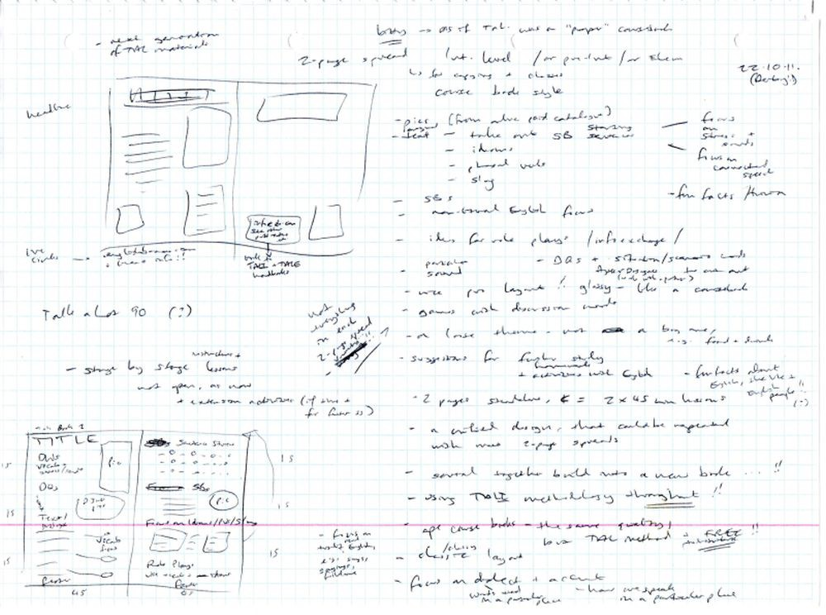

You Are The Course Book 2 – In Practice

The No Course Book Course – Outline; first planning document for YATCB method; 24.02.12
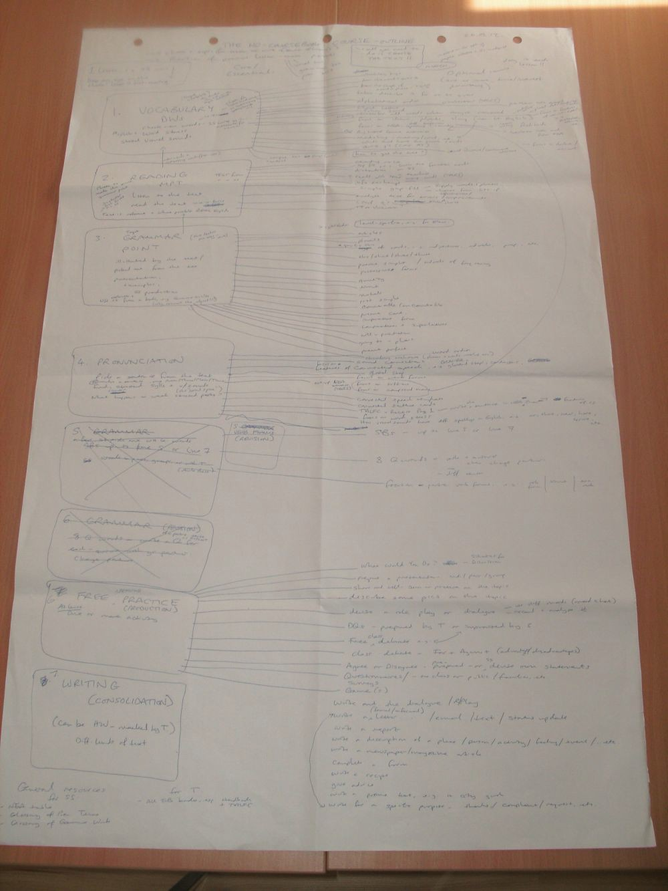

You Are The Course Book 2 – In Practice

First Progress Tracker; April-June 2012; all groups and students are listed together

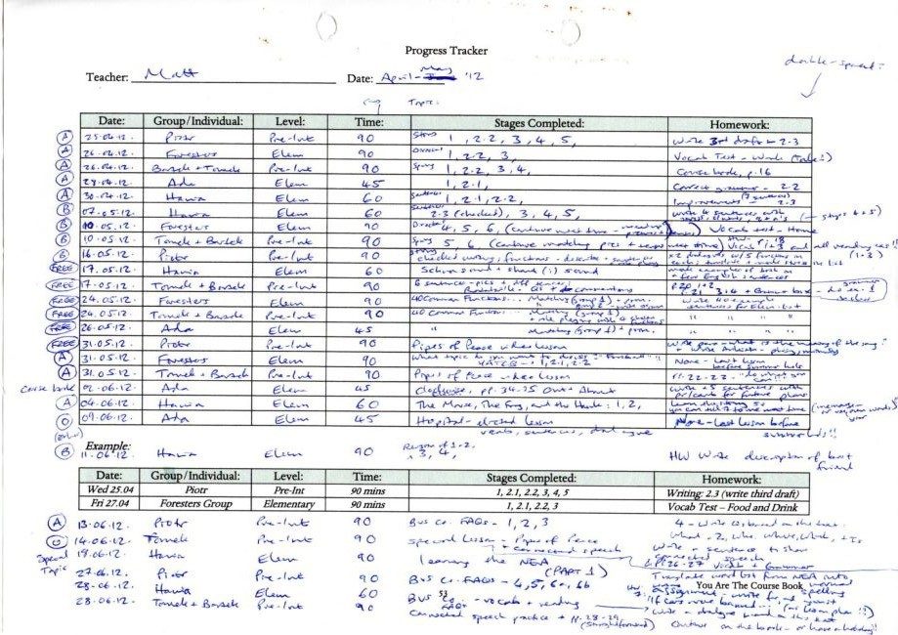

You Are The Course Book 2 – In Practice

Notes from Mode 1 process, including picture story work; Foresters; 26.04.12 & 10.05.12
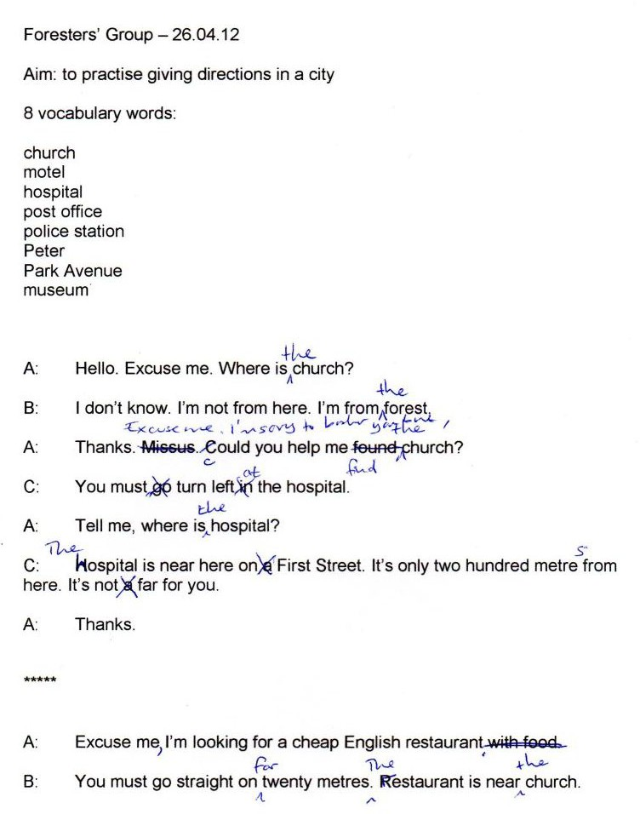

You Are The Course Book 2 – In Practice

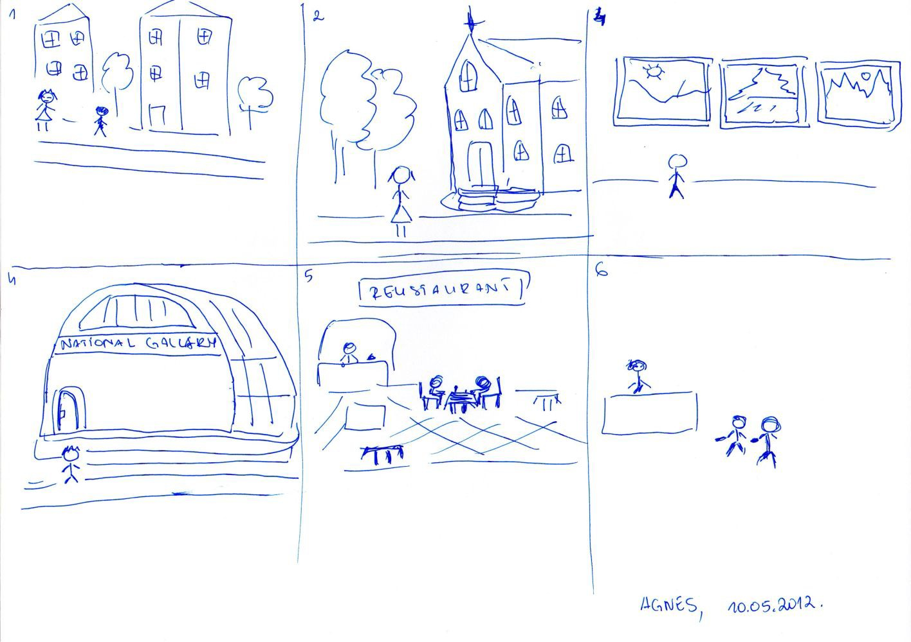

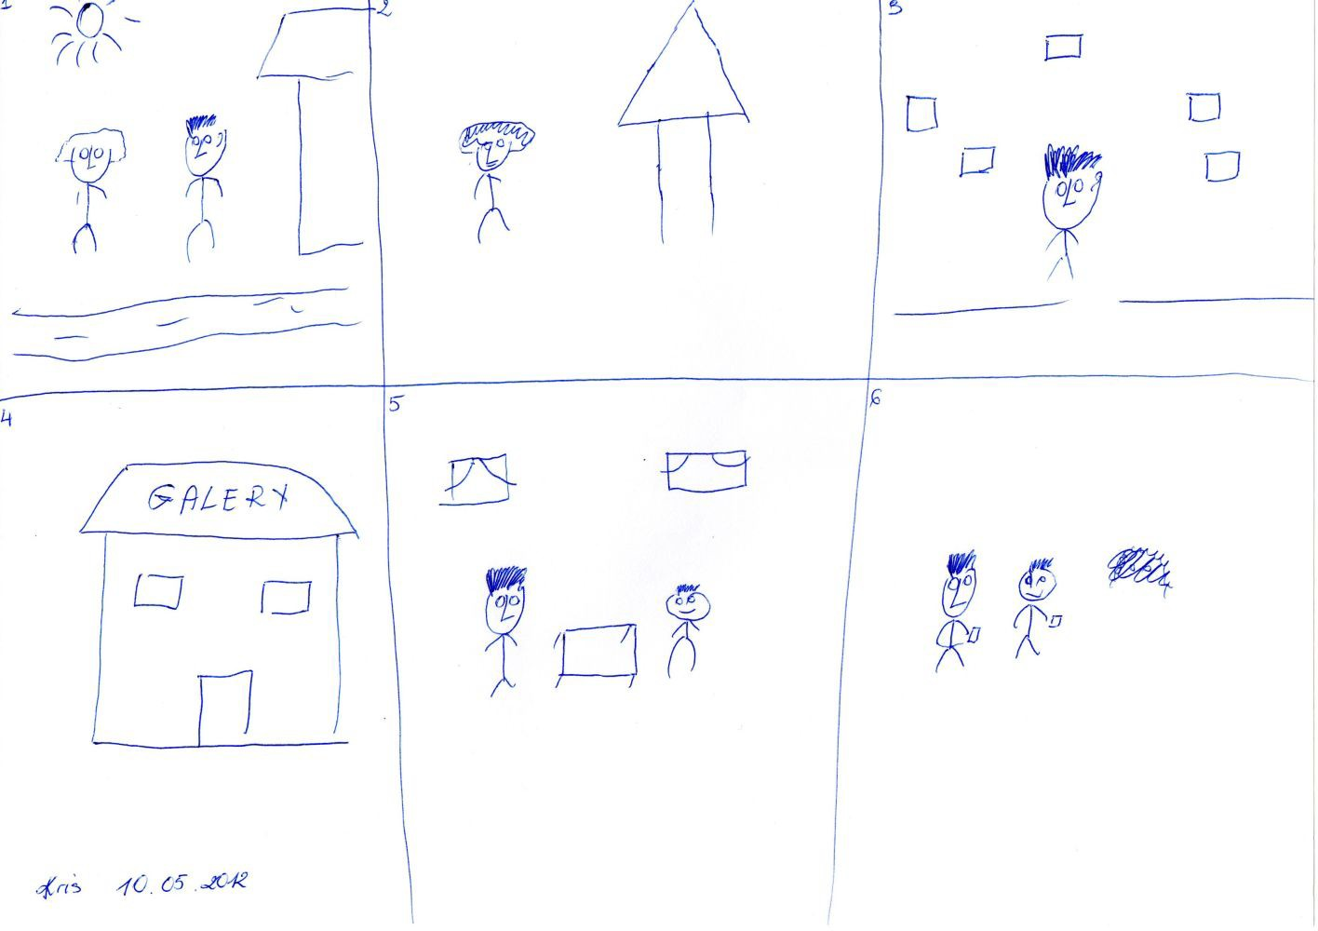

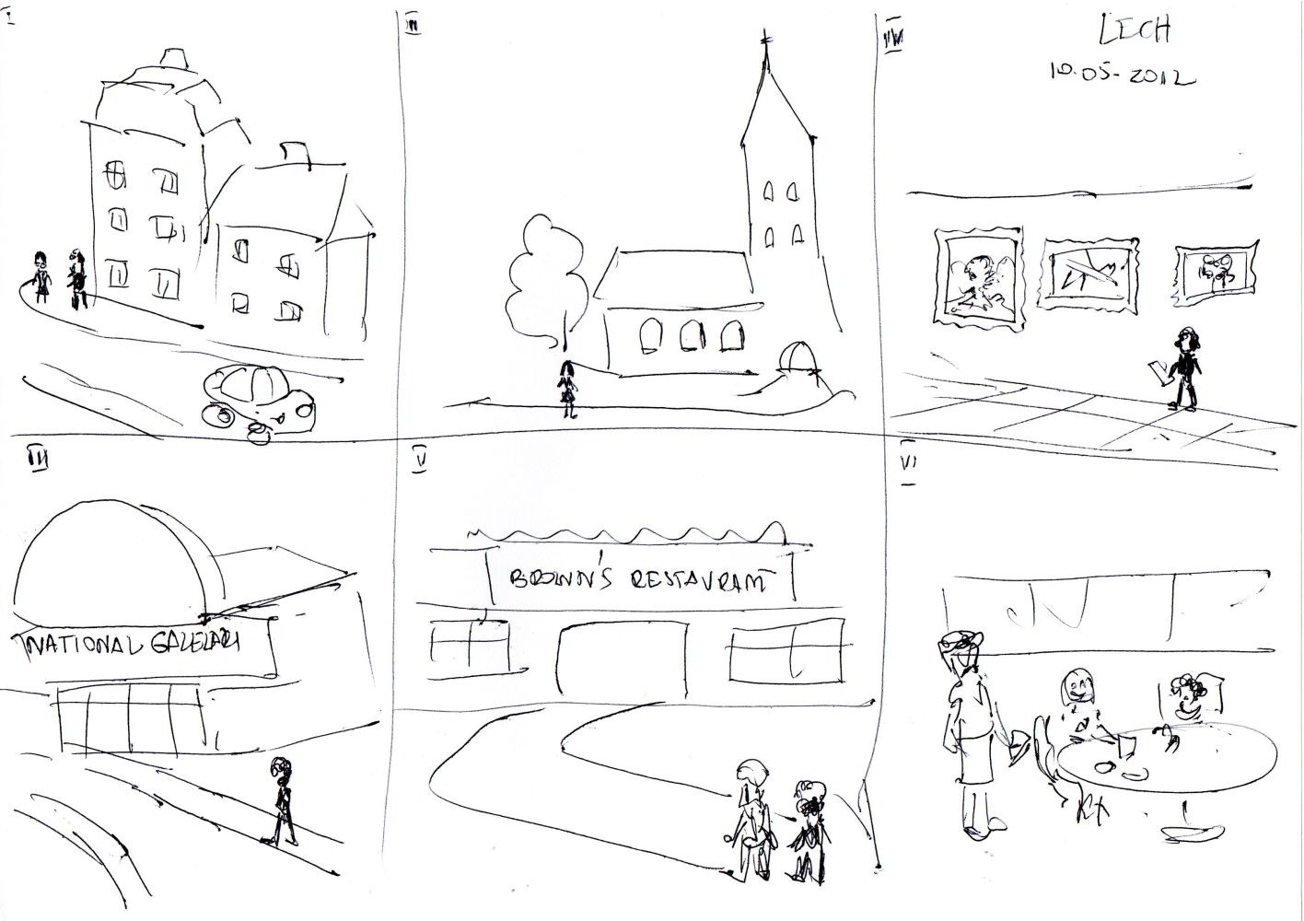

Example of home-made gap-fill material for a Mode 2 lesson about the new Apple iPad; text copied from an online news source (and deliberately blurred due to copyright reasons); students have to complete the gaps with the target vocabulary; April 2012

Planning page for the same lesson, including the target vocabulary, ideas for grammar points to mention, potential discussion questions, and ideas for role play scenarios; all this material is generated by one real text, which was chosen to match the students’ level and interests; 08.03.12
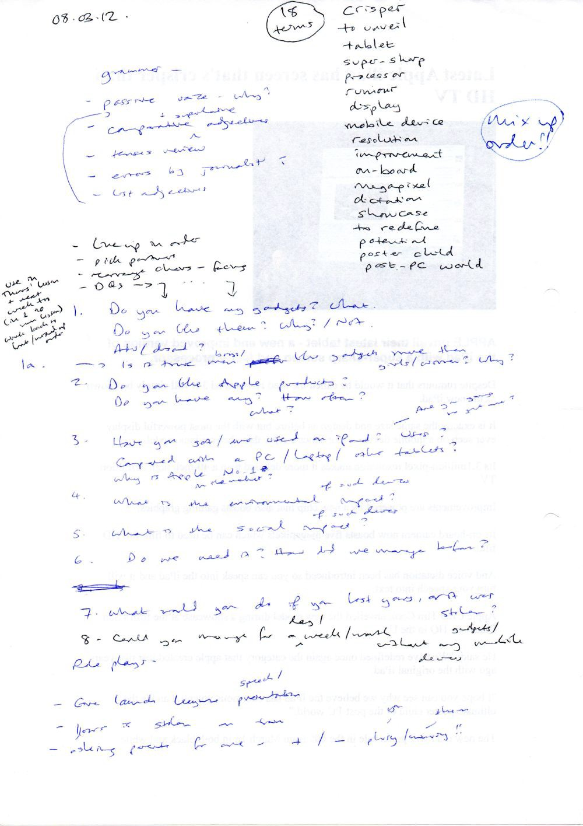

Mode 1 lesson; Piotr; 25.04.12; the first eight words were chosen by Piotr; I challenged him to make them more interesting, which he did (below); then first draft 2.1, which I typed, and second draft 2.2, with his corrections, shown using Track Changes in Microsoft Word

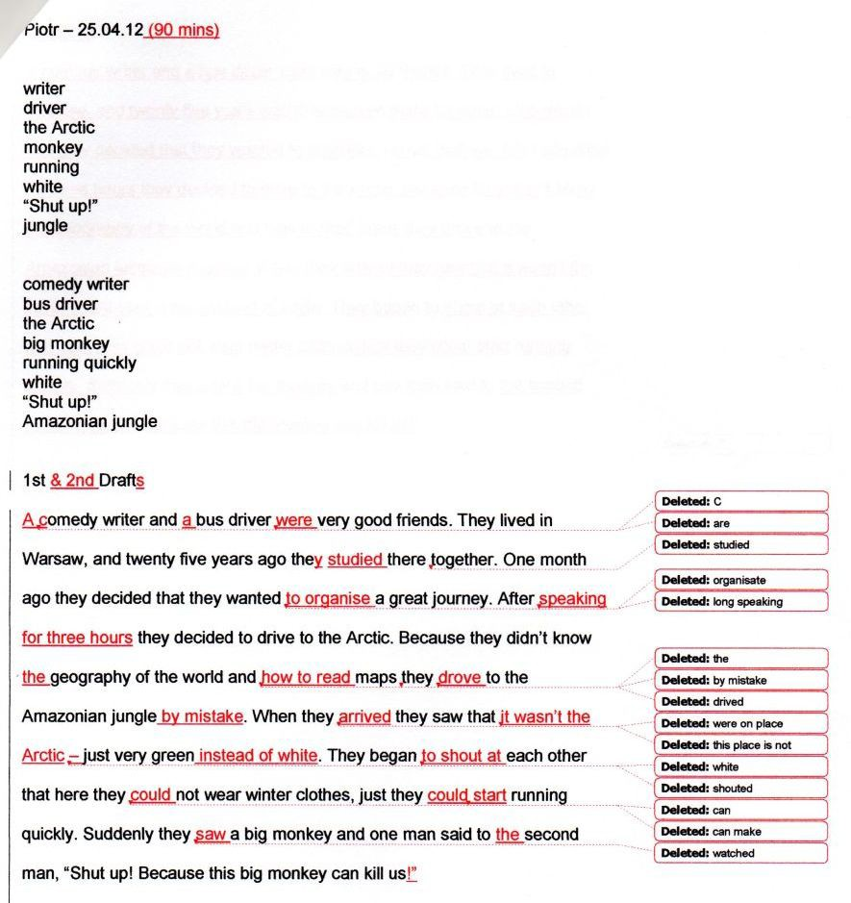

Part 2 – Supporting Documents

Talk a Lot

Spoken English Course

80 Common Functions of Spoken English

Putting the FUN back into Functions!

Instructions

This pack contains printable worksheets with activities for students at Elementary Level and Intermediate Level. You could also use a mix of the two sets for students at Pre-Intermediate Level. Below are some ideas for using the resources, although of course you could always find your own uses for them.

Lesson aims:

- to understand the concept of functions in spoken (or written) English
- to understand and practise x number of functions, e.g. 5, 10, 20, 40, etc.

This work is rewarding: your SS will feel a real sense of achievement when they realise that they are able to recognize and use successfully 20, 40, 60, or 80 different functions in English
- that they can communicate effectively in many different ways.

List – 40 Common Functions of Spoken English (Elementary & Intermediate)

  - Make sure that SS understand the list; they should check new words in a dictionary.
  - Translate each function into students’ first language.
  - Drill them – check pronunciation; notice how very often two-syllable verbs are stressed on the second syllable, e.g. advise, agree, allow, etc. SS practise reading the phonetic NEA (New English Alphabet) version; notice how often the weak syllable doesn’t contain a vowel sound, except a Schwa, e.g. receive = r Seev and suggest = s Jest; find functions that have the same stressed vowel sound, e.g. advise / reply.
  - Work with a partner. Say a sentence – your partner guesses which function(s) you are using.
  - Write a sentence that shows each function in use – but without using the verb, e.g. allow “You can borrow my jacket.” = ✓ “I allow you to borrow my jacket.” = 
  - Work with a partner. Create a dialogue which must include a given group (or random group) of functions.
  - Write the noun form of each infinitive verb, e.g.

explain – explanation; insult – insult; refuse – refusal, etc.

Look at how the stress can change between the words; notice suffixes, e.g. a word is always stressed before “-tion”.
  - Grammar: look at the kind of language typically used with each function, e.g. advise should / ought to, etc.
ask can I…? / is it possible to…?, etc.

Talk a Lot

Spoken English Course

80 Common Functions of Spoken English

Putting the FUN back into Functions!

Instructions

  - Team quiz: separate the SS into two or more teams; give a board pen to one member from each; say a sentence, then they run to the board and write the function – with team members supporting; the winner is the person to write it first with correct spelling; or do it the other way round – say a function and they have to run to the board and write a sentence (with the help of their team members) – or draw a picture to illustrate the function.
  - Which functions are similar? e.g. offer / suggest – what is the difference?

Matching Game 1 & 2

  - Cut up the cards, mix them up, then match each function to an example sentence.
  - Translate each function and/or sentence into your first language.
  - Put the function cards into matching pairs of opposite functions, e.g. ask / reply.
  - Put the functions into groups – positive and negative functions, e.g.

Positive: agree, allow Negative: attack, cancel

  - Mix up the function cards, then put them into alphabetical order, or reverse alphabetical order.
  - Put the function cards into groups – functions that you use in your life: Usually / Often Sometimes Rarely / Never
  - Discuss with a partner: which functions have you used so far today / yesterday / this week? In each case, say why – what was the situation? What happened?
  - Use a dialogue or text that you have found online or in a book, and match different functions to different parts of the text.
  - Give SS one function card each; get them to walk around the room; when they meet another student they have to say something to illustrate their function and the other student has to guess; SS write down a list of who has which function. Alternatively, the student has a function taped to their back and they have to find out what it is by listening as other students say something which illustrates that function.

Matching Game 1 & 2 – Blank Cards

  - Write a sentence that shows each function in use – but without using the verb, e.g. allow “You can borrow my jacket.” = ✓ “I allow you to borrow my jacket.” = 
Then mix up all the cards and match each function card with a sentence card. If SS did the writing part in pairs or small groups, they could then swap sets with another pair or group to get a fresh challenge.

Talk a Lot

Spoken English Course

40 Common Functions of Spoken English (Elementary)

The functions of spoken English are reasons for speaking. When we speak, it is usually with a purpose in mind. We may use many different functions in one conversation. (Note: these functions can also apply to written English.)

Complete the table below:

Function: | Pronunciation: | Translation: | Example Sentence:
advise | uh Dvaiz
agree | uh Gree
allow | uh Lau
apologise | uh Po l jaiz
arrange | uh Reinj
ask | Arsk
attack | uh Tak
cancel | Kan sl
compare | km Peir
complain | km Plein
confirm | kn Ferm
congratulate | kn Gra ch leit
criticise | Kri t saiz
demand | d Marnd
describe | d Skraib
disagree | di s Gree
explain | e Ksplein
give | Giv
greet | Greet
insult | in Sult
interrupt | in t Rupt
introduce | in tr Joos
invite | in Vait
mock | Mok
offer | O f
order | Or d
part | Part
persuade | p Sweid
praise | Preiz
predict | pr Dikt
prohibit | pr Hi bit
promise | Pro mis
receive | r Seev
refuse | r Fyooz
reply | r Plai
suggest | s Jest
tell | Tel
thank | Ttangk
threaten | Ttre tn
warn | Worn

Talk a Lot

Spoken English Course

40 Common Functions of Spoken English (Elementary) Matching Game 1

Cut up the cards below. Then mix them up and students have to match each function (left) with an example sentence:

advise | You ought to put on some sun cream.
allow | You can smoke here.
arrange | Let’s meet at ten o’clock by the lake.
attack | You are so selfish and inconsiderate!  You never do anything to help your family!
compare | My phone is better than yours.
confirm | Yes, tomorrow afternoon at four will be fine.
criticise | I don’t like your jacket, and you  need to get your hair cut.
describe | The garden was large and peaceful.
explain | I was late because I’d lost my train ticket and had to run home to get it.
greet | Hi! How are you doing?
interrupt | Can I just say something...?
invite | Do you want to come to my party tomorrow night?
offer | So we’d like you to work for our company. What do you say?
part | See you.
praise | You are a really wonderful person.
prohibit | You are not allowed to wear trainers here.
receive | It’s just what I wanted!
reply | Is she? Good.
tell | My friend is getting divorced.
threaten | You’d better be on time or I’ll tell the boss.

Talk a Lot

Spoken English Course

40 Common Functions of Spoken English (Elementary) Matching Game 1 – Blank Cards

Cut up the cards below. Students split into groups and each writes some example sentences. Then mix them up and students have to match each function (left) with an example sentence:

advise
allow
arrange
attack
compare
confirm
criticise
describe
explain
greet
interrupt
invite
offer
part
praise
prohibit
receive
reply
tell
threaten

Talk a Lot

Spoken English Course

40 Common Functions of Spoken English (Elementary) Matching Game 2

Cut up the cards below. Then mix them up and students have to match each function (left) with an example sentence:

agree | Yes, you’re right.
apologise | I’m so sorry. Can you forgive me?
ask | Can I have a glass of water, please?
cancel | I’m afraid I won’t be able to attend on Friday after all.
complain | My feet are killing me! I’ve been  running around all day!
congratulate | Well done for passing your exams!
demand | Give me the remote control!
disagree | I don’t think you’re right about that.
give | Here you are.
insult | They are complete idiots.
introduce | This is my friend Tom.
mock | This guy I know got 25% on the last test. He’s so stupid! He really hasn’t got a clue!
order | Do the washing up.
persuade | You have to let me borrow the car. I’ll be so careful with it, and I’ll try to bring it back with a full tank of petrol
predict | It’ll probably rain tomorrow.
promise | I won’t tell anyone your secret.
refuse | I won’t do the shopping for you.  I haven’t got time and I don’t want to.
suggest | Why don’t you try sailing?
thank | Ta very much.
warn | Stay away from that old bridge – it’s really dangerous!

Talk a Lot

Spoken English Course

40 Common Functions of Spoken English (Elementary) Matching Game 2 – Blank Cards

Cut up the cards below. Students split into groups and each writes some example sentences. Then mix them up and students have to match each function (left) with an example sentence:

agree
apologise
ask
cancel
complain
congratulate
demand
disagree
give
insult
introduce
mock
order
persuade
predict
promise
refuse
suggest
thank
warn

Talk a Lot

Spoken English Course

40 Common Functions of Spoken English (Intermediate)

The functions of spoken English are reasons for speaking. When we speak, it is usually with a purpose in mind. We may use many different functions in one conversation. (Note: these functions can also apply to written English.)

Complete the table below:

Function: | Pronunciation: | Translation: | Example Sentence:
accept | uh Ksept
accuse | uh Kyooz
admit | uh Dmit
ask permission | ar skp Mi shn
assure | uh Shuuw
beg | Beg
berate | b Reit
check | Chek
choose | Chooz
claim | Kleim
clarify | Kla r fai
condemn | kn Dem
console | kn Seul
contrast | kn Trarst
convince | kn Vins
curse | Kers
discuss | di Skus
disown | di Seun
embarrass | uhm Ba rs
encourage | in Ku rij
express an emotion | e kspre s n Meu shn
express an opinion | e kspre s n Pin yn
express likes/dislikes | e kspre Slaikz/Di slaikz
guess | Ges
inform | in Form
justify | Ju st fai
moan | Meun
pardon | Par dn
prefer | pr Fer
promote | pr Meut
protest | pr Test
recommend | re k Mend
refute | r Fyoot
regret | r Gret
remind | r Maind
renege | r Neig
sell | Sel
stress | Stres
wish | Wish
wish well | wi Shwel

Talk a Lot

Spoken English Course

40 Common Functions of Spoken English (Intermediate) Matching Game 1

Cut up the cards below. Then mix them up and students have to match each function (left) with an example sentence:

accuse | He did it!
ask permission | Can I have a day off tomorrow, please?
assure | Your job interview will be fine, I’m positive!
berate | You shouldn’t have come back so late! I had to do everything on my own!
choose | I’ll have that one, please.
clarify | So, we’re meeting at two, then, not three?
console | Don’t cry! It’ll be alright! There, there!
convince | You have to believe me, because...
discuss | What do you think, Jeff?
encourage | Keep going – you’re doing really well!
express an opinion | I think that exams are getting easier.
justify | We had to discipline Paul, because he was constantly late for work.
moan | It’s the weekend and I’ve got  far too much homework to do!
prefer | I like dark chocolate best.
protest | We want better pay and working conditions!
recommend | Have you ever been to Edinburgh? It’s  wonderful – you really should go there!
regret | If only I’d been there when Grandma had her fall.
remind | Don’t forget to make your packed lunch.
sell | And if you bought the whole set you could save up to £35.
wish | I would love to visit Thailand before I die.

Talk a Lot

Spoken English Course

40 Common Functions of Spoken English (Intermediate) Matching Game 1 – Blank Cards

Cut up the cards below. Students split into groups and each writes some example sentences. Then mix them up and students have to match each function (left) with an example sentence:

accuse
ask permission
assure
berate
choose
clarify
console
convince
discuss
encourage
express an opinion
justify
moan
prefer
protest
recommend
regret
remind
sell
wish

Talk a Lot

Spoken English Course

40 Common Functions of Spoken English (Intermediate) Matching Game 2

Cut up the cards below. Then mix them up and students have to match each function (left) with an example sentence:

accept | OK, yes. That’s fair enough.
admit | I’m sorry – I was wrong.
beg | Please, please, please let me go with you!
check | What time is it?
claim | The managers made a mistake when they paid me.
condemn | This is the worst hotel I have ever had  the misfortune to book into!
contrast | Both courses were delicious, although the dessert was more unusual.
curse | Drop dead!
disown | I don’t want anything to do with it.
embarrass | Jane was up all night drinking tequila with her mum’s toyboy, weren’t you Jane?
express an emotion | I feel so exhausted today.
express likes/dislikes | I love the works of Antonio Vivaldi.
guess | Are you in the kitchen?
inform | The bus leaves tomorrow morning at 9 am.
pardon | I forgive you.
promote | The latest book by Briggs is another masterpiece.
refute | That is absolute nonsense! Rubbish!
renege | I won’t be able to make it after all.
stress | Her name is Blyth. That’s Blyth, with a “y”.  B.L.Y.T.H. Have you got that?
wish well | I hope you all have a nice time.

Talk a Lot

Spoken English Course

40 Common Functions of Spoken English (Intermediate) Matching Game 2 – Blank Cards

Cut up the cards below. Students split into groups and each writes some example sentences. Then mix them up and students have to match each function (left) with an example sentence:

accept
admit
beg
check
claim
condemn
contrast
curse
disown
embarrass
express an emotion
express likes/dislikes
guess
inform
pardon
promote
refute
renege
stress
wish well

Planning an English Class without a Course Book to Hold your Hand

http://www.wiziq.com/online-class/877925-planning-an-english-class-without-a-course-book-to-hold- your-hand

This pack contains a demonstration of how to plan 2 x 90 minute general ESL (English as a Second Language) classes without using a course book or any other teaching materials – only a text.

It shows how a text can provide enough activities and input for your students to be able to practise the skills that they find the hardest at the time of the class. You can also use the text to introduce new topics.

The example planning documents show a Mode 2-type lesson using the You Are The Course Book method.

You can find out more about this kind of class by downloading and reading the free ebook: You Are The Course Book, which is available here:
https://purlandtraining.com/

YATCB - Lesson Planner (Mode 2)
3. Grammar Point

Rule:
Examples:

A
Warmer:
1. Vocabulary
Level: Date: Teacher: Time: Lesson Objectives:
Introduce:

Practice:

Normal Spelling: NEA Spelling:
2. Text

Title:
Discovery Method:

1.

2.
3.
4.
5.
6.
7.
8.
9.
10.
11.
12.
13.
14.
15.
16.
17.

18.
19.
20.
Interesting Features:
Silent Letters:

4. Verb Forms Revision (Use sentences in Stage 5 for building sentence blocks)
8 Questions: | Short Answers:
1.
2.
3.
4.
5.
6.
7.
8.

YATCB - Lesson Planner (Mode 2)
B

5. Pronunciation (Mark vowel sounds on stressed syllables)

1.

2.

3.

4.

6. Free Practice
a) Discussion Questions or Agree or Disagree statements
1.
2.
3.
4.
5.
6.
7.
8.
b) Class Debate (or Writing) – Controversial proposal (debate for and against):
c) Topic for Individual or Group Presentation:
d) Role Plays – Place: Time: Character: Goal: Barrier: Solution: Mood:
Functions to include:

7. Writing Assignment ( words)
Homework:

The Mouse, the Frog, and the Hawk, from Aesop’s Fables (1912)

A mouse and a frog struck up a friendship; they were not well mated, for the Mouse lived entirely on land, while the frog was equally at home on land or in the water. In order that they might never be separated, the frog tied himself and the mouse together by the leg with a piece of thread. As long as they kept on dry land all went fairly well; but, coming to the edge of a pool, the frog jumped in, taking the Mouse with him, and began swimming about and croaking with pleasure. The unhappy mouse, however, was soon drowned, and floated about on the surface in the wake of the frog. There he was spied by a hawk, who pounced down on him and seized him in his talons. The frog was unable to loose the knot which bound him to the mouse, and thus was carried off along with him and eaten by the hawk.

Source: http://www.gutenberg.org/files/11339/11339-h/11339-h.htm Aesop’s Fables, Collector’s Library, 1912

The Mouse, the Frog, and the Hawk, from Aesop’s Fables

A mouse and a frog struck up a friendship; they were not well mated, for the Mouse lived entirely on land, while the frog was equally at home on land or in the water.

In order that they might never be separated, the frog tied himself and the mouse together by the leg with a piece of thread.

As long as they kept on dry land all went fairly well; but, coming to the edge of a pool, the frog jumped in, taking the Mouse with him, and began swimming about and croaking with pleasure.

The unhappy mouse, however, was soon drowned, and floated about on the surface in the wake of the frog.

There he was spied by a hawk, who pounced down on him and seized him in his talons.

The frog was unable to loose the knot which bound him to the mouse, and thus was carried off along with him and eaten by the hawk.

Moral: harm hatch, harm catch.

Source: http://www.gutenberg.org/files/11339/11339-h/11339-h.htm Aesop’s Fables, Collector’s Library, 1912

Texts for Comparison: Townsend’s translation (1887) The Mouse, the Frog, and the Hawk
A mouse, by an unlucky chance, formed an intimate acquaintance with a frog. The frog one day, intent on mischief, bound the foot of the mouse tightly to his own. Thus joined together, the frog led his friend toward the pool in which he lived, until he reached the very brink, when suddenly jumping in, he dragged the mouse in with him. The frog enjoyed the water amazingly, and swam croaking about as if he had done a meritorious action. The unhappy mouse was soon suffocated with the water, and his dead body floated about on the surface, tied to the foot of the frog. A hawk observed it, and, pouncing upon it, carried it up aloft. The frog, being still fastened to the leg of the mouse, was also carried off a prisoner, and was eaten by the hawk.

Harm hatch, harm catch. (If you think up a plan to harm somebody, you can be affected negatively by the consequences...)

http://en.wikisource.org/wiki/The_Mouse,_the_Frog,_and_the_Hawk

Caxton’s translation (1484)

For he that thynketh euylle ageynst good / the euylle whiche he thynketh shall ones falle vpon hym self

For he that thinks evil against good / the evil which he thinks shall fall upon himself

Idiom:

The frog was “hoist with his own petard” – destroyed by his own plan to destroy another.

L - (?-.1-<.- . YATCB-LessonPlanner(Mode2) C(O v._. ,..r
[).,.,...J....?

W .' J:..rJ,_y..ll. f .e-,lr ('!)- f' ' ( S t')
1. Vocabulary \
Normal Spelling: NEA Spelling:

1. {V\.c-'VSZ M.(.L.{J.S-

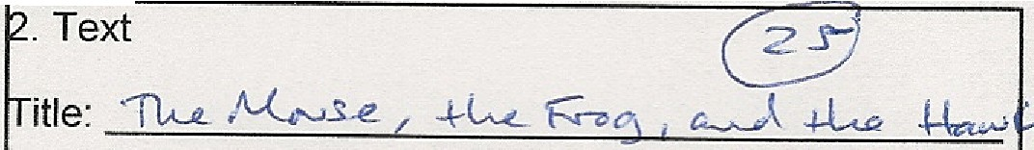
Discovery Method: C ..rf $; - p1..n.: z..&. p;ec s-

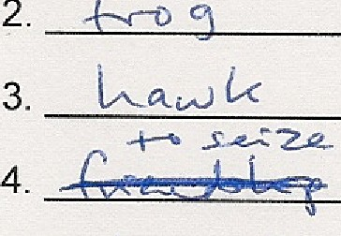
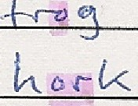The Mouse, the Frog, and the Hawk

A Mouse and a Frog ®@f up a friendsh they w Mouse lived entirely on land, while the Frog was eq

5..+-ok (l 1/\AA:.t-J.
6 . ..e..--vJ..._-v9
7 . :f 't V ,,J..½j
8 . ,...f,Q .s--s
t. b, w €...{ M-e,; t d
u.k lll, :± t:2o-:.t1 Ln
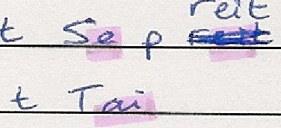Ee... k w G.
the water.!In order that they might never be separa and the Mouse together by the leg with a piece of t on dry land all went fairly well; but, coming to thee jumped in, taking the Mouse with him, and began s croaking with pleas e] The unhappy Mouse, howe and floated about on the surface in the wake of the
by a Hawk, who pounced down on him and seized

9. ..+.::, +,'<2..
was unable to loose the knot which bound him to th

11. o..s l •:·:::_, o,..s-
12. £e-. ½,
1 3. &d-t;,/l.-

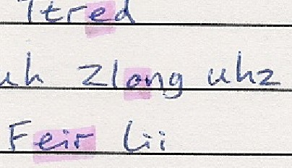

E.. ·-
carried off along with him and eaten by the Hawk\
f\.,lo.rc,....l µ. .,,.,,. k. -1-c.L-- , k _{w.,..,.,...} c l-.
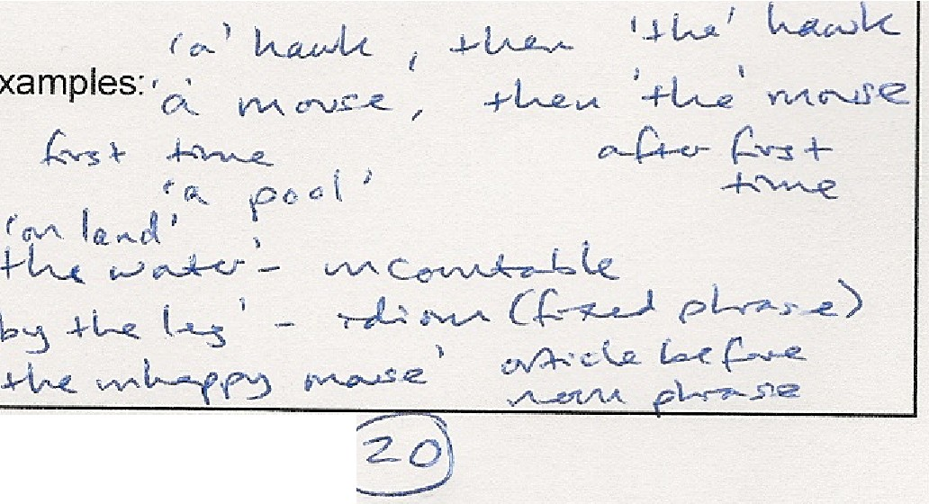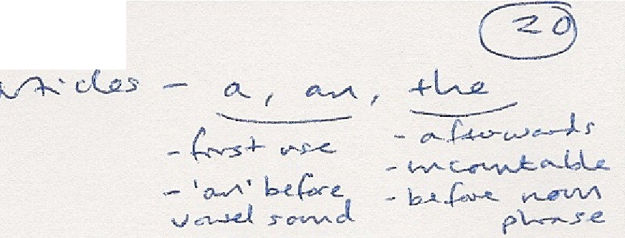-f c ,l-"'-' •'tA - '-'-"-e. ,-,{} j (_ r{ -1---- 1
.\.)
( S 'V'I" CA...; c.Ak.ll.v-- • :-.1I G.$ / f13 :..)
): - sJ. Ly J (.k, s

14. -f.<> C-n"-i..-<.
5 -+c--...:.-.e.s- c,,t-.;:4.,,, _{1V} _{,d\"cJ} _{.s-} ( l...s,)s

1 5. rl:e N'!-...-e
16. -+-o Jnwv
f (,,<t--'=--
17 \-1)
Pl.e. z.z.

. Grammar Point ule:

18. l,J P-Lua.
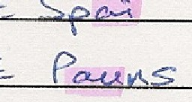19 .
+o s _'j
--h, f c}V\I\.

20.
- l..:n .s...iCC .,.,_3
..> Peu,t11<-S
.A ,_
S:
ilent Letters: _{{I.A} s-
s·...t.-: z. e.
s -+- Y-
+ ! !
< .(:m!!>'
-t <t
nteresting Features:
4. Verb Forms Revision (Use sentences in Stage 5 for building sentence blocks)

8 Questions:
.
1. (,,J:\+O | s-1"'-('Jd..< r | --e A- P.,.,.- a-).J'L: e ? | A ...,..._.,. s-c: | o .. 5-
2. W- 4-cR.G | &...c.J... | C-v-e. : | ,-v--... | ( o.-.J . / o v-- { o--..d. .

Short Answers:

3. lJt+L( cJ..-J. 3 -/---12.. L f .so L,\.,..=.o lu,_
u-v.- k 1.
0

- '7 ·-
4. H:6)tJ <kJ- £-.3, -k L.. C · . · ts 't) -+t...-e_ ( 2-:::S ,₀ -::i-L, e-- f' t e:c..e_ a{ -t-L r: .
5. D \ D .\-- } ..s "? N o ,, k cl-J-\A- t: - k .
6. (;...)4:A 't Wt:V' &.:) - ...h, e4 ? T'o {m,g ..j..L.,., I &k'\ Q t:;, ( ..,./1.--..: J.... - ··)
7 . (_,..) .,- L-"- e·,pf •s ,, ,, .J --&. +a ) 7 4c _{w&-<.S-} _{-c::.e,,.L-e--=} h'!':) :±:½-P k a.,,.,;ik .
8. W:i-\ C\ H O.,,,,:y l..v/1...S av(.,_ - ? r · =::=Q=,=,,,.g=-=· ==k=a==N• =l=-=<=·•========;:r=====::::::::;:::===-----.

You Are The Course Book
225500r
t,l\.cC,k,.
- <-V.r-> tt'V\. r.Jlv t f

YATCB - Lesson Planner (Mode 2) '10 .,.r
,.:---..). r;- (: )- f', CS (:')
0 . 06 1 '2_ .

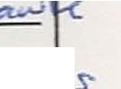
. Text

@

EA Spelling:
itle: 11,u.. A,(,,0us...e. / +k " "' ' , a...J +L.e­

N\.. S iscovery Method: ..re s; - pl.f22.. C.... p te s
The Mouse, the Frog, and the Hawk

A Mouse and a Frog ®@k up a friendshijY, they were not well mated, for the Mouse lived entirely on land, while the Frog was equally at home on land or in

t:. bi we..{ Me; f;d,
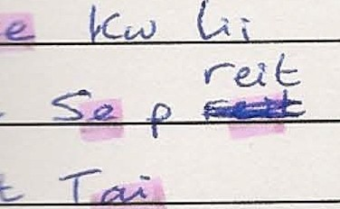
11, ta,,,.j_j L,'
the water.IIn order that they might never be separated, the Frog tied himself and the Mouse together by the leg with a piece of th adf JAs long as they kept on dry land all went fairly well; but, coming to the edge o a pool, the Frog jumped in, taking the Mouse with him, and began swimming about and croaking with pleasure] The unhappy Mouse, however, was soon drowne, d and floated about on the surface in the wake of the o There he was spied
by a Hawk, who pounced down on him and seized ti1m m his t lons) The Frog
was unable to loose the knot which bound him to the Mouse, and thus was carried off along with him and eaten by the H wk.\ -=l- -
AfC ,,. (j/,C
1

s:- k c..e..l,\,.k
M.c,r,,..J. H o< .-v- kP\.+c L.. k OJ'.,,,,._ L.._).
,fV"'-C!.,t----i M-'-"'t,<. - "' (.! j (_ ,{ ,.f. rf)
( S o-v-r 0L ; cM-.Jl..v<.. .. --- /.C .r / ff3 - •· )
) : -- .sL.'f) ?:,,(.se_ .!'
-lc v :-.e..s <-v- .,,. ,v \a, ol .s· (+......l ) .s:.s)

- D.,- V\
. Grammar Point Rule: 6-..A--' d...a:s

... (... -l-- .,...i:--c..
- - 'o-/'' b-!.
v.,,,->Lt sc-vv,.J

----c.. (.-..v-e.... :

Short Answers:
A """" o_,,. J °' £eo5 -

- t.. .So 3 },:y2.U--V- .
!:S'i) -+w. ( 2-;::! cd<'.-':::+L, e-, (? l' t:C&,. og -+L.c- .
N o ,k c.t-J.,---:- t: - k .

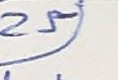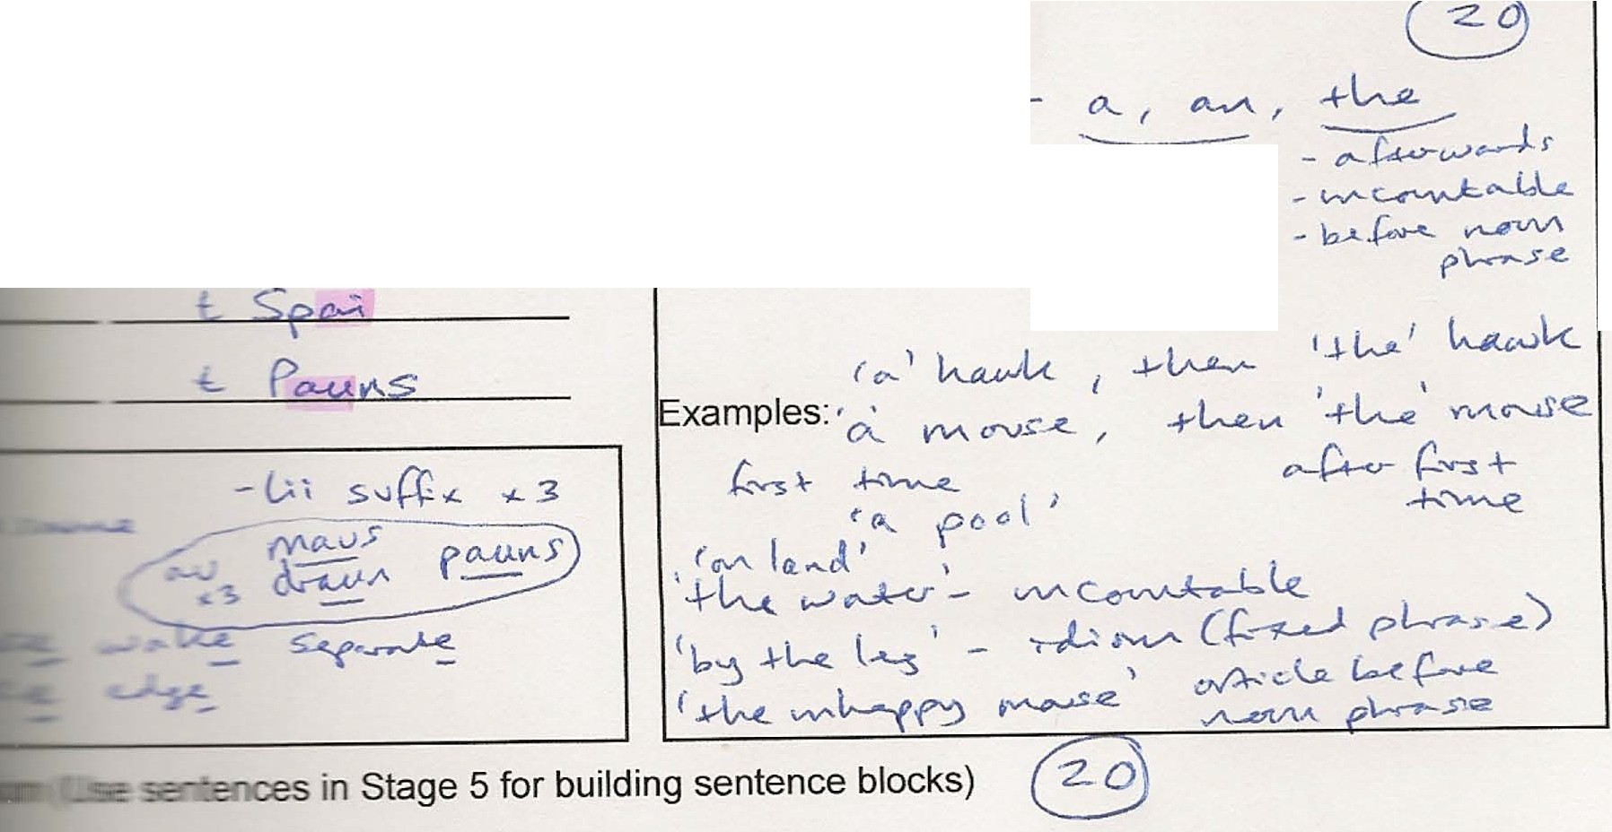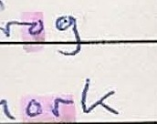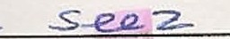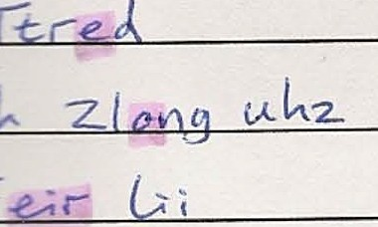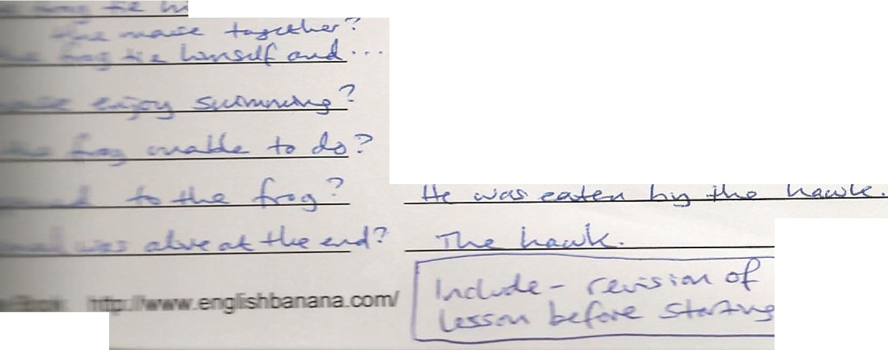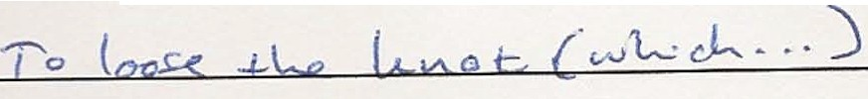225511
f-<....e '\'N.J'
--aw c,.I

YATCB - Lesson Planner (Mode 2) q O vvJvS
@J 5 . Pronunciation (Mark vowel sounds on stressed syllables)
?L (,{_ 0 u. ().. e.
@ 1

1. _ A_ J/1/\-.
-s -e...- - - 17'--_ £.= ,_=-3
0 ee....

._s.+v/v_c_,L_<
Y/f.' ,
=-o¾
-+{y-; -
_s L_:--:-'--'i:i-f-
- - - - - -
or

/ / / / /

2. _-+_k.e..
,G,5, v_..::> oJ' '?_:'(_ _ .:.'._J o<--,,lc. ,_ -,A-JL - (/1./\_.._ l a--.,., G') <_., ._ 7_,..... <:-.,--) =_ *_ -..._e_s-- _ ._ _

0 CU
./ /
a.,U
/ / / / /

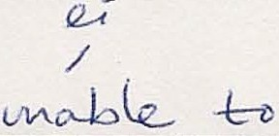
3. +k\L &3 £ J lv11,,<s.,Jf r,..,. J -kb
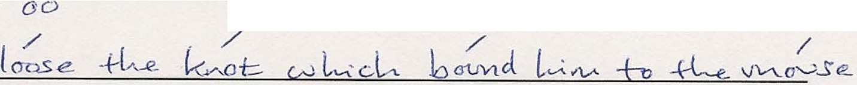0
0
o.,Ll.
o..-U

4. -nu_ _{j}
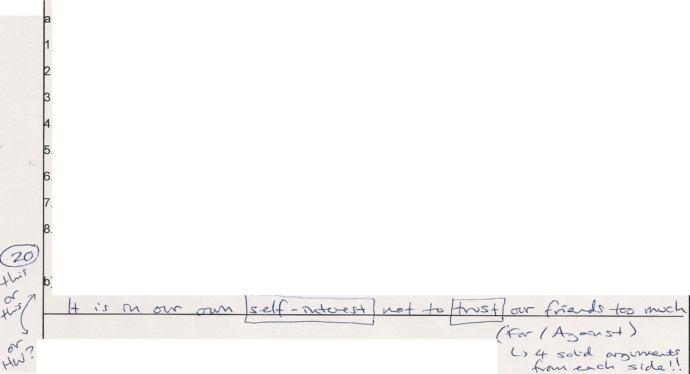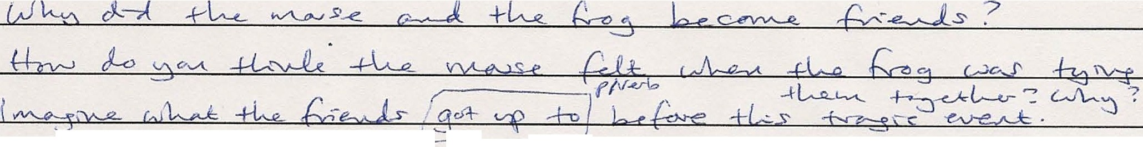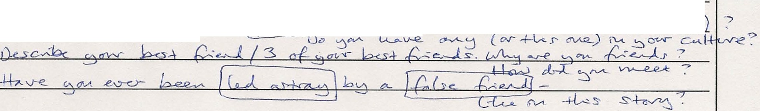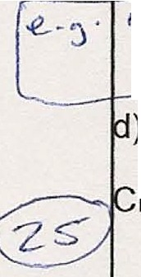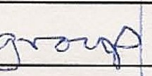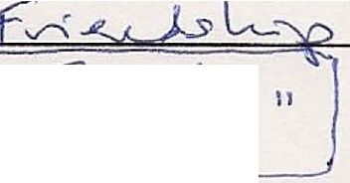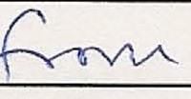@ . Free Practice
M&:lSe.. h· ::J'* lc-1r k, ±Le.. I·!?_j < M- L P> f'ec.e <(+l--r-.:o-J..

) Discussion Questions or Agree or Disagree statements

c,,,,,,v, 0\6 -1::i..,;, .,l.-e 4 ce-.,.--23
L I
O'c.L- v S- ti!..S- who--<., a J;-_-& lsI ::y

{-e_..Js

A.e<h k ..'..YM .J:L\c:-( r , s =tJ,,_g_ {vvu;-.rc,i"j ,f +L...e ..s-+w:t_ ?
1
- . . ..
1
. '.

• /)1,A. 1d _ _ _ _....., ,v-kr ' r -+c..,:;,...,:_,L. &"'- 1...Jv,. ,,J-

) Class Debate (or Writing) - Controversial proposal {debate for and against):

) Topic for Individual or Group Presentation:
.p -s
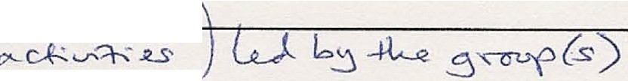,.........-_ ,-, .PY
0- e..S
/( - {v-;,:,..._,._)s,
M..P -f-v w-e.
) Role Plays - Place: Tim: _

haracter: Goal: \
Barrier :
\ S olution:
Mood :

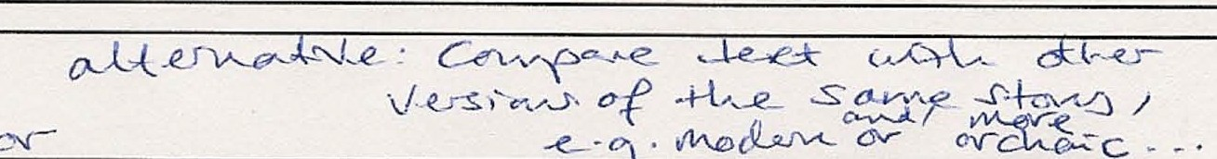µw'.!
unctions to include:
\
l (
t t
l t
l l
. Writing Assignment ( words)
(J, '<-t> la.. la.,v
....-7

0 t::b:===:W::=.='=-"'='\--,=: =A:=.'.J\=>'='-"--' =/ ========(l='\=A.=c=.W..=,
You Are The Course Book

==J'==== "' c..s ::===:===::::::::::::::..,.J
225522
+
r , 5 f'V'- 0 t -A-+-6 11
l,U-:j r-',v-..:k..S. .

http://www.englishbanana.com/

Group/Individual:
Progress Tracker

Level:

Teacher:

Date: | Type: | Time: | Lesson Content: | Homework:

Type: Mode 1A = M1A Mode 1B = M1B Mode 2A = M2A Mode 2B = M2B Special Topic = ST Other = O

- Learn the NEA, e.g. with flashcards.

- Learn about connected speech.

- Use the NEA to look at differences between spelling and sounds at word level: best Best
bread Bred

white Wait

sliced Slaist

- Use the NEA to look at features of connected speech at sentence level:

 | 1 | 2 | 3 | 4 | 5 | 6 | 7 | 8 | 9 | 10 | 11 | 12
A | The | best | kind | of | bread | is | white | sliced | bread.
B
C | Je | nny | has | just | put | the | cheese | in | the | fridge.
D
E | If | you | eat | too | much | cho | colate | you | will | put | on | weight.
F
G | We | should | take | the | lift | to | the | fifth | floor.
H

Answer:

 | 1 | 2 | 3 | 4 | 5 | 6 | 7 | 8 | 9 | 10 | 11 | 12
A | The | best | kind | of | bread | is | white | sliced | bread.
B | th | Be | Skain | d | Fbre | di | Zwai_ | Slai | Stbred.
C | Je | nny | has | just | put | the | cheese | in | the | fridge.
D | Je | nii | - | Zju | Spuu_ | th | Chee | zin | th | Frij.
E | If | you | eat | too | much | cho | colate | you | will | put | on | weight.
F | i | fy | Wee_ | Too | Mu | Chcho | kl_ | yl | - | Puu | Ton | Weit.
G | We | should | take | the | lift | to | the | fifth | floor.
H | wi | shuu | Tei | kth | Li | ft | th | Fi | Ttflor.

Alternative method – write normal spelling:

 | 1 | 2 | 3 | 4 | 5 | 6 | 7 | 8 | 9 | 10 | 11 | 12
A
B | th | Be | Skain | d | Fbre | di | Zwai_ | Slai | Stbred.
C
D | Je | nii | - | Zju | Spuu_ | th | Chee | zin | th | Frij.
E
F | i | fy | Wee_ | Too | Mu | Chcho | kl_ | yl | - | Puu | Ton | Weit.
G
H | wi | shuu | Tei | kth | Li | ft | th | Fi | Ttflor.

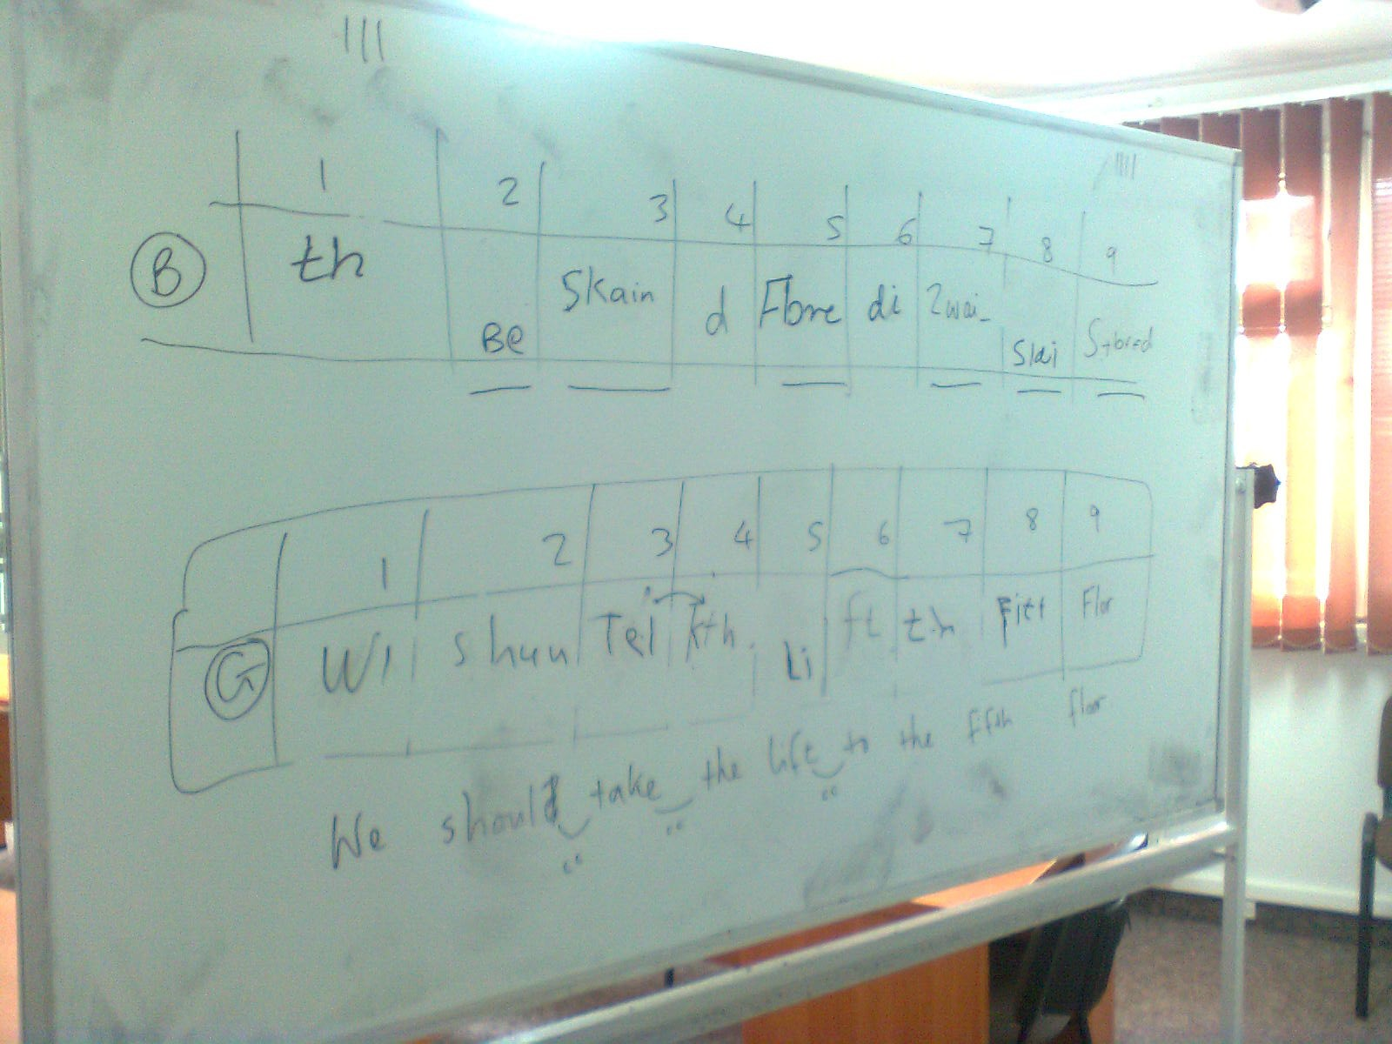

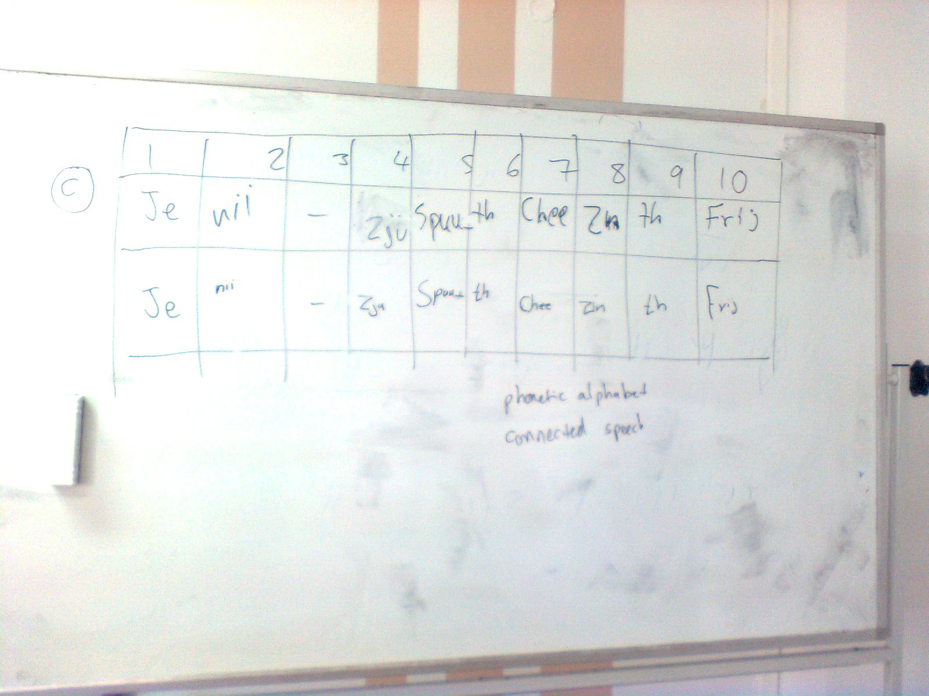

225577

English Banana Trust Summer School Participant Questionnaire (July 2012)

Please answer in as much detail as you feel necessary, and email your answers by 23rd July to Matt at: [email address]

General:

  - Why do you teach?
  - What do you want to get out of the summer school?
  - What are you most looking forward to?
  - What are you most worried about?
  - How will other people benefit from your attendance at the summer school?

Talk a Lot Foundation Course:

- What are the benefits of the NEA?
- Is the NEA more useful than the IPA? Why? / Why not?
- How can I find the sound spine in a sentence?
- Why should students learn to use connected speech?
- What is a friendly consonant sound?
- What is the relevance of the picture on the front cover of this book?
- Sum up the whole book in two words.
- What is wrong with English spelling?
- Give a few examples of words which have silent letters.
- Give examples of contractions and weak forms in a sentence.
- What is the best sound connection?
- What are the features of connected speech? Give one example of each in a sentence.

Translation:

Translate 20 English verbs or nouns from normal spelling into the NEA.

You Are The Course Book:

- What are the advantages of YATCB method compared with using a course book?
- What are the disadvantages of YATCB method compared with using a course book?
- How do Mode 1 and Mode 2 differ?
- What is the meaning of the tale The Story of Baa Baa?
- Why don’t we need course books or printed materials for lessons any more?
- Which mode do you prefer using? Why?
- What experience do you have of using Mode 1 and/or Mode 2? Tell me what happened when you used them.
- What is the role of homework in YATCB method?
- Why is a traditional course book just like junk food?
- One of my students isn’t happy learning with YATCB method and wants to change back to the regular course book. How could I persuade them to stick with YATCB?
- Attach a real text that would be suitable for Mode 2 and explain how you would exploit it in each of the 7 stages.
- What problems can you see for teachers and students using the YATCB method?

Error Correction:

Look at the texts below from Mode 1, Stages 2.1 & 2.2. They were created by students in Poland. Explain what points were addressed by the students between creating the first and second text, i.e. grammar, punctuation, and sense:

Stage 2.1: My Weekend

After week full of work made weekend. I went to the capital city and bought a new car. After that, I drove it around the city. I invited my friend to a big restaurant for dinner. And I cooked traditional food. In the weekend I went with my friend to a park. It was a faster car so I liked I drove it very faster then I had accident. And after that I went to a hospital. After that I died.

Stage 2.2: My Weekend

After a week full of work I had a stressful weekend. I went to the capital city and bought a new car. After that I drove it around the city. I invited my friend to my flat for dinner, and I cooked traditional food. The next morning I went with my friend to a park. It was a fast car so I liked driving it very crazily; then I had an accident. After that I went to hospital. In the end I stayed at home for one week, because I had an excuse.

Improvisation in Teaching (WizIQ class, Matt Purland – 31.07.12) Improvising = making the most of what you have got
Why Improvise?

- It’s fun!
- You can react to live problems that your students have.
- You can improve your skills – you learn where the hidden notes are.
- You will grow in confidence and develop as a teacher.
- Students love to see you enthused – and they become inspired in their turn.
- If you know the route and every turn in the road your journey will be routine – run-of- the-mill.
- Nothing would have been invented or achieved if people hadn’t wondered: “What if...?”
- Students are not predictable; they are not fixed points on a graph; you can’t treat them like known quantities.
- Life is not scripted – it’s natural for there to be mistakes and rough edges.
- If we lose the element of surprise/chance, we lose the vital spark.
- Seeing the list of activities in the course book that must be covered in the lesson time is demotivating for learner and teacher, who tick them off one by one. Learning should be an adventure.

How can I improvise?

- Aim for “planned spontaneity”!
- Form and content: form is fixed, content is free.
- Know the destination but not the exact route, yet have the skills to get there.
- Be less target-driven.
- Be less time-driven. Allow time for smelling the roses; for messing about.
- Focus on core skills.
- Don’t be afraid of repetition – it’s powerful.
- Cover topics and material that is interesting and relevant to you and the group.
- Prepare your own material – reduce dependency on other people’s ideas.
- Have the courage to try something new... and fail.
- Improvise to muted film or create your own DVD commentary.
- Follow You Are The Course Book method – Mode 1.

Lesson Analogies:

- Swimming lanes, or splashing about and having fun – or both?
- Drive straight there, or go the scenic route with detours and a picnic.
- Lecture or workshop?
- Do a crossword puzzle or Sudoku (fixed answer) or sketch a picture – or both. (We need to cater for different learner styles.)
- Receptive/passive skills (reading and listening) vs. productive/active skills (speaking and writing).
- Shopping: go straight for the item or go window shopping.
- Follow a recipe to the letter, or throw away the recipe book and experiment?

FORM CONTENT

fixed free
safety scary
experimental
spontaneity – being in the moment

scripted drama sport (thrilling because the ending is unknown, but the form/framework – is fixed)

The “Too Helpful” Course Book:

The course book and teacher’s book create a disturbing tension in the teacher between what they want to do and what they feel they “should” do.

Imagine if there was a course book to help us get efficiently through every moment of every day:

Exercise 1: Waking Up

- Wake up at 7.10 am and switch off your alarm clock. You may have a maximum of two snoozes.
- Have a warm shower (5 mins). Use 10ml shampoo.
- Make a cup of tea (mug not cup) and drink it fairly quickly (5 mins).

Exercise 42: At the train station

- Wait for the train. (15 mins)
- When the train arrives, get on (after others have got off) and sit towards the middle of the carriage.
- Listen to music on your headphones (Beethoven). (20 mins)
- Look at the weather. What is it like today? Discuss with a partner. (5 mins)

Exercise 534: In the canteen – lunch queue

- Have the sausage and onion casserole with a bread roll and butter.
- Sit in the centre of the room (under the window) with a partner.
- Eat your lunch while glancing at this morning’s paper. (15 mins)
- Go for a brisk walk. (10 mins)

The Alien Game:

Aim: to practise fluency, thinking on your feet, and improvisation. 3 roles:
  - alien
understands English, but doesn’t know anything about this planet; could be forgetful too – as in forgets straightaway what has already been explained; speaks little; asks questions like, Why, How, What, etc. and says “I don’t understand”, “What is...?” and “Can you explain that to me please?” etc. Their role is facilitator to the actor.

  - normal person (actor)

  - writer

Whole Group Version:

SS suggest topics, then watch as alien and normal person chat; writer writes keywords on the board, and SS write the keywords in their notebooks in alphabetical order – while correcting wrong spellings.

The alien tries to keep the conversation going for three minutes (or two, or one, etc. depending on the level). At this point different students take the roles. You could look at the keywords on the board, e.g. spelling, pronunciation, sentence building, etc.

Small Group Version:

SS work in groups of 3. The topics could be pre-decided by the whole group, or the teacher, or the small group think of some topics. Play the game as above, with a time limit. The writer writes on the board. Then SS do some vocab exercises with the words that result from the chat.

Note: this could lead into Stage 1 of YATCB Mode 1 – as a way of finding the discussion words randomly.

Twist to make it harder: SS choose 10 random keywords without the alien knowing and the person has to say them all, without the alien guessing them! The alien tries to guess them all.

Matt Purland 31.07.12
[email address]

M1 lesson; Foresters; 31.05.12; the underlined words were the keywords (on the topic of “Football”) that I elicited from the students; note that they wrote individual sentences, rather than a continuous text, because, as I noted (below) they were lower level; their sentences had to include the keywords; they dictated sentences in turn without first writing them; I typed them and then printed a copy for each student; we discussed the corrections together; the topic was relevant due to Euro 2012 which was about to begin in Poland and Ukraine

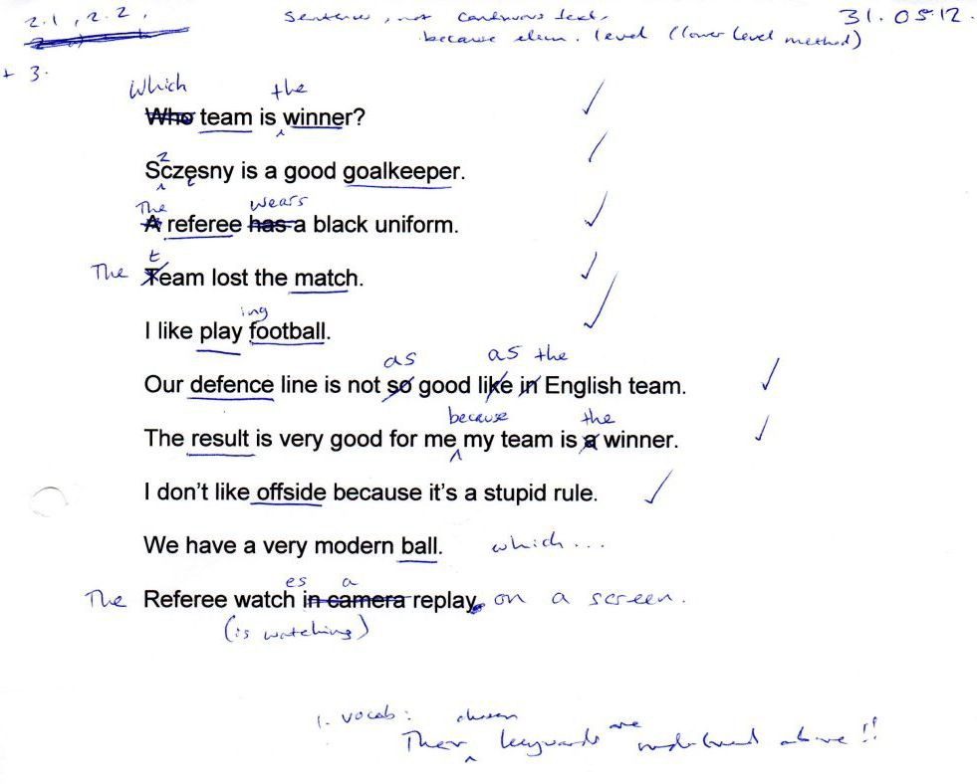

Example of using the Mode 2 Lesson Planner to build a three-hour lesson process using text from a FAQs page on an English bus company’s website; 13.06.12

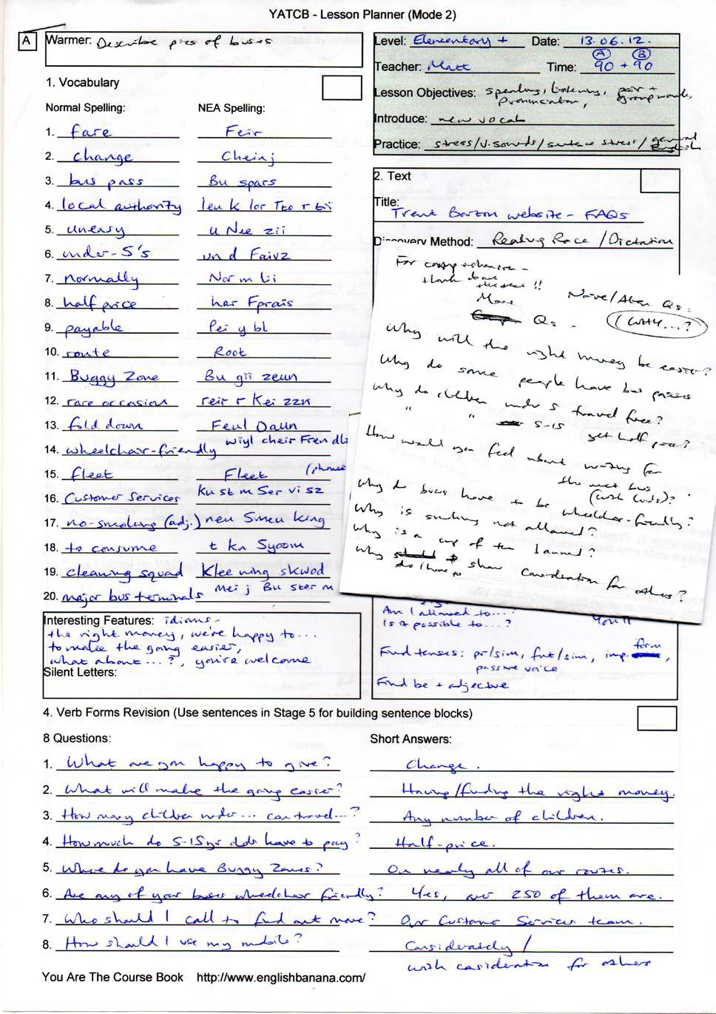

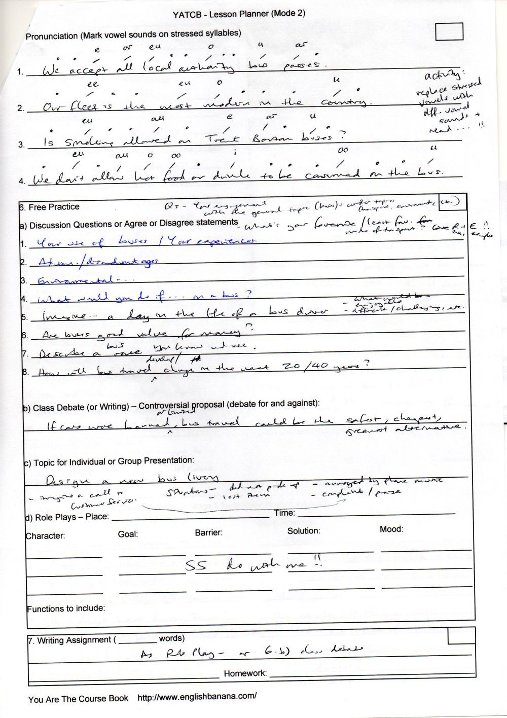

Part 3 – Supporting Documents

The plan for the summer school that I sketched in my diary; 06.08.12

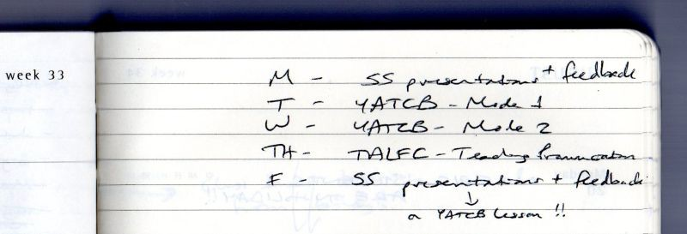

You Are The Course Book 2 – In Practice

Talk a Lot

Clear Alphabet Dictionary

Clear Alphabet – 48 Phonemes (Individual Sounds)

23 vowel sounds: 8 short

5 long

10 diphthongs | 25 consonant sounds: 15 voiced

10 unvoiced

Each phoneme always has the same written identifier (ID). Letters not used from the old alphabet: c, q, x When pronounced on their own, all consonant sounds (including unvoiced) are followed by a schwa sound,
e.g. 7. buh. This is called an embedded schwa sound. Hear the sounds: https://tinyurl.com/ca-sounds

No. | Phonemic ID | Old IPA Symbol | Old Spelling | New Spelling | Type
1. | a | LôL | bat | Bat | v / s
2. | ai | L~fL | time | Taim | d
3. | aiy | L~f]L | hire | Haiy | d
4. | ar | L^WL | star | Star | v / l
5. | au | L~rL | cow | Kau | d
6. | auw | L~r]L | power | Pauw | d
7. | b | LÄL | bag | Bag | c / v
8. | ch | LípL | cheese | Cheez | c / u
9. | d | LÇL | dice | Dais | c / v
10. | e | LÉL | leg | Leg | v / s
11. | ee | LáWL | three | Ttree | v / l
12. | ei | LÉfL | plane | Plein | d
13. | eir | LÉ]L | pear | Peir | d
14. | er | L‰WL | shirt | Shert | v / l
15. | eu | L]rL | home | Heum | d
16. | f | LÑL | frog | Frog | c / u
17. | g | LÖL | glass | Glars | c / v
18. | h | LÜL | head | Hed | c / u
19. | hh | LñL | loch | Lohh | c / u
20. | i | LfL | dish | Dish | v / s
21. | ii | LáL | happy | Ha pii | v / s
22. | iy | Lf]L | here | Hiy | d
23. | j | LÇwL | jam | Jam | c / v
24. | k | LâL | kit | Kit | c / u
25. | l | LäL | lake | Leik | c / v
26. | m | LãL | music | Myoo zik | c / v
27. | n | LåL | nurse | Ners | c / v
28. | ng | LÏL | ring | Ring | c / v
29. | o | LflL | sock | Sok | v / s
30. | oo | LìWL | shoot | Shoot | v / l
31. | or | LlWL | ball | Borl | v / l
32. | oy | LlfL | toy | Toy | d
33. | p | LéL | pig | Pig | c / u
34. | r | LêL | road | Reud | c / v
35. | s | LëL | snow | Sneu | c / u
36. | sh | LpL | shop | Shop | c / u
37. | t | LíL | taxi | Ta ksii | c / u
38. | th | LaL | brother | Bru th | c / v
39. | tt | LqL | thousand | Ttau znd | c / u
40. | u | L¾L | cup | Kup | v / s
41. | uh | L]L | arrive | uh Raiv | v / s
42. | uu | LrL | pull | Puul | v / s
43. | uuw | Lr]L | pure | Pyuuw | d
44. | v | LîL | van | Van | c / v
45. | w | LïL | week | Week | c / v
46. | y | LàL | yoghurt | Yo gt | c / v
47. | z | LòL | zip | Zip | c / v
48. | zz | LwL | revision | r Vi zzn | c / v
 | _ | L\L | football | Fuu_ borl

Key – v = vowel sound: s = short l = long d = diphthong | c = consonant sound: v = voiced u = unvoiced

Talk a Lot

Clear Alphabet Dictionary

Learn the Clear Alphabet with Flashcards

Students can use the flashcards on pp.20-29 for learning and memorising the forty-eight sounds of English with the Clear Alphabet. The aim is to know the sounds by heart, so that they can look at any of the Clear Alphabet IDs (identifiers) on their own and say the sound straight away.

Instructions

- Print the pages back to back onto thin card, in the following order:

  - print pages 20 and 21 back to back
  - print pages 22 and 23 back to back
  - print pages 24 and 25 back to back
  - print pages 26 and 27 back to back
  - print pages 28 and 29 back to back

- Cut out the cards and laminate them, if possible, for extra durability.

- For students: use the cards to learn the sounds by quickly testing yourself in spare minutes of the day, e.g. on the bus, at lunchtime, when you’re watching TV, etc.

- For teachers: use the cards to test your class for a short period of time every day, just to keep the identifiers and sounds in your students’ minds, or give a set of cards to each student and encourage them to practise in pairs or small groups. You could use some or all of the activities below.

Key to Abbreviations

v / s = short vowel sound v / l = long vowel sound d = diphthong
c / v = voiced consonant (i.e. your vocal cords vibrate when you make it; feel your throat as you make a sound to find out whether it’s voiced or not; if it vibrates, it is voiced!)
c / u = unvoiced consonant (your vocal cords don’t vibrate when you make this kind of sound)

Note: it’s well worth getting students to learn the Clear Alphabet sounds with an extra layer of detail, so that they learn the concepts above. For example, that e isn’t only a vowel sound, but that it’s a short vowel sound; or that n isn’t only a consonant sound, but it’s a voiced consonant sound that makes your vocal cords vibrate – and also a friendly consonant sound.

Suggested Classroom Activities

I made my own flashcards like these to learn and memorise which sound each symbol of the IPA represented, when I was training to be an English teacher more than twelve years ago, but there are lots of other ways in which you could use them beyond simply learning quietly at home:

- Put all of the cards on the table – simple side up – in front of your students. Say a sound, and the first to find the correct card is the winner. Or, say “voiced consonant” or “long vowel sound”, etc. (as above) and the first to find one is the winner.

Talk a Lot

Clear Alphabet Dictionary

Learn the Clear Alphabet with Flashcards

- Show a card with a sound on it and students have to say a word each that includes this sound.
- Students have to put several of the cards in order to make a simple word, e.g. “cat” =
k
a
t
- Or you could ask students to spell out their first name, or the make of their car, or their first pet’s name, etc., or one (or more) of any current vocabulary word or phrase, using the cards. You may need a few sets of cards to be able to do this.
- Try this fun game for two students working in a pair (it could also be adapted for two small groups battling each other). Each student has half the cards from the set. They hold them in their hands in a (shuffled) pack so that the other student can’t see which cards they’ve got. The first student produces the first card and their partner has ten seconds (or five, if your group is at a good level!) to say an English word that contains that sound. If they are correct they get the card, and put it in a separate pile from the pack in their hands. If they are wrong, or can’t think of a word, the original student gets to keep the card, again putting it in a separate pile. Play alternates between the two students and continues until the students don’t have any cards left in their hands. The winner will be the student with the most cards at the end of the game (or at the end of an agreed period of time, e.g. fifteen minutes). A variation to make the game harder would be to insist on two words (or more) for each sound, or to get the students to write the words using the Clear Alphabet, as well as saying them.
- Use the rhyming words listed on pp.30-40 to demonstrate how the same sounds in English can be achieved with very different spelling patterns. See also the information on Vowel Clusters (from p.203) and Consonant Clusters (from p.217) later in the dictionary.You could make the important point that English is not a phonetic language, and that the spelling of a word in English often bears little or no relation to the sounds that it contains.
- Or use the rhyming words to get students saying lots of words with the same vowel sound out loud. You could even get them to write sentences using as many words which have the same vowel sound in them as possible, for example:

Sound: ee

Sentence: “Pete’s feet feel the need for speed each week.” or:
Sound: ei

Sentence: “Jane’s Danish mate made it plain that her place in Spain was a waste of space.”

Why not collect together the funniest or longest sentences and make a classroom display, or book.

[This article was adapted from Talk a Lot Elementary Handbook.]

Talk a Lot

Clear Alphabet Dictionary

Simple Flashcards (Page 1 of 5)

i  Talk a Lot | a  Talk a Lot
o  Talk a Lot | uu  Talk a Lot
uh  Talk a Lot | e  Talk a Lot
ii  Talk a Lot | ee  Talk a Lot
ar  Talk a Lot | or  Talk a Lot

Talk a Lot

Clear Alphabet Dictionary

Detailed Flashcards (Page 1 of 5)

a  bat Bat v / s | i  dish Dish v / s
uu  pull Puul v / s | o  sock Sok v / s
e  leg Leg v / s | uh  arrive uh Raiv v / s
ee  three Ttree v / l | ii  happy Ha pii v / s
or  ball Borl v / l | ar  star Star v / l

Talk a Lot

Clear Alphabet Dictionary

Simple Flashcards (Page 2 of 5)

oo  Talk a Lot | er  Talk a Lot
u  Talk a Lot | ei  Talk a Lot
ai  Talk a Lot | oy  Talk a Lot
eir  Talk a Lot | aiy  Talk a Lot
eu  Talk a Lot | au  Talk a Lot

Talk a Lot

Clear Alphabet Dictionary

Detailed Flashcards (Page 2 of 5)

er  shirt Shert v / l | oo  shoot Shoot v / l
ei  plane Plein d | u  cup Kup v / s
oy  toy Toy d | ai  time Taim d
aiy  hire Haiy d | eir  pear Peir d
au  cow Kau d | eu  home Heum d

Talk a Lot

Clear Alphabet Dictionary

Simple Flashcards (Page 3 of 5)

iy  Talk a Lot | uuw  Talk a Lot
auw  Talk a Lot | b  Talk a Lot
g  Talk a Lot | v  Talk a Lot
t  Talk a Lot | d  Talk a Lot
tt  Talk a Lot | th  Talk a Lot

Talk a Lot

Clear Alphabet Dictionary

Detailed Flashcards (Page 3 of 5)

uuw  pure Pyuuw d | iy  here Hiy d
b  bag Bag c / v | auw  power Pauw d
v  van Van c / v | g  glass Glars c / v
d  dice Dais c / v | t  taxi Ta ksii c / u
th  brother Bru th c / v | tt  thousand Ttau znd c / u

Talk a Lot

Clear Alphabet Dictionary

Simple Flashcards (Page 4 of 5)

p  Talk a Lot | k  Talk a Lot
s  Talk a Lot | sh  Talk a Lot
ch  Talk a Lot | h  Talk a Lot
r  Talk a Lot | w  Talk a Lot
y  Talk a Lot | m  Talk a Lot

Talk a Lot

Clear Alphabet Dictionary

Detailed Flashcards (Page 4 of 5)

k  kit Kit c / u | p  pig Pig c / u
sh  shop Shop c / u | s  snow Sneu c / u
h  head Hed c / u | ch  cheese Cheez c / u
w  week Week c / v | r  road Reud c / v
m  music Myoo zik c / v | y  yoghurt Yo gt c / v

Talk a Lot

Clear Alphabet Dictionary

Simple Flashcards (Page 5 of 5)

n  Talk a Lot | ng  Talk a Lot
l  Talk a Lot | f  Talk a Lot
z  Talk a Lot | zz  Talk a Lot
j  Talk a Lot | hh  Talk a Lot
Talk a Lot | _  Talk a Lot

Talk a Lot

Clear Alphabet Dictionary

Detailed Flashcards (Page 5 of 5)

ng  ring Ring c / v | n  nurse Ners c / v
f  frog Frog c / u | l  lake Leik c / v
zz  revision r Vi zzn c / v | z  zip Zip c / v
hh  loch Lohh c / u | j  jam Jam c / v
_
football Fuu_ borl (glottal stop)

Talk a Lot

Clear Alphabet Dictionary

400 Elementary Words

Translate from Clear Alphabet to Normal Spelling

Must |  | Par_ n
Mai |  | Par sport
Neim |  | Pa st
Nei ch |  | Pees
Niy |  | Pee pl
Ne v |  | Per sn
Nyoo |  | Feun
Nekst |  | pi Ya neu
Nais |  | Pees
Nait |  | Pingk
nain Teen |  | Pee_ ts
Neu b dii |  | Plan
Neuz |  | Plein
Not |  | Pleez
Nu tting |  | Plu m
No vl |  | Peu sto fis
neu Vem b |  | p Tei teu
Num b |  | Paund
Ners |  | Pauw
Ov |  | Pri tii
Of |  | Pro blm
O fn |  | Pur pl
eu Kei |  | Puu Ton
On |  | Kyoo
Wun |  | Kwik
Eu pn |  | Kwaiyt
Or |  | Rei dii yeu
O rinj |  | Rein
U th |  | Ran
Auw |  | Reed
Aut |  | Riyl
Eu v |  | Rais
Pein |  | Rich
Pei p |  | Rait
Peir rnt |  | Ri v

Spelling and sounds are different in English. You have to learn both parts of each word!
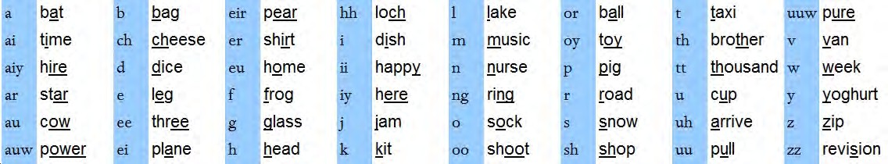

Talk a Lot Clear Alphabet Dictionary

Talk a Lot

Clear Alphabet Dictionary

Translate 40 Famous People from the Clear Alphabet

Here are the top 40 entries in Forbes Magazine’s 100 Most Powerful Celebrities List 2012 (stressed vowel sounds in red). Translate them into normal spelling and discuss why each person is famous:

- je n f Leu pez
- eu pr Win frii
- ju stin Bee b
4. rii Ya n
5. lei dii Gar gar
6. bri_ nii Spiyz
7. kim kar Da shiyn
8. kei tii Pe rii
9. tom Krooz
10. stee vn Spiyl berg
11. tei l Swift
12. tai g Wuudz
13. an j lee n jeu Lee
14. do nl Trump
15. l bron Jeimz
16. bii yon sei Neulz
17. el tn Jon
18. sai mn Kauwl
19. ru Shlim bor
20. tai l Pe rii
21. por lm Kar_ nii
22. je n f Ra n stn
23. glen Bek
24. uh Del
25. bon Jeu vii
26. do kt Drei
27. keu bii Braiynt
28. bra Tpit
29. rai yn See krest
30. ha w Tstern
31. ro j Fe d r
32. dei vi Tbe km
33. ma nii pa Kyau
34. e ln d Je n rz
35. mai kl Bei
36. jor Jloo ks
37. jeim Zpa t sn
38. jei Zee
39. je rii Bruu khai m
40. pei tn Ma ning

Talk a Lot Clear Alphabet Dictionary

Talk a Lot

Foundation Course

Role Play with the New English Alphabet (NEA) 1

Mei king Planz

A lis: Hai, Tom! Hau zi_ Geu win?

Tom: Fain! uhn joo?

A lis: Eu, wai Vgo_ Leu ts Vheum wer kt Doo.

Tom: Ye, mee Too. uh y g n Fi ni shi_ Or lon Taim?

A lis: Ai Deun_ Neu. ai Heu pseu!

Tom: s m v s Geu wing t th Si n mar Lei_ uh. j Won_ uh Joy ns? y Wel k mi fy Wo n.

A lis: Ar, So rii To, mai karn_ t Nai_. ai Pro mi smai Fren dai Tstu dii wi th. May bii y_ th wee Kend? Wo_ ch Thingk?

Tom: Shor! E nii Tai, Mei_! l Te ksch. See y!

Talk a Lot Foundation Course Lesson 2 Page 8

Talk a Lot

Clear Alphabet Dictionary

Clear Alphabet Test (Sample)

- Write your first name using the Clear Alphabet:

- Write two words in English that contain the same vowel sound:

- i
- a

- Write two words in English that contain the same diphthong:

- ei
- eir

- Write two words in English that contain the same consonant sound:

- tt
- ch

- Translate the following sentences into English:

- n Ta sh Du zn_ Won_ e nii So s jz.

- ai Nee d Ku p l Vnyoo Sher_z

- Write the following sentences using the Clear Alphabet:

- Can I have a drink, please?

- My brother’s name is Phil.

- He wants me to go to the theatre.

- There isn’t any coffee.

- Write these words in your first language, then (where possible) translate the results into the Clear Alphabet:

- bread
- newspaper
- friend
- shoulder

Talk a Lot

Clear Alphabet Dictionary

Clear Alphabet Test (Sample) – Answers

Answers:

- Answers will vary.

- Answers will vary, for example:

- i fish, hill
- a cat, flat

- Answers will vary, for example:

- ei train, pain
- eir care, there

- Answers will vary, for example:

- tt thumb, think
- ch chair, itch

5.

- Natasha doesn’t want any sausages.

- I need a couple of new shirts.

6.

- Can I have a drink, please? k nai Ha v Dring, Kpleez?

- My brother’s name is Phil. mai Bru th Znei mi Sfil.

- He wants me to go to the theatre. hi Won_ smi t Geu t th Ttiy t.

- There isn’t any coffee. th Ri zn te nii Ko fii.

- Answers will vary.

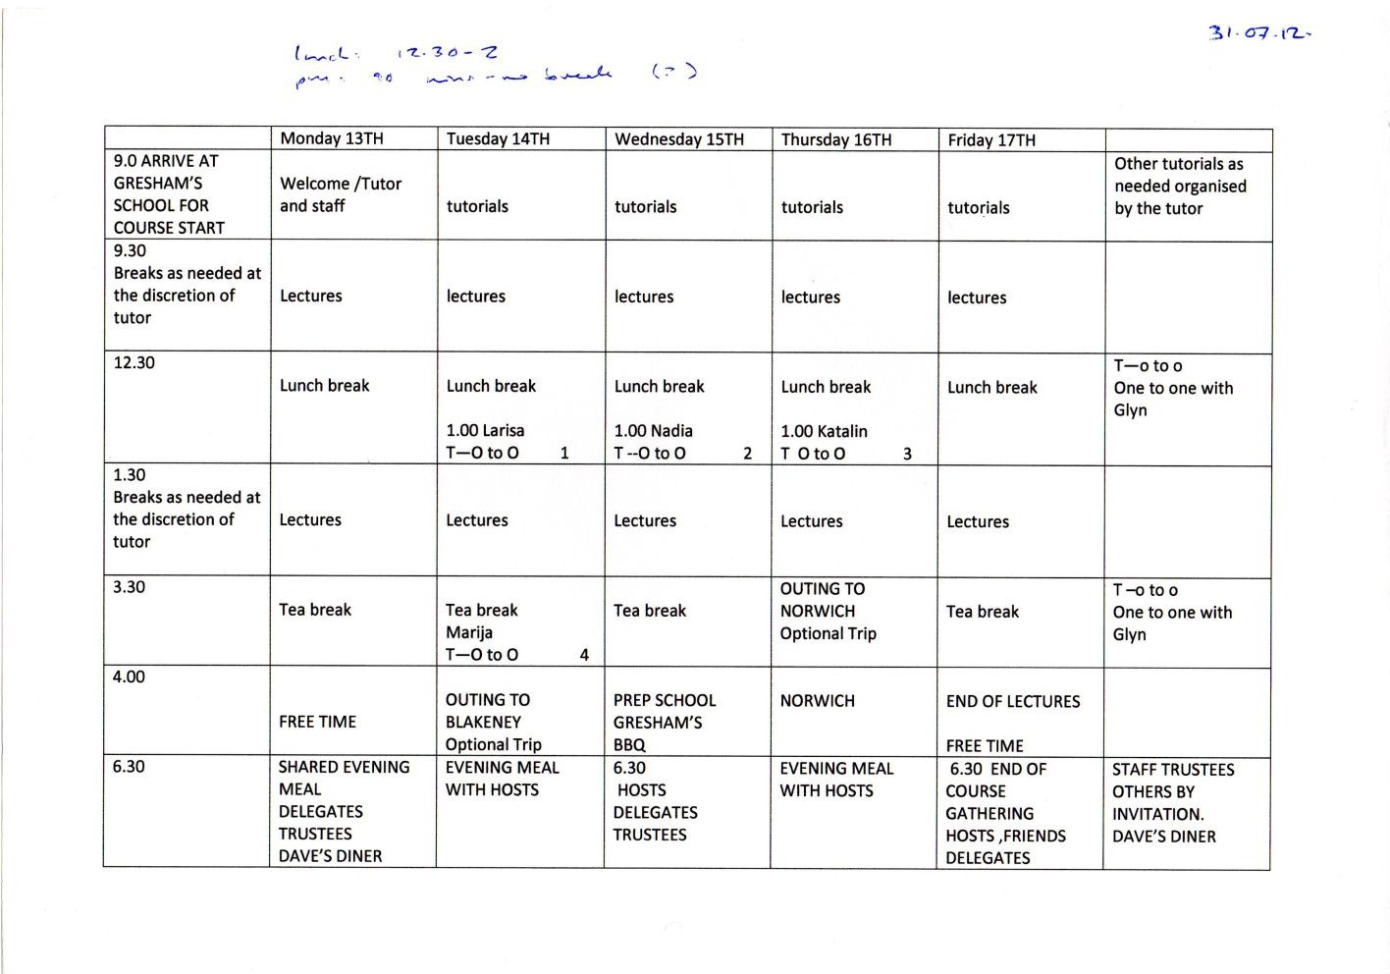
English Banana Trust’s First Summer School – official timetable; 31.07.12

You Are The Course Book 2 – In Practice

Diagrams I drew during the summer school to represent YATCB method; 14.08.12; the first picture shows the usual bad way of learning – with students working individually in their own minds, focused on a course book, yet sitting together, with the teacher walking around monitoring their work – checking that they have completed each segment of each page; the second picture represents Mode 1, with students working together creatively to produce a text, with the teacher guiding and controlling the timing of the process; the third picture shows a Mode 2 lesson, with students working together using an outside (real) text; again the teacher guides and controls the “form” of the lesson
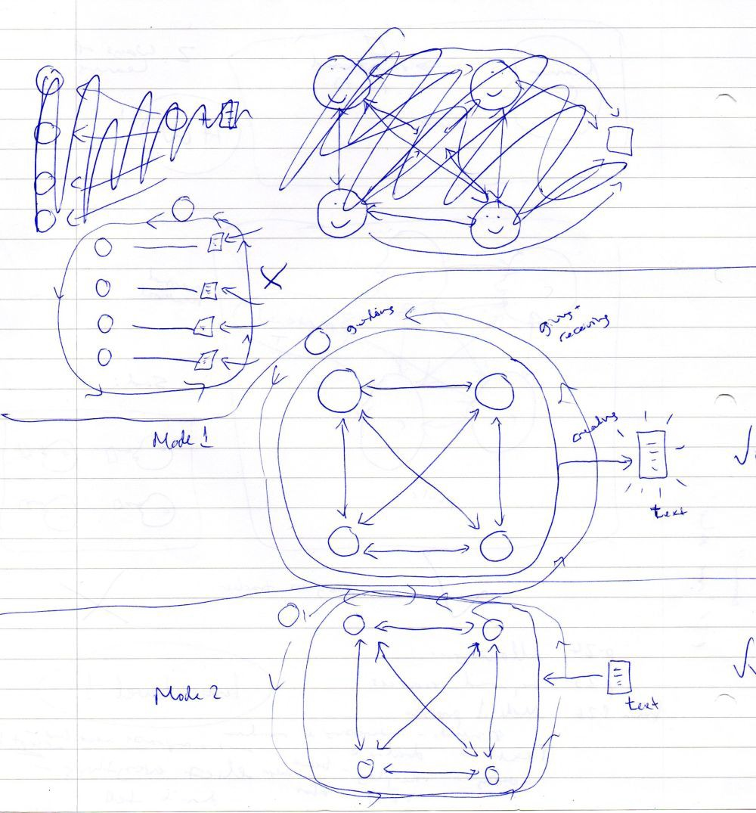

Discussion questions on the topic of “Travelling”; created by Nadia and Kata during the summer school; 15.08.12

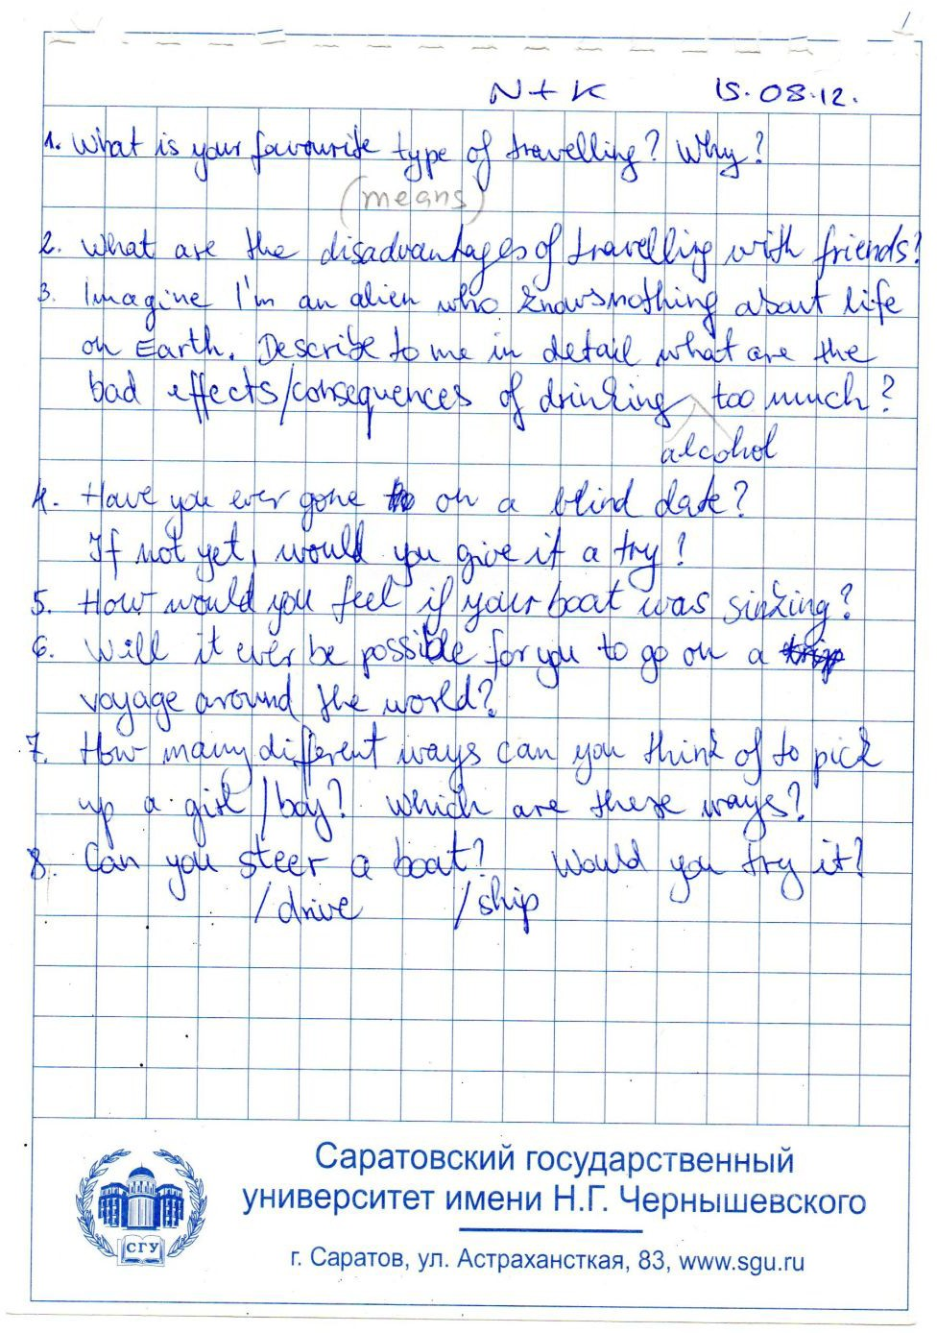

Mode 1 text created by the students at the summer school – 14.08.12

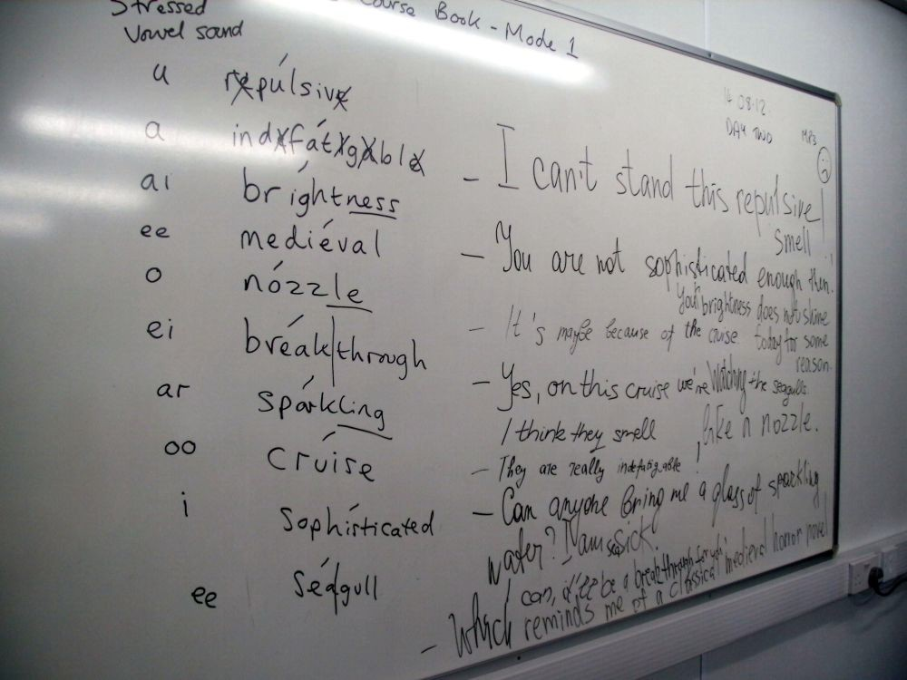

Friday: Mode 1 text created by the students during Kata’s lesson, using the words that Marija had elicited – 17.08.12

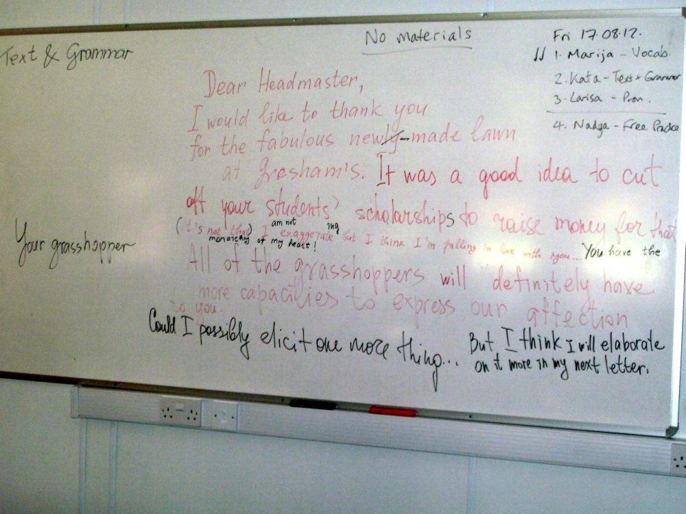

More pictures from the summer school – August 2012
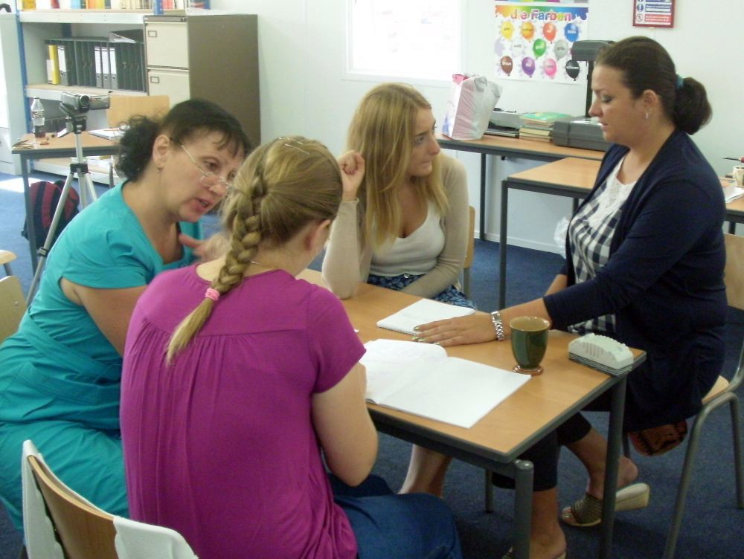
(l-r) Nadia, Kata, Marija, and Larisa work in pairs during a Mode 1 process
The seals at Blakeney Point

More pictures from the summer school – August 2012
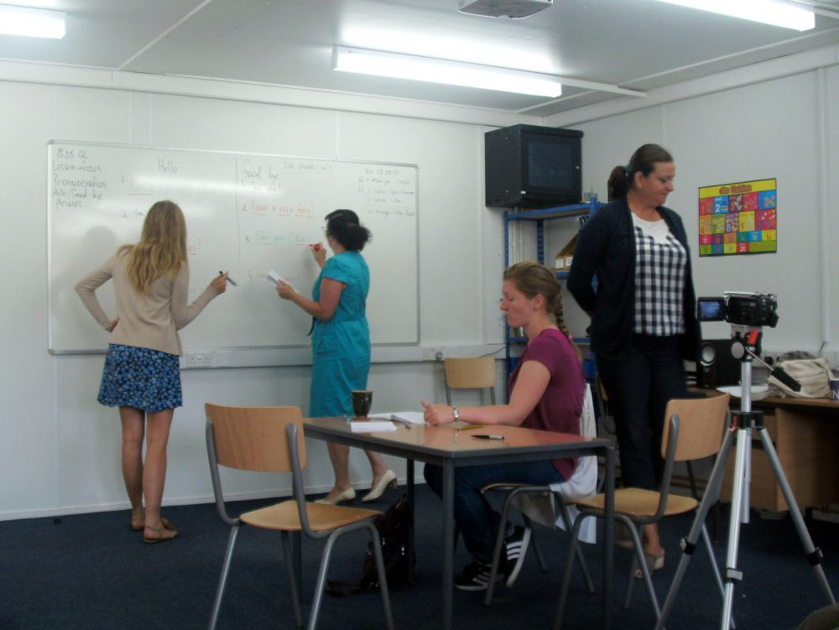
Marija and Nadia write on the board during Larisa’s class with no material on Friday 17.08.12. Note Larisa letting them get on with it
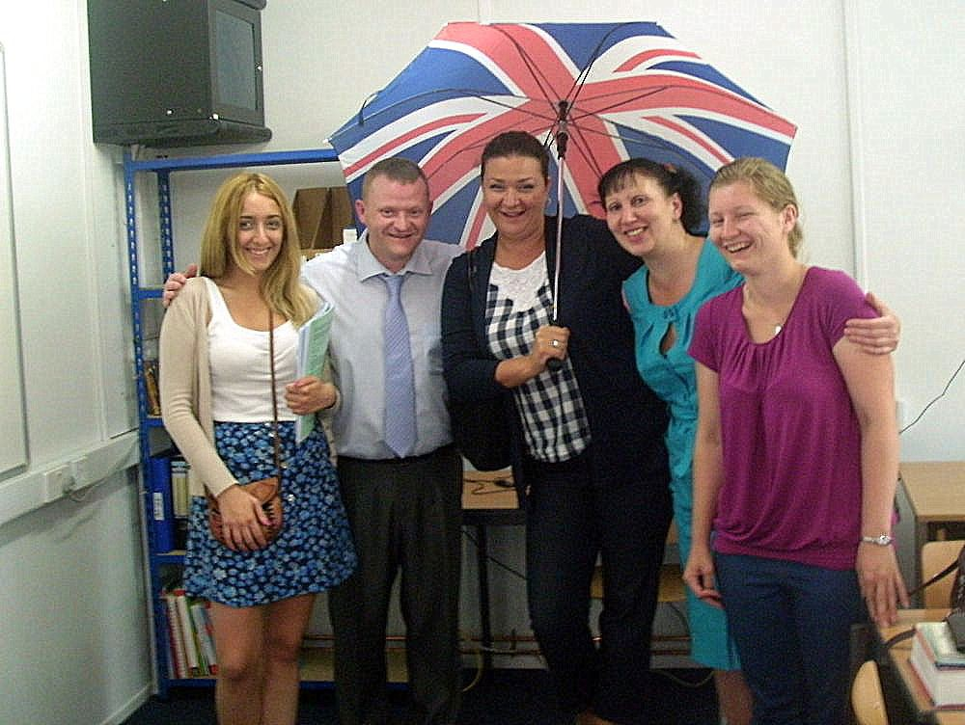
The summer school candidates: (l-r) Marija, me, Larisa, Nadia, and Kata (17.08.12)

Part 4 – Supporting Documents

List of Games and Warmers for Free Practice and Filling Time

No resources/material required apart from student-made

Drawing:

  - Draw whatever somebody describes, e.g. a picture they’re holding
  - Picture stories – draw a sequence of events, then mix up and swap with another team

Art:

  - Painting
  - Modelling with clay, breakfast cereal, balloons, etc. and sellotape

Stress and Sounds:

  - Stress all the wrong syllables in a text
  - Have the right stresses but wrong vowel sounds in a text

Drama:

  - Role play
  - Dialogues
  - Make a musical
  - Puppet work
  - Mime

Improvisation:

  - The Alien Game
  - The Boring Guest – describe a boring activity for as long as you can with a straight face – without laughing
  - Just a minute-style activity
  - Group story – one word or one sentence at a time; or try it in pairs or groups of 3
  - Mime the action as your partner describes a story or part of a film
  - Whatever I ask, you must say “yes” or “no”

Guessing Games:

  - Doctor to patients (whole group) – what’s wrong with sby?
  - Pictionary – on the board – guess the picture

  - I-Spy
  - Something’s Different (change sth in the room)
  - What’s in the Bag? Guess the object(s) in a mystery bag

Answer only yes or no:

  - What kind of x am I? (e.g. animal, job, favourite x, etc.)
  - What’s my problem? (elicit list and choose one)

Listening Practice:

  - Shopping List game (My Butler Went to Meadowhall)
  - Whispering Trees
  - It’s My Birthday – and You’re all Invited! (Well, most of you)

Text:

  - Reduce a text from x words, down to x, then x, then finally x
  - Hangman

Quiz:

  - Quiz where each question has four possible answer; SS have to run to a corner of the room to signal their answer; peer pressure ensues!
  - Quick quiz – SS run up to the board to write the answers, or write in groups quietly
  - TV Guide/Newspaper/Magazine quiz – scan reading practice

Moving Games:

  - Line up in order of... height, age, shoe size, address, first initial, second initial of x, etc. (can be used to pick teams)
  - Simon Says
  - Slow walking race
  - Dead heat – in teams – all SS have to cross the line at the same time

Group Project:

  - Design and market a... hotel, leisure centre, park, city centre, tourist attraction, car, plane, toothpaste, etc. (create a business plan; do market research, etc.)
  - Make a board game
  - Prepare a recipe for a new dish, then make it and bring it in for us!

My pictures – the results of a dictated picture session; pre-intermediate level Polish students; Olsztyn; September 2012

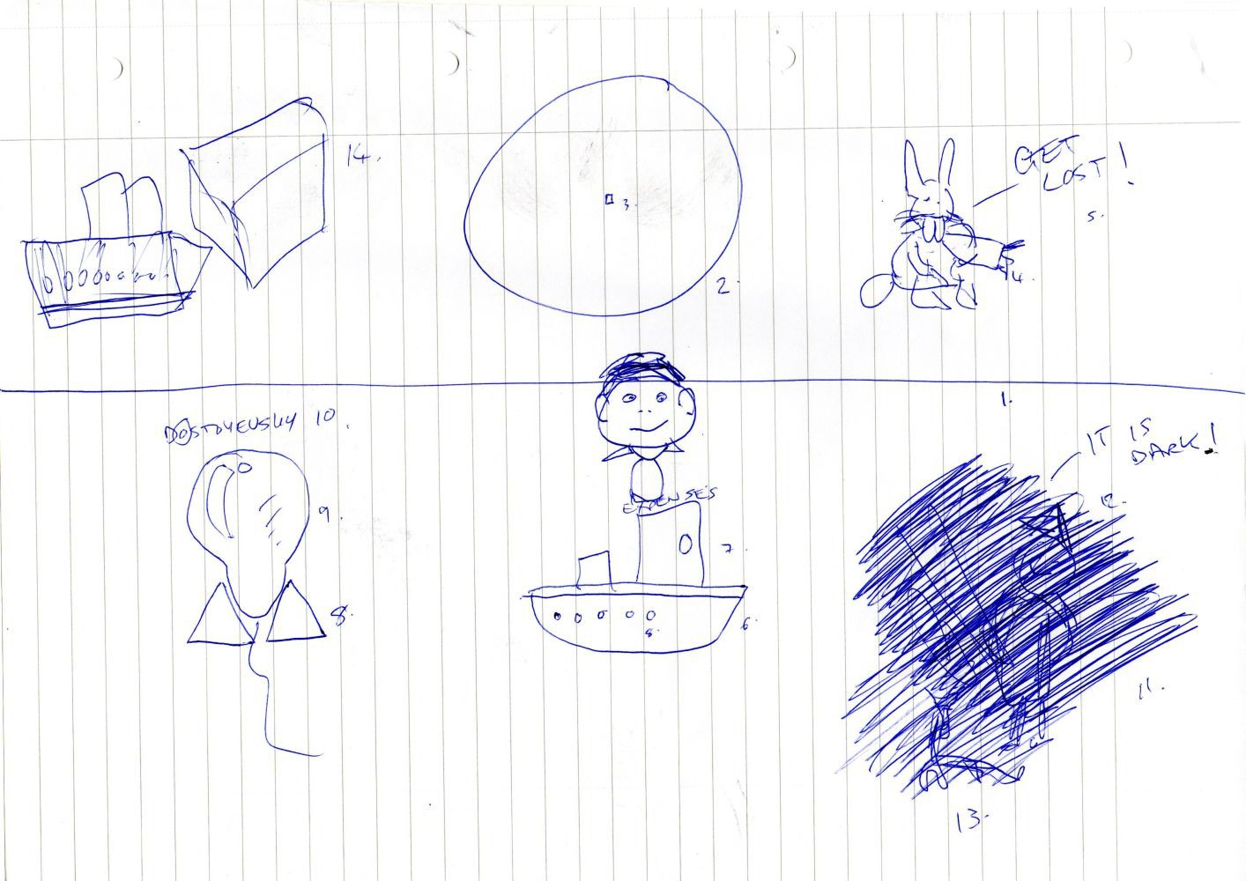

You Are The Course Book 2 – In Practice

The Glottal Stop in English: Clear Alphabet: _ IPA: /ʔ/
- Read these fun sentences out loud:

It's Pat's mate's pet dog.

It's not Pat's mate's pet dog, but your mate Pat's pet dog! Kate wrote a short note and Bart bought some light wheat. Pete’s pet cat knew a neat newt.
We ate out late last night. Uh oh!
Night night.

- Read these common words and phrases where t is replaced by a glottal stop:

absolutely a ps Loo_ lii apartment uh Par_ mnt appointment uh Poyn_ mnt credit card Kre di_ kard football Fuu_ borl
fruit juice Froo_ joos
get angry ge_ Ang grii Great Britain grei_ Bri tn its I_s
nightclub Nai_ klub
partner Par_ n
put down Puu_ Daun seatbelt See_ belt witness Wi_ ns

- What is a glottal stop?

The glottal stop is not a sound but rather an action – the cutting off of a sound at the moment of making it.

English native speakers use the glottal stop to replace the "t" when it is the first sound in a cc sound connection. So glottal stop often combines with elision (deleting a sound) in order to make a vc sound connection.

We make a glottal stop by closing the glottis for a moment. The glottis is the small space at the top of our throat, in between the vocal cords. When you close it the air flow is stopped for a brief moment, and the previous sound is cut short – clipped.

It is possible to learn to control the glottis – to open and close it – since this is only a physical action. It’s like learning to click your fingers, or whistle. It might take some practise, but it can be learned.

The glottal stop is common in Standard Pronunciation, as well as in English spoken with an accent, e.g. a London accent. The glottal stop is not unique to English, but can be found in many other languages, e.g. Chinese, German, and Arabic.

If you are not using glottal stops, your spoken English won’t sound as natural and smooth as it could, because you are pronouncing too many consonant sounds, especially t sounds.
This will slow down your speech and mess up the stress pattern and the sound spine.

In Clear Alphabet it is written as _ The underscore shows that there is something missing (i.e. an unnecessary consonant sound).

I’m afraid neither the Schwa Sound nor the glottal stop can be avoided if you want to speak like a native speaker. Both have to be – and can be – learned and mastered.

- What is my glottis?

Take a look at this picture of the human larynx:
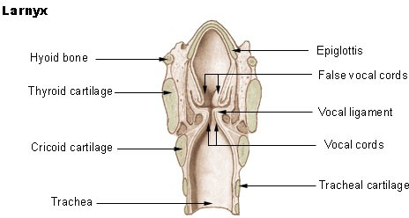

http://commons.wikimedia.org/wiki/File:Illu_larynx.jpg

[Picture awaiting copyright clearance]

Glottis – open (breathing)

[Picture awaiting copyright clearance]

Glottis – closed (sound production/swallowing)

“Our glottis (the phonetic term for the vocal folds/vocal cords) is composed of two pieces of tissue that move together and apart during speech, and vibrate rapidly to create voicing.
Those pieces of tissue can be moved a great deal, and even brought all the way together. Hold your breath with your mouth and nose opened. You’ll feel a pressure build up below your throat, and you’ll probably be able to feel exactly where the air is stopped. That closure is the vocal folds, and what you’re doing now is holding a glottal stop. In order to make a glottal stop in speech, we just pull those two pieces of tissue all the way together until they make a seal,

and then release it again. That’s it. No tongue, no voicing, no nasal worries. Just close the glottis. Easy, huh?”

Source: http://linguisticmystic.com/page19/

Glottal Opera: http://www.youtube.com/watch?v=JBdxI16ZgYU

Note: the glottal stop does not only occur in “bad” accents, like Cockney, but is all around us in Standard Pronunciation – even on BBC Radios 3 and 4!

- Typical places where you can hear glottal stops:

cc sound connections when the first sound is t , e.g.

Problem words for students (GS will usually occur if the next sound is a consonant sound):

  - common function words that end with t : at, that, what, it just out
  - negative auxiliary verbs: not, can’t, don’t, didn’t, wouldn’t, etc.
  - common content words that end with t : white , different , want, common phrasal verbs with get, put, etc.

cc sound connections when the first sounds are ts , e.g.

Problem words for students (GS will usually occur if the next sound is a consonant sound):

  - words ending with ts : sports, it’s, its, let’s, what’s
  - GS occurs with FCL, e.g. “let’s go” = Le_ Sgeu

- Read these sentences. Where are glottal stops likely to be? Now listen and underline the places where glottal stops occur:

- there’s an accident between junctions four and...

- but just the one lane out north of junction four...

- you can get past it, but it’s bound to be busy...

- enjoy it – we’re all here...

- that was the voice that I ’eard...

- tells us what this glorious summer of sport means for the way his network will cover...

- mind you, some listeners don’t think it should have one...

- that possibly didn’t translate as well in the home counties...

- I’ve got up to the second opportunity to make things different if I want to...

- because we felt we were able to bring the games to life in all sorts of ways...

- sports like that, which we discovered could make the most amazing radio; all put together in a way that you would never have predicted...

- how much did it all cost...?

- what was your budget...?

- we don’t have the full figures yet, because the whole BBC operation is...

- get cracking on making that shift. You surely saw that memo yourself? I read about it, yes. I read about that memo...

- Go back to the beginning and practise the fun sentences and words again

- Appendix – 200 One-Syllable Words that End with “t”

Practise making glottal stops with this handy list of one-syllable words that end with t :

ant | fate | meat | sit
art | feat | meet | skate
at | feet | met | soot
bait | fight | might | sot
Bart | fit | mitt | sought
bat | fleet | moat | splat
beat | float | mutt | spout
beet | foot | Nate | sprout
belt | fought | neat | start
bet | gate | net | stat
bit | get | newt | state
bite | git | night | stoat
bleat | gnat | nit | straight
blot | goat | not | tart
boat | got | note | tat
bolt | greet | nought | Tate
boot | grit | nut | taught
bought | grot | oat | thought
brat | gut | ought | throat
Brit | hart | part | tight
brought | hat | pat | tit
built | hate | peat | toot
but | heart | pert | tot
butt | heat | pet | tote
cart | height | Pete | treat
cat | hit | pit | tut
caught | hot | plate | vat
cert | hurt | pleat | vet
chart | hut | port | vote
chat | it | pot | wait
cheat | jet | put | wart
chute | jot | quit | weight
clot | jut | quite | wet
coat | jute | quote | what
coot | Kate | rat | wheat
cot | kit | rate | white
crate | kite | rent | wilt
curt | late | right | wit
cut | let | root | writ
cute | light | rot | wrote
dart | lit | rut | wrought
date | loot | sat | yacht
debt | lot | seat | yet
dirt dot | mart mat | set short | zip
dote fat | mate Matt | shot sight

Answers:

6. Read these sentences. Where are glottal stops likely to be? Now listen and underline the places where glottal stops occur:

- there’s an accident between junctions four and...

- but just the one lane out north of junction four...

- you can get past it, but it’s bound to be busy...

- enjoy it – we’re all here... (00:55)

- that was the voice that I ’eard... (01:16)

- tells us what this glorious summer of sport means for the way his network will cover...

- mind you, some listeners don’t think it should have one...

- that possibly didn’t translate as well in the home counties...

- I’ve got up to the second opportunity to make things different if I want to...

- because we felt we were able to bring the games to life in all sorts of ways...

- sports like that, which we discovered could make the most amazing radio; all put together in a way that you would never have predicted... (04:08)

- how much did it all cost...?

- what was your budget...? (05:18)

- we don’t have the full figures yet, because the whole BBC operation is...

- get cracking on making that shift. You surely saw that memo yourself? I read about it, yes. I read about that memo...

Feedback Form

Name: Date:

- What I enjoyed most about the course:

- What I disliked about the course:

- New things I learned:

- What was the most difficult:

- How I’m going to continue studying English:

Harvest Festival (08.10.12)

Discussion Questions

  - Do you go to church?
  - Do you celebrate Harvest Festival? Why? / Why not?
  - Describe a typical Harvest Festival service at church.
  - What are you thankful for? How do you show your gratitude?
  - Do you give to charity? What? How often?
  - Do you think that society should provide for poorer people... a) in their society, b) in other countries? Why? Why not?
  - Have you ever visited a farm? Describe your impressions.
  - Would you like to live on a farm?
  - What are you dependent on?
  - Can you imagine being dependent on the harvest, where a good harvest means life and a bad one means death? In which countries is this still the case?
  - Why is harvest festival less important to us than to our grandparents and forebears?
  - What other ceremonies do you practise during the year? Make a list in calendar order.
  - Do you enjoy sharing food with others, e.g. at a big family meal? Why?
/ Why not? Describe such an event.
  - Do you have a garden? Do you grow food to eat? What are the differences between growing food and buying food. Which do you prefer? Why?
  - Do you think we will continue to celebrate harvest, considering our increasingly secular society and the security of our food supply?
  - What is your favourite food? Can you imagine life without it? Describe your reaction to the news that it will no longer be available.
  - Close your eyes. What five words come to mind when you think about harvest?
  - Invent your own food and plan the process from growing, harvesting, preparing, packing, transporting, and selling it...

People we could discuss (What Would You Do?) and base situations around (Role Plays):

  - A priest
  - A churchgoer who gives food
  - A farmer
  - The owner of a supermarket
  - The owner of a small family-run store
  - An ancestor, e.g. great-great grandparent
  - An atheist
  - Somebody in need

You Are The Course Book – Mode 1 – in 60 Minutes; notes for a faster version of Mode 1; 28.08.12; the idea of speeding up the process would be realised
later on in Mode 3

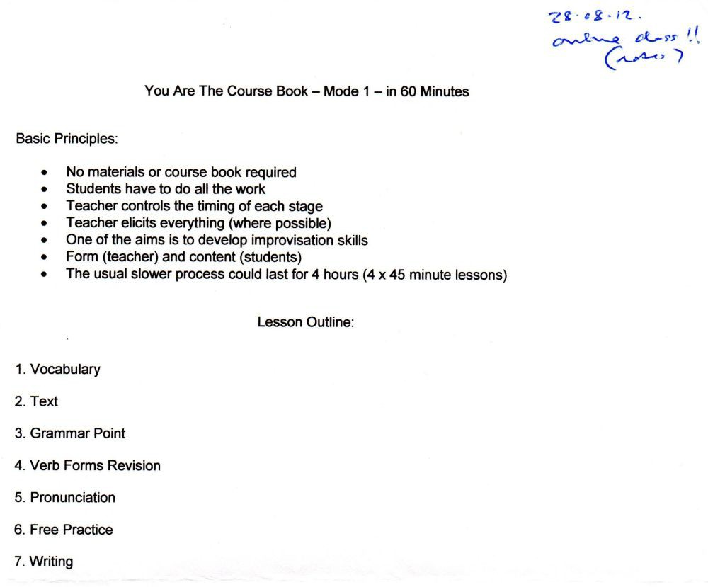

These six sentences came from Mode 1 texts which were created by
pre-intermediate/intermediate level students at the conversation course in Olsztyn; 17.09.12; I translated them into Clear Alphabet for use in a later pronunciation session
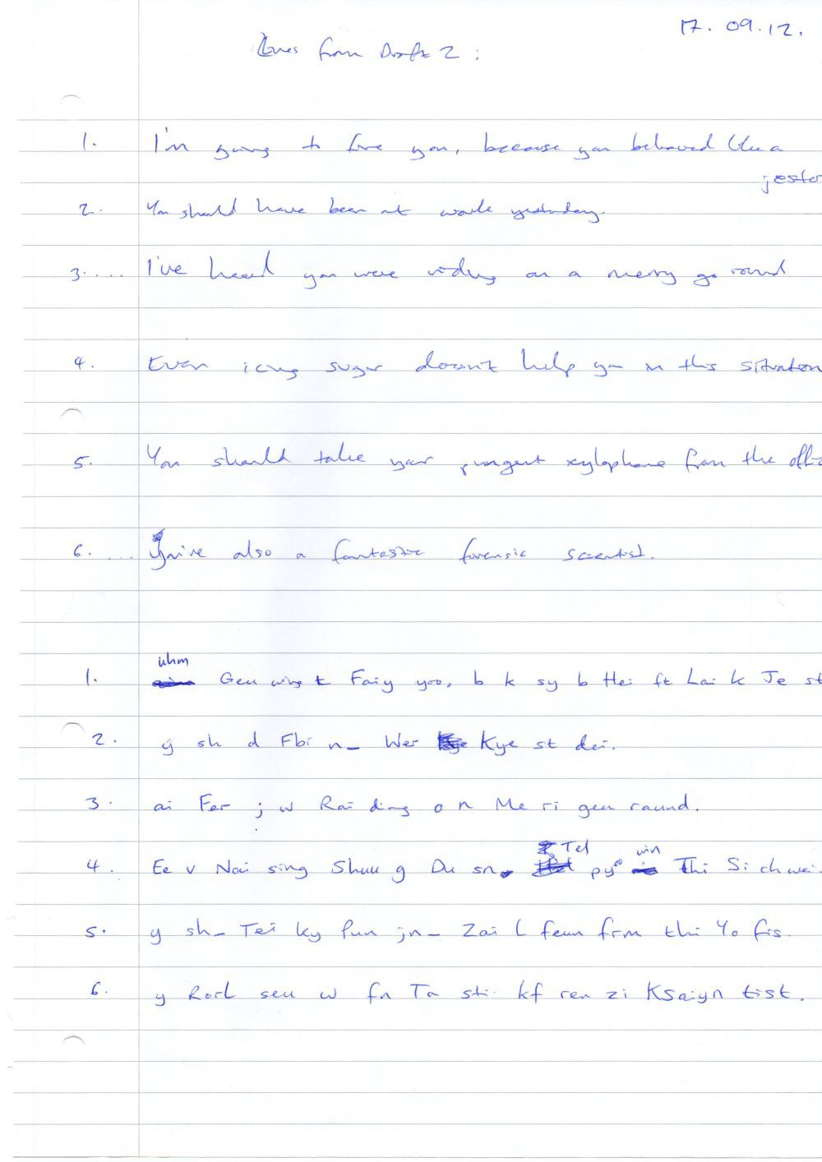

My initial notes during a class which led to the “Person, Problem, Reason, Resolution” (PPRR) activity; Olsztyn; September 2012; I had been looking for an easy way to build role plays, based on the idea that to make drama you need to have a problem; each person connected with the topic (in this case “Music”) could have a problem, which then gets resolved – either in a positive or negative way; what is missing is the column after “problem” which shows the reason – why the problem is a problem. This would be added later
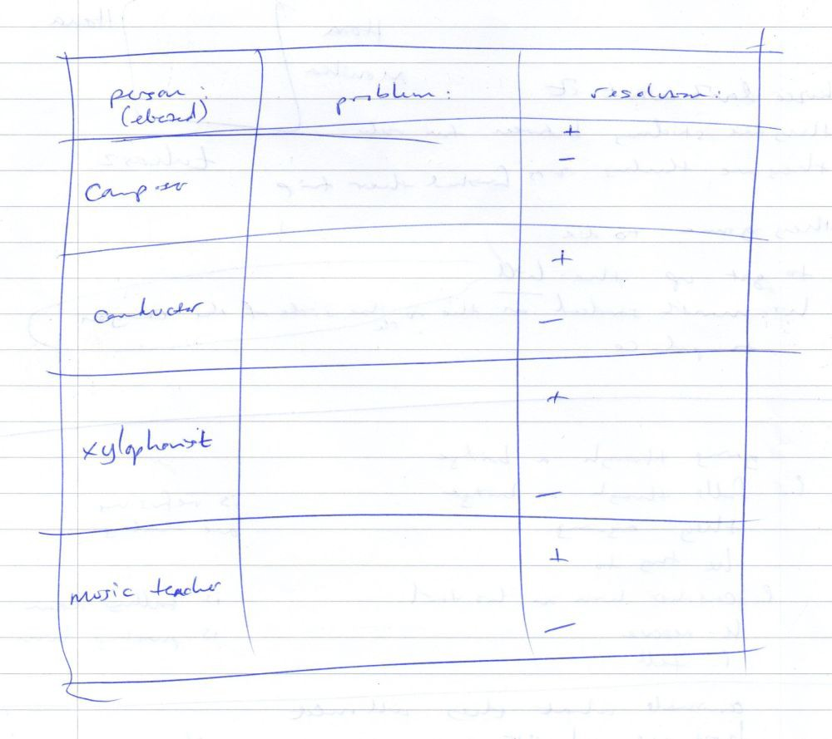

Notes on forward consonant linking (FCL) in cc sound connections; September 2012

15 Voiced Consonant Sounds: 10 Unvoiced Consonant Sounds:

b | > p | Globe theatre, pub food, rib tickler, club night
d | > t | head boy, bird bath, cloud nine, find something
g | > k | big picture, flag day, dog days, pig pen
j | > ch | large piece, page ten, cage fight, wage packet, fridge magnet
th | > tt | Smooth Radio, breathe quickly, loathe rap, with you (finishing a syllable with th is not that common)
v | > f | five people, they've gone, live concert, above you
z | > s | his pen, cheese board, peas, which, business
zz | > sh | beige jumper (zz is a rare sound)

friendly consonant sounds - do not move forward; the tongue can rest on these sounds before starting the next syllable
m n ng

l moves forward as l

r h
w hh
y
r, w, and y are often used in vowel clusters
no syllables in English end with these sounds, so you won't see them at the end of a syllable in Clear Alphabet

topic: assimilation in FCL for cc sound connections
final consonant sounds change from voiced to unvoiced when linking occurs in cc sound connections. Why? It makes the linking smoother - less noticeable
If the next sound is a vowel sound, assimilation does not occur, just FCL, e.g. bad apple = Ba Da pl check list of one-syllable content words!
try it with any word, followed by "which", e.g. globe, which = Gleu, pwich

Planning notes for a Mode 2 lesson on the topic of “Harvest Festival”; 02.10.12. [Note: Picture awaiting copyright clearance.]
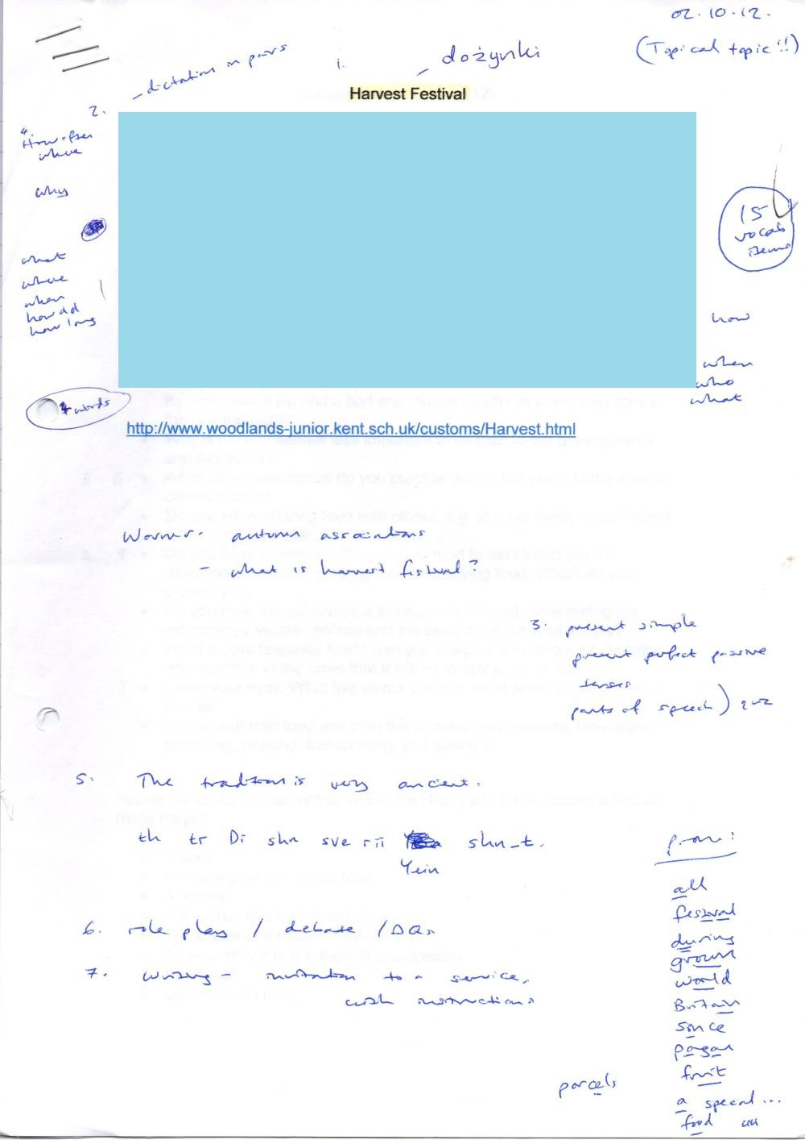

Discussion words template for 20 vocabulary words; 15.10.12; I created this template in case I needed to make a set of 20 discussion words instead of the usual 40
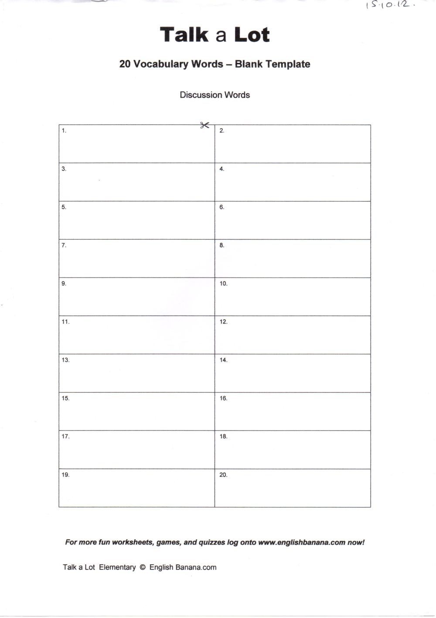

How we make french fries

plant | seed potatoes
harvest | the potatoes
sort | them into different sizes
send | to processing plant
wash | them thoroughly
remove | dirt and rocks
take off | the skin
peel | them carefully
cut | them into thin strips
add | chemicals to stop the colour changing
dry | the strips of potato
fry | the strips for 45-60 seconds
freeze | them to keep them fresh
send | them to branches of McDonalds
fry | them in vegetable oil a second time
serve | them to customers in small paper bags

Part 5 – Supporting Documents

The original running order of Mode 3 activities; 29.10.12
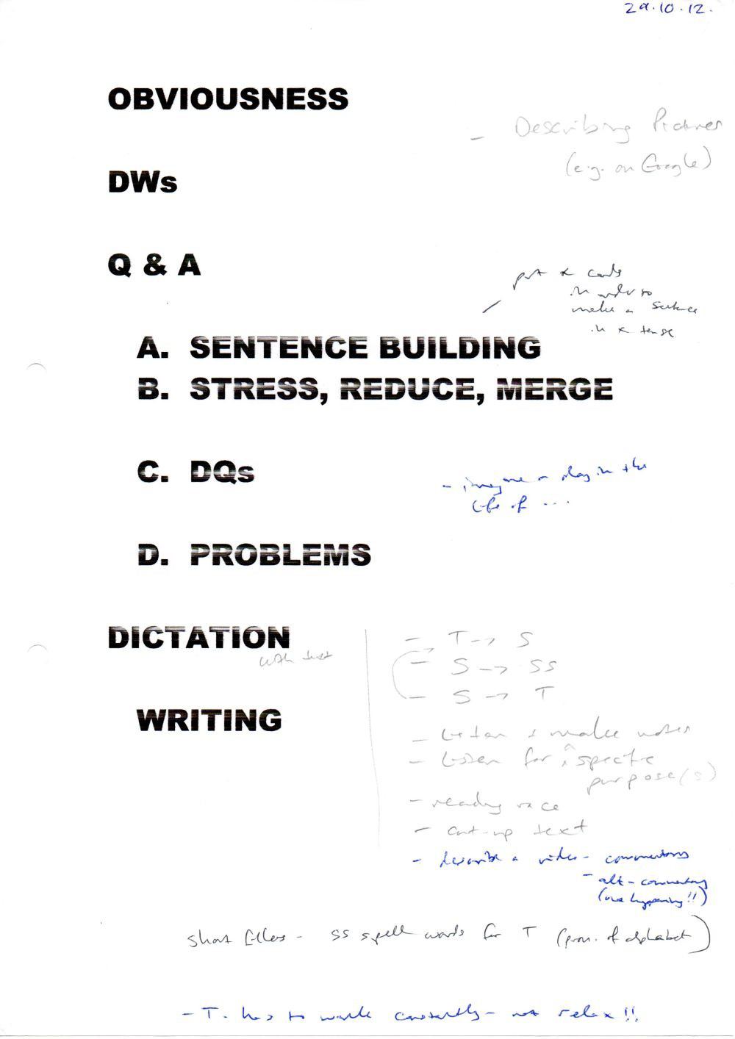

Updated running order of Mode 3 activities (09.11.12), which is still hanging on the wall of my classroom

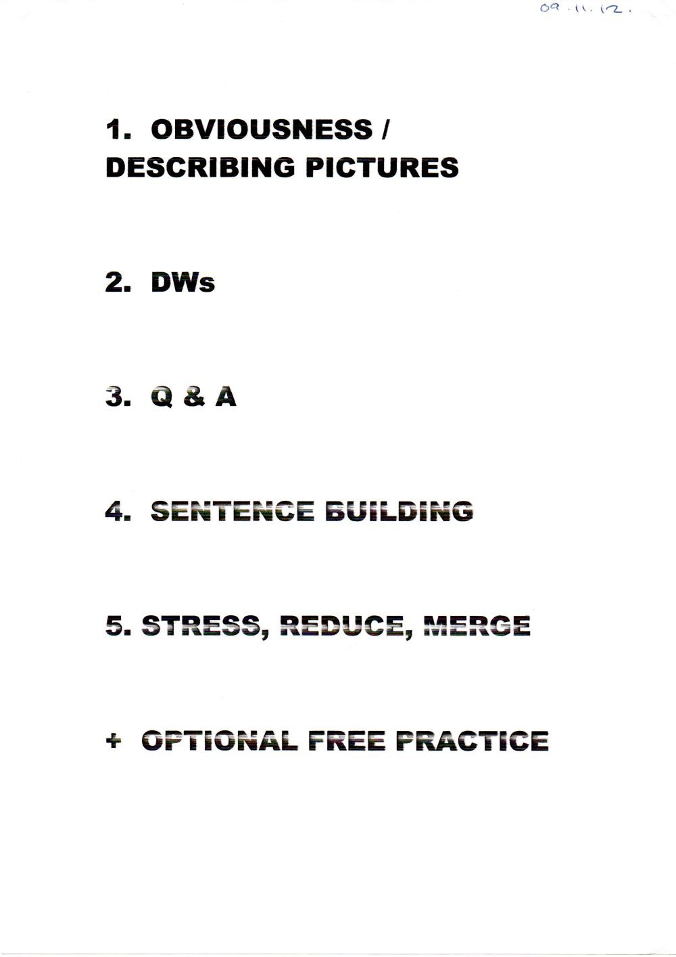

Board plan of a PPRR session with Emilia on the topic of “Health”; 02.11.12

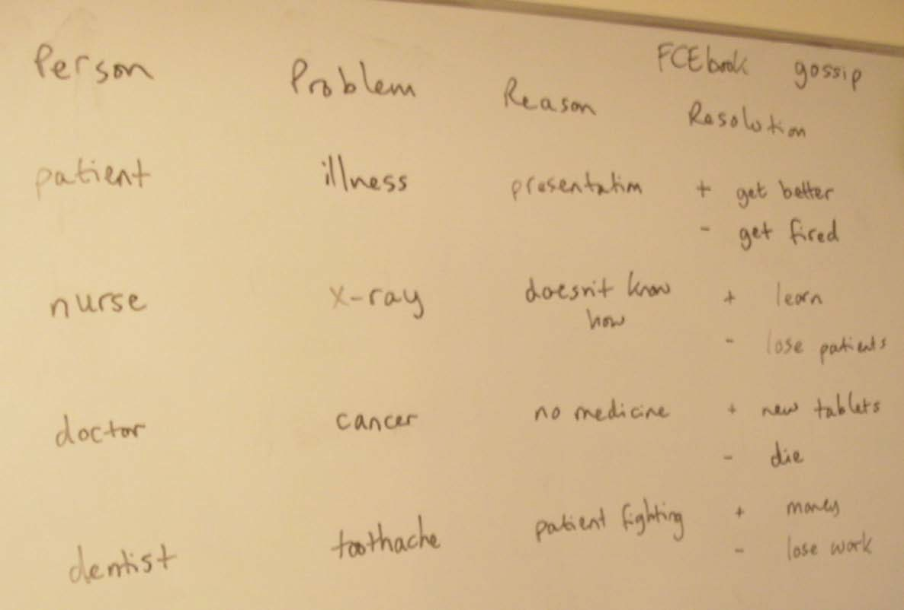

You Are The Course Book 2 – In Practice

General Template:
Person Problem Reason why it's a Problem Result - positive & negative

Cars 1 - An Accident Report
Accident Time Place Parties Involved Cause Fault Injuries/Fatalities

Cars 2 - Selling Your Car
Car Make Model Colour Year Price Mileage

The Human Body 1 - Make a Monster (21.11.12)
Monster Head Body Strengths Weaknesses Name Age

The Human Body 2 - Plastic Surgery
Person Part to Change Reason Price Procedure What Friends & Family Think Result

The Human Body 3 - Identity Parade
Person Gender Age Height Weight Face Body

Match parts of the body to functions (verbs), e.g. heart - beat, pump blood, eyes - see, lips - kiss, hands - touch, etc. Put body parts into groups according to how many of them we have
Describe a person and your partner draws it blindfolded, then reveals the result

The Environment 1 - What are the Problems?
Problem Cause(s) Solution(s) Barrier(s) Most Likely Outcome(s)

Topic Template

speaking and listening/fluency: writing:
role play dialogue
monologue short story
short story newspaper report/article
report
project, e.g. video it info exchange

Damage | Penalty | What Now?
Selling Points | Downsides | Result
Home | Job | Past | Present | Future | etc.
Recommend it?
Clothes | Distinguishing Features | Guilty?

Group/Individual:
Progress Tracker

Level:

Teacher:

Date: | Time: | Lesson Content: | Homework:
 |  | Topic: Tense(s): 1 2 3 4 5 Other:
 |  | Topic: Tense(s): 1 2 3 4 5 Other:
 |  | Topic: Tense(s): 1 2 3 4 5 Other:
 |  | Topic: Tense(s): 1 2 3 4 5 Other:
 |  | Topic: Tense(s): 1 2 3 4 5 Other:
 |  | Topic: Tense(s): 1 2 3 4 5 Other:
 |  | Topic: Tense(s): 1 2 3 4 5 Other:
 |  | Topic: Tense(s): 1 2 3 4 5 Other:
 |  | Topic: Tense(s): 1 2 3 4 5 Other:
 |  | Topic: Tense(s): 1 2 3 4 5 Other:
 |  | Topic: Tense(s): 1 2 3 4 5 Other:
 |  | Topic: Tense(s): 1 2 3 4 5 Other:

Core Activities: 1. Obviousness / Describing Pictures 2. DWs 3. Q & A 4. Sentence Building 5. Stress, Reduce, Merge Optional Free Practice Activities:
a) Role Play (Problems) b) Short Stories (Problems) c) A Day in the Life of... d) Discussion Questions e) Debate f) Text Activities g) Dictation
- Video Commentary i) Topic Template

Progress Tracker for a free online course which used only Mode 3; November-December 2012

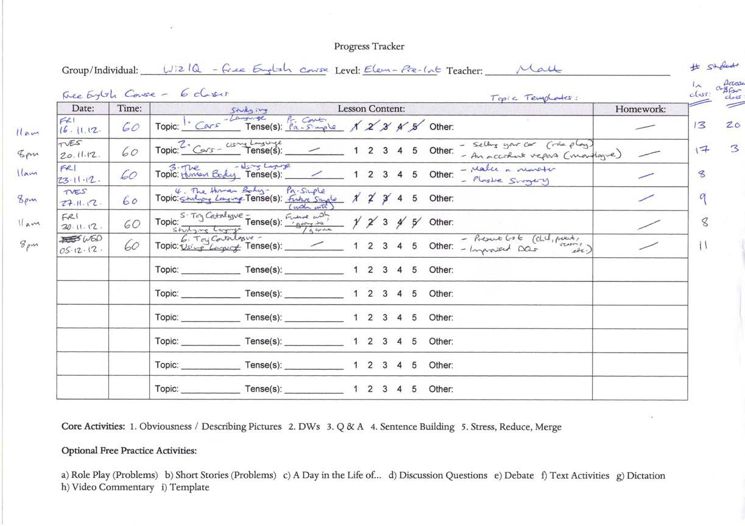

Feedback given by students after the first class of that free online course; 16.11.12

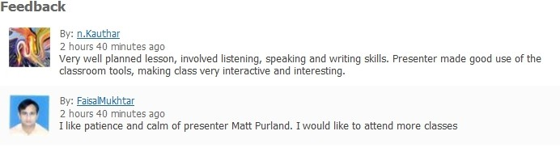

Progress Tracker for a free online course that I taught for an Egyptian company; November 2012-February 2013

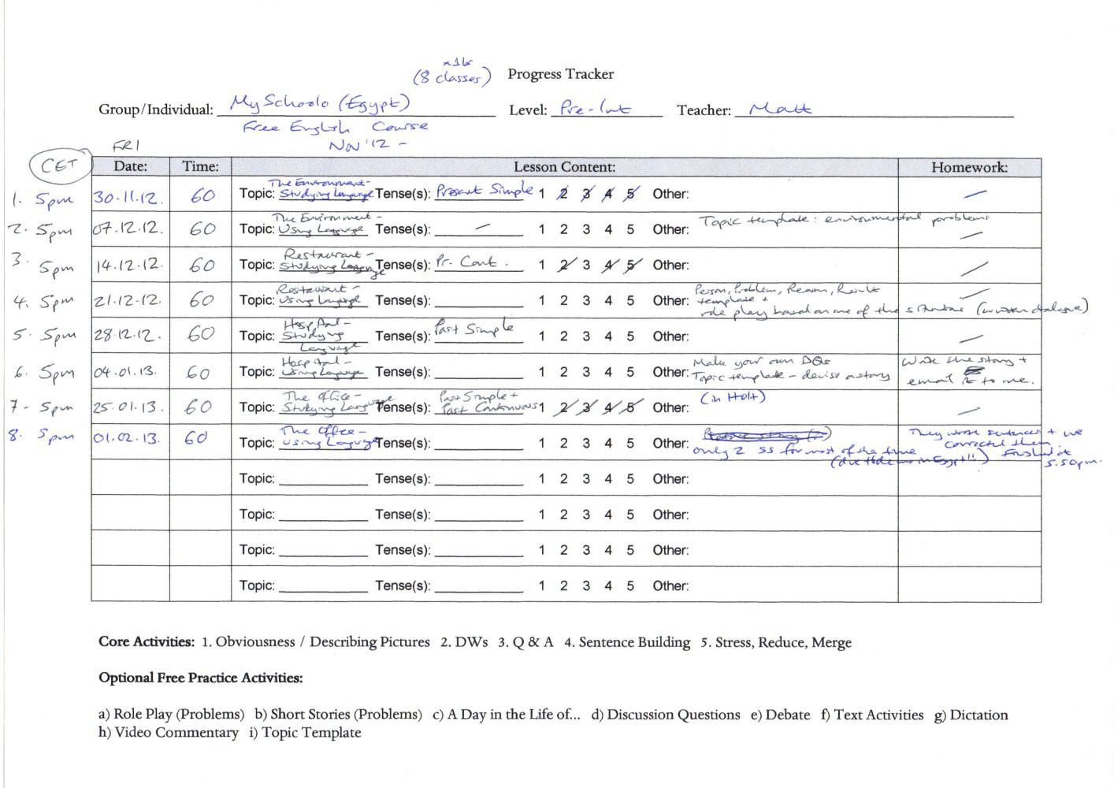

You Are The Course Book Main Principles:
  - My goal is to enjoy my job :)
  - No course book or pre-written material required
  - Students do most of the work
  - Students practice productive skills (speaking and writing) in the classroom with others, and receptive skills (reading and listening) at home on their own
  - Teacher talking time (TTT) is low – about 20%
  - Mode 1 – students produce the text to work with
  - Mode 2 – a real text is provided for students to work with
  - Students have to use their imaginations
  - Pair work and group work, but individual quiet time is low
  - Results: most students like this way of working
  - It allows the teacher to be creative and learn, as well as the students
  - You don’t have to sell the concept (e.g. the world’s fastest car), culture (e.g. white European), or ideology (western; materialist) of the course book spread; you adapt the lesson to suit the needs of your students; use the vocab words how they relate to your students in your context; if you want pictures, you choose them to suit your needs, rather than using what’s in the course book – which may be unsuitable
  - The lesson will be different each time; the teacher doesn’t know what will happen; there will be surprises and fun! It isn’t boring!
  - Form and content: teacher and students practise improvisation within a given structure; repetition provides feeling of security and reinforces learning

You Are The Course Book Mode 3
- Obviousness

- Discussion Words

- Q & A

- Sentence Building

- Stress, Reduce, Merge

- Free Practice, e.g. Topic Template, Discussion, Role Play, Debate

You Are The Course Book How is Mode 3 Different?
  - Quicker pace – get through all of the Studying Language activities in 1 x 90 min class rather than 2
  - Flows well – each activity leads into the next in a logical sequence
  - More variety
  - Input = discussion words from Talk a Lot series – or use your own vocab list, or elicit vocab from students
  - Students learn a lot of new vocabulary in each lesson – up to 40 new words/phrases
  - Second lesson is almost all free practice time
  - Students don’t have to write a long text
  - There is no real text to find or prepare – simply walk into the classroom and teach
  - The activities stay the same but the topic changes after two x 90 min classes
  - Works very well with beginners
  - Focus on different tenses in each group of two classes

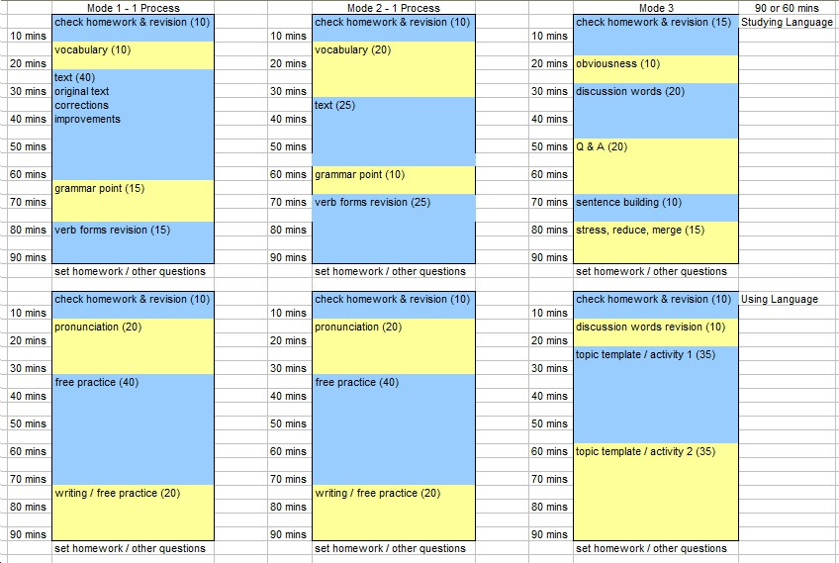

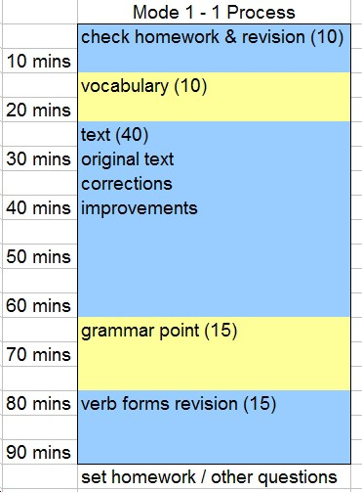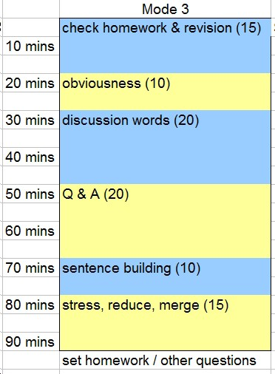

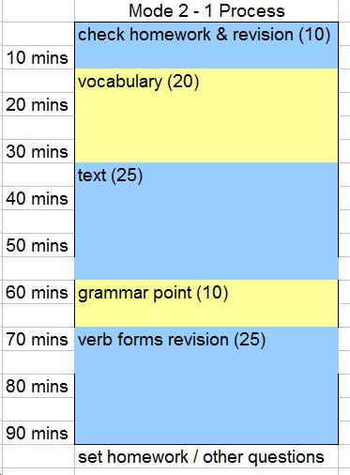

You Are The Course Book

Example of an Online Course Using Only Mode 3

- 1.Cars (Studying Language) | 60 mins | Present Continuous & Past Simple
- 2.Cars (Using Language) | 60 mins | Selling your Car; An Accident Report
- 3.The Human Body (Using Language) | 60 mins | Make a Monster; Plastic Surgery
- 4.The Human Body (Studying Language) | 60 mins | Past Simple & Future Simple
- 5.Toy Catalogue (Studying Language) | 60 mins | Future with “Going to” / “gonna”
- 6.Toy Catalogue (Using Language) | 60 mins | Present List; Improvised Discussion Qs

You Are The Course Book Feedback:

“Very well planned lesson, involved listening, speaking and writing skills. Presenter made good use of the classroom tools, making class very interactive and interesting.” ﺿﯾﺎء Dhiya

“I like patience and calm of presenter Matt Purland. I would like to attend more classes.”
Faisal Mukhtar

“It was funny and challenging to be a policeman reporting a car accident! have never done it before
=)...useful for developing my speaking skills and my teaching skills as well.” Nadia

“This class really proves that such method is really successful to engage the students without a course book.” Tammy Taiba

“Very nice way to encourage students to participate in class.” Lea Angeles

You Are The Course Book Challenges for Mode 3
  - Is it enough? Is it??
  - How to integrate it with other Modes, as well as Input Sessions, e.g. Clear Alphabet, Focus on Connected Speech, etc.
  - Does it suit all kinds of learners? What about those who prefer traditional methods? How can they be persuaded?
  - No more course books to write!

You Are The Course Book Example of a Syllabus with all 3 Modes

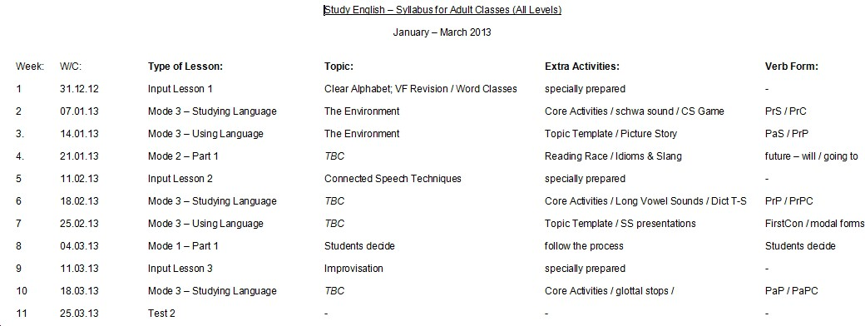

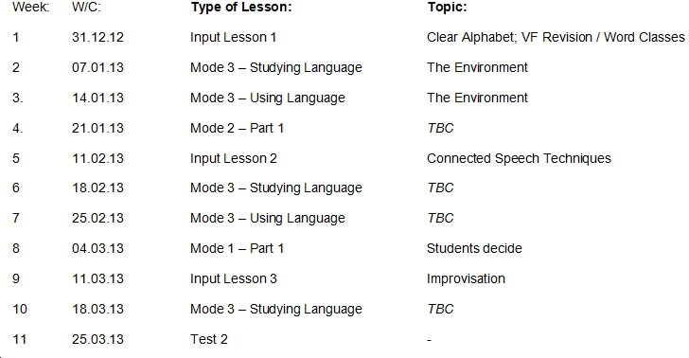
You Are The Course Book Example of a Syllabus with all 3 Modes

You Are The Course Book Example of a Syllabus with all 3 Modes
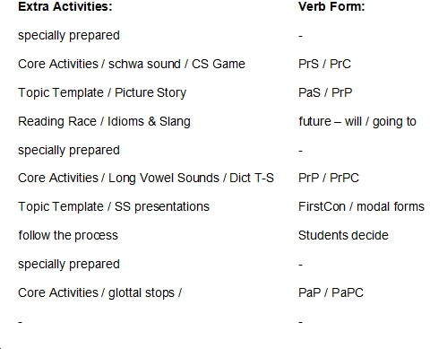

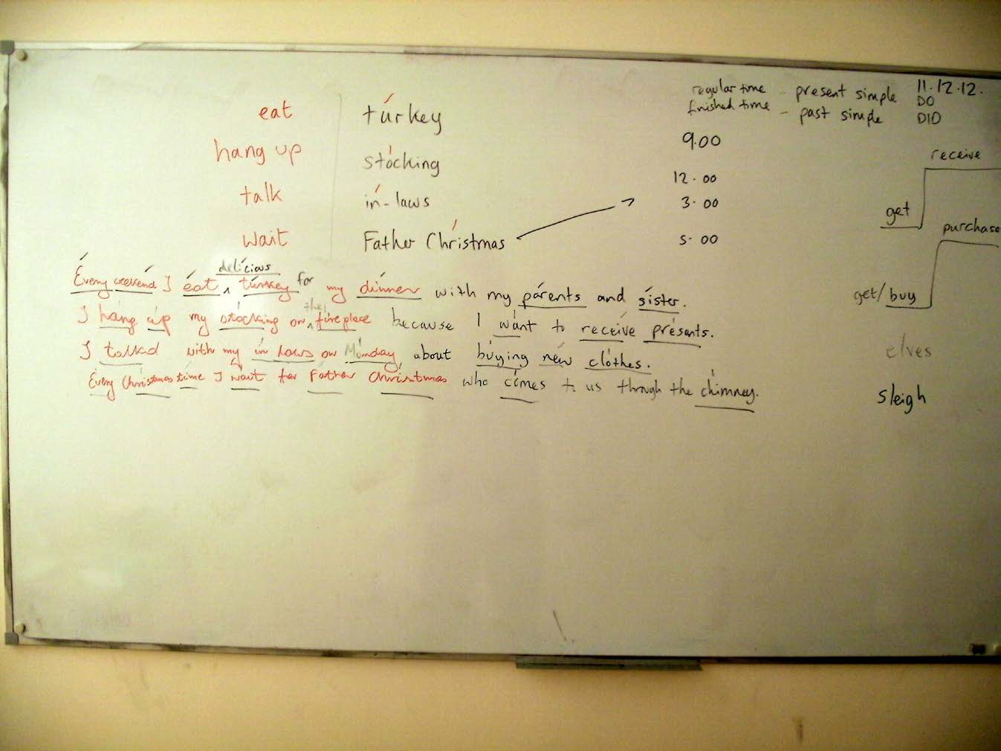

You Are The Course Book

Example of a Board Plan with Mode 3 (B1 Pre-Int Level) – 11.12.12 Individual student (one to one class)

333344

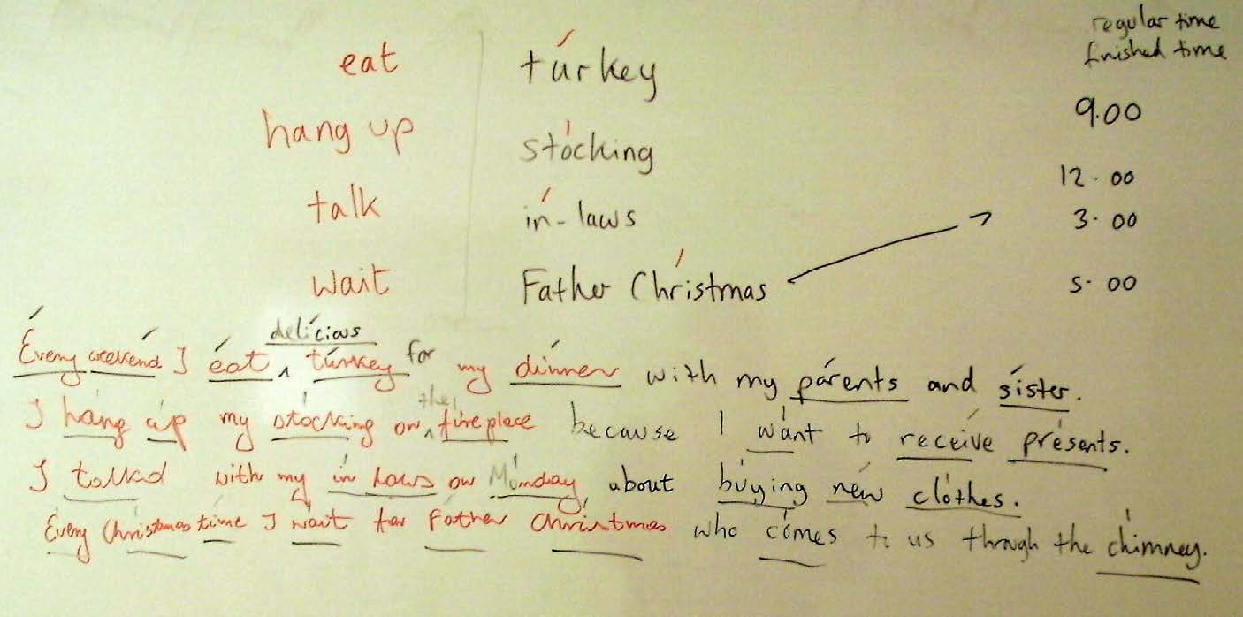

333355

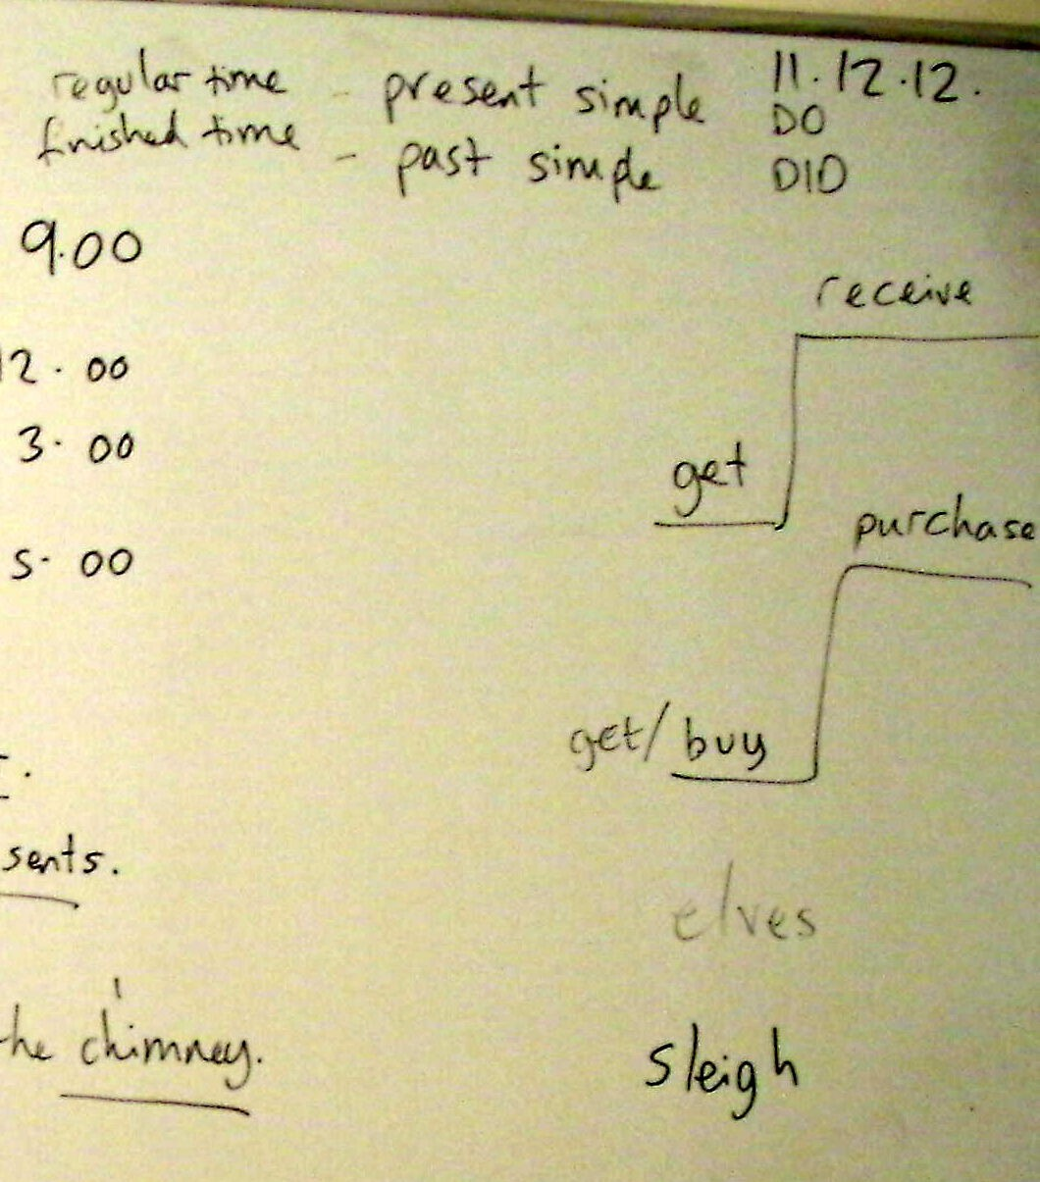

333366

A Standard 90-Minute Lesson for Elementary and Pre-Intermediate with New Method [Mode 3] (21.11.12)

At all times correct students’ spoken errors immediately when they make them. Part 1 – Studying Language
5.00pm – Check Homework
Welcome; chat; checking homework; answering questions

5.15pm – Obviousness
State topic. What is it? Tell me about... What does x mean? Why? etc.

Type of Activity: | productive
Main Skill(s) Practised: | speaking, listening, fluency, pronunciation
Teacher’s Role: | active; push-pull; stimulate production
TTT: | 20%

5.25pm – Discussion Words
Give the discussion words. 40 vocabulary words.
Put the cards into two groups – words you know and words you don’t know. Say the words you know in English and in Polish.
Take away the words that they know (usually about half or two-thirds). Write down the new words.
I say/try to elicit the meanings of the new words. Put the words into alphabetical order.
Say the words out loud – check pronunciation.
Put the words into groups according to how many syllables they have. Mark the stressed syllable on each word.
Elicit the stressed vowel sound in each word.
Put the words into groups according to stressed vowel sound.

Type of Activity: | receptive; input of new language; productive
Main Skill(s) Practised: | vocabulary, pronunciation
Teacher’s Role: | back seat; find out what SS know already
TTT: | 20%

5.45pm – Q&A
Choose four words that you like. Tell me what they are. I write them on the board. Can you think of a verb that goes before each word? I select the best one.
Choose a tense for today’s lesson. Today we’re going to look at present continuous and present perfect.
What is the time in each tense? What is the auxiliary verb?
I make a sentence using a phrase and one of the tenses. I ask the students questions, e.g. “I’m brushing my teeth at the moment. What am I doing?” “Brushing your teeth.” “Am I brushing my teeth?” “Yes, you are.” “Am I eating a sandwich?” “No, you aren’t.” etc.
Continue with all four phrases, using one or both of the tenses. Discussion of usage of the tenses may ensue.

Type of Activity: | productive
Main Skill(s) Practised: | grammar, tenses, speaking, listening, pronunciation, fluency
Teacher’s Role: | active; push-pull; stimulate production
TTT: | 40%

6.05pm – Sentence Building
OK, please choose another four words that you like.
I write them on the board. A student comes to the board. Please write a sentence using this word and one of the two tenses. Each student (or four students from the group) write on the board and then sit down.
OK, can you see any errors in these sentences? Elicit the corrections.
How can we improve these sentences? Can we make them longer? Can we use more advanced vocabulary? Elicit improvements. Discuss grammar points naturally as they arise.

Type of Activity: | productive
Main Skill(s) Practised: | writing, grammar, sentence building, tenses, fluency, error correction
Teacher’s Role: | back seat; let SS make mistakes, then SS correct them, then SS improve their  sentences
TTT: | 10%

6.15pm – Stress, Reduce, Merge
Can you tell me which words in the sentence are content words? I underline them (or the student does).
Where is the stressed syllable in each content word? We mark them. Find the stressed vowel sounds. This is the sound spine.
Look at the weak syllables. How can we make them shorter? Elicit ways, e.g. a contraction. Say the sentences out loud. Let’s hear the stressed syllables loud and clear and the weak syllables low and merged together.
If time, and there is a good example, we could look at part of a sentence with Clear Alphabet to examine how the syllables merge together, e.g. “I have been to work” becomes uh Fbin t Werk.

Type of Activity: | productive
Main Skill(s) Practised: | pronunciation, speaking, listening
Teacher’s Role: | back seat; let SS make mistakes, then SS correct them; introduce elements of  connected speech and encourage use of Clear Alphabet
TTT: | 20%

  - pm – Set Homework for Next Time
Set homework for next time; say goodbye!

Observations:

    - Too much time wasted at the beginning of the class – a slow start, due to homework checking
    - Too much emphasis on vocabulary and word stress (?)
    - Not enough time for Stress, Reduce, Merge
    - We always run out of time...!

Part 2 – Using Language

5.00pm – Check Homework
Welcome; chat; checking homework; answering questions

5.15pm – First Template Task
(varies by topic – see pp.316-317 for example)

A Standard 60-Minute Lesson for Beginners with New Method (21.11.12)

At all times correct students’ spoken errors immediately when they make them. Studying Language & Using Language
10.30am – Check Homework
Welcome; chat; checking homework; answering questions

10.35pm – Short Discussion
State topic. Elicit – what is it? Tell me about... What does x mean? Why? etc. Try to elicit the vocab words – find out how much students know. If possible combine with Q&A – “Is it...?” “Yes, it is.” etc.

10.40am – Discussion Words
Give the discussion words. 40 vocabulary words.
Put the cards into two groups – words you know and words you don’t know. Say the words you know in English and in Polish.
Take away the words that they know (usually about half). Write down the new words.
I say/try to elicit the meanings of the new words. Put the words into alphabetical order.
Say the words out loud – check pronunciation.
Put the words into groups according to how many syllables they have. Mark the stressed syllable on each word.
Elicit the stressed vowel sound in each word.
Put the words into groups according to stressed vowel sound.

11.00am – Template Task
Start the template task which needs the students to use language, including the target keywords. Varies with each task, e.g. for human body it involved drawing and talking about a monster – describing the different body parts it has. [See pp.316-317.]

11.20am – Sentence Building
I extract a simple grammar point and the students have to produce sentences based on this,
e.g. for the monster task the structure was: “He has got” / “He’s got”. This can combine with Q&A too, e.g. “Has he got?” “Yes, he has.” etc. We could look at connected speech too if an opportunity presents itself, e.g. “He has got” can change to i Sgo_

  - am – Set Homework for Next Time
Set homework for next time; say goodbye!

Observations:

    - It works really well! It’s great with low-level learners, e.g. low elementary; also great with unconfident learners
    - Again, we still always run out of time...!
    - The time passes really quickly – “Happy people don’t count the hours...!” 60 minutes is soon over – it feels more like 5 minutes.
    - Everything is included, but in a less formal, more spontaneous way.

Board plan from a Mode 3 Studying Language lesson with Emilia on the topic of “Toy Catalogue”; 01.12.12

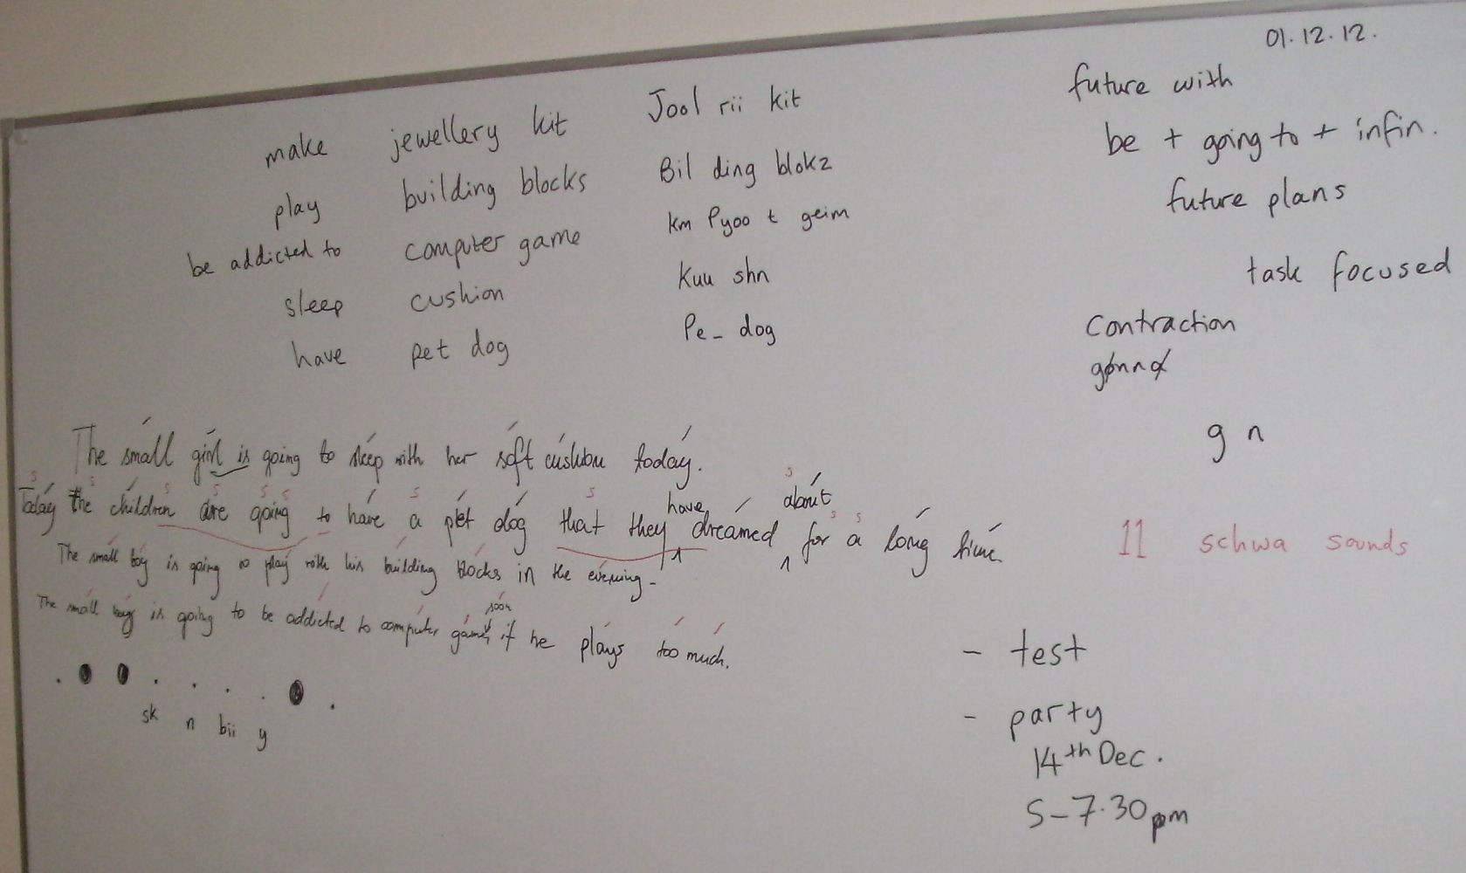

Board plan from a Mode 3 Studying Language lesson with Dorota on the topic of “Toy Catalogue”; 04.12.12; this was Dorota’s first lesson at our school
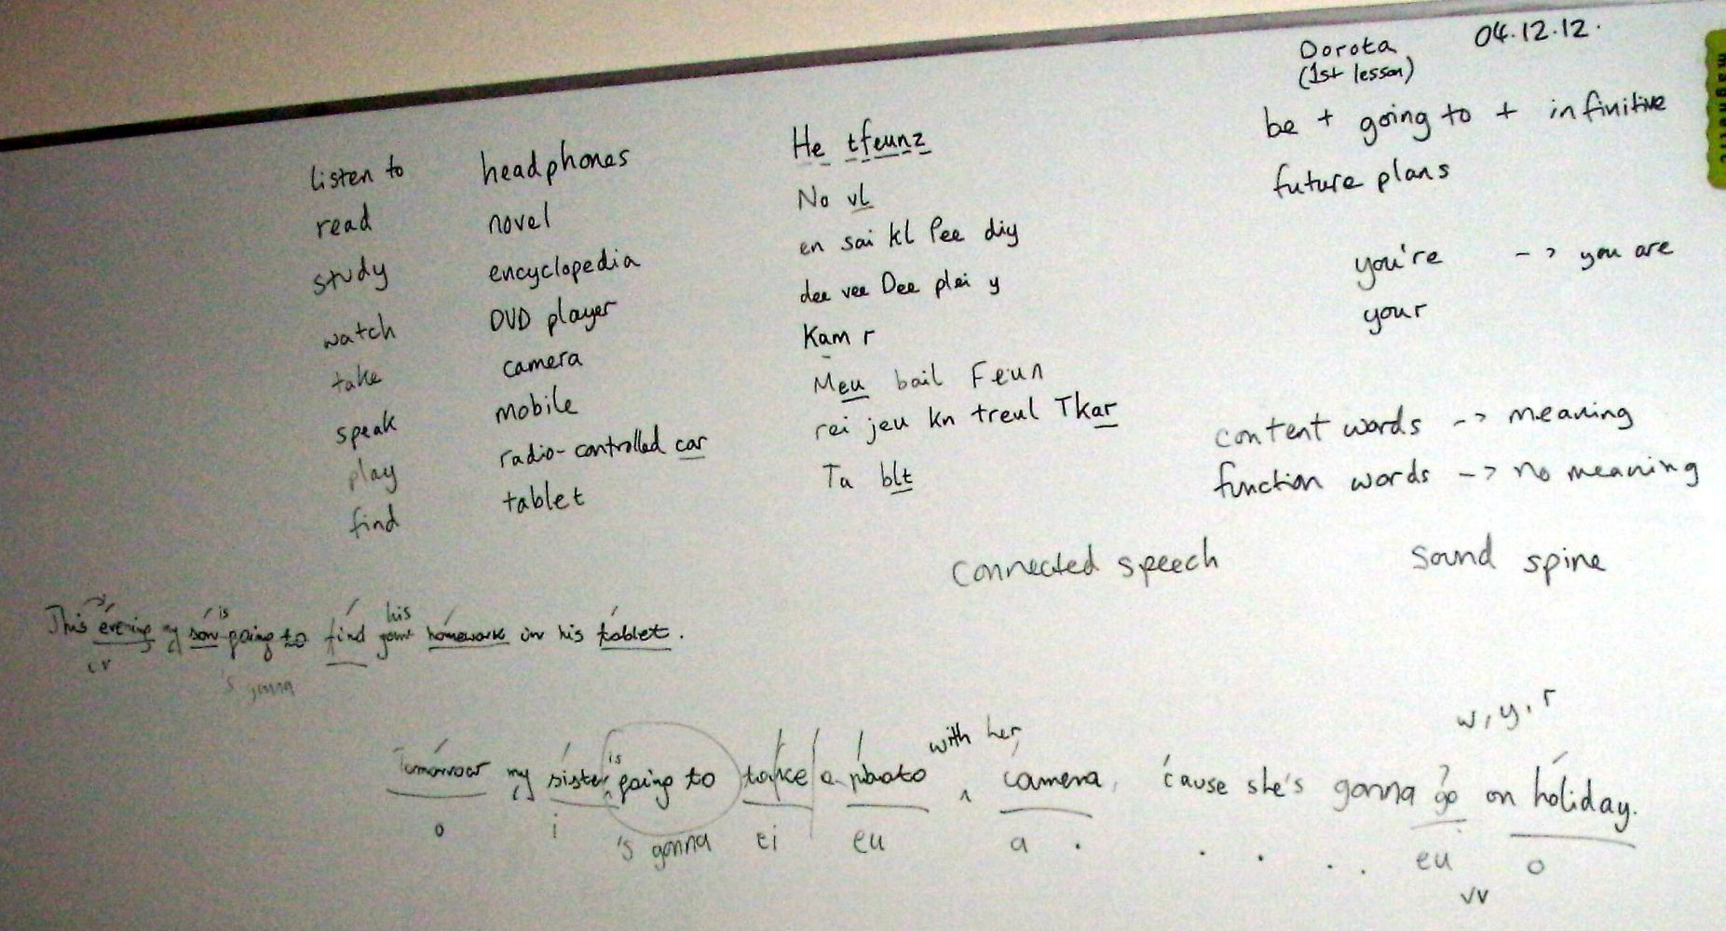

New Talk a Lot Idea Book – Elementary Book 1

    - introduction – not a course book, but an idea/inspiration/example book
    - elementary to pre-intermediate level
- 10 new units – with 10 new topics
- notes for using each activity
- tests

Part 1: Studying Language

- Obviousness

  - 1 page – written example of a dialogue (?)

- Discussion Words

  - 40 word cards (as usual)
  - 1 page – the words with stressed syllables and stressed vowel sounds; the words in Clear Alphabet spellings; the words grouped into various categories

- Q & A

  - 2 verb forms per unit
  - 10 sample collocations
  - 5 jumping-off points for each verb form, with examples

- Sentence Building

  - 5 example basic sentences (wrong), then corrected, then improved (examples)

- Stress, Reduce, Merge

  - the same 5 improved sentences with SRM (?); examples of features to point out
  - using the SRM template page?

Part 2: Using Language

- Topic Templates

  - Headings x 4 with examples

- Discussion Questions

  - List of DQs with the template list [p.370] – examples

- Debate / Agree or Disagree

  - Contentious sentences for debate or agree/disagree – examples

[See next page for a draft of a proposed first unit based on the topic of Toy Catalogue.]

Obviousness

Improvised discussion, with the teacher asking “obvious” questions, like:

  - What is...?
  - What does ... mean?
  - Why?
  - For what?
  - So what?
  - So...

Discussion Words

40 Discussion Words:

action figure A kshn fi g
air hockey Eir ho kii
alarm clock uh Larm klok
board game Bor tgeim
building blocks Bil ding bloks
calendar Ka ln d
camera Kam r
catalogue Ka t log
colouring pencils Ku l ring pen slz
computer game km Pyoo t geim
cushion Kuu shn
doll Dol
DVD player dii vii Dee plei y
educational toy e j Kei sh nl Toy
encyclopedia uhn sai kl Pee diy
games console Geim skon seul
headphones He tfeunz
jewellery kit Jool rii kit
keyboard Kee bord
kitchen set Ki chn set
microphone Mai kr feun
mobile Meu bail
modelling clay Mo d ling klei
musical toy Myoo s kl toy
novel No vl
pen drive Pen draiv
pet dog pe_ Dog
picture book Pi kch buuk
pinball machine Pim borl m sheen

pool table Pool tei bl
puzzle Pu zl
radio-controlled car Rei jeu kn treul Tkar
rocking horse Ro king hors
sledge Slej
soft toy so Ftoy
tablet Ta blt
teddy bear Te dii beir
toy car toy Kar
train set Trein set
truck Truk

- You have 500 zł to spend. What would you buy and for whom and why?
- Group: toys for boys / girls / both
- Look through catalogue and write page no. of each item on its card

Q & A

Discuss the two tenses for the lesson. Past simple usage:
Finished actions in the past; yesterday; last; ago; auxiliary verb is DID

Future with will usage:

Spontaneous actions in the future; tomorrow; next; soon; later; auxiliary verb is WILL

Choose 4 words; think of a verb that goes with each one; build a sentence and then do Q & A, like improvised sentence block building, e.g.

20 Collocations:

infinitive verb: noun: past simple (2nd) form: future with will form:
(phrasal verb) (irregular; regular; regular -ed)

collect action figure collected will collect / ’ll collect set alarm clock set will set / ’ll set create building blocks created will create / ’ll create use camera used will use / ’ll use
break colouring pencils broke will break / ’ll break
lie on cushion lay on will lie on / ’ll lie on
switch on DVD player switched on will switch on / ’ll switch on read encyclopedia read will read / ’ll read
put on headphones put on will put on / ’ll put on carry keyboard carried on will carry on / ’ll carry on hold microphone held will hold / ’ll hold
play with modelling clay played with will play with / ’ll play with enjoy novel enjoyed will enjoy / ’ll enjoy

feed | pet dog | fed | will feed / ’ll feed
receive | pinball machine | received | will receive / ’ll receive
do | puzzle | did | will do / ’ll do
sit on | rocking horse | sat on | will sit on / ’ll sit on
cuddle | soft toy | cuddled | will cuddle / ’ll cuddle
talk to | teddy bear | talked to | will talk to / ’ll talk to
put together | train set | put together | will put together / ’ll put together

Sentence Building

Write a sentence using a collocation and a verb form, e.g. ...

Correct it, e.g. ...

As you do this, discuss the relevant grammar points and practise them if necessary.

Improve it. As you do this, discuss techniques for better writing, e.g. use of conjunctions and relative clauses to make it longer; use of adjectives; use of richer vocabulary to replace basic words.

Here is the finished example sentence: ...

Stress, Reduce, Merge

Use the sentence you’ve written, or create a new one. Follow the Stress, Reduce, Merge process, e.g. ...

Free Practice

General role play/story:

Person: | Problem: | Reason: | Result (+) | Result (-)
e.g.

Present-giving task:

Child: | Age: | Relation to You: | Present: | Price: | Reason: | How Long Wanted: | Behaviour: | Gift Giver:
e.g.

Present workshop task:

Present: | For which Child: | Head Elf: | How Long to Make: | How Difficult to Make: | Difficulties: | Date when Ready:
e.g.

Other activities:

Find items in the catalogue...
DQs based on template questions...
Agree or Disagree / debate contentious statements...

Activities:

speaking and listening/fluency: writing:
role play dialogue
monologue short story
short story newspaper report/article, etc. report
project, e.g. video it info exchange

You Are The Course Book – Mode 3: Self-Study Quiz

Level: B1 – Pre-Intermediate
Topic: Restaurant
Tenses: Present Simple & Present Continuous 25 vocabulary words:
restaurant |  | knife |  | menu
table |  | tip |  | customer
dining room |  | waitress |  | fork
glass |  | starter |  | chef
kitchen |  | chair |  | dessert
waiter |  | dish |  | meal
drink |  | wine list |  | bowl
spoon |  | course
plate |  | bill

Discussion Words

- Translate the 25 vocabulary words into your language.

- Write the words in alphabetical order. Look up any new words in your dictionary and write them in your vocabulary notebook.

- Match these words with their descriptions:

table | a person who cooks my food
waiter | a piece of furniture with four legs where I sit
spoon | a deep dish that can contain soup or ice cream
starter | the list of items for sale in a restaurant
bill | something I hold in my hand and use to eat soup
menu | a person who takes my order and brings my food
chef | the first course of my meal
bowl | the list of items that I have to pay for

- Write the words and phrases in the table according to how many syllables they have:

waiter dish
dining room table
plate waitress dessert drink
customer spoon chair
tip
kitchen menu restaurant

One syllable: | Two syllables: | Three syllables:

- Underline the suffixes in these words and phrases:

restaurant dining room
kitchen waiter
waitress starter
customer dessert

- Underline the schwa sound(s) in each word:

waitress kitchen
dessert starter
customer waiter

- Add the words and phrases to the table to show their stressed vowel sounds:

table waiter kitchen
plate menu dish
knife wine list tip
bill chef
waitress

ai | ei | i | e

- Match the normal spelling with the Clear Alphabet spelling:

restaurant | Miyl
kitchen | Ku st m
plate | Re stront
starter | Naif
dessert | Star t
meal | Pleit
customer | Ki chn
knife | d Zert

Q & A

- Collocation – match the verbs and nouns:

give | table
clear | glass
order | bill
sit on | tip
read | chair
pour | dish
eat | menu
pay | meal

- a) What is the auxiliary verb in present simple?
b) What is the auxiliary verb in present continuous?

- a) What is the time in present simple?
b) What is the time in present continuous?

- Fill in the gaps in this short conversation:

I enjoy going to restaurants because I like different kinds of food.
Why a) you enjoy going to restaurants?
Because I b) different kinds of food.

Do c) cook?
enjoy going to restaurants d)
you can’t

No, I e) . I don’t enjoy going to restaurants because I can’t cook.

James is ordering tomato soup for his starter.
a) is ordering tomato soup for his starter?

James b) .
c) James ordering tomato soup for his main course? No, he d) . James isn’t ordering e) course.

- Choose the best question word to complete each question:

WHAT | are we leaving?
WHERE | is the bill?
WHEN | restaurant do you prefer?
WHO | isn’t Patrick ordering a dessert?
WHY | is the name of your favourite dish?
WHICH | your sister working at this restaurant?
HOW MUCH | shall we sit?
IS | is having beef for their main course?

Sentence Building

- Write each sentence in the correct order:

for his main

room big the very dining is clearing is waitress the the table hot the enough wasn’t starter a beans of the opening chef tin is

- Correct two spelling mistakes in each sentence.

We usually use a nife and fork to eat a meel. The win list is lying on the cabinet over their. The waitr is carrying four plats of food.
Unfortunately, I feel too ful to have a desert.

- Correct the word order error in each sentence.

The customer is right always. Where the dining room is? Menu is the very good. Do you a main course want?

- Make each short sentence longer by matching it with an extension:

I don’t like this restaurant | for my wife.
We’re sitting in the dining room | because the waiters are really slow.
The waitress is pouring a glass of wine | because the owner wants to play golf.
The restaurant is closing early | next to the cloakroom.

Stress, Reduce, Merge

- Read the four sentences below. Divide them into syllables (draw a line between each one).
- Underline the content words in each sentence.
- Mark the stressed syllables on the content words.

- Write the stressed vowel sounds – to get the sound spine. Say the sentences out loud.
- Mark schwa sounds and short i sounds in unstressed syllables.
- Mark any contractions – if possible.
- Mark the sound connections between the syllables: vc, cv, vv, or cc

- The bill comes to eighteen pounds and fifty nine pence without a tip.

- The new menu is full of delicious dishes.

- We are waiting for our drinks and talking about which main course to order.

- The waiter is coming to take away your plates.

- Write a), b), c), or d) to say which sentence these extracts in Clear Alphabet come from:

th Nyoo Men yoo
Sku ming t Tei k
Wei teen Paun tsn Fi ftii
Tor king uh Bau_ wi Chmein

Progress Test 1 (Sept-Dec 2012)
Topics included: Harvest Festival, Railway Station, Bonfire Night, Cars, The Human Body, Toy Catalogue

Name: Date:

- Write how many syllables each word has:
/ 8

timetable, discount, cancellation, commuter, carriage, return, underground, track

/
- Mark the stressed syllable in each word or phrase:

camera, encyclopedia, computer game, puzzle, catalogue, truck, teddy bear, headphones
/ 8

- Underline the schwa sound(s) in each word:

celebrate, festival, parents, important, tradition, favourite, garden, family
/ 8

- Write each word beneath the word with the same stressed vowel sound:

chin, leg, lung, lip, stomach, neck

head blood liver
/ 6

- Translate the Cars vocabulary words from the Clear Alphabet into normal spelling:
A ks dnt |  | Ba t rii
Drai v |  | Seet
Brei klait |  | Reu tsain
Pe dl |  | Par king ti kit

/ 8

- Write 5 things you could find...

  - at home b) in the park c) in a shop d) at a hospital e) on the train

- Write each word again with the correct spelling:
/ 8
/ 25

safetey
boonfire
firewark punisment
acident communitty baked potayto farefighter

- What is the auxiliary verb in:

  - present simple
  - present continuous
  - past simple
  - present perfect

- What time is it in:
/ 4

  - present simple
  - present continuous

- Write any sentence in:
- past simple
- present perfect
/ 4

  - present simple
  - present continuous
  - past simple
  - present perfect

- Complete the gaps in this conversation:
/ 8

I was late for work because I missed the train. Why a) late for work?
Because b) .
Were you late for work c) you woke up late?
No, I d) . I wasn’t late for work because e) late.

We’re going to a big party on Bonfire Night.
f) are you going on g) ? To h) .
i) going to a big party on Bonfire Night? Yes, j) .
/ 10

/
- Underline the content words and mark the stressed syllables in the following sentences:

  - My brother got an action figure for Christmas.

  - I looked in the catalogue to find out the price of the keyboard.

  - Sarah loves playing with her new colouring pencils.
/ 8

  - The DVD player didn’t work, so we took it back to the shop.
Total Language: / 105 Grade:

Speaking Part (10 mins; recorded):
/ 5

- Interview about yourself – past, present, future (verb forms)

- Obviousness (fluency)
/ 5

- Read the sentences in question 12 (pronunciation)
/ 5

- Short role play: imagine that... (improvisation)
/ 5
Total Spoken: / 20 Grade:

Name: Date:

Writing Part:
/ 10

- Write about what you did at the weekend:

- What Christmas presents are you going to buy?
/ 10

- Write about your family:
/ 10

335544 Total Written:
/ 30
Grade:

Record of Achievement

Name: Level:

Progress Test 1 (December 2012)

Part 1 – Studying Language  Score: / 105 | % | Grade (A-E):
Part 2 – Speaking  Score: / 20 | % | Grade (A-E):
Examples of errors:

Part 3 – Writing

Score:
/ 30
% Grade (A-E):

Signed: Date:

Teacher & Owner, Study English Language Centre, Ostróda

335555

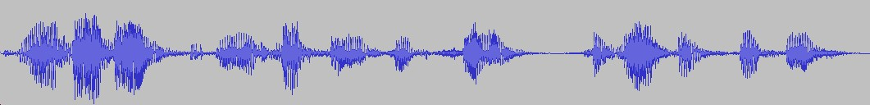My bro ther uh er got an a ction fi gure of Christ mas. 00.04
Foreign speaker (A1):

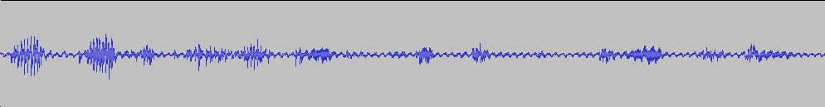00.02
Native speaker:
My
bro
ther
got an a
ction
fi
gure
for
Christ
mas.

mai Bru th Go t Na kshn Fi g f Kri sms. (5)

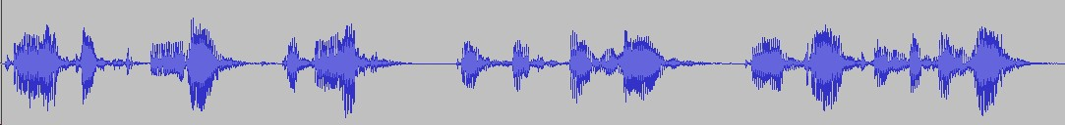00.06
Foreign speaker (A1):
I look ed
in the
ca ta logue
to
find
of
the
er
price of the key board.

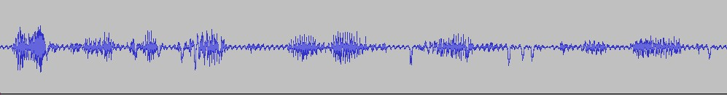00.03
Native speaker:
I looked
in the ca
ta logue
to
find
out
the
price
of the
key
board.

ai Luu ktin th Ka t lo kt Fain Dau_ th Prai s fth Kee bord. (6)

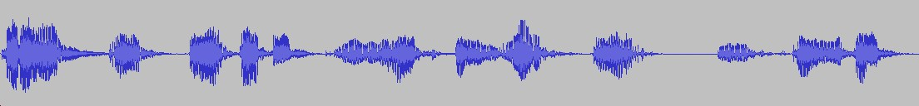00.08
Foreign speaker (A1):
Sarah loves
er
er paint ing
um
with
her
new
er
um
colouring pens.

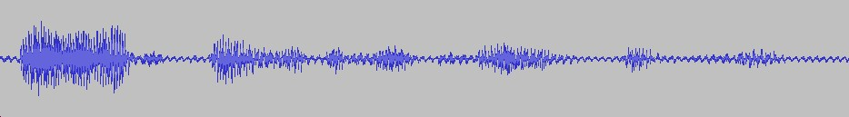00.02
Native speaker:
Sa rah loves
play
ing with her
new
colouring
pen
cils.

Seir r Lu Fsplei ying wi th Nyoo Ku l ring Pen slz. (6)

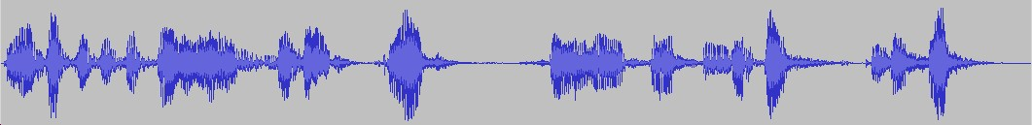00.07
Foreign speaker (A1):
er The D V D play er
didn’t
work
so we
dot in the back
to the shop.

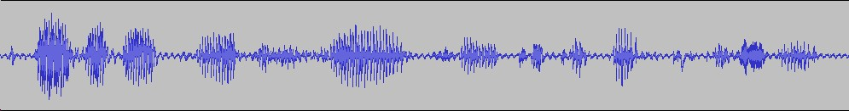00.03
Native speaker:
The D
V
D
player didn’t
wor
k so we took
it
ba
ck to the sho
p.

th Dee Vee Dee Plei y Din_ Wer ks wi Tuu ki_ Ba kt th Shop. (9)

Rough draft of the first Study English Language Centre syllabus for January-March 2013; 02.12.12

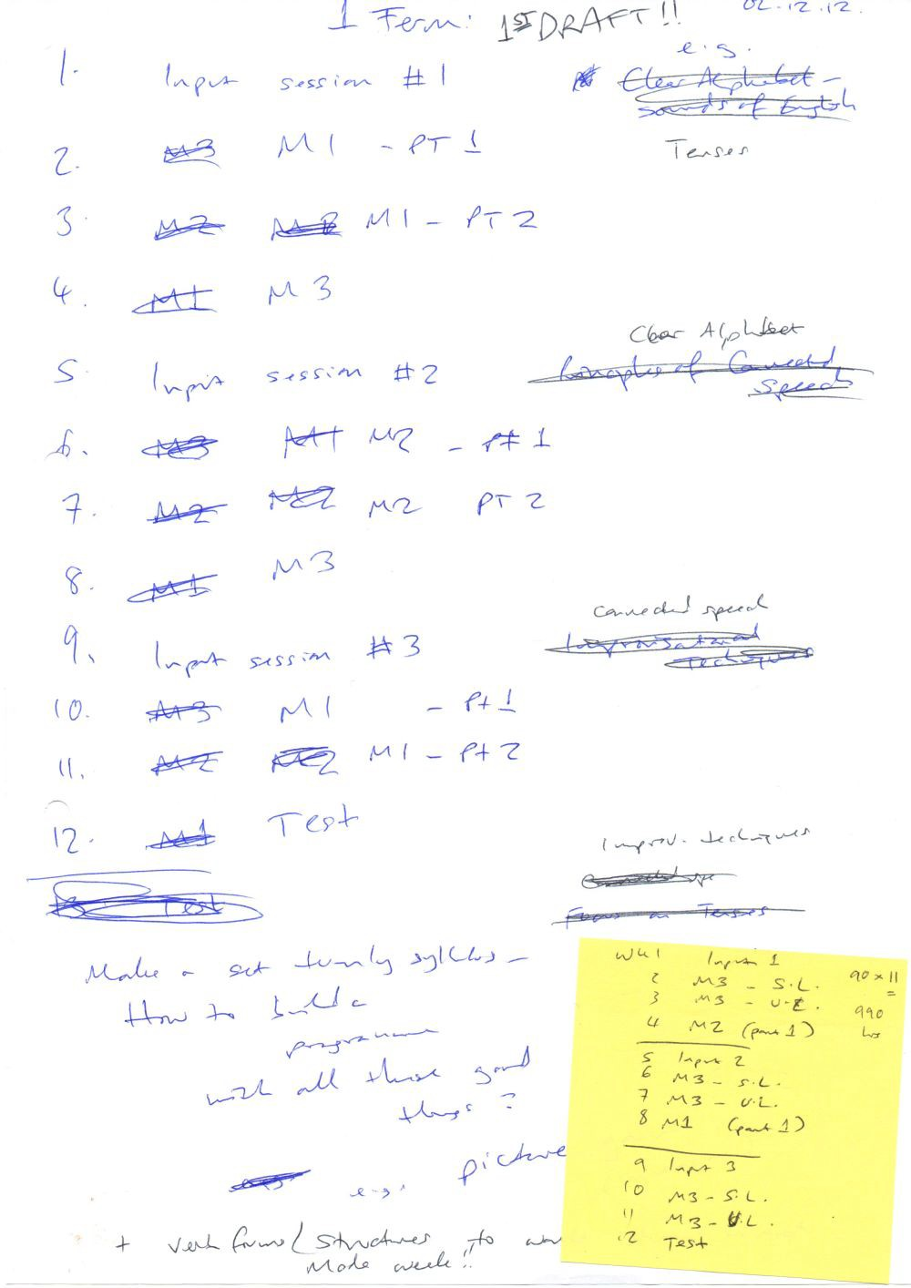

You Are The Course Book 2 – In Practice

WHAT DOES [...] MEAN? | DESCRIBE [...] | AND...
TELL ME MORE ABOUT... | WHY? | SO...?
FOR EXAMPLE... | RETURN TO THE TOPIC | CHANGE TOPIC

What does [...] mean? Why?

Describe [...] For example...

And... Return to the topic

Tell me more about [...] So...? Change topic

Teacher Training Course

You Are The Course Book Method

12 x 60 minute classes

- Teaching English/ESL without a course book
Introduction to the new teaching method as outlined in You Are The Course Book; why we don’t need teaching material to teach English/ESL

- Introduction to Mode 1 of You Are The Course Book Teaching without any material – the students do everything!

- Introduction to Mode 2 of You Are The Course Book
Teaching with a found text, e.g. newspaper article, realia, audio, video, etc.

- Using Talk a Lot materials with You Are The Course Book method; encouraging fluency Teaching without material, apart from a word list, using demanding interactive techniques

- Teaching vocabulary
Using effective techniques to teach vocabulary acquisition

- Teaching grammar as an integral part of the lesson
Focus on error correction throughout the lesson, as well as a fixed grammar point in each lesson process

- Teaching pronunciation using Stress, Reduce, Merge method
Teaching students to find the stress in a sentence, reduce the weak stressed syllables, and merge the syllables together. For more information, please see: https://purlandtraining.com/

- Teaching free practice activities
Unlocking the creativity of the group and giving them the chance to show off what they have learned through role play, discussion, debate, projects, etc.

- Teaching writing
Why writing should be done at home and not in the classroom; helping students to produce better work through stages of revision; understanding punctuation; peer evaluation

- Teachers present their own short lessons (Session 1)
Teachers on the course have the opportunity to present short “micro-lessons” using techniques that they have learned from this course; peer evaluation and feedback

- Teachers present their own short lessons (Session 2)
Teachers on the course have the opportunity to present short “micro-lessons” using techniques that they have learned from this course; peer evaluation and feedback

- Teachers present their own short lessons (Session 3); course summary Teachers on the course have the opportunity to present short “micro-lessons” using techniques that they have learned from this course; peer evaluation and feedback

Homework produced by Krzysztof after a Mode 1 writing process in class; text type: a children’s story; January 2013
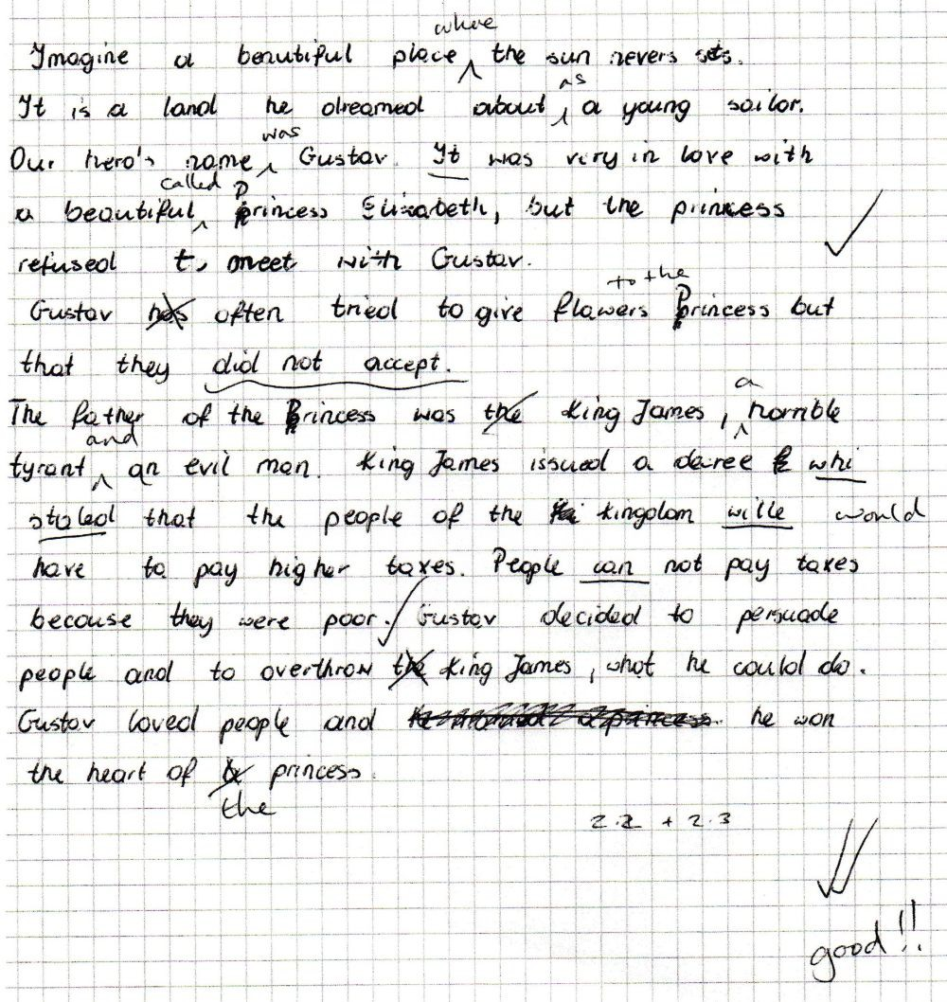

Homework produced by Agnes after a Mode 1 writing process in class; text type: a children’s story; January 2013
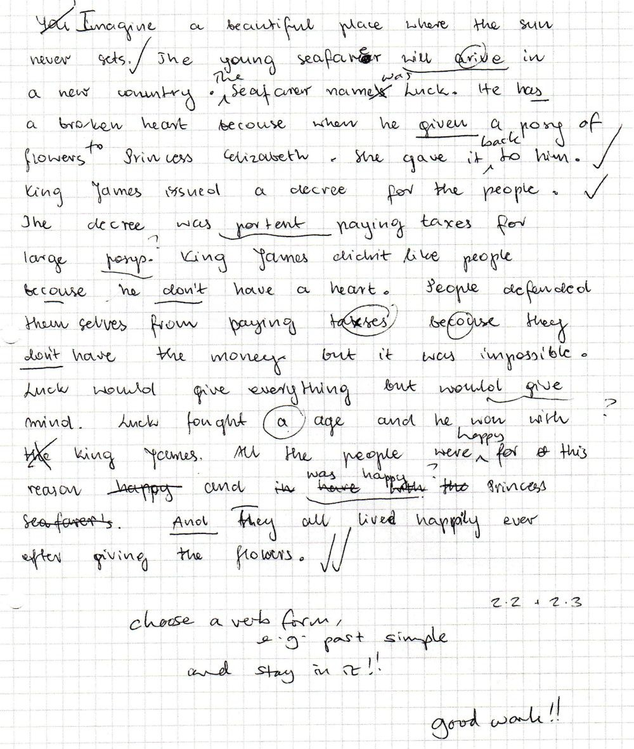

Mode 1 – A children’s story Dorota – 18.12.12, B1
10 words (interesting and random): sky, forest, church, library, cinema, park, friends, stork, lake, car

1st Draft:

It was happened in a forest, the weather was good, on the sky fly stork. It was very hot, so my friends decided to go swimming on lake. So when they came they saw something horrible, because someone in the car ran over stork and then they took injured stork to church because they want founded someone who help them. So the priest told him that they must came to library, because the veterinary surgeon was there, and quickly they went there and veterinary helped stork and safe life, and then they happy came to their cinema, because they know that stork will be healthy.

2nd Draft:

It happened in a forest. A stork was flying in the sky. The weather was good. It was very hot, so my friends decided to go swimming in the lake. But when they went they saw something horrible, because someone in the car ran over the stork, and then they took the injured stork to church because they wanted to find someone who would help them. The priest told them that they had to go to the library, because the vet was there. They went there quickly and the vet helped the stork and saved its life. Finally, they went happily to the cinema, because they knew that the stork would be healthy.

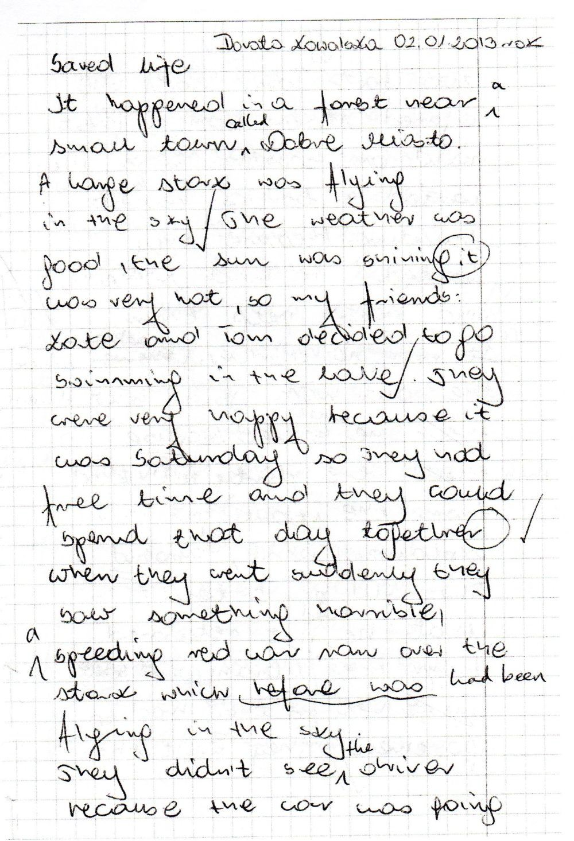

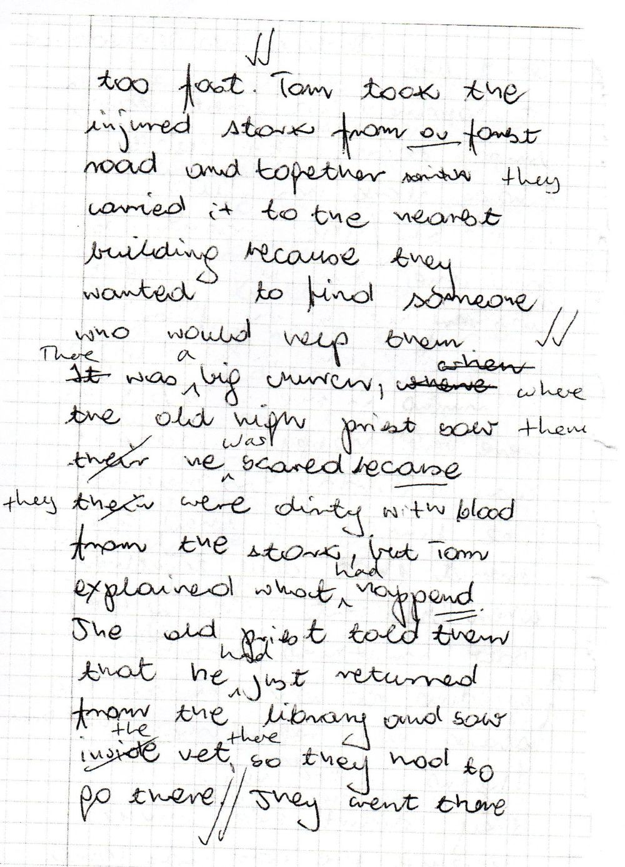

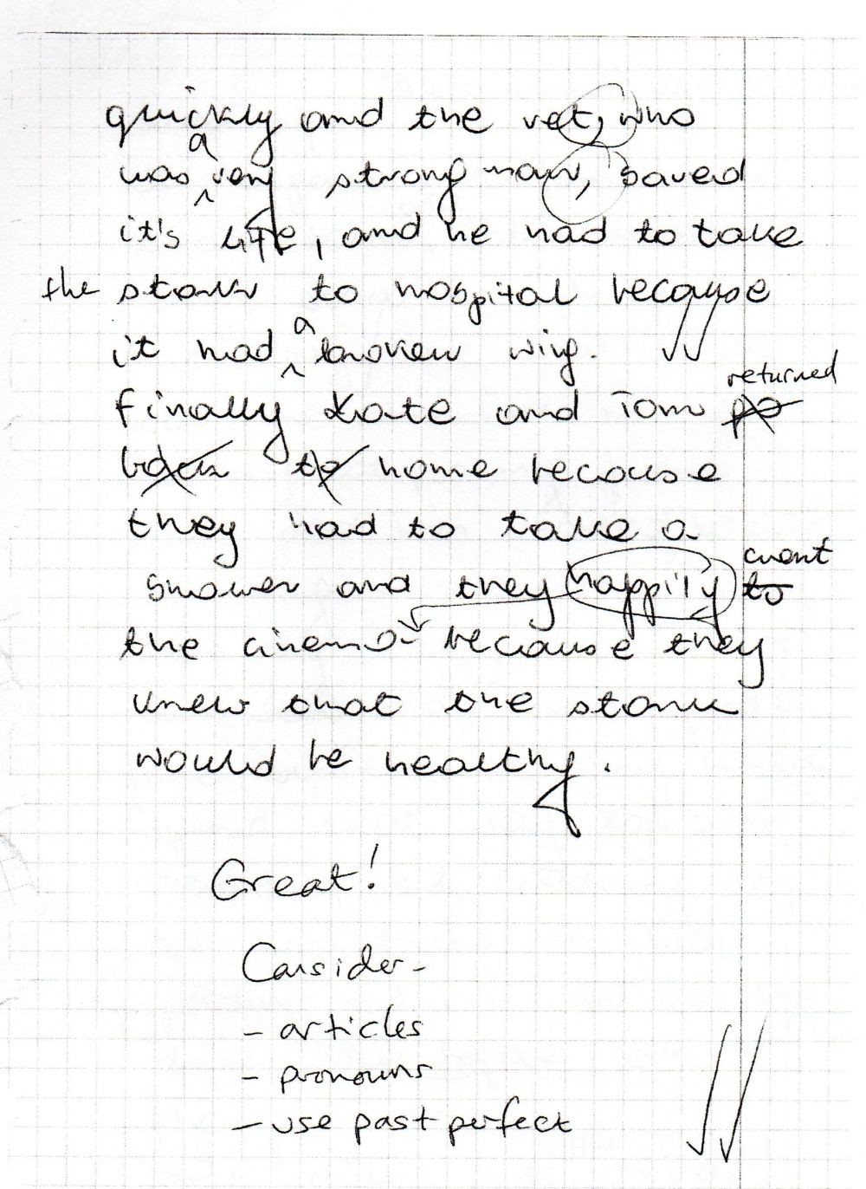

Board plan for Tomek and Bartek’s Mode 1 lesson, stage 2.1 (initial ideas); text type: a children’s story; 20.12.12

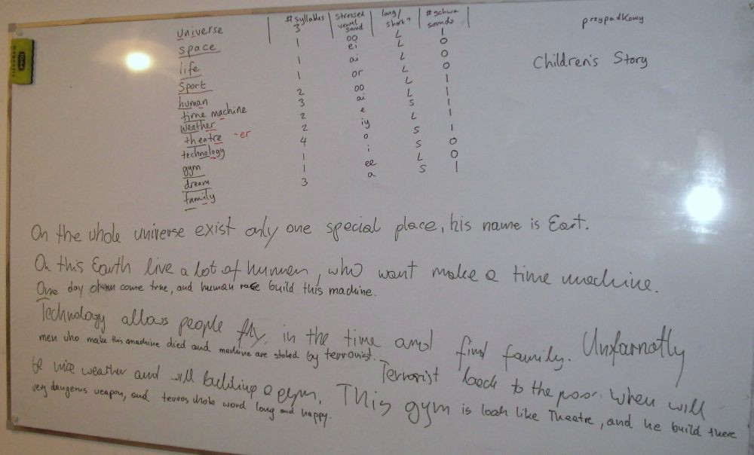

You Are The Course Book 2 – In Practice

My first notes on a variation of Mode 1, which would develop into Mode 3; 26.10.12

aim: speaking and listening focus; very interactive; pair and group work; minimal TTT; suitable for individual and small group lessons; particularly suitable for lower level, e.g. elementary upwards

think of a topic: ...

material: 20/10 blank cards/DWs; board and pens; notebooks; dictionaries

Warmer: alien game around a given topic: to introduce the topic and to get the SS thinking of and using the target vocabulary

Stage 1: SS brainstorm on a topic and write 20 words on cards - a-z, sylls, stress, describe a word, quiz, etc.

Stage 4:choose 4/2 (or more) words; on board; collocate with verbs; focus on particular different tenses; Q&A with these sentences - I ask you and you ask me

Stages 2, 3, & 5: write 4/2 sentences on the board using words in the vocab; corrections + improvements; grammar focus; then stress and connected speech

Stage 6: think of 4/2 people connected with the topic - person/problem/reason/result; act role plays

conclusion: dictation - words and phrases from the lesson

Stage 7: write a dialogue/story/letter/news report, etc.

Outline for a 4-day intensive course with Krzysztof P. – using only the brand new Mode 3 model; 29.10.12-02.11.12

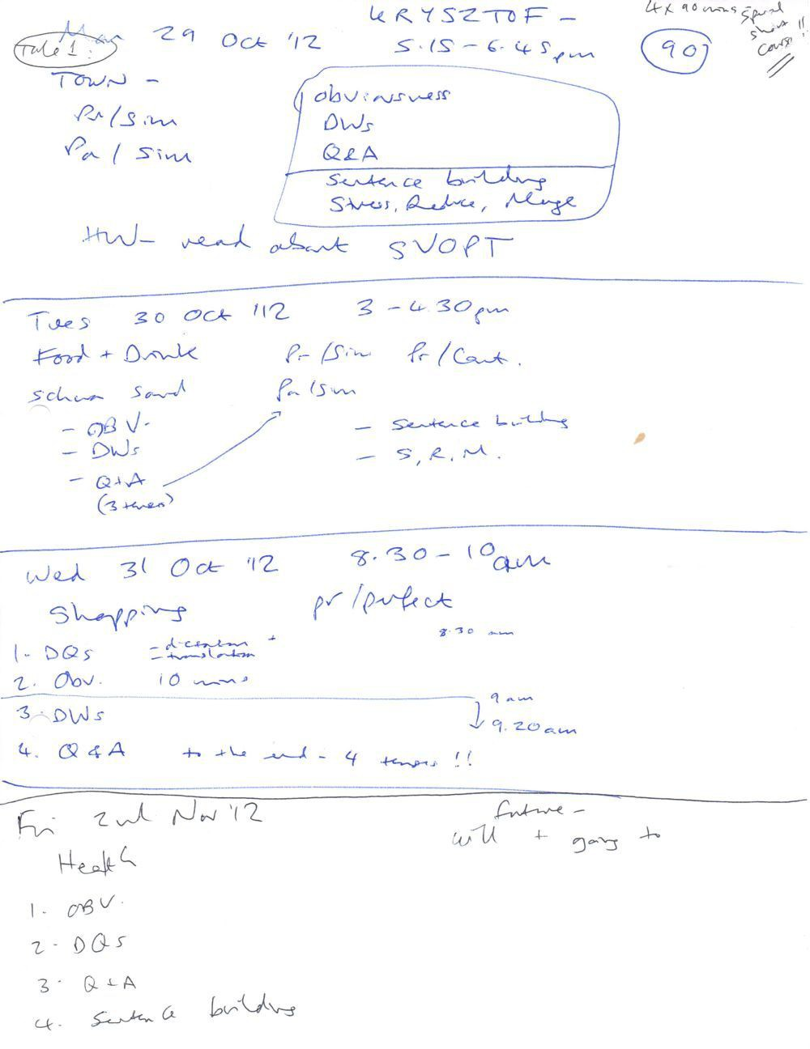

Prompt sheet that I hung on the wall to remind me of effective discussion questions that I could potentially ask in any topic; 28.10.12
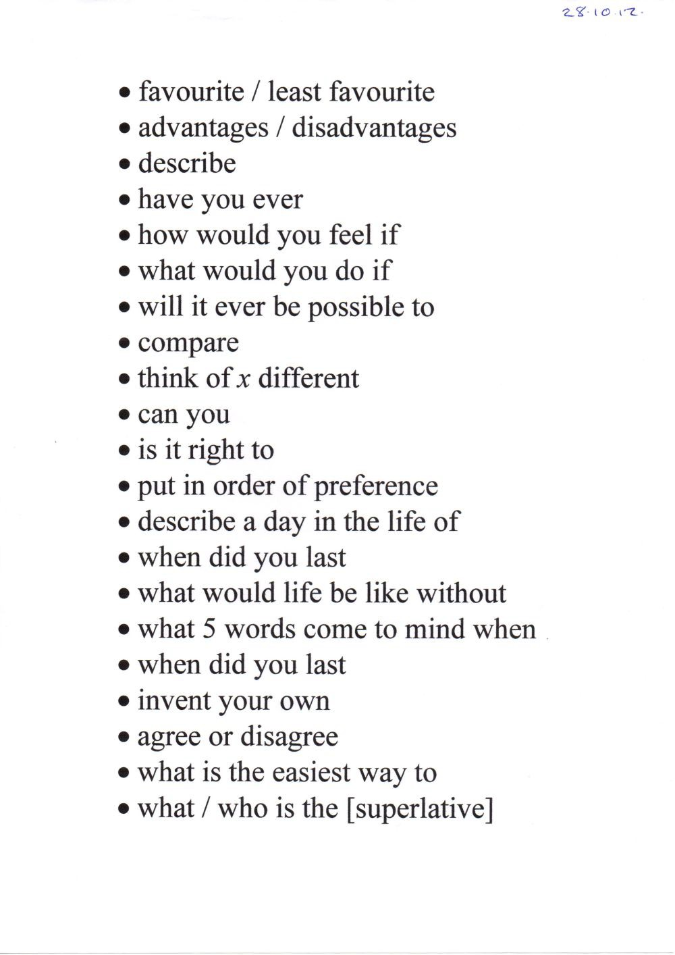

Cars – 40 Common Words

engine automatic boot windscreen parking ticket road
fuel accelerator zebra crossing wheel
hazard pedal brake brake light road rage seatbelt accident side mirror tyre
learner driver
licence plate passenger Highway Code driver
L-plate clutch ban
gear stick Sunday driver indicator
breakdown recovery service

battery seat sports car handbrake
rear view mirror road sign steering wheel dashboard headlights

Outline of a new activity in the vocabulary stage of a YATCB lesson; students have to give information about each vocabulary word or phrase,
i.e. number of syllables; stressed vowel sound; whether it is a long or short vowel sound; number of schwa sounds (if any); 20.12.12
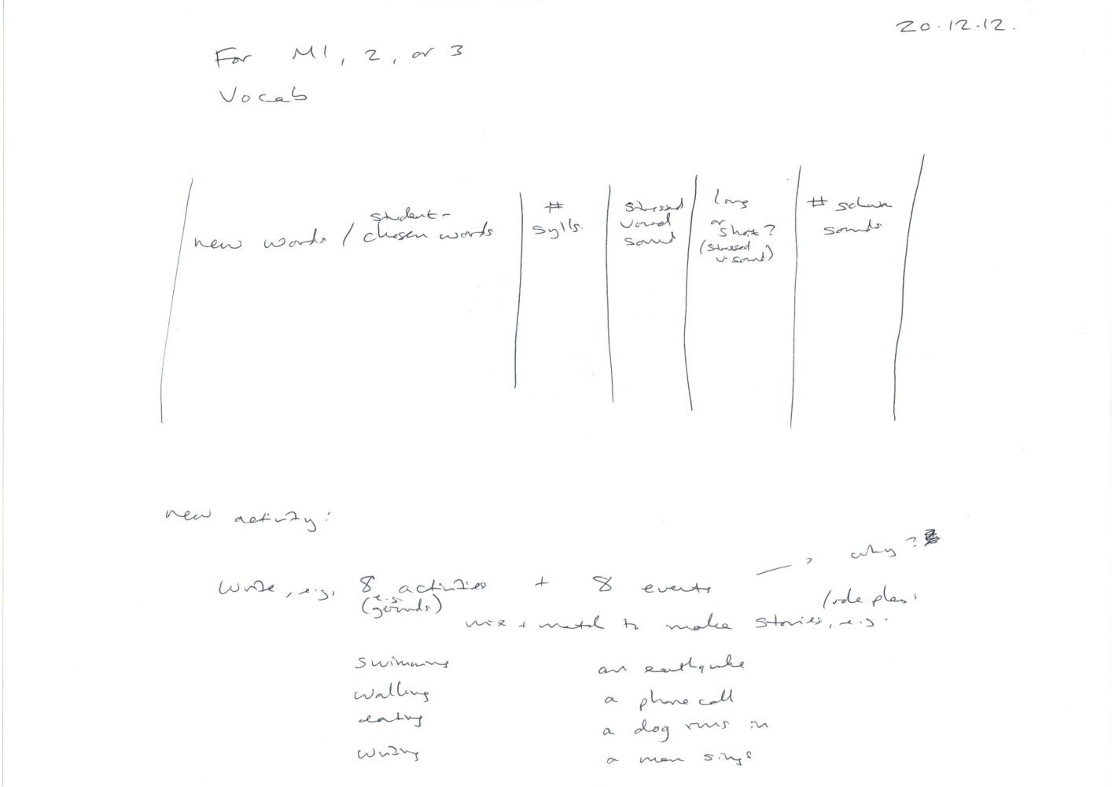

You Are The Course Book 2 – In Practice

Part 6 – Supporting Documents

Progress Tracker

Group/Individual:
Level:
Teacher:

Date: | Time: | Lesson Content: |  |  |  | Homework:
 |  | Topic: | V/Fs: | Activities: | Other:
 |  | Topic: | V/Fs: | Activities: | Other:
 |  | Topic: | V/Fs: | Activities: | Other:
 |  | Topic: | V/Fs: | Activities: | Other:
 |  | Topic: | V/Fs: | Activities: | Other:
 |  | Topic: | V/Fs: | Activities: | Other:
 |  | Topic: | V/Fs: | Activities: | Other:
 |  | Topic: | V/Fs: | Activities: | Other:
 |  | Topic: | V/Fs: | Activities: | Other:
 |  | Topic: | V/Fs: | Activities: | Other:
 |  | Topic: | V/Fs: | Activities: | Other:
 |  | Topic: | V/Fs: | Activities: | Other:

Modes 1 & 2: 1. Vocabulary 2. Text 3. Grammar Point 4. Verb Forms Revision 5. Pronunciation 6. Free Practice 7. Writing Mode 3: A. Obviousness B. Discussion Words C. Q & A D. Sentence Building E. Stress, Reduce, Merge F. Free Practice

Optional Free Practice Activities:

a) Role Play (PPRR) b) Gossip (PPRR) c) A Day in the Life of... d) Invent Your Own... e) Debate f) Discussion Questions g) Agree or Disagree?
- Dictation i) Video Commentary j) Topic Template k) Text Activities

Verb Forms Revision Test – Sample Answers

Verb Form (Tense): | Time: | Auxiliary Verb(s): | Example Sentences:*
present simple | regular time | do / does | + I like chips.  - I do not like chips.  ? Do you like chips?
present continuous | now or future (with time phrase, e.g. “at 8pm”) | am / is / are | + I am reading a book.  - I am not reading a book.  ? Are you reading a book?
past simple | finished time in the past, e.g. last week | did | + I met my friend.  - I did not meet my friend.  ? Did you meet your friend?
past continuous | finished time in the past, e.g. last week | was / were | + I was driving for two hours.  - I was not driving for two hours.  ? Were you driving for two hours?
present perfect | unfinished time, e.g. this week | have / has | + I have finished my breakfast.  - I have not finished my breakfast.  ? Have you finished your breakfast?
present perfect continuous | unfinished time, e.g. this week | have / has + been | + I have been playing football.  - I have not been playing football.  ? Have you been playing football?
past perfect | time before another past action | had | + I had been to Italy before.  - I had not been to Italy before.  ? Had you been to Italy before?
modal forms | various times | modal auxiliary verbs | + I can swim.  - I cannot swim.  ? Can you swim?
future with ‘will’ | immediate future or predicted future | will | + I will pay for lunch.  - I will not pay for lunch.  ? Will you pay for lunch?
future with ‘going to’ | planned future | am / is / are + going to | + I am going to join a gym.  - I am not going to join a gym.  ? Are you going to join a gym?
*Contractions are also acceptable, e.g. ‘I don’t like chips’, ‘I’m reading a book’, ‘I’ve finished my breakfast’, etc.

Word Classes in English – Revision

Content Words – one strong stressed syllable in each one*

Word Class: | Translation: | For Example: | More Examples:
nouns concrete  abstract |  | table  happiness
main verbs normal**  phrasal verbs  negative auxiliary verbs |  | eat wake up  didn’t
adjectives (describe nouns) |  | big
adverbs (describe verbs) |  | quickly
numbers |  | ten
wh-question words (interrogatives) |  | what
interjections |  | Hi!

Function Words – not stressed***

Word Class: | Translation: | For Example: | More Examples:
auxiliary verbs normal  modal |  | have  can
pronouns normal  relative |  | they  which
possessive adjectives |  | their
prepositions |  | for
conjunctions |  | because
determiners articles  quantifiers  demonstratives |  | the some  this

Identify the class of each word: Who was watching two friends of your younger brother quietly eating some of those cakes – which were on the table – and then running away?

- apart from phrasal verbs, which are stressed on both parts, or two parts if there are three
** apart from verb “be” which is not usually stressed as a main verb or as an auxiliary verb
*** unless they occur at the end of a clause, e.g. “What for?”

Board plan from Input lesson #2 (Connected Speech) with Krzysztof P. ; 04.02.13

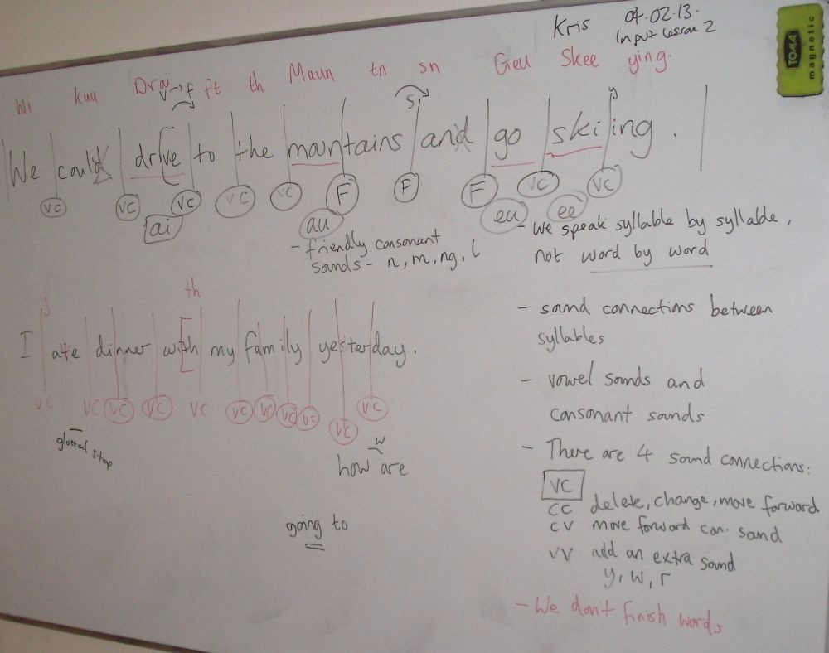

Connected speech homework by Agnes, after Input Lesson #2; 06.02.13

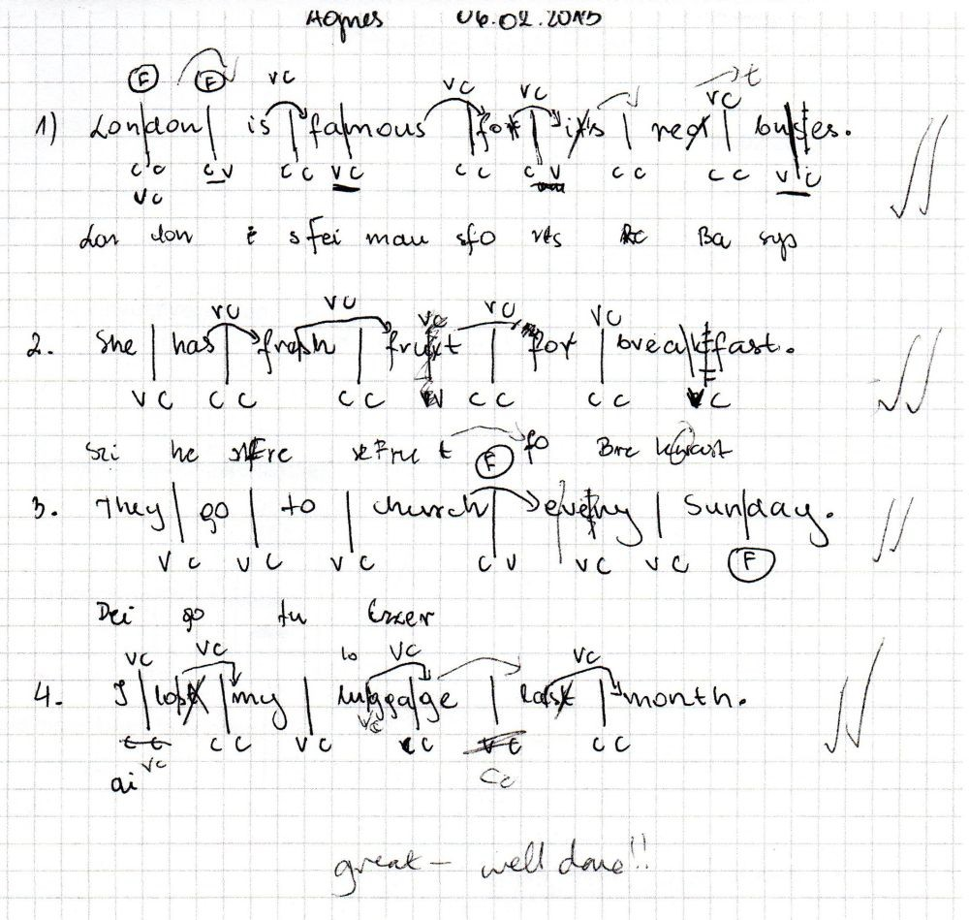

Connected speech homework by Tomek B., after Input Lesson #2; 14.02.13

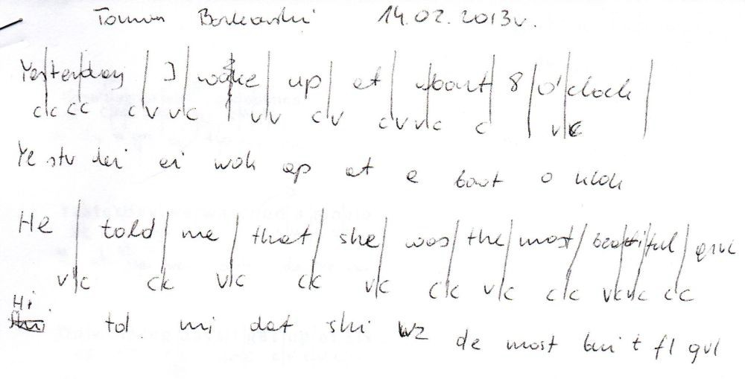

You Are The Course Book 2 – In Practice

Input Lesson #3: Improvisation and Imagination

Why improvise?

  - When we improvise we get something from nothing. YATCB is based on this principle – production, e.g. Obviousness, Sentence Building, PPRR (where the aim is to produce stories and situations; to get something out of the bare minimum of a few people connected with a certain topic), Mode 1 text production, etc. When you produce you need to invent and create from simple prompts, so improvisation skills are useful
  - So it matches important YATCB principles:

    - Your ideas
    - You are engaged
    - Students work together in pairs and groups, not individually. No individual “brain > content” time
    - Teacher is a guide. No top-down teaching. Elicit don’t tell

  - It’s preferable to using a course book in class – we can exercise our imaginations; thinking, not reading somebody else’s work. In the classroom the teacher can guide; for reading you don’t need a teacher – you can do this at home. Reading a book requires far less imagination than producing a text (spoken or written); we learn more by doing
  - Training in positive useful areas, e.g. using higher-level words instead of basic words (see C, below)
  - Exercising your imagination helps you to remember more – cf. memorable lessons from last year, e.g. Abdulrahman is Prime Minister of the Moon [p.32], and so on
  - It helps you to develop your English language skills by practising – with the teacher on hand to guide you. You can increase your fluency – the aim here is to keep talking – production and fluency. To practise what you know; to speak continuously. To be able to describe basic things fluently, e.g. what is a table?
  - Increasing speed in improvisation increases fluency and speeds up our lessons, meaning we can do more
  - It’s fun!

How can we improvise?

  - Say yes! Be open – accept – don’t block. Take another person’s idea and modify/develop it, not dismiss it
  - Practise often; the more you practise something the easier it becomes and the better you get

Activities to try:

  - What am I? (yes/no answers only)
  - Group sentence/story: word by word, then sentence by sentence
  - Let’s… Yes, and then let’s… Good idea, and then let’s… (suggestion-acceptance-suggestion improvisation)¹

1 Salinsky, Tom, and Frances-White, Deborah. The Improv Handbook. London: Continuum International Publishing Group, 2008. Paperback. p.59

  - What’s Just Happened? – improvisation game (see cards below and on p.385). Walk into a room in a particular state and we have to guess what’s happened (present perfect focus) – then use Y/N only! Improvise the backstory – what happened? SS ask questions of whoever has just walked into the room. Variation: “I’ve just made an important decision to…” (has strong objective). Put together pairs (e.g. with opposing objectives) and let them have a conversation. (See A, below, for more situations.)

won the lottery | damaged my car
fallen in love | been in a fight
met a famous person | eaten too much
passed an important exam | heard some bad news
bought a new book | dropped my phone in the toilet
been on TV | been turned down for a job
seen a UFO | lost one hundred Złoty
had a tattoo | been bitten by a dog
had plastic surgery | had an argument
been to a birthday party | watched a really boring film

  - You’ve got a secret: one person goes out; we think of a secret for them; when they return, they have to guess it by asking questions; others give clues
  - Somebody describes a scene (improvising) – the other draws it (then blindfolded)
  - Describe the appearance of something in detail from memory, e.g. a place, a room in your house, your car, a person, etc.; then others can ask questions and introduce fictional details, which the person has to accept, e.g. “You’ve got a green lamp on the table, haven’t you?” “Er, yes I have!” Variation: describe an everyday activity in great detail, e.g. tying your shoelaces, or doing the washing up
  - Tell a funny story while keeping a straight face. If you laugh, it’s somebody else’s turn.
  - One person improvises and dictates a story, which the others must act out

Also try, if time:

  - The original Alien Game (see p.261)
  - Identities game – post-it notes on foreheads: who am I?
  - Practise reading a dialogue in different moods, then continue the conversation
  - Dubbing a film (with the sound turned down) with new dialogue
  - Story Arc (see B, below)

A: What’s Just Happened?

States (on cut-up pieces of paper): I’ve just…

Positive : Negative:

  - won the lottery
  - fallen in love
  - met a famous person
  - met a famous person from history
  - bought something very expensive
  - bought an exotic pet
  - passed an important exam
  - passed my driving test
  - arrived home after an amazing trip
  - got back from the seaside
  - bought some new clothes
  - seen myself on TV
  - won an important match
  - written a song
  - seen a UFO
  - been playing sport
  - had a tattoo
  - had plastic surgery
  - been jogging
  - been to a birthday party
- crashed my car
- been in a fight
- got back from a war
- eaten too much
- heard some bad news
- been to a funeral
- dropped my phone down the toilet
- walked into a lamp post
- stolen something
- fallen over in public
- lost a 100 zł note
- been sunbathing for too long
- been bitten by a dog
- had a row with my partner
- upset somebody
- been told I’ve got two months to live
- watched a really boring film
- had a loan application rejected
- been turned down for a job
- made a fool of myself

B: Story Arc²:

Students have to complete each line (in turn) to complete the story arc:

  - Once upon a time there was…
  - And every day…
  - Until one day…
  - And because of that… (repeat as necessary)
  - Until finally…
  - And ever since then…

C: Basic Words vs. Higher-Level Words:

SS have to match basic and higher-level words in these sets of synonyms (activity for Stage 2.3 Mode 1 and also Mode 3 Sentence Building – Improvements). SS usually tend to reach for basic words in

2 The Improv Handbook. p.400. See also: McWaters, V (2010). Using the Story Spine. Slideshare.net. Retrieved May 7th 2013, from http://www.slideshare.net/vivmcwaters/story-spine

production, rather than being more ambitious, and this has to be corrected in the Improvements stage. They should try to be more imaginative from the outset = save time and get through more!

BASIC: HIGHER-LEVEL:

house residence

dog mutt

red scarlet

bag rucksack

shop greengrocer’s
BASIC: HIGHER-LEVEL:

woman Mrs Parker

hello hiya

car Ford Fiesta

phone iPhone

restaurant Tawerna

Now SS have to write a higher-level (more interesting/specific) word or phrase for each of these basic words:

- ball
- mountain
- chair
- boat
- ice-cream
- cup
- engineer
- forest
- spaghetti
- friend

Board plan for Dorota’s Input Lesson #3; 07.03.13

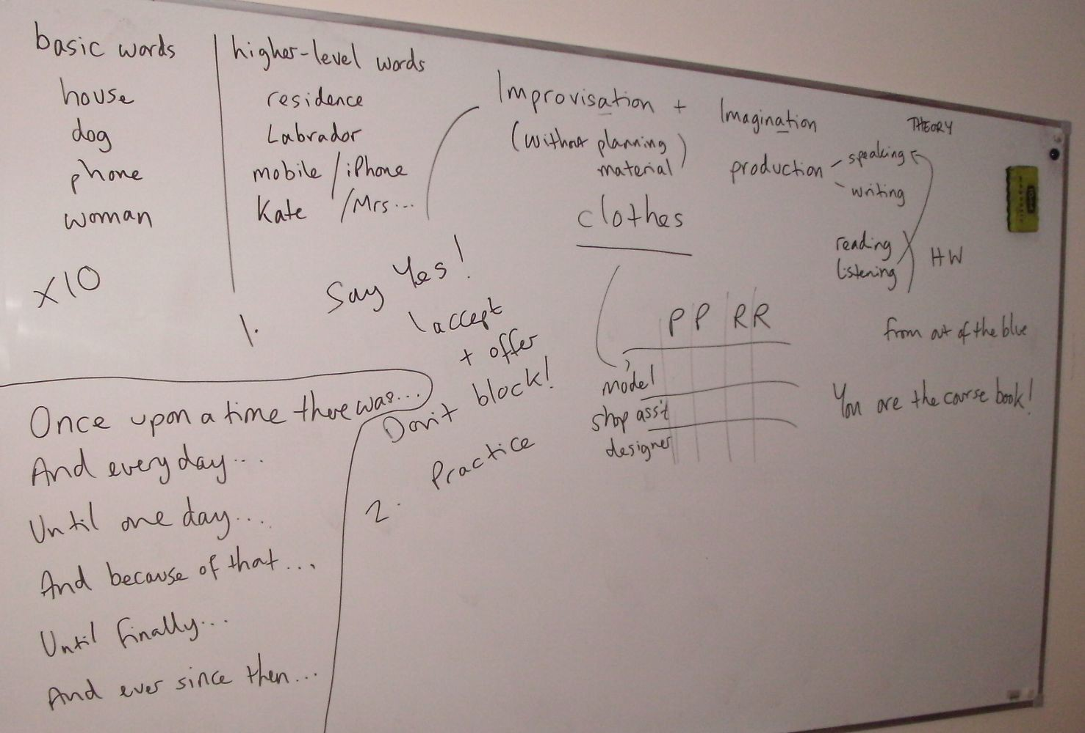

“What’s just happened?” game cards, used in Input Lesson #3; March 2013

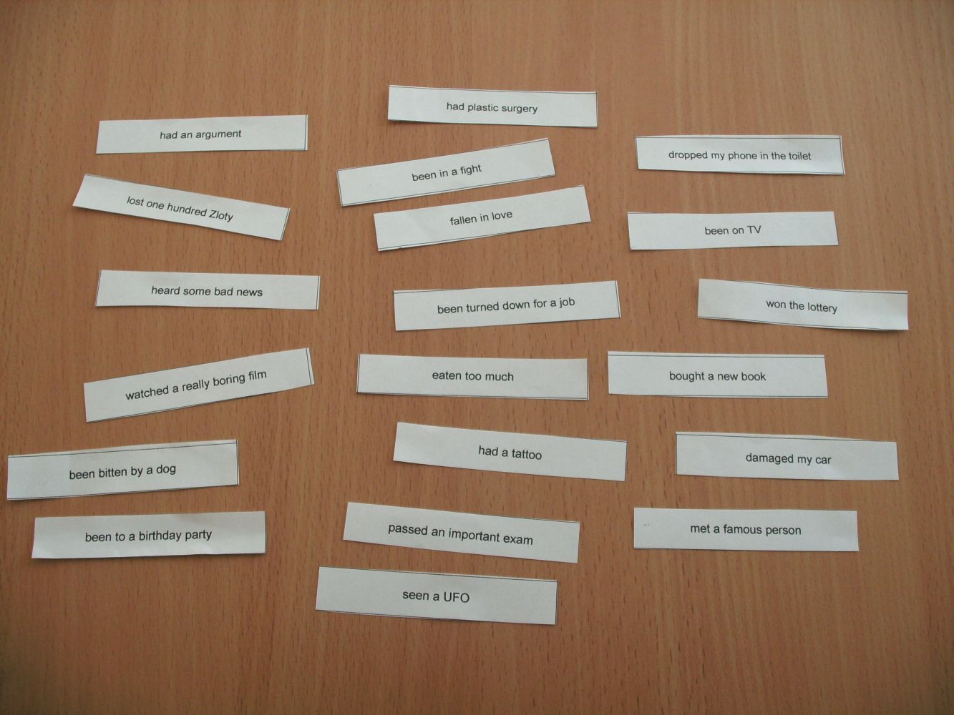

Homework written by Bartek to demonstrate the difference between using basic vocabulary words and higher-level words; 14.03.13

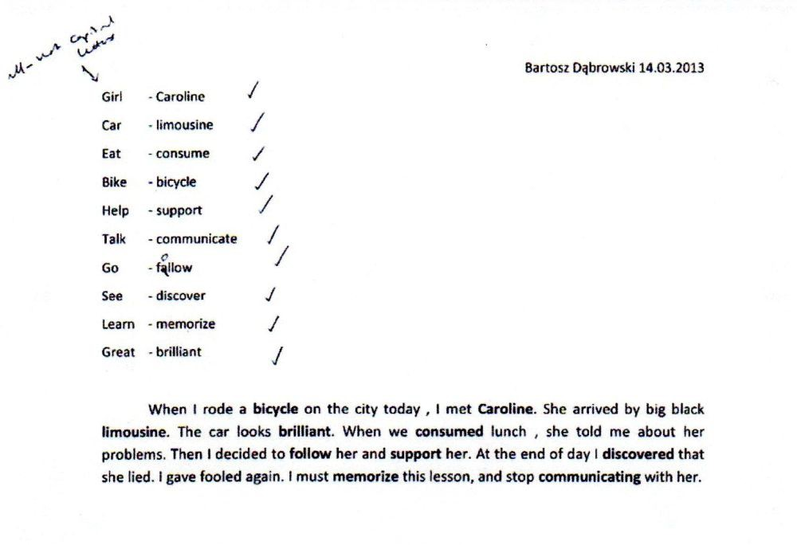

Board plan of Foresters’ Mode 3 lesson on the topic of “The Environment”; 08.01.13

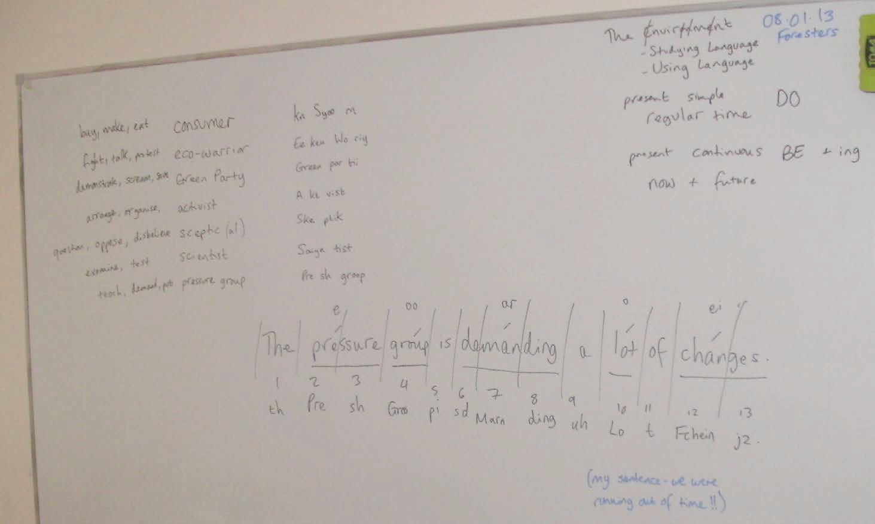

Example of one of the Foresters’ set of six pictures based on my dictated story about the man who gives up his car; from Mode 3 The Environment (Using Language) lesson; January 2013

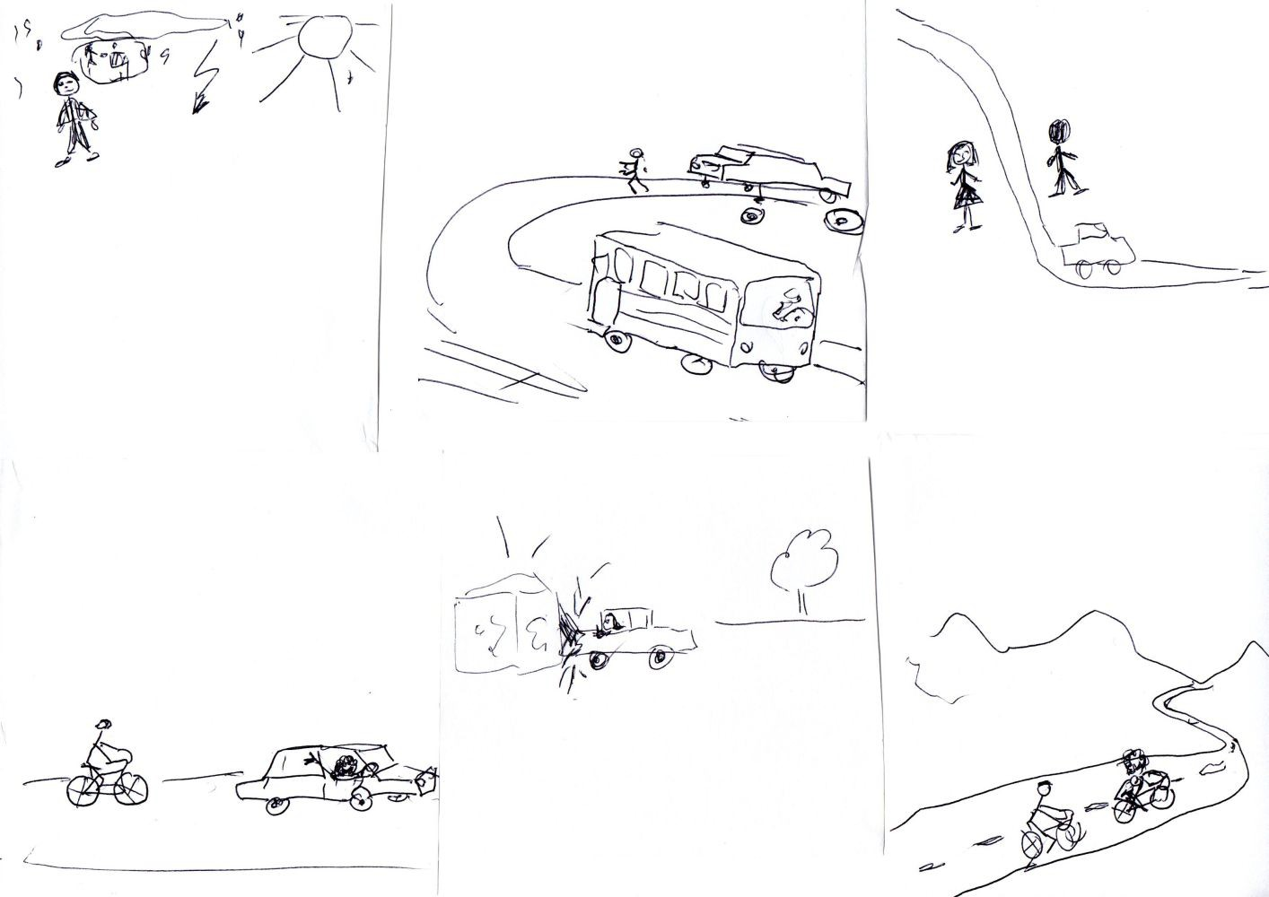

Original picture story, created by Dorota for homework after The Environment (Using Language) lesson on 15.01.13
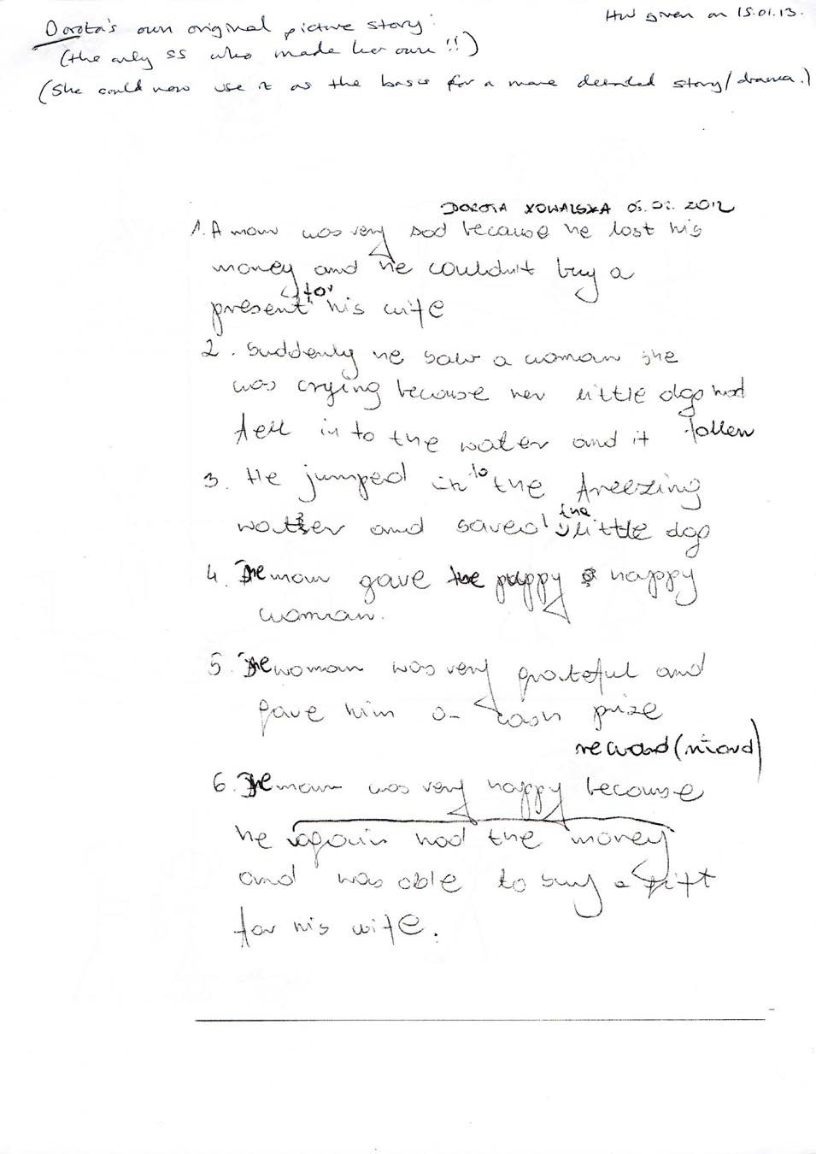

Dorota’s picture story: a man wants to buy his girlfriend a present, but doesn’t have any money; he sees a woman’s cat fall into a river; he dives in to rescue the cat; he gives the cat to the woman; she gives him a reward; he is able to buy a present for his girlfriend after all!

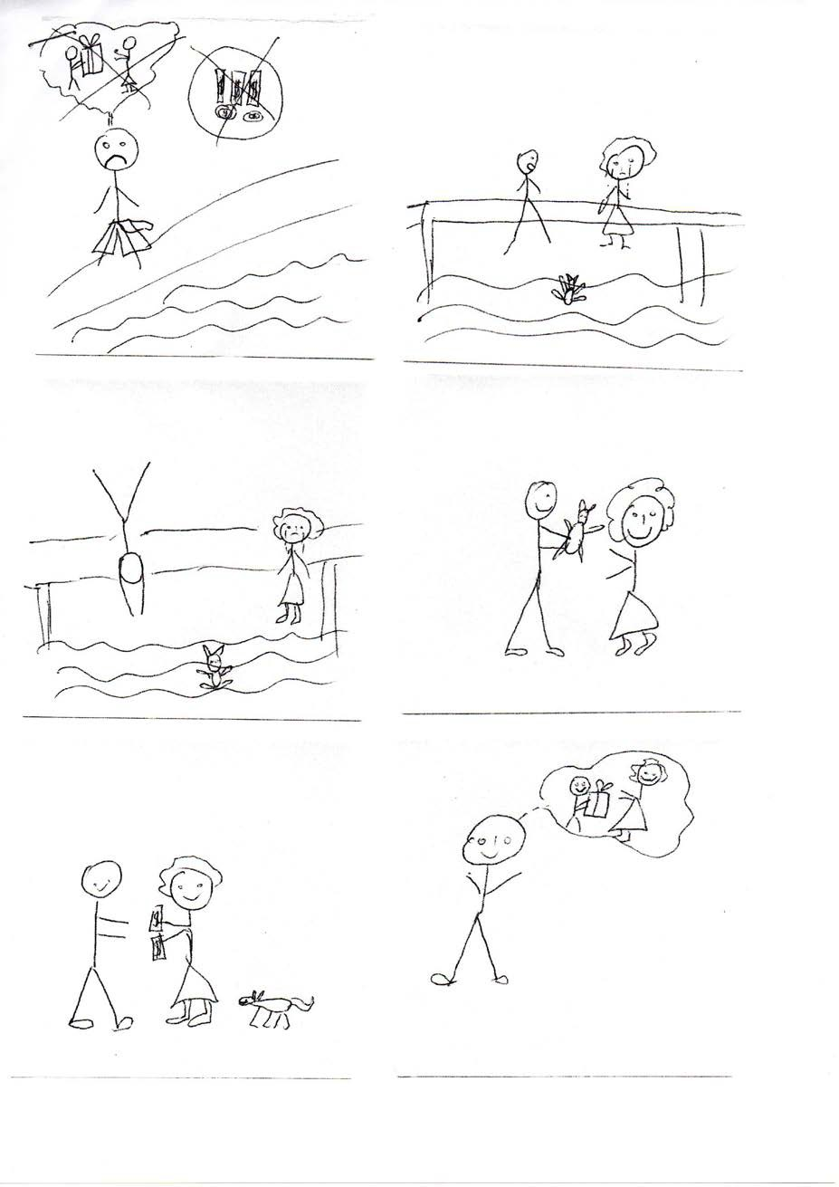

Office – Using Language (w/c 18.02.13)

Dictation Text: Office Politics:

Pat: The biggest problem is where to sit everybody. If I sit Jean next to the window, she will complain because she doesn't like the cold. Tom won’t mind if I put him next to the window, but he’ll spend all day chatting to Clara. So if I sit Clara next to the window, Jean and Tom will be happy, one on either side of her. But if I do that, Alice might feel jealous of Clara, because Alice will have to sit on the other side of the office on her own. Office politics can be so difficult, can’t it?

Possible Activities:

- Student presentations + feedback
- Revision of vocabulary from last week – including spelling on the board
- Find the office equipment: blindfolded (in teams, if possible)
- Dictation (see above) – then SS create their own quiz with comp. questions
- Grammar Point: first conditional (see below) – present, then practise
- PPRR – make a dialogue or gossip
- Video comprehension quiz (see below)
- Video commentary: what is happening?; what can you see? etc. (The Office, with the sound turned off.)

http://www.youtube.com/watch?v=eBhl_ZP_xYs (5:10)

- Name the company.
- Where are they made?
- What are pencils made of?
- The lead is dried to remove .
- What is the sandwich?
- How many coats of lacquer?
- Describe the process.

- "Brand quality with ."
- Difference between making pencils in the past and today?
- How many pencils are made each day?
- Complete the slogan: made in Germany.

- Staedtler pencils
- in Germany
- Graphite and clay.
- water
- The wood around the centre
- Up to 6. 7. ...
- tradition
- Similar, but each used to be hand-made whereas now they are mass-produced
- 1.7 pencils every day.
- perfection

First conditional:

  - predict a likely result in the future; contrast with 2nd conditional; Pat is going to have to do something; it is not hypothetical
  - it is “the realistic conditional”
  - two clauses; if + present simple, then will + infinitive – can be either way round
  - we can use other modal verbs instead of will: shall, can, might, may
  - we often contract will to make ’ll, e.g. he’ll and even Alice’ll
  - positive, question, and negative forms

Office Politics:

Pat says: The biggest problem is where to sit everybody. If I sit Jean next to the window, she will complain because she doesn't like the cold. Tom won’t mind if I put him next to the window, but he’ll spend all day chatting to Clara. So if I sit Clara next to the window, Jean and Tom will be happy, one on either side of her. But if I do that, Alice might feel jealous of Clara, because Alice will have to sit on the other side of the office on her own. Office politics can be so difficult, can’t it?

Board plan for a Mode 3 Office (UL) PPRR activity with Bartek, Tomek, and Sebastian; 21.02.13

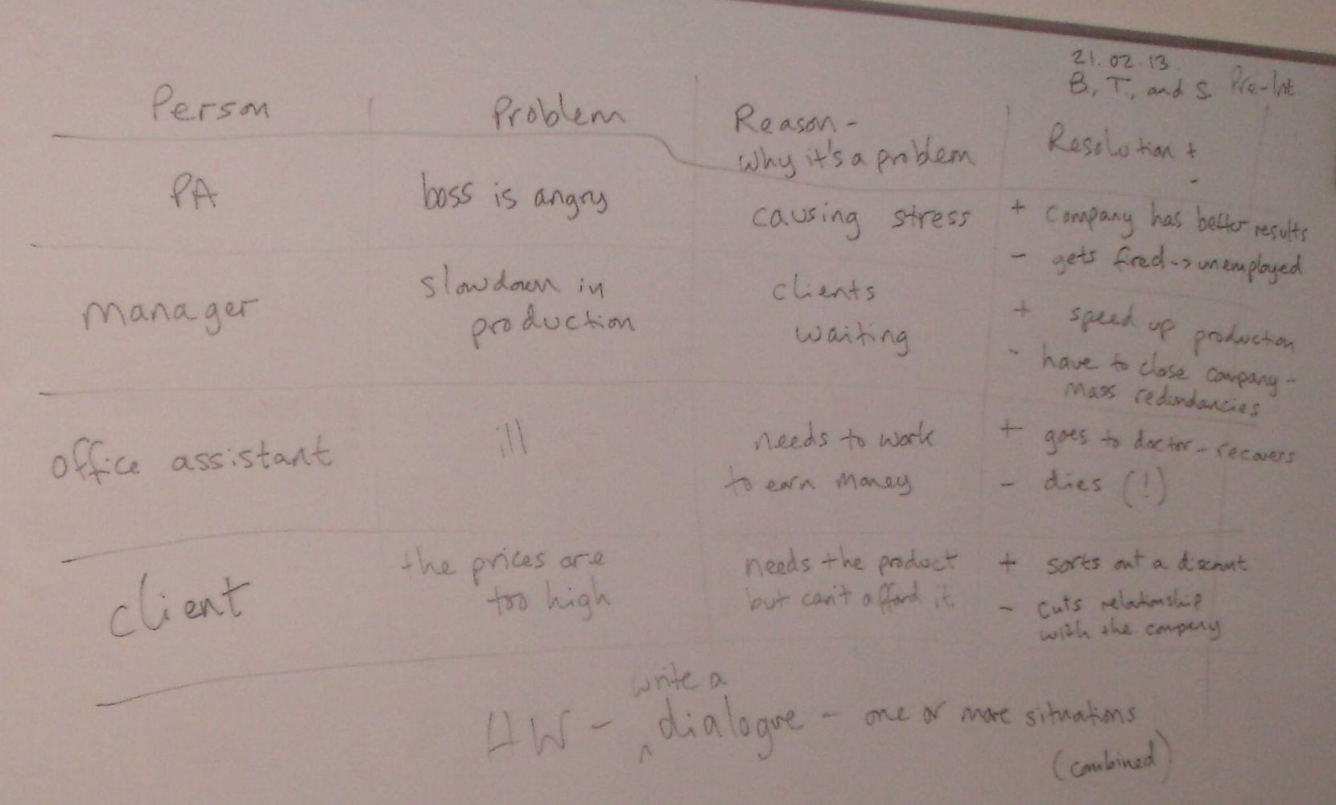

Dorota’s Mode 1 text – stages 1, 2.1, 2.2, and 2.3; text type: a factual text, e.g. a magazine article; 26.02.13

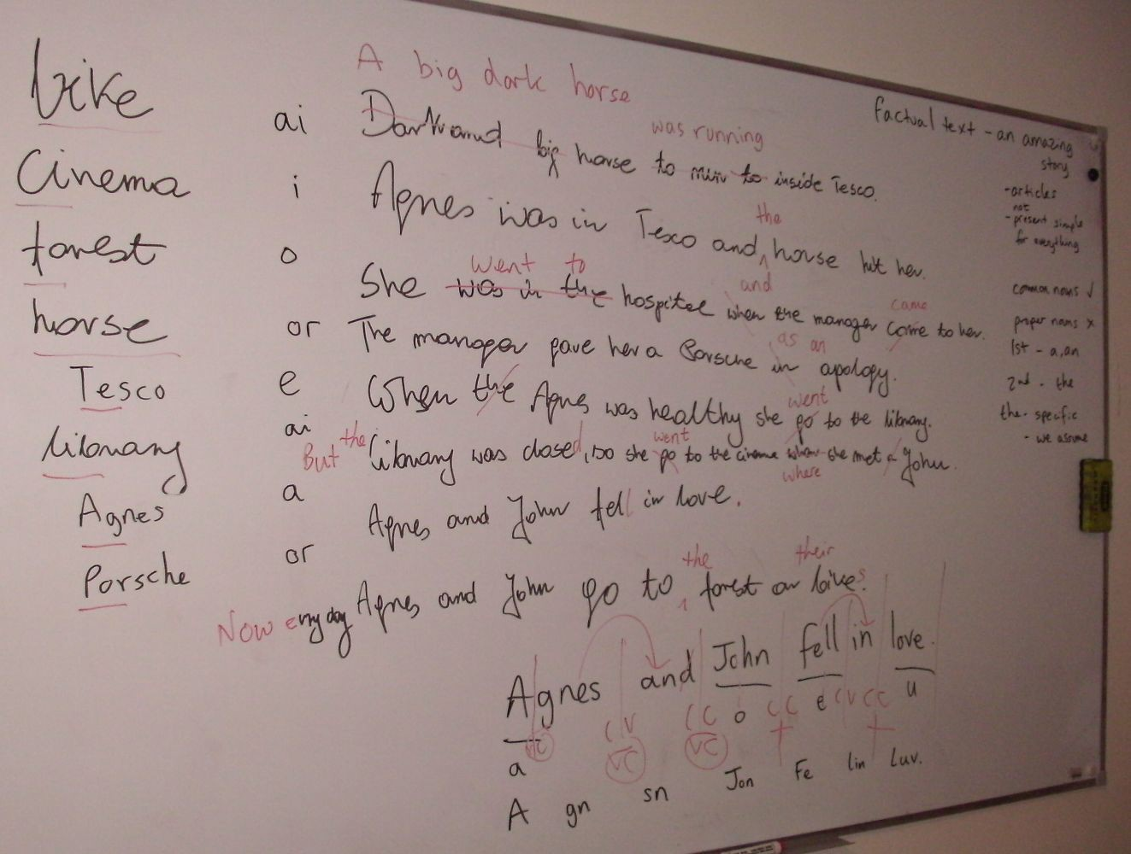

Bartek and Tomek’s Mode 1 text – stages 1, 2.1, 2.2, and 2.3; text type: a factual text, e.g. a magazine article; 28.02.13

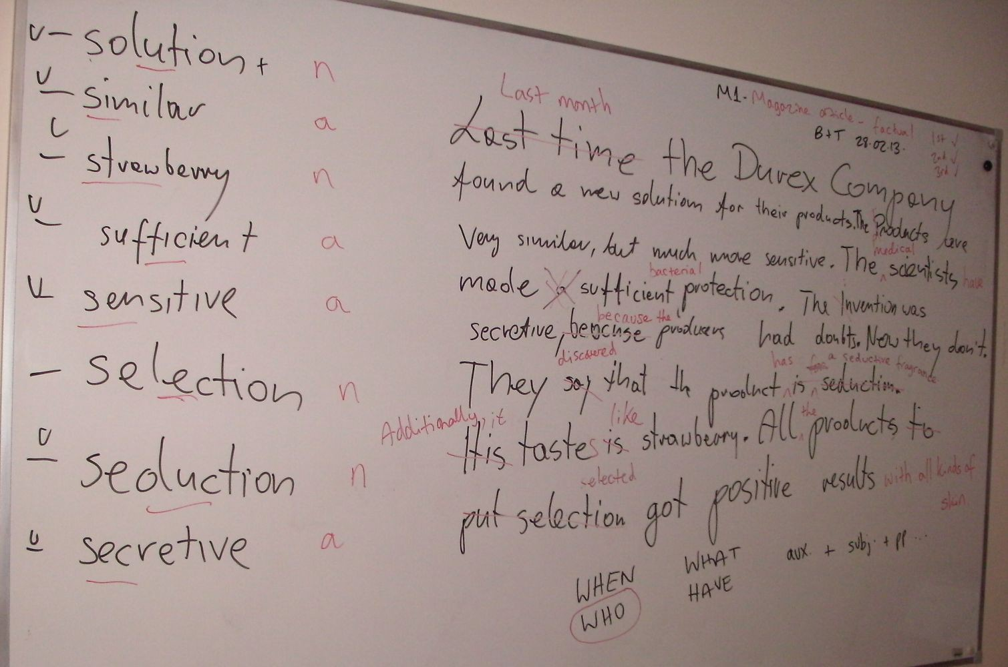

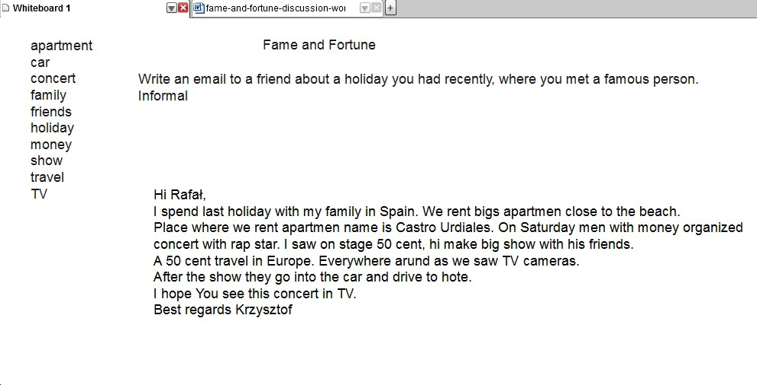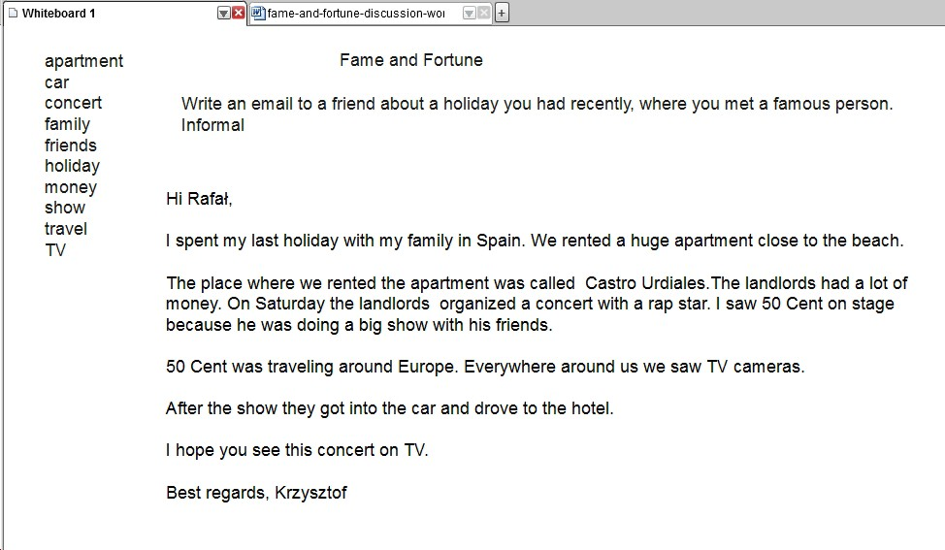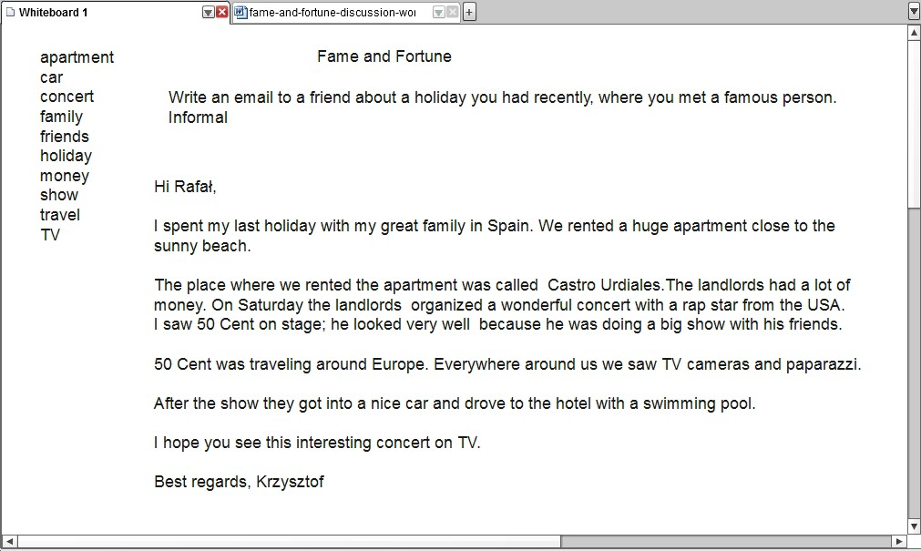
Elementary Level

2.1 Original

2.2 Corrected

2.3 Improved

My first example of a completed Auto Mode 3 page (in portrait mode); 25.02.13

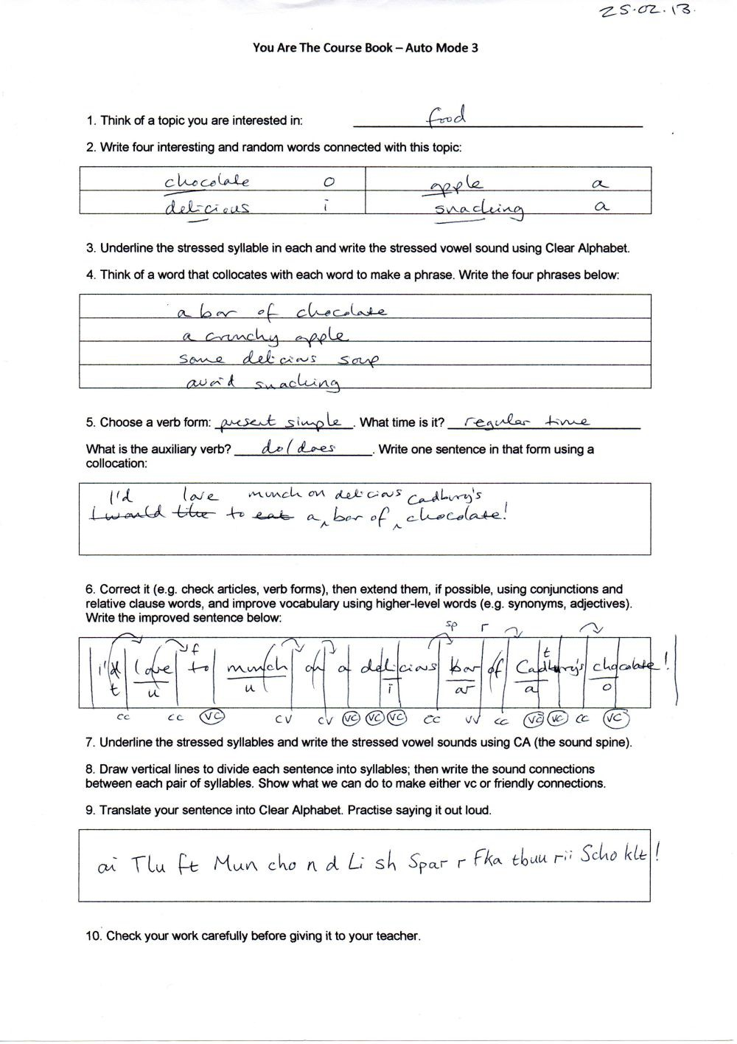

You Are The Course Book 2 – In Practice

You Are The Course Book – Auto Mode 3

- Think of a topic you are interested in:
- Write six interesting and random words connected with this topic:

- Underline the stressed syllable in each and write the stressed vowel sound using Clear Alphabet.
- Think of a word that collocates with each word to make a phrase, adding other words if necessary (e.g. articles, prepositions). Write six phrases:

- Choose a verb form: . What time is it? . What is the auxiliary verb? _. Write one sentence in that form using a collocation:

- Correct your sentence (e.g. check articles, verb forms), then extend them, if possible, using conjunctions and relative clause words, and improve vocabulary using higher-level words (e.g. synonyms, adjectives). Write the improved sentence below:

- Underline the stressed syllables and write the stressed vowel sounds using CA (the sound spine).
- Draw vertical lines to divide each sentence into syllables; then write the sound connections between each pair of syllables. Show how to make either vc or friendly connections.

- Translate your sentence into Clear Alphabet. Practise saying it out loud. 10. Check your work carefully before giving it to your teacher.

Auto Mode 3 – example completed by Agnes for homework; 04.03.13

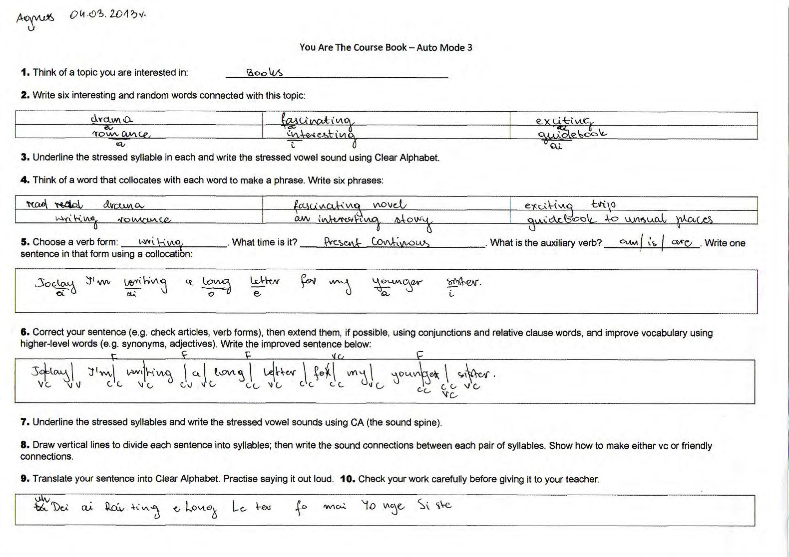

Auto Mode 3 – example completed by Bartek for homework; 07.03.13

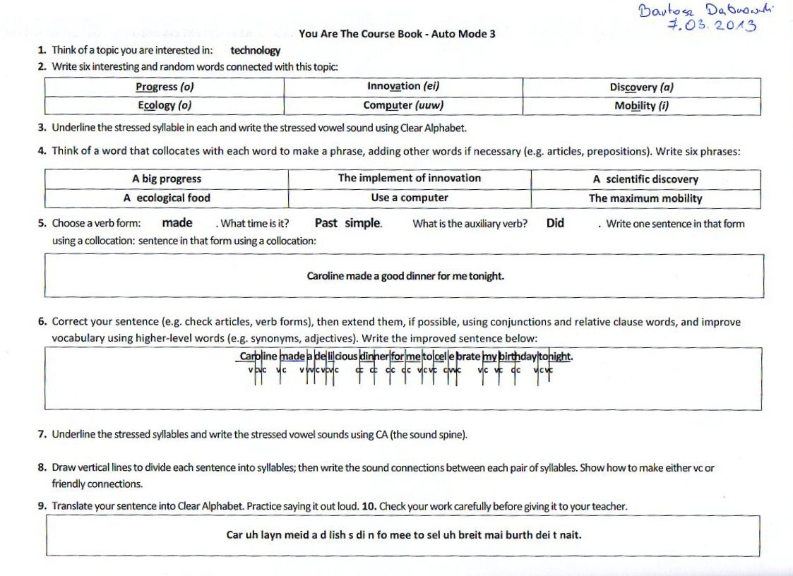

Mode 3 Beginner (SL) board plan on the topic of “Easter”; lesson with Bartek (company); 26.03.13

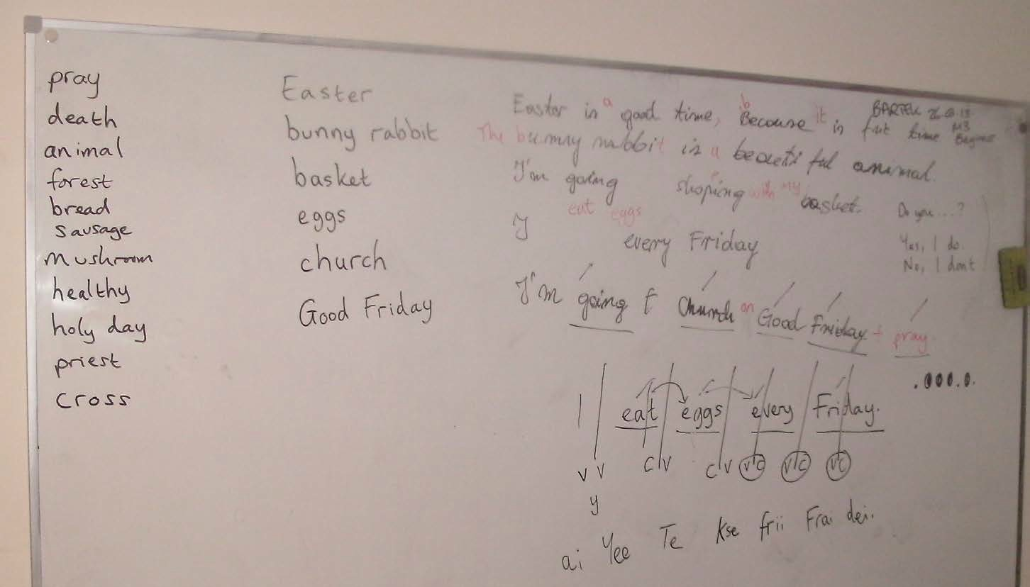

Mode 3 Beginner (SL) – comparison with using a course book for a 60-minute lesson

S = speaking; L = listening; P = pronunciation; I = imagination; W = writing; R = reading

YATCB M3  Beginner | Time (approx) | Notes | Elementary Level Course  Book | Time (approx) | Notes
Topic: Easter |  | - Chosen by the T or SS. Appropriate to what they want to  learn, or the moment, e.g. Easter in Easter week | Topic: Family & Home |  | - Whatever the next topic is – work through the book in order
Vocabulary S, L, P, I | 10 | - Words elicited from SS  - Focus on stress and sounds, including phonetic spelling | Vocabulary R, S, L | 10 | - Words chosen by an outside expert  - No pronunciation focus  - Positive: some discussion using the words = communicative
Discussion S, L, P, I | 10 | - T asks wh- questions regarding the keywords chosen; SS thinking and speaking using the words they suggested; improvisation skills used; T corrects errors and pushes SS to say more | Grammar & Vocabulary R | 30 | - SS read true/false sentences  - SS read two short texts – out loud = not specified  - SS read the texts again and underline vocabulary keywords  - SS match keywords to headings  - COULD BE DONE INDIVIDUALLY AT HOME
Writing W, S, L, I | 15 | - SS write their own sentence on the board for each keyword  - SS correct their sentences  - SS improve their sentences | Grammar Point  R | 20 | - SS fill gaps in sentences  - SS unjumble sentences  - COULD BE DONE INDIVIDUALLY AT HOME
Grammar S, L, P, I | 10 | - Formal Q&A using the improved sentences; T asks questions  with a variety of verb forms and SS reply; then swap roles | The final part of the 3-page course book spread involves speaking and listening. However, we wouldn’t normally get to it in a 60-minute lesson with a beginner. Of course, we could choose to do the unit out of sequence, but then we wouldn’t have practised the necessary vocabulary and grammar structures, so it would feel wrong.  Listening: again, this activity could be done by a student working individually at home  Speaking: communicative = positive
Pronunciation S, L, P, W | 15 | - T elicits stressed syllables in one or more of the sentences; SS write stress and stressed vowel sounds; SS show syllables in one or more sentences, then sound  connections, then write the sentence phonetically

Main differences:

  - We don’t need to buy a book – or use illegal photocopies
  - Absence of reading practice in M3 Beginner, which dominates the course book lesson
  - Absence of writing practice (production) in course book lesson
  - Absence of use of imagination, spontaneity, and improvisation in course book lesson – no need, it’s all there on the page
  - My lesson is for beginners but the course book is for elementary – I don’t have any beginner-level course books; are there any? I’m doing this kind of thing from zero learner upwards; they’re learning these techniques from the get go
  - Looking down at the book (course book) vs. looking up at the board and each other (YATCB)
  - Being allowed to write on the board – to see SS’s ideas and handwriting on the board as valid
  - M3 Beginner is much more demanding of the SS, e.g. in terms of speaking and thinking (use of imagination/production)
  - Sitting down for the whole lesson (course book) vs. standing up and moving around (YATCB)
  - Course book lesson is standardised for many different types of students speaking many different first languages; YATCB is tailored to the SS in the classroom because they suggest the topic and the material. This makes it different each time for the teacher – it’s not the same course book spread over and over again
  - In YATCB method SS do regular homework involving grammar, vocabulary, reading/listening comprehension, and writing

Mode 3 Beginner is easier than standard Mode 3 because:

  - the sentences are on the board when SS do Q&A – it’s not all in their heads
  - fewer vocabulary words
  - I give more help and support – I’m less demanding!

Course book used: Potten, H., and Potten, J. Clockwise Elementary Classbook. Oxford: Oxford University Press, 2001. Paperback. pp.10-12

Mode 3 Beginner (UL) board plan on the topic of “Easter” – PPRR activity; 60-minute follow-on lesson with Bartek (company); 02.04.13

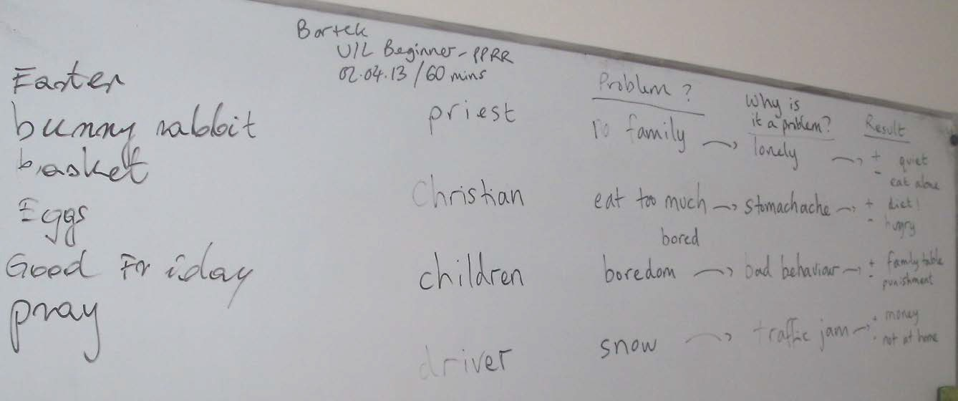

Person: | Problem: | Reason it’s a problem: | Resolution:
priest | no family | lonely | + quiet  - eat alone
Christian | eat too much | stomach ache | + diet!  - hungry
children | boredom | bad behaviour | + family table  - punishment
driver | snow | traffic jam | + money  - not at home

Mode 3 Beginner (SL) annotated board plan on the topic of “Public Transportation”; 50-minute lesson with Irek, who chose the topic; 03.04.13; the notes show the Mode 3 Beginner process

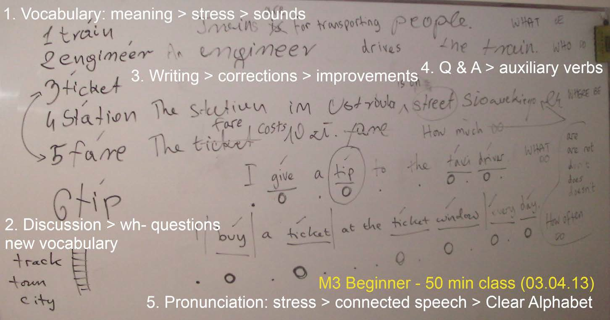

Differences between YATCB Method and Standard Practice (SP) in teaching pronunciation

Standard Practice is represented by the following widely-used text on the subject of English phonetics and phonology:

Roach, Peter. English Phonetics and Phonology, A Practical Course; Fourth Edition; Cambridge: Cambridge University Press, 2009. Paperback

This is to show that there is some theoretical basis to what I do. Some thought has gone into it! My work on pronunciation is based on reading widely (e.g. this book) and choosing the bits I agree with and which work in my classroom, combined with elements that repeatedly prove to be true in my own experience of teaching and writing (e.g. my experiments on connected speech: vc sound connections, friendly consonant sounds, the sound spine, and so on).

- What I already knew – and agree with

- It confirmed some things I have found to be true by experience, but didn’t know to be widely accepted, e.g.
  - ng never occurs initially, therefore it can’t move forward (P.46)
  - t and d often occur at the end of words (P.59)
  - there is one vowel sound per syllable and it forms the nucleus of the syllable where possible (P.60)
  - e.g. I agree with this: P.42: “In reality… aware that they do this.” – how native speakers omit the initial h in words such as he, him, her, etc.
  - This kind of pronunciation work on connected speech is vital for SS so that they can understand English when listening: (P.117) “…learners of English must be made very clearly aware of the problems that they will meet in listening to colloquial, connected speech.” And “An essential part of acquiring fluency in English is learning to produce connected speech without gaps between words, and this is the practical importance of linking” (P.118). Best of all: “…practice usually brings confidence.” – which is what I always tell my students!
  - (P.168) l can become w, e.g. “pill” = Piw

- And other things that are essential building blocks of what I’m teaching, e.g.
  - P.77, “There is a general tendency for verbs to be stressed nearer the end of a word and for nouns to be stressed nearer the beginning.”
  - P.84-87 – a good list of stress rules with suffixes, which is always useful to teach or handy to give out to SS for homework

- What I have learned that could be added

- some new things to consider in SP that could be added, e.g.
  - the short u sound, which is like the short i sound – somewhere between u and υ e.g. in the word influenza: influenzə At the moment I would just use a schwa sound: in fl Wen z, so does u add too much detail?
  - I could write exercises with Clear Alphabet similar to those on P.72: a normal sentence with the consonant sounds below; SS have to fill in the vowel sounds. Especially good for

practising placement of embedded schwa sounds, which are not represented by any symbols, but are there
  - The good point on P.76 that there must be stress rules because, “…in most cases (though certainly not all), when English speakers come across an unfamiliar word, they can pronounce it with the correct stress; in principle, it should be possible to discover what it is that the English speaker knows and to write it in the form of rules.” What we will look at in one of the input lessons of the third term of our school.
  - How we can use logic to find stress in words that don’t comply with any rules (P.78) by considering whether the vowel in each syllable is weak or strong. The weak syllable vowels are: uh, i, ii, and (the new) u: (?!) Most words will have one strong vowel sound syllable and the rest these, apart from, for example compound nouns: cheeseboard – but we know the rule for 2 syllable compound nouns – stress on the first. This is really confirming what I already knew and have been teaching – schwa and second schwa sound i , plus ii. I don’t really use u: in this way, preferring a schwa sound instead. But it’s good to be able to explain this to students, because it makes logical sense. It would be good to try out this theory with a number of polysyllabic words that don’t adhere to a stress rule…
  - When “s” comes at the end of a syllable it will be pronounced as s if the preceding consonant is voiceless but as z if the preceding consonant is voiced, e.g. Jumps and Paks but Dogz and Runz. It’s a small difference, but it feels good to have this clarified and this can be added to the method. (P.113)
  - An interesting point for me personally (P.166): “Some people (who usually turn out to do well in phonetic training) find that in speaking to someone with a different accent their pronunciation gets progressively more like that of the person they are speaking to, like a chameleon adapting its colour to its environment.”

- What have been confirmed for me as fundamental differences

- SP writes phonetic transcriptions with IPA:
  - I don’t use IPA because it can’t be reproduced on a keyboard – we need a different, non- standard, font; it is elitist and antiquated; it is difficult to learn; it’s another alphabet to learn. Clear Alphabet uses familiar Roman letters; CA shows the stressed syllable, which is helpful for SS, reinforcing the stress rules within word classes – SP does not. Challenge: why deviate from the norm? The full alphabet chart page is enough to put off most students – all but the most interested in phonetics, i.e. not 99.9% of students.
  - CA shows the syllable break in a word. In SP there is disagreement regarding where that might be (P.61-62) but in CA I’m sure it is where the vc connection occurs.
  - SP acknowledges that it is necessary to use symbols that can be transcribed using a keyboard (pp.35 & 37).
  - The standard IPA phonemic chart contains 44 phonemes for Standard Pronunciation English (p.34); CA has 48.
- SP writes phonetic transcriptions word by word (P.171). Final consonant sounds in syllables do not move forward, e.g.
  - “Six fat men stopped” = sks ft men stɒpt but in CA I would write: Si Ksfa_ Men Stopt. Or:
  - “Tom picked up twelve books” = tom pkt p twelv bυks = Tom Pi Ktu Ptwel Fbuuks
  - P.89: a həυp ðət ʃi wl = ai Heu pth_ shi Wil.
  - Connected speech: I show the connections between syllables using Clear Alphabet. Formal study does not, e.g. hi wəz leit wɒznt i = hi w Slei_ Wo zn tii? (P.91)

- glottal stop is not recognised as important (see above) in SP:
  - “The glottal plosive occurs frequently but it is of less importance, since it is usually just an alternative pronunciation of p, t, k in certain contexts.” (p.26) But it is crucial for understanding when listening to native speakers talk – and for communicating too using connected speech. Typical dismissive academic statement!
- SP writes phonetically according to rules and principles of its system, rather than how the language sounds, e.g. in writing word by word, not showing syllables, and not showing consonant sounds moving forward:
  - e.g. ði pl represents “the apple” – without any linking consonant: thii Ya pl Who speaks like that without the y ? (P.51)
- no mention of vc sound connections as being the goal
- the importance of stressed vowel sounds (the sound spine) is not mentioned in SP
- no mention of friendly consonant sounds – which really work
- SP discusses assimilation in a way that ignores the necessity of a vc sound connection:
  - See examples on P.111: “that man” = ðp mn and “meat pie” = mip pa and “good boy” = υb bɔ . Who would pronounce the double consonant sounds in the middle of these phrases? Nobody I know! They are just there to fit the system. That is how I remember being taught connected speech. Is this why teachers don’t usually bother following up on this line of study – because they know from their experience that it isn’t true to life? Because they smell a rat?
- SP worries about secondary stress, while I don’t:
  - Stress is only primary; we don’t worry about secondary stress; it’s hard enough to get students to hear one stressed syllable per word, let alone two!
- SP worries about the physical act of speaking, while I don’t, apart from when we focus on difficult to make sounds:
  - Physiology: we don’t focus very much on the physical action of speaking – the organs of speech production. We don’t focus on HOW to make the sounds, apart from difficult sounds like glottal stop and th/tt sounds. We assume that all students can make all the sounds, apart from these; the difficult sounds will vary language by language, e.g. in Japanese l will be more difficult to pronounce. We don’t spend time focusing on tongue, lip, teeth position in each sound – because we haven’t got time. Students learn by listening to a good model – the teacher or a CD/MP3. Teachers can focus on the difficult sounds, not the theory of how to make all the sounds. Theory is interesting in its own right, but our purpose is practice via production.
  - This is because the aim of my classes is communication – not how we do it, or why – but to do it! To communicate – and stress and vowel sounds make this possible; wrong stress and vowel sounds make it much harder; so that’s why we focus on correct stress and vowel sounds.
- SP spends five chapters dealing with intonation, while I discuss it only briefly:
  - Intonation – we don’t worry too much about intonation. Why not? It is largely intuitive – especially for speakers whose mother tongue is an intonation language, like European students, rather than a tone language (e.g. many Asian and African languages) (P.129). Is this right? We could do an input session and look at it week by week, but getting the correct stressed syllables and sounds is far more of a problem for them. So it’s horses for courses. Contrast this with working with students from the Middle East (Saudi Arabia) and Asia (Afghanistan).
  - Also, I can model the correct intonation in the classroom and help students to achieve it by listening to them and correcting them – they are not working in a vacuum on their own.
  - After reading about it for five chapters, I am sure I’m right not to focus too much on it!

- SP offers too much detail which is unnecessary for learners [below Proficiency level…]:
  - I try to keep things simple. I don’t teach terms like “voiced labial-palatal approximant”. My classes are accessible for all levels, from zero beginner upwards; even with my simplified approach students find it hard going at times.
  - There is too much unnecessary detail, e.g. the way “which” can be pronounced differently from “witch” with h plus w at the beginning. This is too subtle and not necessary when learners need to learn the basics of stress and sounds. (P.43)
  - Most students haven’t got time to study a separate course in phonetics and phonology; books are expensive too; we’re lucky if we can devote one 90-minute class to this topic, e.g. learning the sounds of English. Students are often expected to do this, to “pick this up” at home – in addition to their regular homework and other studies and time commitments. Only the truly keen and interested will do it.
  - Too much detail in SP: e.g. syllabic consonants without a schwa sound, such as in “bottle”. I hear a schwa sound each time! (PP.68-69) The author even goes as far as to say: “It is important to remember that it is often not possible to say with certainty whether a speaker has pronounced a syllabic consonant, a non-syllabic consonant or a non-syllabic consonant plus ə.” … So this is not for general language students to waste time studying – a tiny, fractional difference in sound.
  - How connected speech is explained on P.109 using a metrical grid. It shows slight gradations of different levels of stress, while what SS need to know is which syllables to hit with stress and which to reduce. That is enough for all levels before Proficiency.

Summary

- While I acknowledge some limitations with Clear Alphabet – for example the fact that there isn’t one symbol for each phoneme can lead to confusion occasionally (e.g. in Bort, “bought”, do we pronounce four phonemes or three?) and the fact that it lacks precision in documenting minute variations in speech sounds, unlike the IPA – I feel vindicated: what I agree with in SP, I already have in my method, or I will add it from now on; of what I don’t agree with, I haven’t been convinced by analysing the mainstream alternative to my method.

Study English Language Centre – Ostróda

Student Questionnaire – March 2013

Please write your answers in Polish and give as much information as you can. Thank you!

In April 2012 we stopped using course books in our classes and began using a method called “You Are The Course Book” (YATCB).
The aim of this method is to give students the time to produce language in the classroom – by speaking and writing. Students are allowed to work with a course book and practise reading and listening comprehension skills at home, but not in the classroom.

- Do you like the way we learn English in the classroom? Why? / Why not?

- Have you noticed that we don’t use a course book in the classroom? Do you miss it?

- Do you prefer using YATCB method in the classroom or using a course book? Please give reasons.

- What are the differences between the two methods?

- Are you learning more quickly in class without a course book? Please give details.

- Have you learned anything new with YATCB method that you would not have learned using a course book in class?

- Are there any disadvantages to not using a course book? Please give details.

- Do you enjoy using a course book for homework?

- Would you like to keep using YATCB method next term, or return to using a course book in class? Please give reasons.

- Do you have any other comments or requests regarding your learning programme at Study English, Ostróda?

General Principles of You Are The Course Book Method (08.01.13)

Benefits for students:

  - Your work
  - Your ideas
  - Your current errors discussed
  - Your present needs met
  - You do the hard work
  - You are engaged
  - T provides the opportunity and the framework: T = form, SS = content

Students:

  - Student-centred – they do most of the work
  - Students work together in pairs and groups, not individually. Little or no individual “brain > content” time
  - Students need to be active learners and work hard. Lessons will be demanding. There is no free ride. You have to work

Teacher:

  - Teacher is a guide. No top-down teaching. Elicit don’t tell
  - Teacher has to be patient and let the students find the answers
  - Let SS make mistakes. They will learn from their errors
  - If you don’t know the answer, “trick it”, or ask the students to find out. Don’t lose your authority
  - Your positioning is important, e.g. where you stand. Don’t stand over students. Stand away. When with them, sit with them at their level and make eye contact
  - Teacher can disappear. Save your energy! Don’t burn yourself up like the candle which gives light. The students should use their energy. They are there to learn. You are a guide directing them but not doing it for them
  - Teacher controls the timing in the lesson, ensuring a variety of activities and elements are covered
  - Teacher controls the student input, encouraging everybody to get involved

Both:

  - Improvise – don’t block. Take other people’s ideas on board. Say “Yes”! Don’t be dismissive

Environment:

  - The classroom language is English
  - There is a whiteboard and pens, or blackboard and chalk. There is a clock; desks, chairs; students bring with them notebooks, pens, dictionaries
  - Use the board – it democratises the process. Everyone can see the work as it progresses
  - There are resources, e.g. dictionaries, reference books, novels, newspapers, magazines, etc.
  - The layout of the furniture is important. Sit students so they are in pairs and facing each another rather than facing you

The Modes:

  - Take as long as you want with Mode 1
  - All the skills are practised regularly – reading, writing, speaking, and listening, but the focus is on productive skills – speaking and writing
  - 7 elements of English are practised regularly – vocabulary, text (reading and listening), grammar, verb forms, pronunciation, free practice, and writing

YATCB – Syllabus for Adult Classes (1 x 90 mins class per week)

Level:

Dates:

Week:  1 | W/C: | Type of Lesson:  Input Lesson # | Topic: | Extra Activities:  specially prepared | Verb Form:  N/A
2 |  | Mode 3 – Studying Language |  |  | PrS / PrC
3 |  | Mode 3 – Using Language |  | student presentations | PaS / PrP
4 |  | Mode 2 – Part 1 |  |  | future – will / going to
5 |  | Input Lesson # |  | specially prepared | N/A
6 |  | Mode 3 – Studying Language |  |  | PrP / PrPC
7 |  | Mode 3 – Using Language |  | student presentations | FirstCon / modal forms
8 |  | Mode 1 – Part 1 | students decide | follow the process | students decide
9 |  | Input Lesson # |  | specially prepared | N/A
10 |  | Mode 3 – Studying Language |  |  | PaP / PaPC
11 |  | Mode 3 – Using Language |  | student presentations | Second & Third Con
12 |  | Test # | N/A | N/A | N/A

My proposed syllabus for Term 3 at Study English, Ostróda – April-June 2013; 13.03.13

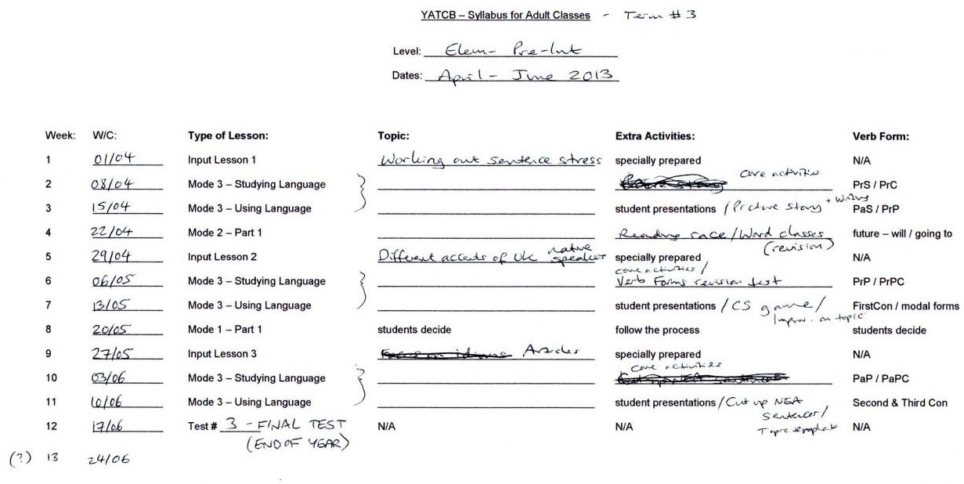

You Are The Course Book 2 – In Practice

Throw away your ELT course books, and let your students create the lesson material!

“Give me ten words – interesting and random.” One of the English as a Foreign Language (EFL) students writes words on the board as other students shout out their ideas: “gravy”, “computer”, “heartbeat”, “ship”… When the ten words are on the board we check everyone understands the meanings and analyse them for stress and sounds; for example “gravy” has got two syllables and is stressed on the first, while “computer” ends with a schwa sound and “heartbeat” contains a glottal stop instead of the middle “t” sound. We move on to the second activity – text production. The students agree to write a children’s story. Each person will write a line of the story on the board, one after the other. The twist is that they must include their ten words somewhere in the story. When the text is finished they work in pairs to correct and then improve it. From the same text we pull out a grammar point – maybe something that has just come up, or a perennial problem area, such as use of articles. After this we stay with grammar, and I ask the students, still working in pairs or small groups, to produce questions and answers with a given verb form, starting with question words (what, where, did, etc.) where the answer lies in the text.

This is the first 90-minute lesson in a two-lesson process. In the concluding lesson, the students will use the same text to study pronunciation – sounds, stress, and connected speech – and to practise their English fluency and improvisational skills in free practice activities, like role playing and discussion. This is You Are The Course Book method, where the students provide the lesson material and do most of the work in class. Based on my book of the same name, which I published last year, this method is founded upon the idea that students attend lessons to learn and practise what they know – to participate. I have found that it works really well with EFL students, who are eager to put down their depressing course books and be creative. Prior to using this method I had been lumbered with the omnipresent EFL course book, which is boring for me to use – since it does all the teaching – and not suitable for class work, because up to 80% of the activities involve reading and listening comprehension activities that can be completed and checked by the students working at home on their own.

You Are The Course Book method helps by providing three modes of learning. In Mode 1, described above, the students do the lot. You don’t need any resources – apart from a board and paper and pens for the students. You can walk into the classroom without preparation and just begin the process. Mode 2 is similar, but students work with a found text – a real example of English, e.g. a newspaper article. In Mode 3 students follow a similar process, but in a much quicker, snappier way, which is great for shorter lessons and online lessons.

I developed this method last year, and published my manifesto online in May. Since then I have been trialling it with small classes of English language students at different levels at my private language school in northern Poland. I have found the results to be really exciting, with students improving their confidence levels and skills rather rapidly, compared with when we used to use a course book. Each lesson is unique, because the text the students create has never been seen or heard anywhere else in the world before. Being present at the birth of creation is much more fun than watching people struggling to fill in the gaps in their course books.

The implications of this method are that we no longer need printed matter for English lessons. Either the students can produce their own material, or the material for analysis can be grabbed from the ether – a leaflet, a song, a letter from your grandma. I’m arguing for a better use of class time; for making it a place where students have a stake in creating their own memorable and enjoyable lessons – and for leaving the tedious book work for homework.

Example of students from Egypt creating their own discussion questions based on elicited vocabulary during a Mode 3 (UL) class online – topic: Hospital; 04.01.13. We used the discussion question prompt sheet (p.370) to give us question types

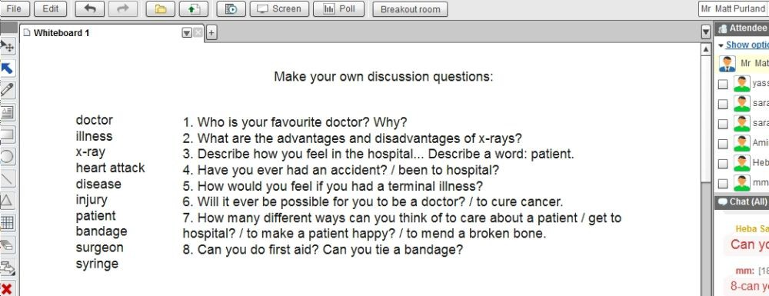

A matching activity made by the Foresters for homework, based on the 10 Famous Events in British History discussion questions (see p.435); they had to adapt it so that instead of being about famous events, it was based on important dates in their lives; 12.02.13

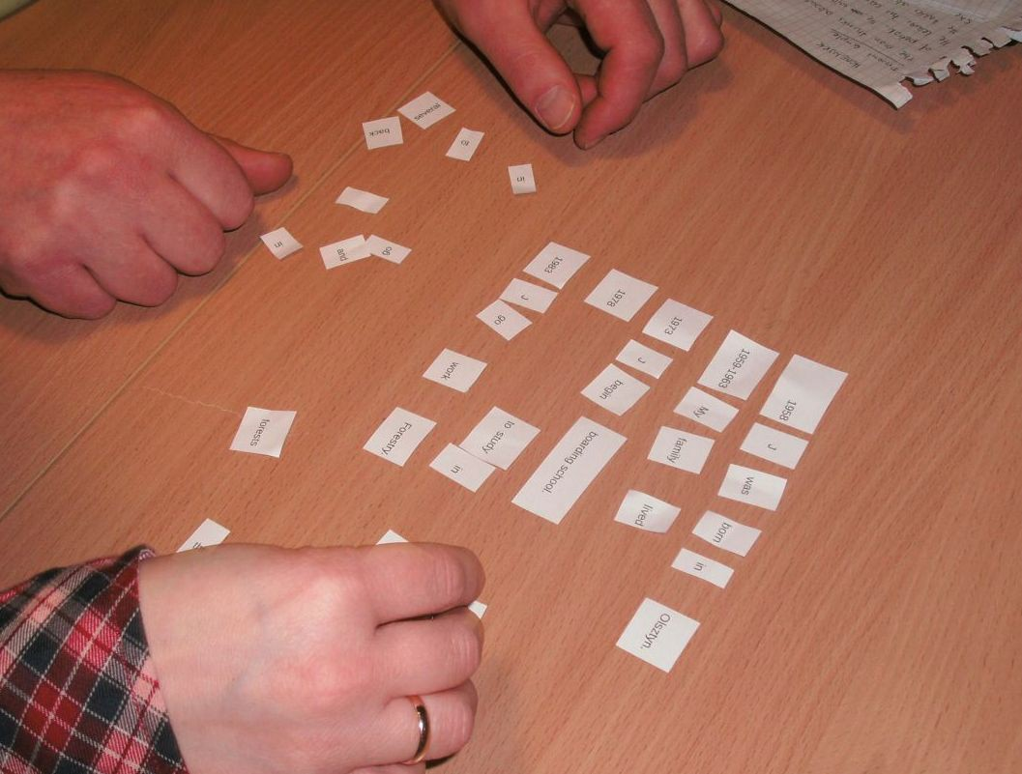

Mode 3 The Environment (UL) planning notes for the picture story activity, including method; 15.01.13

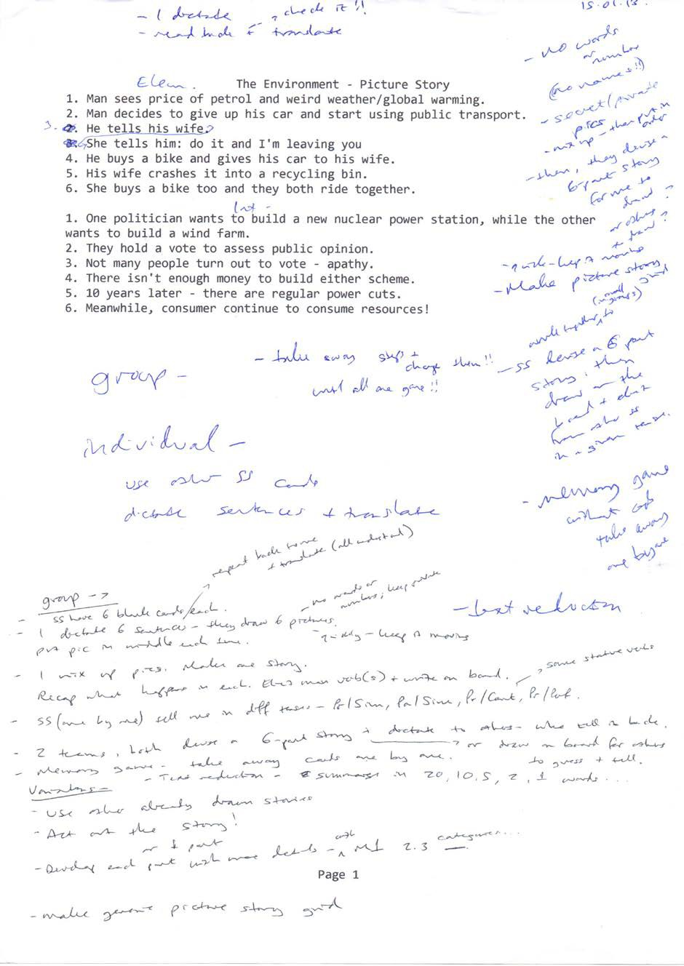

The 40+ vocabulary words from Emilia’s presentation that we checked for stress and vowel sounds; 16.02.13

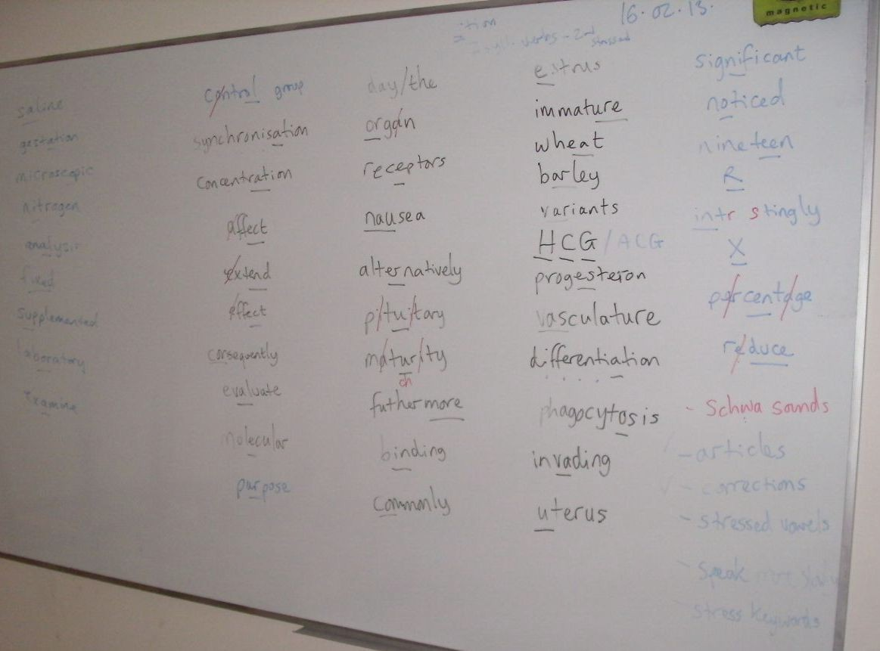

The Foresters’ Mode 1 text – stages 1, 2.1, 2.2, 2.3, and 5; text type: a factual text, e.g. a magazine article; 26.02.13

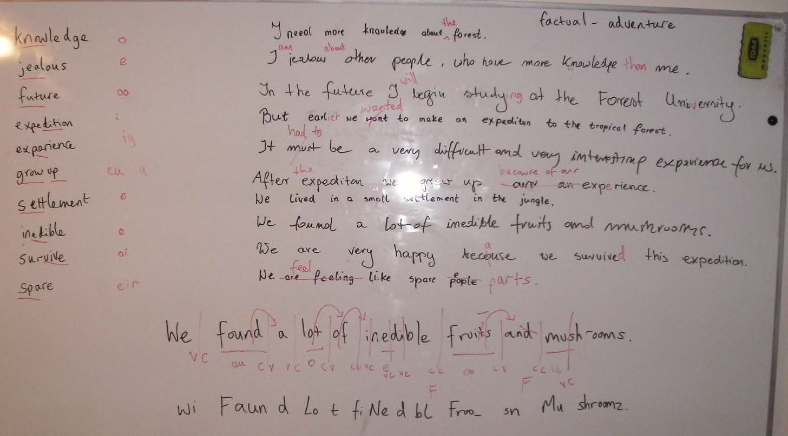

My feedback on students’ presentations during Mode 3 Office (UL) lesson; 19.02.13

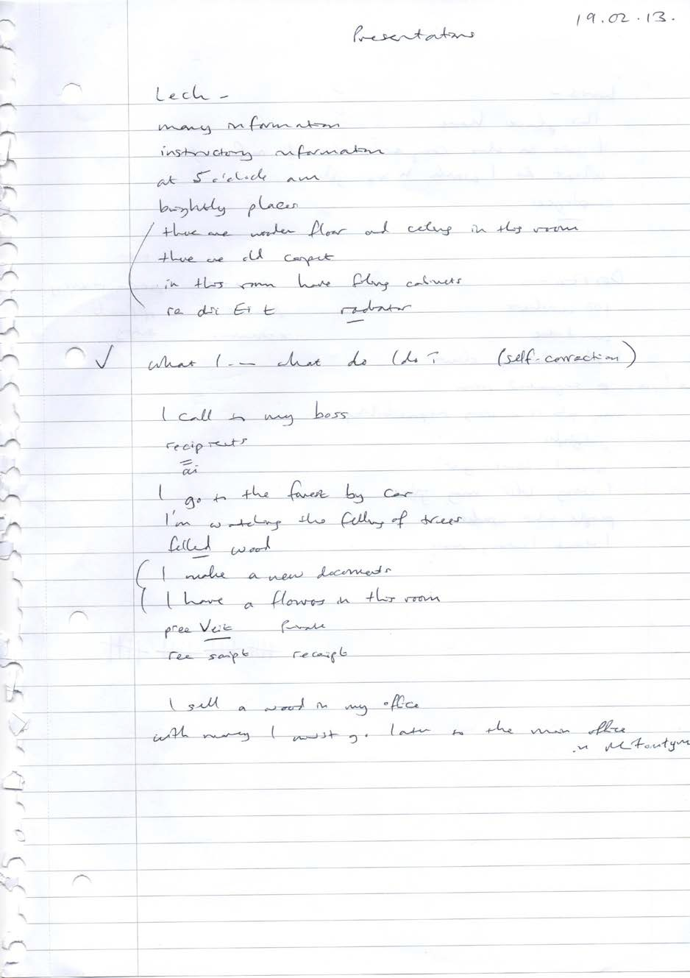

Notes written by Emilia about Past Perfect form during a Mode 3 (SL) lesson on “Fame and Fortune” on 15.03.13; instead of me doing the verb form presentation I spontaneously asked her to do it, thus instituting a new feature: You Are The Teacher! The students can teach each other (or me, in the case of individual students) from the board and I can give guidance, then elicit corrections afterwards; it worked pretty well, although Emilia was very surprised at being asked to teach!

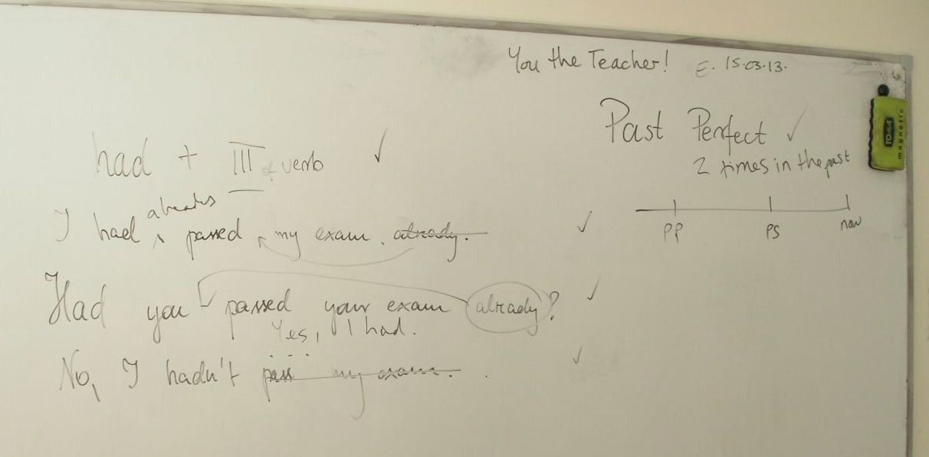

Notes about an improvisation lesson with Tomek (company) on 31.01.13

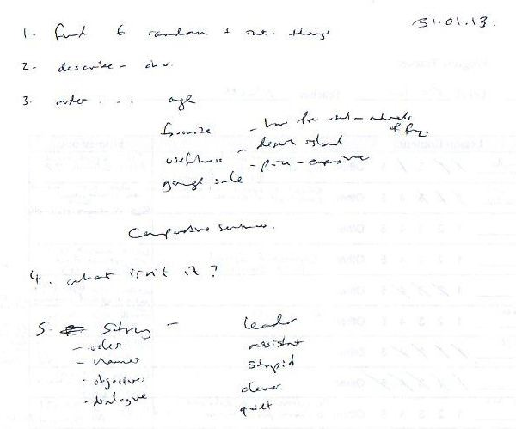

Board plan from a Mode 3 (SL) lesson with Bartek and Tomek on the topic of “Fame and Fortune”; 14.03.13

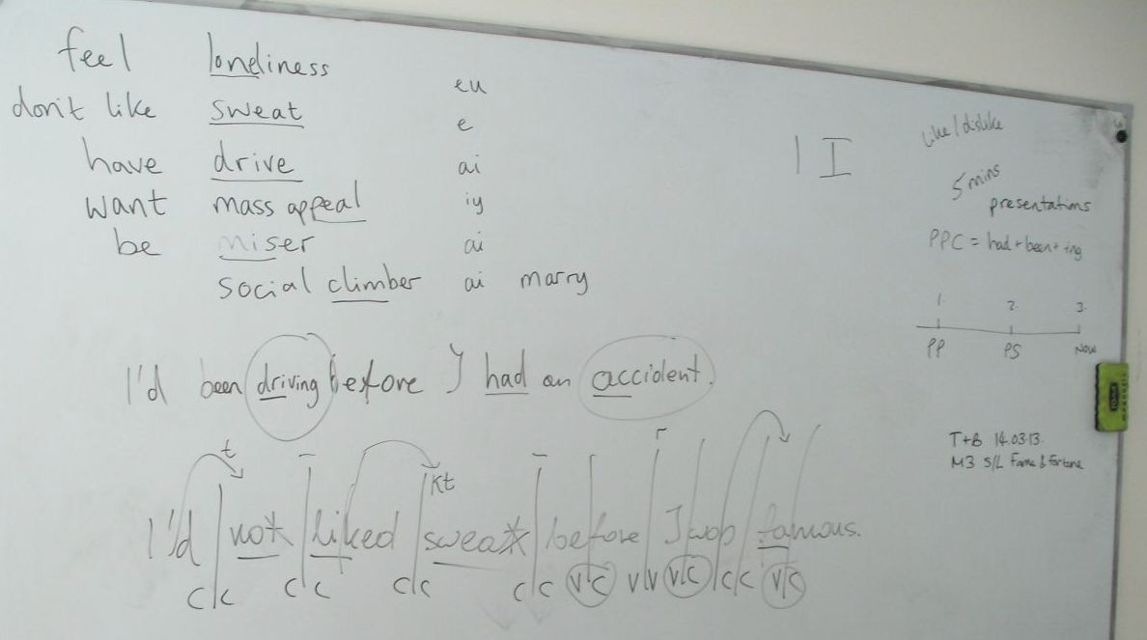

Board plan from a Mode 3 (UL) lesson with Dorota on the topic of “Fame and Fortune”, showing the template for the Create a Celebrity activity that led into role playing; 19.03.13

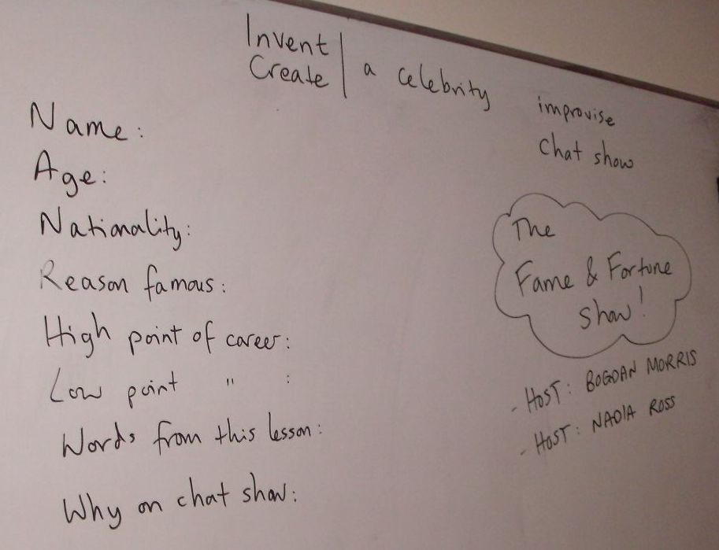

Emilia’s written homework (consolidation) after chat show improvisation, with my notes for correction; March 2013
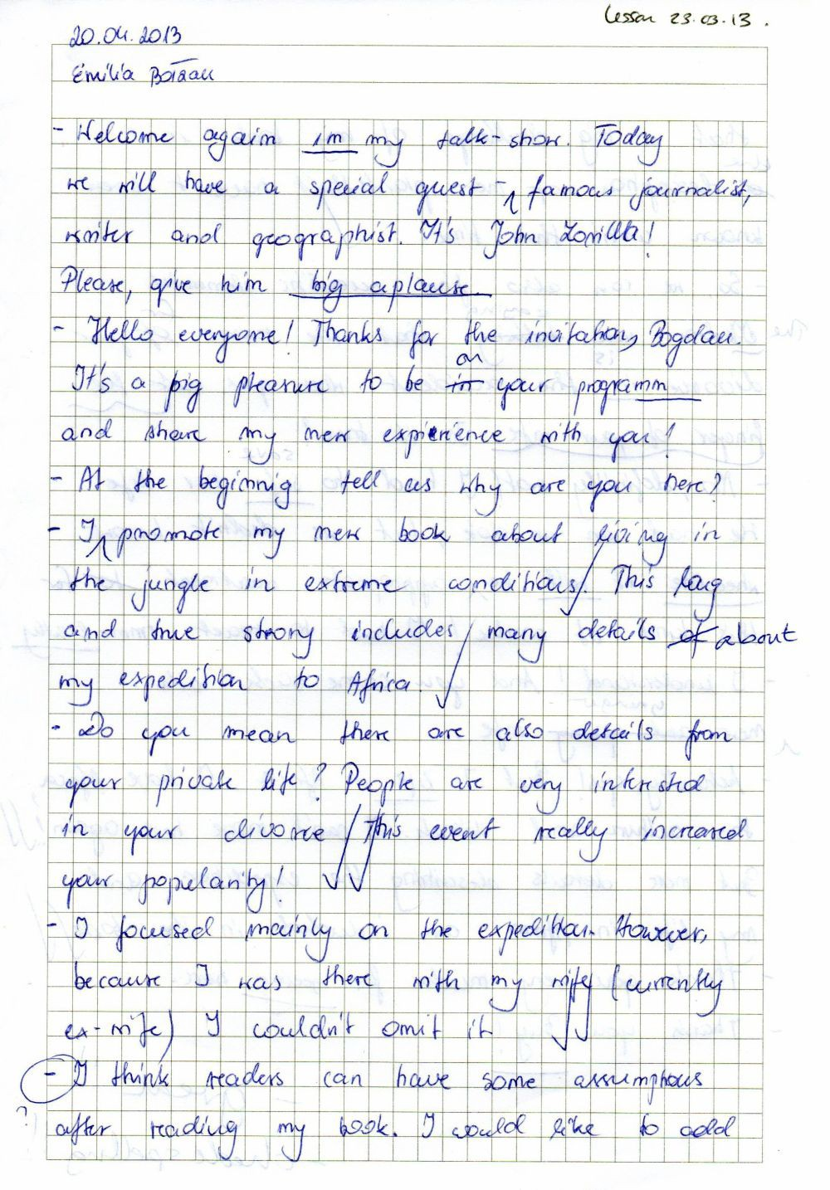

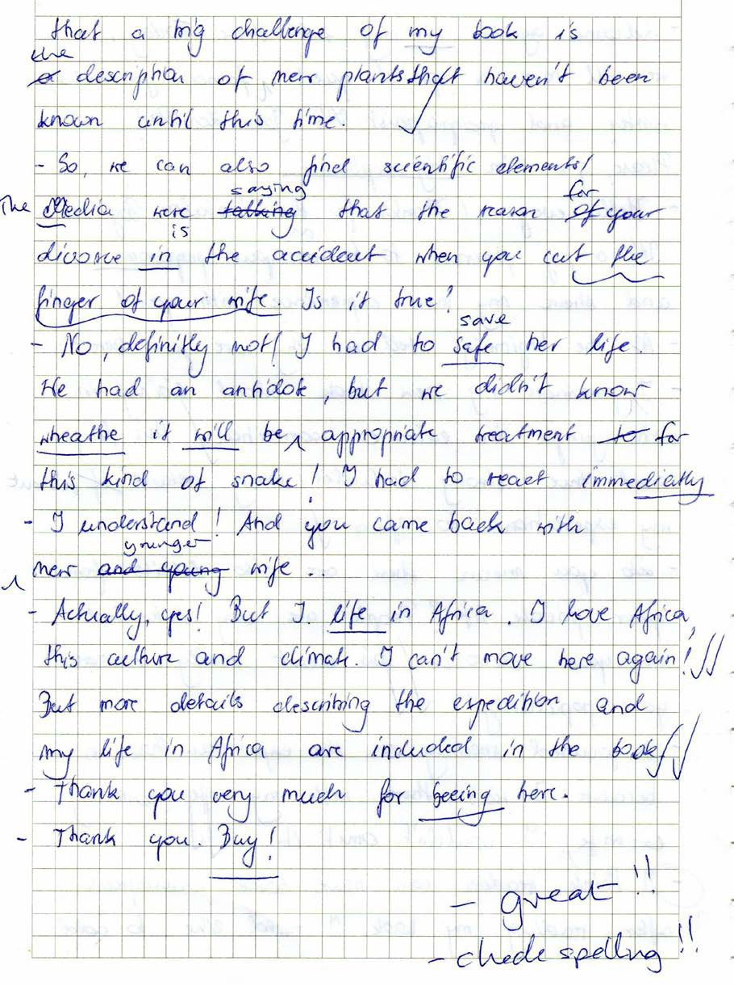

My planning notes for Mode 3 (UL) lessons on the topic of “Fame and Fortune”, with notes taken during the lessons, including presentation feedback for Dorota, role play feedback for various students, and notes about my role play character, prolific author Herbert Stevenson; 17.03.13-23.03.13

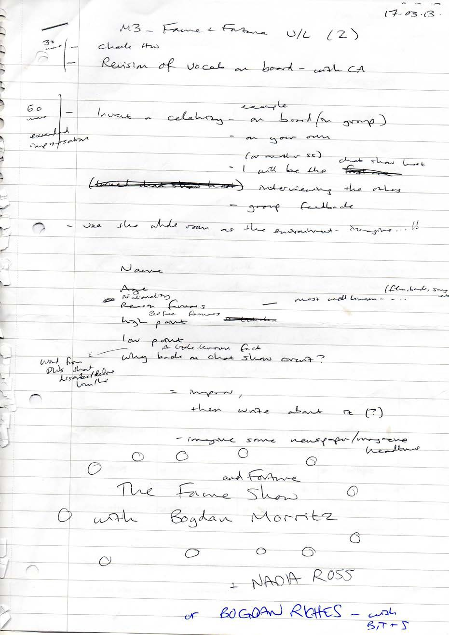

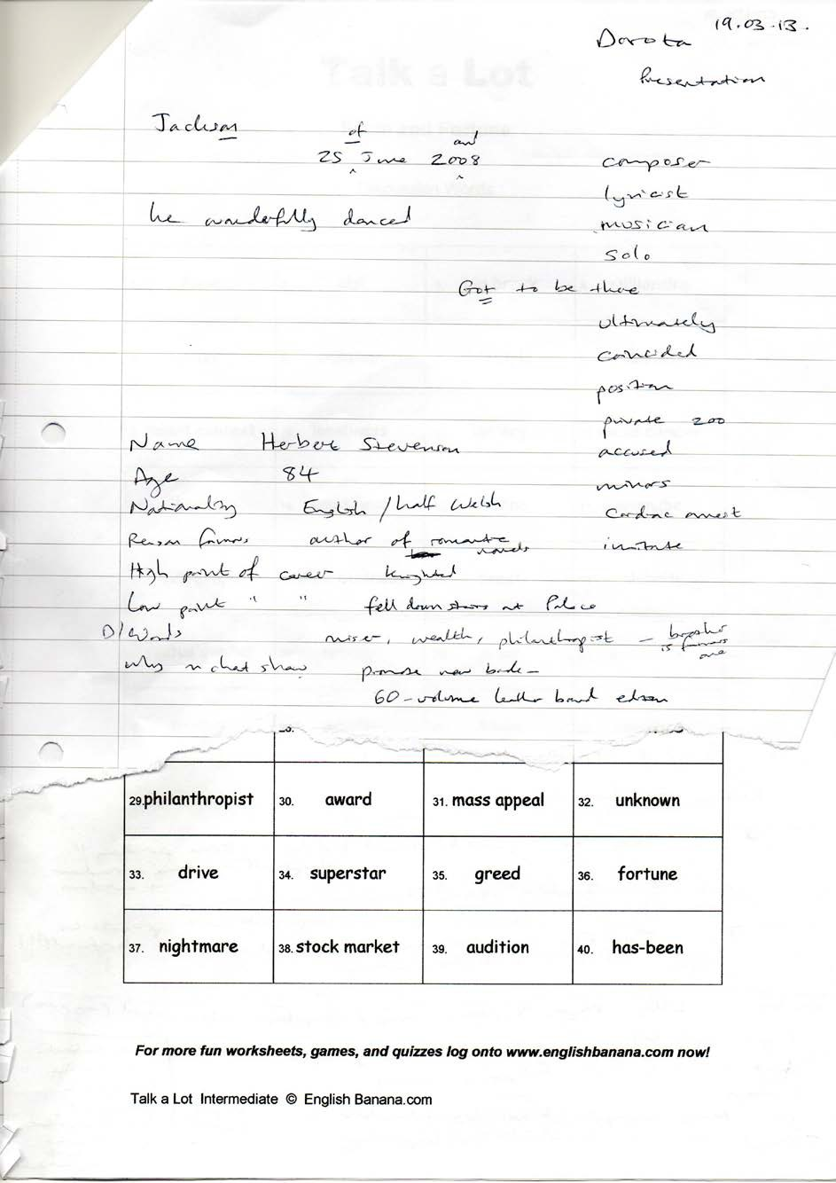

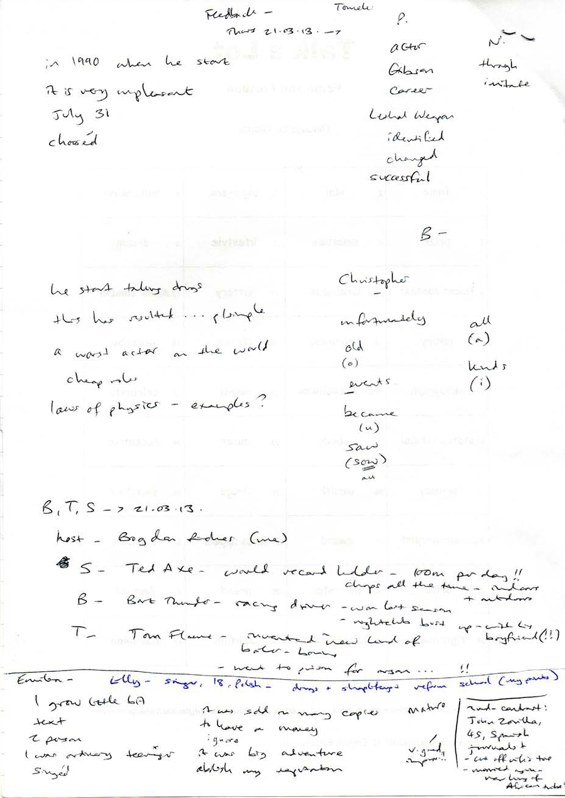

Appendix 2 –

Complete Set of Talk a Lot Discussion Words

Talk a Lot

Discussion Words


1. | 2. | 3. | 4.
5. | 6. | 7. | 8.
9. | 10. | 11. | 12.
13. | 14. | 15. | 16.
17. | 18. | 19. | 20.
21. | 22. | 23. | 24.
25. | 26. | 27. | 28.
29. | 30. | 31. | 32.
33. | 34. | 35. | 36.
37. | 38. | 39. | 40.

Talk a Lot Spoken English Course

Index of 42 Topics with Discussion Words

Topic (A-Z): Level: Source Book:

10 Famous Events in British History | Intermediate | You Are The Course Book 2
Airport | Pre-Intermediate | Talk a Lot Elementary Book 3
Animals | Elementary | Talk a Lot Elementary Book 2
Australia | Pre-Intermediate | Talk a Lot Elementary Book 3
Bonfire Night | Intermediate | You Are The Course Book 2
Books | Pre-Intermediate | Talk a Lot Elementary Book 3
Cars | Elementary | Talk a Lot Elementary Book 2
Christmas | Elementary | Worksheet
Clothes | Beginner | Talk a Lot Elementary Book 1
Colours and Numbers | Elementary | Talk a Lot Elementary Book 2
Crime | Elementary | Talk a Lot Elementary Book 2
Fame and Fortune | Pre-Intermediate | You Are The Course Book 2
Family | Beginner | Talk a Lot Elementary Book 1
Films | Pre-Intermediate | Talk a Lot Elementary Book 3
Food and Drink | Beginner | Talk a Lot Elementary Book 1
Free Time | Beginner | Talk a Lot Elementary Book 1
Getting a Job | Intermediate | Talk a Lot Intermediate Book 4
Health | Beginner | Talk a Lot Elementary Book 1
Home | Beginner | Talk a Lot Elementary Book 1
Hospital | Pre-Intermediate | Talk a Lot Elementary Book 3
Hotel | Intermediate | Talk a Lot Intermediate Book 1
Internet | Pre-Intermediate | Talk a Lot Elementary Book 3
Learning English | Pre-Intermediate | Talk a Lot Elementary Book 3
Life Events | Elementary | Talk a Lot Elementary Book 2
Media | Intermediate | Talk a Lot Intermediate Book 3
Money | Pre-Intermediate | Talk a Lot Elementary Book 3
Music | Elementary | Talk a Lot Elementary Book 2
Nature | Elementary | Talk a Lot Elementary Book 2
Office | Elementary | You Are The Course Book 2
Places in the UK | Pre-Intermediate | Talk a Lot Elementary Book 3
Politics | Pre-Intermediate | Talk a Lot Elementary Book 3
Problems | Intermediate | Talk a Lot Intermediate Book 2
Railway Station | Pre-Intermediate | You Are The Course Book 2
Shopping | Beginner | Talk a Lot Elementary Book 1
Sport | Elementary | Talk a Lot Elementary Book 2
The Environment | Pre-Intermediate | You Are The Course Book 2
The Human Body | Elementary | Talk a Lot Elementary Book 2
Town | Beginner | Talk a Lot Elementary Book 1
Toy Catalogue | Pre-Intermediate | You Are The Course Book 2
Transport | Beginner | Talk a Lot Elementary Book 1
Weather | Elementary | Talk a Lot Elementary Book 2
Work | Beginner | Talk a Lot Elementary Book 1

Talk a Lot

10 Famous Events in British History

Discussion Words

1.  ice sheet |   2.  melt | 3.  divide Britain and Europe | 4.  20,000-40,000  years BC
5.  Romans | 6.  leave | 7.  Britain | 8.  410
9.  Vikings | 10.  invade | 11.  York | 12.  866
13.  Black Death | 14.  kill | 15.  1.4 million people | 16.  1348
17.  Geoffrey Chaucer | 18.  write | 19.  The Canterbury Tales | 20.  1387-1400
21.  William Shakespeare | 22.  die | 23.  Stratford- upon-Avon | 24.  1616
25.  Scotland | 26.  unite | 27.  England and Wales | 28.  1707
29.  women | 30.  get | 31.  the vote | 32.  1918
33.  England Football Team | 34.  win | 35.  World Cup | 36.  1966
37.  Sir Tim Berners-Lee | 38.  invent | 39.  world wide web | 40.  1989

Talk a Lot Elementary

Talk a Lot

Airport

Discussion Words

ticket |   holiday | flight | departure lounge
economy class | check-in desk | passenger | customs
turbulence | duty-free | excess baggage | destination
seatbelt | long-haul flight | luggage | crash
boarding pass | airline | landing | transfer
take-off | business class | arrivals | aeroplane
airport | passport | terminal | pilot
priority boarding | runway | seat | gate
passport control | reservation | security guard | visa
upgrade | flight attendant | budget airline | tourist

Talk a Lot

Animals

Discussion Words:

zebra | crocodile | spider | kangaroo
panda | insect | tiger | lizard
bear | hippopotamus | giraffe | cat
elephant | sheep | gorilla | tortoise
ant | snail | whale | octopus
goldfish | lion | caterpillar | monkey
dog | bee | shark | cow
horse | worm | starfish | fish
mouse | butterfly | rabbit | bird
pig | dolphin | frog | mammal

Talk a Lot

Australia

Discussion Words

rainforest |   Sydney | Aboriginal Australians | kangaroo
Pacific Ocean | didgeridoo | minerals | Brisbane
walkabout | Queensland | footy | great white shark
mining | barbie | climate change | Outback
koala bear | Shane Warne | forest fire | emu
coast | Canberra | Uluru | Kylie Minogue
duck-billed platypus | soap opera | Barossa Valley | drought
melting pot | convict | Sydney Opera House | Gallipoli
boomerang | Great Barrier Reef | pom | Captain Cook
transportation | Cate Blanchett | immigration | gold rush

Talk a Lot

Bonfire Night

Discussion Words

1. safety |   2. firefighter | 3. punishment | 4. King James I
5. gunpowder | 6. terrorist | 7. baked potato | 8. firework
9. Catholic | 10. bonfire | 11. Protestant | 12. sparkler
13. conspiracy | 14. community | 15. Guy Fawkes | 16.5th November
17. religion | 18. Houses of Parliament | 19. accident | 20. plot
21. | 22. | 23. | 24.
25. | 26. | 27. | 28.
29. | 30. | 31. | 32.
33. | 34. | 35. | 36.
37. | 38. | 39. | 40.

Talk a Lot

Books

Discussion Words

novel |   chapter | non-fiction | fantasy
bookshop | paperback | author | romance
science fiction | library | word | index
illustration | front cover | genre | story
plot | title | fiction | thriller
spine | play | hardback | character
biography | paragraph | ebook | page number
introduction | page | poetry | sentence
children’s book | literature | quotation | contents
translation | autobiography | back cover | reader

Talk a Lot

Cars

Discussion Words:

engine | automatic | boot | windscreen
parking ticket | road | fuel | accelerator
zebra crossing | wheel | hazard | pedal
brake | brake light | road rage | seatbelt
accident | side mirror | tyre | learner driver
licence plate | passenger | Highway Code | driver
L-plate | clutch | ban | gear stick
Sunday driver | indicator | breakdown recovery service | battery
seat | sports car | handbrake | rear view mirror
road sign | steering wheel | dashboard | headlights

Talk a Lot

Christmas

Discussion Words

1.  pudding |   2.  card | 3.  present | 4.  cracker
5.  mince pie | 6.  New Year’s Eve | 7.  Jesus Christ | 8.  nativity
9.  carol | 10.  advent calendar | 11.  late-night shopping | 12.  turkey
13.  Father Christmas | 14.  work do | 15.  goodwill | 16.  in-laws
17.  get-together | 18.  snowman | 19.  decoration | 20.  tree
21.  tinsel | 22.  materialism | 23.  manger | 24.  depression
25.  mulled wine | 26.  Bethlehem | 27.  over-indulgence | 28.  angel
29.  bauble | 30.  anticipation | 31.  tradition | 32.  stocking
33.  pantomime | 34.  sprout | 35.  Lapland | 36.  Boxing Day
37.  reindeer | 38.  mistletoe | 39.  holly | 40.  Mary and Joseph

Talk a Lot Intermediate Book 1

Talk a Lot

Clothes

Discussion Words:

slipper | zip | vest | tracksuit
tie | buttons | earring | blouse
nightdress | bra | dress | suit
trousers | high heels | t-shirt | jumper
pants | underwear | ring | necklace
tights | jeans | skirt | glasses
shorts | knickers | coat | pyjamas
scarf | sock | belt | shoe
jacket | top | trainer | shirt
handbag | uniform | hat | glove

Talk a Lot

Colours and Numbers

Discussion Words:

nine | thirty | blue | thirteen
fourteen | red | twenty | three
hundred | seventy | purple | ninety
yellow | one | eight | twelve
five | forty | nineteen | black
ten | zero | grey | two
brown | four | eleven | fifty
seven | fifteen | orange | seventeen
eighteen | sixty | eighty | six
white | green | sixteen | pink

Talk a Lot

Crime

Discussion Words:

suspended sentence | detective | fine | appeal
GBH | police station | innocence | neighbourhood watch scheme
prison sentence | victim | criminal | gun
terrorism | guilt | burglar alarm | prison
electronic tag | life sentence | community service | solicitor
trial | antisocial behaviour | punishment | suspect
blackmail | witness | theft | arson
handcuffs | judge | violence | fingerprints
police officer | drug trafficking | shoplifting | court
jury | arrest | murder | defendant

Talk a Lot

The Environment

Discussion Words

1.  waste |   2.  recycling | 3.  nature | 4.  climate change
5.  wind farm | 6.  consumer | 7.  global warming | 8.  eco-warrior
9.  economy | 10.  oil | 11.  fossil fuel | 12.  litter
13.  ice cap | 14.  activist | 15.  greed | 16.  earthquake
17.  cycle lane | 18.  energy | 19.  forest fire | 20.  air pollution
21.  Green Party | 22.  weird weather | 23.  environment | 24.  pressure group
25.  exhaust fumes | 26.  ozone layer | 27.  devastation | 28.  petrol
29.  public opinion | 30.  alternative energy | 31.  self-interest | 32.  drought
33.  scientist | 34.  polar bear | 35.  exploitation | 36.  sceptic
37.  disaster | 38.  pollution | 39.  flooding | 40.  apathy

Talk a Lot Elementary

Talk a Lot

Fame and Fortune

Discussion Words

1. fame |   2. idol | 3. big break | 4. millionaire
5. prize | 6. ambition | 7. lifestyle | 8. dream
9. talent contest | 10. loneliness | 11. lottery | 12.social climber
13. luxury | 14. emptiness | 15. chance | 16. wannabe
17. autograph | 18.show business | 19. sweat | 20. celebrity
21.status symbol | 22. nobody | 23. miser | 24. eccentric
25. privacy | 26. wealth | 27. drugs | 28. sacrifice
29.philanthropist | 30. award | 31. mass appeal | 32. unknown
33. drive | 34. superstar | 35. greed | 36. fortune
37. nightmare | 38. stock market | 39. audition | 40. has-been

Talk a Lot

Family

Discussion Words:

boyfriend | mother | son | grandchild
adopted family | father-in-law | girl | niece
granddad | child | grandma | brother-in-law
mother-in-law | foster parent | dad | nephew
mum | uncle | woman | girlfriend
grandson | daughter | parent | brother
baby | ex- | aunt | family
fiancée | sister-in-law | cousin | father
husband | sister | man | partner
boy | fiancé | wife | granddaughter

Talk a Lot

Films

Discussion Words

blockbuster |   home movie | record | classic
pause | film | sequel | screenplay
subtitles | flop | widescreen | romance
DVD player | projectionist | cinema | DVD
star | horror | comedy | forward
box office | actor | plot | video camera
review | action | surround sound | popcorn
rental | animation | soundtrack | actress
director | award | special effects | play
drama | editor | download | hero

Talk a Lot

Food and Drink

Discussion Words:

milk | carrot | rice | soup
orange | bread | tomato | banana
pizza | mineral water | fruit | cereal
meal | sausage | potato | wine
crisps | cheese | lemonade | lamb
onion | nut | butter | fruit juice
meat | chocolate | fish | flour
vegetable | chicken | apple | egg
pie | chips | food | pasta
strawberry | water | beef | mushroom

Talk a Lot

Free Time

Discussion Words:

tent | swimming pool | internet | tennis
fishing | cooking | camping | relaxation
hobby | cinema | hiking | picnic
volleyball | hotel | computer game | cycling
leisure centre | sleeping bag | rugby | park
skiing | holiday | theatre | climbing
swimming | reading | watching TV | weekend
sport | football | café | safari park
bowling club | playground | jogging | sunbathing
golf | basketball | beach | amusement park

Talk a Lot

Getting a Job

Discussion Words

1.  perseverance |   2.  voluntary work | 3.  preparation | 4.  curriculum vitae [CV]
5.  self-improvement | 6.  achievements | 7.  presentation | 8.  strategy
9.  nerves | 10.  training course | 11.  seasonal work | 12.  body language
13.  key skills | 14.  discipline | 15.  success | 16.  networking
17.  promotion | 18.  application form | 19.  self-esteem | 20.  work experience
21.  recruitment agency | 22.  independence | 23.  candidate | 24.  objective
25.  rejection letter | 26.  employment history | 27.  jobseeker | 28.  redundancy
29.  Jobcentre Plus | 30.  rival | 31.  qualifications | 32.  discrimination
33.  salary | 34.  mortgage | 35.  classified advert | 36.  goal
37.  referee | 38.  job security | 39.  covering letter | 40.  interviewer

Talk a Lot Intermediate Book 1

Talk a Lot

Health

Discussion Words:

infection | bruise | toothbrush | cut
stomach ache | health | emergency | illness
pharmacy | surgery | stethoscope | stretcher
toothpaste | broken bone | hospital | cancer
dentist | injection | stitches | receptionist
headache | waiting room | crutch | ambulance
nurse | fever | tablets | examination
x-ray | doctor | plaster | appointment
prescription | wheelchair | allergy | patient
rash | accident | problem | needle

Talk a Lot

Home

Discussion Words:

house | carpet | bathroom | light
DVD player | bedroom | apartment | detached house
semi-detached house | bungalow | cooker | flat
cupboard | garden | dining room | washing machine
fireplace | kitchen | door | garage
freezer | ceiling | stairs | wall
fridge | radiator | television | sideboard
hall | floor | toilet | sink
living room | dining chair | bed | bath
shower | sofa | dining table | wardrobe

Talk a Lot

Hospital

Discussion Words

patient |   wheelchair | clinic | accident
visiting hours | emergency | appointment | ward
x-ray | surgeon | hospital | pain
broken arm | anaesthetic | diagnosis | blood test
nurse | consultant | drip | trolley
porter | maternity | outpatient | syringe
illness | A & E | mortuary | doctor
waiting list | injury | NHS | heart attack
ambulance | crutch | midwife | operation
corridor | stethoscope | medical student | psychiatrist

Talk a Lot

Hotel

Discussion Words

1.  dinner |   2.  arrival | 3.  receptionist | 4.  complaint
5.  cancellation | 6.  communication skills | 7.  sauna | 8.  wake up call
9.  hospitality | 10.  room service | 11.  food hygiene | 12.  complimentary newspaper
13.  vegetarian | 14.  restaurant | 15.  hotel | 16.  continental breakfast
17.  lunch | 18.  swipe card | 19.  refund | 20.  housekeeper
21.  sous chef | 22.  business trip | 23.  reservation | 24.  morale
25.  eye contact | 26.  bouncer | 27.  waiter | 28.  catering assistant
29.  facilities | 30.  en-suite bathroom | 31.  vacancy | 32.  welcome
33.  fitness suite | 34.  maid | 35.  bed and breakfast | 36.  holiday rep
37.  chef | 38.  spa | 39.  duty manager | 40.  departure

Talk a Lot Intermediate Book 1

Talk a Lot

The Human Body

Discussion Words:

head | skin | bone | finger
chest | neck | elbow | blood
throat | vein | face | hair
skeleton | knee | back | hand
leg | eye | toe | liver
heart | stomach | nail | nose
tongue | ear | foot | cheek
tooth | wrist | lung | arm
chin | kidney | mouth | brain
lip | shoulder | muscle | ankle

Talk a Lot

Internet

Discussion Words

Wi-Fi |   link | email | download
Google | cookie | internet | podcast
social network | spam | advertising | webcam
cyberspace | attachment | history | password
home page | forum | account | world wide web
Twitter | profile | security | connection
username | Facebook | search engine | ISP
browser | inbox | pen drive | comment
YouTube | URL | web server | favorites
virus | website | hacker | chat

Talk a Lot

Learning English

Discussion Words

word |   course | student | grammar
partner | auxiliary verb | consonant | qualification
class | answer | letter | vowel
speaking | school | lesson | question
alphabet | example | vocabulary | sentence
noun | writing | teacher | homework
stress | pronunciation | verb | listening
language | syllable | dictionary | reading
test | exercise | examination | adjective
level | break | spelling | sound

Talk a Lot

Life Events

Discussion Words:

bridesmaid | stag night | midwife | menopause
widow | birth | biography | wedding
funeral | education | terminal illness | affair
mistress | marriage | redundancy | groom
best man | qualification | childhood | further education
graduation | labour | coffin | pregnancy
death | adolescence | engagement | employment
friendship | custody battle | birthday | separation
divorce | teenager | bride | best friend
anniversary | first kiss | growing pains | old age

Talk a Lot

Media

Discussion Words

1.  ratings |   2.  tabloid | 3.  web page | 4.  jingle
5.  file sharing | 6.  advert | 7.  freesheet | 8.  channel
9.  headline | 10.  box set | 11.  paparazzi | 12.  feature
13.  presenter | 14.  censorship | 15.  competition | 16.  article
17.  podcast | 18.  programme | 19.  streaming video | 20.  mobile
21.  remote control | 22.  journalist | 23.  editor | 24.  HDTV
25.  listener | 26.  data transfer | 27.  playlist | 28.  interactive content
29.  reality TV | 30.  subtitles | 31.  convergence | 32.  show
33.  gossip | 34.  bias | 35.  viewer | 36.  [Wi-Fi] device
37.  digital radio | 38.  touchscreen | 39.  TV licence | 40.  sidekick

Talk a Lot Intermediate Book 1

Talk a Lot

Money

Discussion Words

coin |   interest | expenditure | balance
salary | bank | mortgage | wallet
bank account | overdraft | change | income
loan | payment | investment | pence
cheque | note | debt | currency
deposit | cashpoint | poverty | thief
savings | stock market | chequebook | cash
withdrawal | tax | accountant | purse
inheritance | debit card | charity | benefits
price | millionaire | pound | credit card

Talk a Lot

Music

Discussion Words:

drum | R & B | rock | orchestra
group | musical | saxophone | violin
brass | pop | conductor | oboe
blues | trumpet | audience | guitar
string | instrument | folk | nightclub
pop star | stereo | classical | keyboard
piano | electric guitar | wind | radio
singer | jazz | verse | double bass
musician | organ | ballet | choir
chorus | DJ | performer | hip-hop

Talk a Lot

Nature

Discussion Words:

forest | river | sea | hill
countryside | land | winter | fire
cliff | stream | sky | plant
environment | season | field | ocean
reservoir | sand | flower | valley
national park | lake | sunset | spring
beach | coast | crop | mountain
air | summer | water | grass
waterfall | desert | tree | geography
bush | rainbow | autumn | wave

Talk a Lot

Office

Discussion Words

1.  whiteboard | 2.  door |  3.  pencil | 4.  mouse
5.  client | 6.  wall | 7.  air conditioning | 8.  argument
9.  admin assistant | 10.  marker | 11.  pen | 12.  meeting
13.  boredom | 14.  stationery | 15.  carpet | 16.  PA
17.  contract | 18.  phone | 19.  stapler | 20.  coffee machine
21.  scissors | 22.  ceiling | 23.  window | 24.  work
25.  eraser | 26.  photocopier | 27.  computer | 28.  hole punch
29.  in-tray | 30.  shelf | 31.  fax machine | 32.  promotion
33.  filing cabinet | 34.  curtain | 35.  printer | 36.  chair
37.  radiator | 38.  manager | 39.  desk | 40.  file

Talk a Lot

Places in the UK

Discussion Words

Snowdonia |   Skegness | Giant’s Causeway | Edinburgh
Scotland | Oxford | Manchester | York
Llandudno | Hathersage | Wimbledon | Norwich
Hadrian’s Wall | Brick Lane | English Channel | United Kingdom
Aberdeen | Bristol | England | Cardiff
Bournemouth | Norfolk Broads | Alton Towers | London
John o’Groats | Stonehenge | Sherwood Forest | Greenwich
Great Britain | Orkney | Cardigan Bay | Cambridge
Belfast | Lake District | Wales | Clumber Park
Loch Ness | Northern Ireland | Land’s End | Stratford-upon-Avon

Talk a Lot

Politics

Discussion Words

government |   trust | democracy | voter
representative | MP | politics | improvement
debate | strike | decision | Conservative Party
economy | council | election | tax
president | Labour Party | policy | state
dictator | satire | United Nations | anarchist
idealism | corruption | bill | politician
monarchy | citizen | prime minister | ideology
opposition | mayor | majority | fascism
constituency | Parliament | legislation | freedom

Talk a Lot

Problems

Discussion Words

1.  neglect |   2.  divorce | 3.  fuel bill | 4.  sibling rivalry
5.  peer pressure | 6.  disillusionment | 7.  criminal record | 8.  obesity
9.  loneliness | 10.  student loan | 11.  boredom | 12.  high expectations
13.  ambition | 14.  detention | 15.  state pension | 16.  appearance
17.  reconciliation | 18.  Alzheimer’s Disease | 19.  childcare | 20.  single parent
21.  dating | 22.  benefits trap | 23.  debt | 24.  suicide
25.  broken home | 26.  ingratitude | 27.  contraception | 28.  addiction
29.  funeral expenses | 30.  STI | 31.  gambling | 32.  truancy
33.  retirement home | 34.  fertility treatment | 35.  euthanasia | 36.  negative equity
37.  alcoholism | 38.  child poverty | 39.  acne | 40.  bullying

Talk a Lot Intermediate Book 1

Talk a Lot

Railway Station

Discussion Words

1.  seat |   2.  timetable | 3.  platform | 4.  train
5.  first class | 6.  bench | 7.  single | 8.  reservation
9.  queue | 10.  passenger | 11.  journey | 12.  fare
13.  announcement | 14.  waiting room | 15.  newsagent | 16.  lost luggage
17.  guard | 18.  departure | 19.  discount | 20.  refreshments
21.  accident | 22.  cancellation | 23.  travel | 24.  destination
25.  arrival | 26.  ticket office | 27.  aisle | 28.  railway station
29.  notice | 30.  track | 31.  commuter | 32.  carriage
33.  season ticket | 34.  snack bar | 35.  delay | 36.  taxi rank
37.  accessibility | 38.  return | 39.  underground | 40.  vandal

Talk a Lot Elementary

Talk a Lot

Shopping

Discussion Words:

aisle | local shop | customer | groceries
cash | car park | debit card | price
market | till | sale | way in
promotion | checkout assistant | scales | trolley
change | restaurant | checkout | express lane
queue | manager | supermarket | pence
shelf | bag | cash point | receipt
lift | shopping centre | pounds | way out
bench | refund | delicatessen | money
shop | escalator | opening times | frozen food

Talk a Lot

Sport

Discussion Words:

football | badminton | commentator | ball
referee | tennis | cup | rule
racquet | score | game | motor racing
final | American football | squash | ice hockey
skiing | volleyball | boxing | cue
swimming | table tennis | Olympics | puck
snooker | hockey | team | baseball
athletics | stadium | championship | goal
winner | player | bat | supporter
sailing | match | rugby | cricket

Talk a Lot

Town

Discussion Words:

pavement | bed and breakfast | office | bakery
apartment block | bank | church | bookshop
bus stop | optician’s | building site | mosque
clothes shop | football stadium | post office | casino
library | river | tennis court | school
community centre | building | cathedral | traffic lights
department store | market place | chemist | university
college | town | car showroom | village
town hall | lake | bridge | police station
holiday resort | public toilets | city | tax office

Talk a Lot

Toy Catalogue

Discussion Words

1. train set |   2. teddy bear | 3.building blocks | 4. pool table
5. DVD player | 6. pinball machine | 7. truck | 8. rocking horse
9. calendar | 10. mobile | 1c1o. louring pencils | 12. kitchen set
13. air hockey | 14c. omputer game | 15.picture book | 16. tablet
17. alarm clock | 18e. ducational toy | 19. camera | 20. encyclopedia
21. soft toy | 22.games console | 23. keyboard | 24. pen drive
25. board game | 26. puzzle | 27. novel | 28r.adio-controlled  car
29. pet dog | 30. action figure | 31. catalogue | 32. jewellery kit
33. headphones | 34.modelling clay | 35. musical toy | 36. microphone
37. sledge | 38. cushion | 39. doll | 40. toy car

Talk a Lot

Transport

Discussion Words:

fare | petrol pump | tyre | boat
ticket | bus | take-off | motorway
fine | cruise | passenger | canoe
station | driver | train | commuter
engine | aeroplane | ferry | tractor
car | taxi | cancellation | bike
emergency exit | driving licence | car park | road
ship | road sign | reservation | motorbike
flight | service station | airport | roundabout
garage | runway | van | journey

Talk a Lot

Weather

Discussion Words:

dry spell | umbrella | mist | cold
cyclone | sun | thermometer | drizzle
suntan | weather forecast | hurricane | snowman
snow | tsunami | rain | wind farm
flooding | wind | sunblock | heat
heat wave | fog | forest fire | sunglasses
prediction | natural disaster | winter tyres | ice
storm | hailstones | sleet | Wellington boots
windscreen wipers | raincoat | sledge | cloud
temperature | thunder and lightning | fog lamps | drought

Talk a Lot

Work

Discussion Words:

pharmacist | sales assistant | gardener | plumber
manager | farmer | jeweller | nurse
doctor | mechanic | electrician | florist
artist | admin assistant | painter and decorator | estate agent
accountant | hairdresser | chauffeur | baker
actor | optician | singer | nursery nurse
teacher | newspaper reporter | travel agent | factory worker
receptionist | soldier | builder | lecturer
head teacher | greengrocer | security guard | police officer
train driver | DJ | model | butcher

Notes

Notes

You Are The Course Book 2 – In Practice
Teaching English for one year without a course book

About the Author:

Matt Purland is an English teacher and writer living and working in the pretty Polish lakeside town of Ostróda.

Tired of having to teach with boring and irrelevant course books, Matt wrote about his feelings and outlined a new way for English teachers to inspire and train their students in You Are The Course Book (2012)... by getting them to do all of the work!

One year on, this sequel describes how he got on when he began to put his ideas into practice. If you are an English teacher and you are looking for a more stimulating teaching experience than following a course book, this method could be for you!

