Answer:

Jesus said: “I am the way, the truth, and the life. No one comes to the Father, except through me.” John 14:6
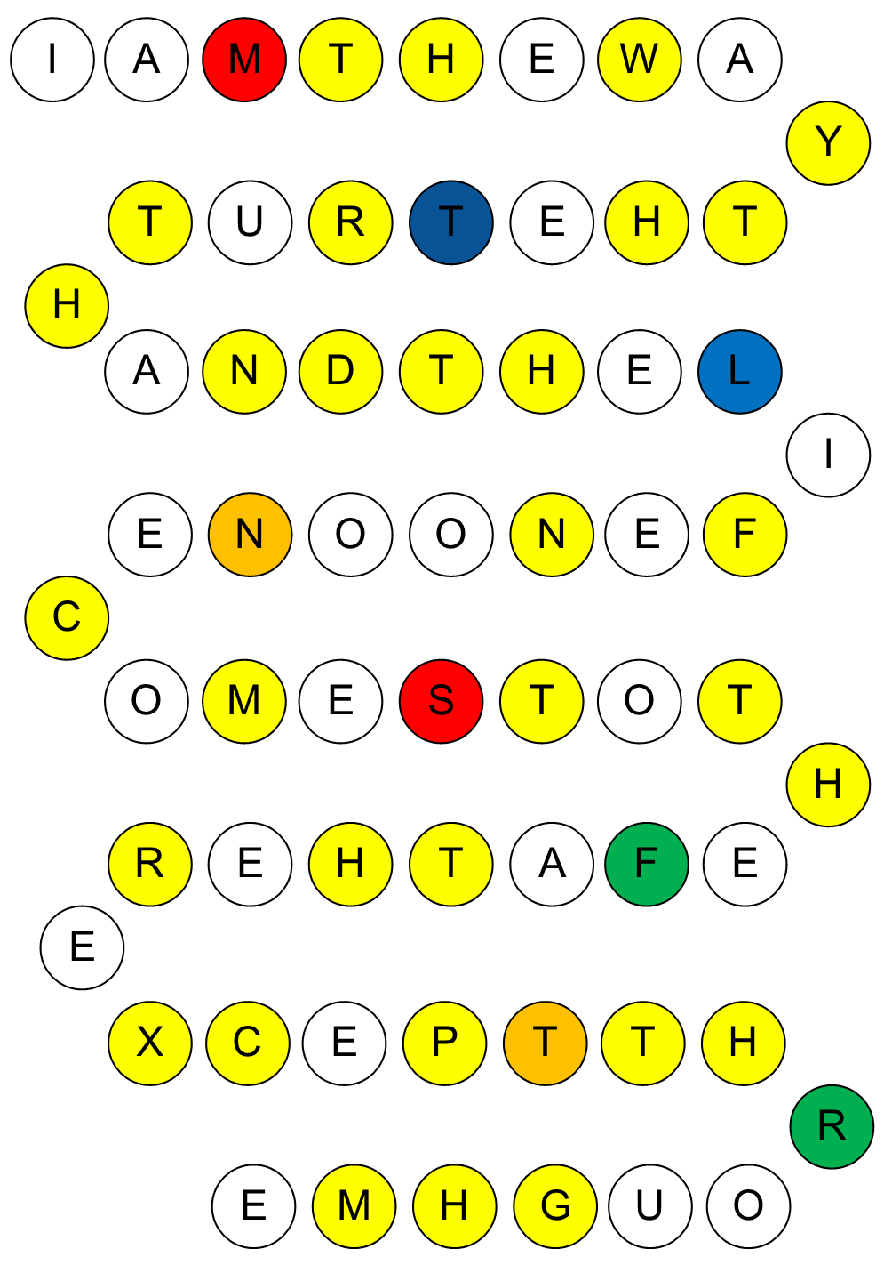

Note: the different colours have no significance in the activity. They are there to make it harder to form a sequence!

