Answers:

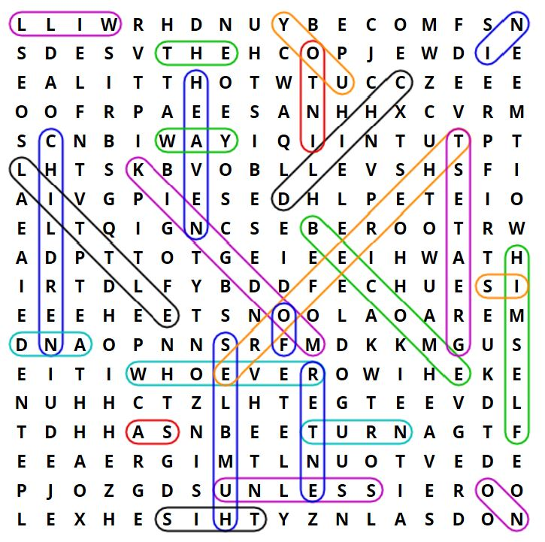
Matthew 18:2-4:
2 Jesus called a little child to himself, and set him in the middle of them 3 and said, ‘Most certainly I tell you, unless you turn and become as little children, you will in no way enter into the Kingdom of Heaven. 4 Whoever therefore humbles himself as this little child is the greatest in the Kingdom of Heaven.’

