Answer:

Jesus said: “Love your enemies, bless those who curse you, do good to those who hate you…” Matthew 5:44
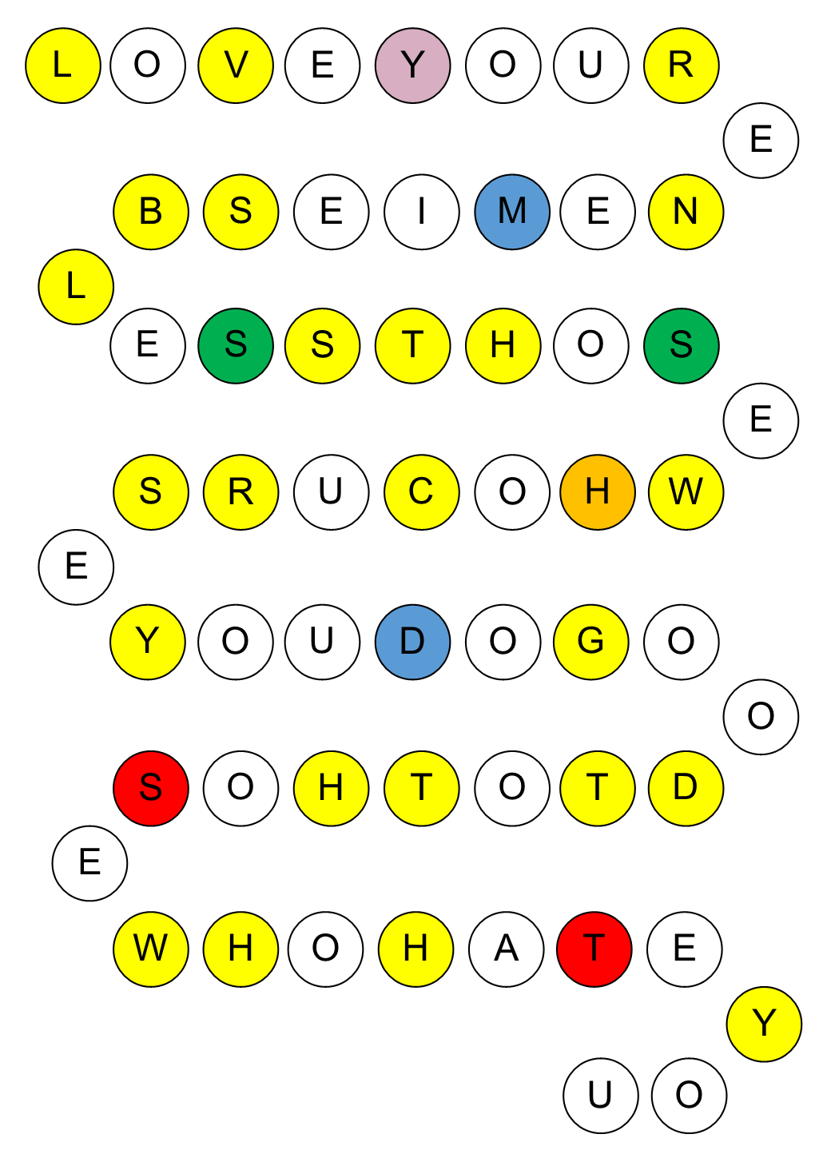

Note: the different colours have no significance in the activity. They are there to make it harder to form a sequence!

