- Find 29 words in the word search puzzle (not duplicates). Note: words can be in any direction, including diagonal and backwards.

- Write the words (including duplicates) in order to form a well-known saying of Jesus.
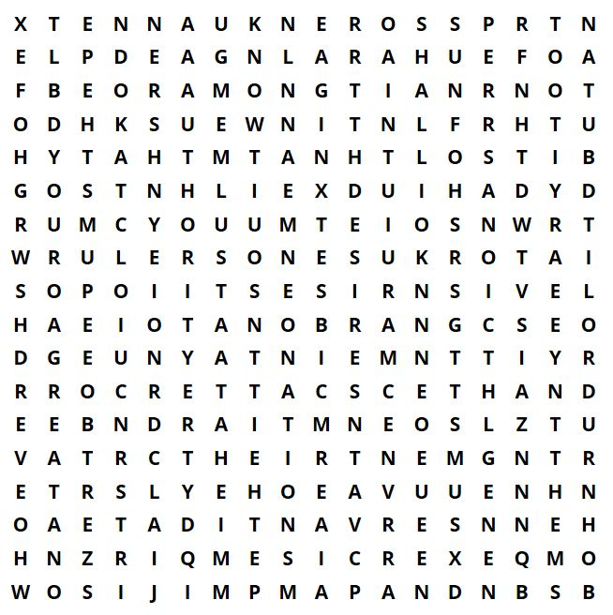

- nations
- among x2
- ones
- rulers
- that
- great x2
- become
- your
- but
- desires
- to
- exercise
- over x2
- know
- be x2
- lord
- and
- them x2
- authority
- you x3
- not
- the x2
- of
- whoever
- servant
- shall x2
- so
- their
- it x2

Jesus said: ‘_______________________________________________________________________
_________________________________________________________________________________
________________________________________________________________________________.’

