- Find 26 words in the word search puzzle (not duplicates). Note: words can be in any direction, including diagonal and backwards.

- Write the words (including duplicates) in order to form a well-known saying of Jesus.
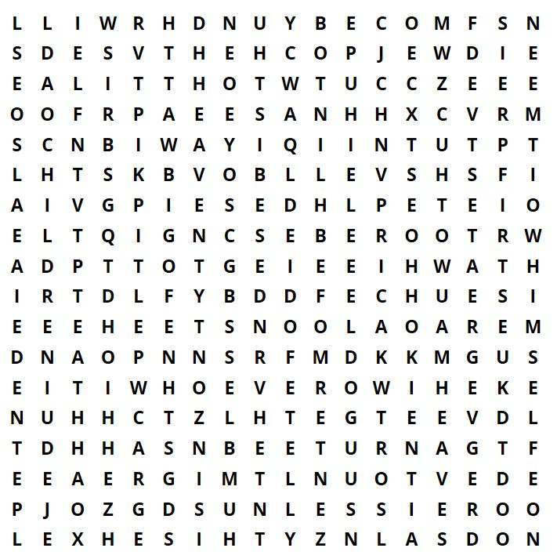

- kingdom x2
- humbles
- therefore
- greatest
- you x2
- this
- of x2
- child
- the x3
- will
- enter
- in x2
- and
- no
- turn
- heaven x2
- way
- whoever
- little x2
- as x2
- into
- become
- himself
- is
- children
- unless

Jesus said: ‘_______________________________________________________________________
________________________________________________________________________________.’

